**United States Department of Agriculture**

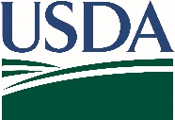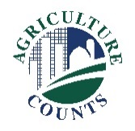

National Agricultural Statistics Service

July 19, 2021

**What should I do next?**

Complete your survey in one of the following ways:

**Online** at [agcounts.usda.gov](http://www.agcounts.usda.gov). Online reporting is fast and secure.All you need is the survey code on the enclosed form to begin.

By **mail or fax**. Complete the survey questionnaire and mail it back in the envelope provided or fax it to (855) 415-3687.

**Why am I getting this letter?**

You have been selected to participate in the 2021 Feral Swine Livestock Damage Survey. The U.S. Department of Agriculture’s National Agricultural Statistics Service (NASS) is conducting this national survey in cooperation with the Animal and Plant Health Inspection Service (APHIS). Please complete the questionnaire at your earliest convenience.

You can complete the questionnaire and return it by mail or complete it online. If you do not respond by August 5, a trained enumerator will follow up to collect the data by phone.

**What will data from this survey be used for?**

Your information is important, as it will help evaluate the impact that feral swine or wild hogs have to livestock operations across the country.

The information you provide will be used for statistical purposes only. In accordance with federal law, your responses will be kept confidential and will not be disclosed in identifiable form. APHIS will analyze these data as a baseline for future studies and any published information will be made available to the public by the APHIS’ National Wildlife Research Center.

Thank you for participating and for your support of our programs and U.S. agriculture. If you have any questions, please feel free to contact us at (888) 424-7828.

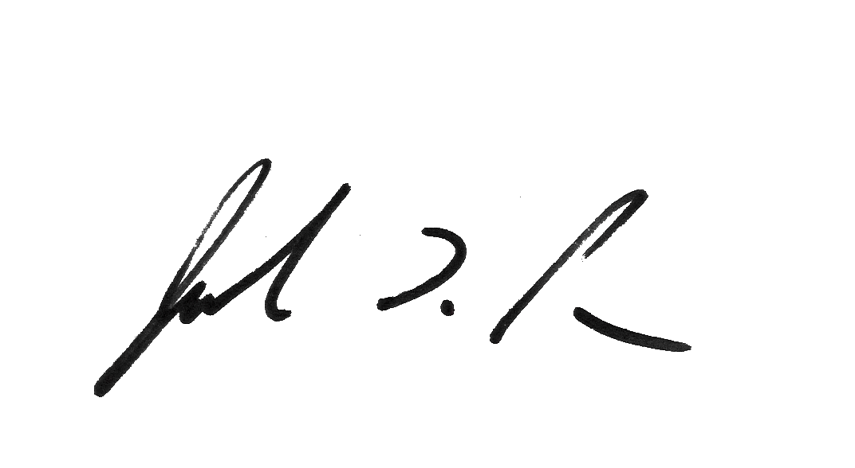

Sincerely,

Joseph L. Parsons

Chair, Agricultural Statistics Board

Enclosure