- 2021 Section A new questions on historic conservation payments

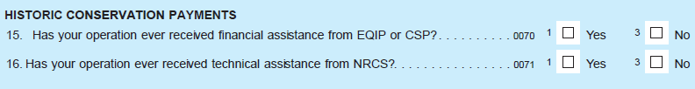

- Additions in cover crops and other practices in conservation practices questions in Section A
2021
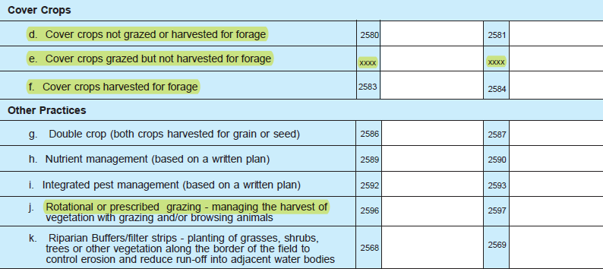
- Section E removed the sales compared to previous year column for #4
- Section E added sustainability commitments question
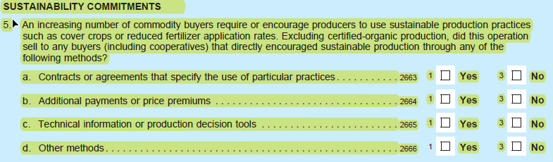
- Section G 2020 removed #2 c and d (yes/no questions on receiving EQIP or CSP or assistance from NRCS)

- Section G (covid related loans/grants) are more specific and they have combined asking about the paycheck protection program and economic injury disaster loans into one question and added “pandemic assistance program” to be asked with CFAP.

2021
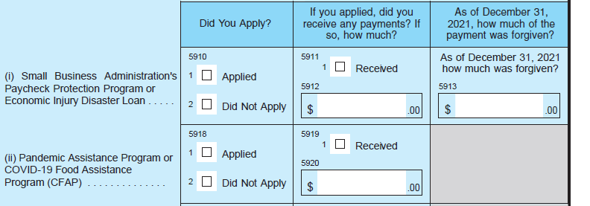

- Section G #3 g is now #3 h and is asked differently including sub questions
2021
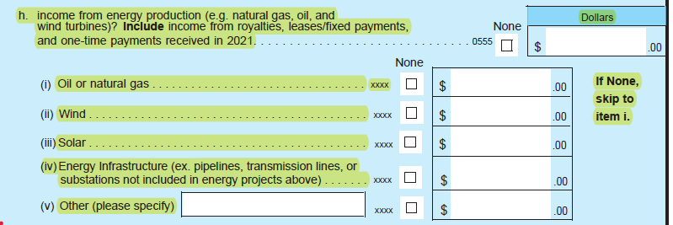

- Section G agritourism questions have been added
2021
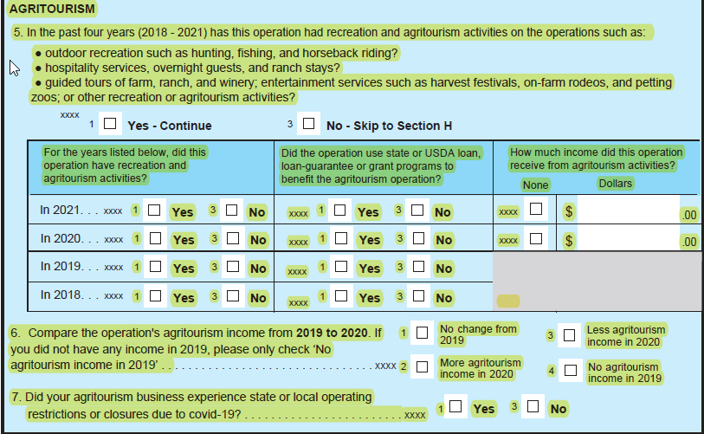
- Section J new question #5
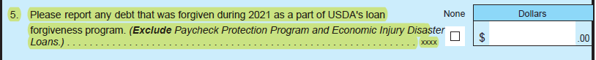

- Section K #15 removed 2 right columns asking number who experienced a loss in health insurance and if they lost health insurance was it due to a loss of employment

- Section K removed #16 and #17 from 2020 about owning another business and if you did own another business did you apply for any covid relief programs.

- Section K – these questions are added
