**Illinois Nutrient Loss Reduction Questionnaire - 2021**

**Removed from approved questionnaire**

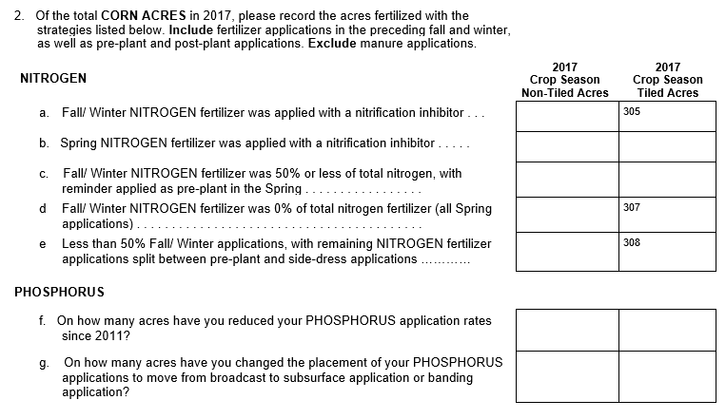

**Added in 2021**

