United States Department of Agriculture

Farm Production
And Conservation (FPAC)

Farm Service Agency (FSA)

1400 Independence Avenue, SW
Stop 0540
Washington, DC
20250-0540

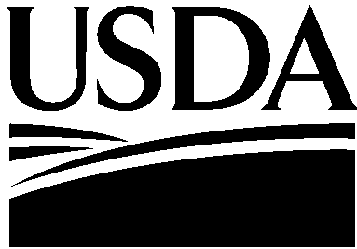

DATE: April 1, 2021

TO: Cortney Higgins
OMB Desk Officer

THROUGH: Ruth Brown
USDA Information Collection Officer

FROM: Brad Karmen 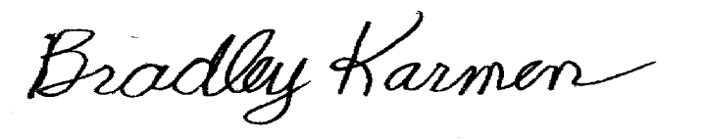
Acting FSA Deputy Administrator Farm Programs

SUBJECT: Request for Emergency Approval to Reinstate the Information Collection Package—Coronavirus Food Assistance Program (CFAP 2) – 0560-0297

FSA is requesting the emergency to reinstate the information collection request (ICR) of OMB 0569-0297 for the Coronavirus Food Assistance Program (CFAP). The justification for the reinstatement is that the current Administration is considering the need for changes and the ways in which the provisions of legislation will be implemented, and the current administration just recently determined the need to continue the CFAP ICR. Also, the CFAP ICR is not within the realm of normal information collection activities. Without CFAP ICR, the program’s COVID-19 related benefit payments to farmers would be jeopardize. The 60-day notice to request for public comment on the information collection request will be published on April 2, 2021.

FSA needs to continue to collect from eligible producer by completing CFAP 2 application (AD-2117). Producers are also required to have the following forms on file with FSA: CCC-902 (I or E), Farm Operating Plan for Payment Eligibility; CCC-901,Member Information for Legal Entities, if applicable; CCC-941, Average Adjusted Gross Income (AGI) Certification and Consent to Disclosure of Tax Information; CCC-942, Certification of Income from Farming, Ranching, and Forestry Operations, Optional; and AD-1026, Highly Erodible Land Conservation (HELC) and Wetland Conservation Certification for CFAP Payments.

If there are any questions or concerns, please call Deirdre Holder at 202-205-5851 or Mary Ann Ball at 202-720-4283.

