Department of Commerce

U.S. Census Bureau

OMB Information Collection Request
Quarterly Financial Report (QFR) Program
OMB Control Number 0607-0432

B. Collections of Information Employing Statistical Methods

1. and 2. Universe and Respondent Selection/Procedures for Collecting Information

The frame from which the major portion of the QFR sample is selected consists of the IRS file of those corporate entities which are required to file IRS Form 1120, 1120A or 1120S and which also have as their principal industrial activity: manufacturing, mining, wholesale trade, retail trade, information, or professional and technical services (except legal). The IRS file is sampled once each year. At the time the sample is selected, the file does not contain those corporate entities whose first income tax return has not been processed. In addition, several months elapse between the selection of this sample and its introduction into the QFR Program.

To keep the QFR sample up-to-date, staff reviews current corporate news releases and public records to identify any potential large additions and changes to the target population. Corporations thus identified and thought to meet QFR in-scope criteria are contacted to verify their in-scope status. If determined to be in-scope of the QFR, the corporation will automatically be included in the survey for the remainder of the sample year.

The QFR sample contains two types of entities: certainty corporations who are canvassed every quarter and non-certainty corporations who are rotated in and out of the sample over time. Larger companies, as measured by assets and receipts reported to the IRS, are included in the sample with certainty, with a one-out-of-one sampling fraction. Asset and receipt cut-off values are determined on an industry-specific basis, so if a corporation has assets or receipts at or above the cut-off values for their industry, that corporation is made a permanent sample member.

Simple random samples are selected from the eligible units in the remaining industry-by-size groups. The total sample size for the non-certainty portion of the sample remains the same from year to year. After the initial sample allocation, the sample allocation may be adjusted to ensure the time-in/time-out constraints required by SEC. 3. Burden Reduction Regarding Quarterly Financial Report Program at Bureau of the Census of the 1995 Paperwork Reduction Act are achieved.

The non-certainty sample in each industry-by-size group is divided systematically into four panels that are introduced over the next year. Each panel is in the survey for two years, for eight successive quarters. Each quarter, one panel is rotated out and a new panel is rotated into the sample. This means that the non-certainty portion of the sample for adjacent quarters is seven-eighths identical and is one-half identical for quarters ending one year apart.

These statistical procedures yield a sample of corporations that are considered potential respondents. After an initial screening, and if the company is found to be within the scope of the program, filing of the QFR report form is mandatory.

The table below, Composition of the Sample, by NAICS Sector and Size of Total Assets, summarizes the resulting sample size by industry sector and size groups.

Composition of the Sample, by NAICS Sector and Size of Total Assets
Third Quarter 2020
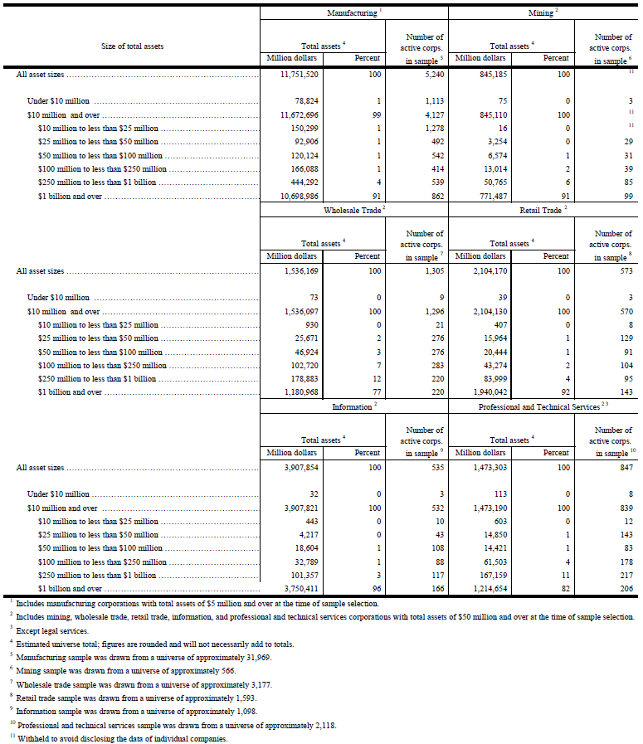

The QFR response rates differ by size category. On average, from 2019Q4 to 2020Q3, certainty corporations with assets and receipts above industry-specific cut-offs achieved a response rate of about 71%; non-certainty corporations below the asset and receipt cut-offs achieved a response rate of about 49%; over all asset size categories, the QFR achieved a response rate of about 61%. Data are imputed for corporations that are active but do not respond to the survey. This is done using statistical procedures that utilize previously reported data (if available) and data from current respondents of similar asset size and industry classification. The total quantity response rate, defined as the percentage of a published estimate represented by data from respondents or equivalent source data, is over 82% for the QFR major data items. Relative standard errors for key items estimates at the sector level vary but are generally less than 0.2. This is adequate to support the precision requirements of the survey.

Each QFR report form received is reviewed by QFR staff accountants for adherence to GAAP and QFR guidelines. Should QFR requirements dictate a classification of data different from the reporting corporation's report, the accountant is responsible for reclassifying or adjusting the data item(s). If complex problems arise, officials of the reporting corporation are contacted to discuss proposed adjustments.

Nonresponse Bias Study

A nonresponse bias analysis completed in 2021 reviewed unit response rates (URR), total quantity response rates (TQRR), relative bias, and correlated frame data for 2017Q4 through 2019Q3. While initial URRs for manufacturing, wholesale trade, and retail were lower than 60%, the rates increased to greater than 60% over subsequent quarters as revised numbers became available. The retail trade sector remains as the sector with the lowest URR due to the timing of its business cycle. Unrevised TQRRs are all greater than 80% except for wholesale until its first revision. A graph showing these differences for Manufacturing, Mining, Wholesale Trade, and Selected Service Industries is publicly available at: https://www.census.gov/econ/qfr/documents/hist_mmw_resp_rates.pdf.
A similar graph for Retail Trade is also available at: https://www.census.gov/econ/qfr/documents/hist_ret_resp_rates.pdf.

The relative bias and correlated frame analyses are based on companies’ assets. The aerospace products and parts industry (NAICS 386) suffered from a large relative bias in the 2014, 2018, and 2021 nonresponse bias studies. Computer systems design (NAICS 545) was also found to have a particularly high relative bias. To improve nonresponse bias in the future, it is recommended to identify and target chronic certainty nonrespondents for additional follow-up in industry 545 to boost URR, TQRR, and decrease relative bias.

3. Methods to Maximize Response

A set of QFR report forms is mailed during the last month of a company's quarter. Upon expiration of the 25-day filing requirement, a letter advising the company of its delinquency is mailed with a form. Companies are contacted via email up to two times a quarter to remind them to report and if they remain delinquent. In the event of continued noncompliance, companies are contacted by telephone and advised of the report's mandatory nature. QFR also conducts courtesy calls to companies sampled for the first time informing them that they will begin receiving the QFR survey.

In addition, QFR has implemented the following efforts in order to improve the response rate:
- QFR staff conducts research each quarter on non-certainty companies that have been non-respondent for two or more quarters. This research often results in the following types of actions: updating a company’s address, updating a company’s contact information, and/or removing the company from the survey due to merger and/or acquisition activity.
- QFR staff conducts research annually on certainty companies that have been non-respondent for three or more quarters. This research often results in the following types of actions: updating a company’s address, updating a company’s contact information, and/or removing the company from the survey due to merger and/or acquisition activity.
- Utilization of the Census Bureau’s Secure Messaging Center (SMC) for correspondence with companies. This secure system is often a preferred method of communication by respondents.

4. Tests of Procedures or Methods

Forms and methods used in the QFR program are subject to continued informal assessments. They have been refined as warranted to reflect changed conditions in the private sector and improved data program practices. The program has 65 years of experience collecting this information. The information requested is easily accessible by reporting corporations, and the burden associated with completing these forms is not considered significant.

The QFR report forms are in traditional corporate income statement and balance sheet formats. Reporting rules conform, for the most part, to GAAP and financial statement presentation. The QFR report short form was developed and introduced in 1981. The short form (a simplified version of the long form) was developed in response to comments from small companies and representatives of small businesses.

5. Contacts for Statistical Aspects and Data Collection

In July 2016, the QFR's statistical methods were evaluated in accordance with OMB Statistical Policy Directive No. 3, and the completed evaluation clearly supports continuation of the current methodology. In October 2005, QFR’s variable weight estimator was validated. In addition, the QFR's primary users, the BEA and FRB, have expressed continued satisfaction with the reliability of this data series for estimation of the corporate profits component of the GDI and the Flow of Funds accounts respectively.

Ms. Brandi Hanley, Chief of the Quarterly Financial Branch for the Quarterly Financial Report Program, is responsible for collection and analysis of QFR data. She can be reached at (301) 763-6600. Mr. Colt S. Viehdorfer, Chief of the Manufacturing Surveys Statistical Methods Branch, is responsible for oversight of and consultation regarding the QFR statistical methods. He can be reached at (301) 763-6796.

List of Attachments

A. Letter of Support from BEA

B. Forms Used in Conducting the QFR Program:

QFR-200 (MT) and instructions QFR-200 (I)
QFR-201 (MG) and instructions QFR-201 (I)
QFR-300 (S) and instructions QFR-300 (I)

C. Cover Letters:

QFR-006 (L1)
QFR-29 (L2)

D. Internet Instrument Used in Conducting the QFR Program:

Centurion

E. Title 13 Relevant Sections

https://www.census.gov/srd/papers/pdf/rrs2005-08.pdf

