SUPPORTING STATEMENT - PART A
U.S. Army Corps of Engineers
Pacific Northwest Households Recreation Use Survey - 0710-0021

Summary of Changes from Previously Approved Collection
- Small increase in respondent burden due to small increase in respondent hourly wages
- Large decrease in cost to the Federal Government due to completion of survey development and other processes since last approval.

1. Need for the Information Collection
Authority for this collection is based on the National Environmental Policy Act (NEPA). The U.S. Army Corps of Engineers (Corps), Bonneville Power Administration (BPA), and Bureau of Reclamation (BOR) (collectively, the Action Agencies, or AAs) are responsible for managing 14 multiple-purpose federal projects and related facilities that are operated as a coordinated system within the interior Columbia River basin in Idaho, Montana, Oregon, and Washington. In the 1990s, the AAs analyzed the socio-economic and environmental effects of operating the system in the Columbia River System Operation Review (SOR) environmental impact statement (EIS). Each of the AAs issued respective Records of Decision (RODs) in 1997 that adopted a system operation strategy. This included operations supporting Endangered Species Act (ESA)-listed fish while fulfilling all other congressionally-authorized purposes. On May 14, 2016, U.S. District Court Judge Simon issued an Opinion and Order finding that the National Marine Fisheries Service biological opinion (BiOp) on the operation of the Federal Columbia River Power System violated the ESA, and that the Corps and BOR violated NEPA for failing to prepare an EIS upon deciding to implement the BiOp reasonable and prudent alternative. The court remanded the BiOp with completion by December 31, 2018. For NEPA, the AAs were originally ordered to produce a comprehensive EIS by March 26, 2021, and sign RODs by September 24, 2021. However, based on an Oct. 19, 2018 Presidential memorandum that addressed streamlining federal agency decision-making, the schedule for the EIS was shortened by a year to September 30, 2020.

The AAs jointly developed the Columbia River System Operations (CRSO) EIS, meeting the required September 30, 2020 deadline for the Record of Decision (ROD). Due to the expedited schedule, the Corps was unable to implement the previously approved Pacific Northwest Households Recreation Use Survey for the initial EIS. Instead the Corps relied upon available information and a qualitative analysis approach for describing potential water-based recreation impacts. However, the Columbia River System litigation continues, with multiple complaints filed against the recently completed CRSO EIS citing that the AA failed to prepare an environmental impact statement that complies with the requirements of NEPA. Anticipating that the Corps will be required to address potential shortfalls in the initial EIS, it is requested that the Pacific Northwest Households Recreation Use Survey implementation timeframe be extended.

As part of the EIS, the Corps was tasked with evaluating changes in the economic value provided by water-based recreation. Recreation is one of several activities expected to be impacted by alternatives considered within this CRSO EIS; in particular, in conjunction with breaching of one or more of the four lower Snake River dams. Recreation is a congressionally authorized project purpose (Section 4 of the Flood Control Act of 1944 and Water Project Recreation Act of 1965 as amended) for the 12 projects constructed and operated by the Corps of Engineers, including the 4 Lower Snake projects.

To estimate changes in the distribution of recreational activity and associated economic impacts, it is necessary to collect current use information suitable to develop system-wide water-based recreational demand models. The model will be used to evaluate recreational impacts associated with alternatives identified within the CRSO EIS. The proposed design involves a web-based survey to collect data on recreational trips and activities within the region.

The survey and subsequent analyses will allow USACE and other AAs to fulfill their obligations under NEPA addressing the shortfalls of the water-based recreation analysis included in the initial CRSO EIS. Existing recreational use information has limitations that presented significant challenges for supporting an accurate and reliable evaluation of recreational impacts. Collected information may also be used to inform future management actions not necessarily related to the EIS.

2. Use of the Information
Our general approach to estimating changes in economic value for inland water-based recreation activities involves developing two random utility maximization (RUM) travel cost models using data on recreation trips taken by residents of the Pacific Northwest. One of the models will focus on recreational fishing and the other will focus on recreational boating. RUM models are used by economists to describe an individual’s decisions regarding the frequency and destination of recreation trips. The models take into account the location of the individual’s primary residence, the individual’s characteristics (e.g., age, income), and the attributes and locations of available recreation sites in the region. After using trip data to estimate the parameters of a RUM model, the model can be used to estimate changes in economic value associated with changes in site attributes or site availability.

Considering the limitations of existing information, data for the two RUM models will be collected through a general population web survey of households in Washington, Oregon, Idaho, and western Montana. The survey will be split into three “waves” covering different subsamples of households to minimize recall error: May and June (Wave 1), July and August (Wave 2), and September and October (Wave 3). Households contacted in a given wave will be asked to provide information about the number of recreation trips taken to rivers, lakes, or reservoirs in the region in the preceding two months, focusing on fishing, boating, paddling/rafting, and swimming trips.

We do not anticipate that the survey will yield enough trip data for paddling/rafting and swimming to develop separate RUM models for these activities. Therefore, impacts to these activities will be addressed using benefits transfer. Changes in the locations and amount of recreation for rafting/paddling and swimming from CRSO management alternatives will be estimated using a combination of recreation use data from the web survey, other existing data, and professional judgment. Values for these recreation activities will be adapted from available literature. Benefits transfer will also be used to assess impacts to other recreational activities not covered by the survey.

The rest of this response is organized into three sections:

- Overview of the RUM Model: This section provides a brief summary of RUM models and how the model will be used to support the CRSO EIS.

- Recreation Survey Implementation Plan: This section reviews how the recreation survey will be implemented. We describe the data collection and sampling approach, expected response rate, and potential analyses to evaluate non-response bias.

- Analysis Methodology: This section describes how the information collected through the recreation survey will be combined with other existing data to estimate the RUM models, and how these models will be used to calculate changes in recreation-related value under various CRSO management alternatives.

Overview of RUM Model
The study will use data on individuals’ recreation trips, recreation site attributes, and travel costs to estimate a RUM travel cost model. The specific type of RUM travel cost model that will be estimated is a “repeated nested logit” model, and it describes individuals as making a series of independent choices throughout the recreation season: each day (or “choice occasion”), they choose: (1) whether or not to go to a recreation site; and, (2) which recreation site to visit, should they choose to go.

The first decision is often described as the “participation” decision, and it is modeled as a function of demographic characteristics. The second decision is typically described as the “site choice” decision, and it is modeled as a function of recreation site characteristics and travel cost. Travel cost is defined as the per-person out-of-pocket cost of travel (e.g., gasoline) plus the opportunity cost of the time taken to travel to the site. The recreation trip data from the survey, combined with existing data on site characteristics (discussed below in the Analysis Methodology section), provide information on how individuals trade off various site attributes (e.g., catch rates versus travel costs), which allows one to estimate changes in economic value associated with changes in these attributes or with the removal/addition of sites. For modeling purposes, recreation “sites” will be specified as publicly accessible reservoirs, lakes, or stream sections within Washington, Oregon, Idaho, and western Montana. A minimum site size threshold will be imposed prior to modeling to avoid including a large number of insignificant sites in the model.

Recreation Survey Implementation Plan
Trip data will be collected through a general-population web survey of residents of the states of Washington, Oregon, Idaho, and western Montana. A review of previous recreation studies indicates that this region is likely to cover the vast majority of potential recreationists on the Columbia River System. Existing data may be used to incorporate impacts to recreationists who reside outside of the region.

The survey will be split into three two-month waves (covering May through October) with different samples of individuals contacted during each wave. The survey will request data on trips occurring during a single two-month period: either May-June (wave 1), July-August (wave 2), or September-October (wave 3) in 2021. Individuals will be contacted immediately after the period for which trip data are desired. Focusing on two-month periods will help to minimize respondent burden and recall error in reporting trips.

Sampled individuals will be contacted via mail to complete the survey on-line. The invitation letter will request that the adult member of the household (age 18 or older) with the most recent birthday complete the survey, and contain a unique URL that links to the questionnaire. A postcard reminder will be sent seven days after the initial mailing, and a second follow-up letter will be sent seven days later. All mailings (envelopes, letterhead, etc.) will be “branded” with the USACE logo, which will encourage response by signaling that the survey is a high-quality, government-sponsored effort rather than a marketing effort. In addition, a toll-free number will be provided in the survey correspondence to address any questions.

The first two questions in the web survey (Appendix A) will focus on opinions regarding Corps missions and priorities, followed by two general questions focused on recreation trips taken by the respondent to rivers, lakes, or reservoirs in 2020. These same questions, together with demographic questions, will be replicated in a follow-up survey of non-respondents (described below).

The survey will then gather information about four different types of potential trips from the previous two-month period: fishing trips, boating trips (i.e., motor boating or jet skiing without fishing), paddling/rafting trips (i.e., non-motorized boating), and swimming trips. The survey establishes a hierarchy in order to avoid double-counting trips where multiple activities take place (e.g., boating trips where the respondent fishes and swims). For each of the four types of trips, the survey gathers information about the total number of day trips and overnight trips that the respondent took during the preceding two-month period, as well as how those trips were distributed across sites. The survey requests a few additional details regarding the most recent trip to each site, such as the number of persons per vehicle and detailed catch information for fishing trips. At the end of each of the four trip sections, the respondent is asked about the importance of various site characteristics for that particular type of trip. Finally, the survey concludes with standard questions about demographic characteristics, such as income (necessary for estimating individual’s opportunity cost of time) and age.

Sampling Plan
A stratified random sample of households will be selected from Washington, Oregon, Idaho, and western Montana using address-based sampling (ABS) and the United States Postal Service’s Computerized Delivery Sequence File (CDSF) and divided equally across the three survey waves. Four primary strata will be defined as follows (Exhibit 1):
- Stratum 1 (Lower Snake River): Counties bordering the Lower Snake River from Lewiston, Idaho to Pasco, Washington.
- Stratum 2 (Columbia River East of Cascades): Counties bordering the Columbia River from Hood River, OR to the U.S./Canadian border.
- Stratum 3 (West of Cascades): Counties in Washington and Oregon west of the Cascades.
- Stratum 4 (Other Counties East of Cascades): All other counties within the sampling frame but outside of strata 1, 2, and 3.

Initial sample sizes within each stratum are presented in Exhibit 2. The sampling rate is highest in strata 1 and 2, areas near the Columbia and Lower Snake rivers east of the Cascades. These areas have a high potential for impacts associated with changes to CRSO. To reflect our expectations about potential for CRSO-related impacts, the sampling rate will be greatest for stratum 1, followed by stratum 2, stratum 4, and stratum 3 (sampling rates by stratum shown in Exhibit 2). Within each stratum, the sample will be allocated to counties in proportion to the square root of each county’s population. This allocation ensures that the sample will be well distributed geographically within each stratum.

Exhibit 1. Sampling Strata
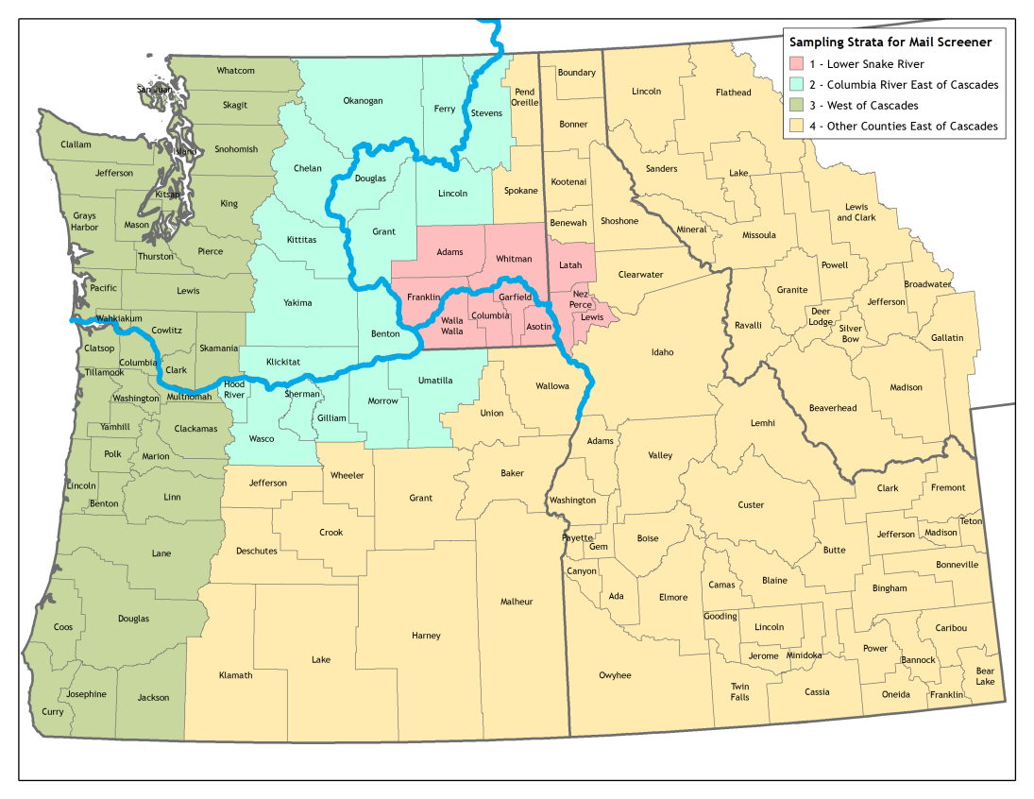

Exhibit 2. Sampling Rates

Stratum | Total Households | Sample Size | Percentage  of Sample | Sampling Rate  (per 1,000 HHs)
1. Lower Snake River | 114,833 | 15,000 | 30% | 131
2. Columbia River East of Cascades | 337,005 | 15,000 | 30% | 45
3. West of Cascades | 3,474,377 | 10,000 | 20% | 3
4. Other Counties East of Cascades | 1,143,108 | 10,000 | 20% | 9
With 50,000 sampled addresses, we anticipate approximately 9,200 survey responses:
50,000 | Sampled addresses
x 0.92 | Expected proportion valid addresses
x 0.20 | Expected survey response rate
9,200 | Survey responses

With the sampled addresses allocated equally across the three temporal waves, we anticipate obtaining approximately 3,067 survey responses per wave.

Response Rates and Potential Non-Response Bias
Several measures will be taken to encourage sampled individuals to respond to the survey, including:
- Branded survey materials with color USACE logos
- Multiple follow-up reminders after the initial invitation
- Provision of a toll-free number in survey correspondence to address any questions
Despite these measures, the response rate for the web survey may be as low as 20%, raising potential concerns about non-response bias. Demographic differences between respondents and non-respondents will be addressed by calibrating design weights through iterative proportion fitting, or “raking” (Kolenikov 2014; Battaglia, Hoaglin, and Frankel 2009) to match demographic controls from the American Community Survey (e.g., gender, age, ethnicity, and education) within each of the four sampling strata.

Even after controlling for demographic differences between respondents and non-respondents, avid recreationists may be more likely to respond to the survey, which could lead to overestimates of recreation activity for the population of interest. The potential for this type of non-response bias will be investigated through a targeted non-respondent follow-up survey (NRFU). The NRFU survey will consist of a subset of questions from the main survey, including general questions about participation in outdoor recreation and demographics. The survey will be formatted as an oversized postcard and sent to a sample of 5,000 non-respondents via priority mail. Responses to the NRFU survey will be compared to responses to the main survey to assess the potential for non-response bias.

Finally, recreation trip estimates generated from the survey data will be compared to existing recreation trip estimates generated through onsite counts by federal and state agencies at various sites within the region (e.g., creel surveys of fishing effort or recreation counts at USACE reservoirs). If large differences are observed, the survey data may be calibrated so that trip estimates align more closely with these onsite counts.

Analysis Methodology
The recreation survey will be combined with other existing data to estimate the RUM models, and these models will be used to calculate changes in the economic value under various CRSO management alternatives. The survey will provide respondent demographic data (i.e., gender, age, income, and education) and data on numerous fishing and boating trips taken to sites in the region. These two types of data form the foundation for the RUM models, which will explain trip frequency as a function of demographics, and trip destinations as a function of travel costs and site characteristics.

For modeling purposes, sites will be defined as significant lakes, reservoirs, or stream sections located within the sampling frame for the survey. Site characteristics data will be gathered from existing sources—such as state or federal databases, Geographic Information System coverages depicting access points and parks, state 305(b) reports, United States Geological Survey (USGS) flow gages, CRSO EIS Hydrologic and Hydraulic (H&H) Team data on flows and elevations, and state fish consumption advisories—and from catch rate data gathered through the web survey.

After estimating the parameters of the fishing and boating RUM models, they can be used to estimate changes in economic value associated with changes in site attributes or site availability. Changes in value will be driven by changes in the type and location of recreational activities covered by the RUM model, as well as changes in overall participation. For example, some CRSO alternatives being considered may lead to higher future fish populations in the Columbia River and Snake River, as well as associated tributaries. The change in value associated with changes in fish populations will be assessed using the RUM model by increasing the assumed catch rates at the affected subset of sites. Experts from the Corps and other agencies will provide information on the expected percentage fish population increase or decline at various sites under each CRSO alternative. These population increases or declines will be reflected in the recreational fishing model through equivalent increases or declines in catch rates. Gains or losses are calculated on a “per trip” or “per day” basis. These gains or losses are then aggregated across all trips/days to estimate seasonal gains or losses for the sample. The sample losses are aggregated to the entire population of the region through the application of sampling weights.

3. Use of Information Technology
100% of responses will be collected electronically through online survey administration and stored in a secure database. The invitation letter (and subsequent mailings) will contain a unique URL that links to the questionnaire.

4. Non-duplication
The information obtained through this collection is unique and is not already available for use or adaptation from another cleared source.

5. Burden on Small Businesses
This information collection does not impose a significant economic impact on a substantial number of small businesses or entities.

6. Less Frequent Collection
This is a one-time survey and is therefore the most infrequent collection interval possible.

7. Paperwork Reduction Act Guidelines
This collection of information does not require collection to be conducted in a manner inconsistent with the guidelines delineated in 5 CFR 1320.5(d)(2).
8. Consultation and Public Comments
Part A: PUBLIC NOTICE
A 60-Day Federal Register Notice (FRN) for the collection published on Friday, February 26, 2021. The 60-Day FRN citation is 86 FR 11736.
No comments were received during the 60-Day Comment Period.
A 30-Day Federal Register Notice for the collection published on Wednesday, April 21, 2021. The 30-Day FRN citation is 86 FR 20670.
Part B: CONSULTATION
No additional consultation apart from soliciting public comments through the Federal Register was conducted for this submission.
9. Gifts or Payment
No payments or gifts are being offered to respondents as an incentive to participate in the collection.

10. Confidentiality
A Privacy Act Statement is required for this collection. It is provided to respondents on the invitations and reminders from which the web survey link is accessed. Additionally, it is displayed on the Non-Response Follow Up Survey postcard.

A System of Record Notice (SORN) is not required for this collection because records are not retrievable by PII.

Privacy Impact Assessment (PIA) is not required for this collection because PII is not being collected electronically.

The record number is 200-1c, Environmental Quality Surveys. As described in the Records Instruction Details for 200-1c, the records would remain in the current files area (CFA) until no longer needed for conducting business, then retired to the records holding area (RHA) or army electronic archive (AEA). The RHA/AEA will destroy the record when the record is 50 years old.

11. Sensitive Questions
Respondents will be asked what their total household income was in 2020 before taxes. This information is necessary to construct the travel cost variable, which will be used to estimate a RUM travel cost model. This information will be used only to develop an estimate of an opportunity’s cost of travel time and will not be used further.

12. Respondent Burden and its Labor Costs
Part A: ESTIMATION OF RESPONDENT BURDEN
- Collection Instrument(s)
Main Survey
- Number of Respondents: 9,200
- Number of Responses Per Respondent: 1
- Number of Total Annual Responses: 9,200
- Response Time: 20 minutes
- Respondent Burden Hours: 3,066.7 hours

Non-Respondent Follow Up
- Number of Respondents: 500
- Number of Responses Per Respondent: 1
- Number of Total Annual Responses: 500
- Response Time: 10 minutes
- Respondent Burden Hours: 83.3 hours

- Total Submission Burden
  - Total Number of Respondents: 9,700
  - Total Number of Annual Responses: 9,700
  - Total Respondent Burden Hours: 3,150 hours

Part B: LABOR COST OF RESPONDENT BURDEN

Respondents come from a variety of occupations that cannot be defined in advance of the survey. The labor cost burden is calculated with the median hourly wage of all occupations as reported by the Bureau of Labor Statistics in their National Occupational Employment and Wage Estimates (http://www.bls.gov/oes/current/oes_nat.htm). The reported value was $19.14 at the time this supporting document was written.

- Collection Instrument(s)
Main Survey
- Number of Total Annual Responses: 9,200
- Response Time: 20 minutes
- Respondent Hourly Wage: $19.14
- Labor Burden per Response: $6.38
- Total Labor Burden: $58,696

Non-Respondent Follow Up
- Number of Total Annual Responses: 500
- Response Time: 10 minutes
- Respondent Hourly Wage: $19.14
- Labor Burden per Response: $3.19
- Total Labor Burden: $1,595

- Overall Labor Burden
  - Total Number of Annual Responses: 9,700
  - Total Labor Burden: $60,291

13. Respondent Costs Other Than Burden Hour Costs
There are no annualized costs to respondents other than the labor burden costs addressed in Section 12 of this document to complete this collection.

14. Cost to the Federal Government

Part A: LABOR COST TO THE FEDERAL GOVERNMENT
- Collection Instrument(s)
Main Survey
- Number of Total Annual Responses: 9,200
- Processing Time per Response: 10 minutes
- Hourly Wage of Worker(s) Processing Responses: $40.78
- Cost to Process Each Response: $6.80
- Total Cost to Process Responses: $62,529.33

Non-Respondent Follow Up
- Number of Total Annual Responses: 500
- Processing Time per Response: 5 minutes
- Hourly Wage of Worker(s) Processing Responses: $40.78
- Cost to Process Each Response: $3.40
- Total Cost to Process Responses: $1,699.17

- Overall Labor Burden to the Federal Government
  - Total Number of Annual Responses: 9,700
  - Total Labor Burden: $64,229

Part B: OPERATIONAL AND MAINTENANCE COSTS

- Cost Categories
  - Equipment: $2,000
  - Printing: $1,200
  - Postage: $300
  - Software Purchases: $1,500
  - Licensing Costs: $0
  - Other: $2500

- Total Operational and Maintenance Cost: $7,500

Part C: TOTAL COST TO THE FEDERAL GOVERNMENT

- Total Labor Cost to the Federal Government: $64,229

- Total Operational and Maintenance Costs: $7,500

- Total Cost to the Federal Government: $71,729

15. Reasons for Change in Burden
The respondent burden has increased slightly since the previous approval due to a small increase in the average respondent wage. Cost to the Federal Government has decreased significantly because previous approval’s estimate included expected costs of survey development and other processes that have since been completed.

16. Publication of Results
The results of this information collection will be reported by the AAs as required to address the shortfalls of the initial CRSO EIS. Reporting of the results will allow USACE and other AAs to fulfill their obligations under NEPA through completing a comprehensive EIS and/or producing a supplemental EIS. It has not been determined whether the datasets supporting these results will be published as part of the EIS.

Data tabulation will include response frequencies and measures of central tendency, as appropriate. The recreation survey will be combined with other existing data to estimate the RUM models, and these models will be used to calculate changes in the economic value under various CRSO management alternatives.

The estimated schedule for the full survey and reporting is as follows:
- Final Material Preparation & Coordination Upon Approval
- Survey Implementation June 1 – November 30 2021
- Data analysis and Reporting August 1 – March 2022

17. Non-Display of OMB Expiration Date
We are not seeking approval to omit the display of the expiration date of the OMB approval on the collection instrument. The OMB control number and expiration date will be displayed on the web and non-response follow-up surveys.

18. Exceptions to “Certification for Paperwork Reduction Submissions”
We are not requesting any exemptions to the provisions stated in 5 CFR 1320.9.

References
Battaglia, M. P., D. C. Hoaglin, and M. R. Frankel. 2009. “Practical Considerations in Raking Survey Data,” Survey Practice 2(5).
Kolenikov, S. 2014. “Calibrating Survey Data Using Iterative Proportional Fitting (Raking),” The Stata Journal, 14(1): 22–59.

