10903 New Hampshire Avenue
Silver Spring, MD 20993 February 4, 2021

To: [Facility Contact Name], [Facility Name]
From: Thomas Henry, Office of the Commissioner, Office of Policy, Legislation and International Affairs, Office of Economics and Analysis, Economics Staff
Re: FDA invites your participation in a survey of pharmaceutical manufacturing practices

Dear [Mr./Ms./Dr.] [Surname]

Recently, I sent you a letter regarding FDA’s Survey of Drug Product Processing Facilities. If you have already submitted your survey on line, thank you! But, if not, please consider submitting it soon; or, if you prefer, fill out the enclosed hard copy version of the survey and return it in the business reply envelope, also enclosed.

The purpose of the survey is to obtain information on industry-wide Current Good Manufacturing Practices (CGMPs), current risk management approaches, and practices for ensuring the quality and suitability of drug components, containers and closures, and finished drug products. The results of this survey will help inform FDA’s economic analyses of human and animal drug manufacturing practices.

Your participation in, and responses to, the survey are considered private. This survey is being administered for FDA by our survey contractor, Eastern Research Group, Inc. (ERG). FDA’s agreement with ERG holds that ERG will not identify any individual facility or their responses to FDA, nor will ERG provide any information to FDA that would enable the identification any facility or company. All data obtained will be aggregated by facility size and location (i.e., foreign or domestic) and main line of business.

To take the survey or preview it on line, go to www.myfdasurvey.com.
Your facility’s password is 111111.

This survey is voluntary and may take 30 minutes to 60 minutes to complete. You can close the browser window and then log in again at any time to resume where you left off.

If you have any questions about the survey process or items, please call ERG’s survey helpline at
866-623-8999, or send an email to myFDAsurvey@erg.com. If you have general questions concerning this study and its uses, please call me at 301-796-9100 or email me at Thomas.Henry@fda.hhs.gov. I am the FDA Supervisory Economist overseeing this work. This work is covered under Contract No. HHSF223201400008I, Task Order No. HHSF22301007T.

Thank you in advance for your participation. FDA greatly appreciates your input.

Sincerely,
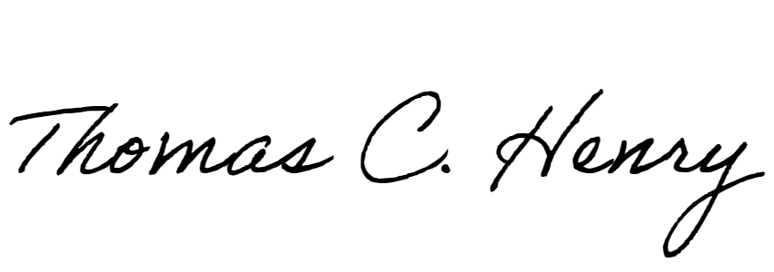
Thomas Henry
Office of the Commissioner, Office of Policy, Legislation and International Affairs, Office of Economics and Analysis
Mail Stop HFP-60
Silver Spring MD 20993-0002
000500
301-796-9100

