Appendix 1.1
Survey Pre-notification/Survey Link

10903 New Hampshire Avenue
Silver Spring, MD 20993 September 14, 2020

To: [Facility Contact Name], [Facility Name]
From: Thomas Henry, Office of the Commissioner, Office of Policy, Legislation and International Affairs, Office of Economics and Analysis, Economics Staff
Re: FDA invites your participation in a survey of drug product manufacturing practices

Dear [Mr./Ms./Dr.] [Surname]

FDA is conducting a survey of facilities currently registered with FDA as manufacturers of drug products, packers, labelers, and/or sterilizers of human or animal drug products marketed in the United States. Your facility has been selected at random to participate in this survey.

The purpose of the survey is to obtain information on industry-wide Current Good Manufacturing Practices (CGMPs) 21 CFR Parts 210 and 211, including:

- Current risk management approaches,
- Supplier qualification, and
- Practices for qualification and oversight of drug product components, containers, and closures used in the manufacturing, processing, and packing of drug products.

The results of this survey will help inform FDA’s economic analyses of human and animal drug product manufacturing practices.

Your participation in, and responses to, the survey are considered private. This survey is being administered for FDA by our survey contractor, Eastern Research Group, Inc. (ERG). FDA’s agreement with ERG holds that ERG will not identify any individual facility or their responses to FDA, nor will ERG provide any information to FDA that would enable the identification any facility or company. All data obtained will be aggregated by facility size and location (i.e., foreign or domestic) and main line of business.

To take the survey or preview it online, go to www.myfdasurvey.com.
Your facility’s password is 111111.

This survey is voluntary and may take 30 minutes to 60 minutes to complete. You can close the browser window and then log in again at any time to resume where you left off.

If you have any questions about the survey process or items, please call ERG’s survey helpline at
866-623-8999, or send an email to myFDAsurvey@erg.com. If you have general questions concerning this study and its uses, please call me at 301-796-9100 or email me at Thomas.Henry@fda.hhs.gov. I am the FDA Supervisory Economist overseeing this work. This work is covered under Contract No. HHSF223201400008I, Task Order No. HHSF22301007T.

Thank you in advance for your participation. FDA greatly appreciates your input.

Sincerely,
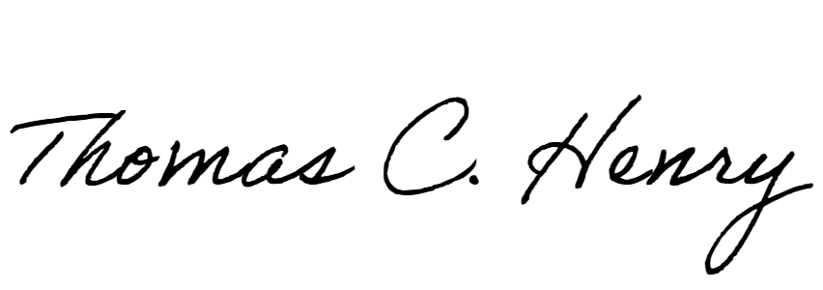
Thomas Henry, Ph.D.
U.S. Food and Drug Administration
OC/OPLIA/OEA/ECS
10903 New Hampshire Ave
Bldg 32, Room 3238
Silver Spring, MD 20993
240-402-5049 (office)

