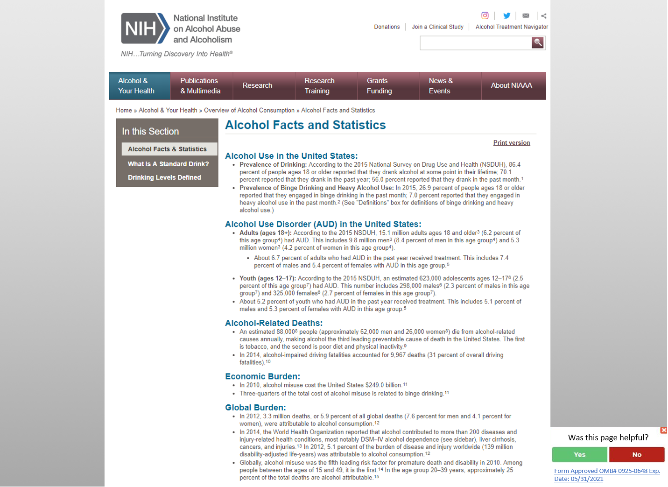

From here, a user can choose to answer the first survey question. If the user answers the first question, subsequent questions may appear on the same page in the same place (no more than 6 questions). A user can also click the “x” to make the survey go away, or they can click on the hyperlinked “Form Approved OMB#” text to visit our privacy page, which will include the full OMB burden statement.

https://www.niaaa.nih.gov/alcohol-health/overview-alcohol-consumption/alcohol-facts-and-statistics
Surveys on any NIAAA websites will link to NIAAA website privacy page (https://www.niaaa.nih.gov/privacy), which will be updated with the following text when we start running the survey:

Survey Disclaimer

OMB # and expiration date:
Public reporting burden for this collection of information is estimated to average five minutes per response, including the time for reviewing instructions, searching existing data sources, gathering and maintaining the data needed, and completing and reviewing the collection of information. An agency may not conduct or sponsor, and a person is not required to respond to, a collection of information unless it displays a currently valid OMB control number. Send comments regarding this burden estimate or any other aspect of this collection of information, including suggestions for reducing this burden, to: NIH, Project Clearance Branch, 6705 Rockledge Drive, MSC 7974, Bethesda, MD 20892-7974, ATTN: PRA (0925-0648). Do not return the completed form to this address.

