OMB Number: 0925-0648 (Expiration Date: 5/31 2021)

Public reporting burden for this collection of information is estimated to average 1 minute per submission. An agency may not conduct or sponsor, and a person is not required to respond to, a collection of information unless it displays a currently valid OMB control number. Send comments regarding this burden estimate or any other aspect of this collection of information, including suggestions for reducing this burden, to: NIH, Project Clearance Branch, 6705 Rockledge Drive, MSC 7974, Bethesda, MD 20892-7974, ATTN: PRA 0925-0648. Do not return the completed form to this address.

Polling
Note: Each poll question is only open 30 seconds, is anonymous, voluntary, and only available for live webinar participants. Webinar participants may also expound or offer any additional comments questions or opinions through a chat box built into the GoToMeeting Software, and so are not limited only to the choices presented

OPEN POLL
- The first polling question asks: Does your Disaster Plan include contingencies for pandemics?

- Yes
- No
- In Development

CLOSE POLL:

Let’s see how many institution’s Disaster Plan include contingencies for pandemics

SHARE POLL

- An overwhelming majority selected_______
- The audience seem to favor _______________
- The decision is unanimous, the audience clearly thinks that ___________
- The response is clear cut and the audience has spoken.
- Looks like there are split reactions to this question. About half selected __________ whereas the other half choose________
- The response appears to be evenly distributed between ___________ and __________

HIDE POLL

OPEN POLL
- The 2nd polling question asks: Has your institution implemented some or all of its pandemic contingencies in response to the COVID-19 outbreak?
- Yes
- No
- In Development

CLOSE POLL:

Let’s see which how many institutions have implemented their pandemic contingencies in response to the COVID-19 outbreak?

SHARE POLL:

- An overwhelming majority selected_______
- The audience seem to favor _______________
- The decision is unanimous, the audience clearly thinks that ___________
- The response is clear cut and the audience has spoken.
- Looks like there are split reactions to this question. About half selected __________ whereas the other half choose________
- The response appears to be evenly distributed between ___________ and __________

HIDE POLL:

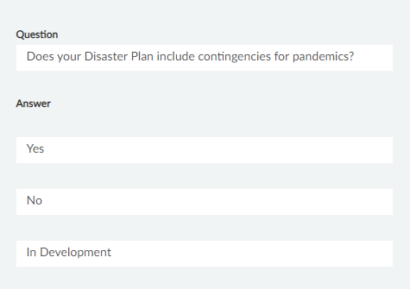
Has your institution implemented some or all of its pandemic contingencies in response to the COVID-19 outbreak?

