NIA.NIH.GOV Feedback Survey Setup
The following information details how the feedback survey will be setup and function on nia.nih.gov.
- Survey Tool — The survey is a Drupal module that will be added survey functionality to the NIA website.
- Pages for Survey — The survey will appear on many pages of the site. The survey will not appear on staff bio pages, Spanish content, and the homepage. A list of pages the survey will appear on is included in a separate file. This list may change as pages are added or removed from the site.
- Survey Box Placement —
  - Desktop: The survey box will appear in the bottom right corner of the screen as the page loads, in an “absolute” position (meaning it will stay in this place even if the user scrolls down the page). This location is the least obtrusive, appearing in the margin for most users, and less likely to annoy users.
  - Mobile: The survey box will appear at the bottom of the screen.
- Pop-up Functionality —
  - Users can “X out” of the survey, which will hide the survey box for 48 hours.
  - Users who completed a survey will not be prompted to complete the survey on that page again (Note: this is done via a web browser cookie, so the user’s settings may impact this functionality. This is something beyond our control.).
  - Users who complete a survey will not be shown another survey on the site for 48 hours.
  - Upon completion, users will see a thank you screen that disappears after 5 seconds.
- Survey Box Content
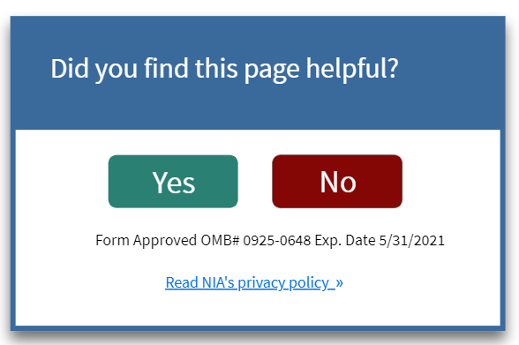
  - Website visitors will be shown the first question of the survey. Answering the first question will display the next question (see survey questions below for more details)
  - The bottom of the survey box will always display the OMB clearance number, expiration date, and have a link to the privacy policy page (see image).
  - The link to the privacy policy will take users directly to the survey disclaimer text on https://www.nia.nih.gov/about/policies#privacy.

Privacy Policy
NIA will add the following to its privacy policy page (https://www.nia.nih.gov/about/policies#privacy):
Survey Disclaimer
OMB#: 0925-0648 Exp. Date 05/31/2021
Public reporting burden for this collection of information is estimated to average two minutes per response, including the time for reviewing instructions, searching existing data sources, gathering and maintaining the data needed, and completing and reviewing the collection of information. An agency may not conduct or sponsor, and a person is not required to respond to a collection of information unless it displays a currently valid OMB control number. Send comments regarding this burden estimate or any other aspect of this collection of information, including suggestions for reducing this burden, to: NIH Project Clearance Branch, 6705 Rockledge Drive, MSC 7974, Bethesda, MD 20892-7974, ATTN: PRA (0925-0648).
Screenshot of policy
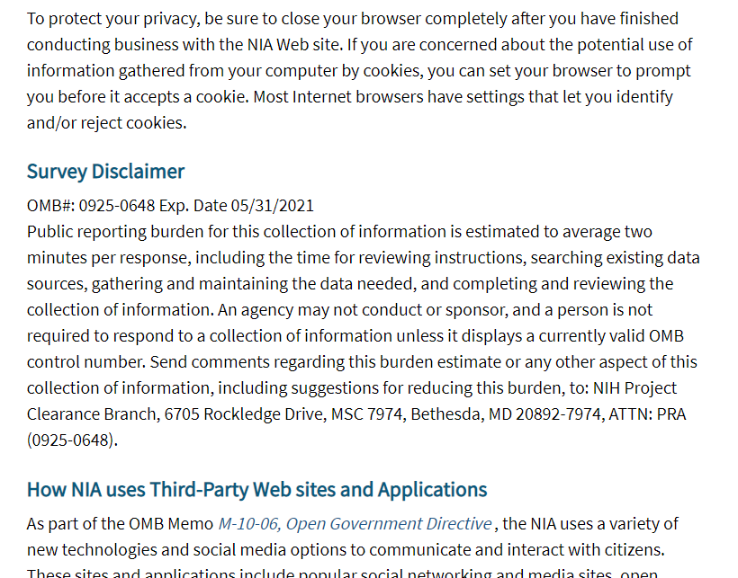

Survey Questions
The survey pop-up box will display the first question. If users select an answer, they will see the next question prompt. In total, it should take users less than a minute to complete the five questions below.
- Did you find this page useful?
  - Yes [if yes, users will skip to question 4]
  - No
- I did not find this page useful because it:
  - had too little information
  - had too much information
  - was confusing
  - was out-of-date
  - Something else
- What can we do to improve this page? [Open-ended text field]
- What was your main reason for visiting the NIA site today?
  - To get health information related to aging
  - To learn about clinical trials
  - To learn about funding opportunities
  - To learn about research at NIA labs
  - For the latest aging research and news
  - Other
- Which of the following best describes you?
  - Older Adult
  - Family Member/Caregiver
  - Health Care Professional
  - Media/Journalist
  - Policy Maker
  - Public Health Professional
  - Scientist/Researcher
  - Educator
  - Student

[Final window] Thank you for your feedback.
[This text will persistently appear below the question responses with a hyperlink to the NIA’s privacy policy.] Responses Form Approved OMB#: 0925-0648 Exp. Date 05/31/2021. Read NIA’s privacy policy >

Survey Screenshots
The following screenshots show how the survey window will look on the site.

Survey Screenshot – 1st Question
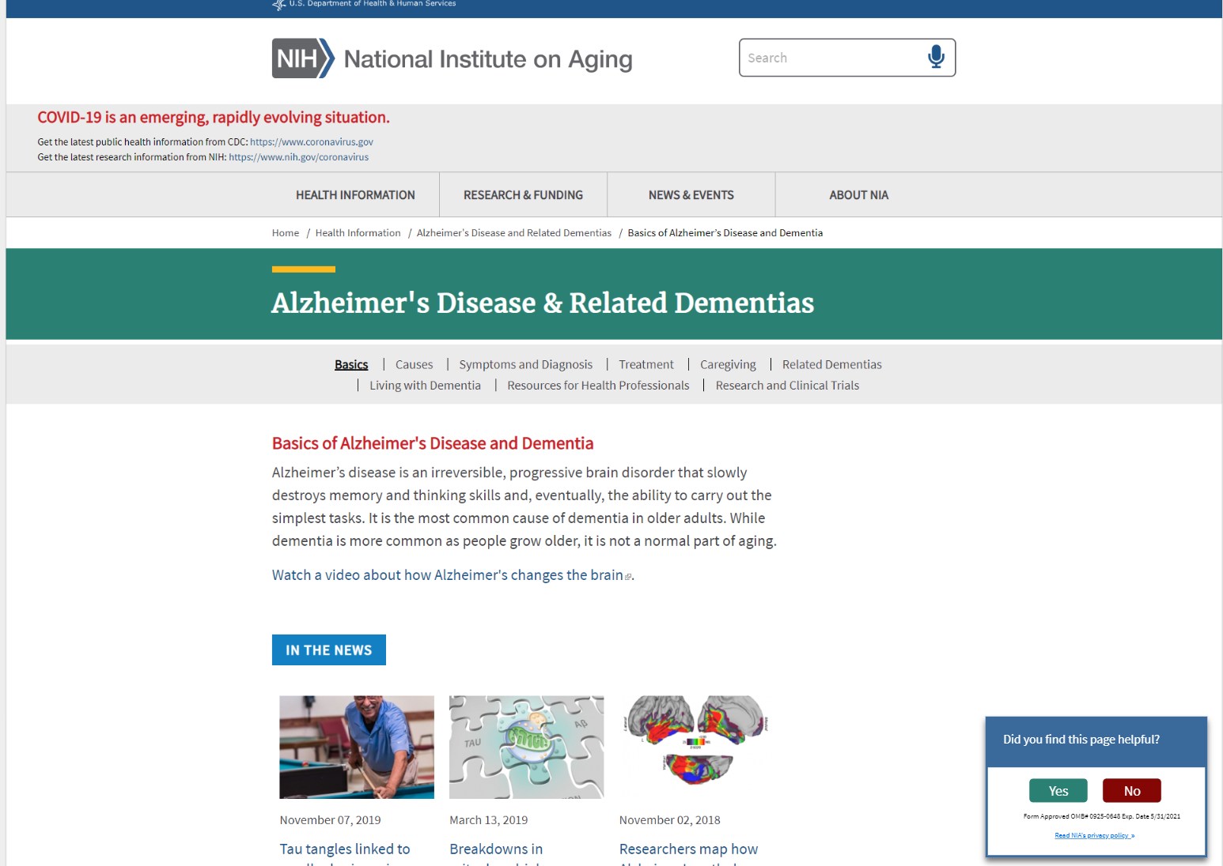

Survey Screenshot – 2nd Question
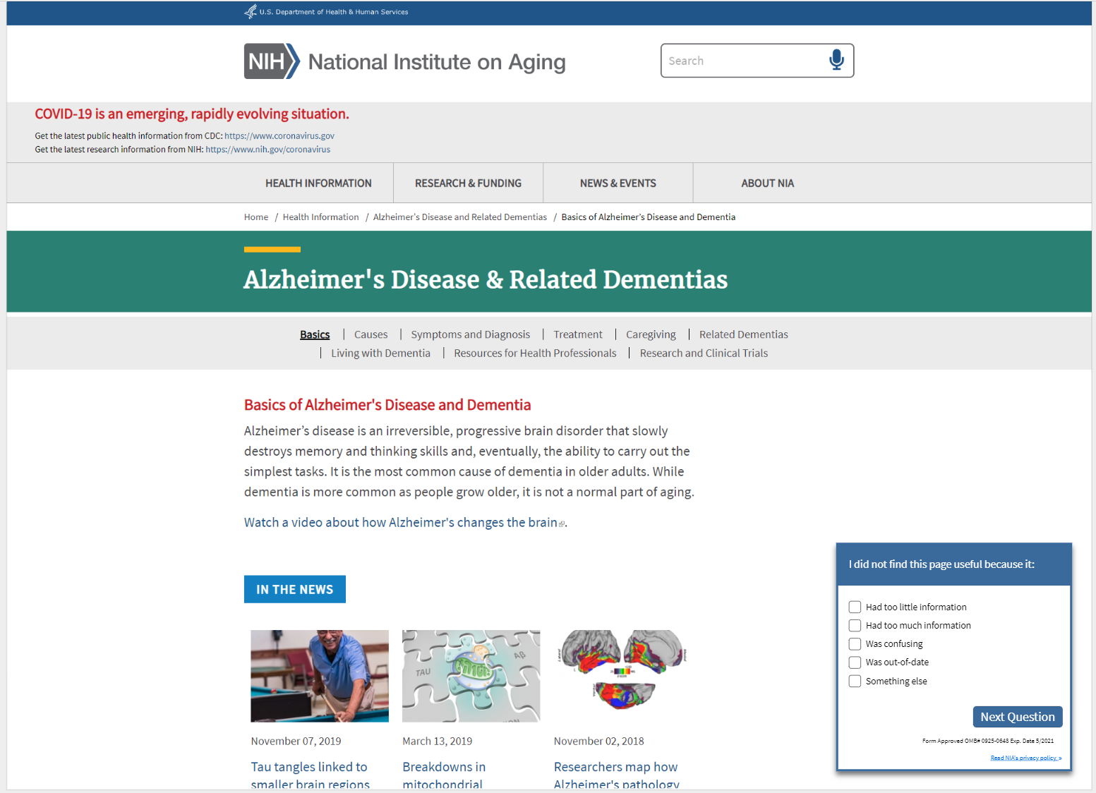

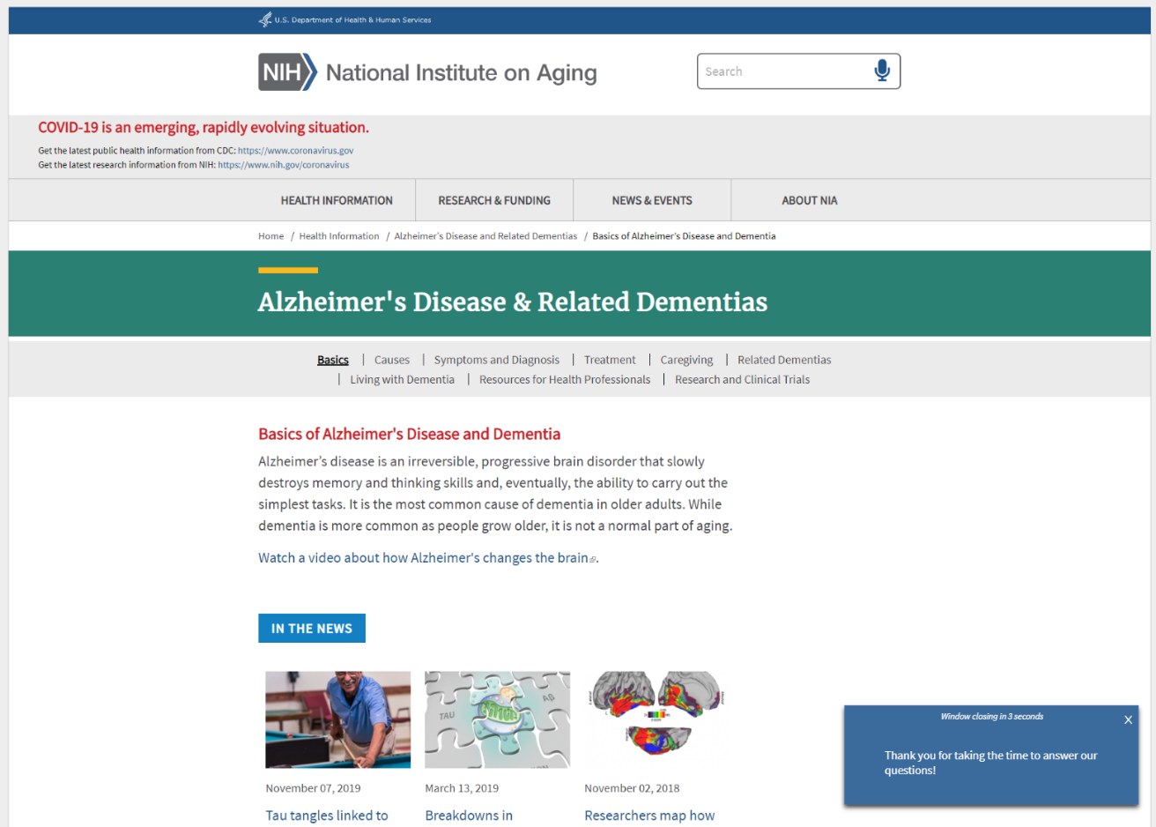
Survey Screenshot - Thank You Message

