Screenshots of email requests

For off-boarding trainees to participate in NINR Exit Survey

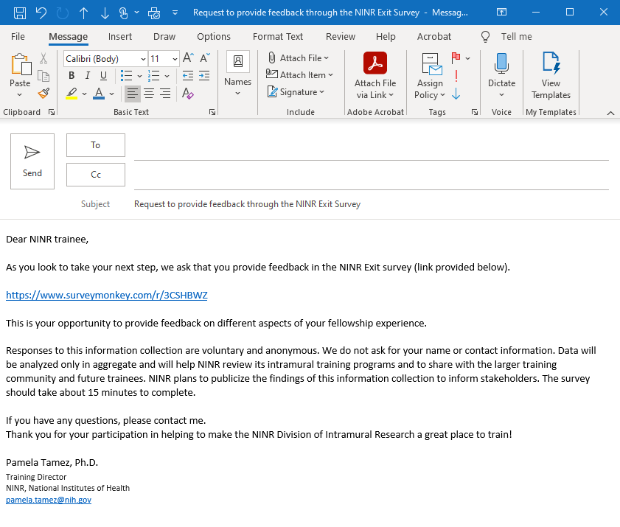

For current trainees to participate in the NINR Trainee Viewpoint Survey

