Attachment 3: NICHD DASH – Biospecimen Requester Survey

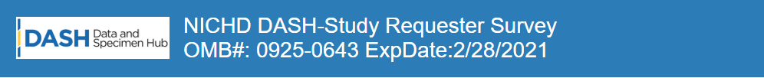
NICHD DASH-Biospecimen Requester Survey
OMB#: 0925-0648 ExpDate: 05/2021
Public reporting burden for this collection of information is estimated to average 5 minutes per response, including the time for reviewing instructions, searching existing data sources, gathering and maintaining the data needed, and completing and reviewing the collection of information. An agency may not conduct or sponsor, and a person is not required to respond to, a collection of information unless it displays a currently valid OMB control number. Send comments regarding this burden estimate or any other aspect of this collection of information, including suggestions for reducing this burden, to: NIH, Project Clearance Branch, 6705 Rockledge Drive, MSC 7974, Bethesda, MD 20892-7974, ATTN: PRA (0925-0648). Do not return the completed form to this address
- Was the DASH Biospecimen Request process easy to follow?
☐Yes ☐No
☐If No, please indicate what you were looking for and/or why it was not easy to find? (Open text field box)

- Was it easy to locate biospecimen information in DASH?
☐Yes ☐No
☐If No, please explain. (Open text field box)

- Which of the following DASH resources did you use during the Biospecimen Request process? (Check all that apply)
☐DASH Support Team
☐Frequently Asked Questions
☐DASH Tutorial
☐None

How helpful were the resources? (Open text field box)

- How would you rate your overall DASH Biospecimen Request experience?
Poor Fair Good Very Good Excellent

- How can we improve the Biospecimen Request process? (Please include any issue(s) you encountered during the Biospecimen Request process) (Open text field box)

