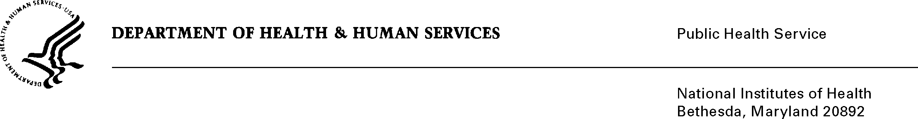

DATE: March 23, 2020

TO: Office of Management and Budget (OMB)

Through: Reports Clearance Officer, Debbie Kramer, DHHS
Mikia P. Currie, Project Clearance Chief, NIH
Tawanda Abdelmouti, Project Clearance Liaison, OD

FROM: Ericka M. Boone, Ph.D.
Director, Division of Loan Repayment, OER, OD

SUBJECT: Change Request to a Currently Approved Form
(OMB # 0925-0361, Expiration Date 10/31/2022)

This is a request for OMB to approve non-substantial modifications to the National Institutes of Health Loan Repayment Programs information collection approved under 0925-0361 which does not change the approved data collection, burden hours, or number of respondents. We are adding the Research in Emerging Areas Critical to Human Health (REACH) LRP as a new program subcategory for applicants to choose from the dropdown list on the Profile Information form (NIH 2674-15). We are also adding a sentence to Section B, Paragraph 6 of the LRP contract (NIH 2674-12) to add emphasis that participants cannot receive any salary support or participate in research that receives funding support from a for-profit institution or organization.

Attachment A – NIH 2674-15 Profile Information

Attachment B – NIH 2674-12 LRP Contract

Your full consideration is appreciated.

Signature of Submitter

