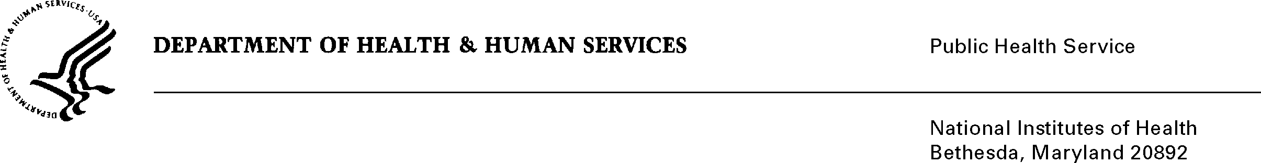

DATE: April 14, 2021

TO: Office of Management and Budget (OMB)

Through: Reports Clearance Officer, Debbie Kramer, DHHS
Mikia P. Currie, Project Clearance Chief, NIH
Tawanda Abdelmouti, Project Clearance Liaison, OD

FROM: Ericka M. Boone, Ph.D.
Director, Division of Loan Repayment, OER, OD

SUBJECT: Change Request to a Currently Approved Form
(OMB # 0925-0361, Expiration Date 10/31/2022)

This is a request for OMB to approve non-substantial modifications to the National Institutes of Health Loan Repayment Programs information collection approved under 0925-0361, which does not change the approved data collection, burden hours, or number of respondents. We are moving the LRP application to the Application Submission System & Interface for Submission Tracking (ASSIST), a system operated by NIH for applicants to prepare and submit applications electronically to NIH and other Public Health Service agencies. Also, we removed the SSN from the application to reduce the number of NIH systems collecting and storing SSNs. Finally, we added the Commons ID field to the Institutional Contact form to facilitate electronic notifications to Institutional Business Officials.

Attachment A – Applicant forms (ASSIST)

Your full consideration is appreciated.

Signature of Submitter

