IPFQR Program Web-Based Data Collection Tool Images

Vendor Authorization
Select vendor authorization option.
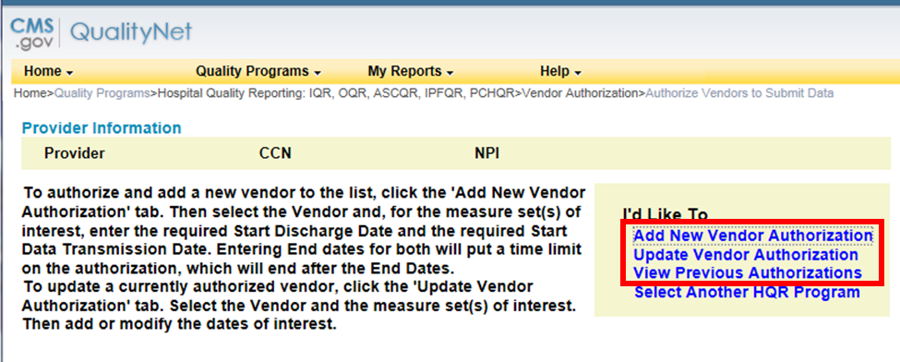
Add a vendor: by typing in the first letter of the name of existing vendors, the list will populate with those identified as IPF vendors.
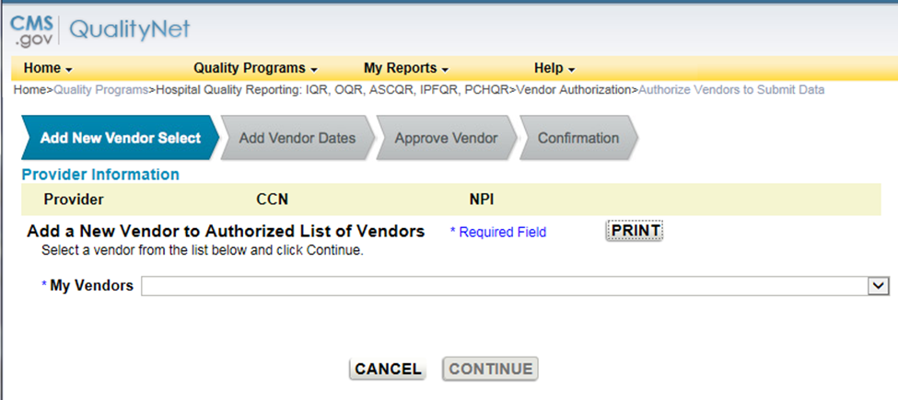

Update vendor authorization: if a vendor had been previously selected, this page allows the facility to update the vendor’s information.
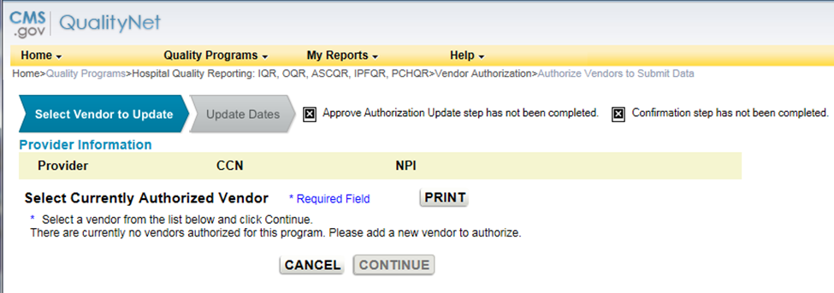

Data Accuracy and Completeness Acknowledgement (DACA)
DACA is located under the “Manage Measures” task heading.
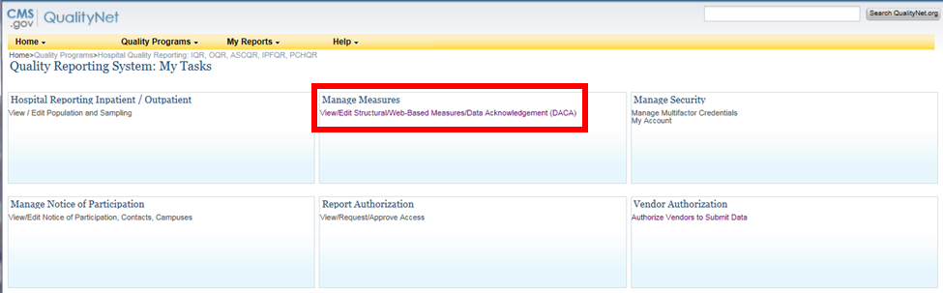

Select the program.
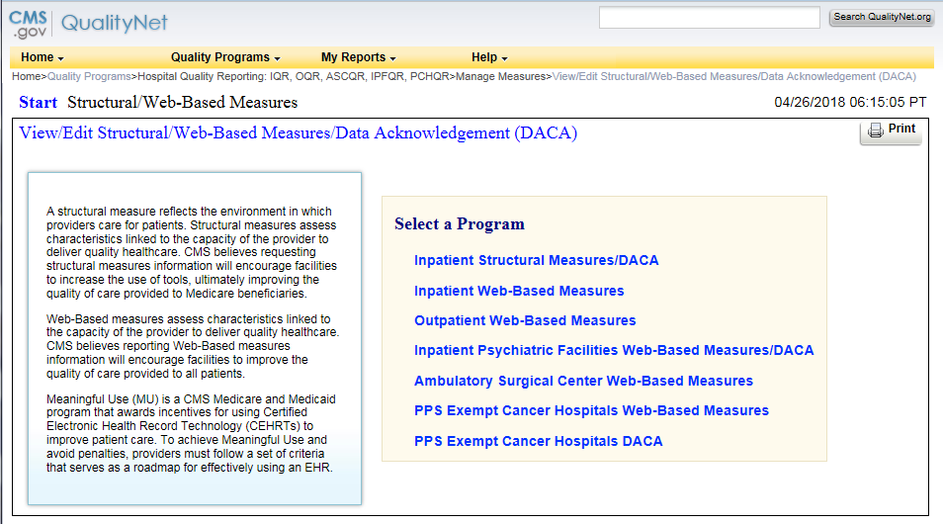
Select the payment year.
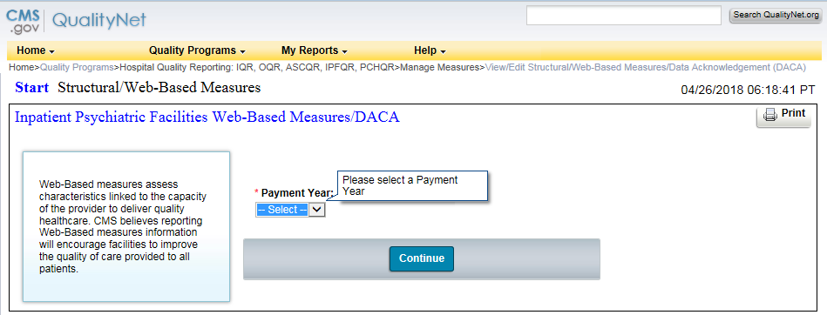

Provider selection: A single facility with access only to its own data will not see this page. However, a user with access to more than one provider (for example, a vendor) must select the CCN for one or more providers.
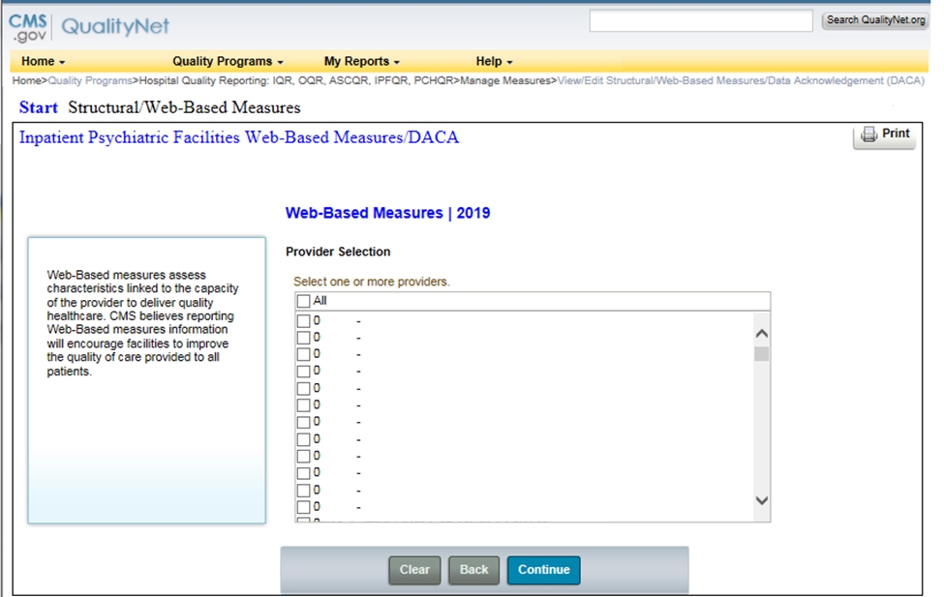
IPFQR Data Submission Selection.
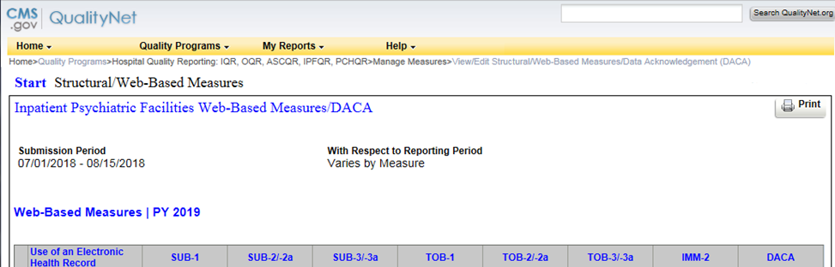

IPFQR Data Accuracy and Completeness Acknowledgement.
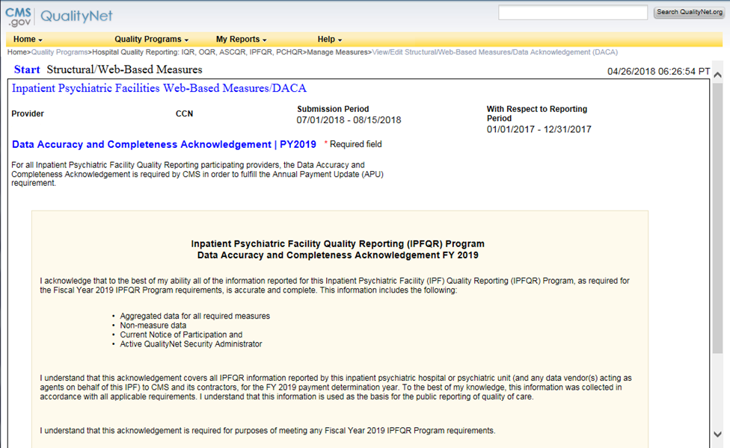

HBIPS-2
Enter the numerator and the denominator
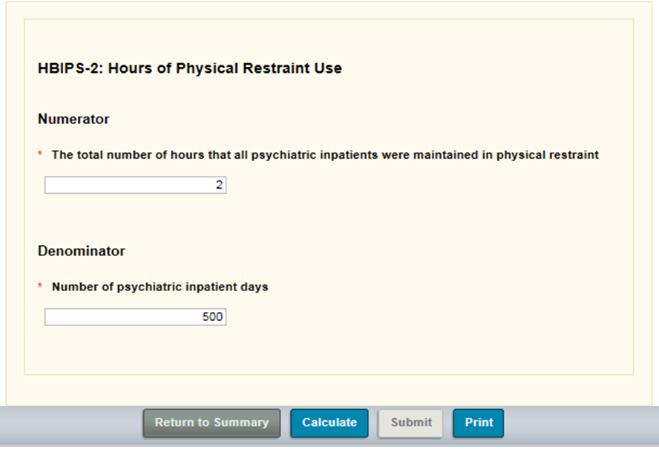

HBIPS-3
Enter the numerator and the denominator.
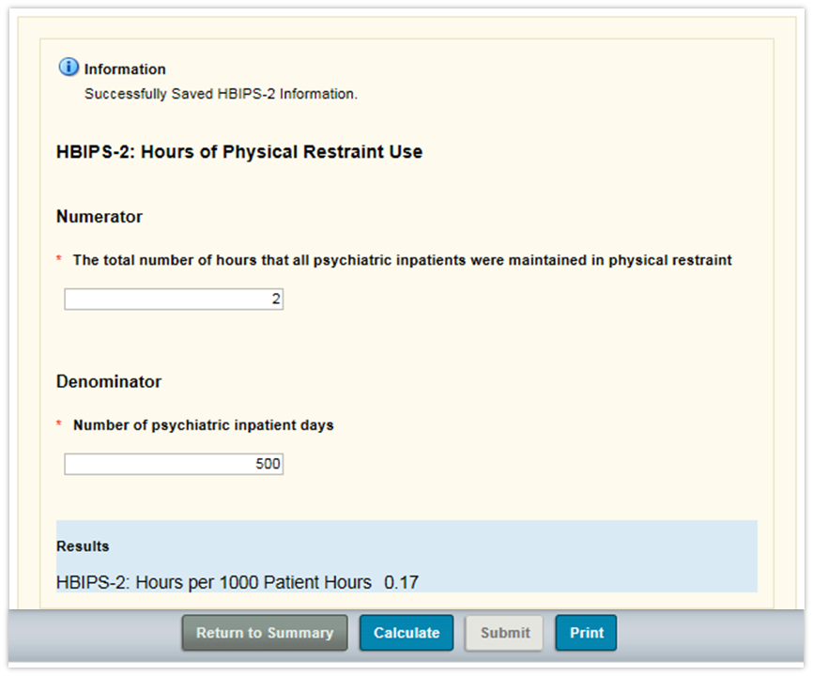

HBIPS-5
Enter the numerator and the denominator.
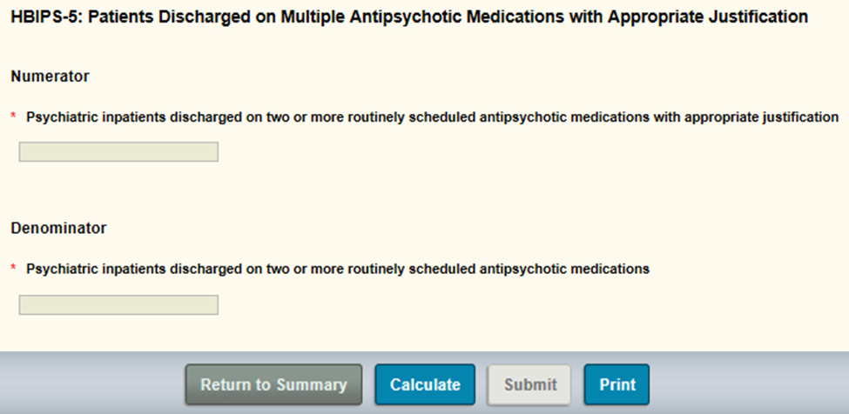

TOB-3 and TOB-3a
Enter the numerator for TOB-3, the numerator for TOB-3a and the denominator.
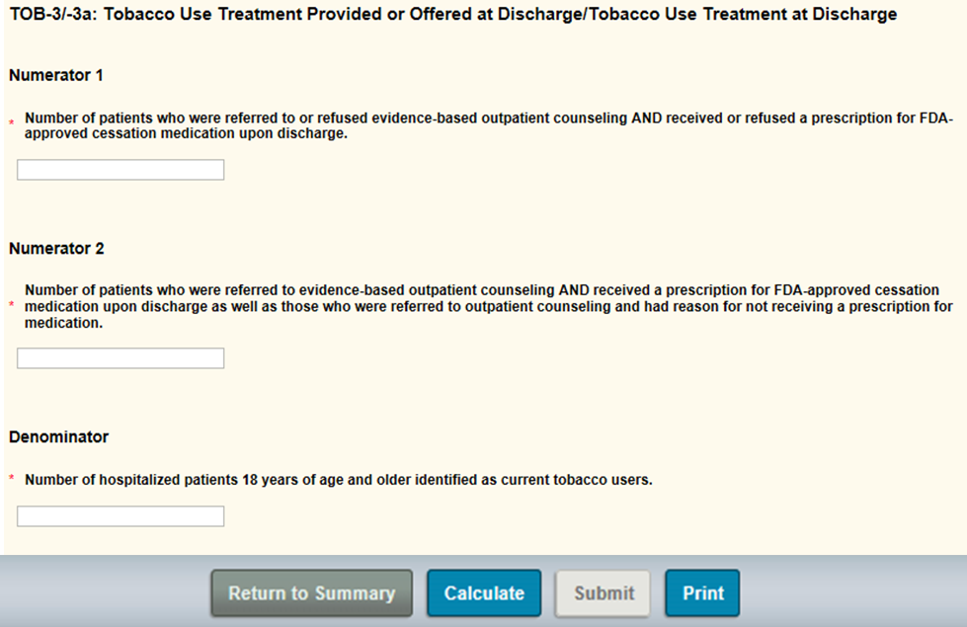

SUB-3 and SUB-3a
Enter the numerator for SUB-3, the numerator for SUB-3a, and the denominator.
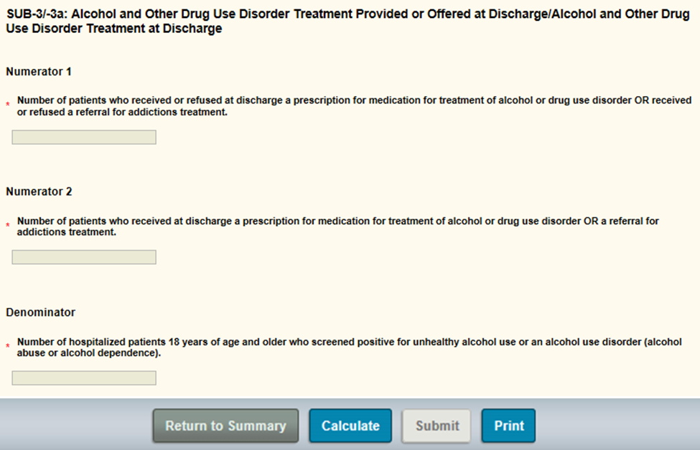

IMM-2
Enter the numerator and the denominator.
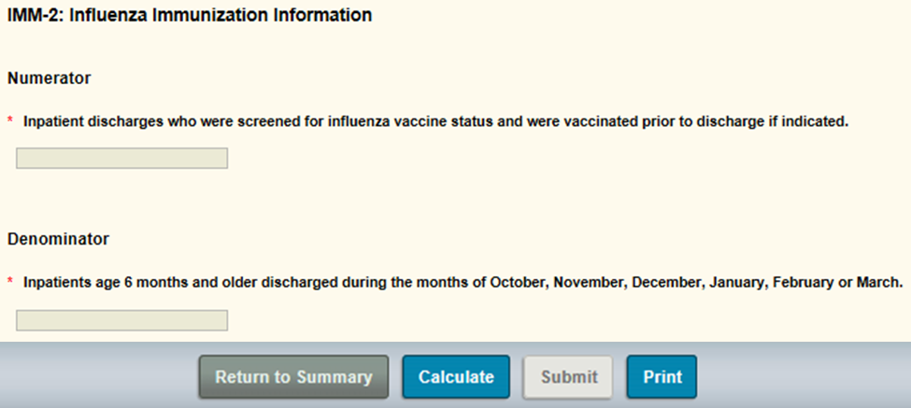

Screening for Metabolic Disorders Measure
Enter the numerator and the denominator.
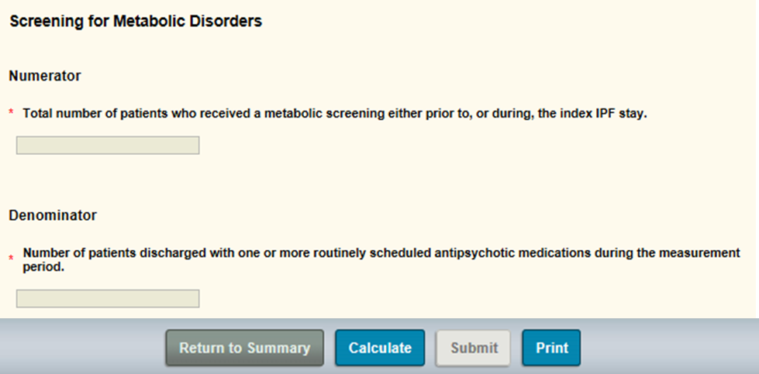

Transition Record with Specified Elements Received by Discharged Patients Measure
Enter the numerator and the denominator.
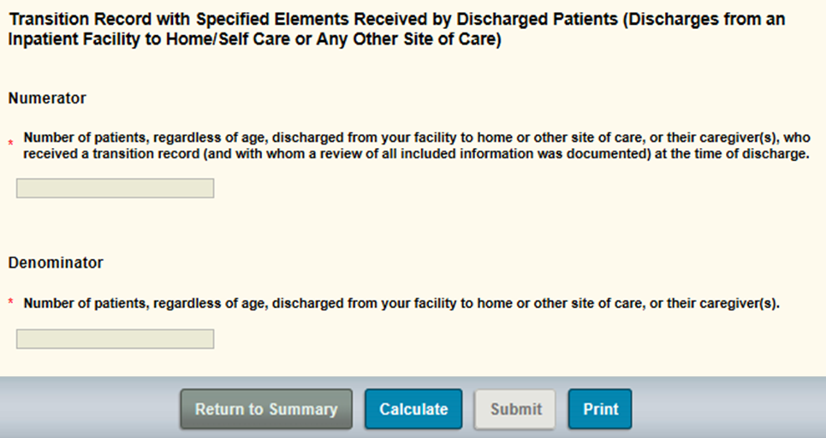

Non-Measure Data Collection
Enter information regarding total annual discharges.
