APPENDIX F
Providers Discussion Guide Instructions
Communications Focus Groups for Remaking the Safety Net
Paperwork Reduction Act of 1995 (Pub. L. 104-13) STATEMENT OF PUBLIC BURDEN: Through this information collection, ACF is gathering information to provide constituent research designed to understand target audiences with experience with economic and social safety net programming. The focus group and research will help identify experiences and perception of participants, and identify ways for the Office of Family Assistance (OFA) to produce communications messaging about safety net programming in a clear and resonant manner. The focus group will assist the program office in; (1) gathering feedback on safety net programming, (2) creating resonant communications messages, and (3) identifying trustworthy and relevant channels for communication with program service providers and beneficiaries. Public reporting for this collection of information is estimated to average 2 hours per respondent, including time for reviewing instructions, gathering and maintaining the data needed, and reviewing the collection of information. This collection of information is not required to retain a benefit. An agency may not conduct or sponsor, and a person is not required to respond to, a collection of information subject to the requirements of the Paperwork Reduction Act of 1995, unless it displays a currently valid OMB control number. The OMB # for this collection is 0970-0531 and the expiration date is 7/31/2022. If you have any comments on this collection of information, please contact Lizeth Hester, Program Specialist, Training and Technical Assistance - Office of Family Assistance, Lizeth.Hester@acf.hhs.gov (202) 205-8283.

INTRODUCTION (5 Minutes)
INSTRUCTION: [MODERATOR INTRODUCES THEMSELVES AND BRIEFS PARTICIPANT AS TO PURPOSE AND MANNER OF ONLINE FOCUS GROUP. INFORM PARTICIPANTS THE DISCUSSION IS RECORDED FOR THE PURPOSE OF DEVELOPING A REPORT AND OTHER RESEARCHERS ARE CURRENTLY OBSERVING THE GROUP. INFORM PARTICIPANTS THAT THE GROUP IS PART OF A PROJECT OF THE FEDERAL GOVERNMENT, AND THAT THEIR RESPONSES WILL IN NO WAY IMPACT THEIR ORGANIZATION’S ELIGIBILITY FOR GRANTS, CONTRACTS, ETC. ALL INFORMATION DISCUSSED WILL BE KEPT CONFIDENTIAL AND NOT TIED BACK TO THEM INDIVIDUALLY. REMIND PARTICIPANTS THAT INFORMATION DISCUSSED IN THE SESSION SHOULD NOT BE DISCUSSED WITH ANYONE AFTER THE FOCUS GROUP].
INSTRUCTION: MODERATOR TO ASK FOR INTRODUCTIONS

EXPERIENCES PROVIDING SAFETY NET PROGRAMS (15 minutes)
- INSTRUCTION: LISTEN AND RECORD; PROBE FOR DAY-TO-DAY EXPERIENCE AND EMOTIONAL REACTIONS
- INSTRUCTION: LISTEN AND RECORD
  - INSTRUCTION: PROBE How would you resolve this challenge if it were up to you?
- INSTRUCTION: LISTEN AND RECORD
  - INSTRUCTION: IF NO, PROBE: What specific services or support structures need to change?
- INSTRUCTION: LISTEN AND RECORD

MESSAGE MAP TESTING [35 MINUTES)
INSTRUCTION: READ RSN DESCRIPTOR:
This project is about a new government effort called Remaking the Safety Net. The safety net is made up of more than 80 distinct government programs, totaling more than $1 trillion in benefits, goods, and services. But these programs are uncoordinated, and too often fail to help people achieve independence. Remaking the Safety net envisions a system that is designed and operated so it helps people grow their capacity to the point they no longer need safety net programs.

- INSTRUCTION: LISTEN AND RECORD
- INSTRUCTION: LISTEN AND RECORD
- INSTRUCTION: LISTEN AND RECORD; PROBE FOR WHY

INSTRUCTION: READ - Next, I am going to share some specific messages for “Remaking the Safety Net.” The first message is the foundation or core of the strategy. It is a mission statement of sorts.

INSTRUCTION: SHOW MESSAGE MAP CORE STATEMENT ON SCREEN
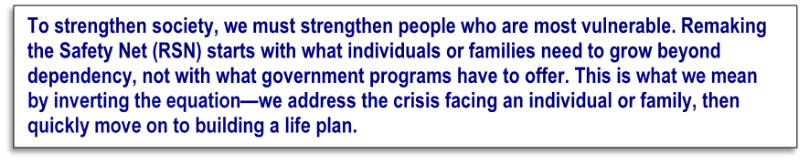

- INSTRUCTION: LISTEN AND RECORD
- INSTRUCTION: LISTEN AND RECORD
- INSTRUCTION: LISTEN AND RECORD
INSTRUCTION: PROBE FOR UNDERSTANDING OF SPECIFIC TERMS
- INSTRUCTION: LISTEN AND RECORD
- INSTRUCTION: LISTEN AND RECORD
- INSTRUCTION: PROBE - How might it change their current experiences with the safety net?
- INSTRUCTION: LISTEN AND RECORD
INSTRUCTION: SET UP NEXT SECTION AND SHARE CREATIVE
INSTRUCTION: SHOW REMAINING MESSAGE MAP COMPONENTS ON SCREEN ONE AT A TIME. AFTER SHOWING EACH NEW IDEA, ASK
- INSTRUCTION: LISTEN AND RECORD
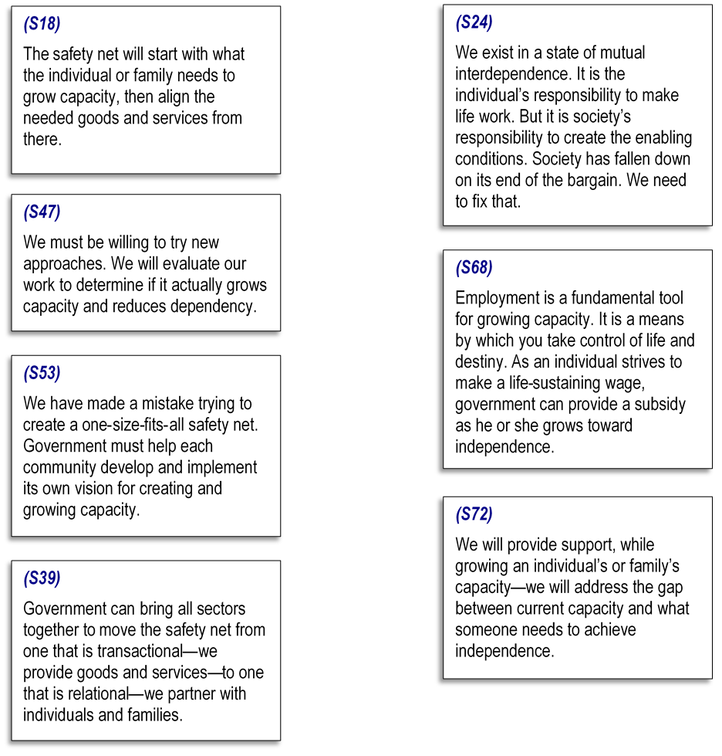
- INSTRUCTION: LISTEN AND RECORD

- INSTRUCTION: LISTEN AND RECORD
  - INSTRUCTION: PROBE FOR CLARITY IN COMMUNICATIONS—HOW ARE THEY INTERPRETING THE MESSAGE AND DOES THAT MIRROR ITS INTENDED PURPOSE
- INSTRUCTION: LISTEN AND RECORD
- INSTRUCTION: LISTEN AND RECORD
- INSTRUCTION: LISTEN AND RECORD
- INSTRUCTION: LISTEN AND RECORD; PROBE AS BELOW
- INSTRUCTION: S47 PROBE Do you believe it is time to try “new approaches” to help your clients and people like your clients? Why or why not?
    - INSTRUCTION: PROBE; LISTEN AND RECORD
- INSTRUCTION: S39 PROBE This statement says government can unite all sectors to move from a system that is transactional to one that is relational, to create a partnership with individuals and families. What does this mean to you?
- INSTRUCTION: PROBE; LISTEN AND RECORD
- INSTRUCTION: S72 PROBE What does it mean to grow an individual’s or family’s capacity? How do we address the gap between current capacity and what someone needs to achieve independence?
INSTRUCTION: SET UP ACTIVITY FOR PARTICIPANTS TO WRITE THOUGHTS DOWN INDIVIDUALLY BEFORE GROUP SESSION
- INSTRUCTION: HAVE PARTICIPANTS READ STATEMENTS AGAIN
  - INSTRUCTION: PARTICIPANTS TO WRITE DOWN ELEMENTS THEY LIKE
  - INSTRUCTION: PARTICIPANTS TO WRITE DOWN ELEMENTS THEY DO NOT LIKE
  - INSTRUCTION: PARTICIPANTS TO WRITE DOWN ELEMENTS THEY FIND CONFUSING OR REQUIRE MORE INFORMATION
- INSTRUCTION: LISTEN AND RECORD
- INSTRUCTION: LISTEN AND RECORD
- INSTRUCTION: LISTEN AND RECORD

“DESIGN A SAFETY NET” CREATIVE EXERCISE (20 Minutes)
INSTRUCTION: READ INTRODUCTION AND EXERCISE INSTRUCTIONS
- INSTRUCTION: PARTICIPANTS TO WRITE THOUGHTS/IDEAS
- INSTRUCTION: PARTICIPANTS TO WRITE THOUGHTS/IDEAS
- INSTRUCTION: PARTICIPANTS TO WRITE THOUGHTS/IDEAS
- INSTRUCTION: PARTICIPANTS TO WRITE THOUGHTS/IDEAS
INSTRUCTION: GROUP DISCUSSION OF RESPONSES TO Q 27-30

SAFETY NET STRATEGY AND IDEATION RECAP (5 minutes)
- INSTRUCTION: LISTEN AND RECORD
- INSTRUCTION: LISTEN AND RECORD
  - INSTRUCTION: LISTEN AND RECORD
- INSTRUCTION: LISTEN AND RECORD; PROBE FOR SPECIFIC MESSAGING SOURCES SUCH AS EMAIL/NEWSLETTER, DEDICATED WEBSITE, EDUCATIONAL PROGRAMS (SUCH AS SEMINARS), EDUCATIONAL MATERIALS, PROFESSIONAL ASSOCIATION, ETC.
- INSTRUCTION: LISTEN AND RECORD
- INSTRUCTION: LISTEN AND RECORD
- INSTRUCTION: LISTEN AND RECORD

CLOSING
INSTRUCTION: THANK PARTICIPANTS; EXIT INSTRUCTIONS; END SESSION

