Attachment A. PAGI Project Conceptual Framework
The PAGI project literature review (White et al., 2018) and consultation with stakeholders and experts led to the development of the conceptual framework depicted in Exhibit A.1. The primary outcome of interest, post adoption and guardianship instability, is depicted on the far right of the framework; it includes the various types of instability, and differences between children who exit foster care through adoption compared to guardianship. The intermediate outcomes affect this primary distal outcome; the other constructs depicted in the conceptual framework are through to influence instability in different ways.
Attention to time is an important feature of the conceptual framework. It is displayed across the top of the framework with the periods of pre- and post-permanence noted. Some constructs (e.g., motivations across the top and characteristics across the bottom) are important to consider as they change over time. Therefore, these constructs cross time periods in the framework.
In the conceptual framework, constructs and pathways are assumed to function similarly for adoptive versus guardianship families. However, research has found that, in examining differences between adoption and guardianship, it is critical to control for key characteristics between these two groups. These characteristics include, for example, the age of the caregiver and kinship adoption or guardianship, as these factors are important to consider when examining what would have occurred if a guardianship relationship was not available. Furthermore, specific constructs may be more or less relevant, or function somewhat differently within the framework, for these two different permanency arrangements. For example, the relationship motivator of family duty may operate more strongly in guardianship than adoption families because kin caregivers often select guardianship as a permanency option.
Motivations to initiate and sustain the adoptive or guardianship relationship are depicted at the top of the framework. These motivations are examined from the perspectives of both the child and the caregiver. The motivations that underlie a caregiver’s decision to adopt or become a guardian are key to understanding post adoption and guardianship instability. Social scientists from a variety of disciplines agree on a common core of relationship motivators that structure most human relationships (England, Folbre, & Carrie, 2012; Fiske & Haslam, 1996). These motivators are about the relationships between people, and how and why they interact, rather than individual characteristics. For example, a person may be motivated to initiate and maintain a relationship to a child based on whether that person is the child’s grandparent or the child’s foster parent. A grandparent may be motivated by a sense of family duty (e.g., “She is my granddaughter, so I will provide care for her”) while a foster parent may be motivated by a religious calling. These motivators are instrumental in initiating a relationship between a child and her caregiver. It can also impact the child’s or caregiver’s decision to maintain the relationship. These relationship motivators have important implications for understanding post adoption and guardianship instability. Caregivers may transition to a permanent caregiver role out of a compelling sense of duty or obligation, because of social or economic rewards or perceived reciprocity, a feeling of affinity or compassion, or because of a calling to a higher purpose. These motivators may shift over time and may enhance or diminish a caregiver’s motivation to sustain the relationship. Similarly, while a child may not have as much say in the initiation of an adoptive or guardianship relationship, his or her motivations affect the longevity of that relationship.
Child, caregiver, and family characteristics. Key among the risk and protective factors that influence post adoption and guardianship instability are child, caregiver, and family characteristics. These include items like the child’s experiences in foster care and biological relatedness of the child and caregiver that are set (unmodifiable) and known at the time of permanence. There are also other factors that change over time (e.g., current age of the child and caregiver, level of expectations of self and of the adoptive or guardianship relationship).
Pre-permanency characteristics are depicted at the far left of the framework. These include items related to a child or youth, such as the child’s race or ethnicity, the age of the child at the time of legal permanence, or the young person’s perceptions and involvement in the permanency decision. This category also involves caregiver characteristics, such as parenting competencies, the biological relatedness between the child and caregiver, and demographic characteristics (e.g., marital status, age, race).
Characteristics that change over time are depicted at the bottom of the framework, and noted at the child, caregiver, and family levels. These are characteristics such as age, expectations of self, and the adoptive or guardianship relationship that change as the relationship grows through developmental stages.
Child, caregiver, and family characteristics can directly affect post adoption and guardianship instability (e.g., the robust finding that the age of the child is a key predictor of post adoption and guardianship instability). Child and caregiver characteristics can be diminished or enhanced by the relationship qualities in the family. For example, the biological relationship (kinship) can strengthen or diminish the familial bonds when a caregiver adopts a child.
These constructs are complex, and concepts may overlap in certain areas. Therefore, constructs and variables were placed in the conceptual framework where they fit the best, understanding that the framework is simply a model of the real world, intended to describe post adoption and guardianship instability and inspire future research. Constructs in the conceptual framework are frequently discussed in multiple areas of this literature review (e.g., kinship), and the constructs in the conceptual model may influence, or moderate the effects of other constructs, in complex ways over time. For example, consider the robust finding that child behavioral problems are associated with post adoption and guardianship instability. Although this finding is fairly clear in the literature, how a caregiver addresses difficult child behaviors can be understood by examining the kinship relationship between the child and caregiver (e.g., Does the caregiver use different methods of discipline with the child because they are kin?). Finally, an adoptive parent or guardian’s decision to seek assistance for difficult child behaviors may be moderated by the level of informal support she or he has in the family, and by the availability of formal services in the geographic area where the caregiver lives.
Intermediate outcomes. Key intermediate outcomes examined in the existing literature are listed in the middle section of the framework. Most studies examine these outcomes rather than directly examining post adoption and guardianship instability. These intermediate outcomes are assumed to be related to instability, either according to theory or previous empirical literature.
Research that examines only proximal (or intermediate) outcomes, rather than instability itself, has significant limitations. Foremost is that families who experience worse proximal outcomes will not automatically also experience instability; there is really no way to tell the difference between those families who will experience instability and those who will not. A related limitation is that studies may suffer from endogenous selection bias which occurs when families are selected in a non-random way after the intervention and the outcome have already occurred (Elwert & Winship, 2014). This bias results in participants not being representative of the population in a way that may impact the intermediate outcome of interest, because, for instance, they only include samples of families that are intact. Thus, families who actually have experienced the worse outcomes related to instability are not included in study samples, which can lead to positive bias in results (i.e., families may seem to be doing better than they really are if those who struggled most have already dropped out).
Contextual moderators. Adoptive and guardianship family relationships are impacted by outside forces such as informal systems of support that, if activated, can diminish caregiver burden, for instance, and reduce the risk of post adoption and guardianship instability. Availability of formal services also affects familial relationships. A family in need of mental health services may experience post adoption and guardianship instability if the caregiver feels that the only way for their child to receive needed services (e.g., psychiatric hospitalization) is by relinquishing custody to the state to allow state-funded payment for services. On the other hand, if mental health services are available, and provided by a therapist experienced in adoption and trauma, a family may have a higher level of commitment that allows stability.
Policies also impact post adoption and guardianship instability, through direct and indirect relationships. For example, differential rates of instability across states may occur depending on how difficult or easy ending the guardianship is. In addition, this policy could moderate the relationship between the level of caregiver commitment and post adoption and guardianship instability. Caregivers with a strong level of commitment, for instance, may not be impacted by the ease at which they can legally end their relationship with their grandchild.
Historical factors and relationship qualities also affect policies and practices. Consider, for instance, the reasons and norms parents adopt. When adoption was widened beyond infertile couples, this opening altered the relationship quality or calling. That calling can impact parents’ sense of duty, their willingness to seek formal and informal supports, and ultimately, their ability to maintain a child in their home when faced with difficult familial relationships.

Exhibit A.1. Post Adoption and Guardianship Instability Conceptual Framework
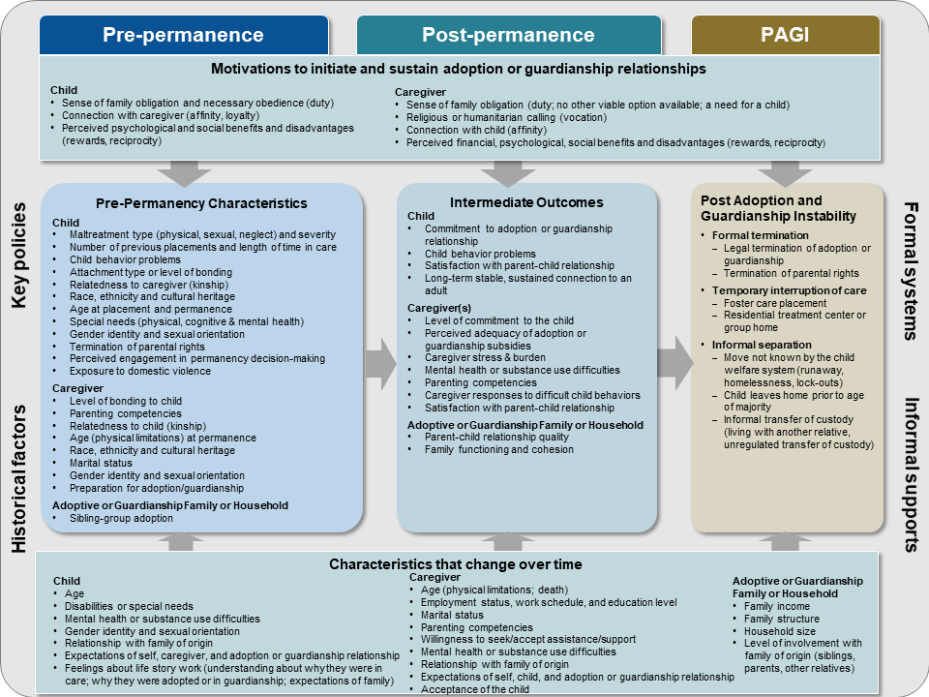

Appendix A. References

Elwert, F., & Winship, C. (2014). Endogenous selection bias: The problem of conditioning on a collider variable. The Annual Review of Sociology, 40(2), 2.1-2.23. http://dx.doi.org/10.1146/annurev-soc-071913-043455
England, P., Folbre, N., & Carrie, L. (2012). Motivating care. In N. Folbre (Ed.), For love and money: Care provision in the United States (pp. 21-39). New York: Russell Sage Foundation.
Fiske, A. P., & Haslam, N. (1996). Social cognition is thinking about relationships. Current Directions in Psychological Science, 5(5), 143-148.
White, K. R., Rolock, N., Testa, M., Ringeisen, H., Childs, S., Johnson, S., & Diamant-Wilson, R. (2018). Understanding post adoption and guardianship instability for children and youth who enter foster care. Washington, DC: Office of Planning, Research, and Evaluation, the Administration for Children and Families, U.S. Department of Health and Human Services.

