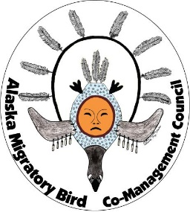
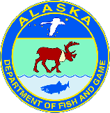
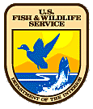Alaska Migratory Bird Co-Management Council

Subsistence Harvest Survey Household Invitation

This survey asks about harvest of birds and eggs for food and other customary and traditional uses. Participation of communities and households in the survey is voluntary. On behalf of your community, your Tribal Council has agreed to participate in the survey. By random selection, your household was selected to participate. Your participation is important, even if your household has not harvested birds or eggs.
Harvest estimates from this survey are used to:
- Show the importance of subsistence uses of migratory birds.
- Protect sustainable subsistence harvest opportunities.
- Plan for the conservation of birds.
- Assess whether harvest regulations are appropriate.
□ If the local surveyor came to your household but missed you, please
call _________________________________________to schedule your survey.
(local surveyor and phone number)

Thank you very much for your help!
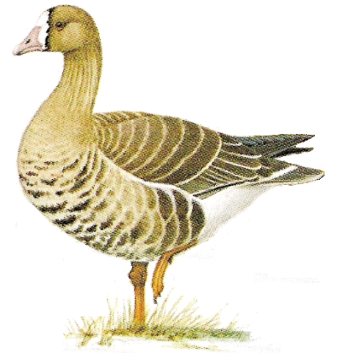

For more information:
- talk with your village surveyor,
- contact the closest ADF&G or USFWS office,
- visit the AMBCC website http://alaska.fws.gov/ambcc.

Paperwork Reduction Act Statement

In accordance with the Paperwork Reduction Act (44 U.S.C. 3501), the U.S. Fish and Wildlife Service (Service) collects information authorized by the Migratory Bird Treaty Act (16 U.S.C. 703 et seq.), the Migratory Bird Treaty Act Protocol Amendment (1995), and its letter of submittal from the Department of State to the White House, which specifies the need for harvest monitoring. Information requested in this form is purely voluntary. We will use the information your household provides to estimate subsistence migratory bird harvest in subsistence eligible areas of Alaska. Household harvest reports are anonymous and we do not collect names on harvest report forms. The Service calculates harvest estimates at the regional and sub-regional levels. According to the Paperwork Reduction Act of 1995, an agency may not conduct or sponsor and a person is not required to respond to a collection of information unless it displays a currently valid OMB control number. OMB has approved this collection of information and assigned Control No. 1018-0124.

ESTIMATED BURDEN STATEMENT
With help of a surveyor, we estimate it will take about 5 minutes each to provide household consent and to report your seasonal bird/egg harvest, including time for reviewing instructions, gathering and maintaining data and completing and reviewing the form. Direct comments regarding the burden estimate or any other aspect of Forms 3-2380, 3-2381-1, 3-2381-2, 3-2381-3, 3-2381-4, and 3-238-5 to the Service Information Clearance Officer, Fish and Wildlife Service, U.S. Department of the Interior, 5275 Leesburg Pike, MS: AMAD-ARM-PPM, Falls Church, VA 22041-3803, or via email at Info_Coll@fws.gov. Please do not send your completed form to this address.

