Digital Trails Portal

Sample User Experience Forms
All forms in this document are sample forms. The actual design of the forms will be finalized once the application has been developed.
First users have to choose which existing account type they want to login with. Then they have to provide credentials for the selected account to authenticate the access into the Trails Data Portal. Once logged in, users choose if they would like to provide trails data to USGS or view comments provided by USGS for previously submitted data.
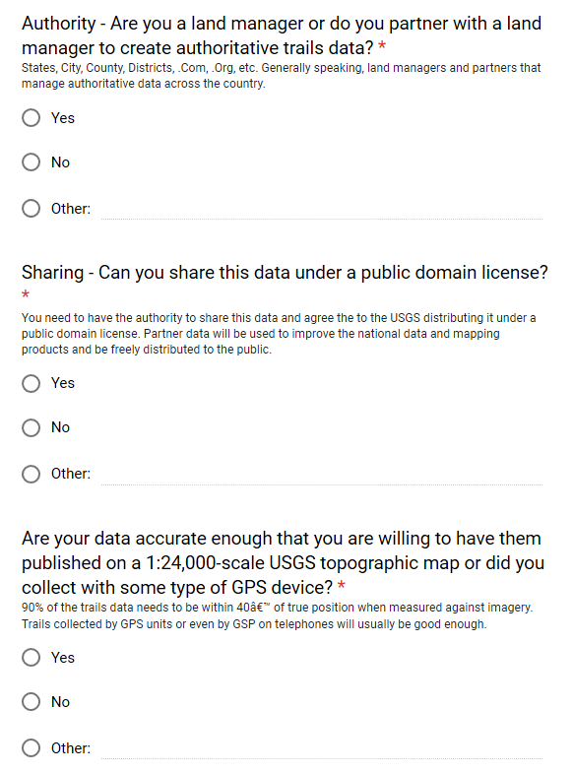
Step 1: The user accesses a website and chooses an option to submit authoritative public domain trails data to USGS. They are first asked a series of questions to vet the authoritativeness and quality of the data. If they pass the “authoritativeness” screening questions, they are required to register (using Microsoft Office or Google based email or with ArcGIS Online credentials) in order to submit data to USGS.

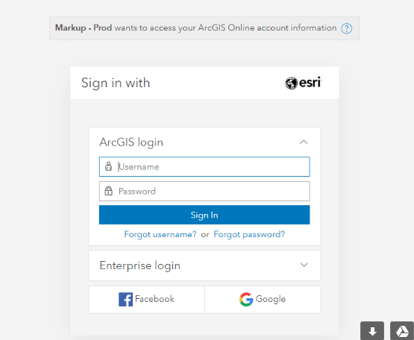
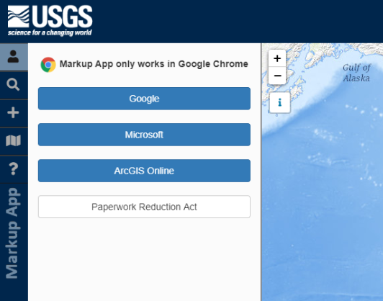
Step 2: User chooses to sign in with their credentials. Here the user can click on the Paperwork Reduction Act button to view the relevant information.

Step 3: The user is asked to upload their trails data file.
Step 4: The user is asked to provide metadata and data point of contact information.
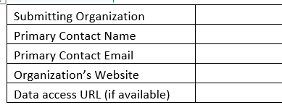
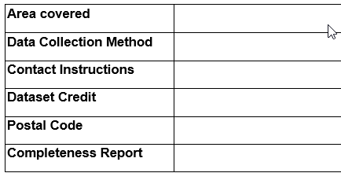
Step 5: The user is asked to crosswalk their data attributes with those of the USGS trails dataset.
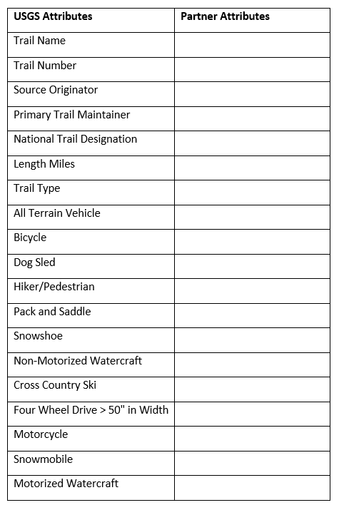
Once step 5 is complete, a message pops up saying their dataset is under review and they will be notified once the process has been completed.

PAPERWORK REDUCTION ACT STATEMENT: We are collecting this information subject to the Paperwork Reduction Act (44 U.S.C. 3501) to evaluate hunter harvest on open water environments and collect hunter opinions on regulatory changes to Wisconsin waterfowl season frameworks. Your response is voluntary, and we will not share the results publicly. We may not conduct, or sponsor and you are not required to respond to a collection of information unless it displays a currently valid OMB Control Number. OMB has reviewed and approved this survey and assigned OMB Control Number 1028-NEW.
ESTIMATED BURDEN STATEMENT: We estimate the survey will take you 26minutes to complete, including time to read instructions, gather information, and complete and submit the survey. Comments regarding this collection of information should be directed to the Bureau Clearance Officer, U.S. Geological Survey, gs-info_collections@usgs.gov.

