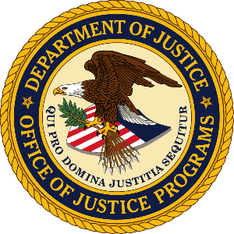

U.S. Department of Justice

Office of Justice Programs

Bureau of Justice Statistics

Washington, D.C. 20531

MEMORANDUM

TO: Robert Sivinski
Office of Statistical Policy and Planning
Office of Management and Budget

THROUGH: Melody Braswell, Clearance Officer, Justice Management Division

FROM: Heather Brotsos, Victimization Statistics Unit Chief, Bureau of Justice Statistics

SUBJECT: Submission of non-substantive modification for the National Crime Victimization Survey (OMB #1121-0111)

DATE: April 27, 2021

This memo concerns a non-substantive modification to the National Crime Victimization Survey (NCVS) (OMB #1121-0111). Specifically, the Bureau of Justice Statistics (BJS) is requesting to remove the expiration date from advance letters that are sent to residents selected for an NCVS interview. Specifically, we propose replacing the following sentence:

This collection has been approved by the Office of Management and Budget (OMB Number: 1121-0111; Expiration Date: 02/28/2022).

with the following:

This collection has been approved by the Office of Management and Budget (OMB Number: 1121-0111).

Impact

The expiration date indicates when the OMB approval for a data collection expires. Since the NCVS is an ongoing, annual survey, not having the expiration date on advance letters provides flexibility for the printing operations and reduces waste from excess letters printed with old dates.

If there are any questions concerning this request, please contact Heather Brotsos, Victimization Statistics Unit Chief, Bureau of Justice Statistics, at (202) 598-7960 or by email at Heather.Brotsos@usdoj.gov.

A copy of the current NCVS advance letter can be found here: https://www.bjs.gov/content/pub/pdf/ncvs_advance_letter.pdf

