Data items collected by the eGov Utility Tax Exemption request but not collected by the DS-98 Form;
- Date of Birth
- Personal Address: *
  - Street Number
  - Street Name
  - Street Type:
    - AVENUE
    - BOULEVARD
    - CANYON
    - CENTER
    - CIRCLE
    - COURT
    - COVE
    - CRESENT
    - DRIVE
    - EXPRESSWAY
    - FREEWAY
    - GATE
    - HIGHWAY
    - LANE
    - LOOP
    - LOT
    - PARK
    - PARKWAY
    - PASSAGE
    - PATH
    - PIKE
    - PLACE
    - PLAZA
    - POINT
    - ROAD
    - SQUARE
    - STREET T
    - ERRACE
    - TRAIL
    - TURNPIKE
    - Unknown
    - VIEW
    - WAY
  - Quadrant:
    - NW
    - SW
    - NE
    - SE
    - N
    - S
    - E
    - W
  - Unit Type:
    - APARTMENT
    - BOX
    - BUILDING
    - DEPARTMENT
    - FLOOR
    - LOT
    - OFFICE
    - PENTHOUSE
    - ROOM
    - SUITE
    - UNIT
  - Unit Number
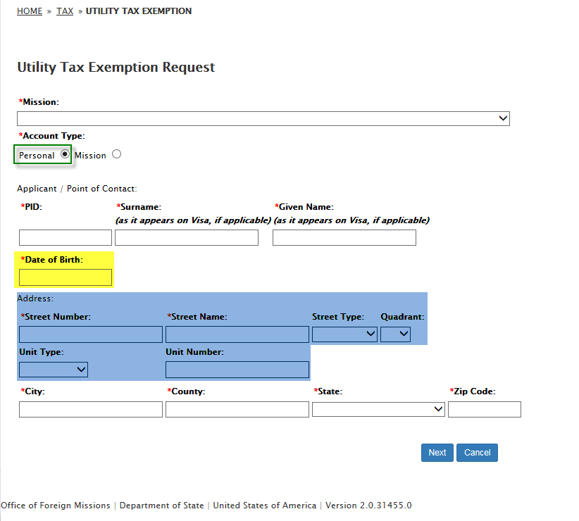
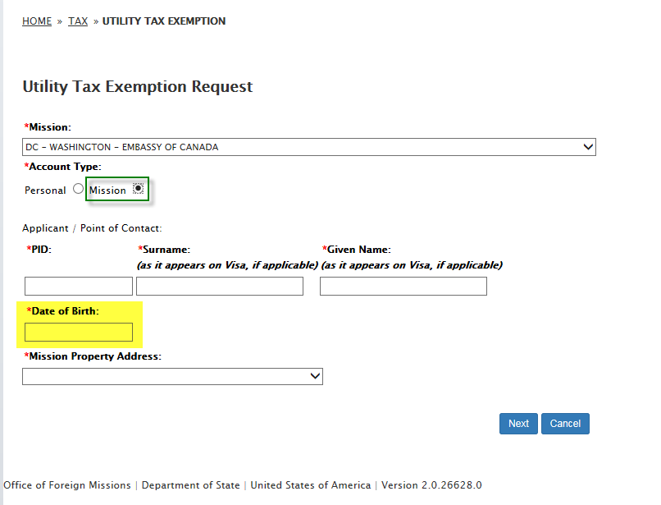

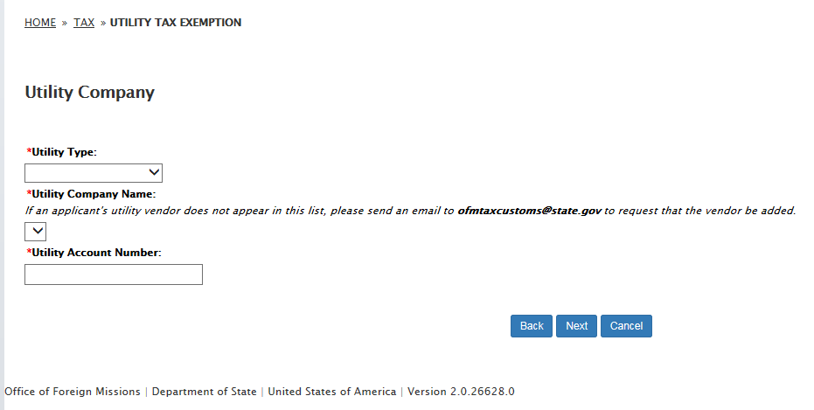
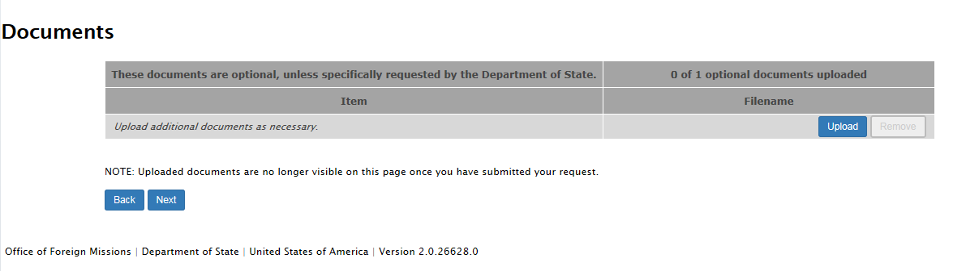
- Remarks
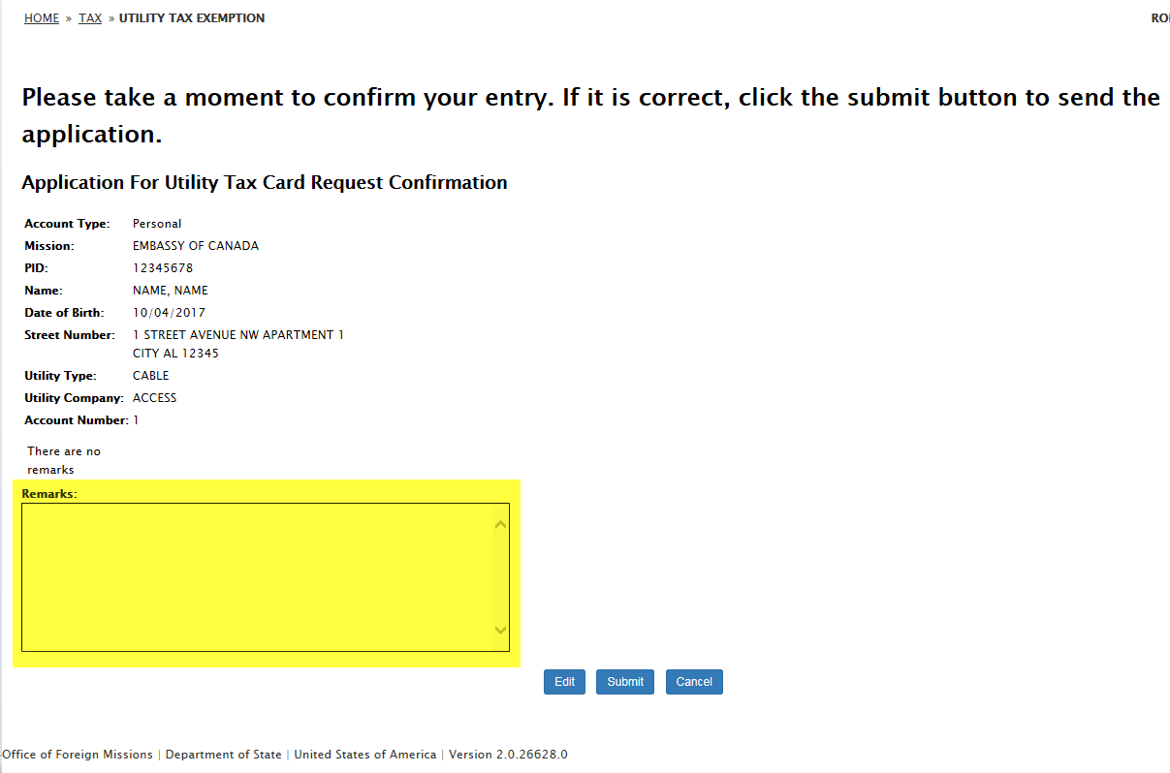

* Address input fields are subdivided due to IT security requirements. This Address input field change also occurs in the following eGov Service Request programs:
- DS-99 Form / Gasoline Tax Exemption Request
- DS-100 Form / Registration (Mission Vehicle) Request
- DS-101 Form / Registration (Personal Vehicle) Request
- DS-102 Form / Application for Vehicle Title Request
- DS-104 Form / Replacement Plates Request
- DS-1972 Form / Driver License & Non-Driver ID Application
- DS-1972 Form / Sales Tax Exemption
- DS-2003 Form / Notification of Appointment (Diplomatic) Request
- DS-2004 Form / Notification of Appointment (Employee) Request
- DS-2005 Form / Notification of Appointment (Honorary Consular Officer) Request
- DS-2006 Form / Notification of Change Request

