**Data items collected by the eGov Vehicle Title request but not collected by the DS-102 Form;**

1. **Registration Type**
   1. **Mission Vehicle**
   2. **Personal Vehicle**

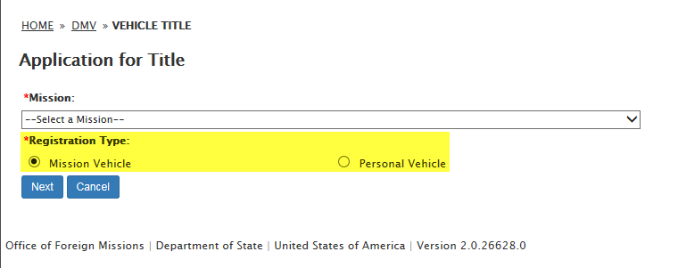

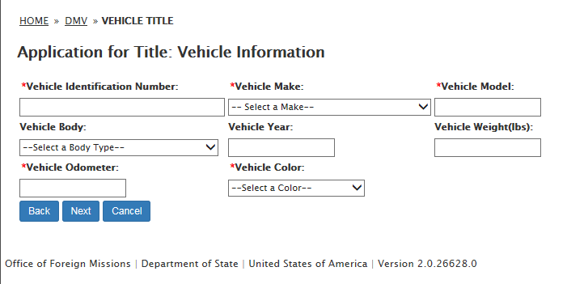

1. **Vehicle Title Type:**
   1. **JUNK**
   2. **LEASE**
   3. **SALVAGE**
   4. **STOLEN VEHICLE**

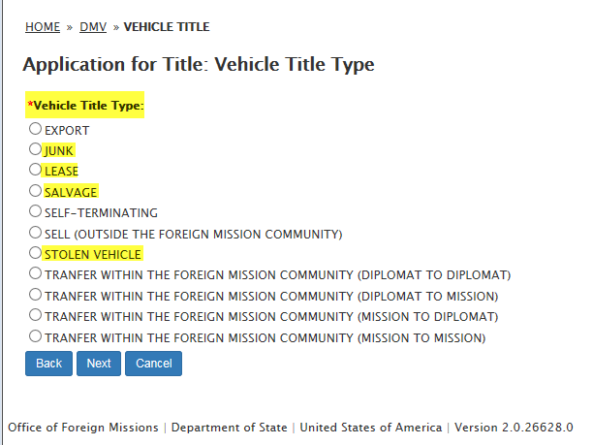

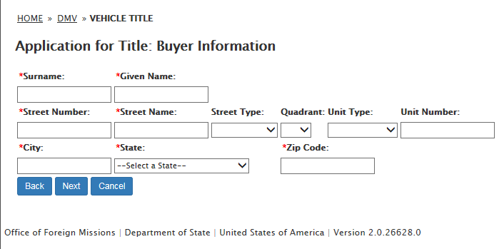

1. **Transferee Information:**
   1. **PID**
   2. **Date of Birth**

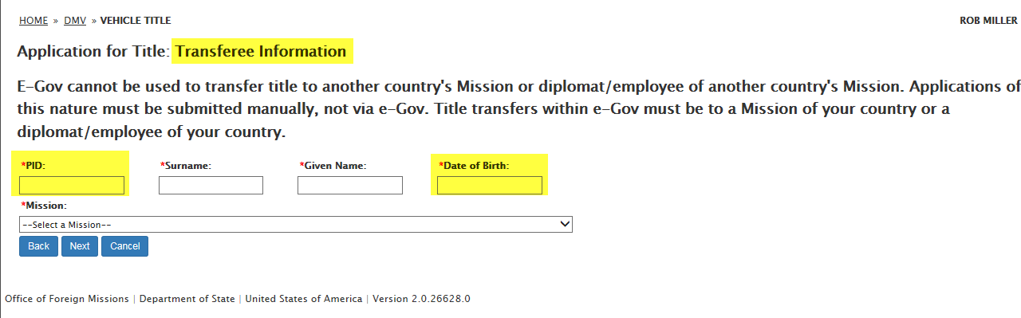

1. **Junkyard Information:**
   1. **Junkyard Name**
   2. **Street Number**
   3. **Street Name**
   4. **Street Type**
   5. **Quadrant**
   6. **Unit Type**
   7. **Unit Number**
   8. **City**
   9. **State**
   10. **Zip Code**

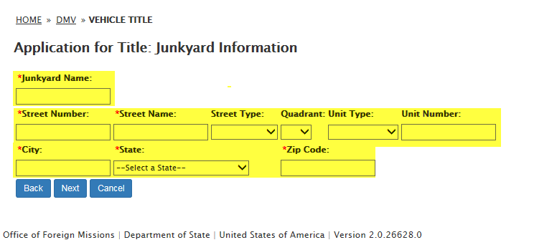

1. **Lease Information:**
   1. **Name**
   2. **Street Number**
   3. **Street Name**
   4. **Street Type**
   5. **Quadrant**
   6. **Unit Type**
   7. **Unit Number**
   8. **City**
   9. **State**
   10. **Zip Code**

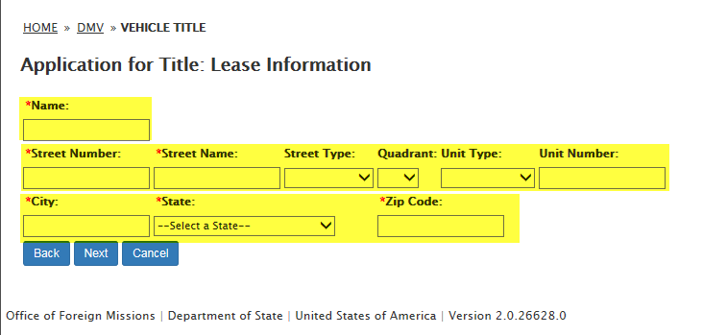

1. **Insurance Company Information:**
   1. **Insurance Company Name**
   2. **Street Number**
   3. **Street Name**
   4. **Street Type**
   5. **Quadrant**
   6. **Unit Type**
   7. **Unit Number**
   8. **City**
   9. **State**
   10. **Zip Code**

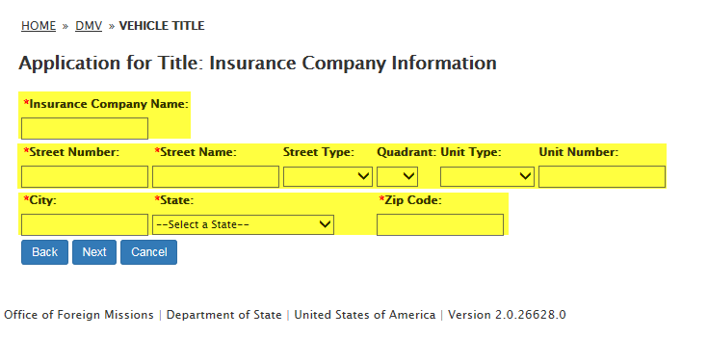

1. **Stolen Information:**
   1. **OFM Report Number**
   2. **Stolen Type**

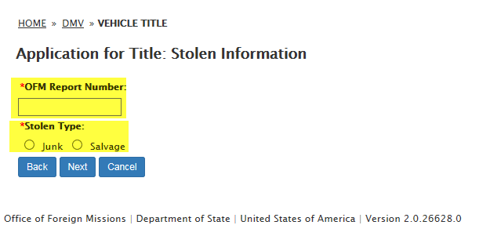

1. **Owner Information:**
   1. **PID**
   2. **Date of Birth**

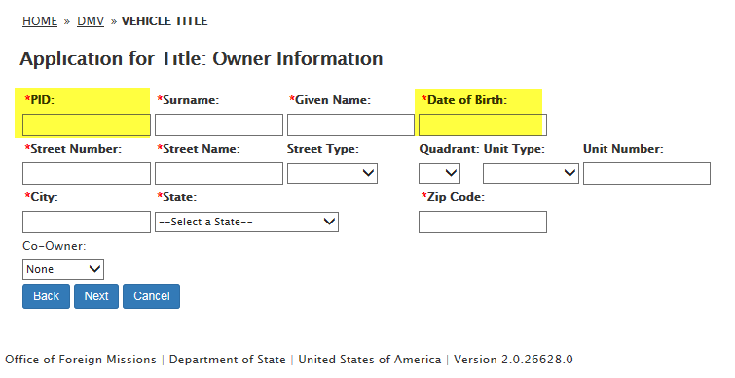

1. **New Mission Information: New Mission**

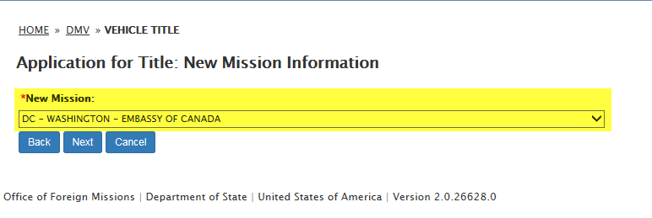

1. **Remarks**

