Data items collected by the eGov Bonded Warehouse Ordering Exemption request but not collected by the DS-1504 Form;
- Warehouse
- Intended Use
- Order Point of Contact or Consignee: Date of Birth
- Delivery Address:
  - Address Line 1
  - Address Line 2
  - City
  - State
  - ZIP Code
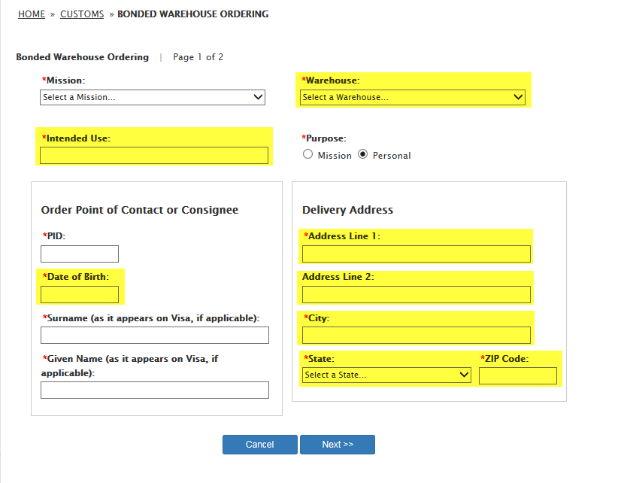

- Mission Property Address
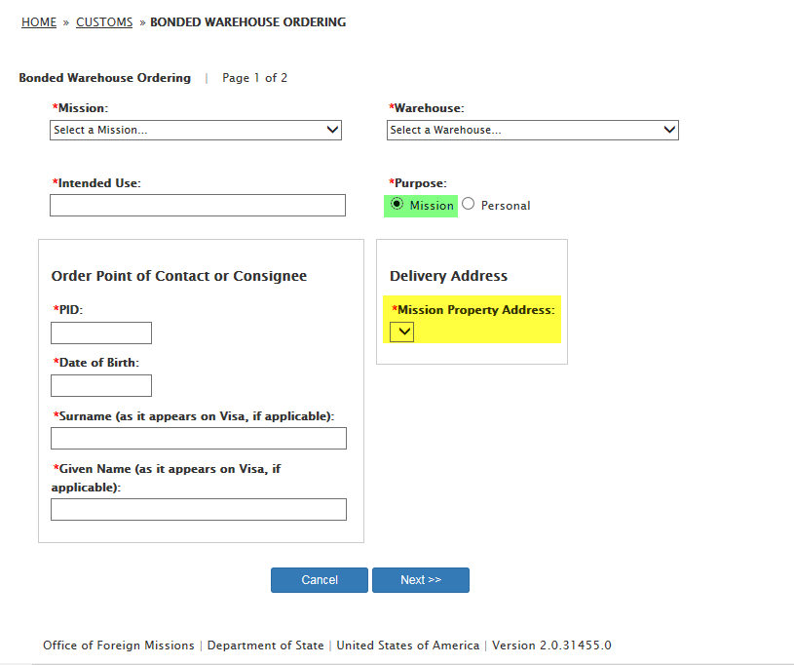
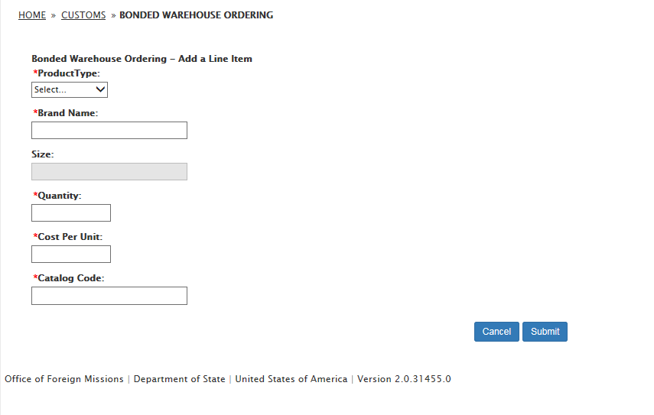
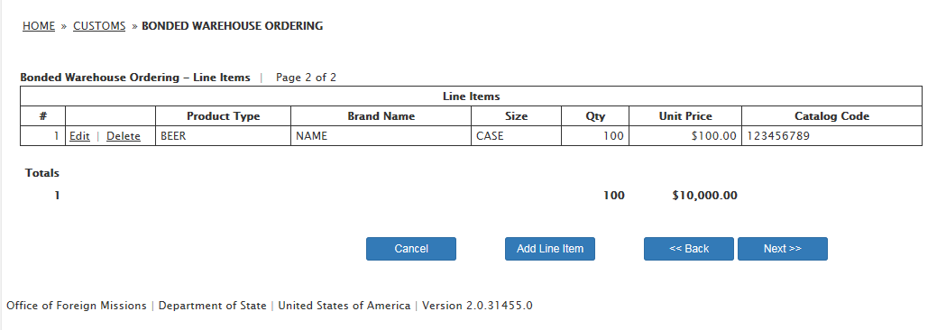

- Remarks
