**Data items collected by the eGov Driver License & Non-Driver ID Application request but not collected by the DS-1972 Form;**

1. **Vehicle Class:**
   1. **Regular**
   2. **Motorcycle**
   3. **Regular and Motorcycle**
2. **Have you held a DOS DL?**

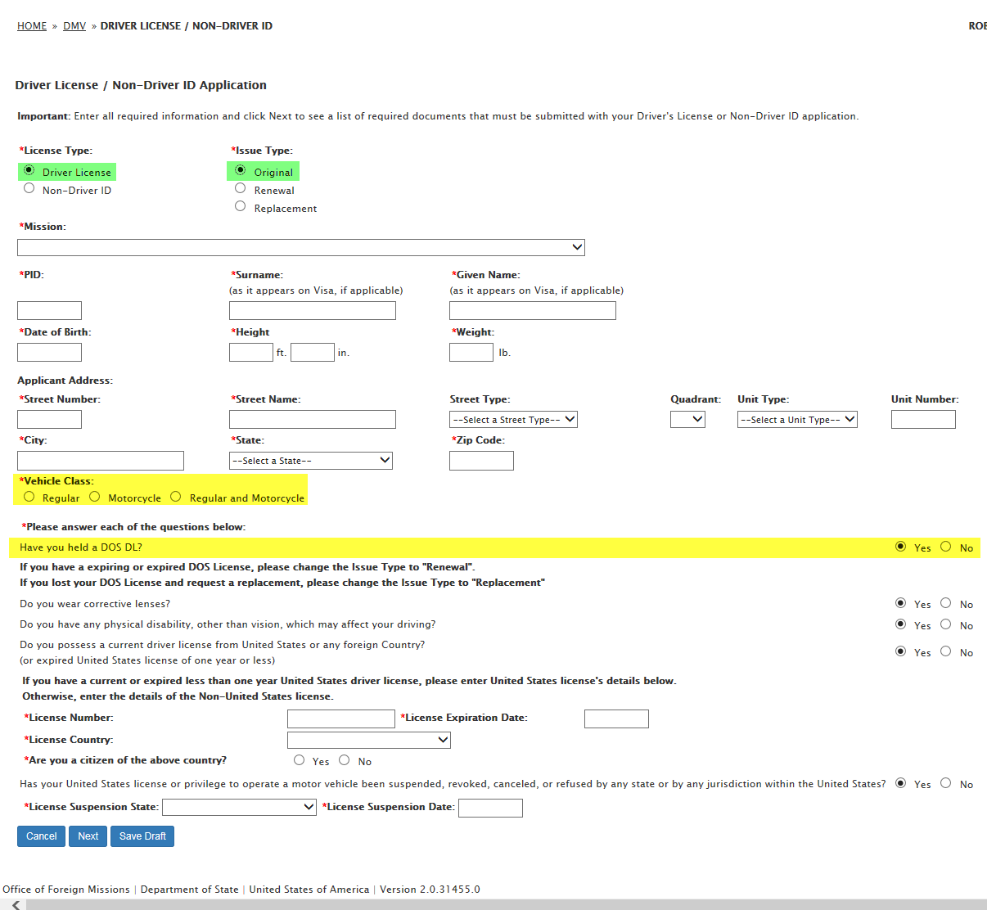

1. **Do you possess a current driver license from United States or any foreign Country?:**
   1. **Are you a citizen of the above country?**
   2. **If you are not a citizen of the above country, please select your country of citizenship**

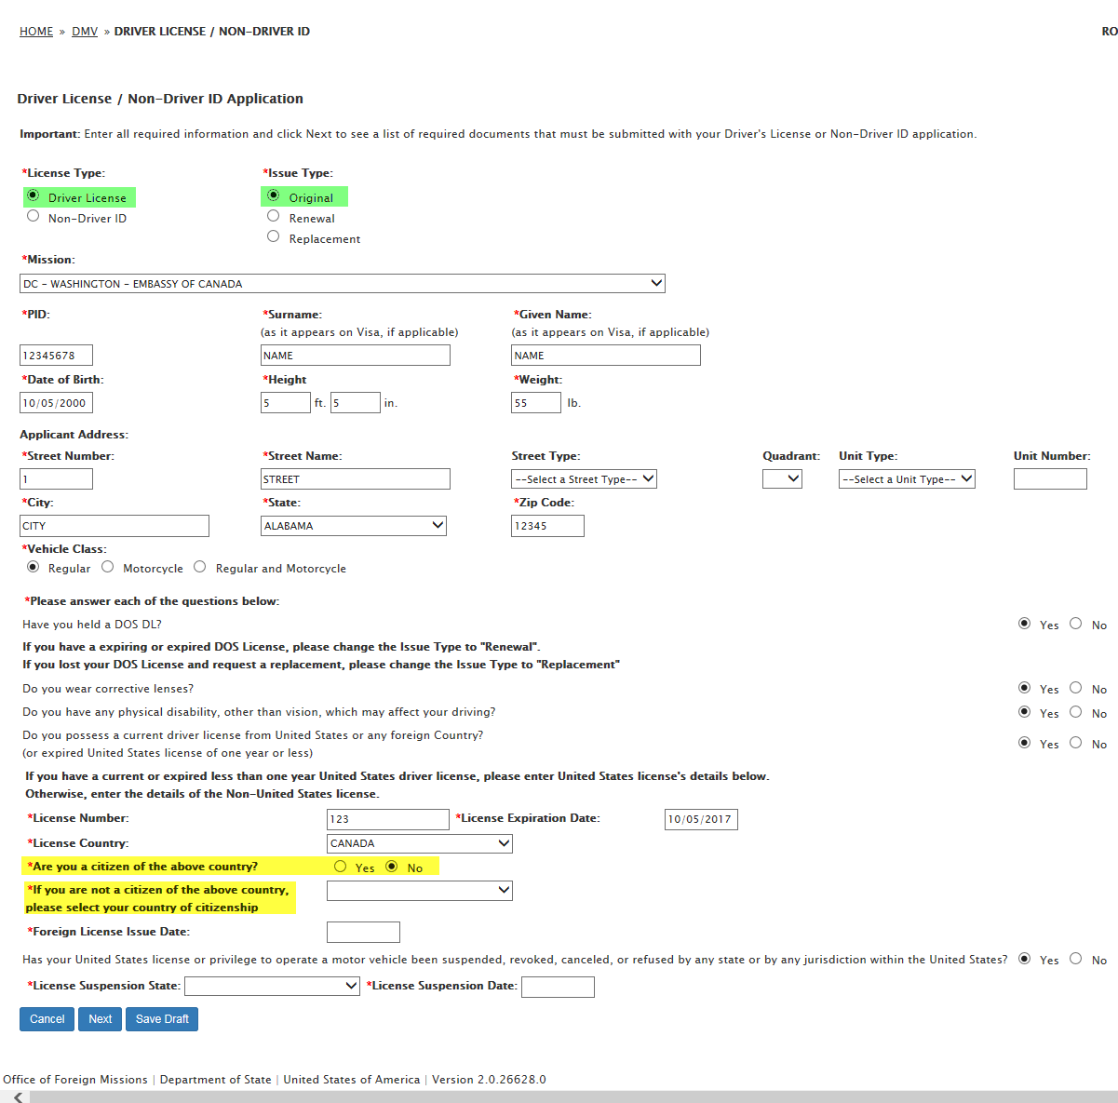

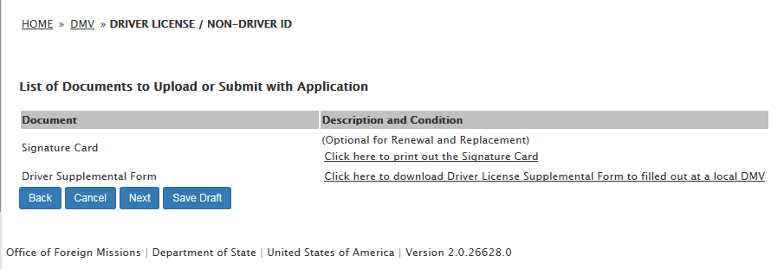

1. **Remark**

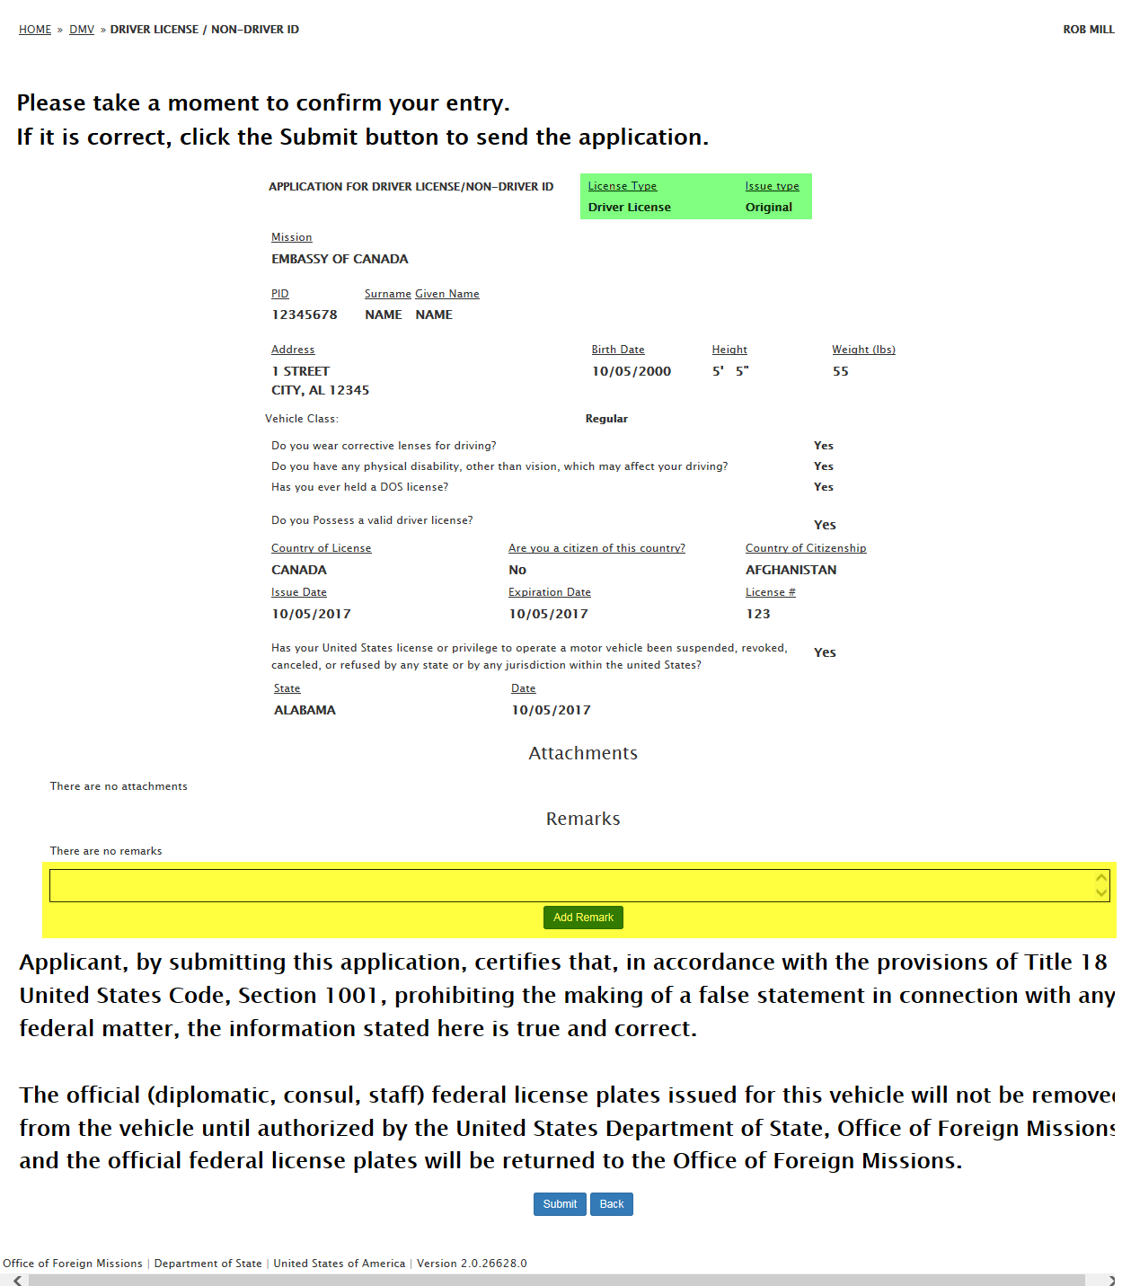

1. **License Type: Driver License / Issue Type: Replacement:**
   1. **Documents to Upload: Police Report; Copy of police report detailing lost of license**

