**Data items collected by the eGov Courtesies of Port request but not collected by the DS-4285 Form;**

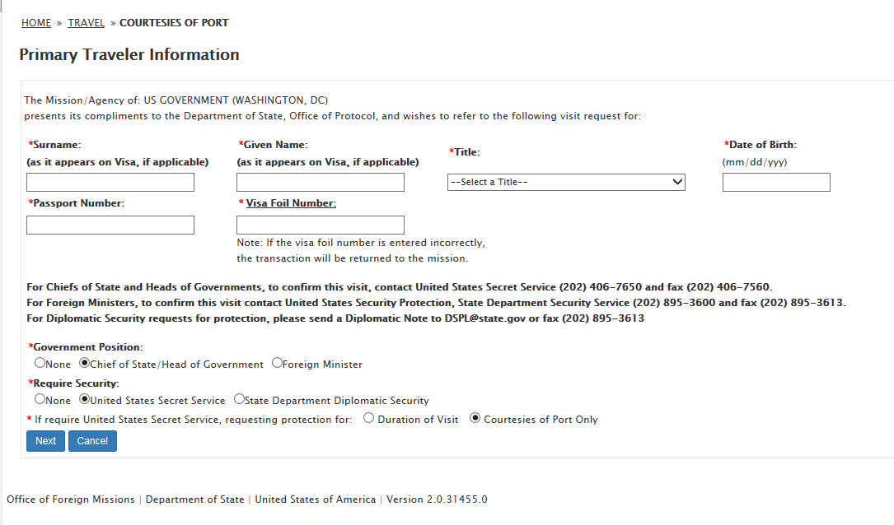

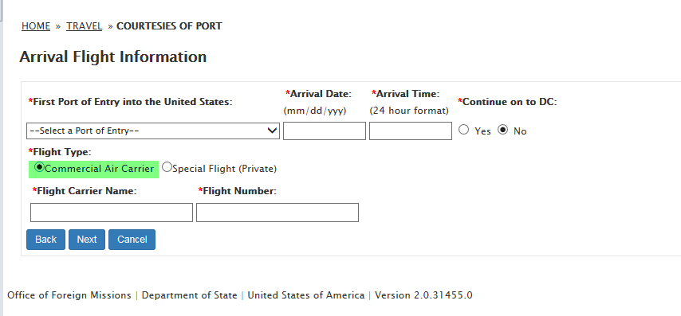

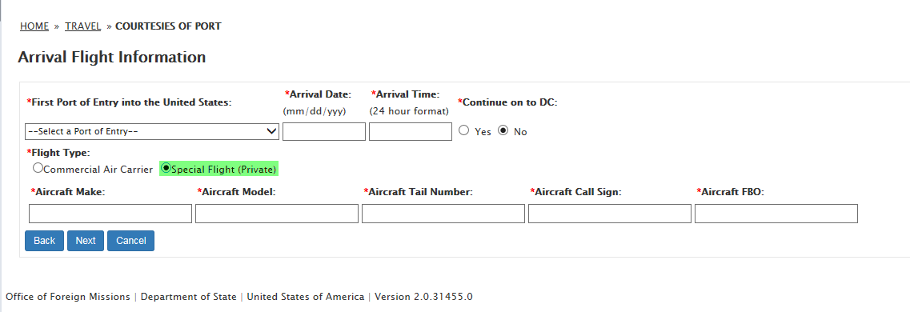

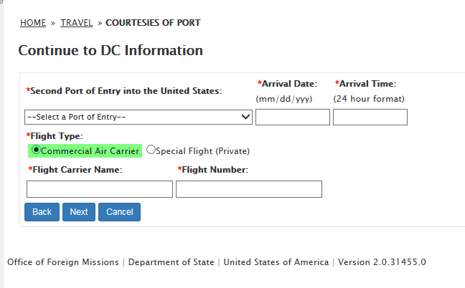

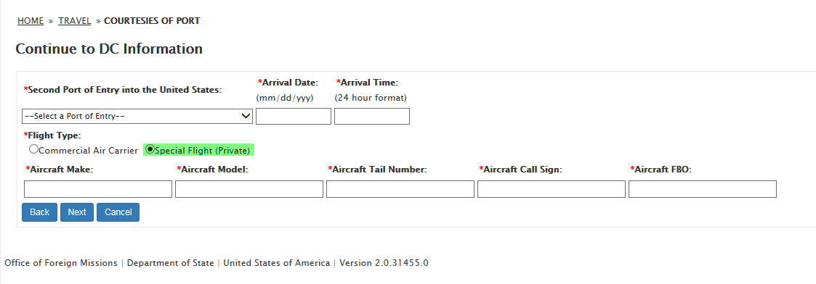

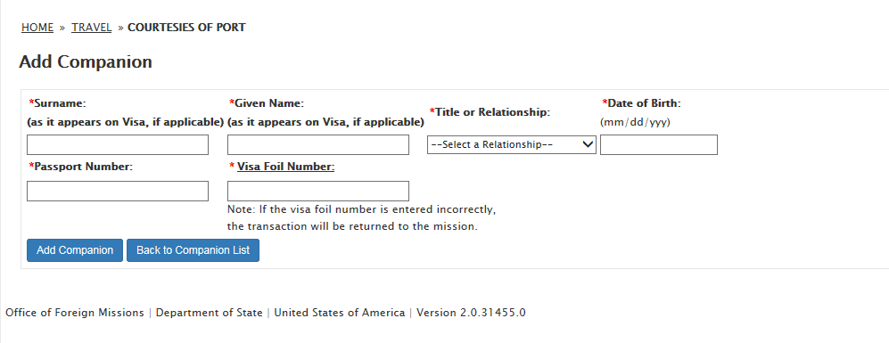

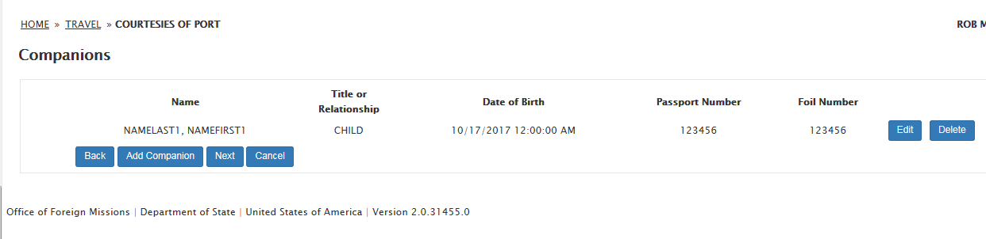

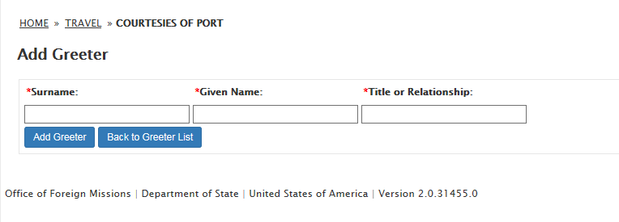

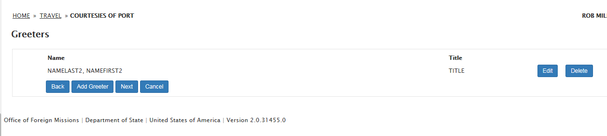

1. **Armed Security:**
   1. **Visa Foil Number**

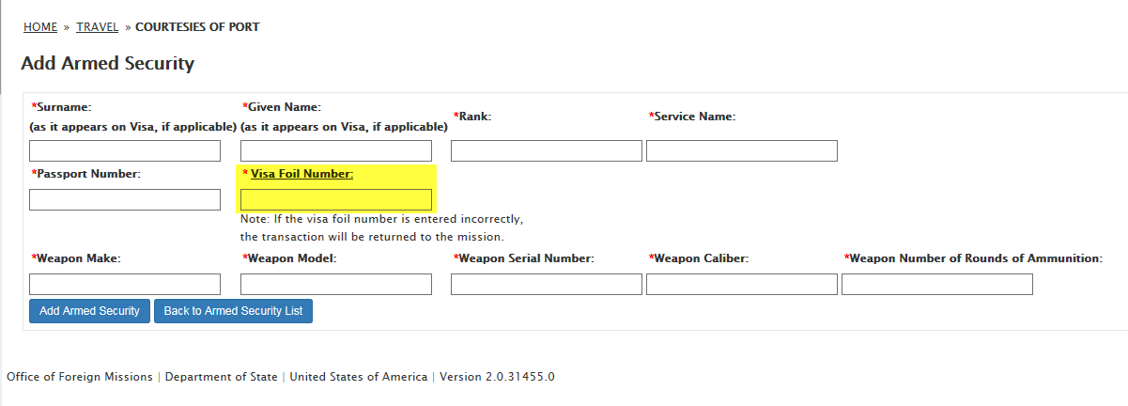

* 1. **Statement**

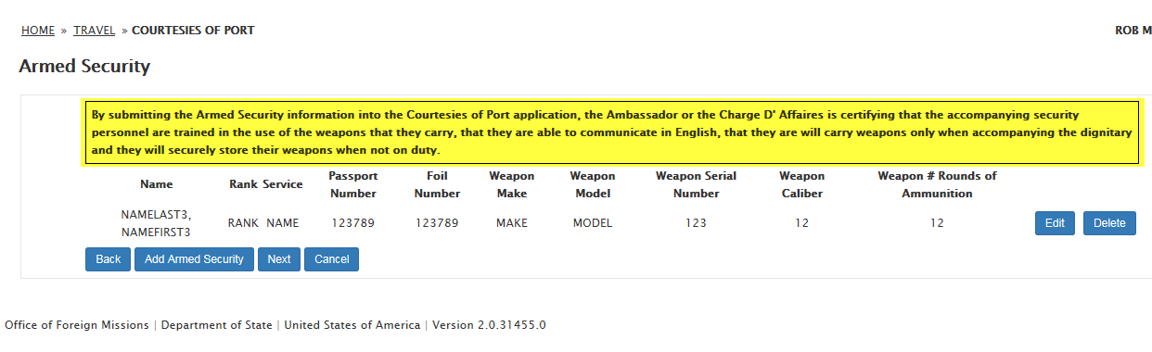

1. **POC and CDH Information:**
   1. **Point of Contact Information:**
      1. **Surname**
      2. **Given Name**
      3. **Title**
      4. **Telephone Number**
      5. **Cell Phone Number**
   2. **Contact Document Handler Information:**
      1. **Surname**
      2. **Given Name**
      3. **Telephone Number**
      4. **Cell Phone Number**
   3. **Enter Departure Flight Information:**
      1. **Yes**
      2. **No**

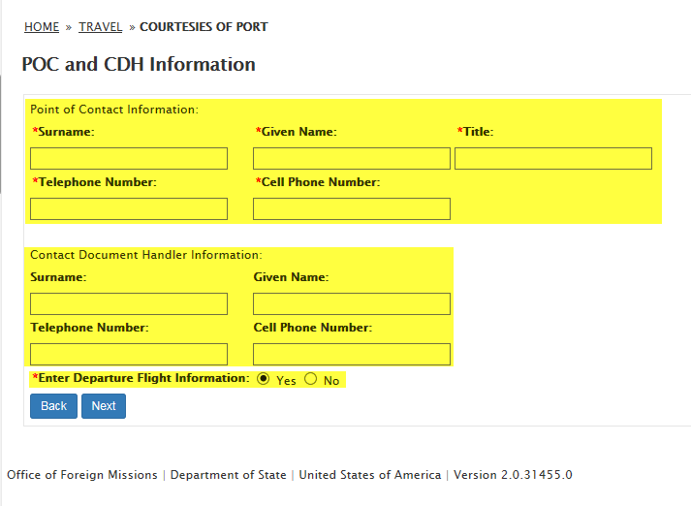

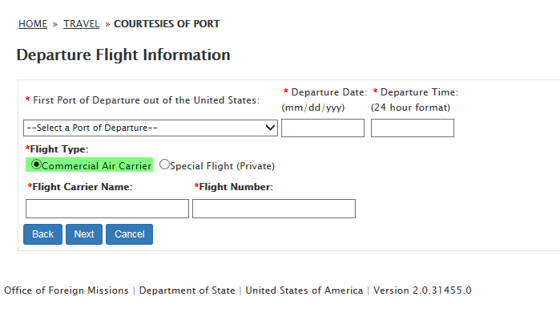

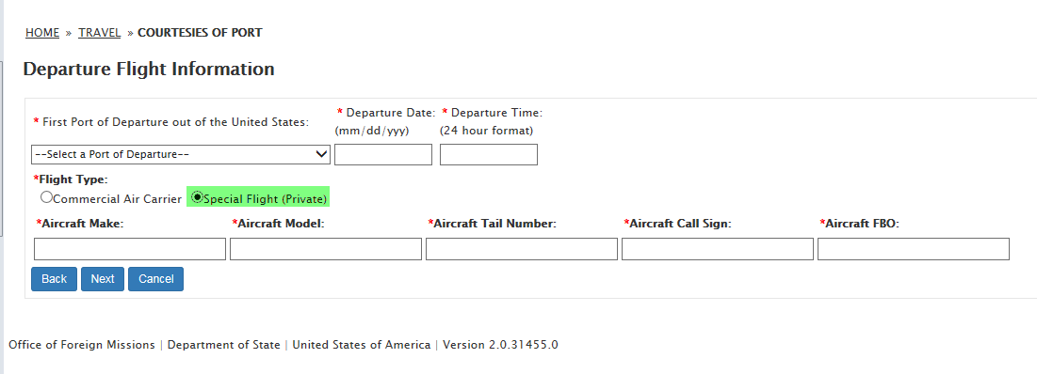

1. **Remark**

