**Data items collected by the eGov Sales Tax Exemption request but not collected by the DS-1972 Form;**

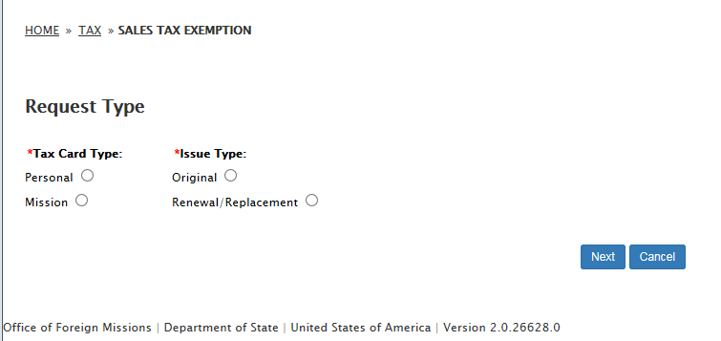

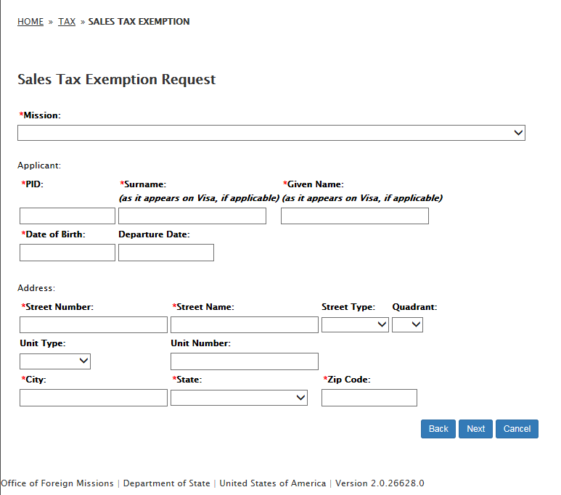

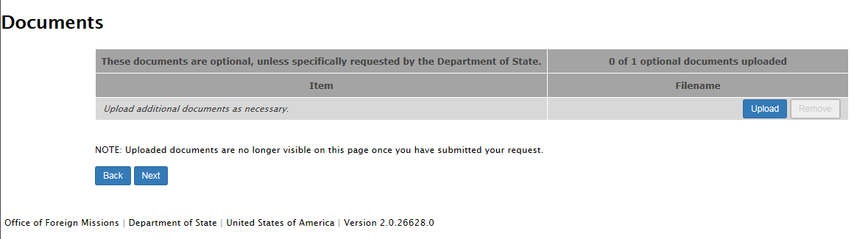

1. **Remarks**

