Home page:

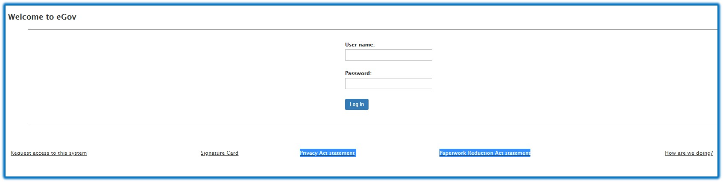

Paperwork Reduction Act

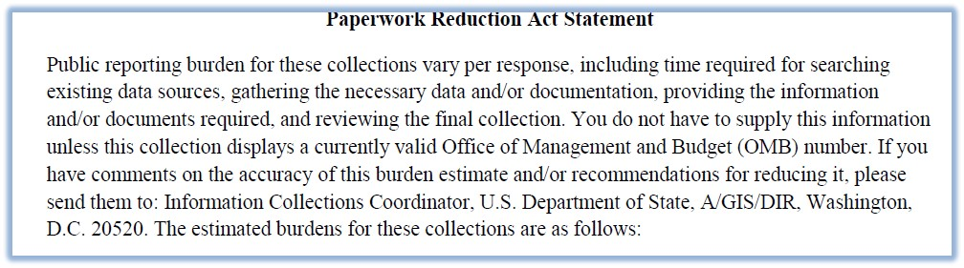

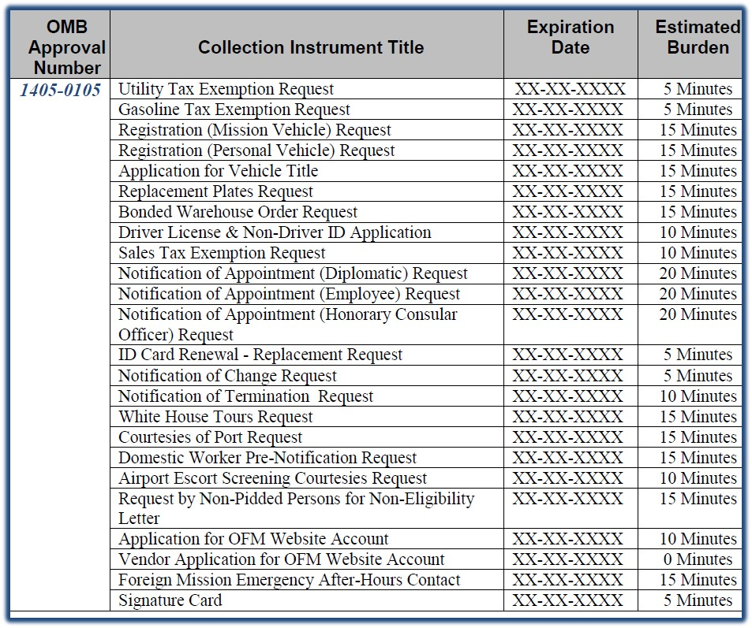

Privacy Act

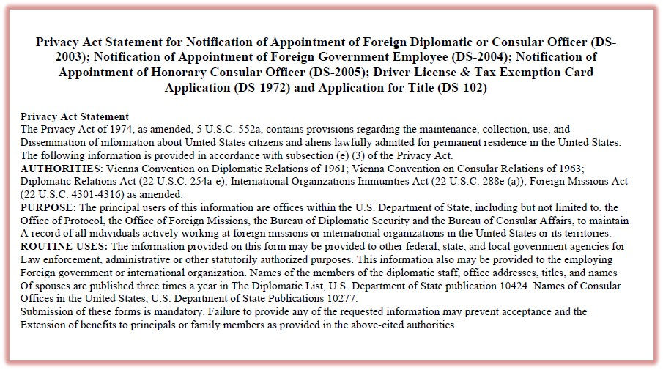

From your email attachment:

In the **Privacy Act Statement**, the new text is:

**DS Forms - Privacy Act Statement;**

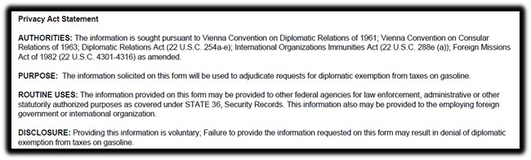

In the **Paperwork Reduction Act Statement**; the new text is:

**DS Forms - Paperwork Reduction Act Statement;**

