MUD Online Diary Study

Paperwork Reduction Act Notice: For Fiscal Service to speak with the public, we are required to have approval from the Office of Management and Budget. You are not required to respond unless a currently valid OMB approval number is provided. The approval number for this project is 1530-XXXX. This study is estimated to average 2 hours. If you have any comments regarding this study, please write to: Bureau of the Fiscal Service, Bruce Sharp, Parkersburg, WV 26106-1328.

Objective:
To gain current contextual insights around the MUD bond redemption process including behaviors, information needs, triggers, channels, motivations, barriers, and customer experience/satisfaction.

Community Logistics
The online community platform allows for various qualitative and discussion-based activities in a moderated, online environment.
The community will be live for 30 days. All content/activities will be made live at midnight each day. Reminder emails will be sent to those who have not completed all activities each day.
Participants will be expected to log in to the community each week to complete activities and answer follow-up questions and probes. Daily emails will be sent to ask if participants have completed any redemption related steps each day. Yes answers will trigger follow up questions. Specific timelines and deadlines will be communicated to participants via the community instructions. Total required participation is 2 hours.

Participants:
30 Paper Bond Owners – bonds in possession (estimating 10 over-recruit)
- 3-5 – Paper Bond Owners – bonds lost/stolen (nice to have)

Incentives:
$200-225* per participant for approximately 2-2.25 total hours spent in online study
*Incentives are typically higher for diary studies, particularly in cases where we expect participants to spend time researching and redeeming their bonds and engaging with us daily
Milestones:
1 – Complete first three days of activities, $50
2 – Complete 10 days of daily logs, $50
3 - Complete bond redemption and final activity $100
4- Additional incentive for participants past day 15, video call - $25
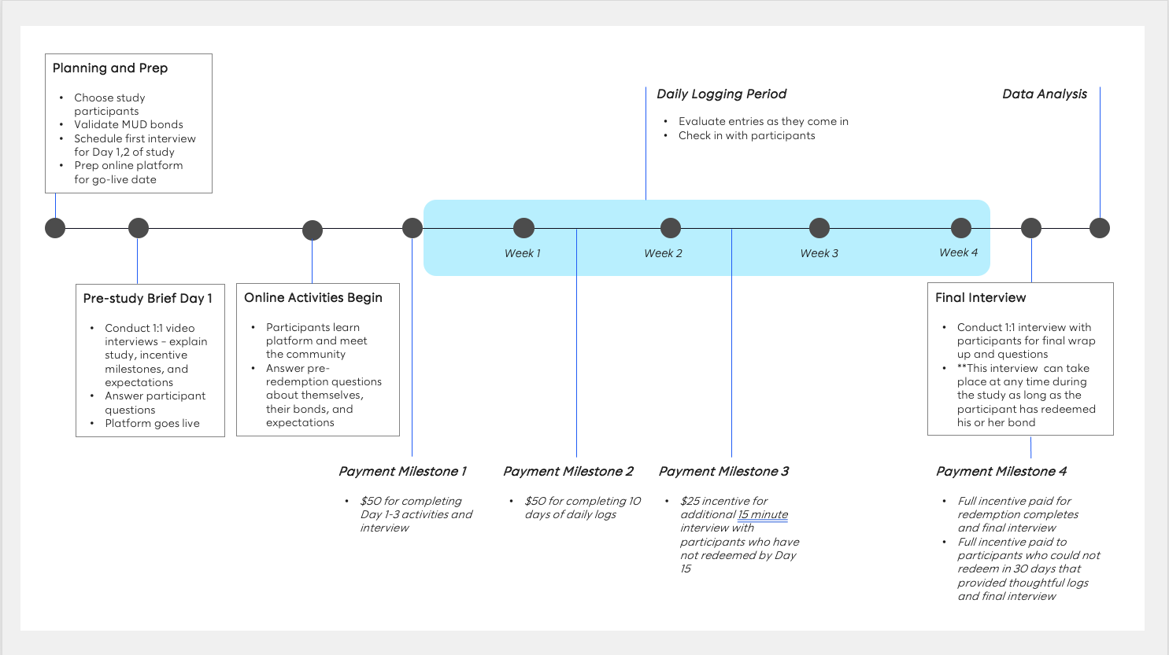

Day 1 - Getting comfortable and setting expectations

Objective: Establish rapport, set expectations, answer questions, get to know the platform and community

Time Expectation: 20 Minutes

1.1 Introductory Video Call
10-15 minute Teams video call – all participants

1.2. Opening Discussion (online)
Welcome/Instructions (All Participants)
Welcome to our online community with participants from across the country! We appreciate your time and we look forward to getting to know you a bit over the next few weeks. We know that you are busy, so we have set up the community to provide maximum flexibility. There are several types of questions and activities that we would like you to complete. You can complete them on your own time throughout the day and from whatever device is most comfortable and practical for you (phone, tablet, desktop, laptop, etc.), but we do ask that you complete all activities as they are assigned.
It is expected that you will spend approximately 2-2.5 hours interacting with this community over the next 15-30 days (varies based on how long it takes you to redeem your bond).
Over the first three days, our goal is to get to know a little bit about you, learn about your bond(s), and expectations to cash in (redeem) your bonds. After that, we’ll check in with you daily to see if you’ve completed any bond redemption activities. If you have, we’ll ask you to answer a few questions about those activities. We will likely have some follow-up questions that will also require responses. Your compensation is tied to your thoughtful completion of all assigned activities and follow-up questions. Your participation will help improve customer experiences to better meet your needs and the needs of people like you.
We will be scheduling a 15 minute video call with each of you to kick off the study and answer any questions you may have. We’re looking forward to meeting you!
Your Moderators,
Kate and Rita

- Briefly introduce yourself (first name only, state)
- We’re going to begin with a fun, easy question to get you in the groove of our community. Tell us about the best customer experience you’ve ever had in financial services (banking, investing, etc.). What made it stand out?
- Once you’ve finished, take a minute to look at other responses and like and/or comment on responses relevant to you

Day 2 – Getting to know you and your bonds

Objective: Understand savings bond perceptions, financial goals, and bond background

Time Expectation: 10 minutes

  - About You
- What 3-5 words come to mind when you think about savings bonds? [text response, 3 word minimum]
- Which of the following resources for cashing in your bonds are you aware of? (Select all that apply)
- Treasury’s website
- Fiscal service’s website
- Treasury Hunt
- TreasuryDirect
- Treasury’s call center
- Treasury’s email contact
- Any bank / credit union
- None of the above
- What are some of your short term financial goals? [text response]
- What are some of your long term financial goals? [text response]
- On a scale of 0-10, 0 being not at all confident and 10 being extremely confident, how do you feel about managing your finances to meet your goals?
- Please explain [text response]

  - About Your Bond

- Please tell us about your bond or each of your bonds and be as specific as possible in your responses.
- How did you receive your bonds? Did you purchase them, were they gifted to you, or did you inherit them?
- What were the circumstances? If gifted or inherited - when do you remember first hearing about them or receiving them? If purchased – when and why?
- What, if anything, made you think about them over the years or more recently (it’s okay to say you haven’t or that it’s this study that made you think about them)?
- On a scale on 0-10, 0 being not at all likely and 10 being extremely likely - Prior to this study, how likely were you to cash your bonds within the next year?
- Please explain

Day 3 – Redemption Research

Objective: Understand research process – channels used, information needs, pains/gains, and expectations for redemption post-research

Time Expectation: 15 minutes

3.1 We’d like you to start researching how to redeem your bond. Think about where you would go to look for information, what information you’d need to know before you redeem.
- What do you want to know first?
- Where will you go to find that out?
- Take that first step and continue your search from there. When you’re ready, come back here and tell us the following:
- What steps did you take - websites visited, phone calls made, talked to friends or family? Please be as specific as possible
- What did you find out about your bond(s) and/or bond redemption?
- Was there anything you found that was particularly confusing or helpful? Feel free to share quotes, screenshots, or pictures.
- On a scale of 0-10 – how easy (0) or difficult (10) do you think it will be to redeem your bond(s)? Please explain your rating.
- Choose 2 pictures that describe how you feel about redeeming your bond (image search or choose from options in platform). Please explain.

Days 4-29 – Bond Redemption

Objective: Understand redemption process – channels used, information needs, pains/gains, and experience

Time Expectation: 1 minute/day for No answers, 5 minutes for Yes answers, 60 minutes max

Each day, we’ll ask you if you’ve taken any steps to redeem your bond – anything big or small counts here. If you visited a website, stepped into a bank, or just had a conversation with a friend or family member, please click yes and let us know. After you click yes, we’ll ask you for a little more detail – what was the interaction like, was it positive or negative, helpful or unhelpful. Please try to log your activity and thoughts right after you’ve completed a bond redemption related activity. For ease, you can email us your daily log at email@email.com . Please be sure to use this template in order to ensure you’ve completed all questions. You can also log into the platform to complete your daily log. We will send daily reminders to see if you haven’t completed your log by the end of the day.

Daily Log (can this be done via email/message) – Auto send at 5pm local time
- Have you taken any action today to redeem your savings bond today? Yes/No
If Yes –
- What action(s) did you take and why?
- Was it a positive or negative experience? Scale. Why?
- Was it a helpful or unhelpful experience? Scale. Why?
- How much time did you spend?
- How much effort did you put in?
- If there are more steps to take, how motivated are you to take the next step? Please explain.
- Did you redeem your savings bond(s)? Yes/No
- Add logic?

*If you redeemed your bond(s) today, congrats! We’ll move you onto the final activity tomorrow (What can they share with us to confirm redemption? - Bank receipt (1099), photo of forms, confirmation from treasury/customer service, funds received)

Midway Check-in Day 15 – for participants who have not yet redeemed

1:1 check-ins with those who have not yet redeemed via Teams call - 15 minutes

Final Activity (For redeemed participants) – Post-study Interview
Time Expectation: 20 minutes
Congratulations! We’re thrilled you’ve reached this point and have completed redeeming your savings bond(s). We have a few final questions for you.

Alternate option (preferred choice) – do this via video call
- How would you rate your bond redemption experience overall? Scale 0-10 Poor to Excellent
- Please explain
- How would you rate the value of redeeming the bond compared to the effort of redeeming it? 0-10 Scale…? Please explain
- Looking back at activity 3.1, how did the actual process compare to what you thought it would be when you first started researching?
- What were the most difficult or frustrating parts of the process, if any?
- What were the easiest or most motivating parts of the process, if any?
- Imagine you were able to redesign the bond redemption process – what would you change and why?
- Any other thoughts you’d like to share with us about redeeming your bond?
Interest scale – How interested would you be in –
- Donating your bond directly to an organization of your choice?
- Put bond value directly towards paying your taxes?
- Educational benefits? [do they even know about them]

Final Activity (for participants who did NOT complete bond redemption by Day 30)
15 minute phone call

- Similar to questions asked of those who did redeem
- What would need to have been different for you to have successfully redeemed your bond?

Thank you so much for your participation in this important study! We appreciate your thoughtful participation and the energy you put into redeeming your bond.

