NATIONAL CENTER FOR EDUCATION STATISTICS NATIONAL ASSESSMENT OF EDUCATIONAL PROGRESS

National Assessment of Educational Progress (NAEP)
2022

Appendix J-S

2022 Spanish Questionnaires

OMB# 1850-0928 v.22

March 2021
No changes since November 2020 (1850-0928 v.21)

Appendix J-S provides a sample from 2020 (OMB# 1850-0928 v.21). Depending on the status of Survey Questionnaires, final versions may be available for Amendment #1 by June 2021, or some combination of Amendment #1 (by June 2021) and Amendment #2 (by August 2021).

Table of Contents
Student Login Screen 5
Appendix J-1a-s-BL: Summary of Changes Operational Grade 4 CORE 7
Appendix J-1a-s-BL: Operational Grade 4 CORE 12
Appendix J-1b-s-PR: Summary of Changes Operational Grade 4 CORE 16
Appendix J-1b-s-PR: Operational Grade 4 CORE 21
Appendix J-1c-s-BL: Summary of Changes Operational Grade 8 CORE 25
Appendix J-1c-s-BL: Operational Grade 8 CORE 32
Appendix J-1d-s-PR: Summary of Changes Operational Grade 8 CORE 38
Appendix J-1d-s-PR: Operational Grade 8 CORE 44
Appendix J-1e-s-BL: Summary of Changes Operational Grade 4 Mathematics 50
Appendix J-1e-s-BL: Operational Grade 4 Mathematics 55
Appendix J-1f-s-PR: Summary of Changes Operational Grade 4 Mathematics 59
Appendix J-1f-s-PR: Operational Grade 4 Mathematics 64
Appendix J-1g-s-BL: Summary of Changes Operational Grade 8 Mathematics 68
Appendix J-1g-s-BL: Operational Grade 8 Mathematics 77
Appendix J-1h-s-PR: Summary of Changes Operational Grade 8 Mathematics 82
Appendix J-1h-s-PR: Operational Grade 8 Mathematics 90
Appendix J-1i-s-BL: Summary of Changes Operational Grade 4 Reading 95
Appendix J-1i-s-BL: Operational Grade 4 Reading 100
Appendix J-1j-s-BL: Summary of Changes Operational Grade 8 Reading 104
Appendix J-1j-s-BL: Operational Grade 8 Reading 110
Appendix J-1k-s-BL: Operational Grade 8 Civics 115
Appendix J-1l-s-BL: Operational Grade 8 US History 122
Appendix J-1m-s-BL: Summary of Operational Grade 4 Debrief 128
Appendix J-1m-s-BL: Operational Grade 4 Debrief 129
Appendix J-1n-s-PR: Summary of Operational Grade 4 Debrief 130
Appendix J-1n-s-PR: Operational Grade 4 Debrief 131
Appendix J-1o-s-BL: Summary of Operational Grade 8 Debrief 131
Appendix J-1o-s-BL: Operational Grade 8 Debrief 133
Appendix J-1p-s-PR: Summary of Operational Grade 8 Debrief 134
Appendix J-1p-s-PR: Operational Grade 8 Debrief 135
Appendix J-1q-s-BL: Operational Grade 4 COVID-19 (ELA) (New) 136
Appendix J-1r-s-BL: Operational Grade 8 COVID-19 (ELA) (New) 139
Appendix J-1s-s-BL: Operational Grade 4 COVID-19 (Math) (New) 142
Appendix J-1t-s-PR: Operational Grade 4 COVID-19 (Math) (New) 145
Appendix J-1u-s-BL: Operational Grade 8 COVID-19 (Math) (New) 148
Appendix J-1v-s-PR: Operational Grade 8 COVID-19 (Math) (New) 151
Appendix J-1w-s-BL: Online Grade 4 (CORE) (New) 154
Appendix J-1x-s-PR: Online Grade 4 (CORE) (New) 156
Appendix J-1y-s-BL: Online Grade 8 (CORE) (New) 158
Appendix J-1z-s-PR: Online Grade 8 (CORE) (New) 163
Appendix J-1aa-s-BL: Online Grade 4 (Math) (New) 167
Appendix J-1bb-s-PR: Online Grade 4 (Math) (New) 171
Appendix J-1cc-s-BL: Online Grade 8 (Math) (New) 175
Appendix J-1dd-s-PR: Online Grade 8 (Math) (New) 181
Appendix J-1ee-s-BL: Online Grade 4 (Reading) (New) 187
Appendix J-1ff-s-BL: Online Grade 8 (Reading) (New) 191
Appendix J-1gg-s-BL: Online Grade 4 COVID-19 (ELA) (New) 196
Appendix J-1hh-s-BL: Online Grade 4 COVID-19 (Math) (New) 199
Appendix J-1ii-s-PR: Online Grade 4 COVID-19 (Math) (New) 202
Appendix J-1jj-s-BL: Online Grade 8 COVID-19 (ELA) (New) 205
Appendix J-1kk-s-BL: Online Grade 8 COVID-19 (Math) (New) 208
Appendix J-1ll-s-PR: Online Grade 8 COVID-19 (Math) (New) 211
Teacher Login Screen 214
Appendix J-2-s: Spanish Translations of Teacher Questionnaires 215
Appendix J-2a-s-PR: Summary of Changes Operational Grade 4 CORE 216
Appendix J-2a-s-PR: Operational Grade 4 CORE 224
Appendix J-2b-s-PR: Summary of Changes Operational Grade 8 CORE 230
Appendix J-2b-s-PR: Operational Grade 8 CORE 239
Appendix J-2c-s-PR: Summary of Changes Operational Grade 4 Mathematics 247
Appendix J-2c-s-PR: Operational Grade 4 Mathematics 253
Appendix J-2d-s-PR: Summary of Changes Operational Grade 8 Mathematics 259
Appendix J-2d-s-PR: Operational Grade 8 Mathematics 266
Appendix J-2e-s-PR: Operational Grade 4 COVID-19 (New) 272
Appendix J-2f-s-PR: Operational Grade 8 COVID-19 (New) 277
School Administrator Login Screen 282
Appendix J-3-s: Spanish Translations of School Questionnaires 283
Appendix J-3a-s-PR: Summary of Changes Operational Grade 4 CORE 284
Appendix J-3a-s-PR: Operational Grade 4 CORE 295
Appendix J-3b-s-PR: Summary of Changes Operational Grade 8 CORE 305
Appendix J-3b-s-PR: Operational Grade 8 CORE 316
Appendix J-3c-s-PR: Summary of Changes Operational Grade 4 Mathematics 326
Appendix J-3c-s-PR: Operational Grade 4 Mathematics 329
Appendix J-3d-s-PR: Summary of Changes Operational Grade 8 Mathematics 332
Appendix J-3d-s-PR: Operational Grade 8 Mathematics 335
Appendix J-3e-s-PR: Operational Grade 4 COVID-19 (New) 339
Appendix J-3f-s-PR: Operational Grade 8 COVID-19 (New) 347

Student Login Screen
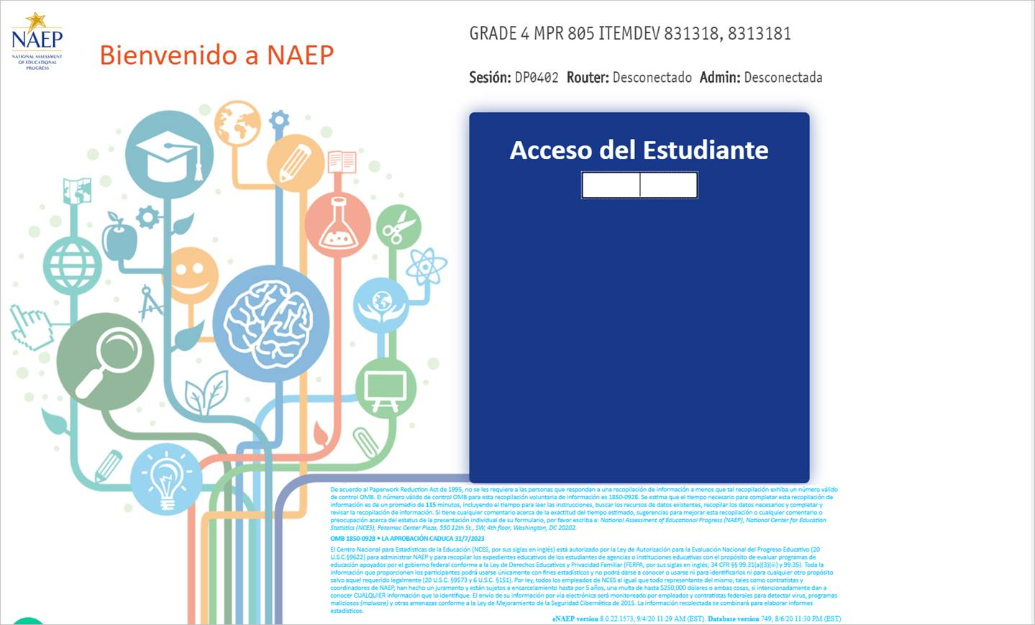

Appendix J-1-s: Spanish Translations of Student Questionnaires

Appendix J-1a-s-BL: Summary of Changes Operational Grade 4 CORE
2021 Operational Grade 4 Core Student – Bilingual
Previous item | 2021 item | D/A/R/NC+ | Rationale
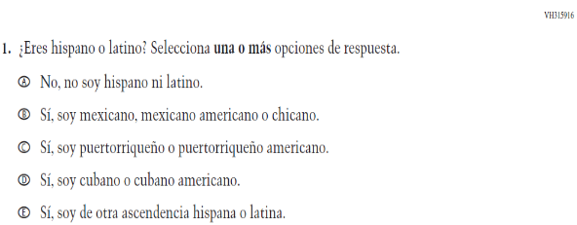  (2019 Operational Grade 4 Student Core - Bilingual) | \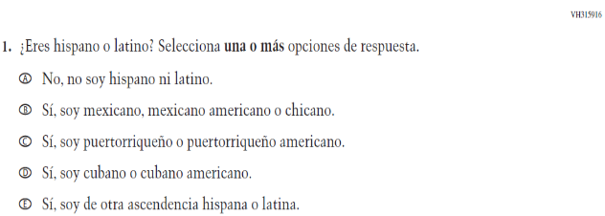  Issue: Race/Ethnicity | NC | N/A
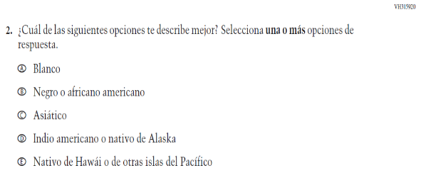  (2019 Operational Grade 4 Student Core - Bilingual) | 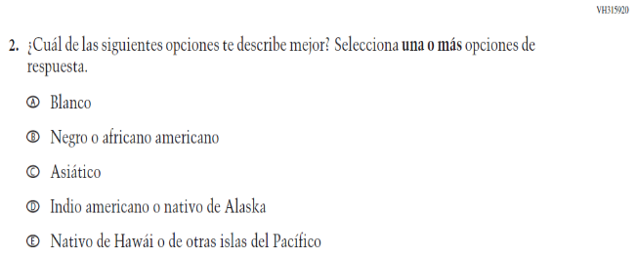  Issue: Race/Ethnicity | NC | N/A
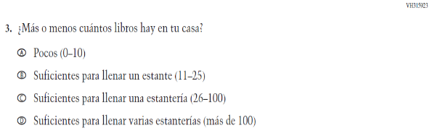  (2019 Operational Grade 4 Student Core - Bilingual) | 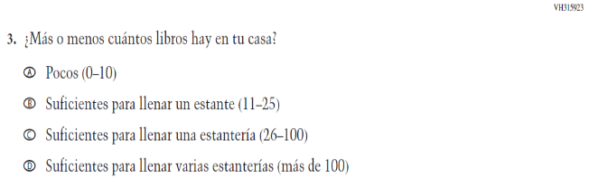  Issue: Socioeconomic Status | NC | N/A

2021 Operational Grade 4 Core Student – Bilingual
Previous item | 2021 item | D/A/R/NC+ | Rationale
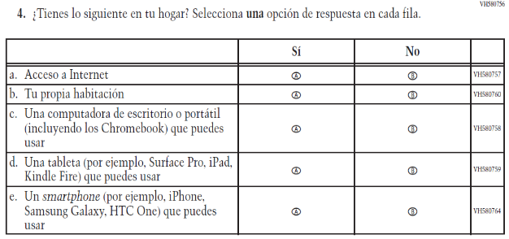  (2019 Operational Grade 4 Student Core - Bilingual) | 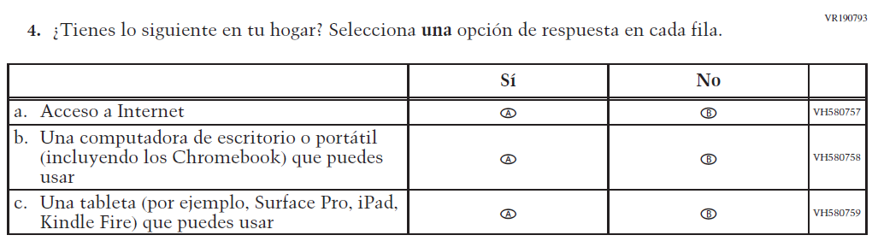  Issue: Socioeconomic Status | R | To keep student burden low, sub-items b and e were dropped.
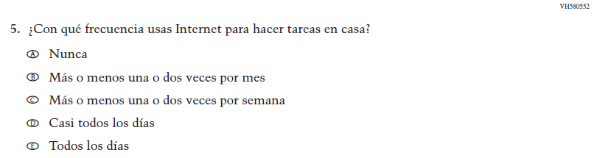  (2019 Operational Grade 4 Student Core - Bilingual) | N/A | D | To keep student burden low, this item was dropped.
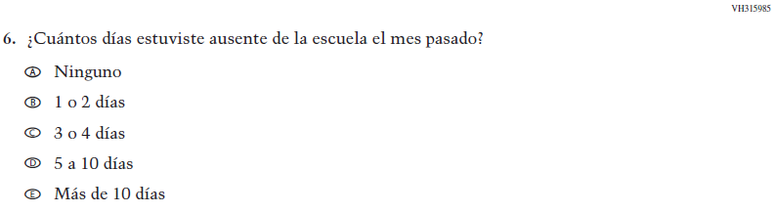  (2019 Operational Grade 4 Student Core - Bilingual) | 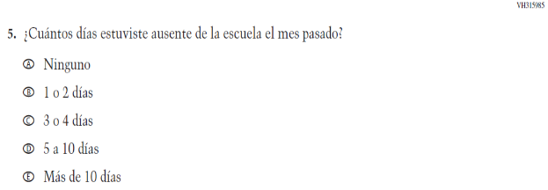  Issue: School Climate | NC | N/A

2021 Operational Grade 4 Core Student – Bilingual
Previous item | 2021 item | D/A/R/NC+ | Rationale
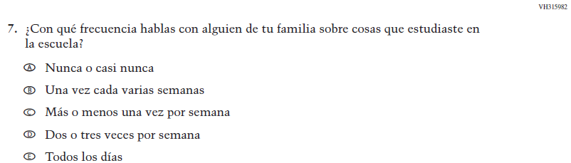  (2019 Operational Grade 4 Student Core - Bilingual) | N/A | D | To keep student burden low, this item was dropped.
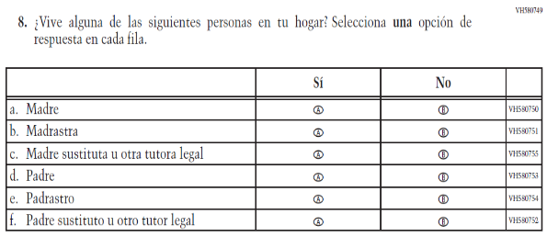  (2019 Operational Grade 4 Student Core - Bilingual) | 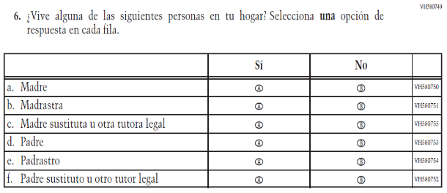  Issue: Socioeconomic Status | NC | N/A
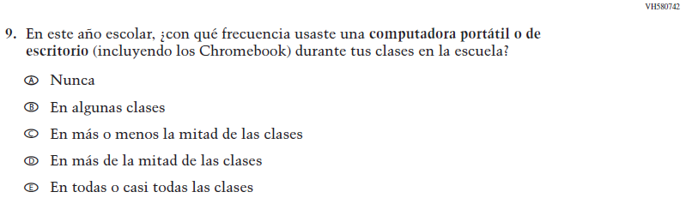  (2019 Operational Grade 4 Student Core - Bilingual) | 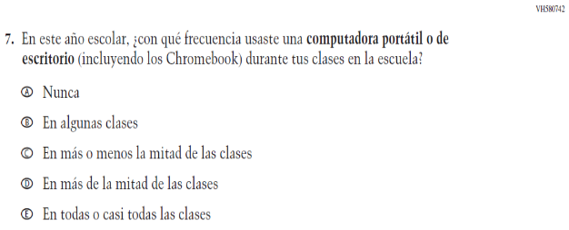  Issue: Technology Use | NC | N/A

2021 Operational Grade 4 Core Student – Bilingual
Previous item | 2021 item | D/A/R/NC+ | Rationale
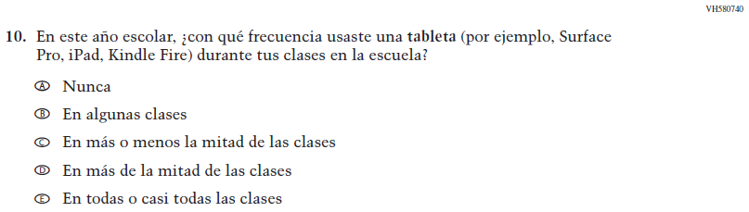  (2019 Operational Grade 4 Student Core - Bilingual) | N/A | D | To keep student burden low, this item was dropped.
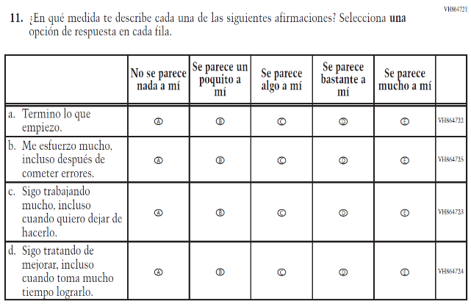  (2019 Operational Grade 4 Student Core - Bilingual) | N/A | D | To keep student burden low, this item was dropped.
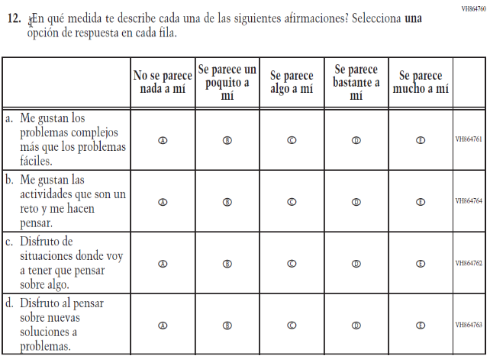  (2019 Operational Grade 4 Student Core - Bilingual) | 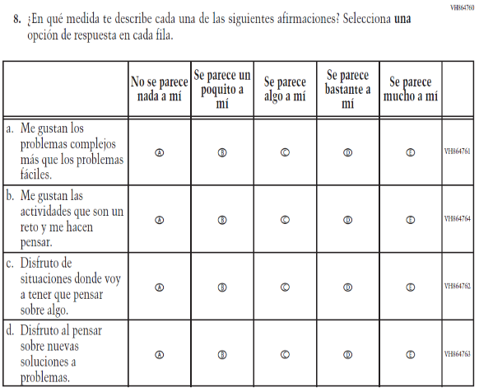  Issue: Desire for Learning | NC | N/A

2021 Operational Grade 4 Core Student – Bilingual
Previous item | 2021 item | D/A/R/NC+ | Rationale
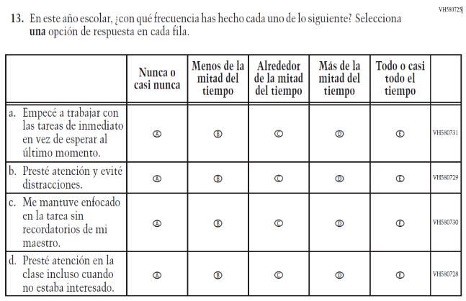  (2019 Operational Grade 4 Student Core - Bilingual) | 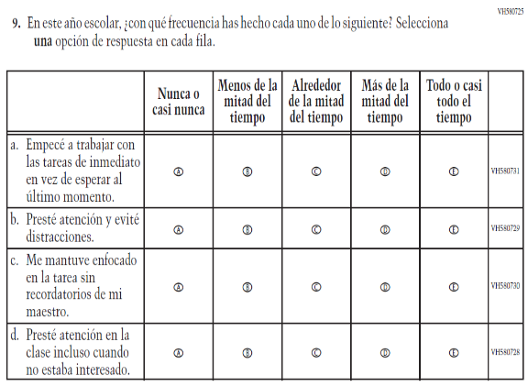  Issue: Grit | NC | N/A
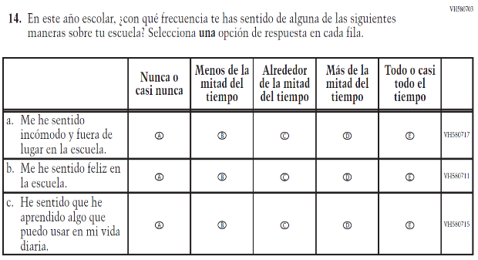  (2019 Operational Grade 4 Student Core - Bilingual) | N/A | D | To keep student burden low, this item was dropped.

Appendix J-1a-s-BL: Operational Grade 4 CORE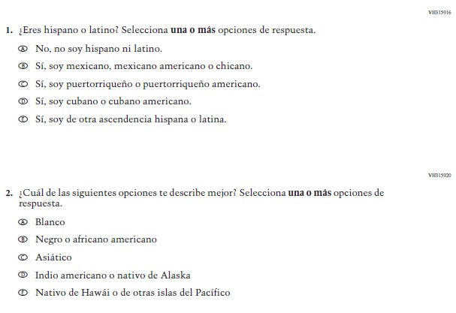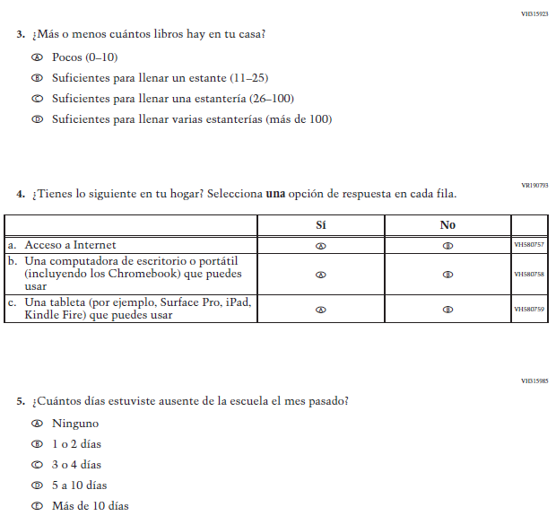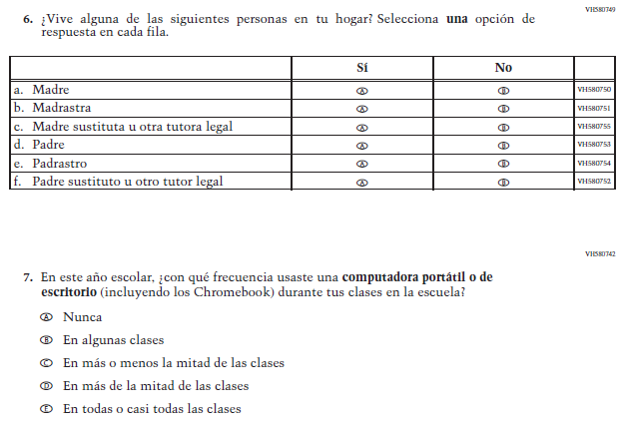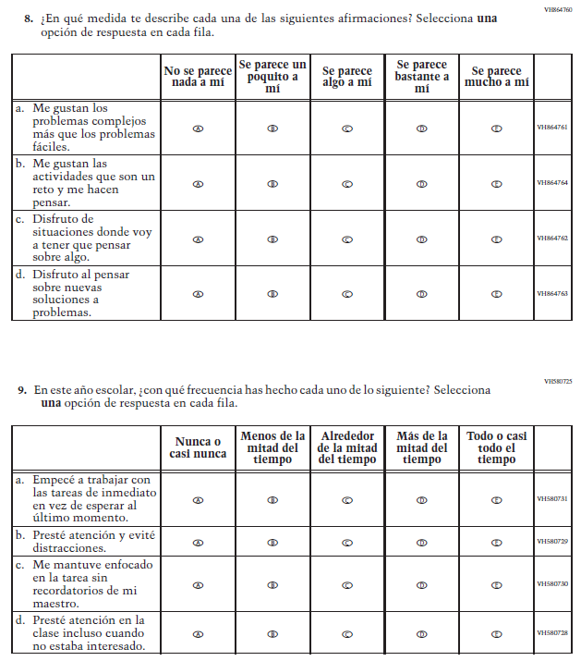

Appendix J-1b-s-PR: Summary of Changes Operational Grade 4 CORE
2021 Operational Grade 4 Core Student – Puerto Rico

Previous item | 2021 item | D/A/ R/NC+ | Rationale
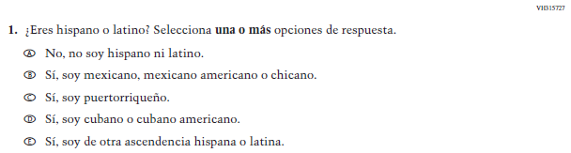  (2019 Operational Grade 4 Student Core – Puerto Rico) | 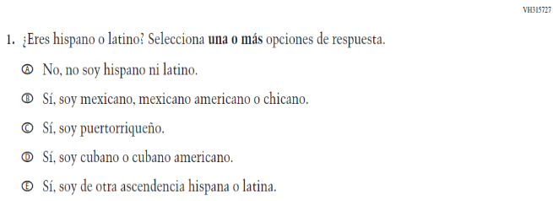  Issue: Race/Ethnicity | NC | N/A
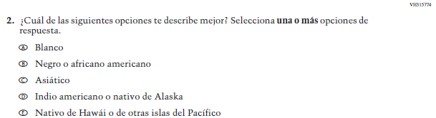  (2019 Operational Grade 4 Student Core – Puerto Rico) | 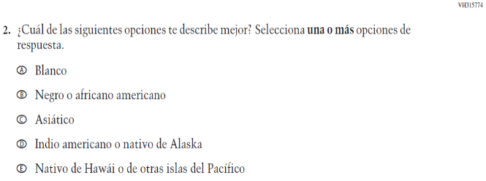  Issue: Race/Ethnicity | NC | N/A
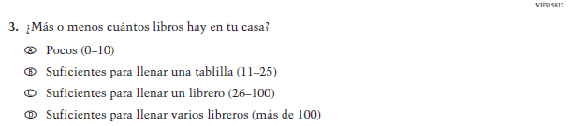  (2019 Operational Grade 4 Student Core – Puerto Rico) | 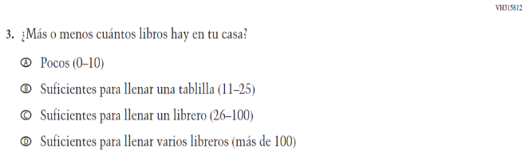  Issue: Socioeconomic Status | NC | N/A
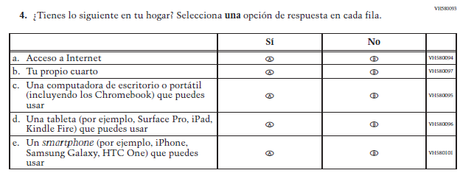  (2019 Operational Grade 4 Student Core – Puerto Rico) | 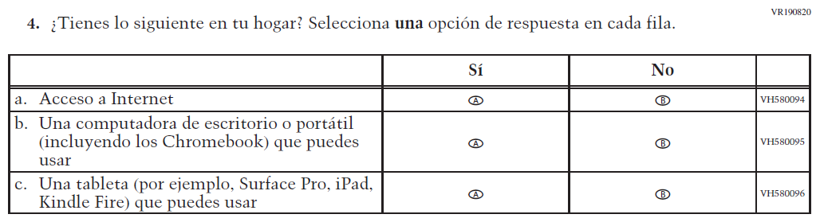  Issue: Socioeconomic Status | R | To keep student burden low, sub-items b and e were dropped.
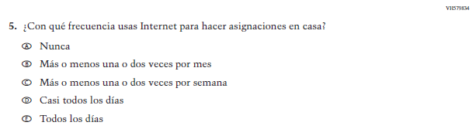  (2019 Operational Grade 4 Student Core – Puerto Rico) | N/A | D | To keep student burden low, this item was dropped.
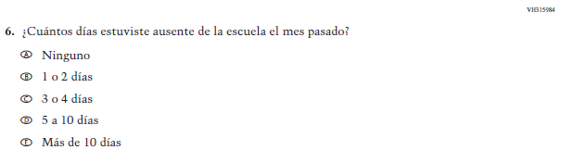  (2019 Operational Grade 4 Student Core – Puerto Rico) | 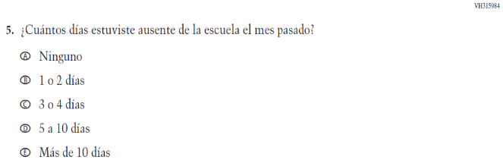  Issue: School Climate | NC | N/A

2021 Operational Grade 4 Core Student – Puerto Rico

Previous item | 2021 item | D/A/ R/NC+ | Rationale
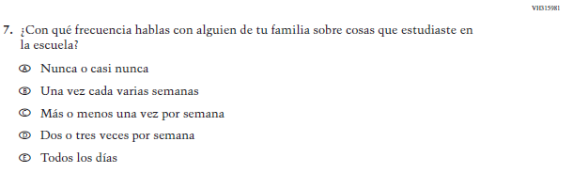  (2019 Operational Grade 4 Student Core – Puerto Rico) | N/A | D | To keep student burden low, this item was dropped.
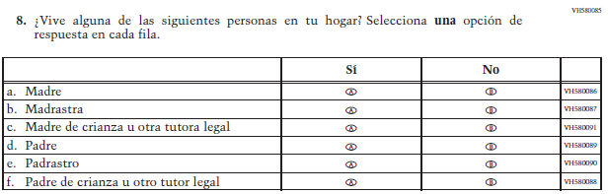  (2019 Operational Grade 4 Student Core – Puerto Rico) | 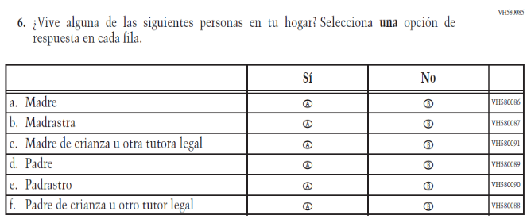  Issue: Socioeconomic Status | NC | N/A
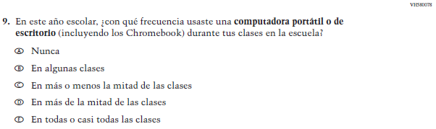  (2019 Operational Grade 4 Student Core – Puerto Rico) | 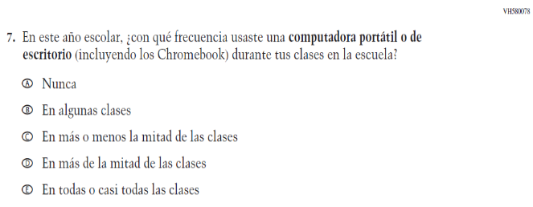  Issue: Technology Use | NC | N/A
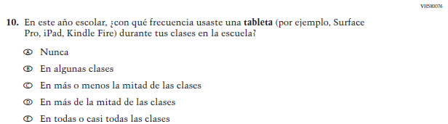  (2019 Operational Grade 4 Student Core – Puerto Rico) | N/A | D | To keep student burden low, this item was dropped.

2021 Operational Grade 4 Core Student – Puerto Rico

Previous item | 2021 item | D/A/ R/NC+ | Rationale
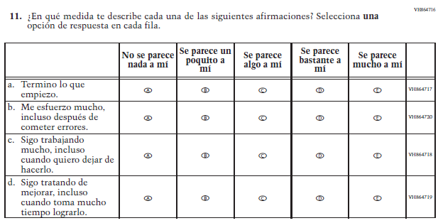  (2019 Operational Grade 4 Student Core – Puerto Rico) | N/A | D | To keep student burden low, this item was dropped.
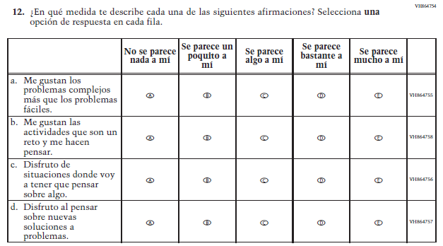  (2019 Operational Grade 4 Student Core – Puerto Rico) | 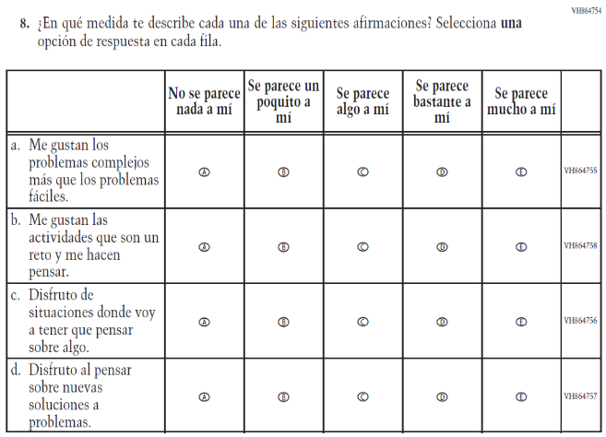  Issue: Desire for Learning | NC | N/A

2021 Operational Grade 4 Core Student – Puerto Rico

Previous item | 2021 item | D/A/ R/NC+ | Rationale
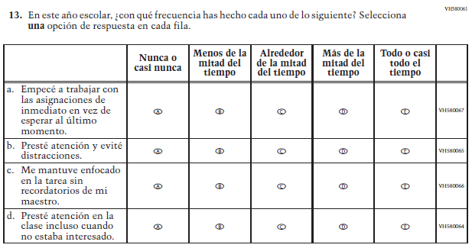  (2019 Operational Grade 4 Student Core – Puerto Rico) | 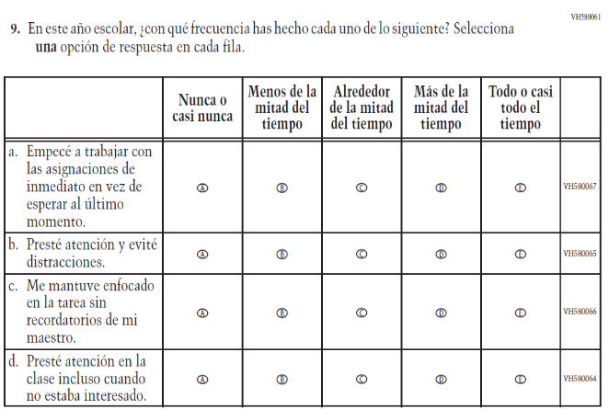  Issue: Grit | NC | N/A
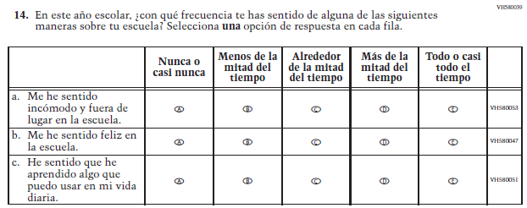  (2019 Operational Grade 4 Student Core – Puerto Rico) | N/A | D | To keep student burden low, this item was dropped.

Appendix J-1b-s-PR: Operational Grade 4 CORE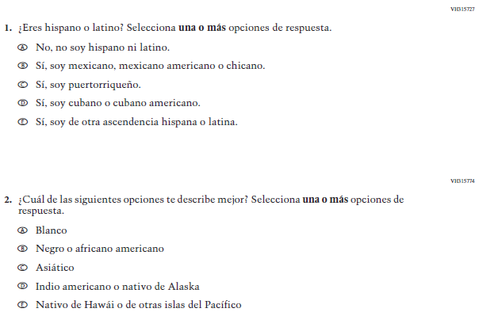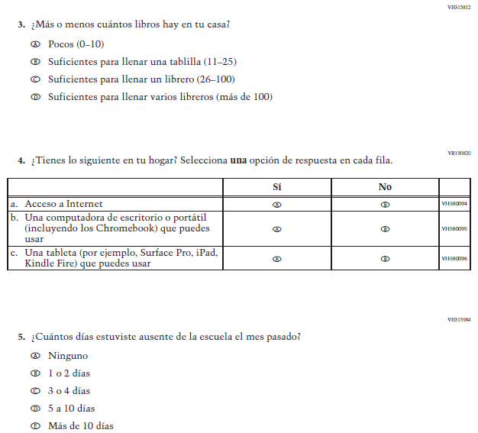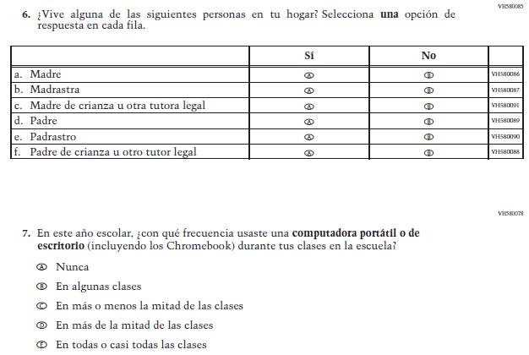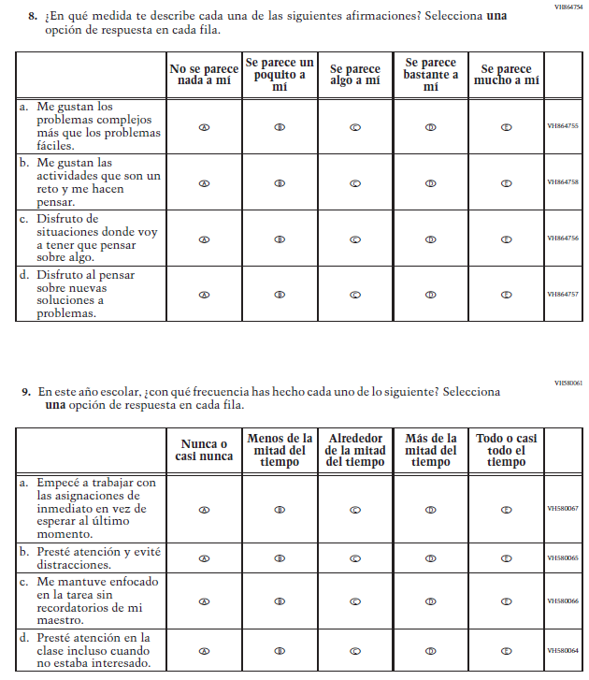

Appendix J-1c-s-BL: Summary of Changes Operational Grade 8 CORE
2021 Operational Grade 8 Core Student – Bilingual
Previous item | 2021 item | D/A/R/NC+ | Rationale
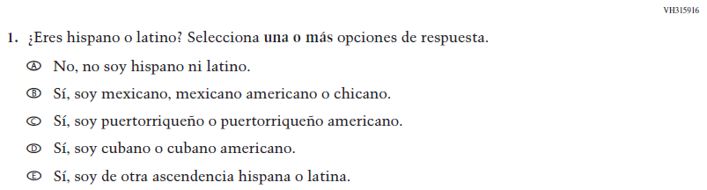  (2019 Operational Grade 8 Student Core - Bilingual) | Issue: Race/Ethnicity | NC | N/A
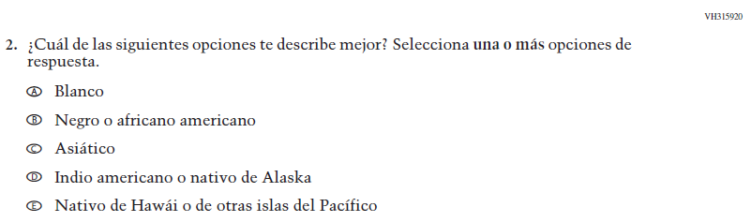  (2019 Operational Grade 8 Student Core - Bilingual) | Issue: Race/Ethnicity | NC | N/A
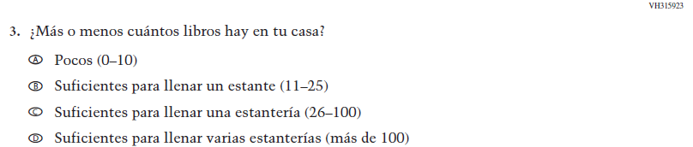  (2019 Operational Grade 8 Student Core - Bilingual) | Issue: Socioeconomic Status | NC | N/A

2021 Operational Grade 8 Core Student – Bilingual
Previous item | 2021 item | D/A/R/NC+ | Rationale
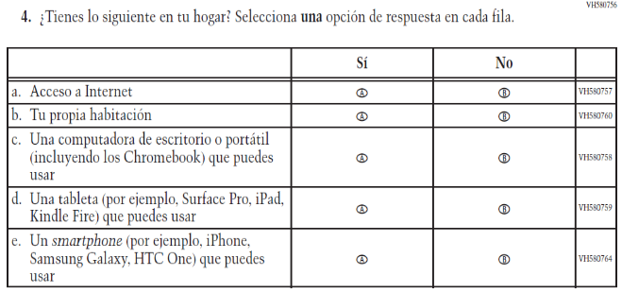  (2019 Operational Grade 8 Student Core - Bilingual) | 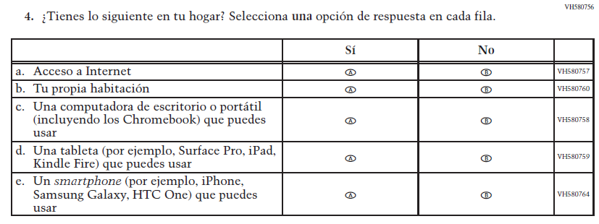  Issue: Socioeconomic Status | NC | N/A
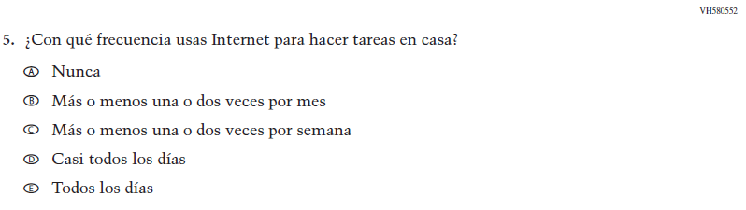  (2019 Operational Grade 8 Student Core - Bilingual) | Issue: Technology Use | NC | N/A
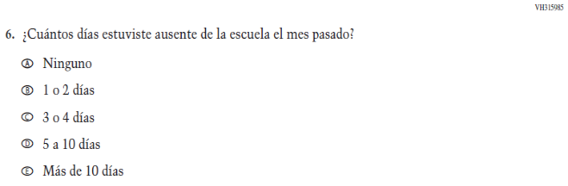  (2019 Operational Grade 8 Student Core - Bilingual) | 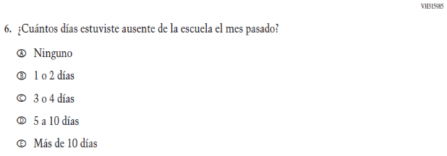  Issue: School Climate | NC | N/A

2021 Operational Grade 8 Core Student – Bilingual
Previous item | 2021 item | D/A/R/NC+ | Rationale
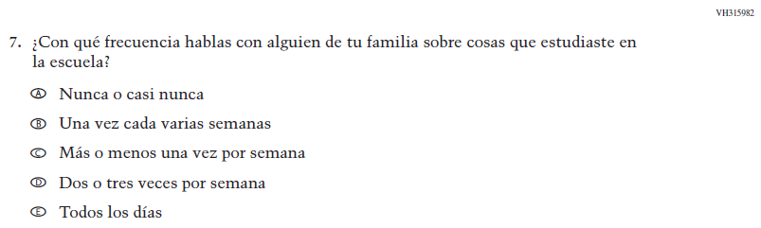  (2019 Operational Grade 8 Student Core - Bilingual) | Issue: Socioeconomic Status | NC | N/A
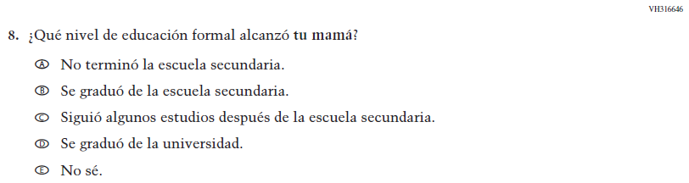  (2019 Operational Grade 8 Student Core - Bilingual) | Issue: Socioeconomic Status | NC | N/A
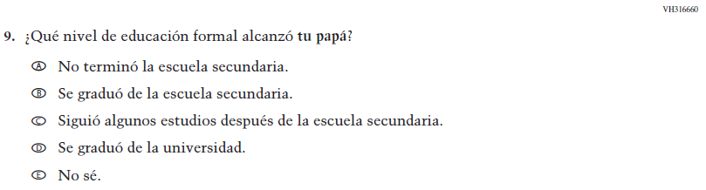  (2019 Operational Grade 8 Student Core - Bilingual) | Issue: Socioeconomic Status | NC | N/A

2021 Operational Grade 8 Core Student – Bilingual
Previous item | 2021 item | D/A/R/NC+ | Rationale
(2019 Operational Grade 8 Student Core - Bilingual) | Issue: Socioeconomic Status | NC | N/A
(2019 Operational Grade 8 Student Core - Bilingual) | Issue: Socioeconomic Status | NC | N/A
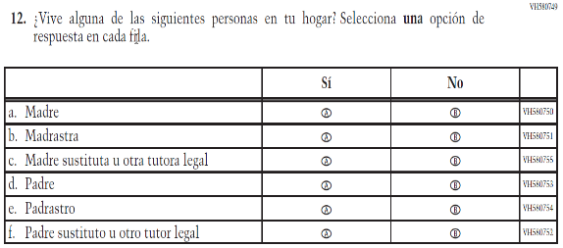  (2019 Operational Grade 8 Student Core - Bilingual) | 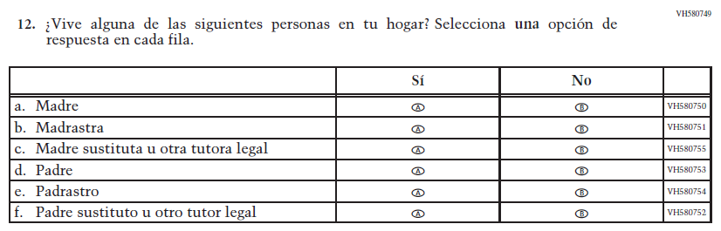  Issue: Socioeconomic Status | NC | N/A

2021 Operational Grade 8 Core Student – Bilingual
Previous item | 2021 item | D/A/R/NC+ | Rationale
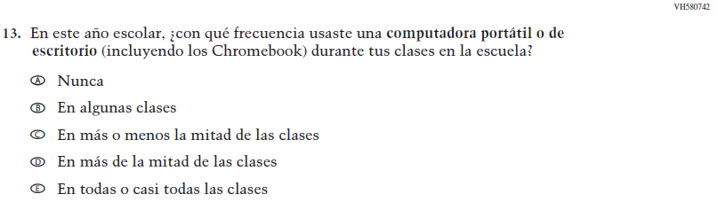  (2019 Operational Grade 8 Student Core - Bilingual) | Issue: Technology Use | NC | N/A
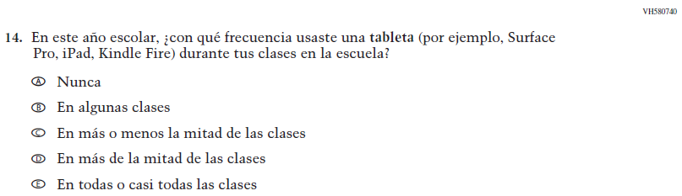  (2019 Operational Grade 8 Student Core - Bilingual) | Issue: Technology Use | NC | N/A
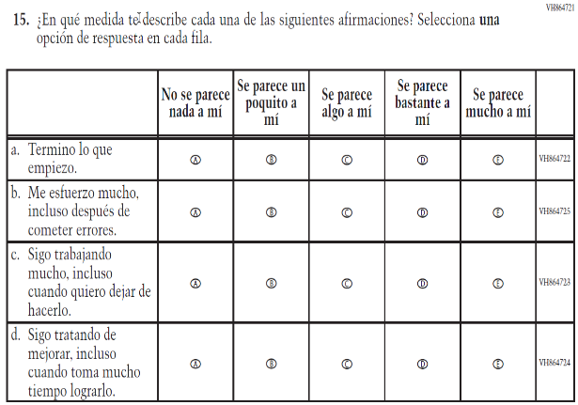  (2019 Operational Grade 8 Student Core - Bilingual) | 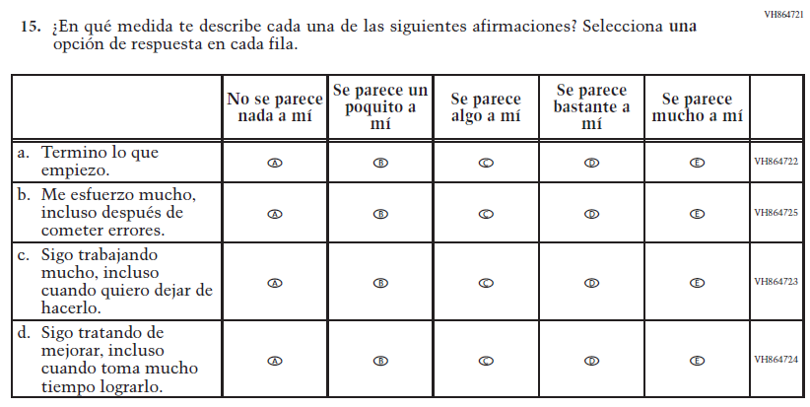  Issue: Grit | NC | N/A

2021 Operational Grade 8 Core Student – Bilingual
Previous item | 2021 item | D/A/R/NC+ | Rationale
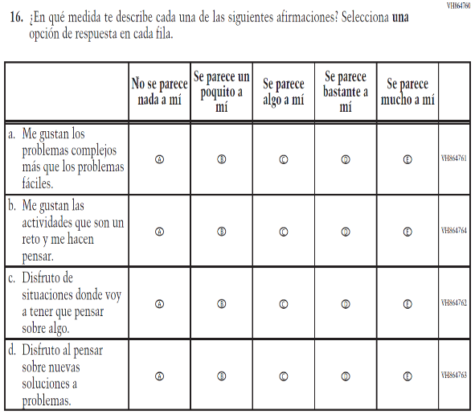  (2019 Operational Grade 8 Student Core - Bilingual) | 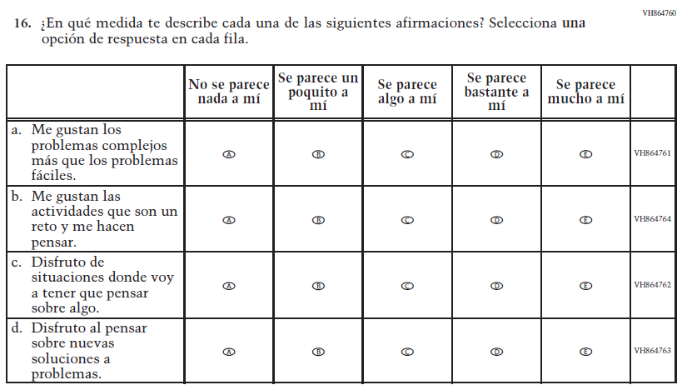  Issue: Desire for Learning | NC | N/A
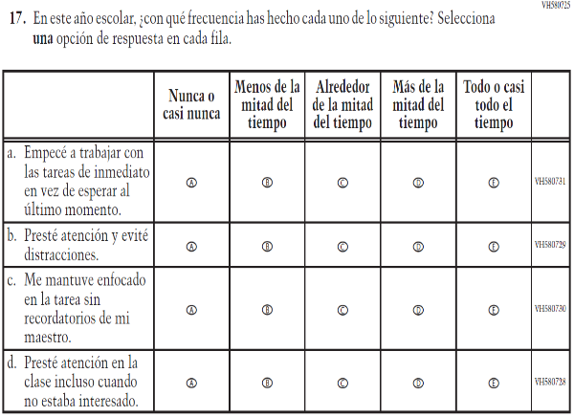  (2019 Operational Grade 8 Student Core - Bilingual) | 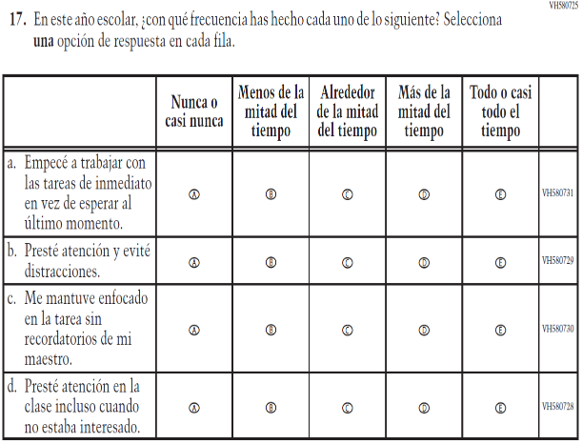  Issue: Grit | NC | N/A

2021 Operational Grade 8 Core Student – Bilingual
Previous item | 2021 item | D/A/R/NC+ | Rationale
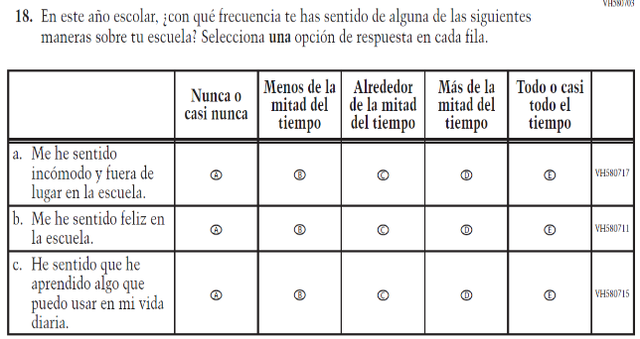  (2019 Operational Grade 8 Student Core - Bilingual) | N/A | D | To keep student burden low, this item was dropped.
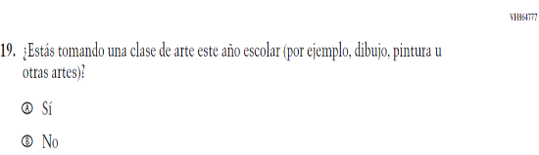  (2019 Operational Grade 8 Student Core - Bilingual) | 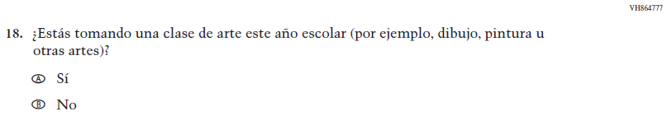  Issue: Educational Experiences | NC | N/A

Appendix J-1c-s-BL: Operational Grade 8 CORE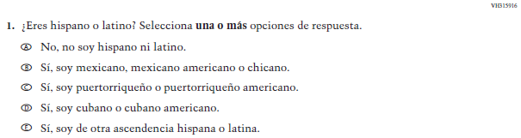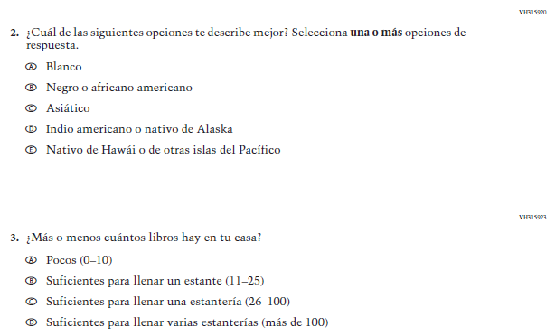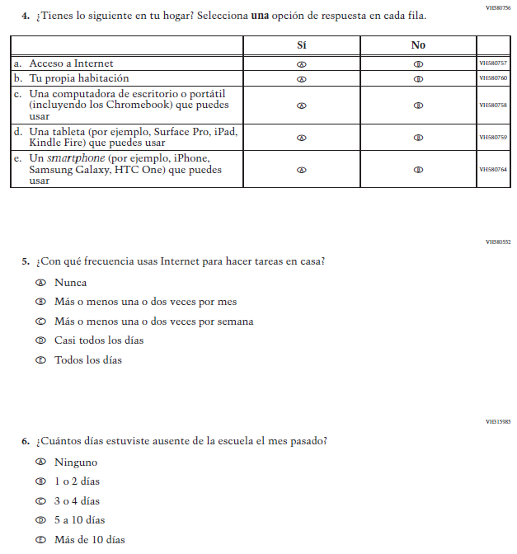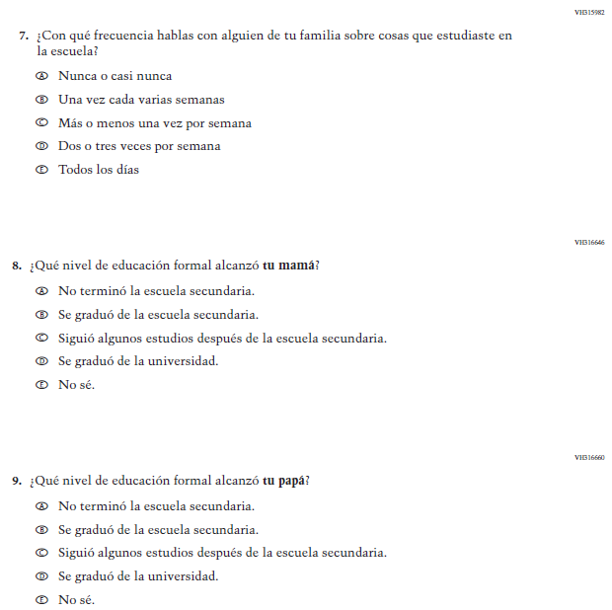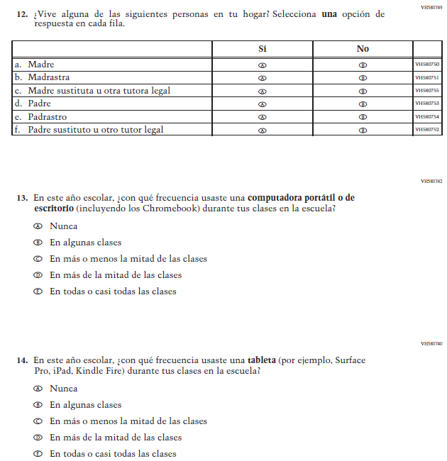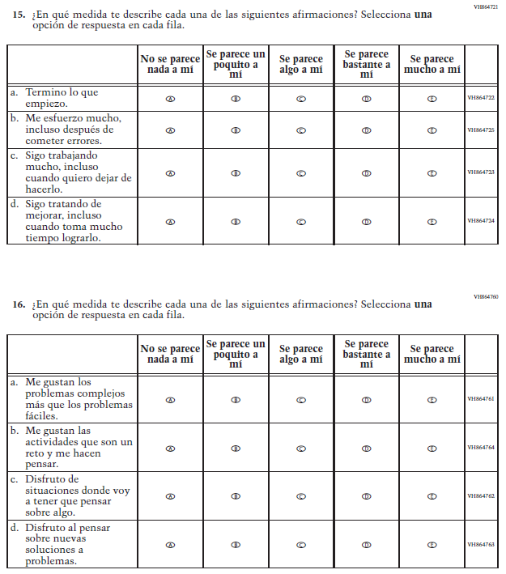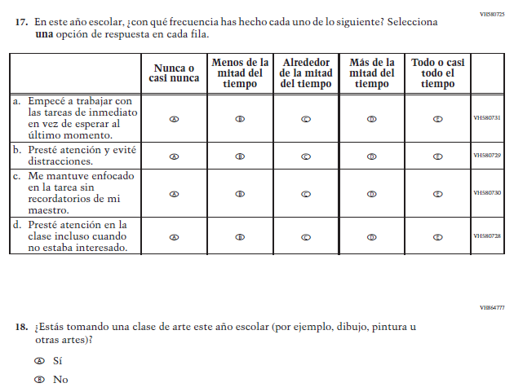

Appendix J-1d-s-PR: Summary of Changes Operational Grade 8 CORE
2021 Operational Grade 8 Core Student – Puerto Rico

Previous item | 2021 item | D/A/ R/NC+ | Rationale
(2019 Operational Grade 8 Student Core – Puerto Rico) | 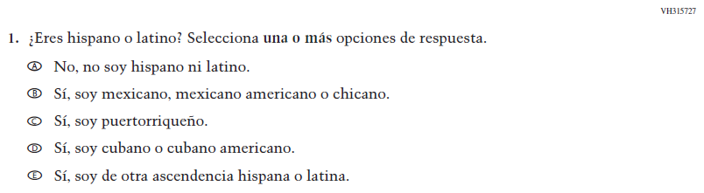  Issue: Race/Ethnicity | NC | N/A
(2019 Operational Grade 8 Student Core – Puerto Rico) | 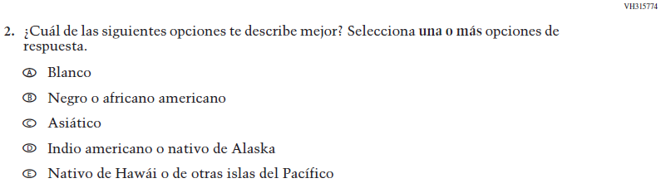  Issue: Race/Ethnicity | NC | N/A
(2019 Operational Grade 8 Student Core – Puerto Rico) | 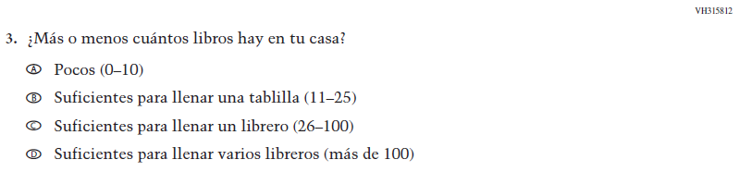  Issue: Socioeconomic Status | NC | N/A
(2019 Operational Grade 8 Student Core – Puerto Rico) | Issue: Socioeconomic Status | NC | N/A
(2019 Operational Grade 8 Student Core – Puerto Rico) | Issue: Technology Use | NC | N/A
(2019 Operational Grade 8 Student Core – Puerto Rico) | Issue: School Climate | NC | N/A
(2019 Operational Grade 8 Student Core – Puerto Rico) | Issue: Socioeconomic Status | NC | N/A
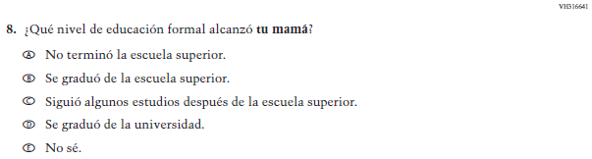  (2019 Operational Grade 8 Student Core – Puerto Rico) | Issue: Socioeconomic Status | NC | N/A
2021 Operational Grade 8 Core Student – Puerto Rico

Previous item | 2021 item | D/A/ R/NC+ | Rationale
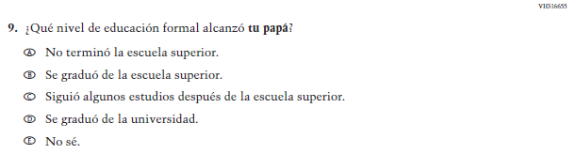  (2019 Operational Grade 8 Student Core – Puerto Rico) | Issue: Socioeconomic Status | NC | N/A
(2019 Operational Grade 8 Student Core – Puerto Rico) | Issue: Socioeconomic Status | NC | N/A
(2019 Operational Grade 8 Student Core – Puerto Rico) | Issue: Socioeconomic Status | NC | N/A
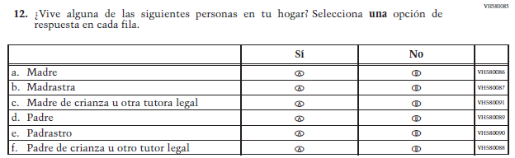  (2019 Operational Grade 8 Student Core – Puerto Rico) | Issue: Socioeconomic Status | NC | N/A

2021 Operational Grade 8 Core Student – Puerto Rico

Previous item | 2021 item | D/A/ R/NC+ | Rationale
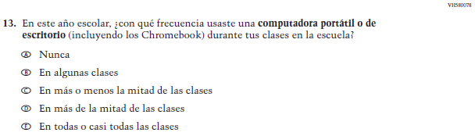  (2019 Operational Grade 8 Student Core – Puerto Rico) | Issue: Technology Use | NC | N/A
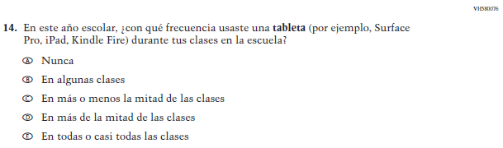  (2019 Operational Grade 8 Student Core – Puerto Rico) | Issue: Technology Use | NC | N/A
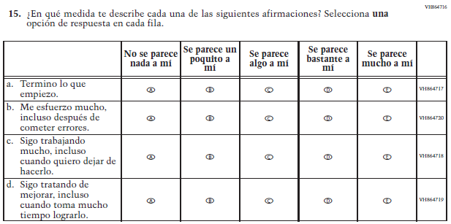  (2019 Operational Grade 8 Student Core – Puerto Rico) | Issue: Grit | NC | N/A

2021 Operational Grade 8 Core Student – Puerto Rico

Previous item | 2021 item | D/A/ R/NC+ | Rationale
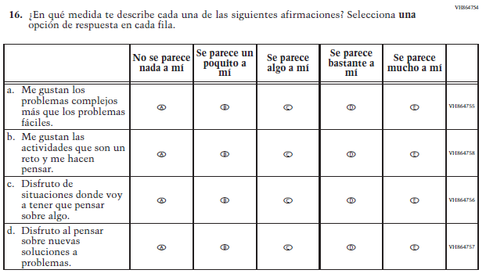  (2019 Operational Grade 8 Student Core – Puerto Rico) | Issue: Desire for Learning | NC | N/A
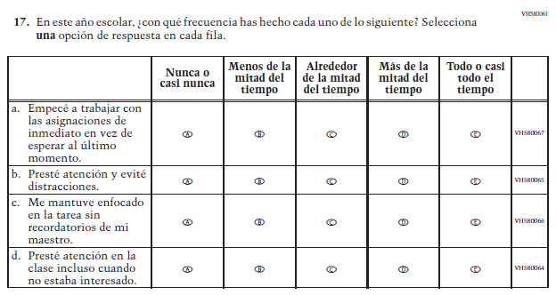  (2019 Operational Grade 8 Student Core – Puerto Rico) | Issue: Grit | NC | N/A

2021 Operational Grade 8 Core Student – Puerto Rico

Previous item | 2021 item | D/A/ R/NC+ | Rationale
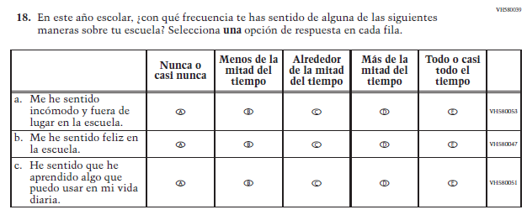  (2019 Operational Grade 8 Student Core – Puerto Rico) | N/A | D | To keep student burden low, this item was dropped.
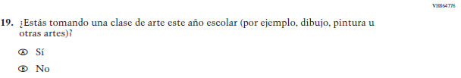  (2019 Operational Grade 8 Student Core – Puerto Rico) | 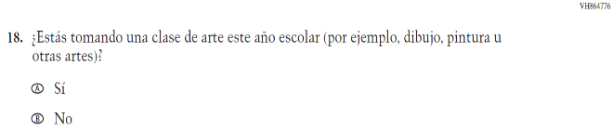  Issue: Educational Experiences | NC | N/A

Appendix J-1d-s-PR: Operational Grade 8 CORE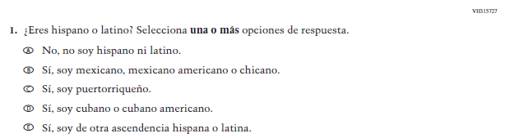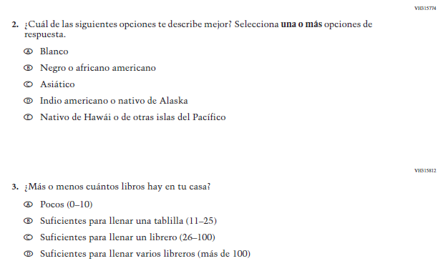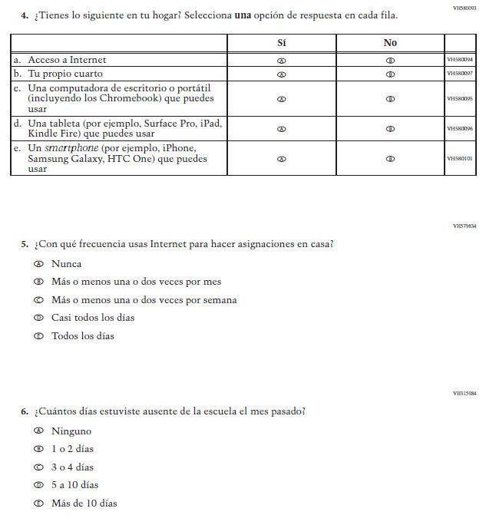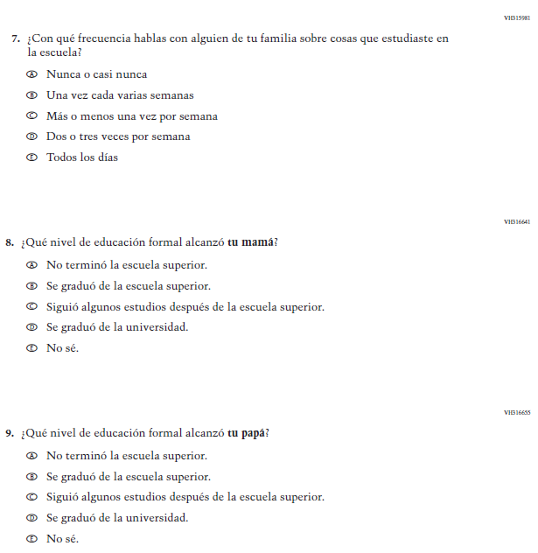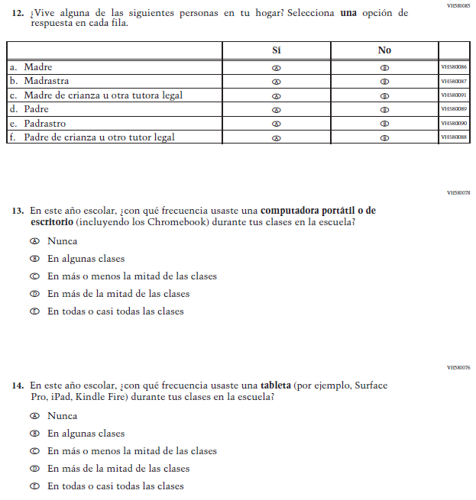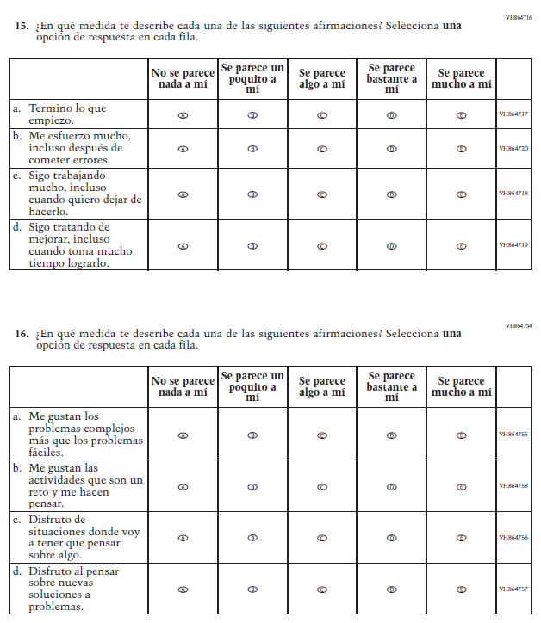

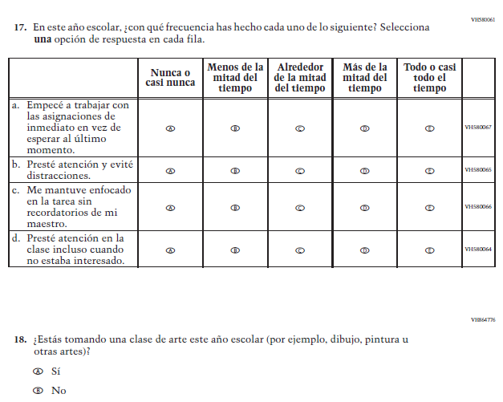

Appendix J-1e-s-BL: Summary of Changes Operational Grade 4 Mathematics
2021 Operational Grade 4 Mathematics Student – Bilingual
Previous item | 2021 item | D/A/R/NC+ | Rationale
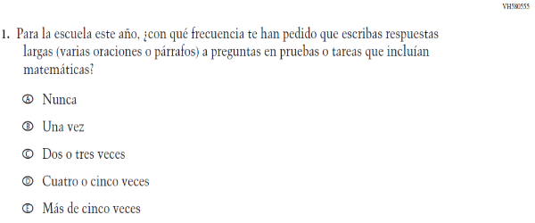  (2019 Operational Grade 4 Student Mathematics - Bilingual) | 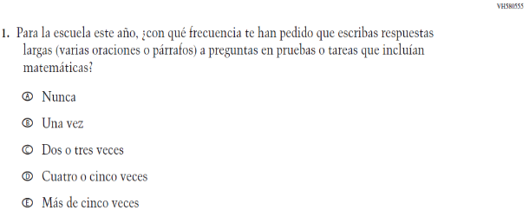  Issue: Organization of Instruction | NC | N/A
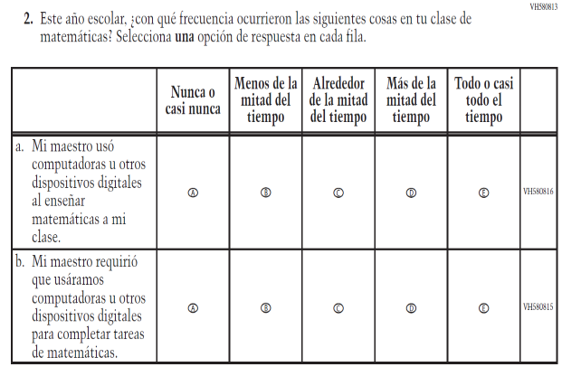  (2019 Operational Grade 4 Student Mathematics - Bilingual) | 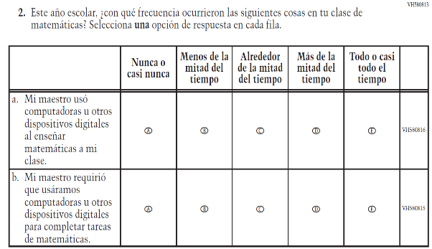  Issue: Resources for Learning and Instruction | NC | N/A

2021 Operational Grade 4 Mathematics Student – Bilingual
Previous item | 2021 item | D/A/R/NC+ | Rationale
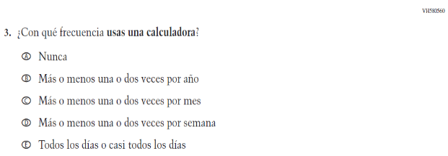  (2019 Operational Grade 4 Student Mathematics - Bilingual) | 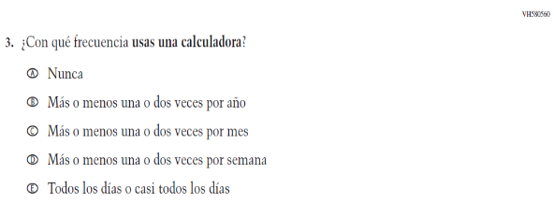  Issue: Resources for Learning and Instruction | NC | N/A
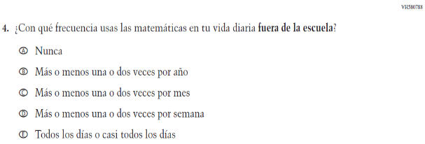  (2019 Operational Grade 4 Student Mathematics - Bilingual) | 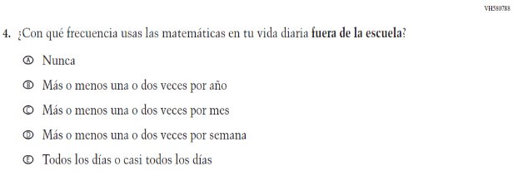  Issue: Resources for Learning and Instruction | NC | N/A
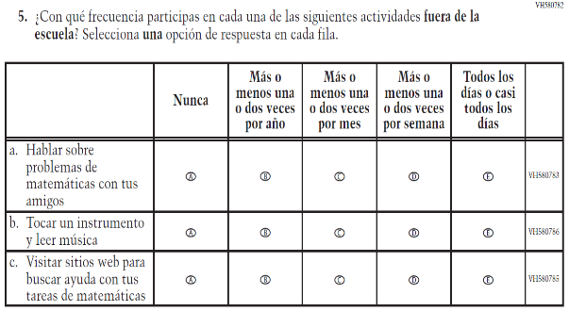  (2019 Operational Grade 4 Student Mathematics - Bilingual) | 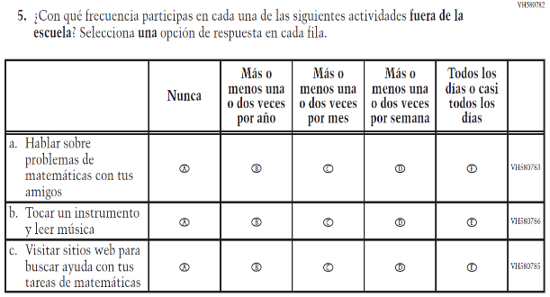  Issue: Resources for Learning and Instruction | NC | N/A

2021 Operational Grade 4 Mathematics Student – Bilingual
Previous item | 2021 item | D/A/R/NC+ | Rationale
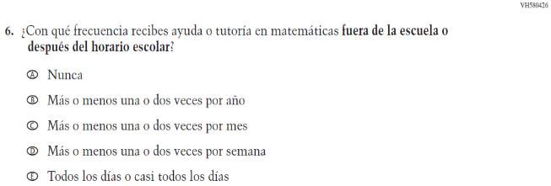  (2019 Operational Grade 4 Student Mathematics - Bilingual) | 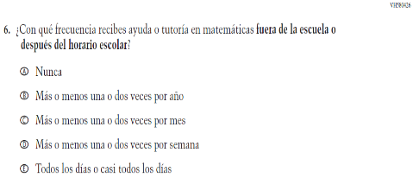  Issue: Resources for Learning and Instruction | NC | N/A
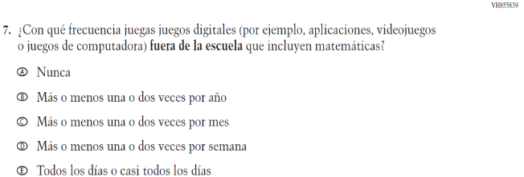  (2019 Operational Grade 4 Student Mathematics - Bilingual) | 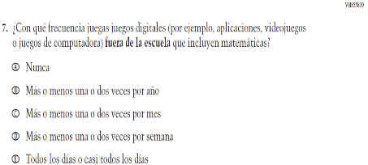  Issue: Resources for Learning and Instruction | NC | N/A
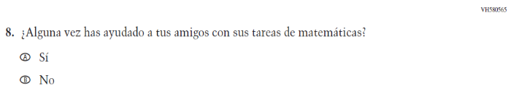  (2019 Operational Grade 4 Student Mathematics - Bilingual) | N/A | D | To keep student burden low, this item was dropped.
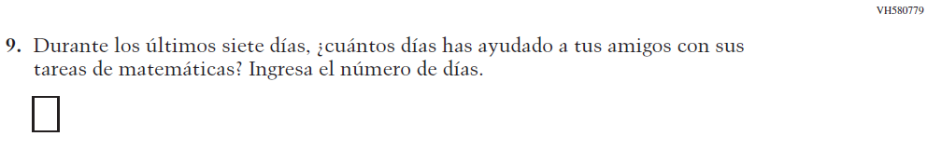  (2019 Operational Grade 4 Student Mathematics - Bilingual) | N/A | D | To keep student burden low, this item was dropped.

2021 Operational Grade 4 Mathematics Student – Bilingual
Previous item | 2021 item | D/A/R/NC+ | Rationale
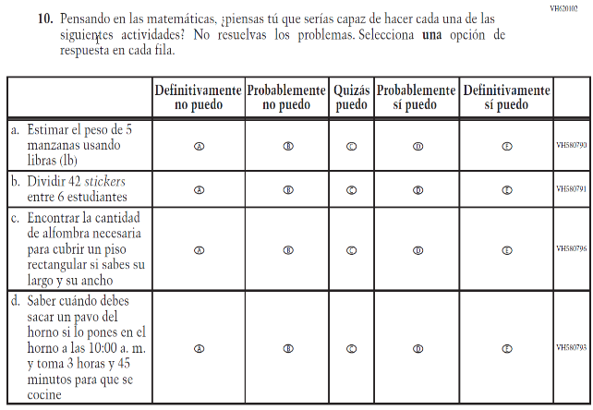  (2019 Operational Grade 4 Student Mathematics - Bilingual) | 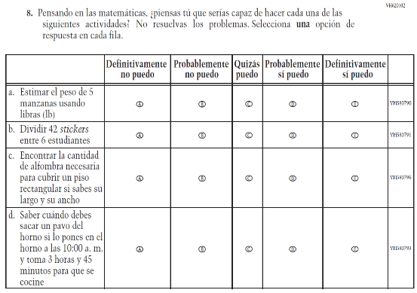  Issue: Student Factors | NC | N/A
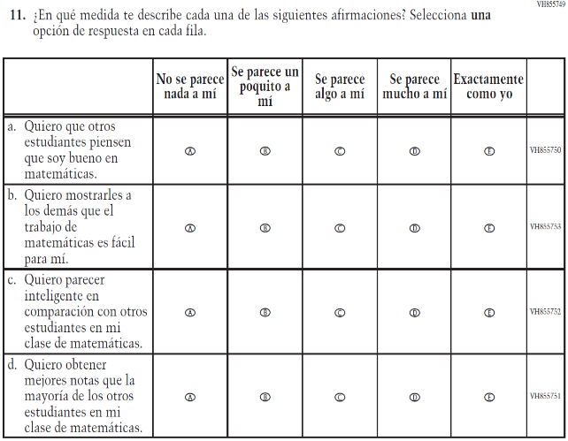  (2019 Operational Grade 4 Student Mathematics - Bilingual) | N/A | D | To keep student burden low, this item was dropped.

2021 Operational Grade 4 Mathematics Student – Bilingual
Previous item | 2021 item | D/A/R/NC+ | Rationale
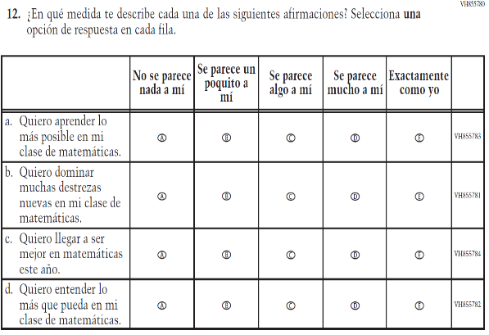  (2019 Operational Grade 4 Student Mathematics - Bilingual) | 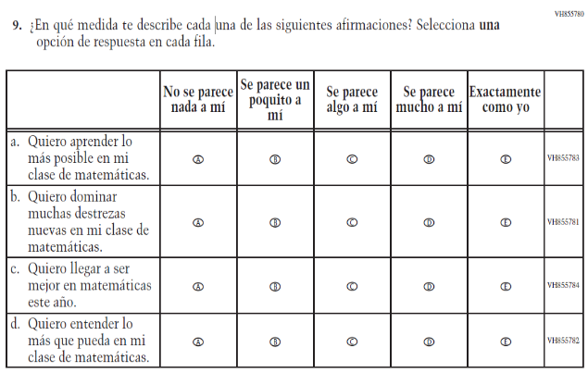  Issue: Student Factors | NC | N/A
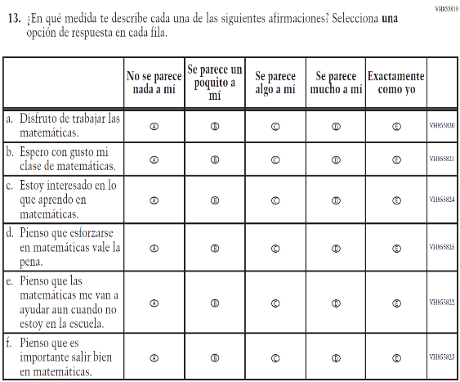  (2019 Operational Grade 4 Student Mathematics - Bilingual) | 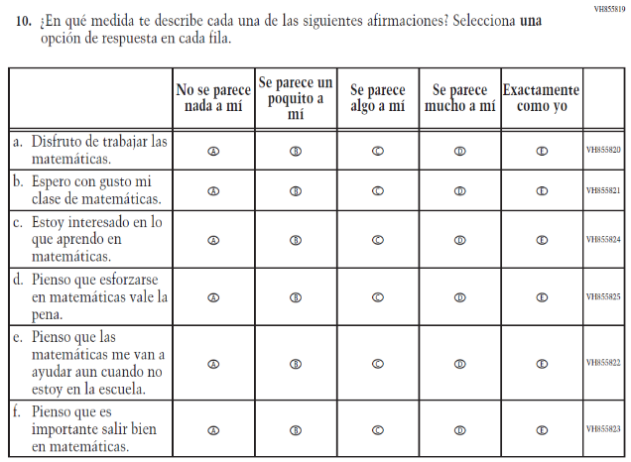  Issue: Student Factors | NC | N/A

Appendix J-1e-s-BL: Operational Grade 4 Mathematics
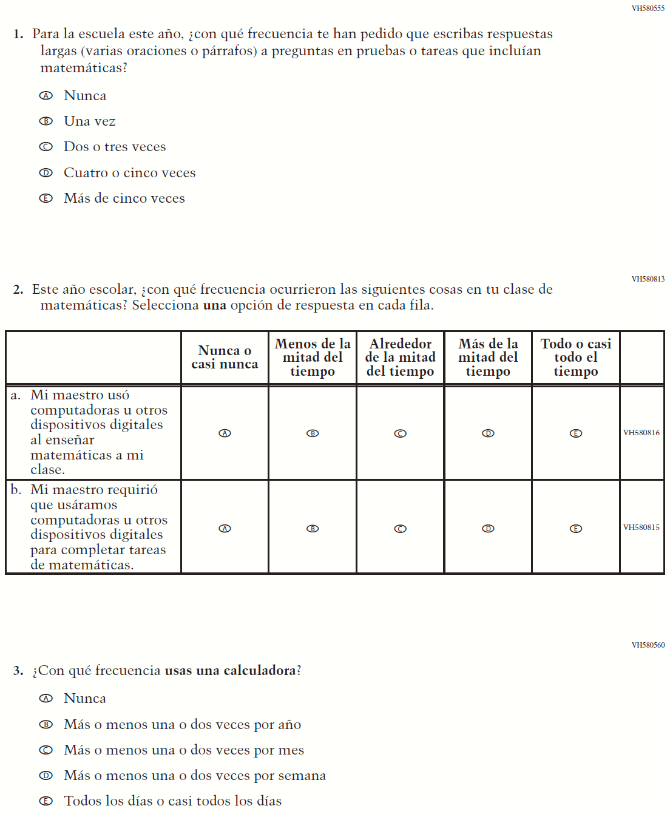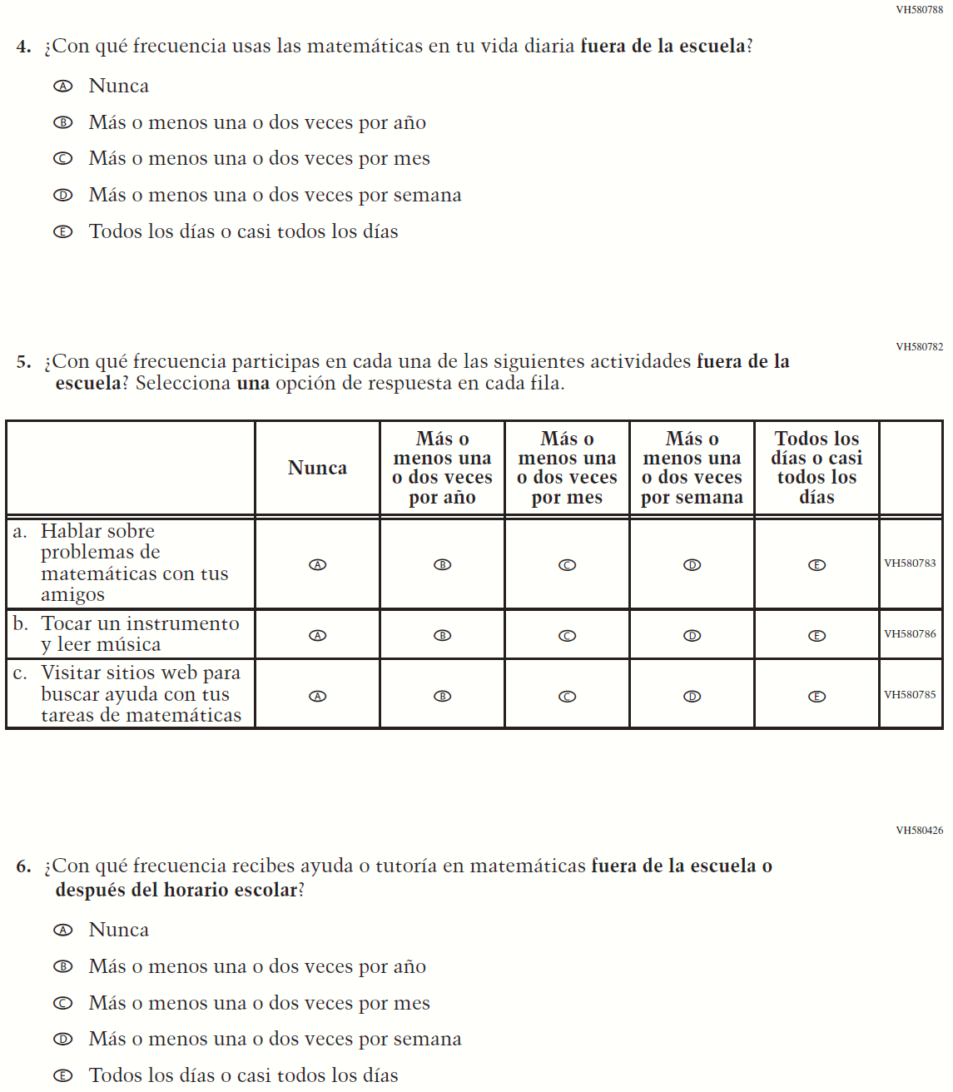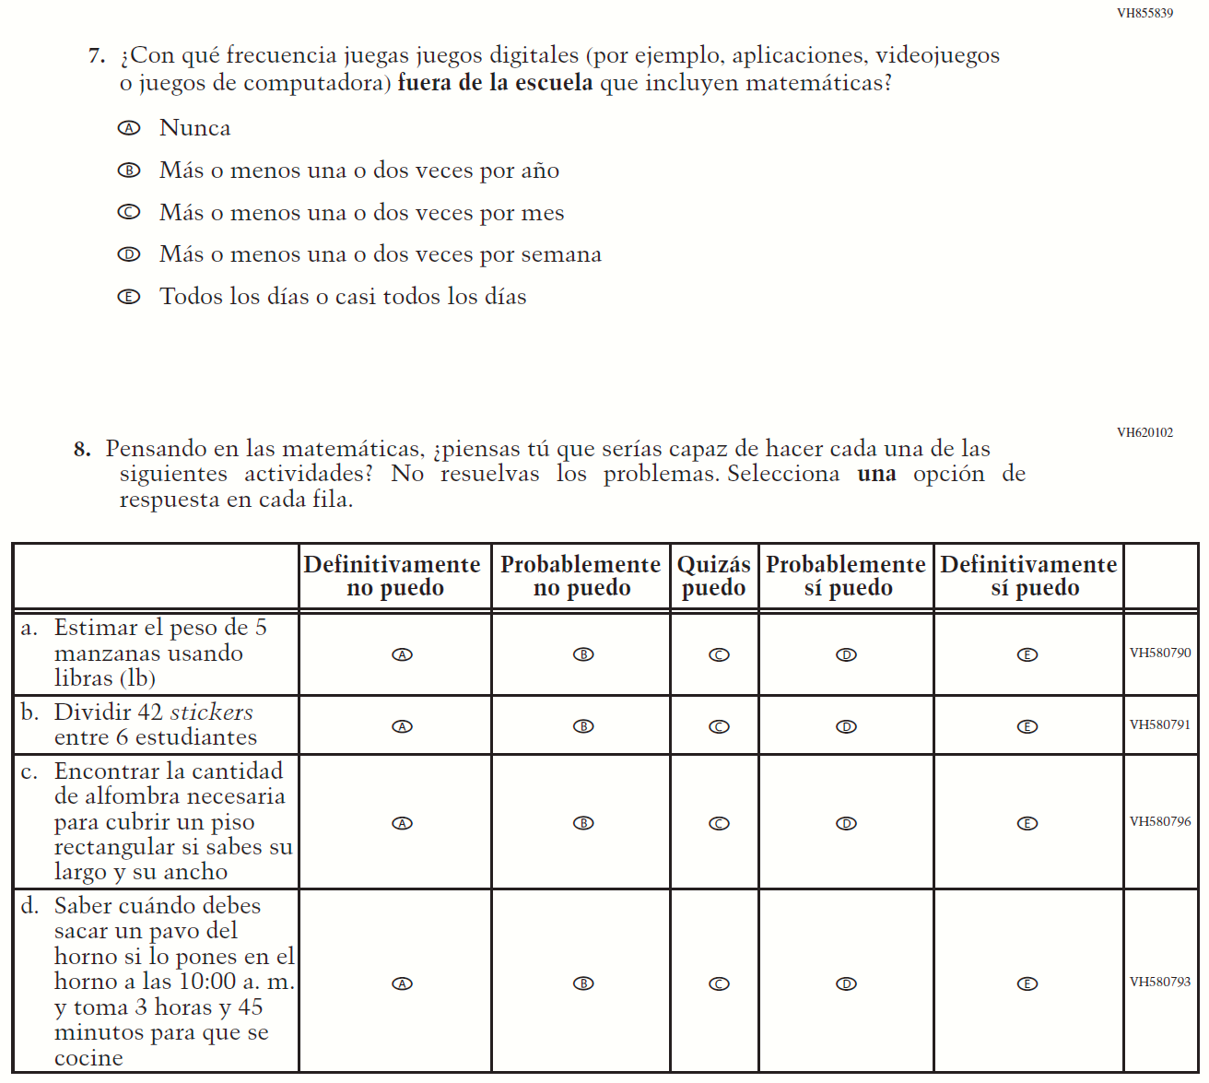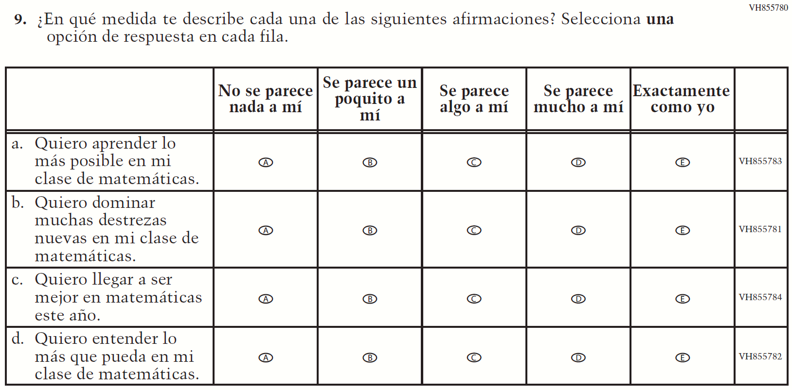

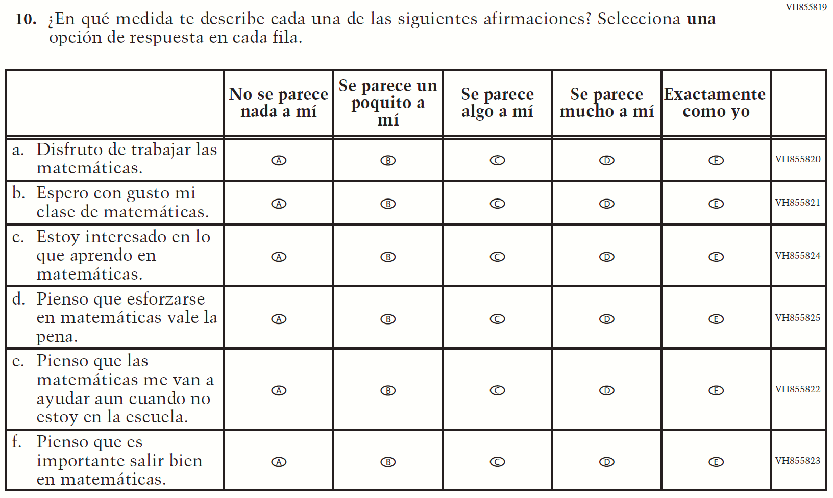

Appendix J-1f-s-PR: Summary of Changes Operational Grade 4 Mathematics
2021 Operational Grade 4 Mathematics Student – Puerto Rico

Previous item | 2021 item | D/A/ R/NC+ | Rationale
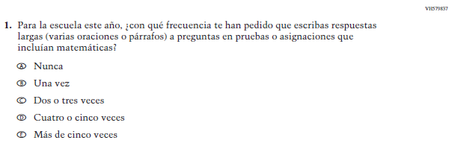  (2019 Operational Grade 4 Student Mathematics – Puerto Rico) | Issue: Organization of Instruction | NC | N/A
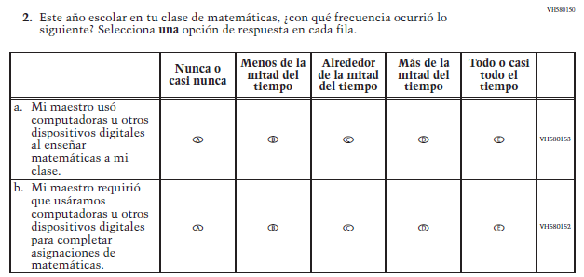  (2019 Operational Grade 4 Student Mathematics – Puerto Rico) | Issue: Resources for Learning and Instruction | NC | N/A
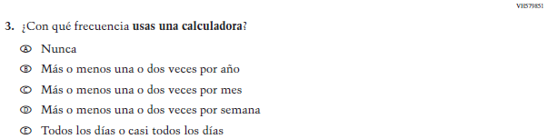  (2019 Operational Grade 4 Student Mathematics – Puerto Rico) | Issue: Resources for Learning and Instruction | NC | N/A
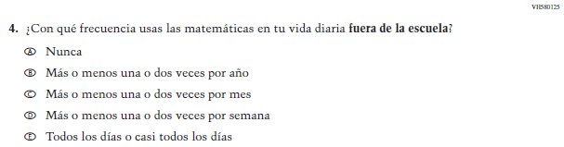  (2019 Operational Grade 4 Student Mathematics – Puerto Rico) | Issue: Resources for Learning and Instruction | NC | N/A
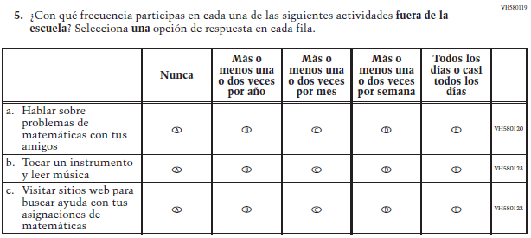  (2019 Operational Grade 4 Student Mathematics – Puerto Rico) | Issue: Resources for Learning and Instruction | NC | N/A
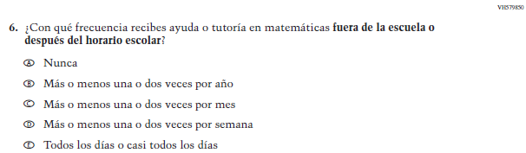  (2019 Operational Grade 4 Student Mathematics – Puerto Rico) | Issue: Resources for Learning and Instruction | NC | N/A

2021 Operational Grade 4 Mathematics Student – Puerto Rico

Previous item | 2021 item | D/A/ R/NC+ | Rationale
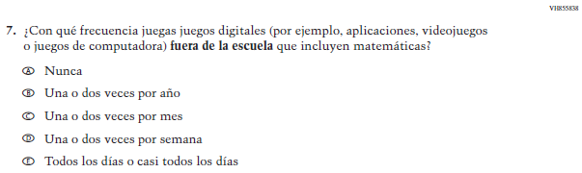  (2019 Operational Grade 4 Student Mathematics – Puerto Rico) | Issue: Resources for Learning and Instruction | NC | N/A
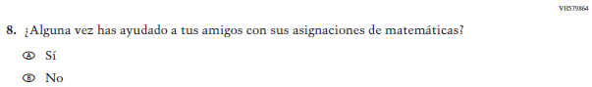  (2019 Operational Grade 4 Student Mathematics – Puerto Rico) | N/A | D | To keep student burden low, this item was dropped.
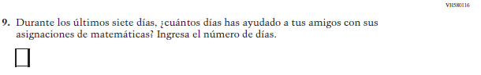  (2019 Operational Grade 4 Student Mathematics – Puerto Rico) | N/A | D | To keep student burden low, this item was dropped.
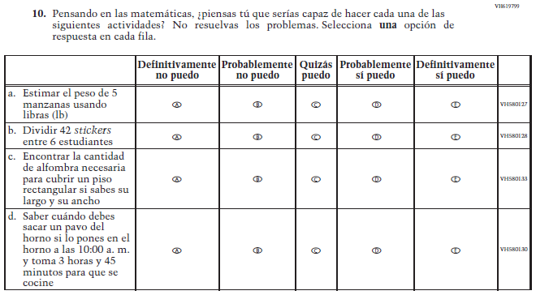  (2019 Operational Grade 4 Student Mathematics – Puerto Rico) | 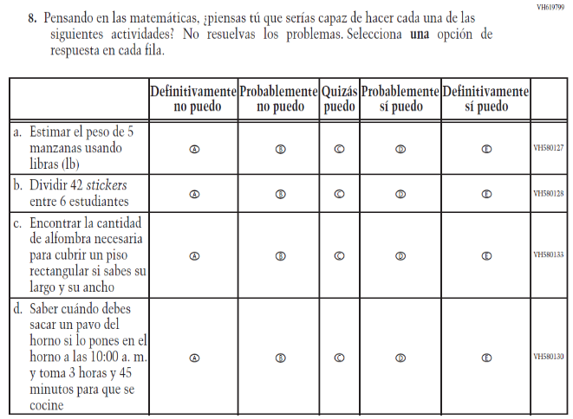  Issue: Student Factors | NC | N/A

2021 Operational Grade 4 Mathematics Student – Puerto Rico

Previous item | 2021 item | D/A/ R/NC+ | Rationale
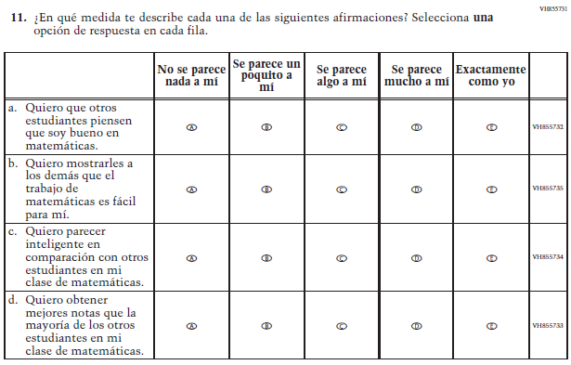  (2019 Operational Grade 4 Student Mathematics – Puerto Rico) | N/A | D | To keep student burden low, this item was dropped.
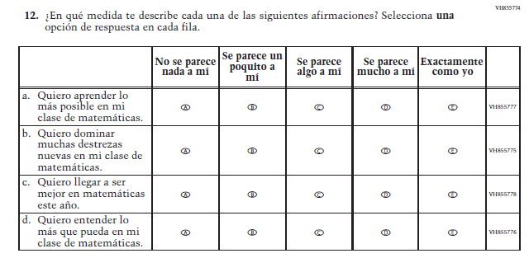  (2019 Operational Grade 4 Student Mathematics – Puerto Rico) | 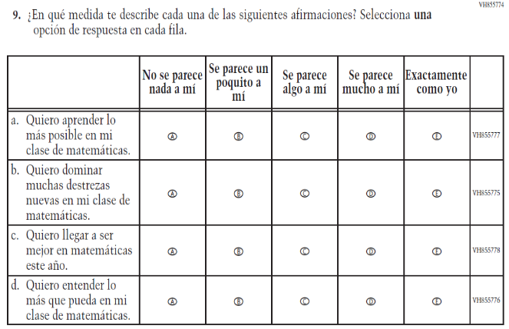  Issue: Student Factors | NC | N/A

2021 Operational Grade 4 Mathematics Student – Puerto Rico

Previous item | 2021 item | D/A/ R/NC+ | Rationale
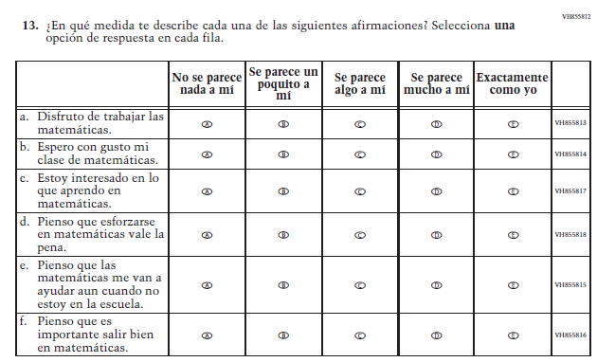  (2019 Operational Grade 4 Student Mathematics – Puerto Rico) | 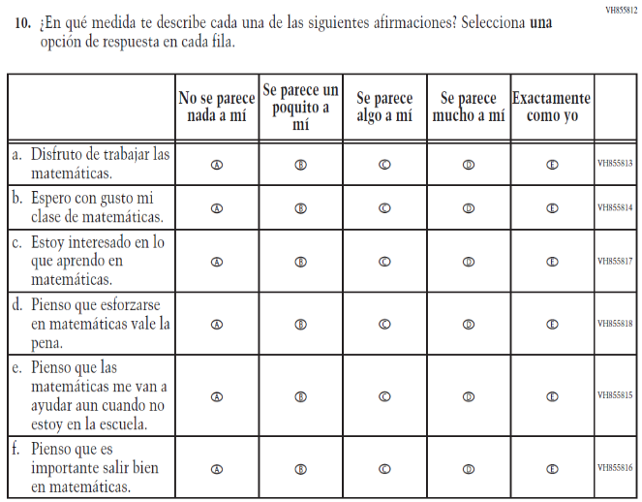  Issue: Student Factors | NC | N/A

Appendix J-1f-s-PR: Operational Grade 4 Mathematics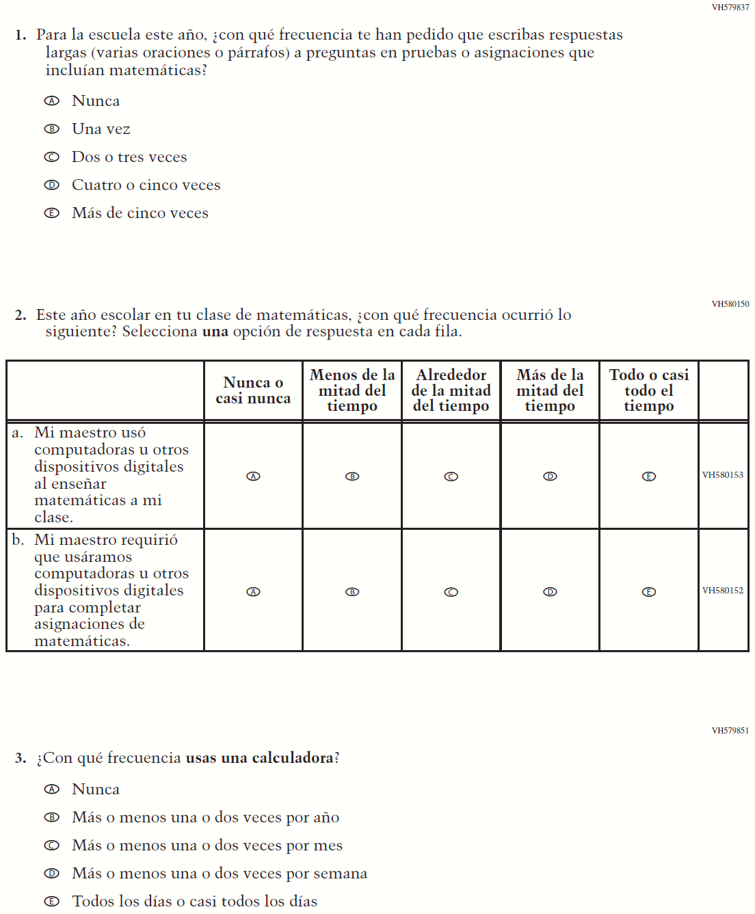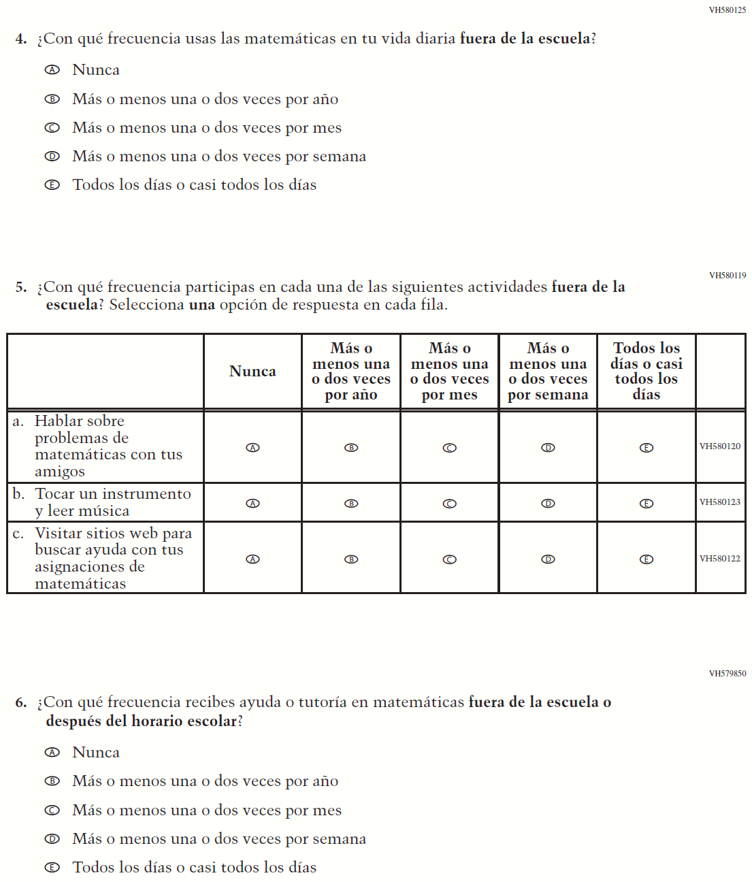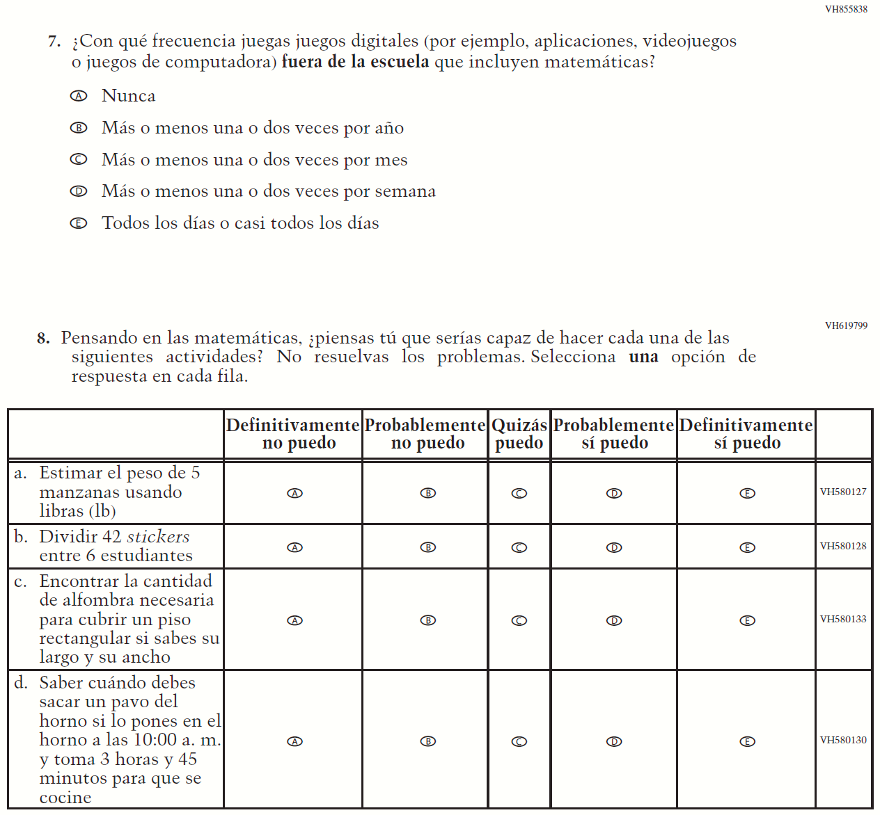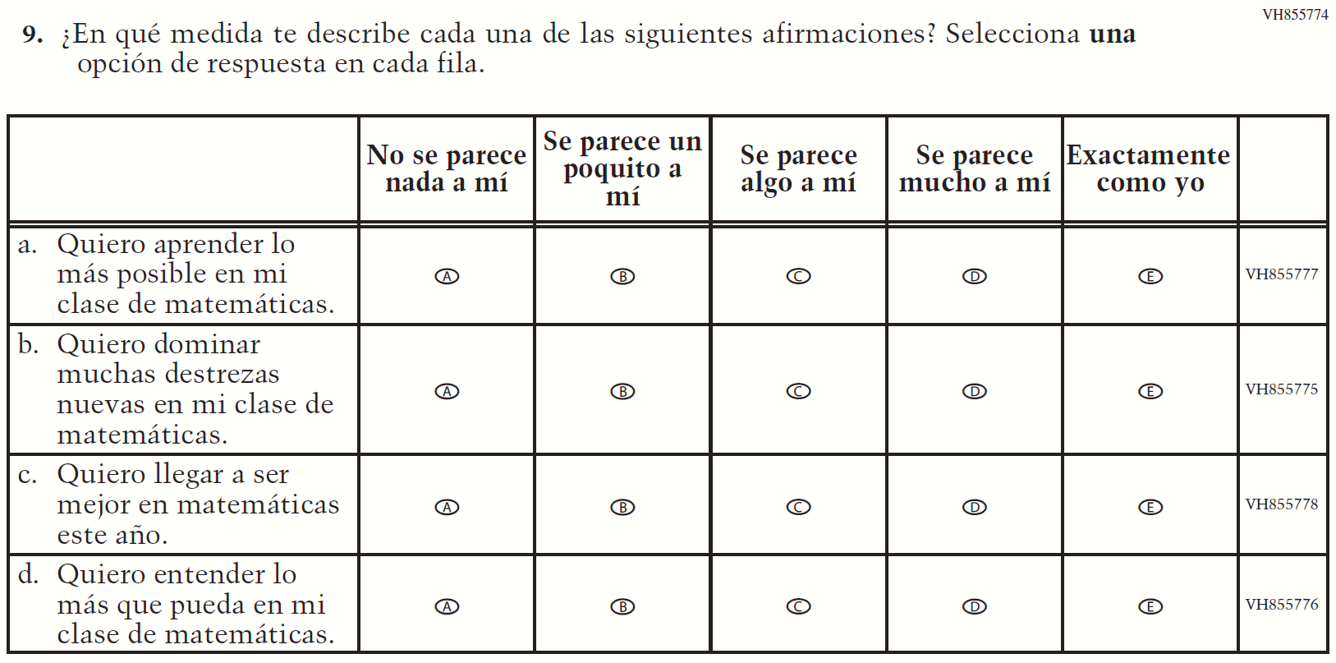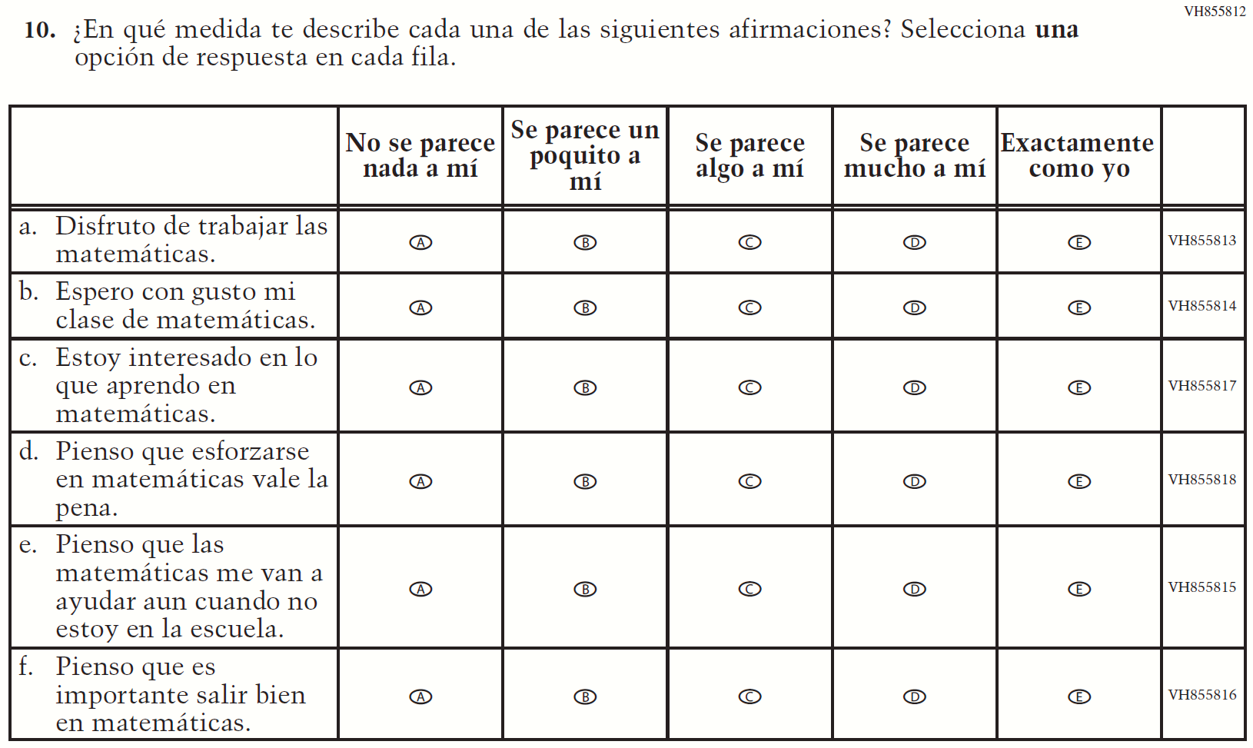

Appendix J-1g-s-BL: Summary of Changes Operational Grade 8 Mathematics
2021 Operational Grade 8 Mathematics Student – Bilingual
Previous item | 2021 item | D/A/R/NC+ | Rationale
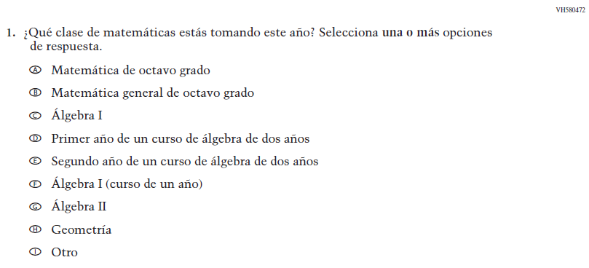  (2019 Operational Grade 8 Student Mathematics - Bilingual) | Issue: Organization of Instruction | NC | N/A
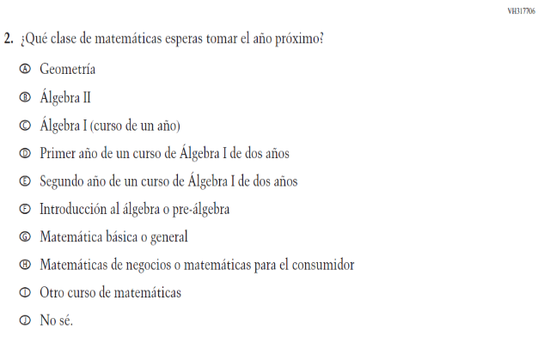  (2019 Operational Grade 8 Student Mathematics - Bilingual) | 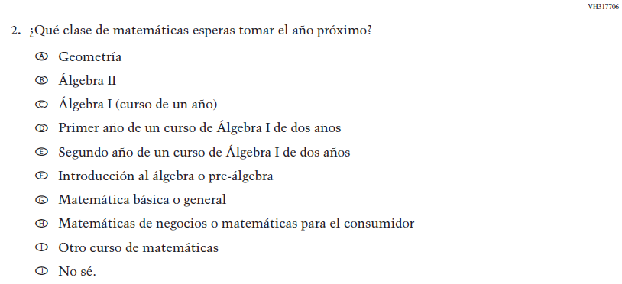  Issue: Organization of Instruction | NC | N/A

2021 Operational Grade 8 Mathematics Student – Bilingual
Previous item | 2021 item | D/A/R/NC+ | Rationale
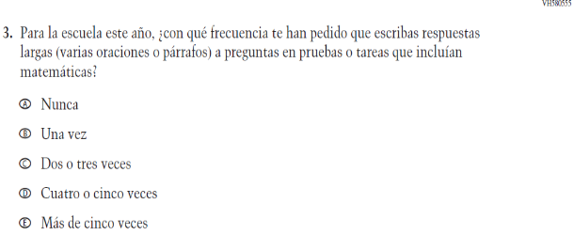  (2019 Operational Grade 8 Student Mathematics - Bilingual) | 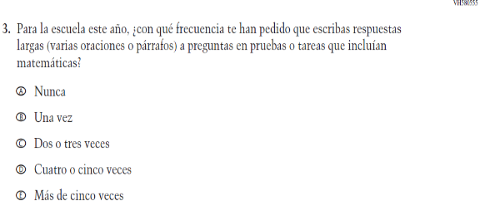  Issue: Organization of Instruction | NC | N/A
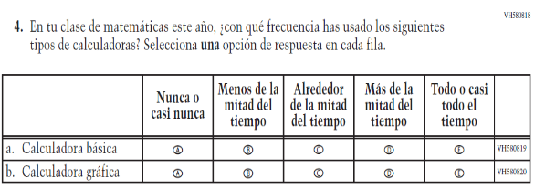  (2019 Operational Grade 8 Student Mathematics - Bilingual) | 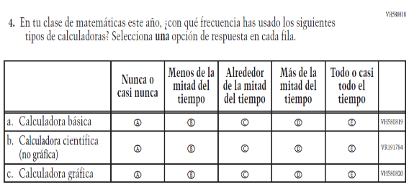  Issue: Resources for Learning and Instruction | A: sub-item “b”  NC for SL and sub-items “a” and “c” | The “Scientific (not graphing) calculator” sub-item was dropped previously due to an oversight and is being reinstated to capture calculator features in mathematics as students progress from K to 12.

2021 Operational Grade 8 Mathematics Student – Bilingual
Previous item | 2021 item | D/A/R/NC+ | Rationale
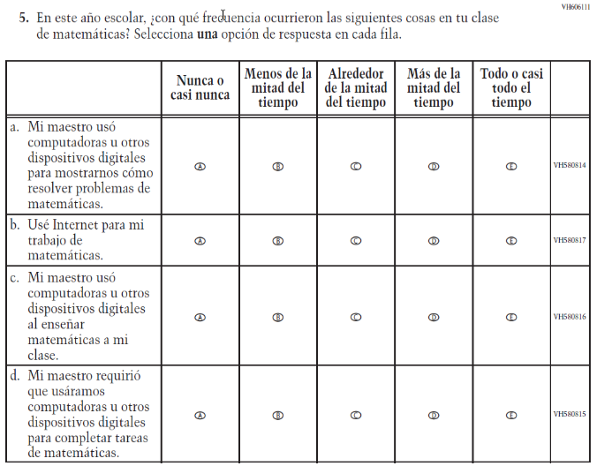  (2019 Operational Grade 8 Student Mathematics - Bilingual) | 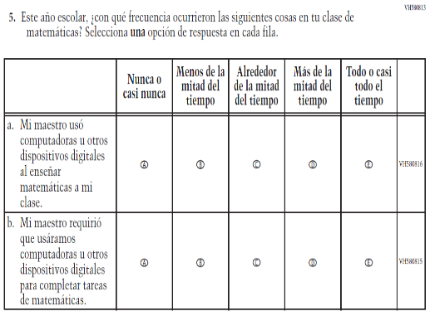  Issue: Resources for Learning and Instruction | R | To keep student burden low, sub-items a and b were dropped.
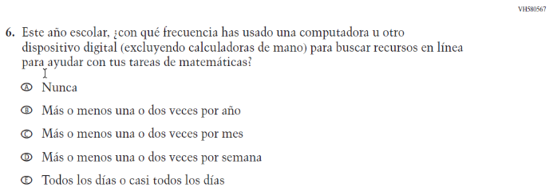  (2019 Operational Grade 8 Student Mathematics - Bilingual) | N/A | D | To keep student burden low, this item was dropped.

2021 Operational Grade 8 Mathematics Student – Bilingual
Previous item | 2021 item | D/A/R/NC+ | Rationale
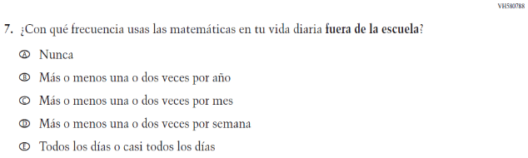  (2019 Operational Grade 8 Student Mathematics - Bilingual) | 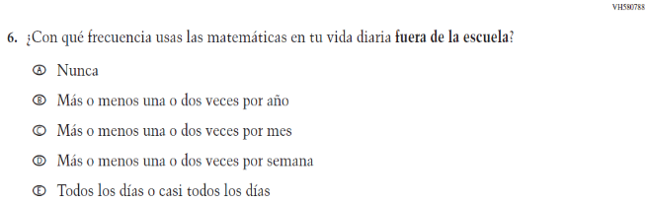  Issue: Resources for Learning and Instruction | NC | N/A
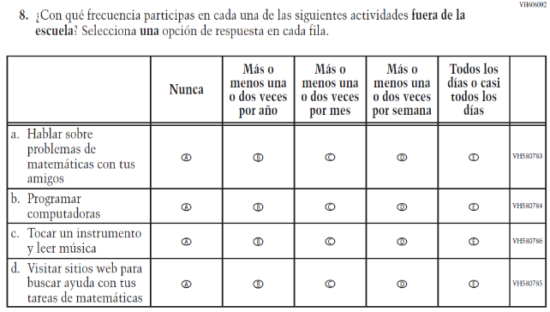  (2019 Operational Grade 8 Student Mathematics - Bilingual) | 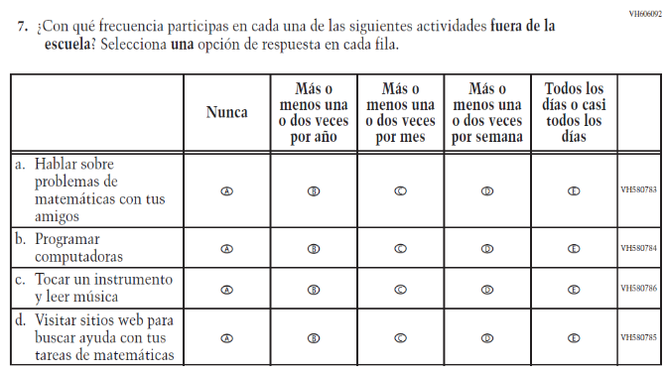  Issue: Resources for Learning and Instruction | NC | N/A

2021 Operational Grade 8 Mathematics Student – Bilingual
Previous item | 2021 item | D/A/R/NC+ | Rationale
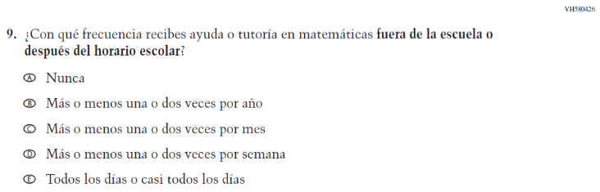  (2019 Operational Grade 8 Student Mathematics - Bilingual) | 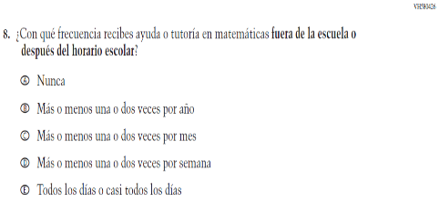  Issue: Resources for Learning and Instruction | NC | N/A
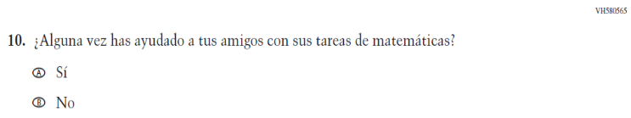  (2019 Operational Grade 8 Student Mathematics - Bilingual) | N/A | D | To keep student burden low, this item was dropped.
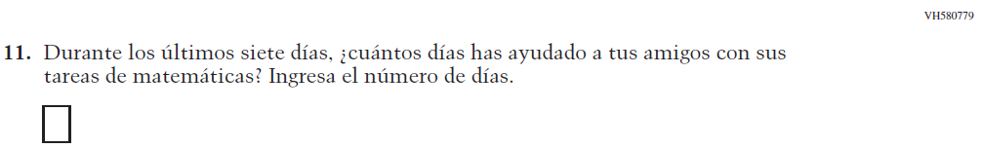  (2019 Operational Grade 8 Student Mathematics - Bilingual) | N/A | D | To keep student burden low, this item was dropped.
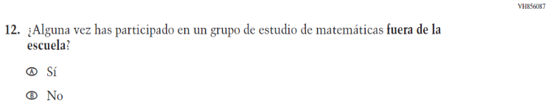  (2019 Operational Grade 8 Student Mathematics - Bilingual) | N/A | D | To keep student burden low, this item was dropped.

2021 Operational Grade 8 Mathematics Student – Bilingual
Previous item | 2021 item | D/A/R/NC+ | Rationale
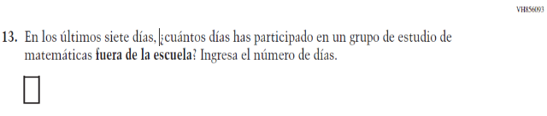  (2019 Operational Grade 8 Student Mathematics - Bilingual) | N/A | D | To keep student burden low, this item was dropped.
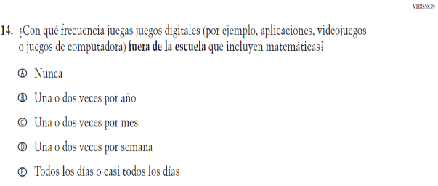  (2019 Operational Grade 8 Student Mathematics - Bilingual) | 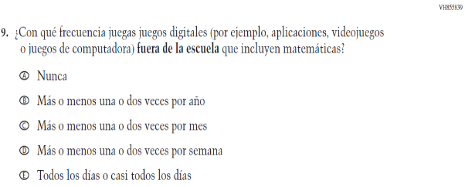  Issue: Resources for Learning and Instruction | NC | N/A

2021 Operational Grade 8 Mathematics Student – Bilingual
Previous item | 2021 item | D/A/R/NC+ | Rationale
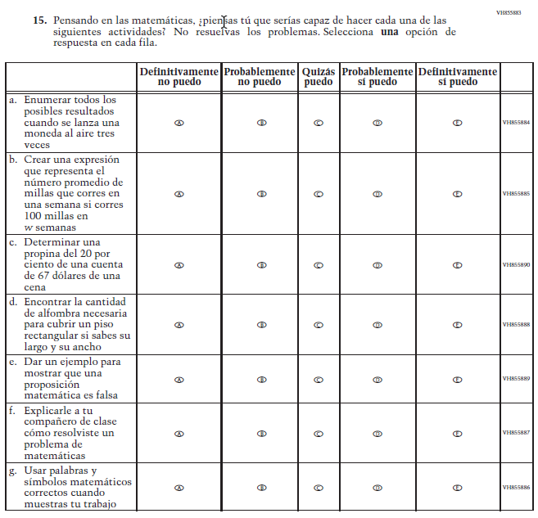  (2019 Operational Grade 8 Student Mathematics - Bilingual) | 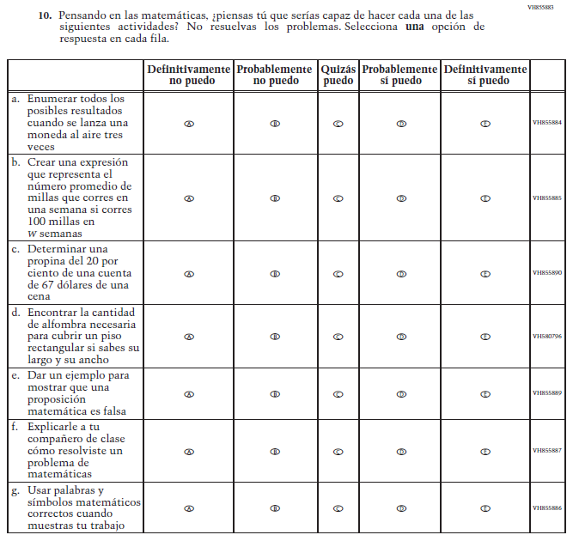  Issue: Student factors | NC | N/A

2021 Operational Grade 8 Mathematics Student – Bilingual
Previous item | 2021 item | D/A/R/NC+ | Rationale
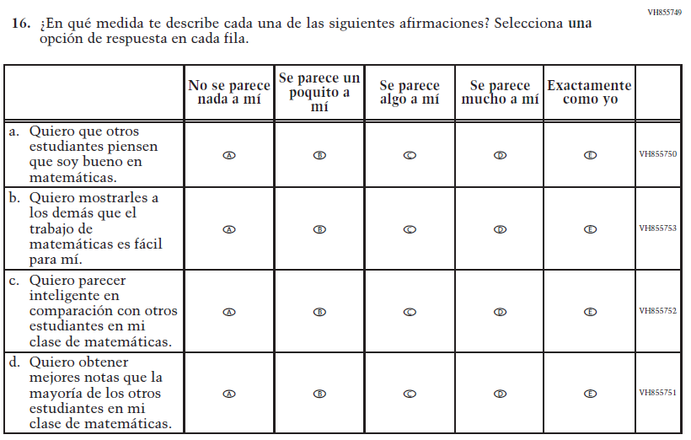  (2019 Operational Grade 8 Student Mathematics - Bilingual) | N/A | D | To keep student burden low, this item was dropped.
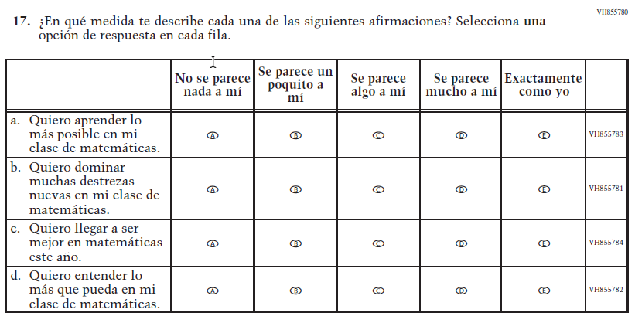  (2019 Operational Grade 8 Student Mathematics - Bilingual) | 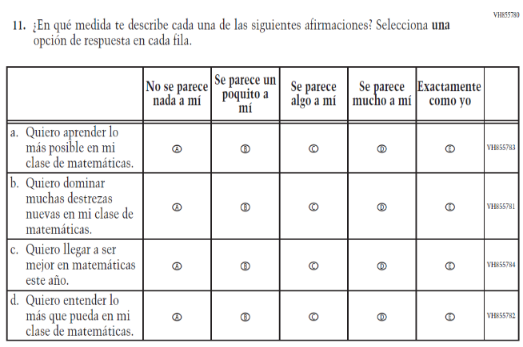  Issue: Student Factors | NC | N/A

2021 Operational Grade 8 Mathematics Student – Bilingual
Previous item | 2021 item | D/A/R/NC+ | Rationale
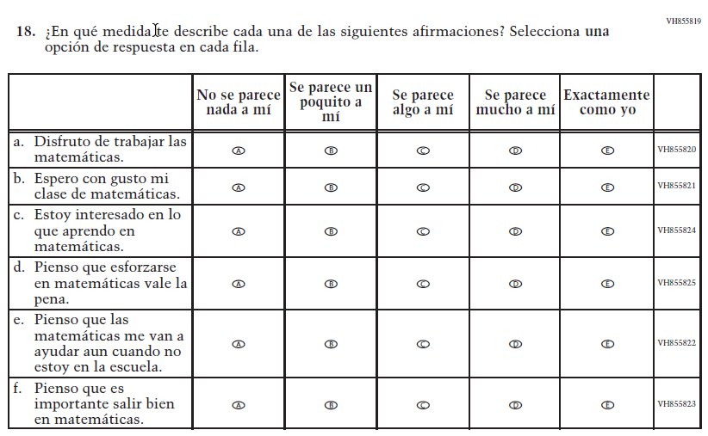  (2019 Operational Grade 8 Student Mathematics - Bilingual) | 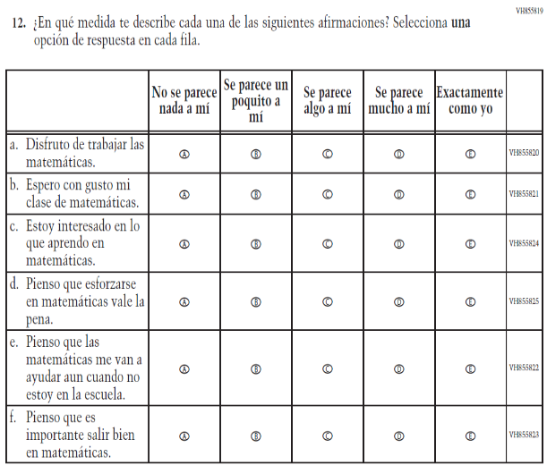  Issue: Student Factors | NC | N/A
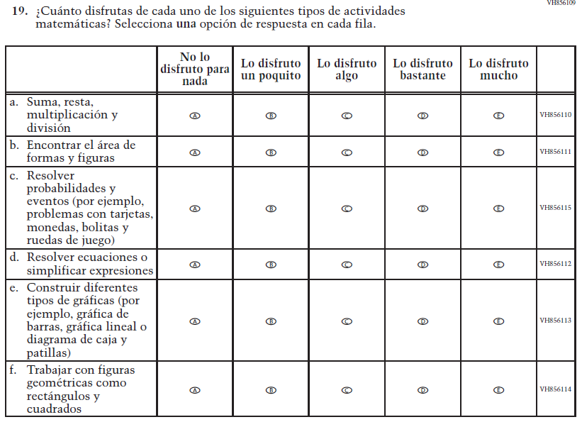  (2019 Operational Grade 8 Student Mathematics - Bilingual) | 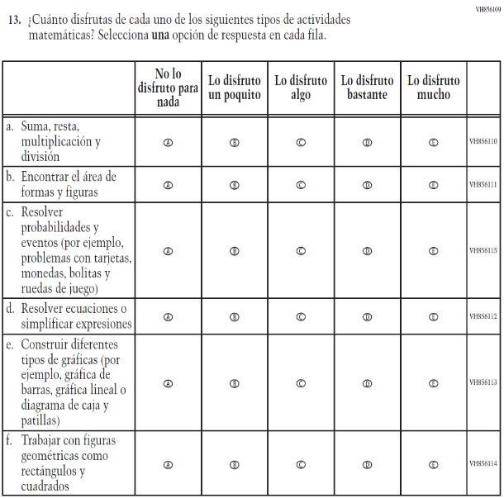  Issue: Student Factors | NC | N/A

Appendix J-1g-s-BL: Operational Grade 8 Mathematics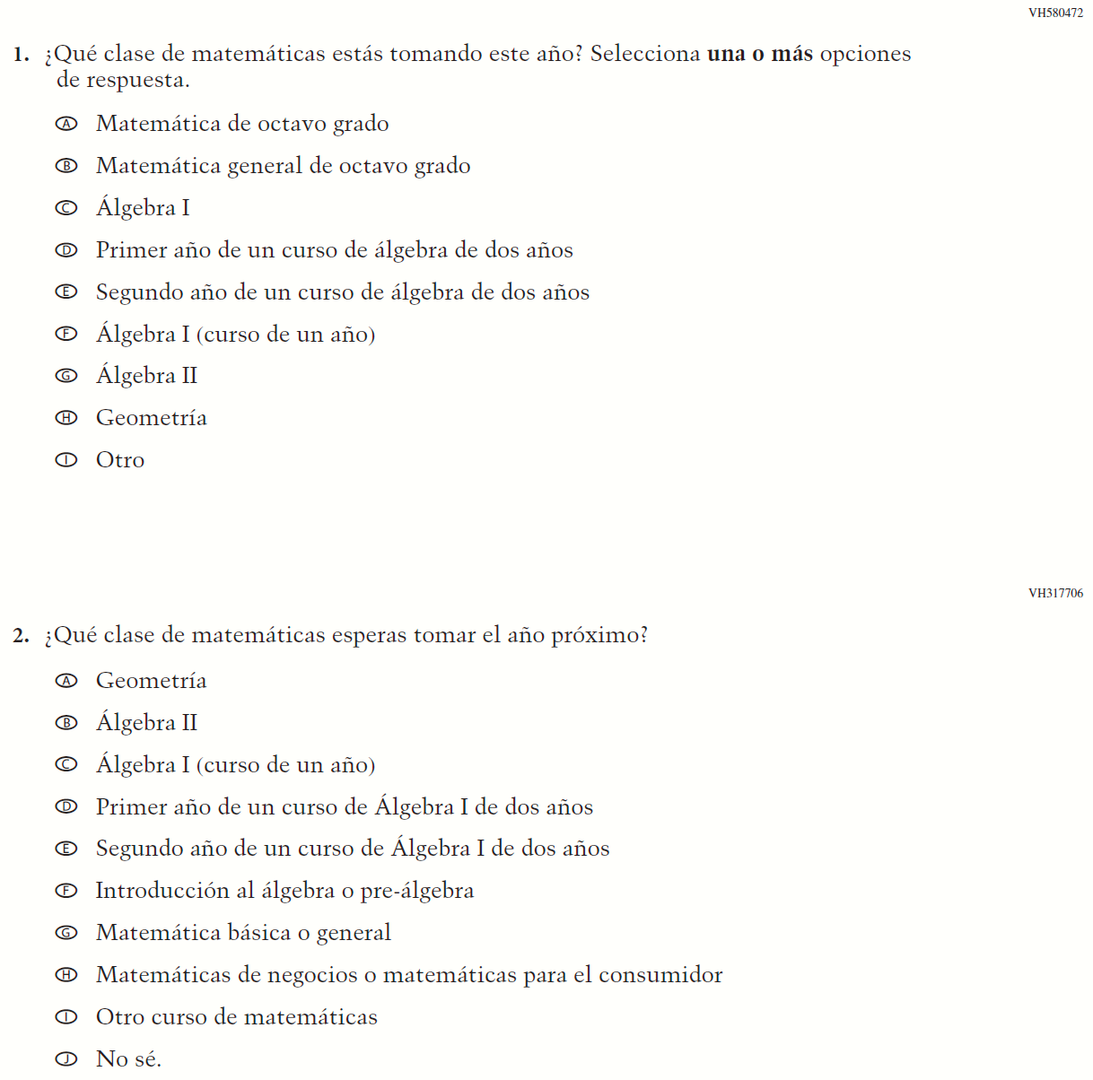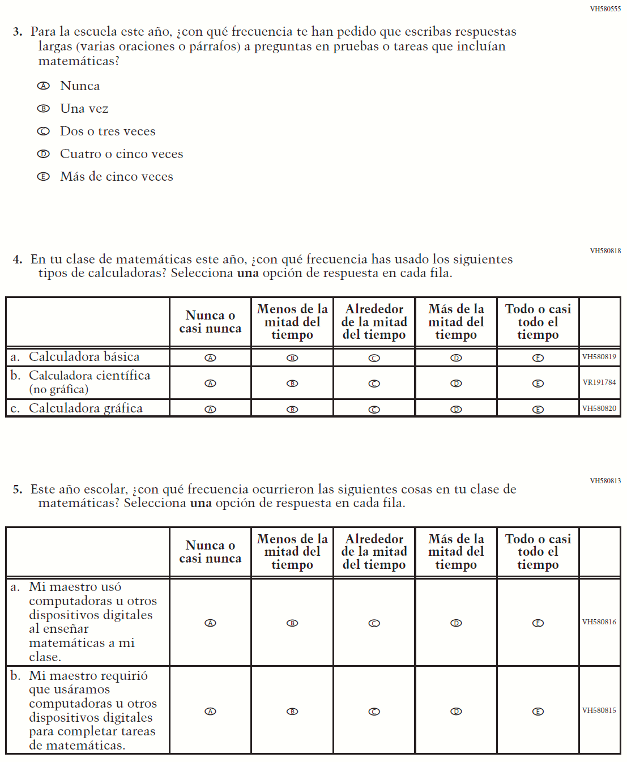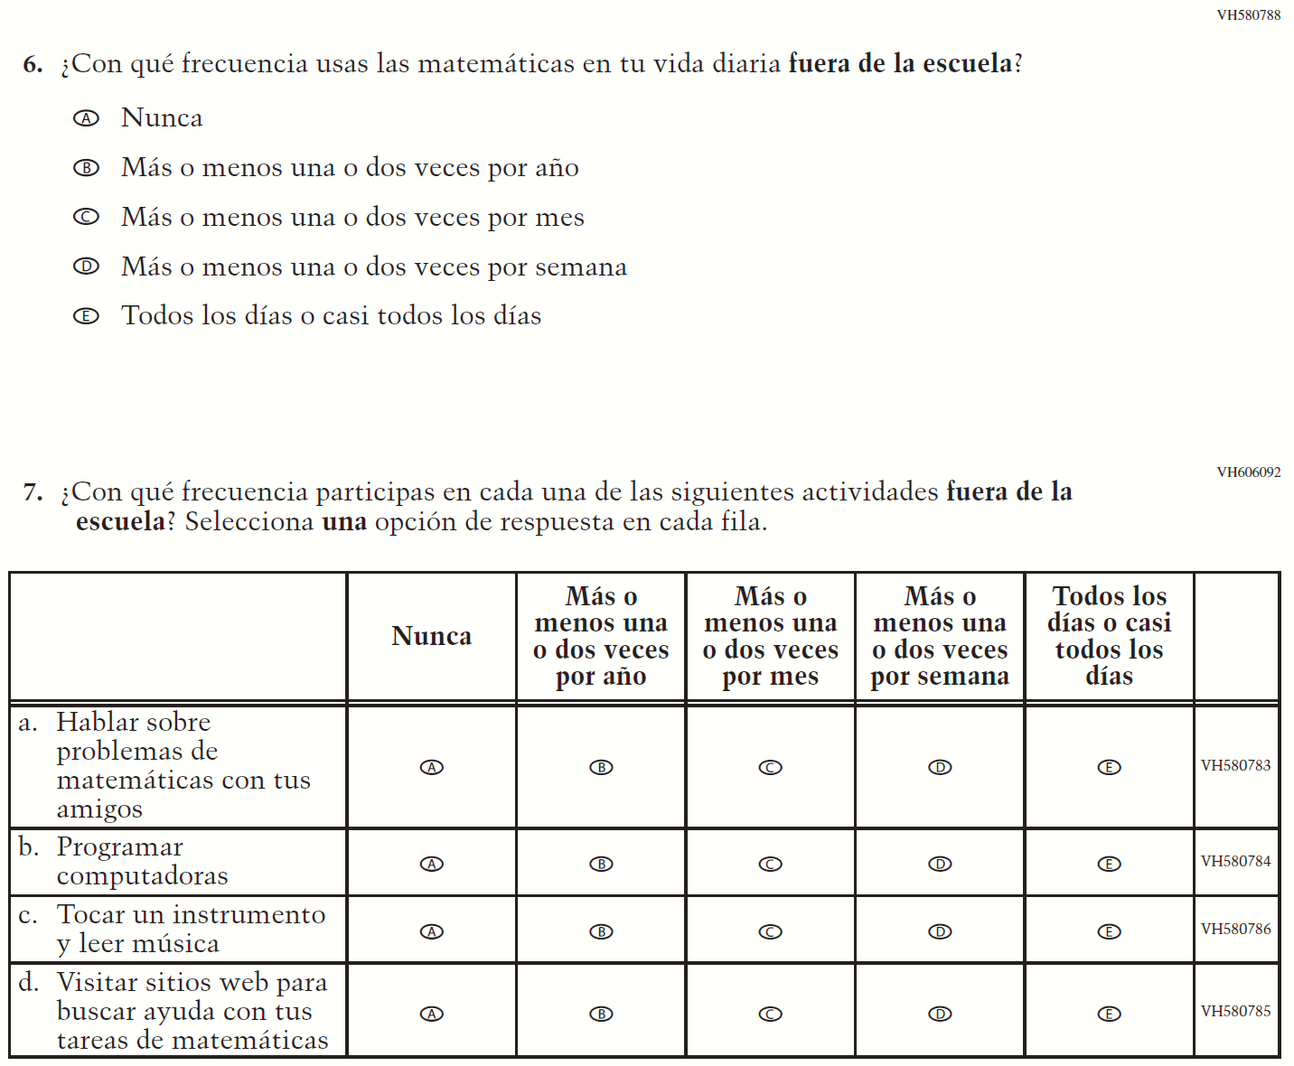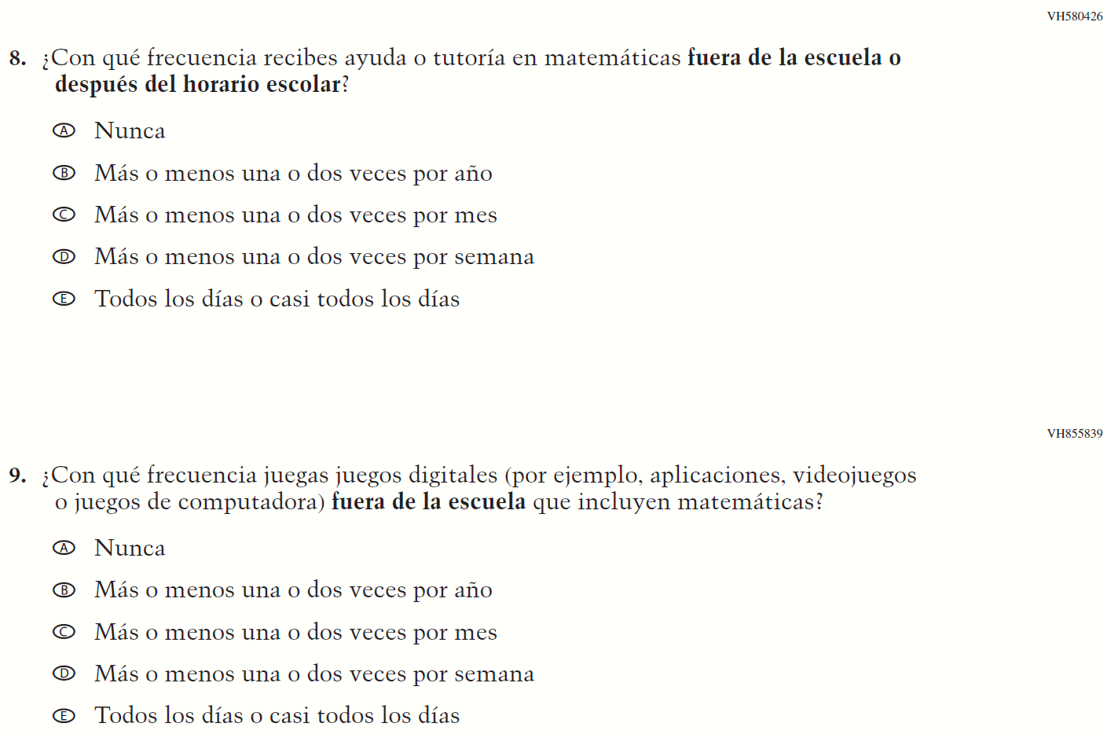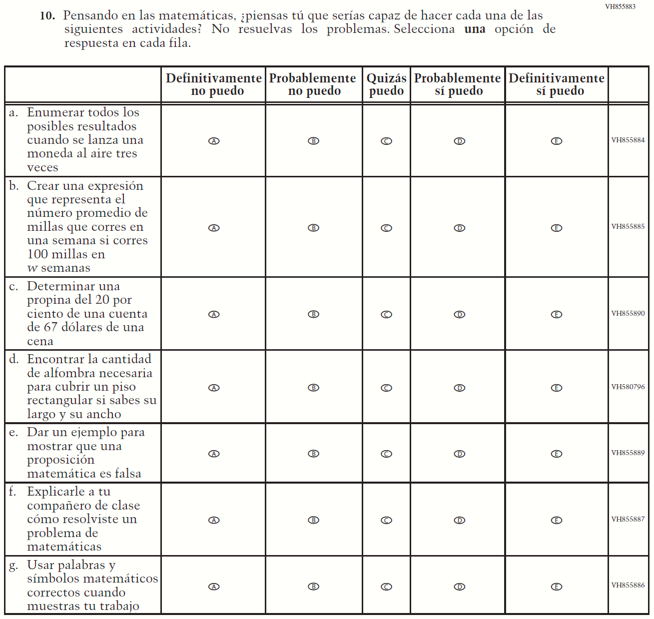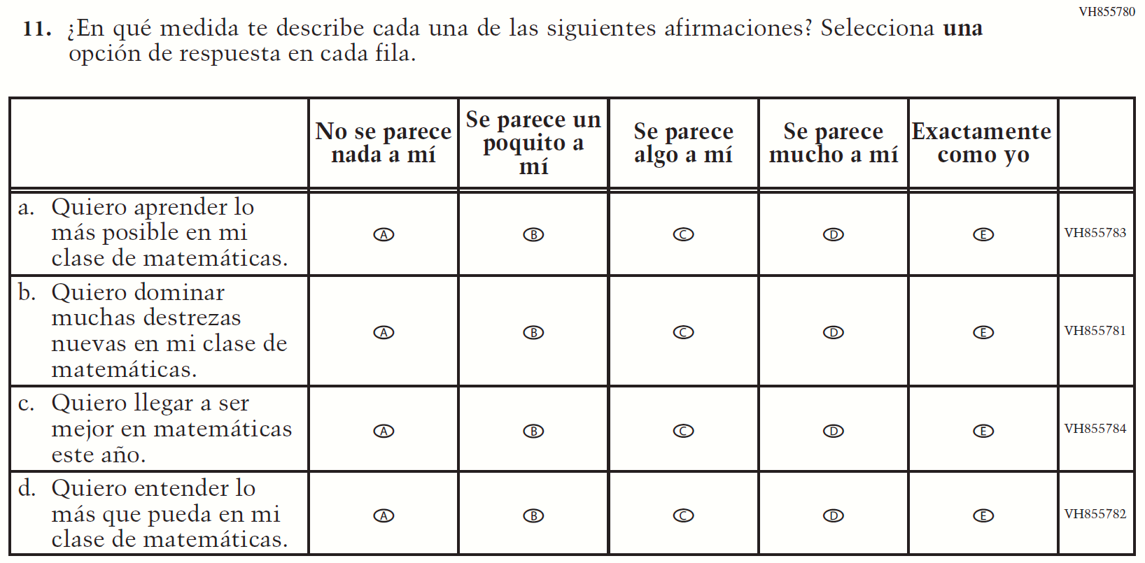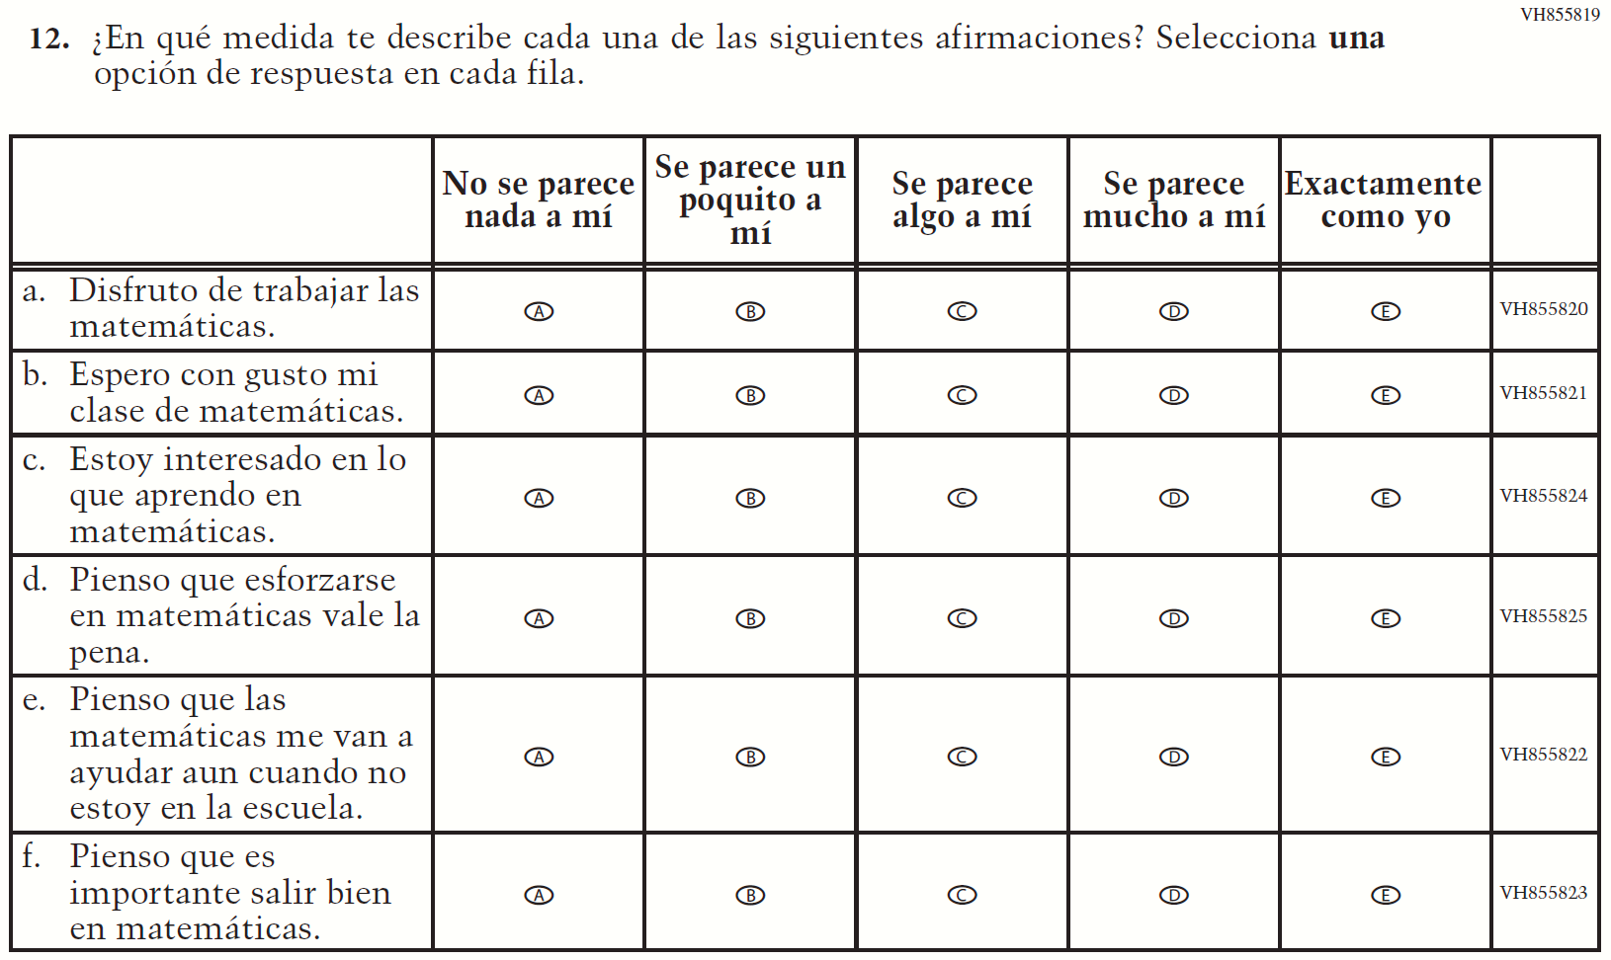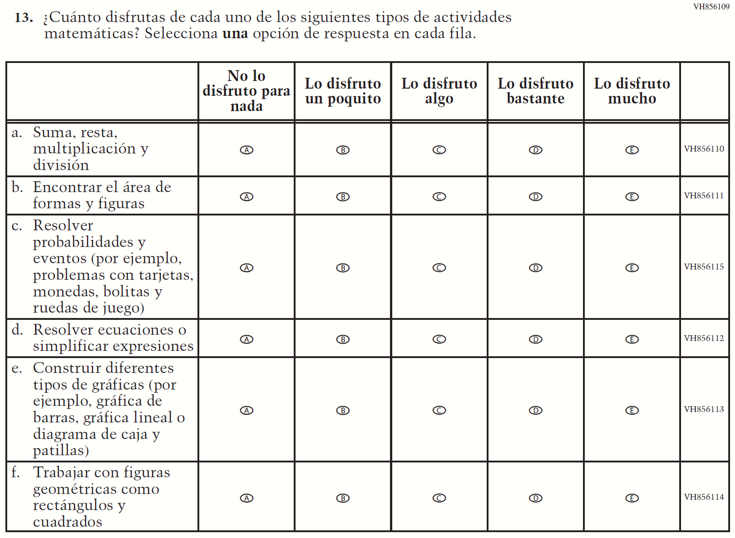

Appendix J-1h-s-PR: Summary of Changes Operational Grade 8 Mathematics
2021 Operational Grade 8 Mathematics Student – Puerto Rico

Previous item | 2021 item | D/A/ R/NC+ | Rationale
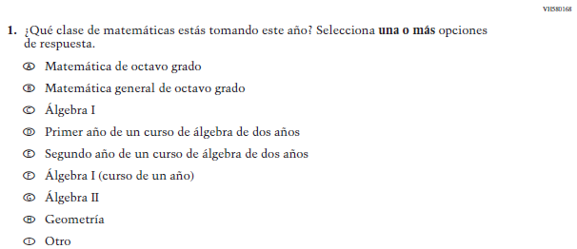  (2019 Operational Grade 8 Student Mathematics – Puerto Rico) | Issue: Organization of Instruction | NC | N/A
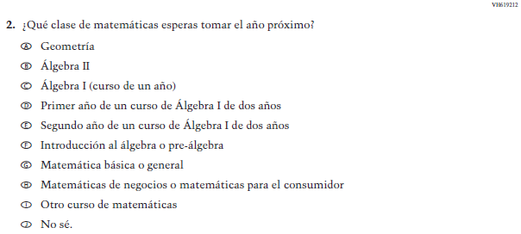  (2019 Operational Grade 8 Student Mathematics – Puerto Rico) | Issue: Organization of Instruction | NC | N/A
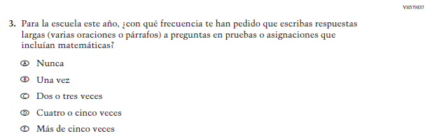  (2019 Operational Grade 8 Student Mathematics – Puerto Rico) | Issue: Organization of Instruction | NC | N/A
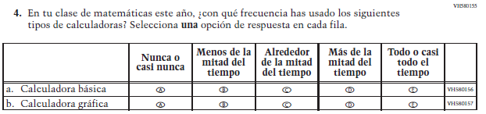  (2019 Operational Grade 8 Student Mathematics – Puerto Rico) | 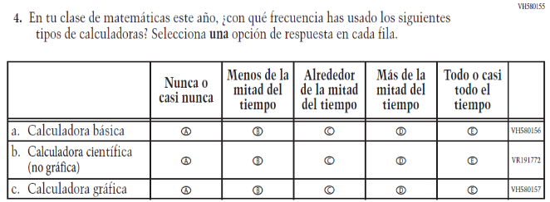  Issue: Resources for Learning and Instruction | A: sub-item “b”  NC for SL and sub-items “a” and “c” | The “Scientific (not graphing) calculator” sub-item was dropped previously due to an oversight and is being reinstated to capture calculator features in mathematics as students progress from K to 12.
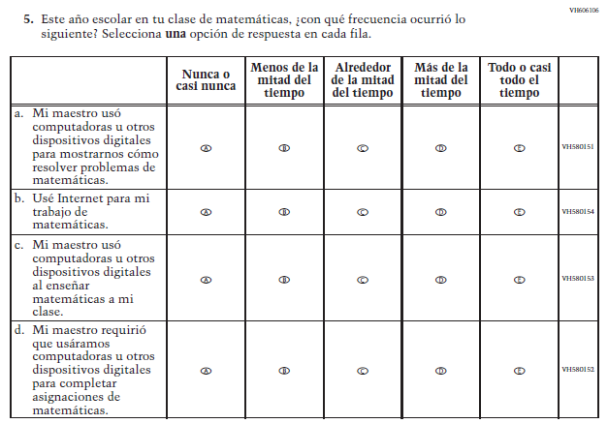  (2019 Operational Grade 8 Student Mathematics – Puerto Rico) | 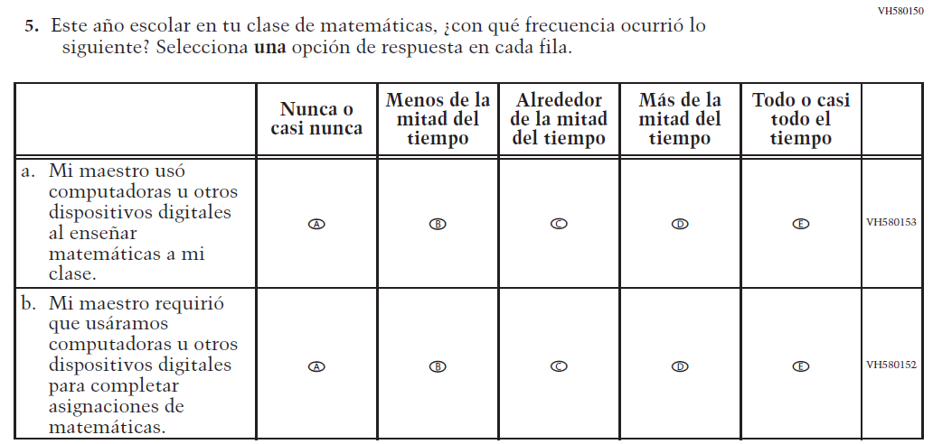  Issue: Resources for Learning and Instruction | R | To keep student burden low, sub-items a and b were dropped.
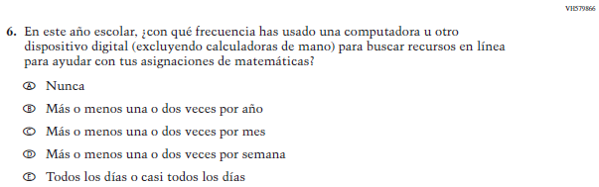  (2019 Operational Grade 8 Student Mathematics – Puerto Rico) | N/A | D | To keep student burden low, this item was dropped.
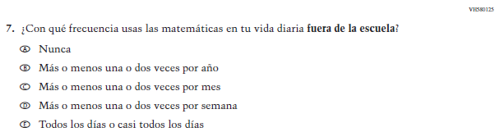  (2019 Operational Grade 8 Student Mathematics – Puerto Rico) | 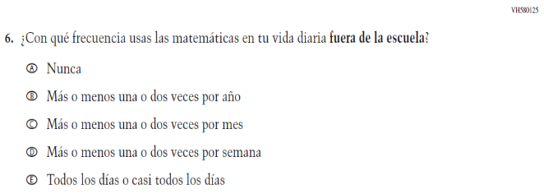  Issue: Resources for Learning and Instruction | NC
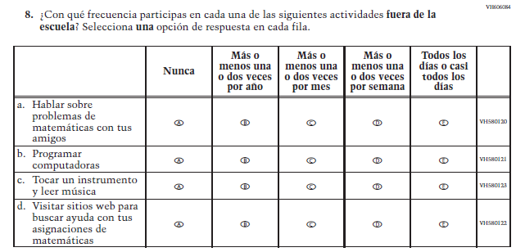  (2019 Operational Grade 8 Student Mathematics – Puerto Rico) | 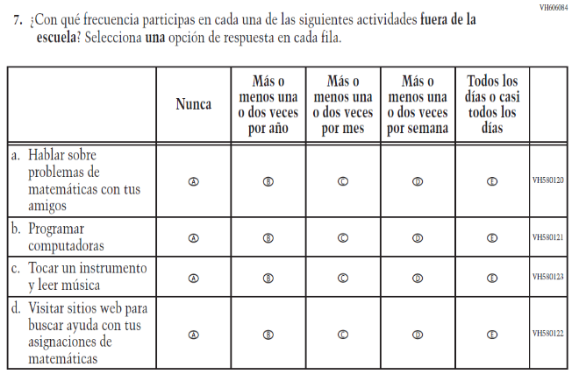  Issue: Resources for Learning and Instruction | NC | N/A
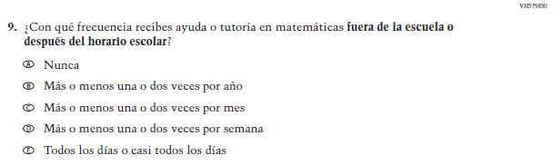  (2019 Operational Grade 8 Student Mathematics – Puerto Rico) | 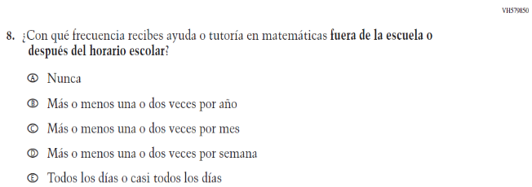  Issue: Resources for Learning and Instruction | NC | N/A

2021 Operational Grade 8 Mathematics Student – Puerto Rico

Previous item | 2021 item | D/A/ R/NC+ | Rationale
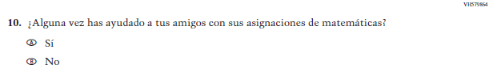  (2019 Operational Grade 8 Student Mathematics – Puerto Rico) | N/A | D | To keep student burden low, this item was dropped.
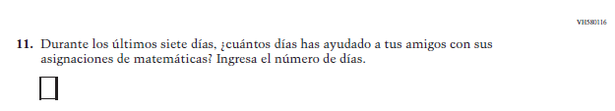  (2019 Operational Grade 8 Student Mathematics – Puerto Rico) | N/A | D | To keep student burden low, this item was dropped.
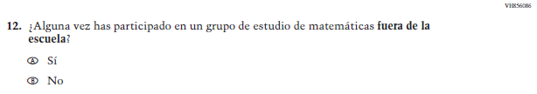(2019 Operational Grade 8 Student Mathematics – Puerto Rico) | N/A | D | To keep student burden low, this item was dropped.
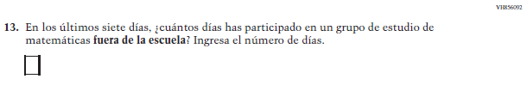  (2019 Operational Grade 8 Student Mathematics – Puerto Rico) | N/A | D | To keep student burden low, this item was dropped.

2021 Operational Grade 8 Mathematics Student – Puerto Rico

Previous item | 2021 item | D/A/ R/NC+ | Rationale
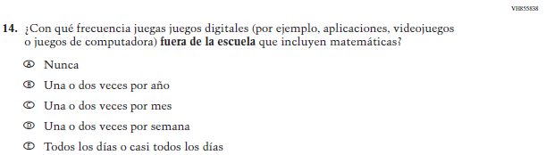  (2019 Operational Grade 8 Student Mathematics – Puerto Rico) | 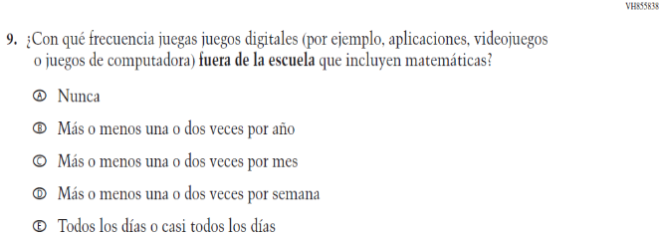  Issue: Resources for Learning and Instruction | NC | N/A
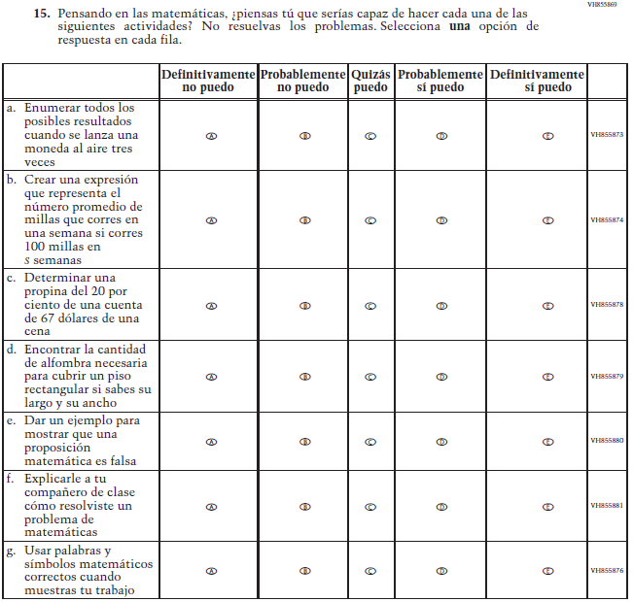  (2019 Operational Grade 8 Student Mathematics – Puerto Rico) | 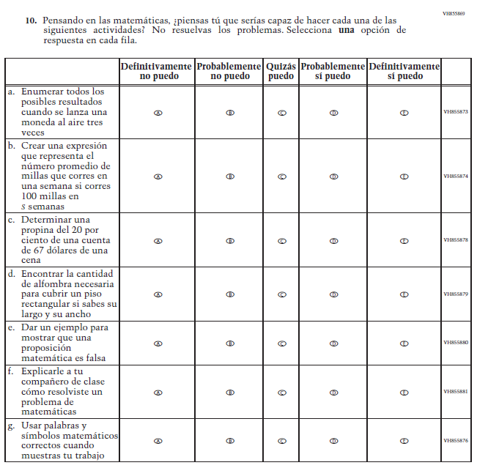  Issue: Student factors | NC | N/A

2021 Operational Grade 8 Mathematics Student – Puerto Rico

Previous item | 2021 item | D/A/ R/NC+ | Rationale
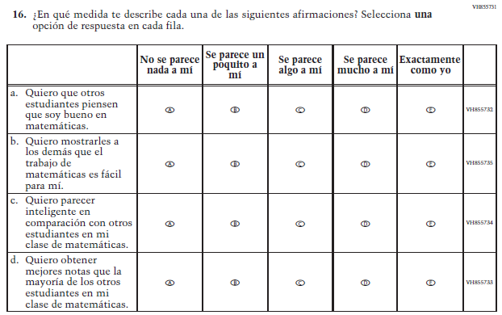  (2019 Operational Grade 8 Student Mathematics – Puerto Rico) | N/A | D | To keep student burden low, this item was dropped.
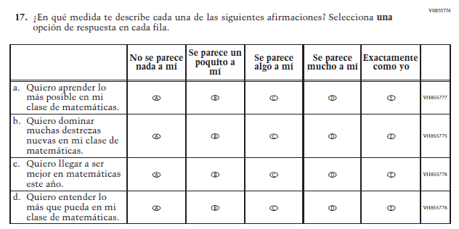  (2019 Operational Grade 8 Student Mathematics – Puerto Rico) | 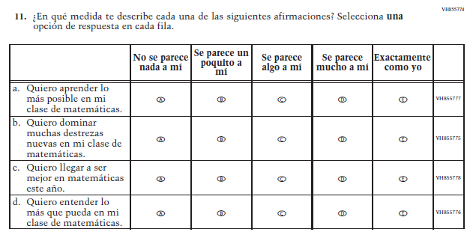  Issue: Student Factors | NC | N/A

2021 Operational Grade 8 Mathematics Student – Puerto Rico

Previous item | 2021 item | D/A/ R/NC+ | Rationale
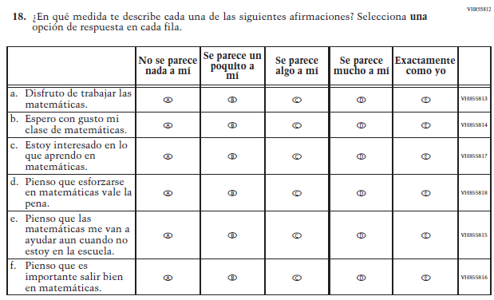  (2019 Operational Grade 8 Student Mathematics – Puerto Rico) | 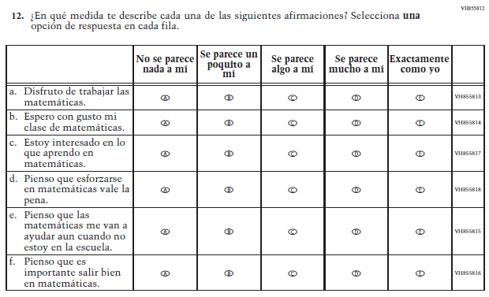  Issue: Student Factors | NC | N/A
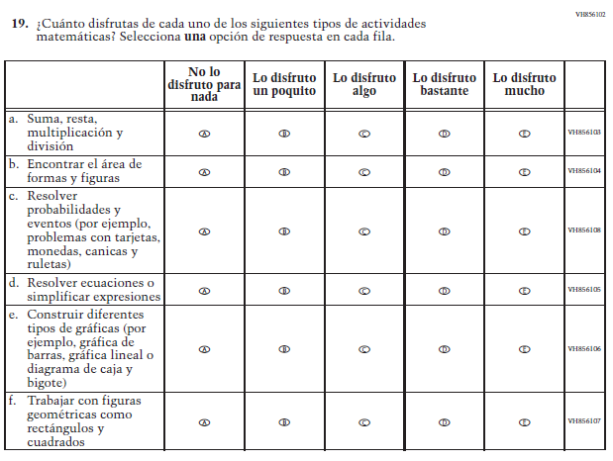  (2019 Operational Grade 8 Student Mathematics – Puerto Rico) | 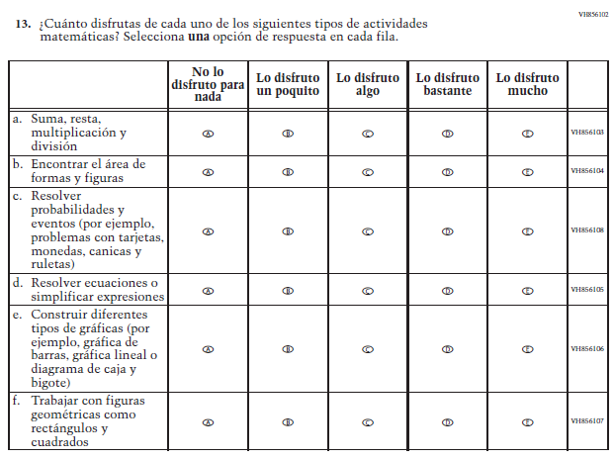  Issue: Student Factors | NC | N/A

Appendix J-1h-s-PR: Operational Grade 8 Mathematics

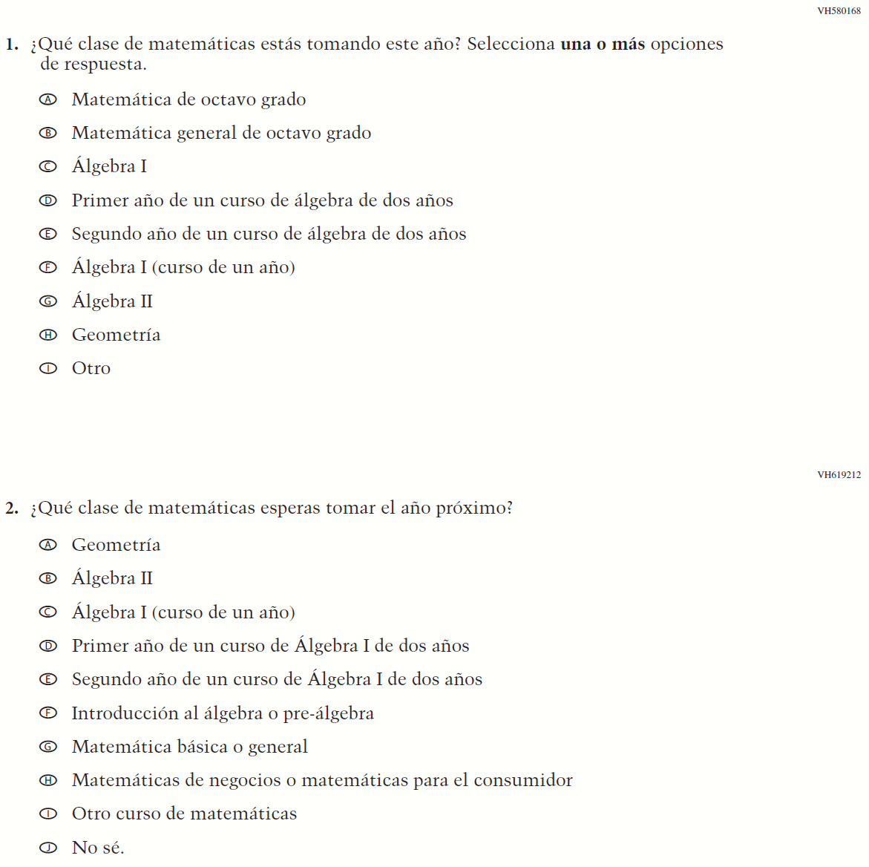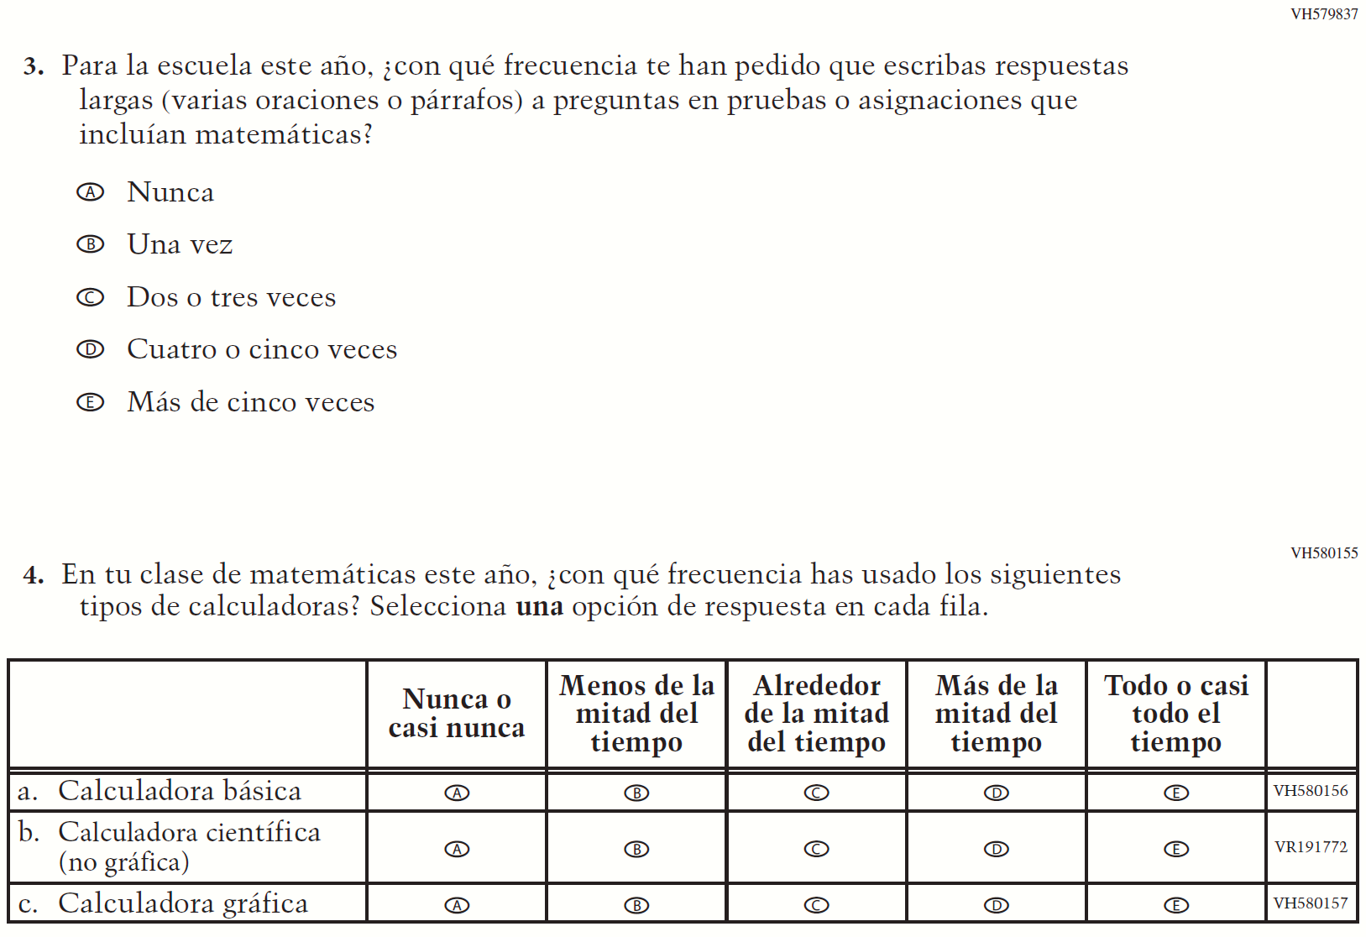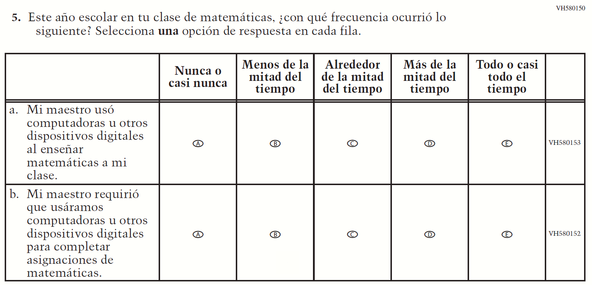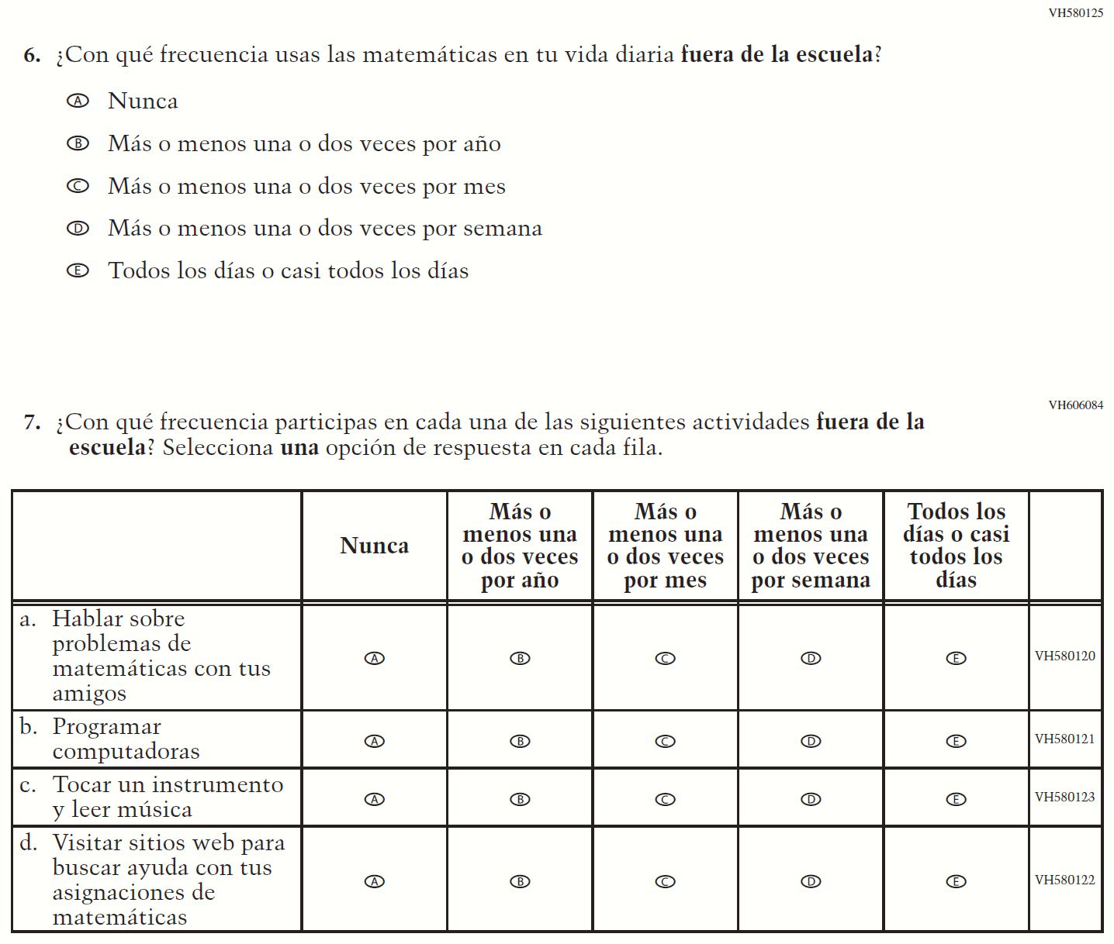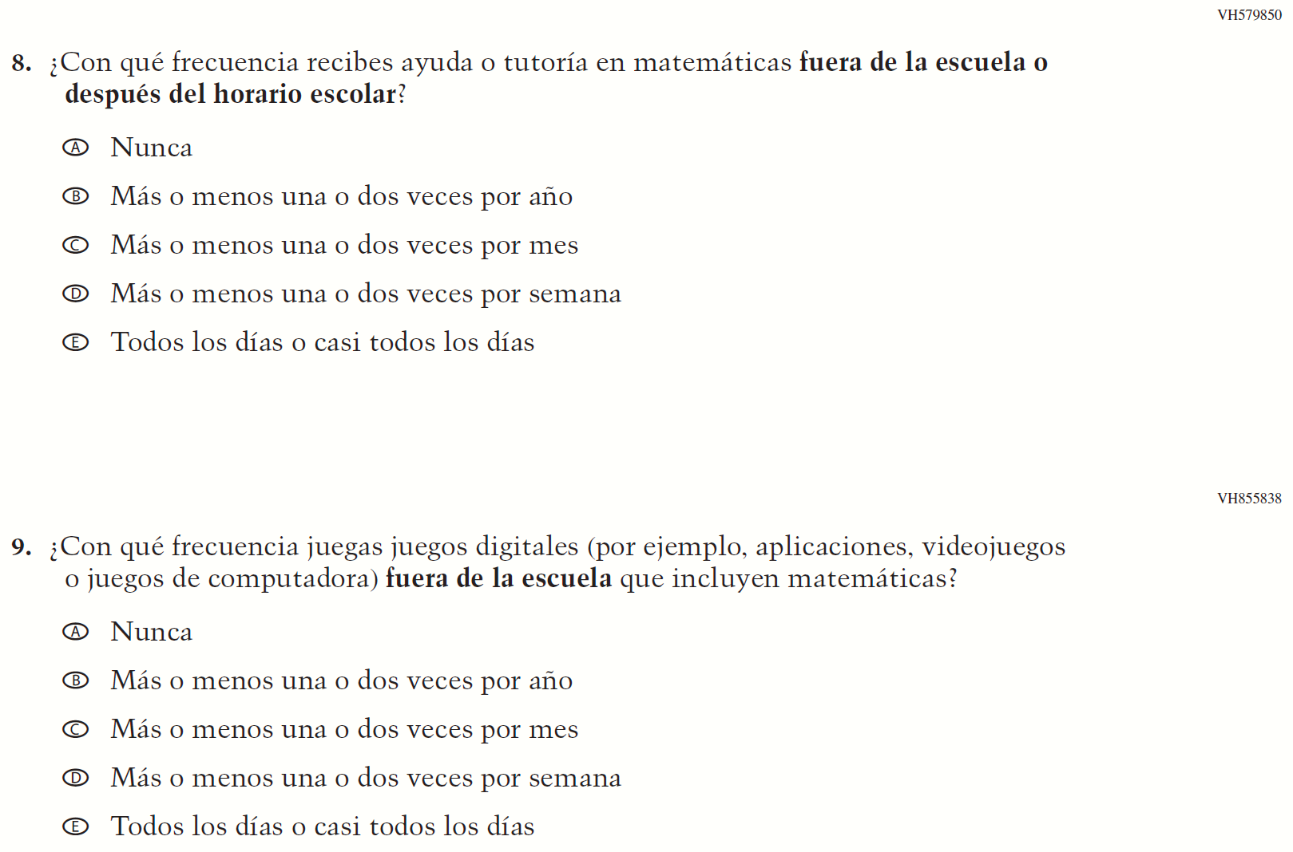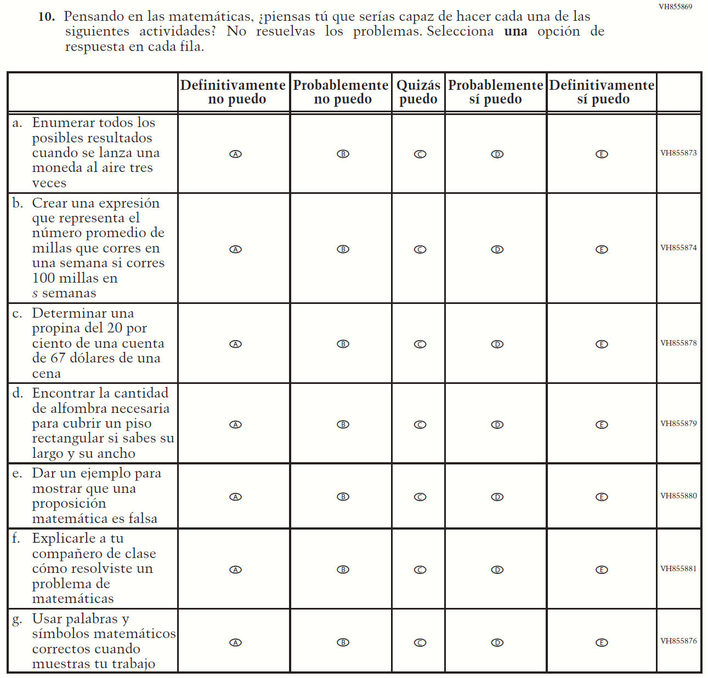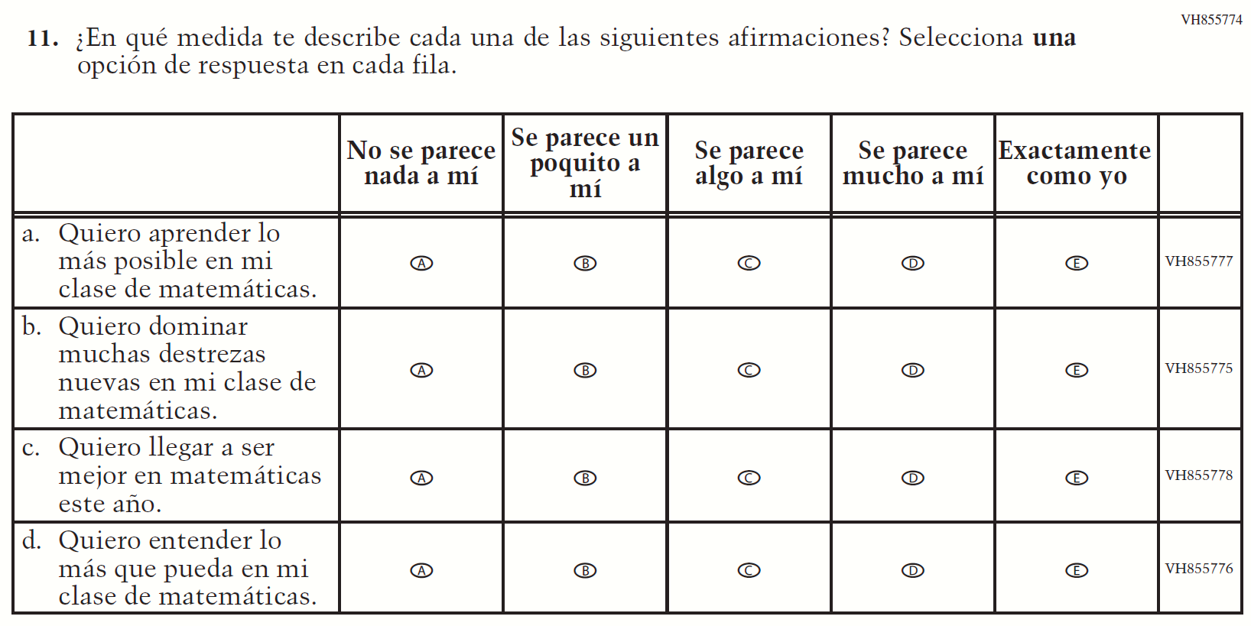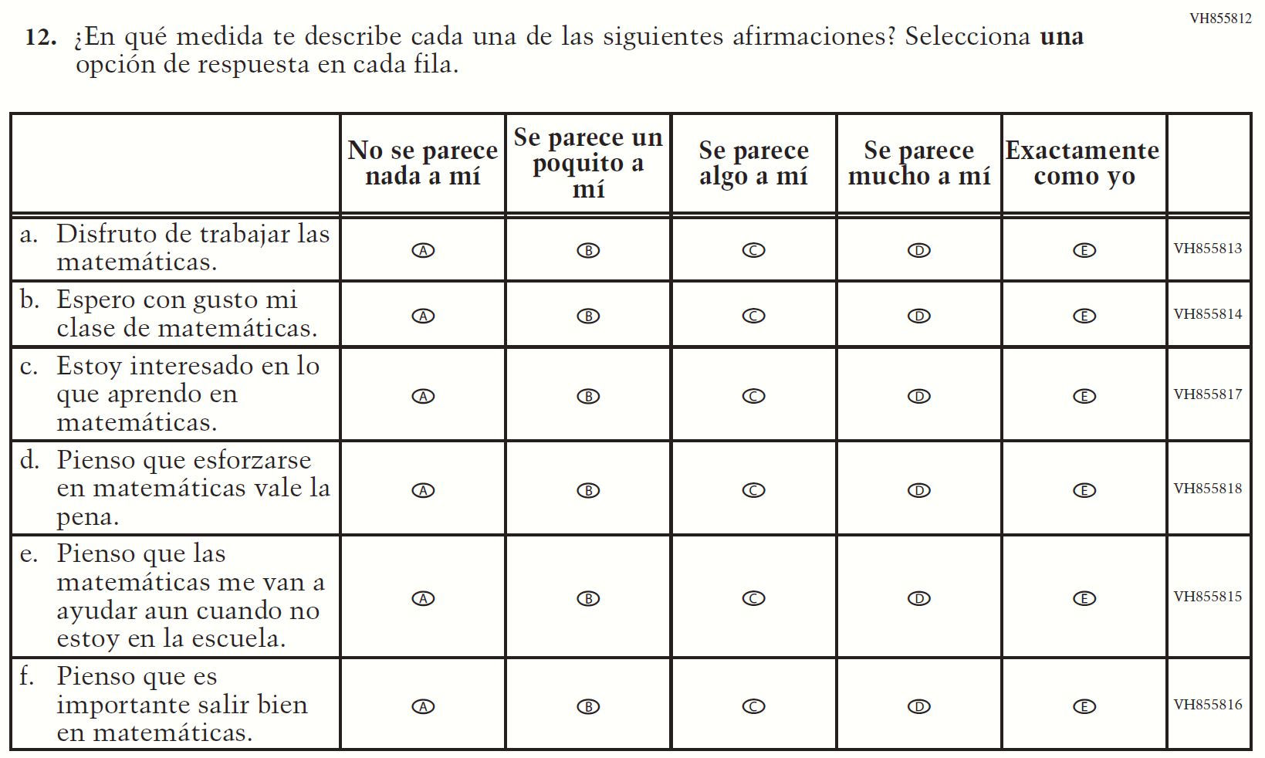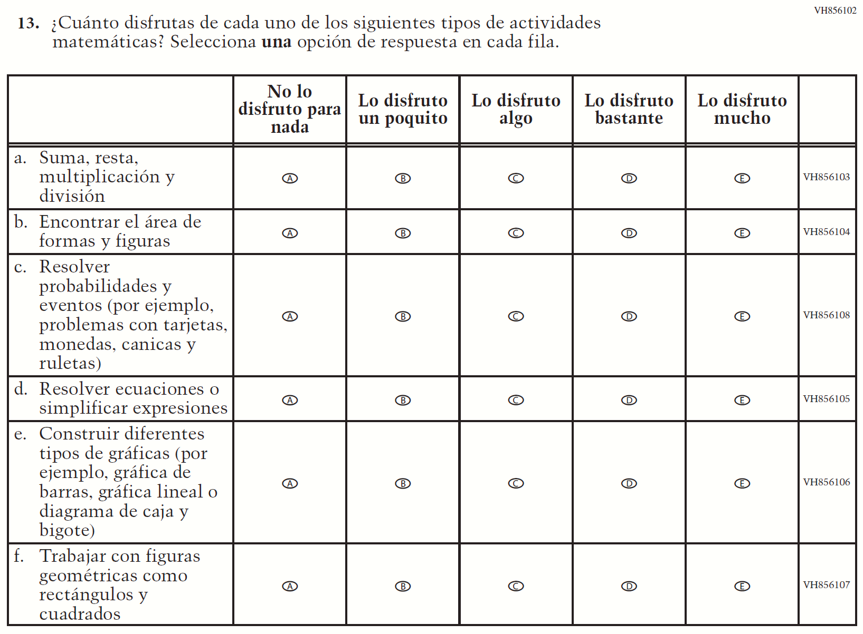

Appendix J-1i-s-BL: Summary of Changes Operational Grade 4 Reading
2021 Operational Grade 4 Reading Student – Bilingual
Previous item | 2021 item | D/A/R/NC+ | Rationale
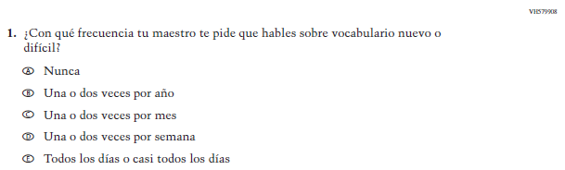  (2019 Operational Grade 4 Student Reading - Bilingual) | 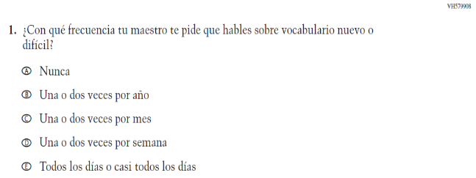  Issue: Organization of Instruction | NC | N/A
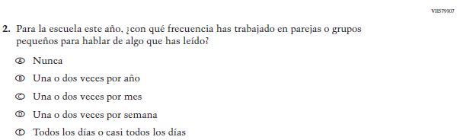  (2019 Operational Grade 4 Student Reading - Bilingual) | 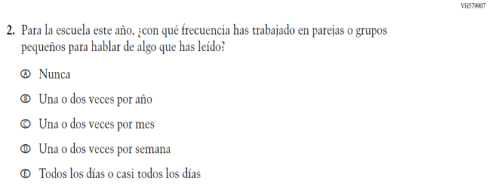  Issue: Organization of Instruction | NC | N/A
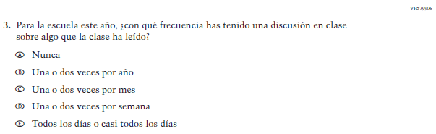  (2019 Operational Grade 4 Student Reading - Bilingual) | 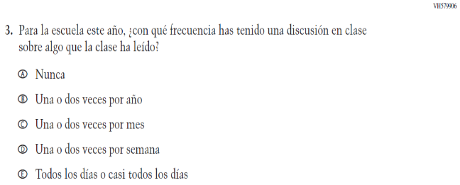  Issue: Organization of Instruction | NC | N/A
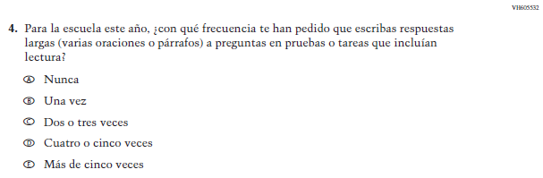  (2019 Operational Grade 4 Student Reading - Bilingual) | 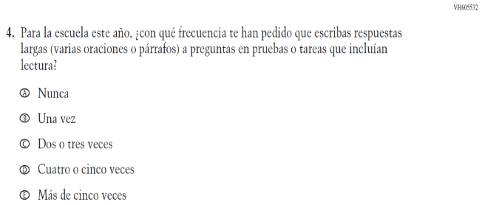  Issue: Organization of Instruction | NC | N/A

2021 Operational Grade 4 Reading Student – Bilingual
Previous item | 2021 item | D/A/R/NC+ | Rationale
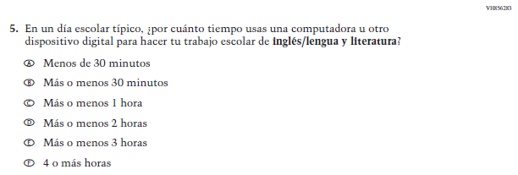  (2019 Operational Grade 4 Student Reading - Bilingual) | N/A | D | To keep student burden low, this item was dropped.
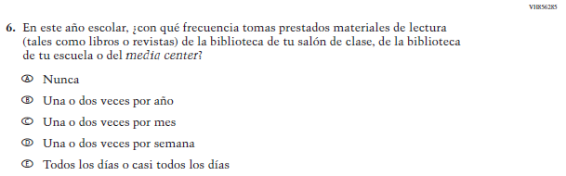  (2019 Operational Grade 4 Student Reading - Bilingual) | 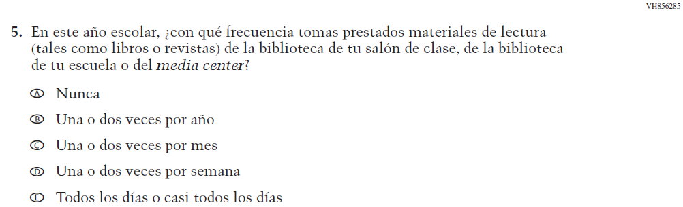  Issue: Resources for Learning and Instruction | NC | N/A
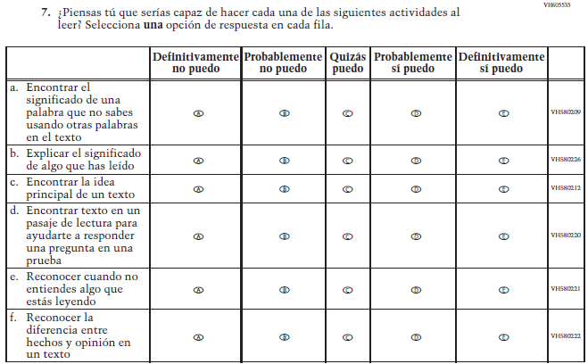  (2019 Operational Grade 4 Student Reading - Bilingual) | 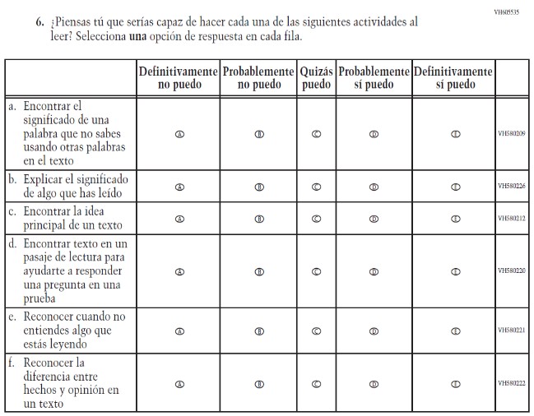  Issue: Student Factors | NC | N/A

2021 Operational Grade 4 Reading Student – Bilingual
Previous item | 2021 item | D/A/R/NC+ | Rationale
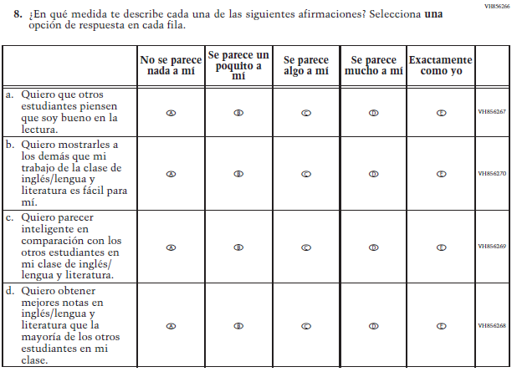  (2019 Operational Grade 4 Student Reading - Bilingual) | N/A | D | To keep student burden low, this item was dropped.
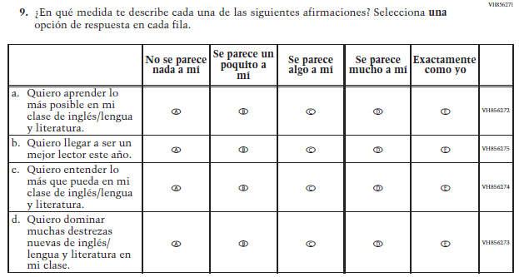  (2019 Operational Grade 4 Student Reading - Bilingual) | 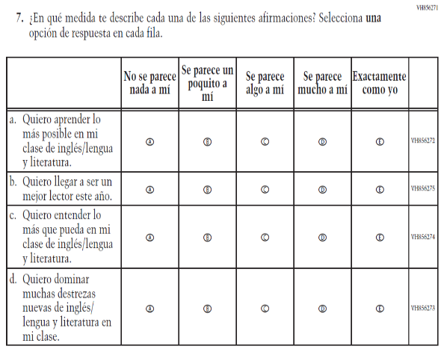  Issue: Student Factors | NC | N/A

2021 Operational Grade 4 Reading Student – Bilingual
Previous item | 2021 item | D/A/R/NC+ | Rationale
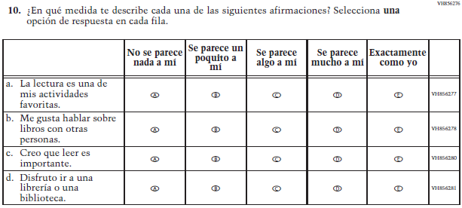  (2019 Operational Grade 4 Student Reading - Bilingual) | 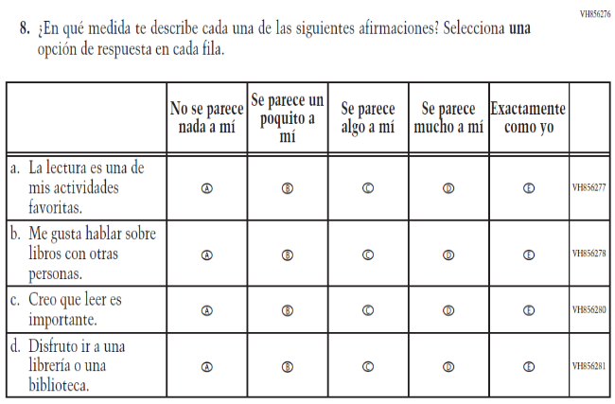  Issue: Student Factors | NC | N/A
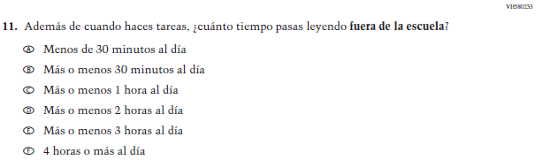  (2019 Operational Grade 4 Student Reading - Bilingual) | 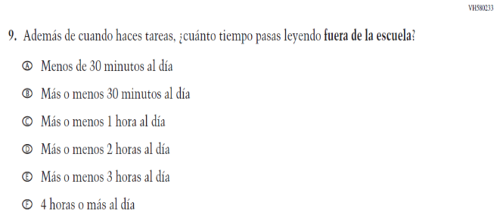  Issue: Student Factors | NC | N/A
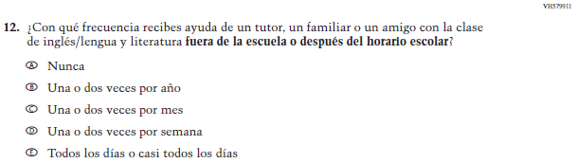  (2019 Operational Grade 4 Student Reading - Bilingual) | 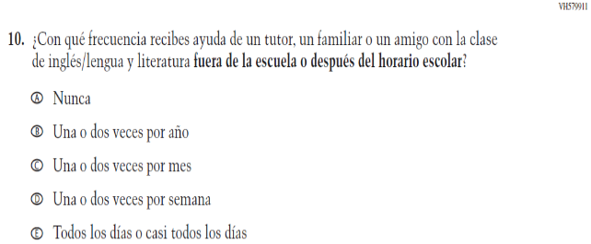  Issue: Resources for Learning and Instruction | NC | N/A

2021 Operational Grade 4 Reading Student – Bilingual
Previous item | 2021 item | D/A/R/NC+ | Rationale
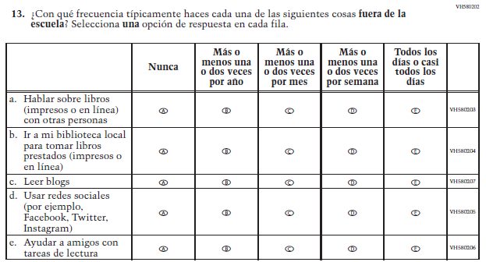  (2019 Operational Grade 4 Student Reading - Bilingual) | 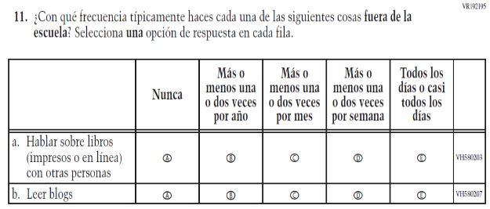  Issue: Student Factors | R | To keep student burden low, sub-items b, d, and e were dropped.

Appendix J-1i-s-BL: Operational Grade 4 Reading
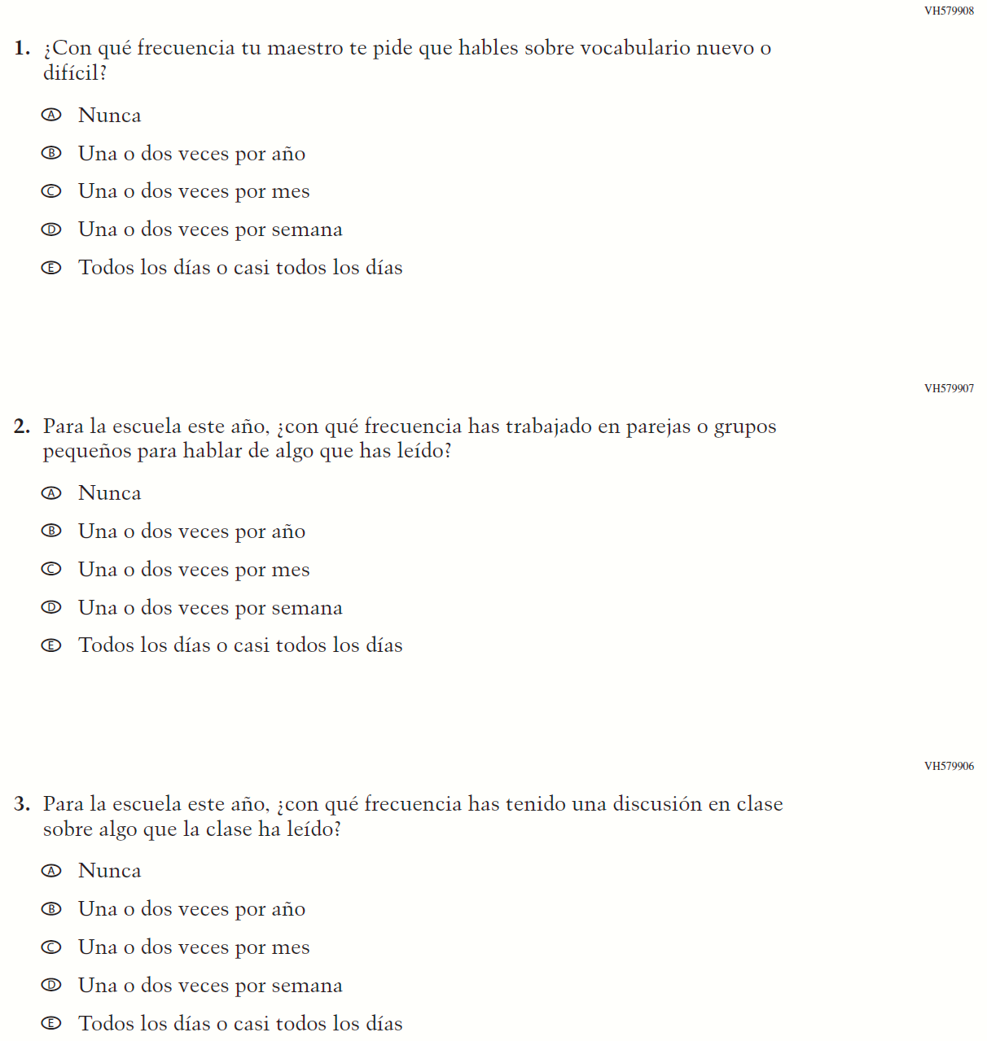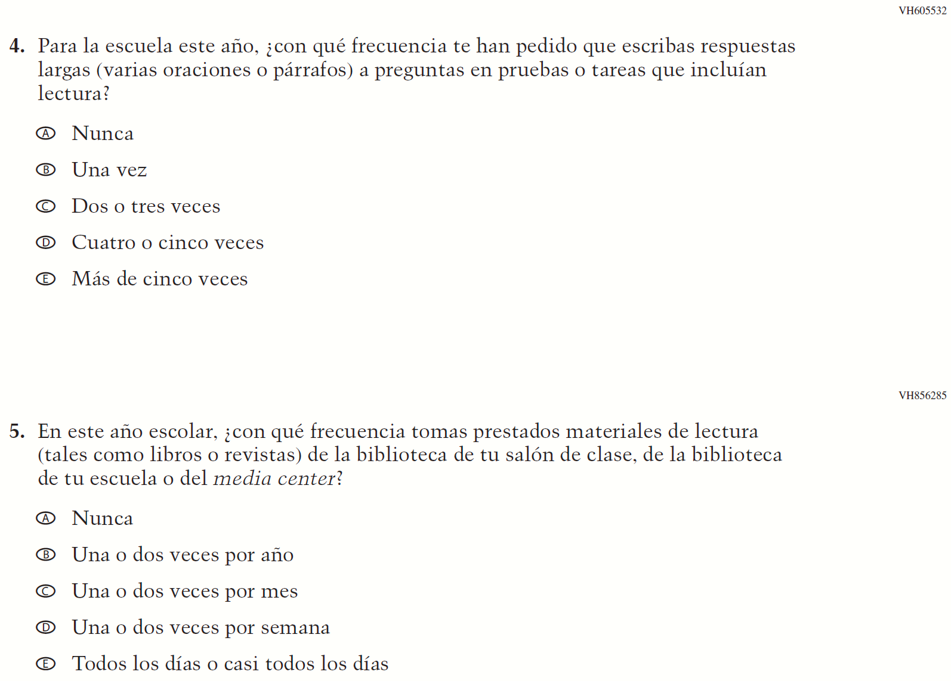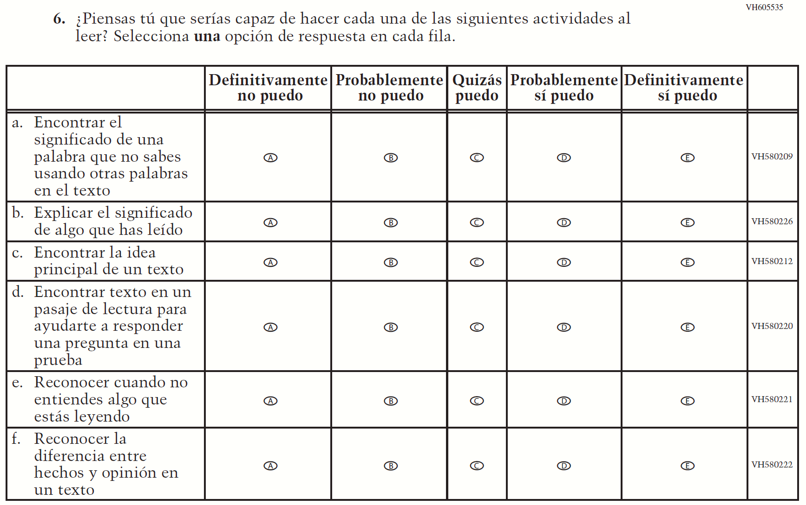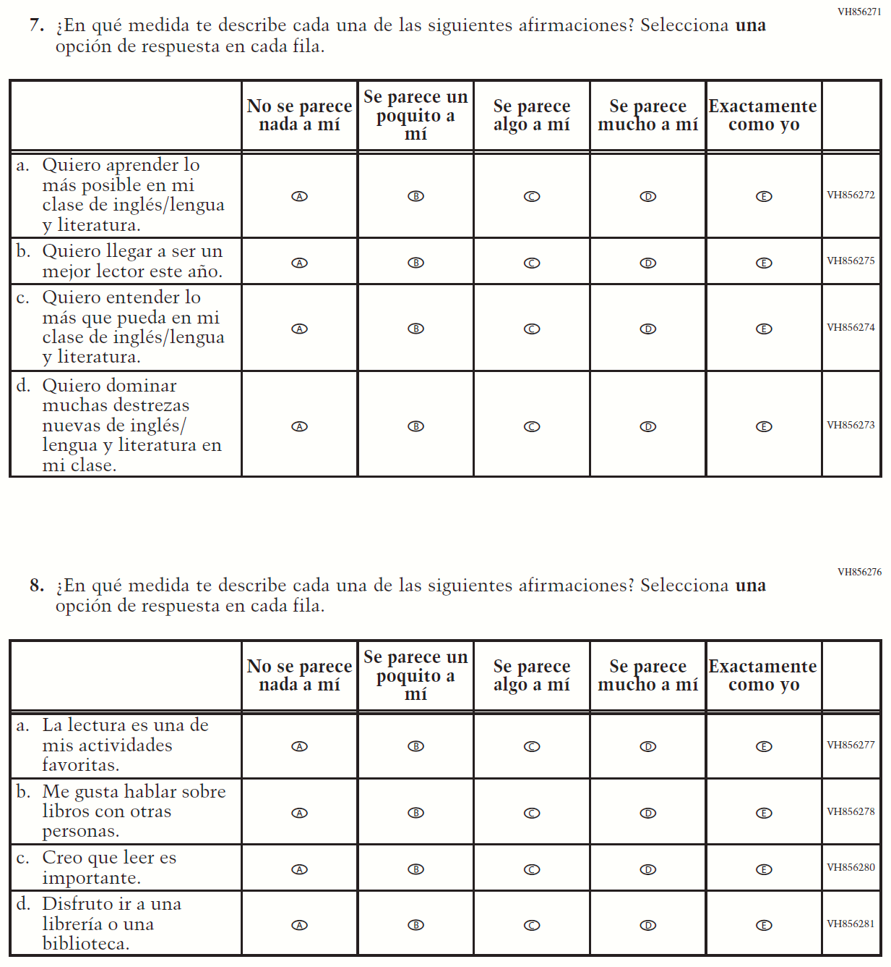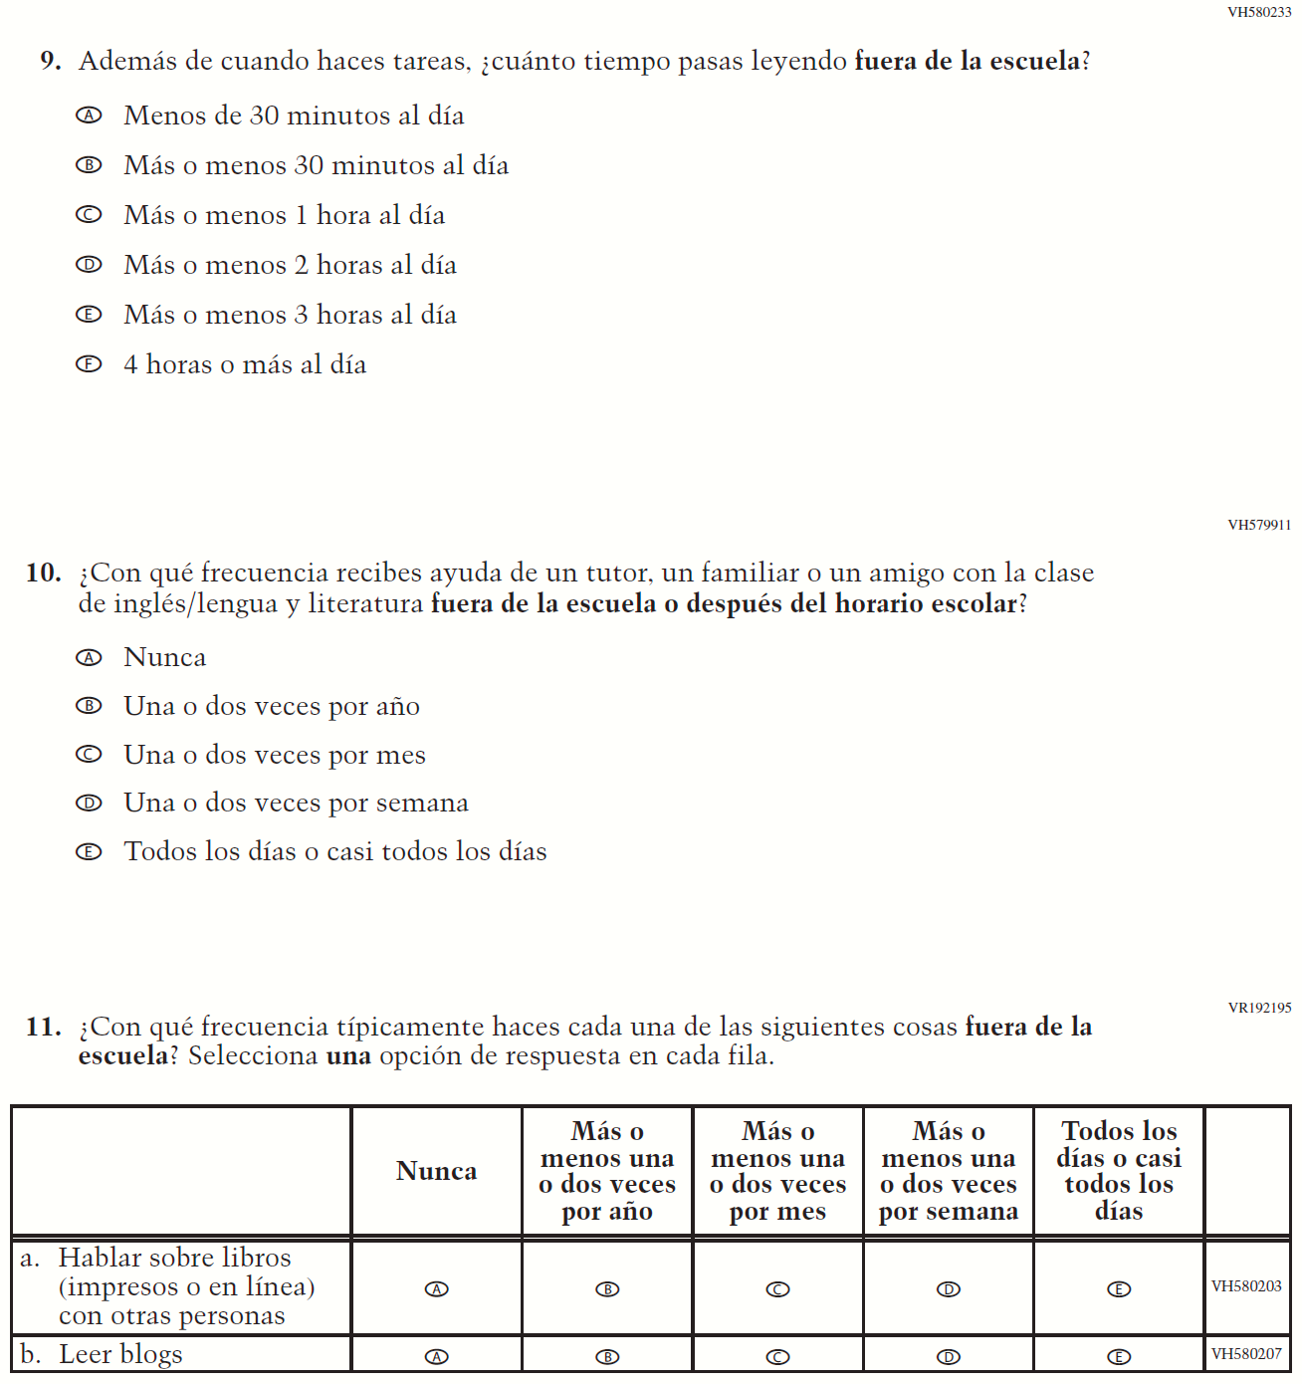

Appendix J-1j-s-BL: Summary of Changes Operational Grade 8 Reading
2021 Operational Grade 8 Reading Student – Bilingual

Previous item | 2021 item | D/A/ R/NC+ | Rationale
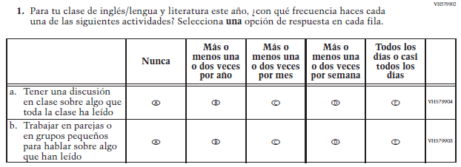  (2019 Operational Grade 8 Student Reading – Bilingual) | 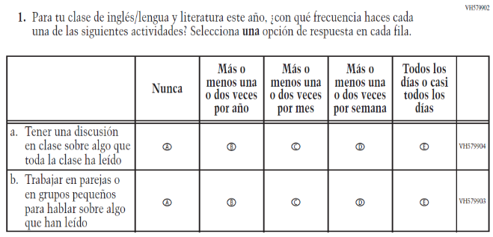  Issue: Organization of Instruction | NC | N/A
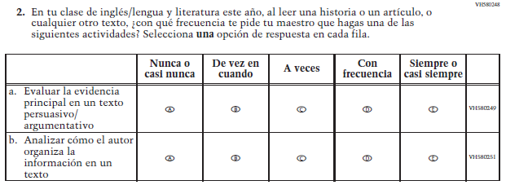  (2019 Operational Grade 8 Student Reading – Bilingual) | 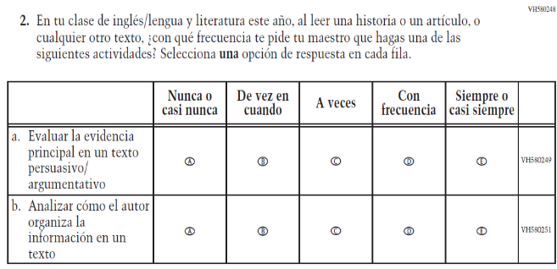  Issue: Organization of Instruction | NC | N/A
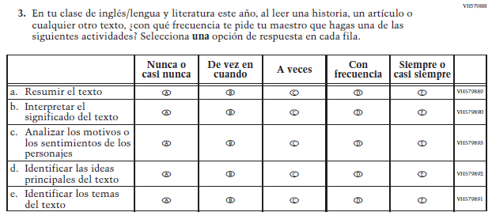  (2019 Operational Grade 8 Student Reading – Bilingual) | 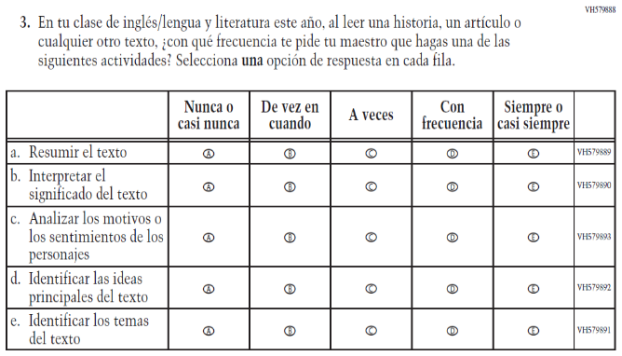  Issue: Organization of Instruction | NC | N/A
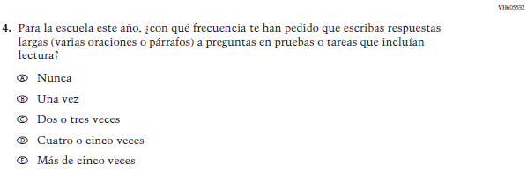  (2019 Operational Grade 8 Student Reading – Bilingual) | 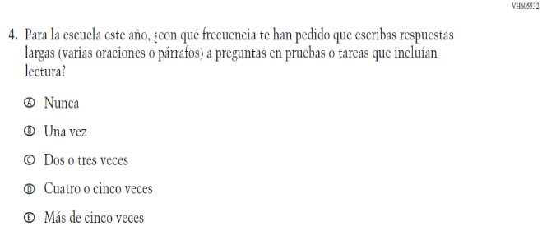  Issue: Organization of Instruction | NC | N/A
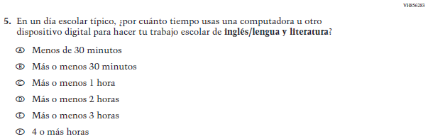  (2019 Operational Grade 8 Student Reading – Bilingual) | N/A | D | To keep student burden low, this item was dropped.
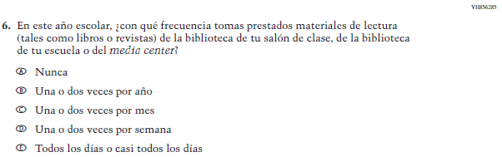  (2019 Operational Grade 8 Student Reading – Bilingual) | N/A | D | To keep student burden low, this item was dropped.

2021 Operational Grade 8 Reading Student – Bilingual

Previous item | 2021 item | D/A/ R/NC+ | Rationale
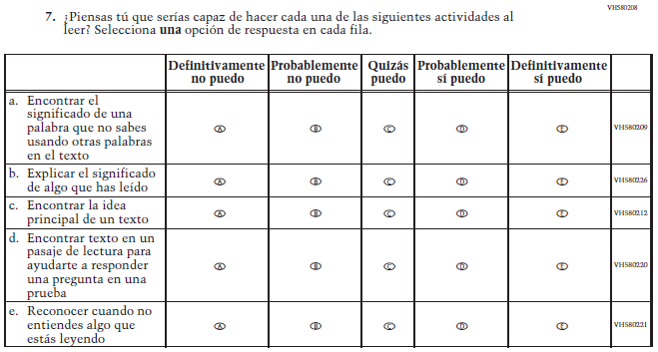  (2019 Operational Grade 8 Student Reading – Bilingual) | 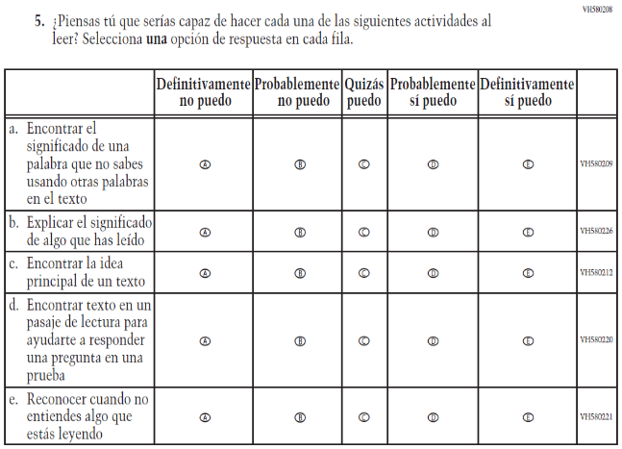  Issue: Student Factors | NC | N/A
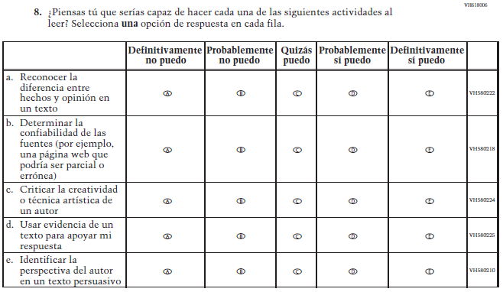  (2019 Operational Grade 8 Student Reading – Bilingual) | 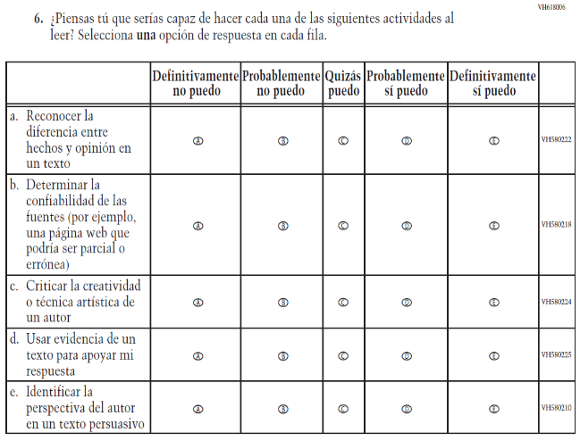  Issue: Student Factors | NC | N/A

2021 Operational Grade 8 Reading Student – Bilingual

Previous item | 2021 item | D/A/ R/NC+ | Rationale
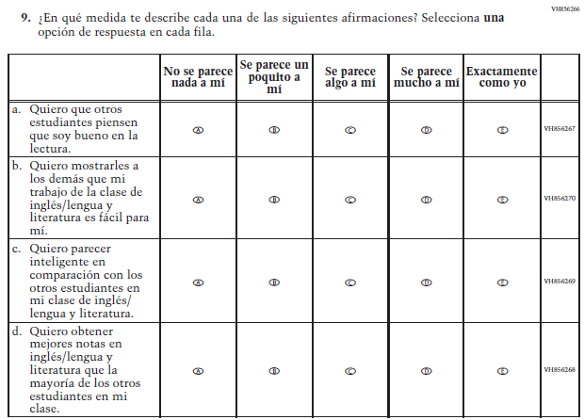  (2019 Operational Grade 8 Student Reading – Bilingual) | N/A | D | To keep student burden low, this item was dropped.
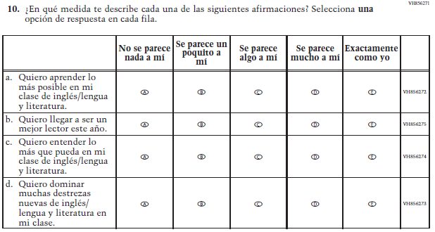  (2019 Operational Grade 8 Student Reading – Bilingual) | 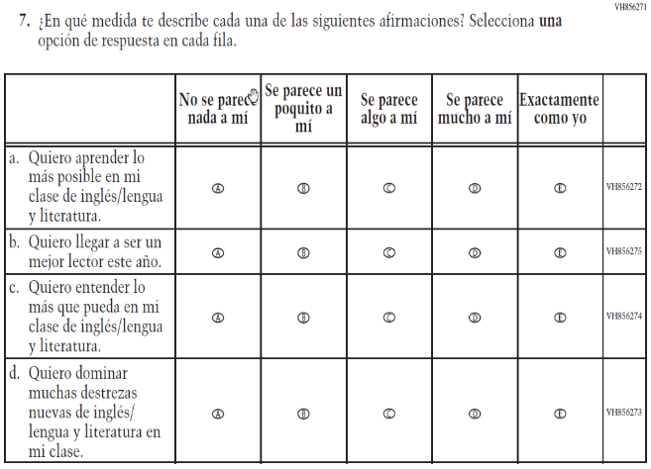  Issue: Student Factors | NC | N/A

2021 Operational Grade 8 Reading Student – Bilingual

Previous item | 2021 item | D/A/ R/NC+ | Rationale
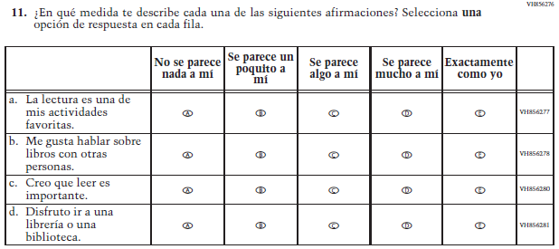  (2019 Operational Grade 8 Student Reading – Bilingual) | 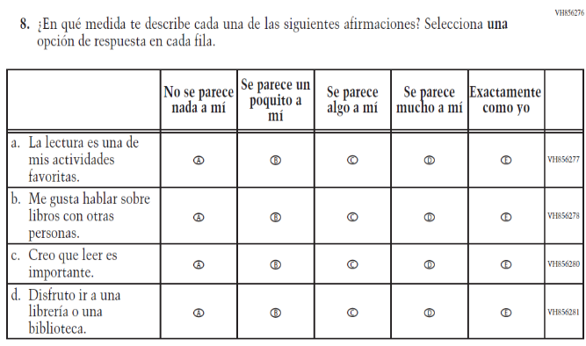  Issue: Student Factors | NC | N/A
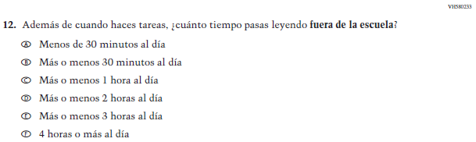  (2019 Operational Grade 8 Student Reading – Bilingual) | 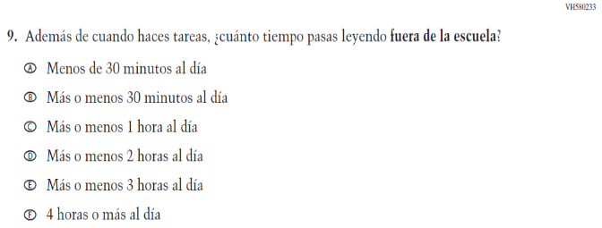  Issue: Student Factors | NC | N/A
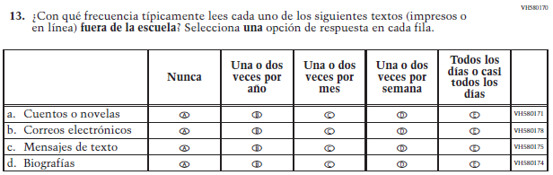  (2019 Operational Grade 8 Student Reading – Bilingual) | 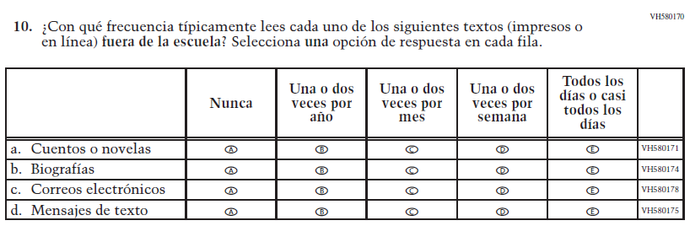  Issue: Student Factors | R | The order of sub-items b, c, and d was revised.

2021 Operational Grade 8 Reading Student – Bilingual

Previous item | 2021 item | D/A/ R/NC+ | Rationale
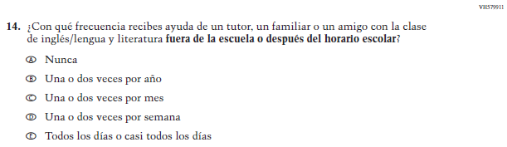  (2019 Operational Grade 8 Student Reading – Bilingual) | 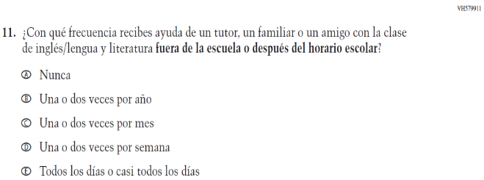  Issue: Resources for Learning and Instruction | NC | N/A
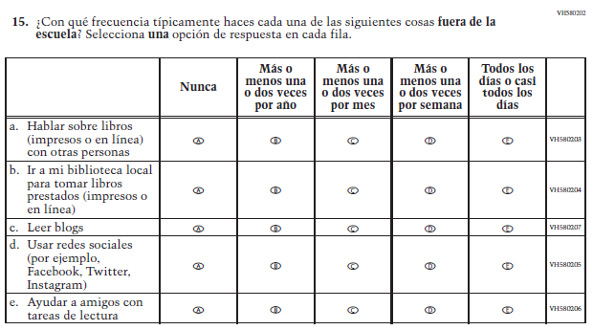  (2019 Operational Grade 8 Student Reading – Bilingual) | 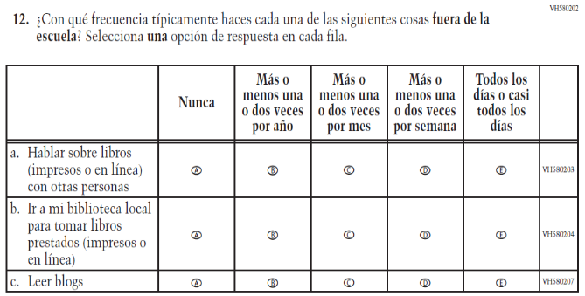  Issue: Student Factors | R | To keep student burden low, sub-items d and e were dropped.

Appendix J-1j-s-BL: Operational Grade 8 Reading

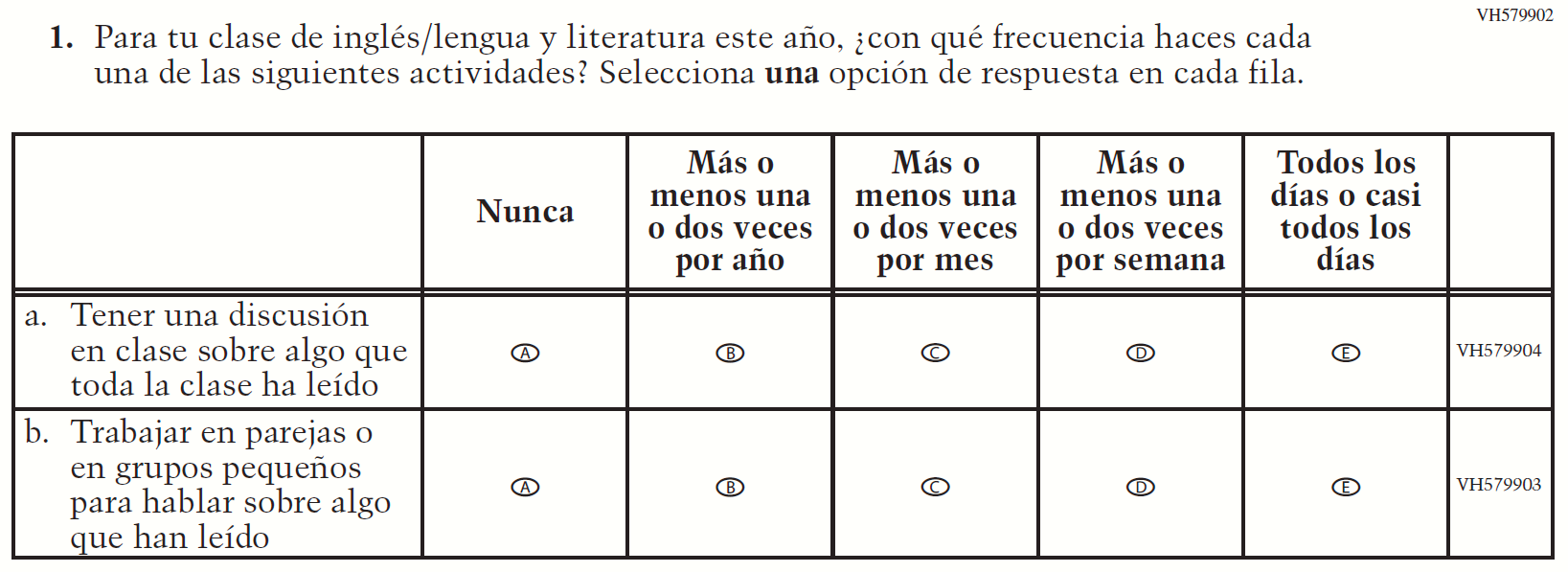
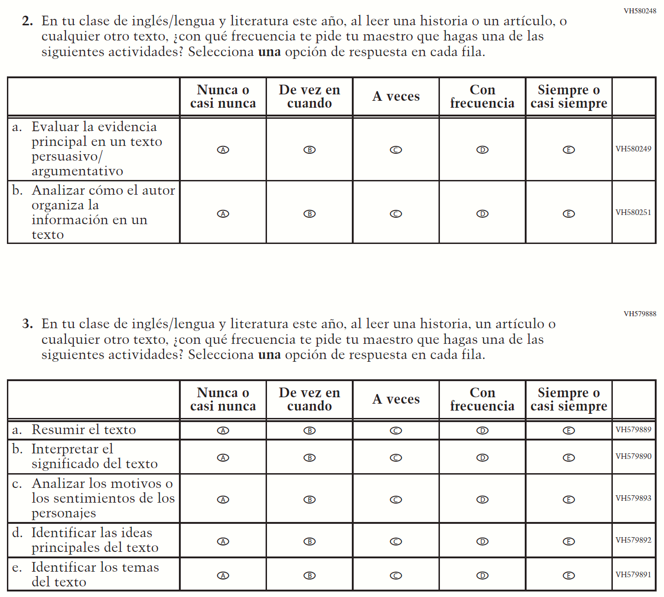

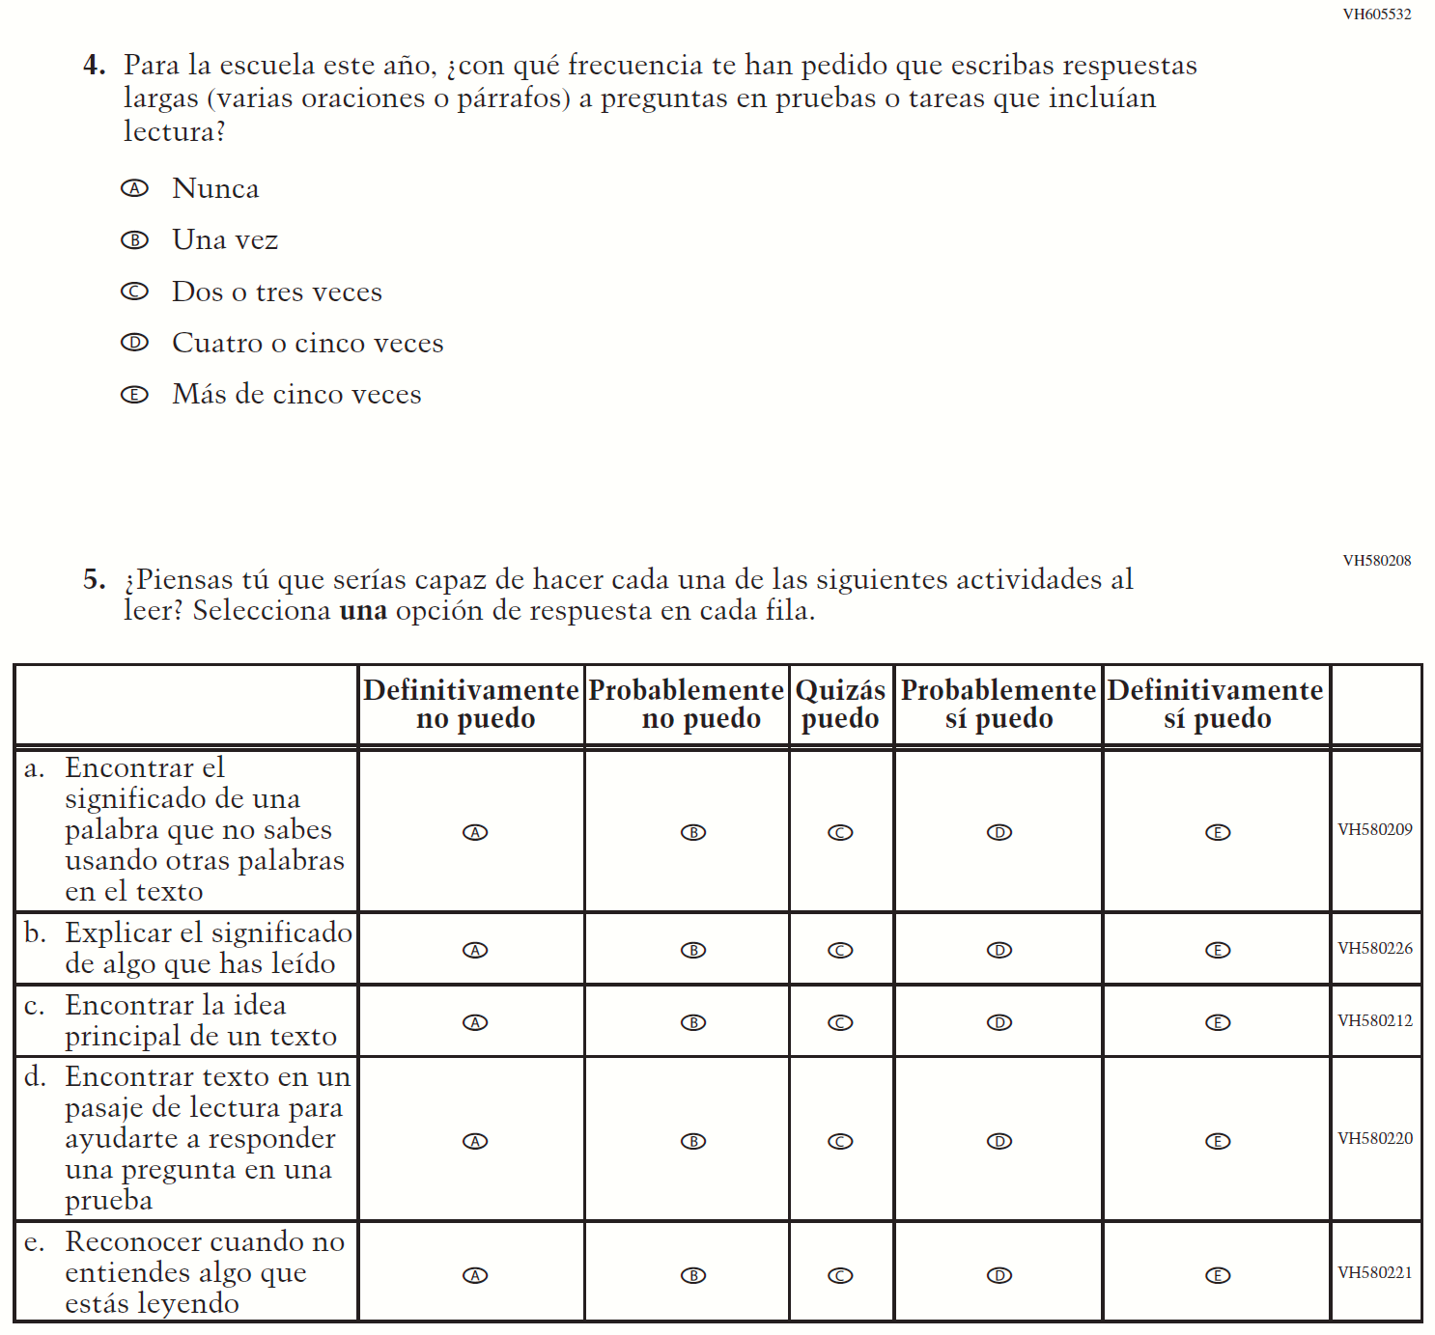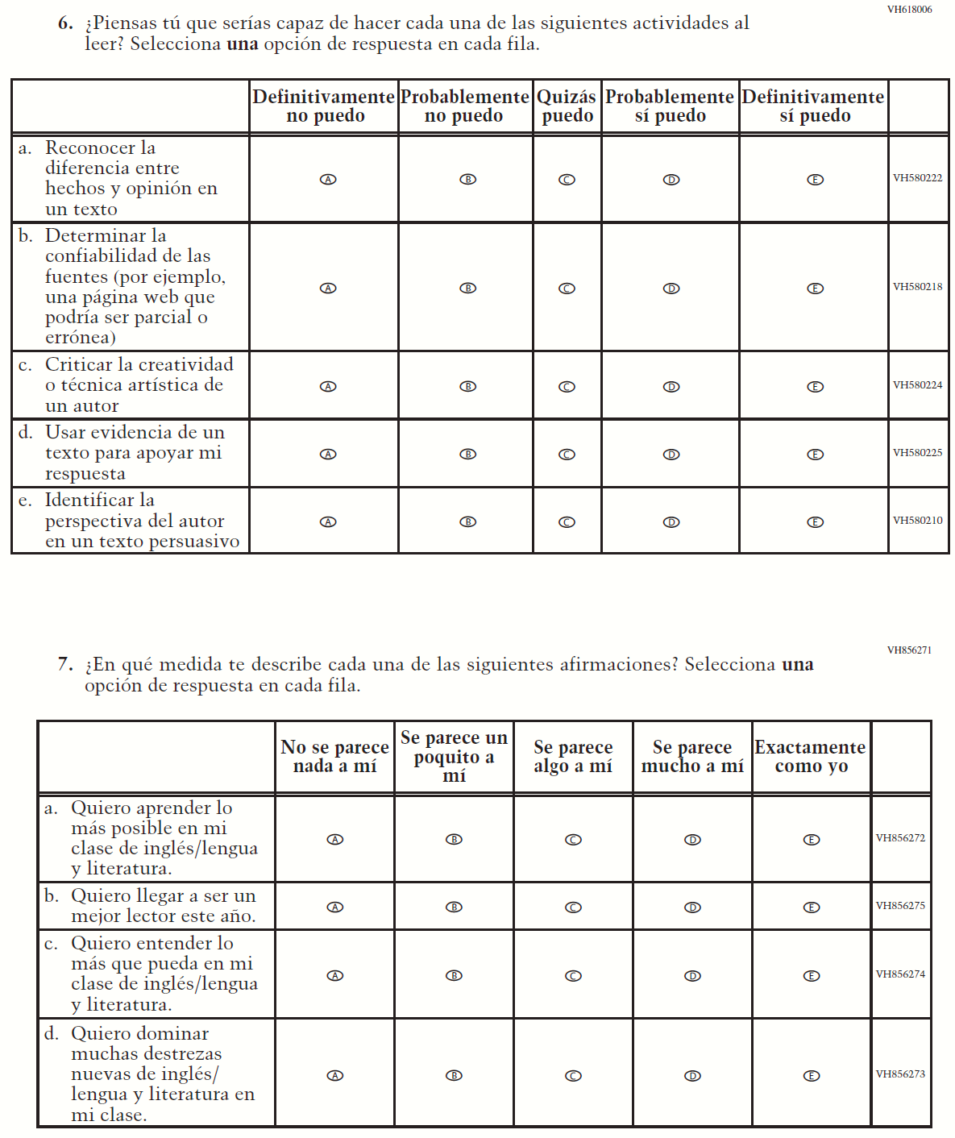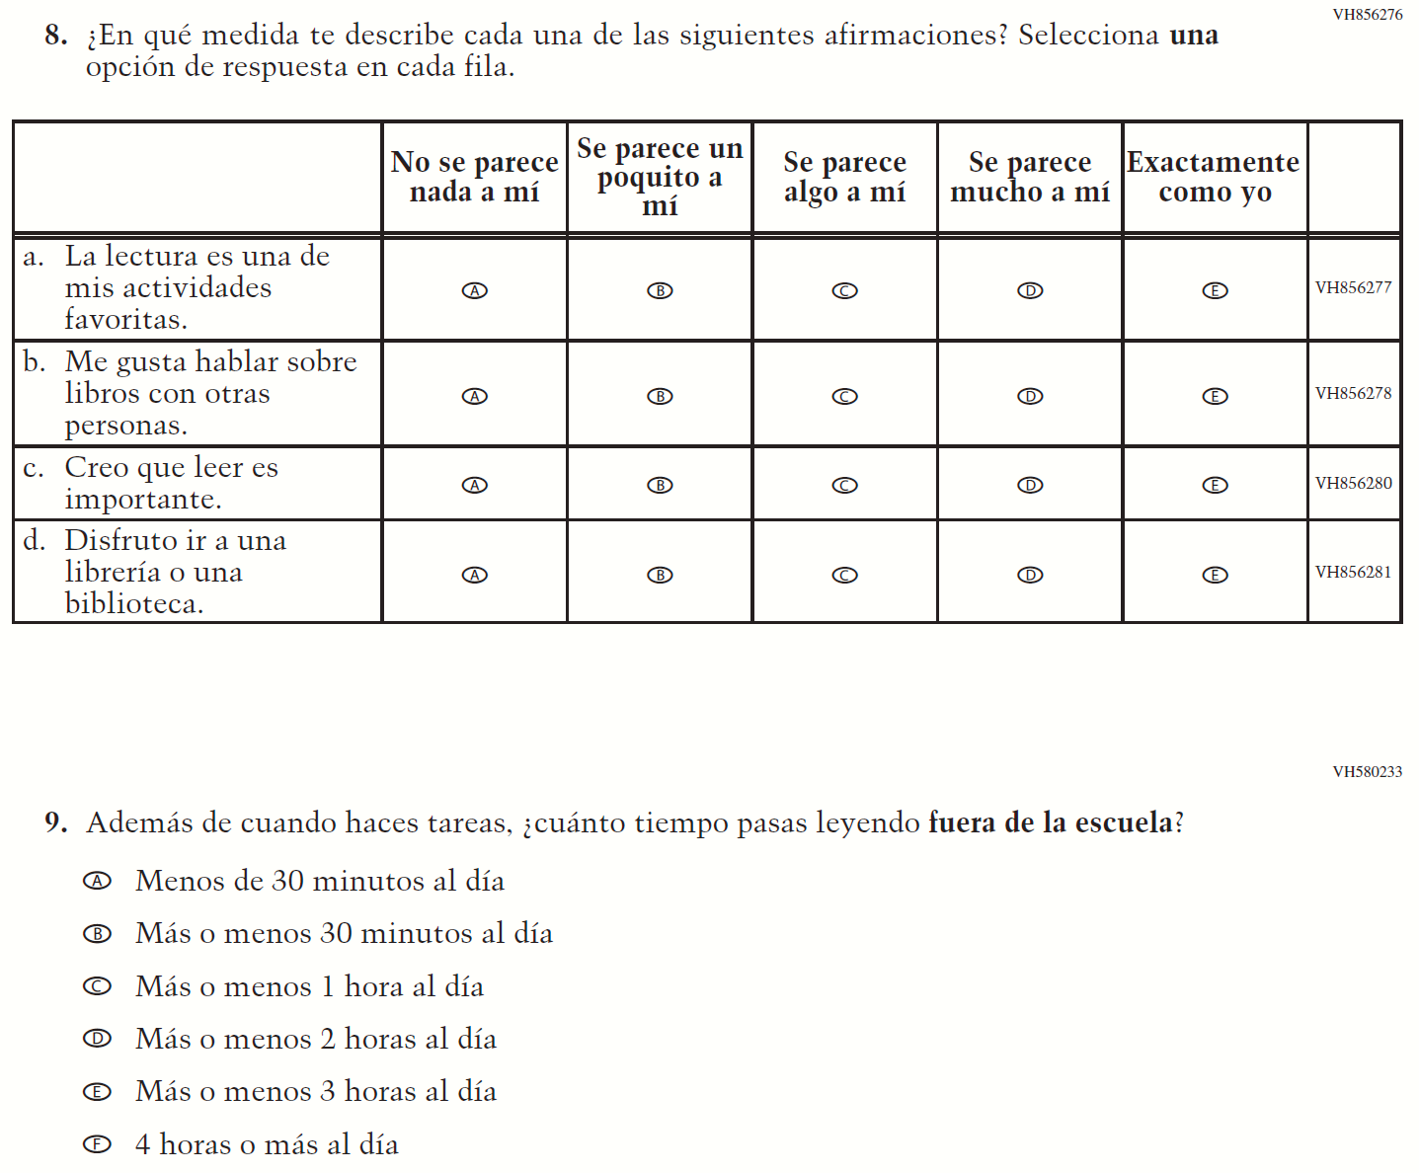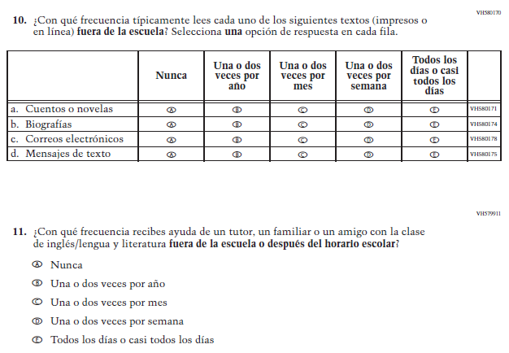
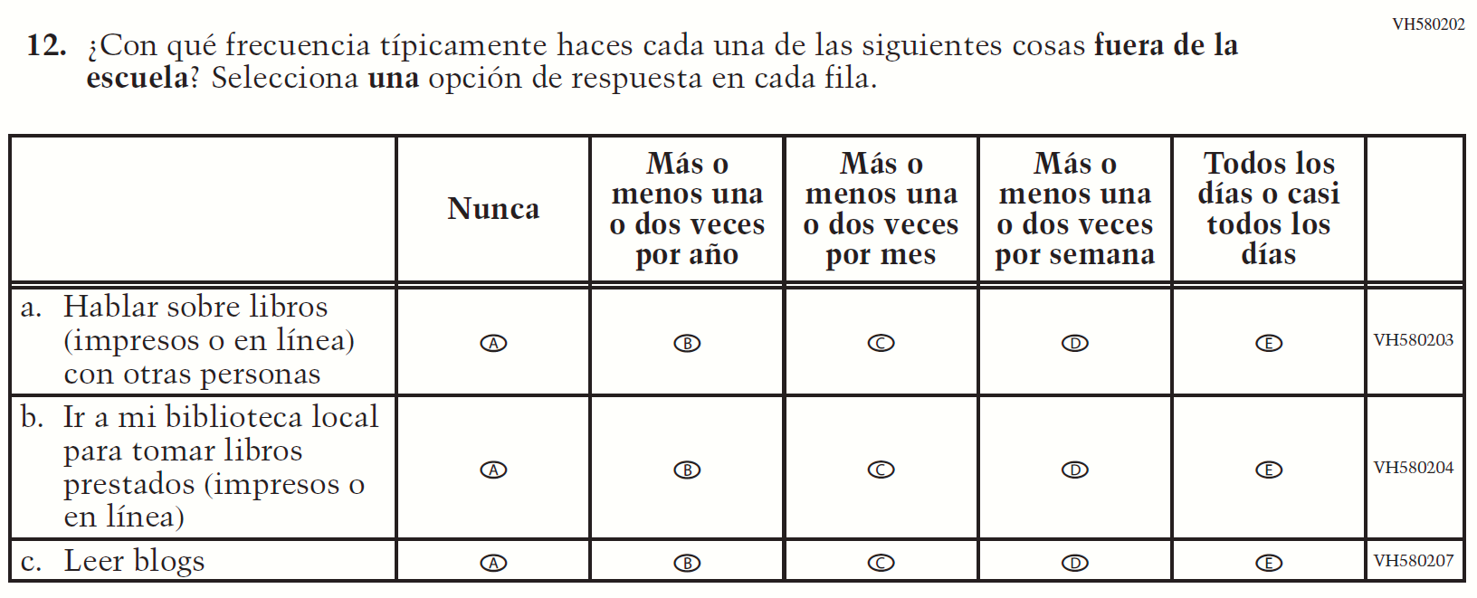

Appendix J-1k-s-BL: Operational Grade 8 Civics
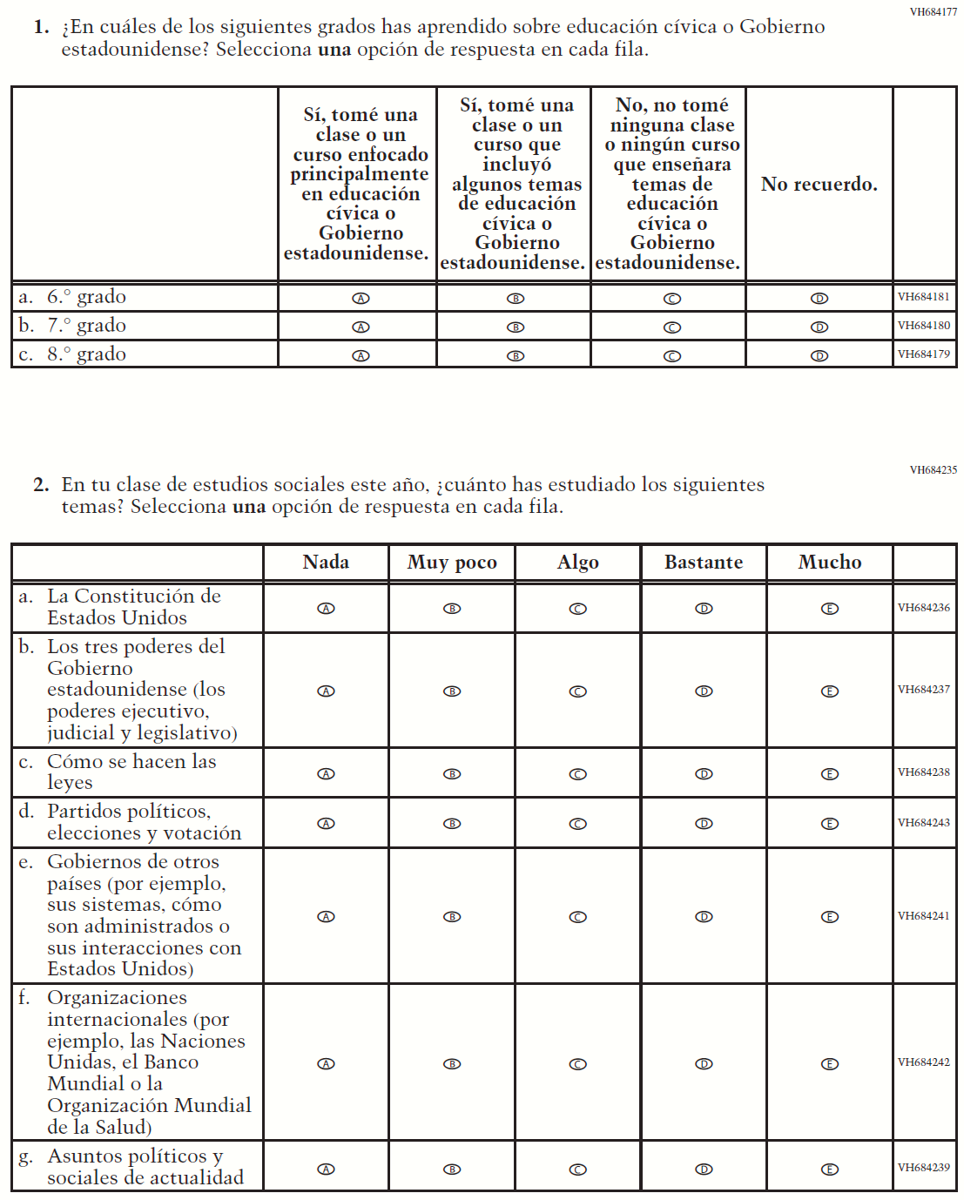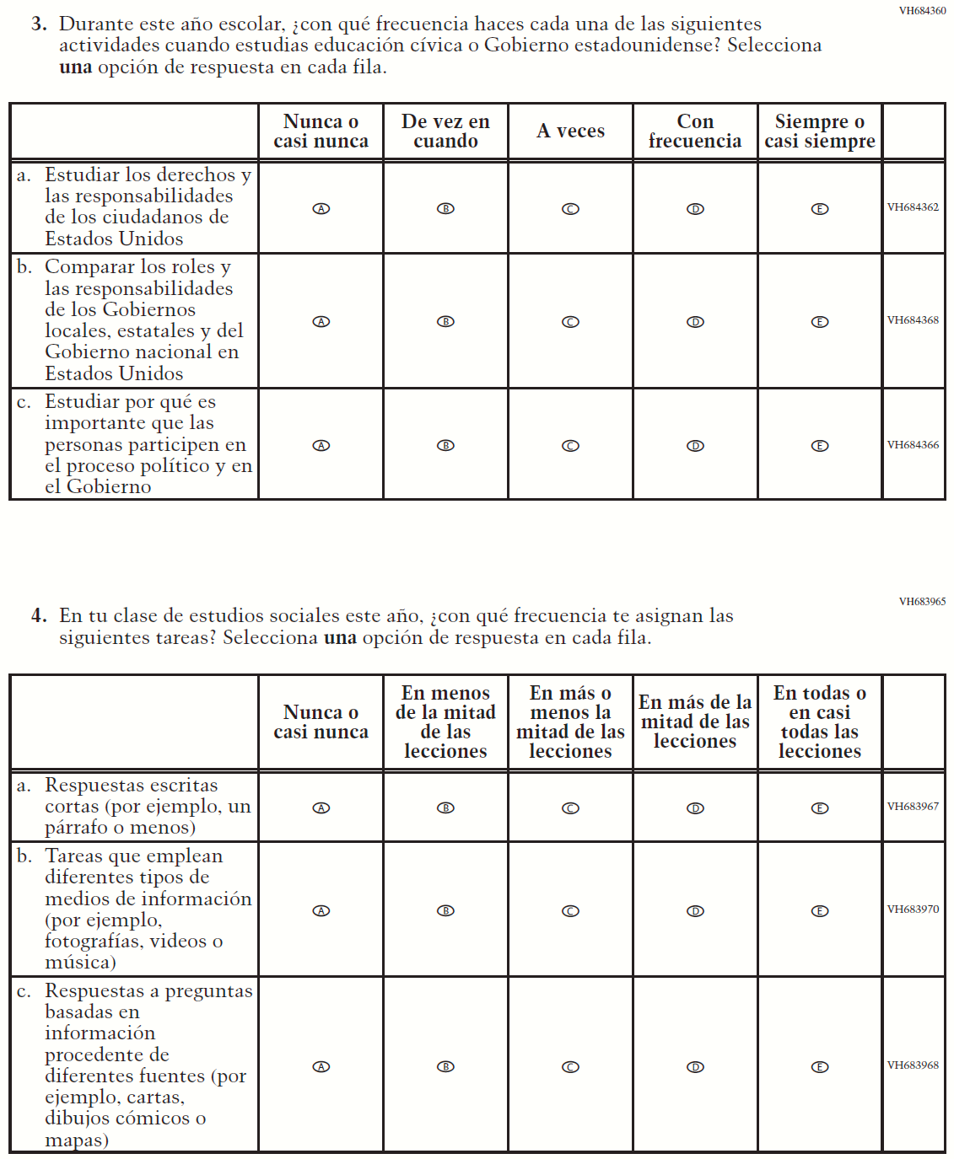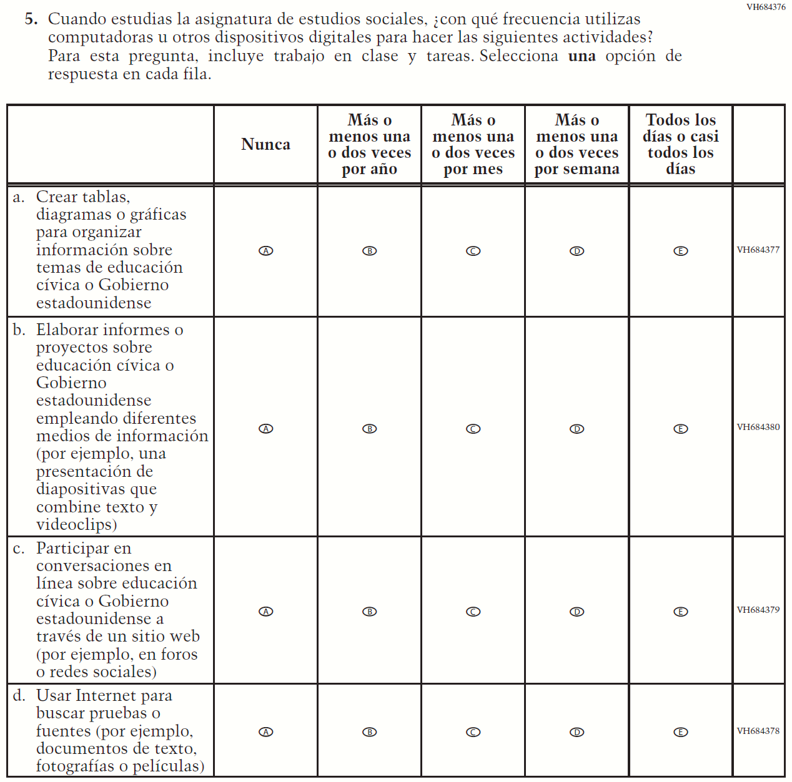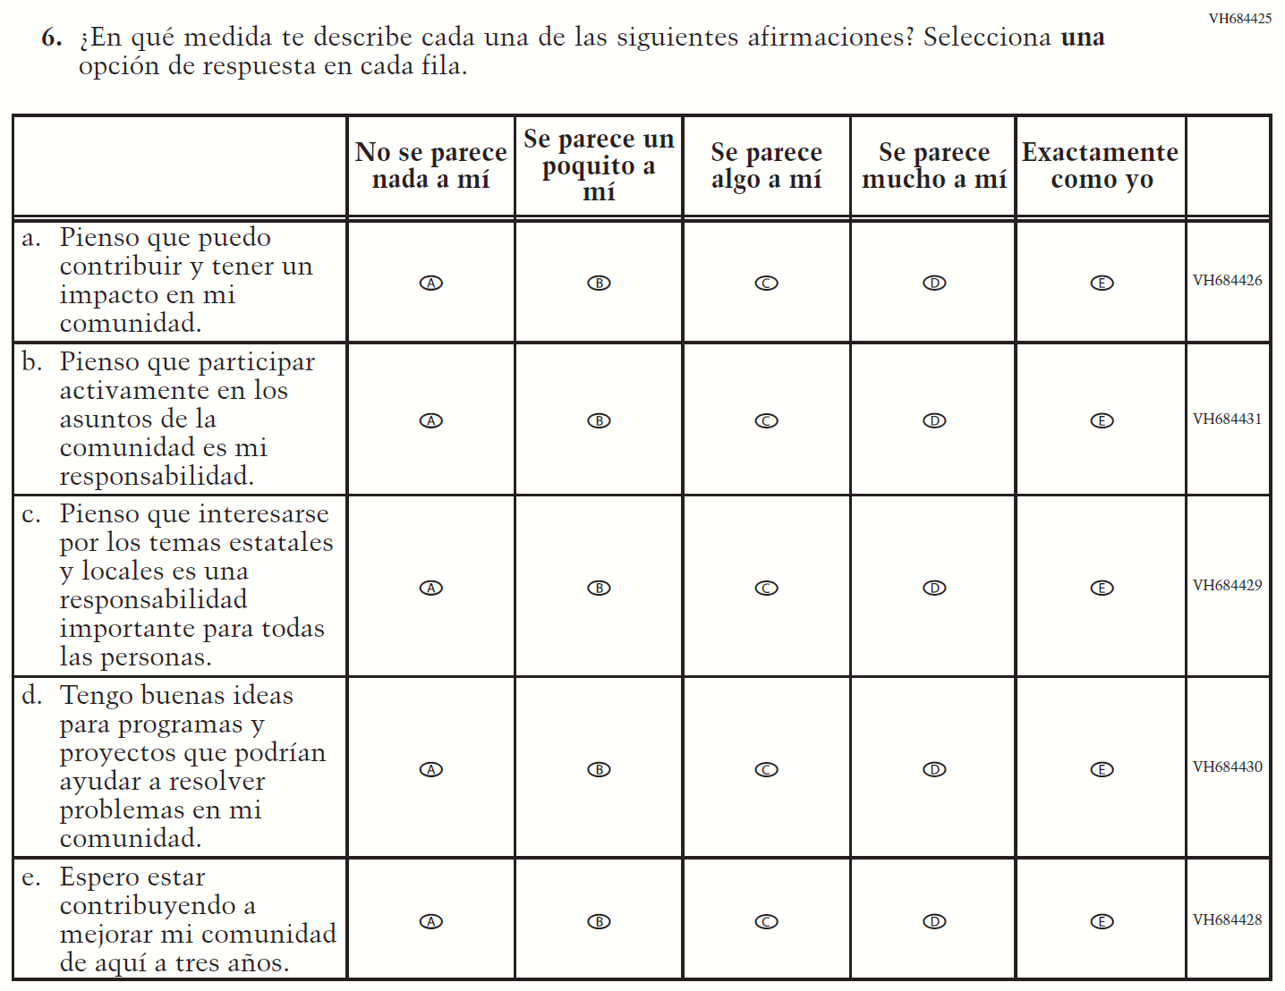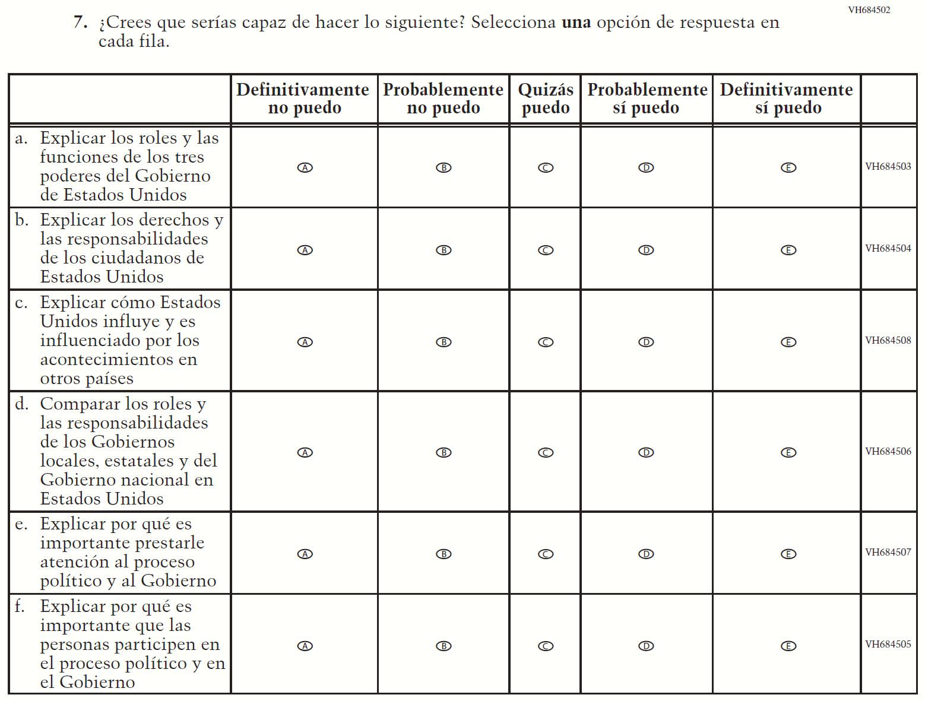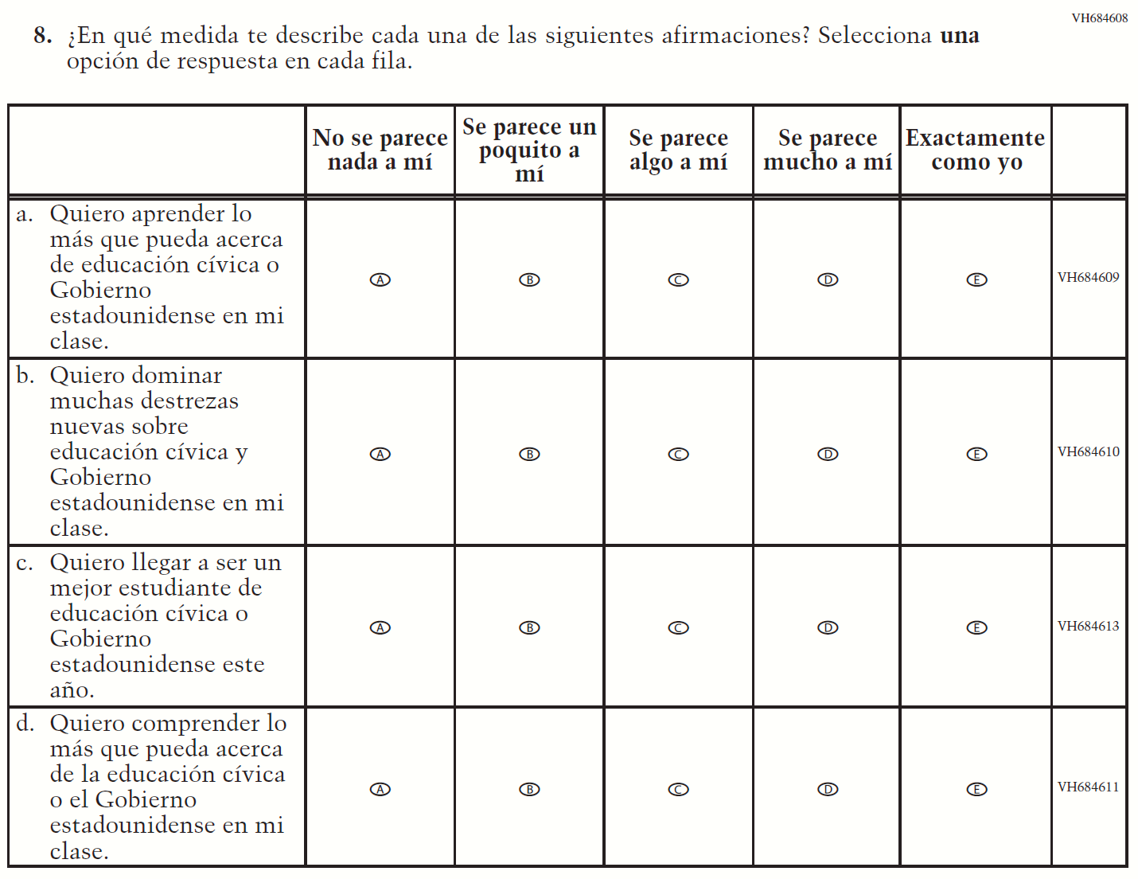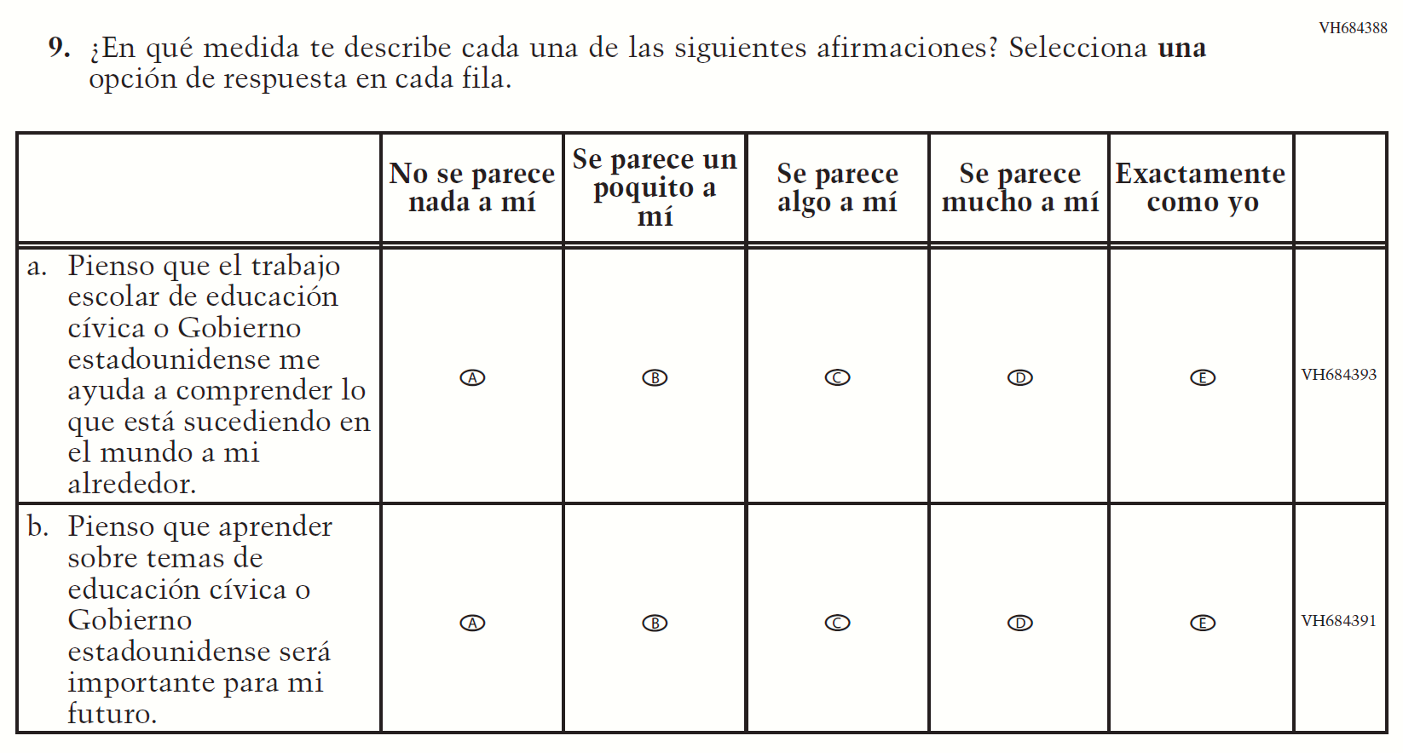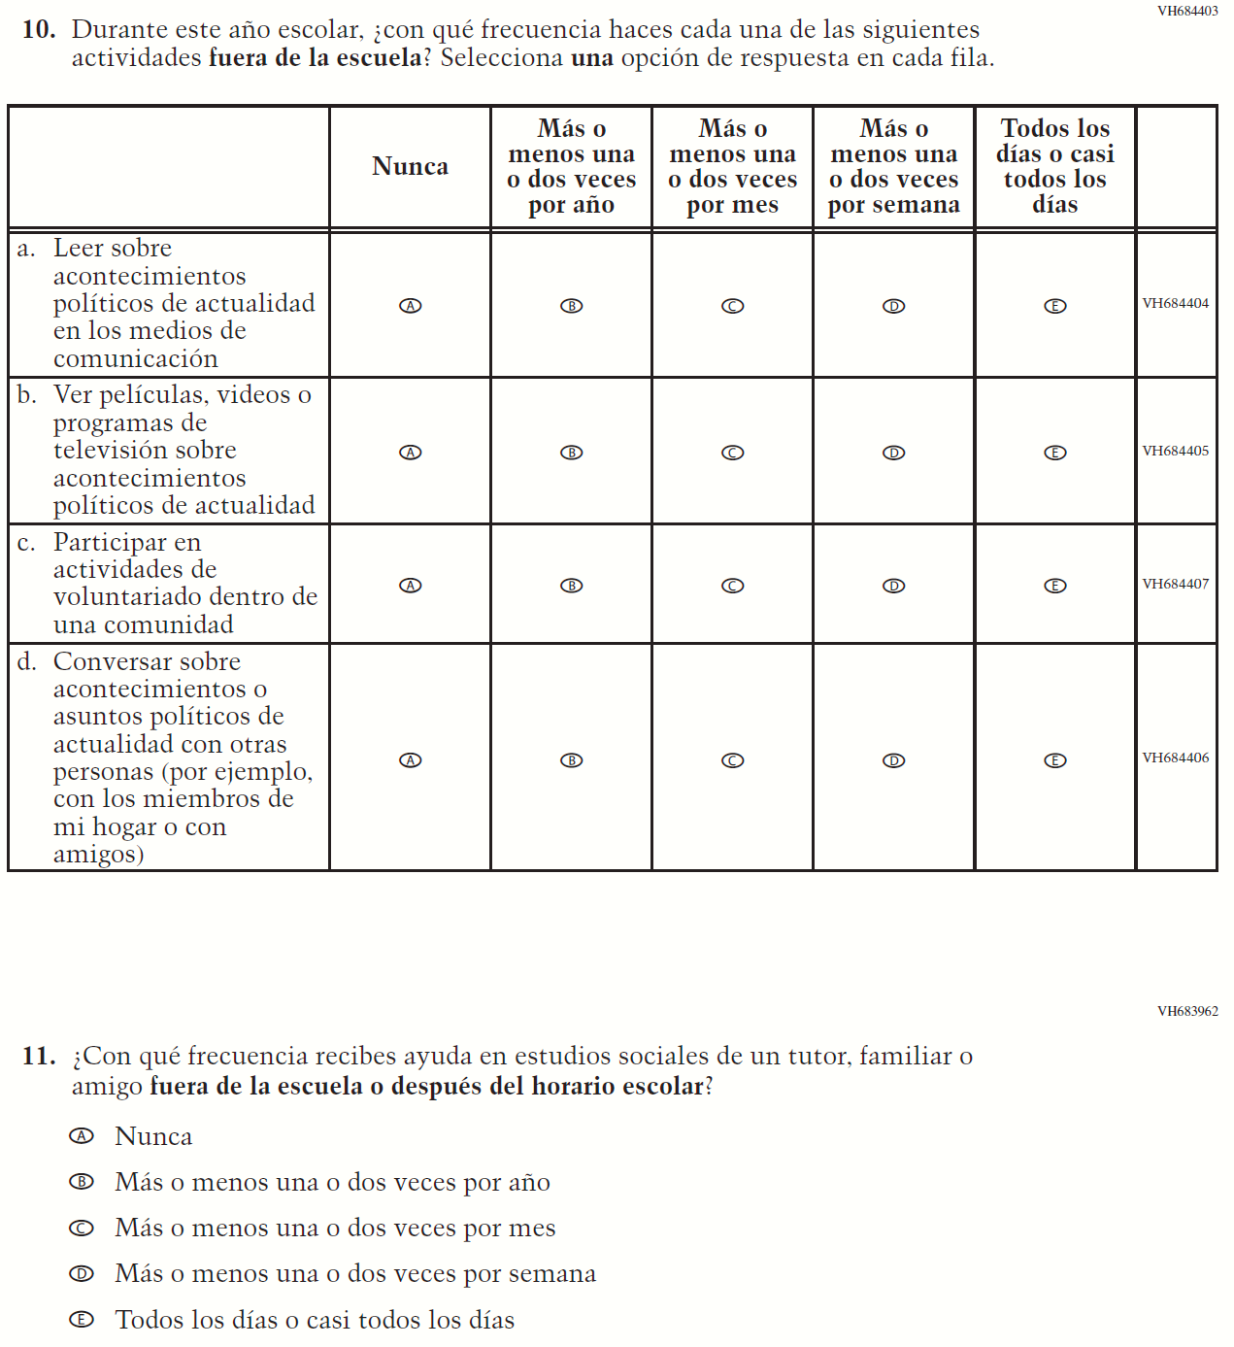

Appendix J-1l-s-BL: Operational Grade 8 US History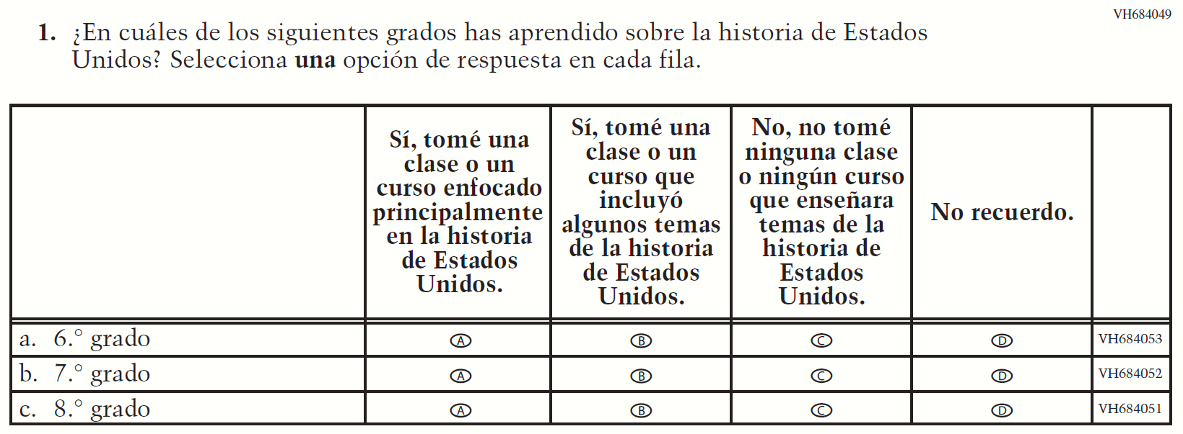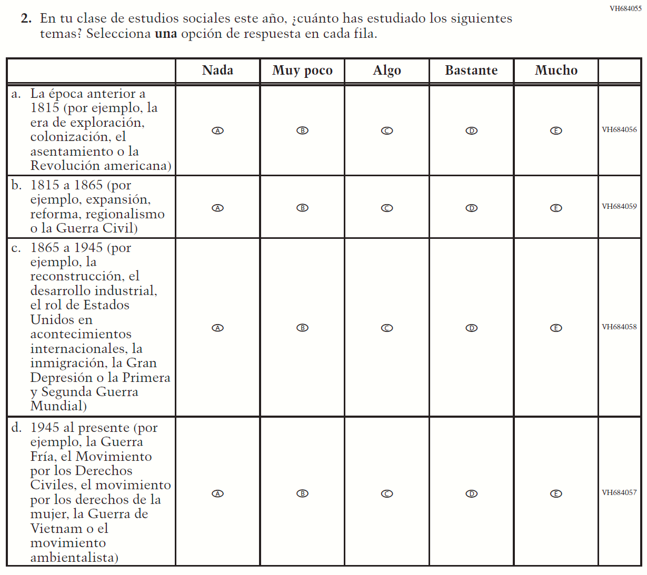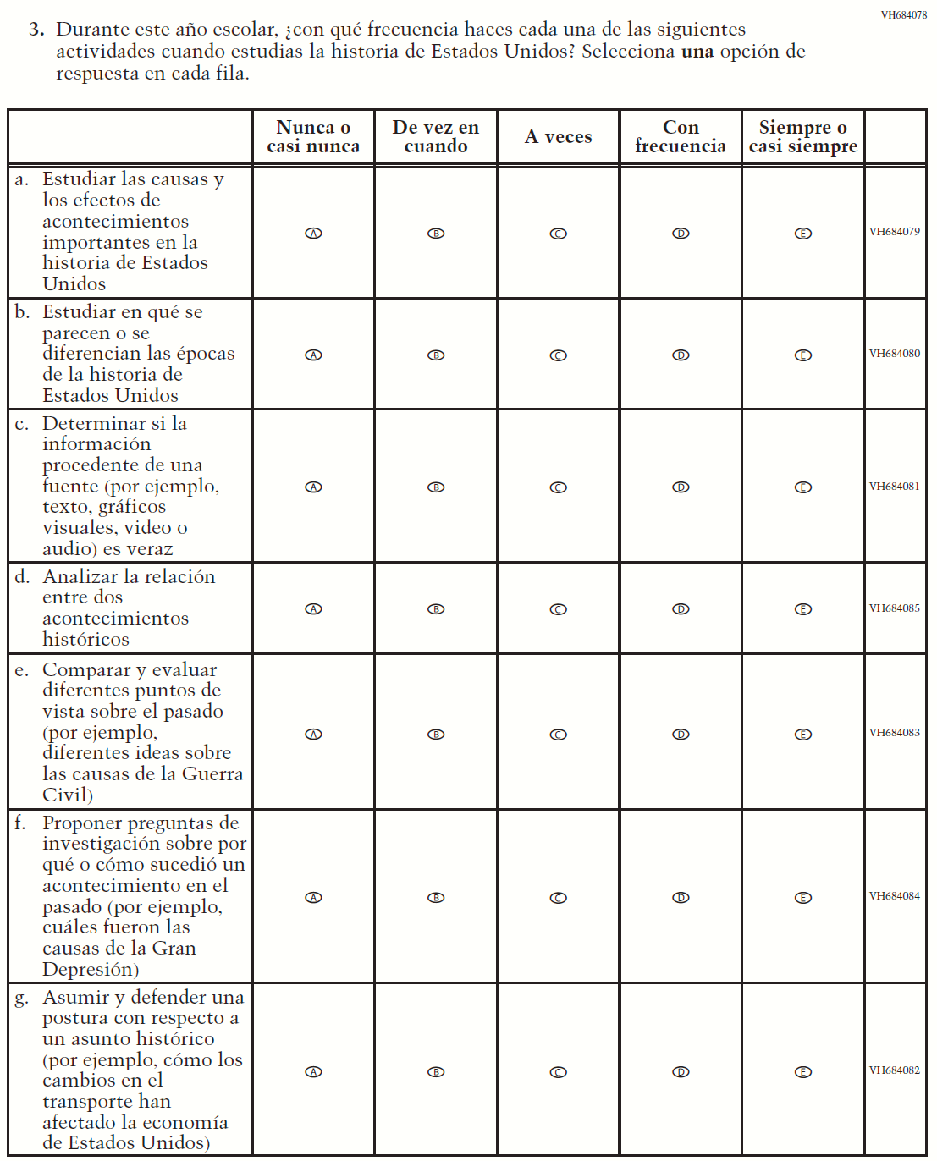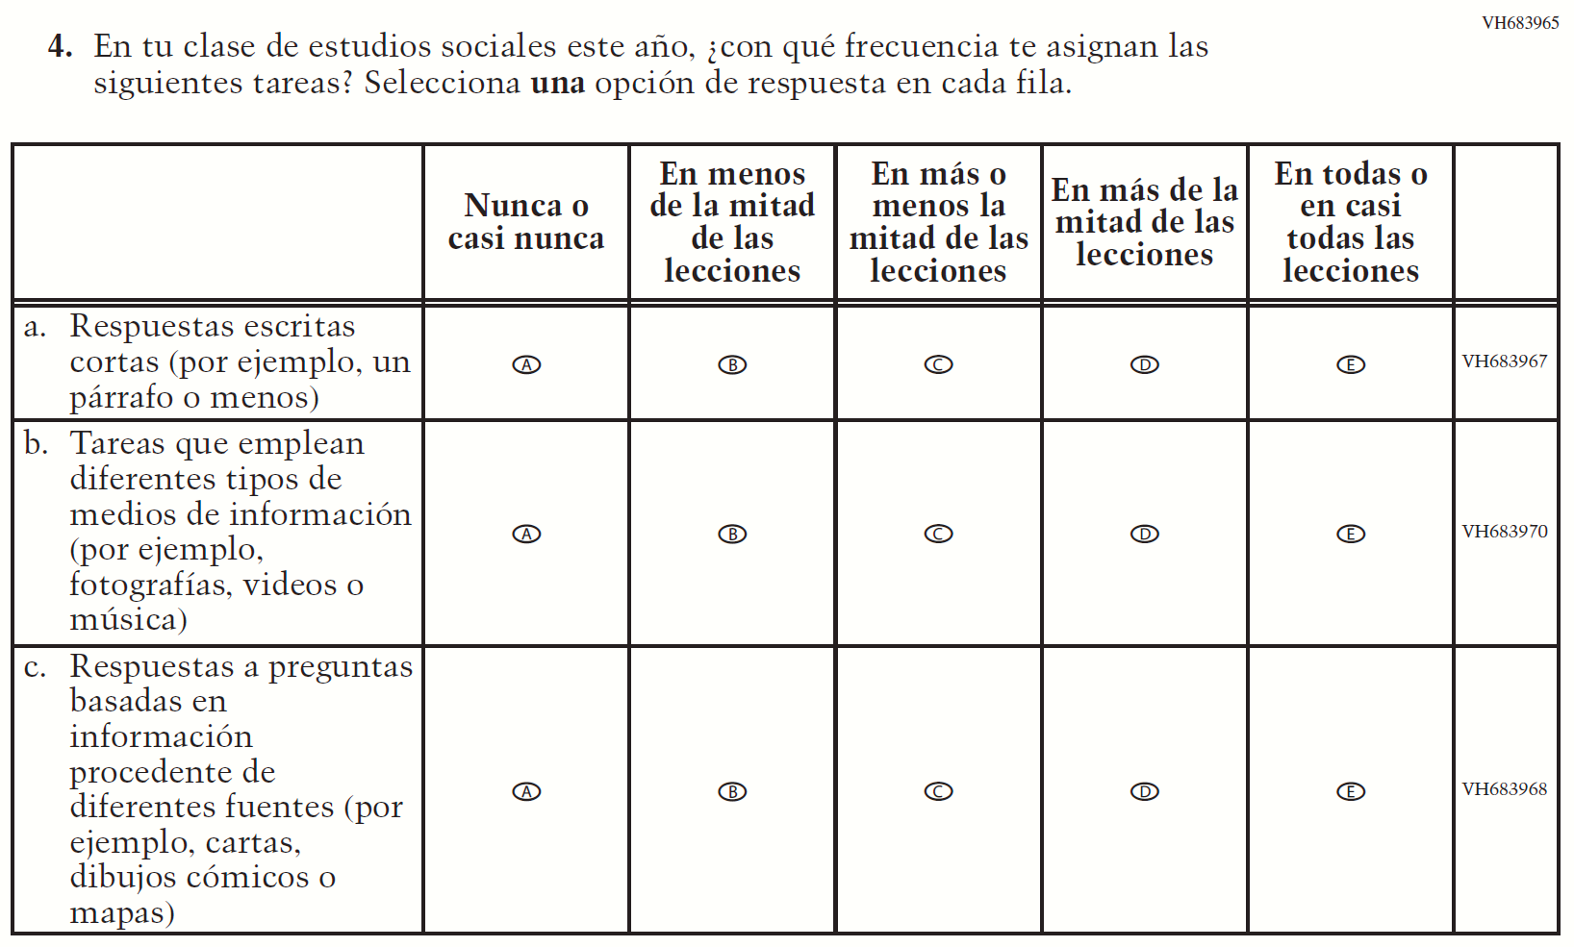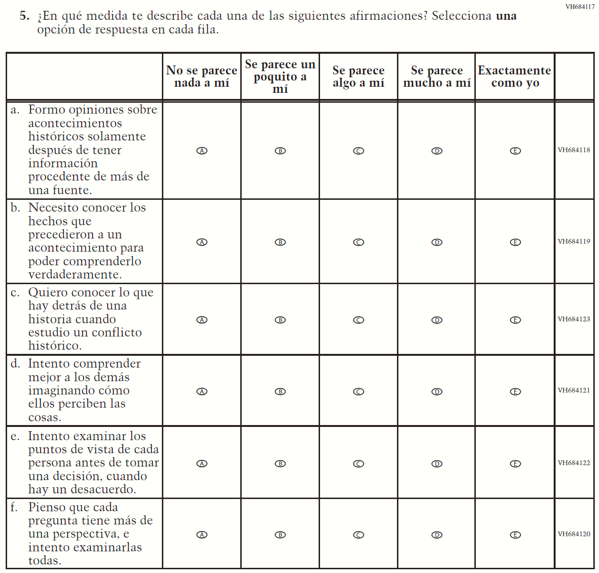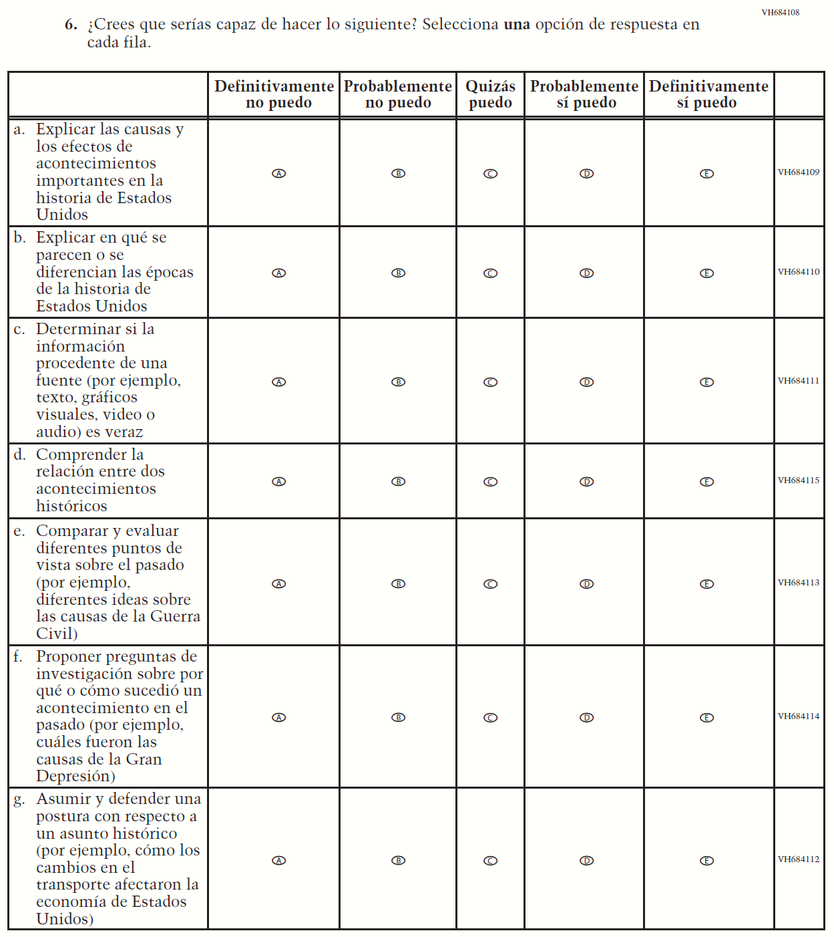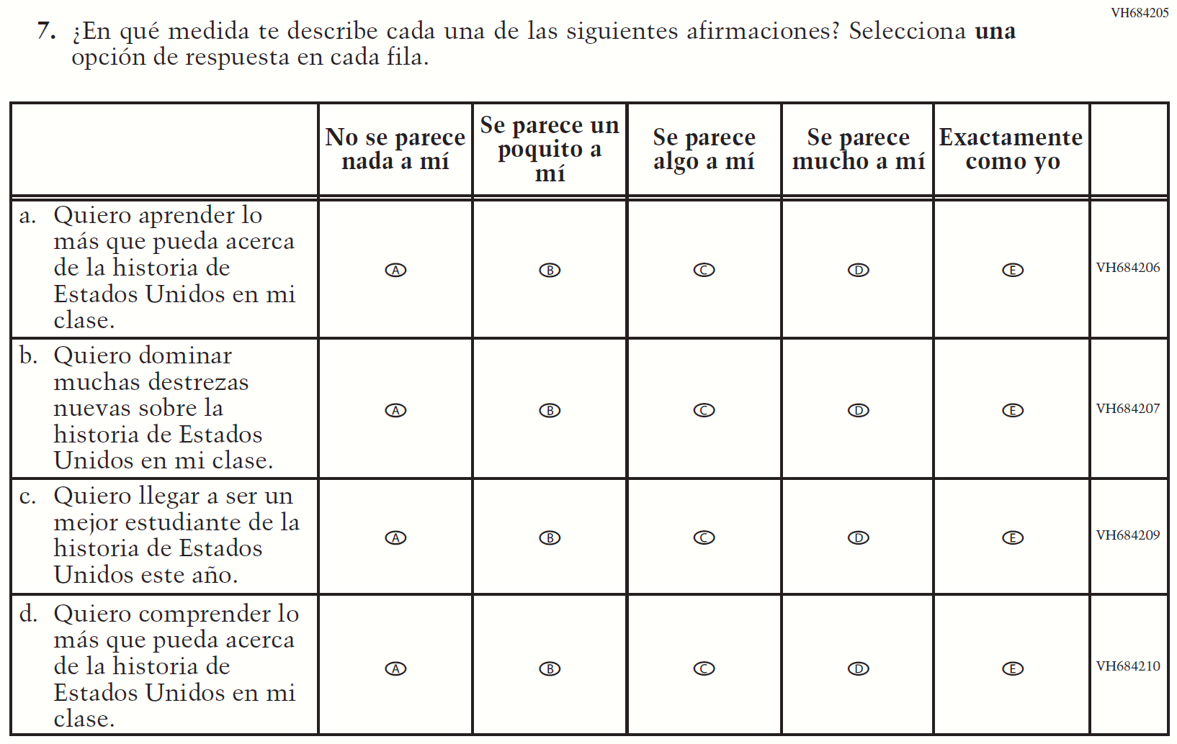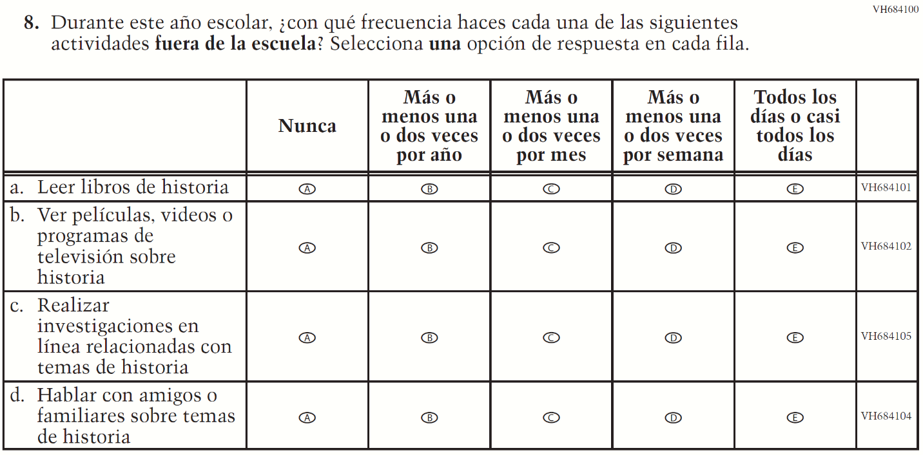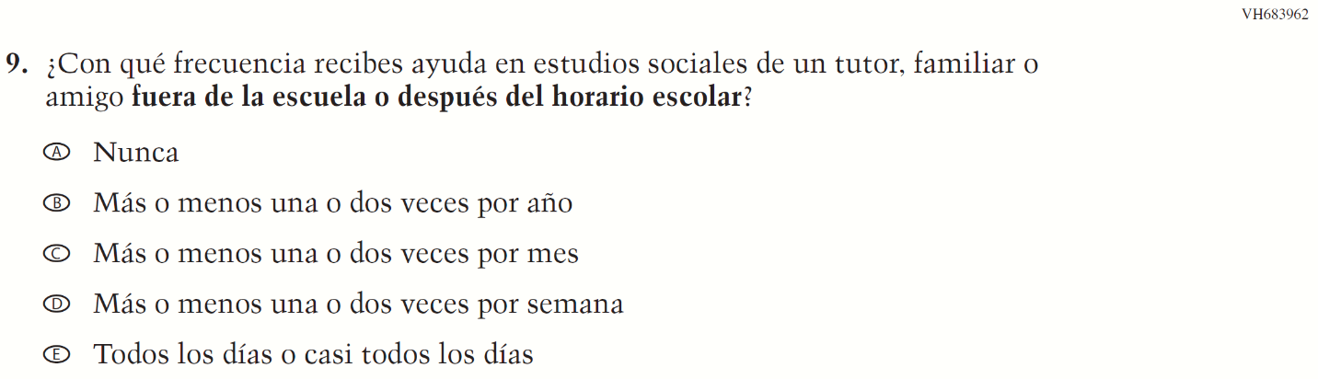

Appendix J-1m-s-BL: Summary of Operational Grade 4 Debrief
2021 Operational Grade 4 Debrief Student –Bilingual
Previous item | 2021 item | D/A/R/NC+ | Rationale
VH580900  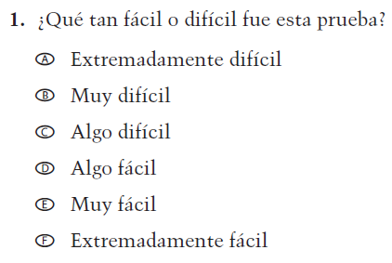  (2019 Operational Grade 4 and 8 Student Debrief- Bilingual) | N/A | D | To keep student burden low, this item was dropped.
VH580572  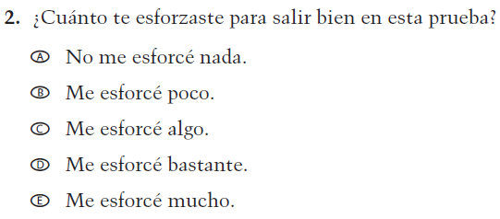  (2019 Operational Grade 4 and 8 Student Debrief- Bilingual) | VH580572  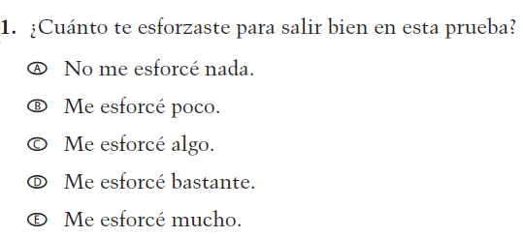  Issue: Debrief | NC | N/A

Appendix J-1m-s-BL: Operational Grade 4 Debrief
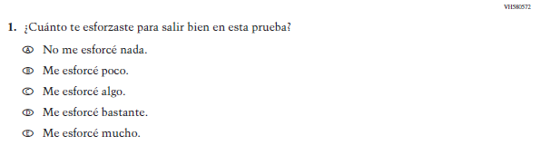

Appendix J-1n-s-PR: Summary of Operational Grade 4 Debrief
2021 Operational Grade 4 Debrief Student – Puerto Rico

Previous item | 2021 item | D/A/ R/NC+ | Rationale
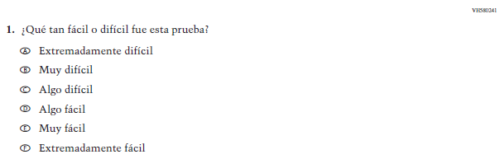  (2019 Operational Grade 4 and 8 Student Debrief – Puerto Rico) | N/A | D | To keep student burden low, this item was dropped.
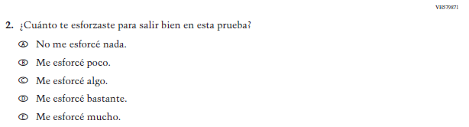  (2019 Operational Grade 4 and 8 Student Debrief – Puerto Rico) | 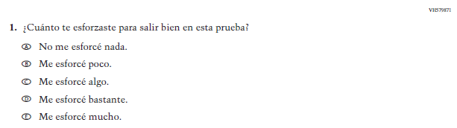  Issue: Debrief | NC | N/A

Appendix J-1n-s-PR: Operational Grade 4 Debrief
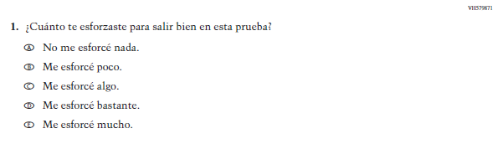

Appendix J-1o-s-BL: Summary of Operational Grade 8 Debrief
2021 Operational Grade 8 Debrief Student – Bilingual
Previous item | 2021 item | D/A/R/NC+ | Rationale
VH580900  (2019 Operational Grade 4 and 8 Student Debrief- Bilingual) | VH580900  Issue: Debrief | NC | N/A
VH580572  (2019 Operational Grade 4 and 8 Student Debrief- Bilingual) | VH580572  Issue: Debrief | NC | N/A

Appendix J-1o-s-BL: Operational Grade 8 Debrief
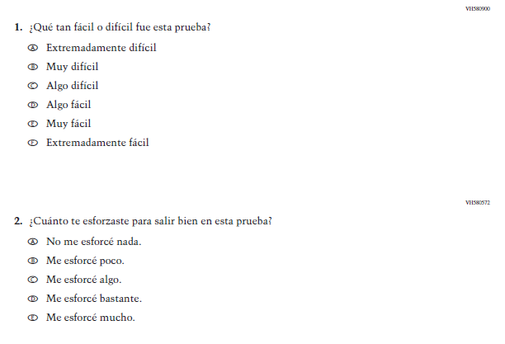

Appendix J-1p-s-PR: Summary of Operational Grade 8 Debrief
2021 Operational Grade 8 Debrief Student – Puerto Rico

Previous item | 2021 item | D/A/ R/NC+ | Rationale
(2019 Operational Grade 4 and 8 Student Debrief – Puerto Rico) | Issue: Debrief | NC | N/A
(2019 Operational Grade 4 and 8 Student Debrief – Puerto Rico) | Issue: Debrief | NC | N/A

Appendix J-1p-s-PR: Operational Grade 8 Debrief
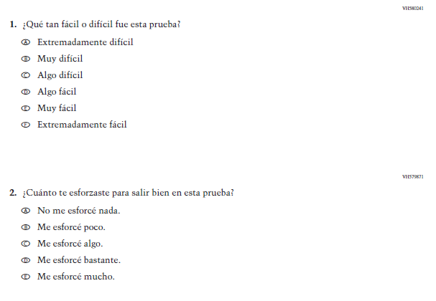

Appendix J-1q-s-BL: Operational Grade 4 COVID-19 (ELA) (New)
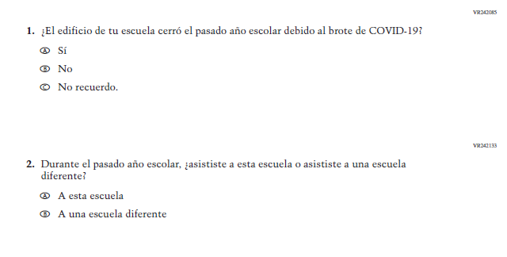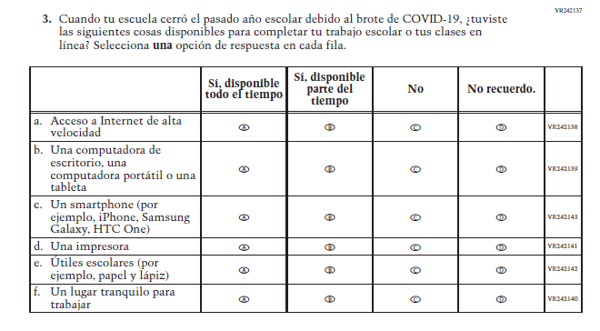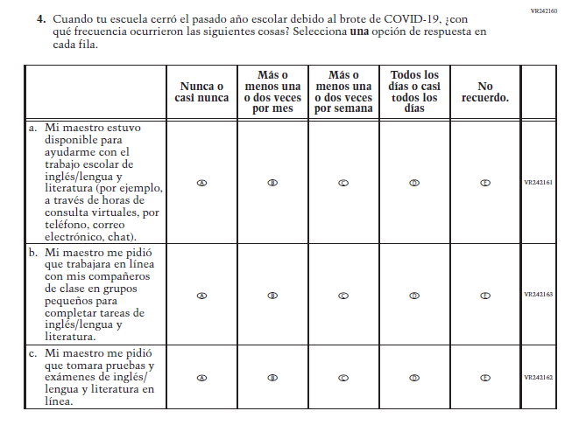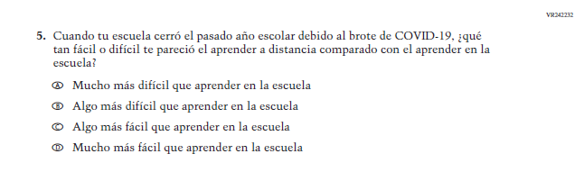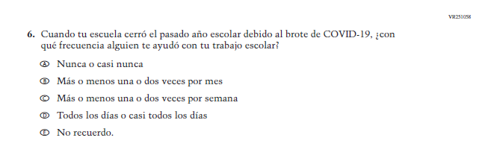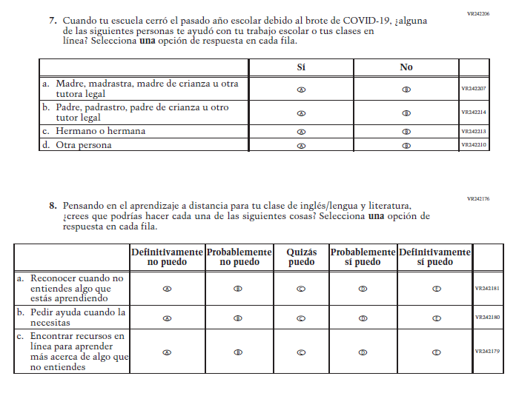

Appendix J-1r-s-BL: Operational Grade 8 COVID-19 (ELA) (New)
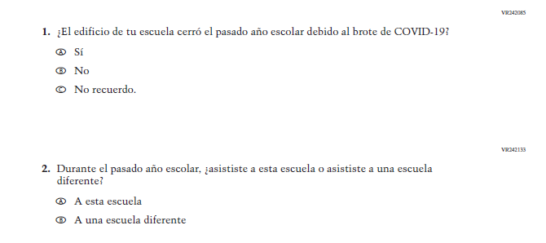
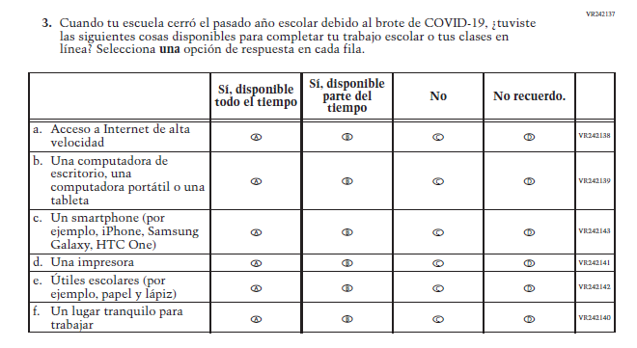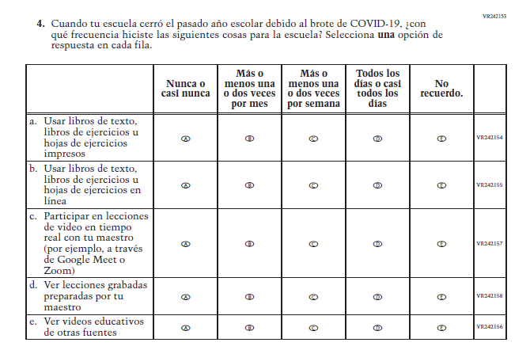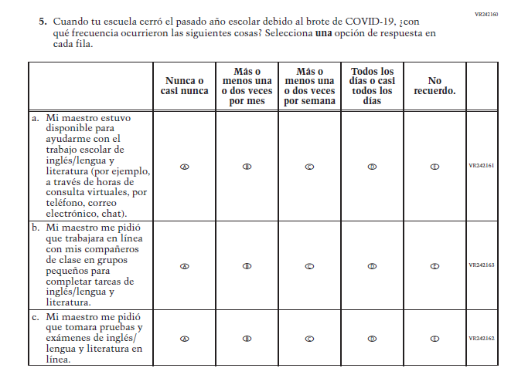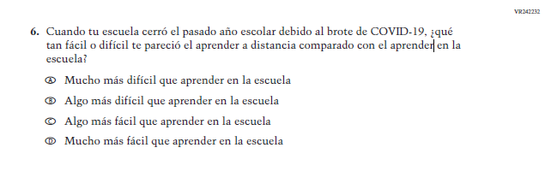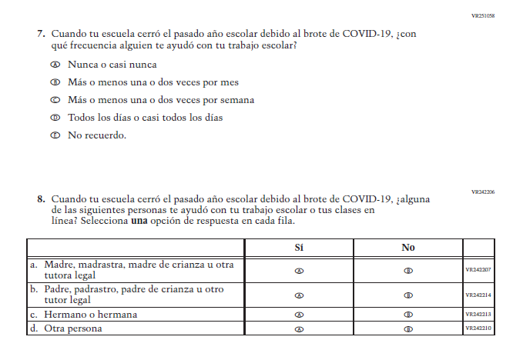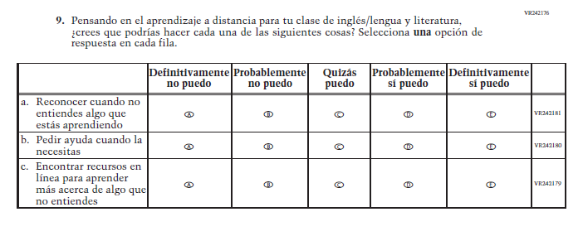

Appendix J-1s-s-BL: Operational Grade 4 COVID-19 (Math) (New)
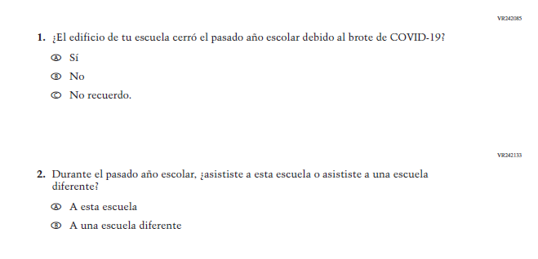
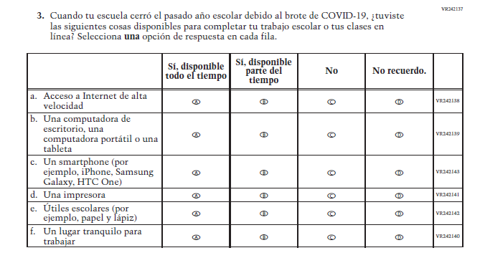
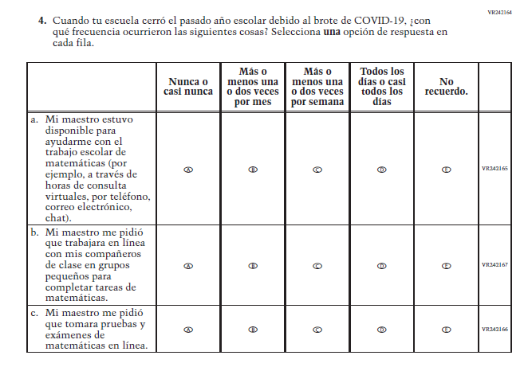
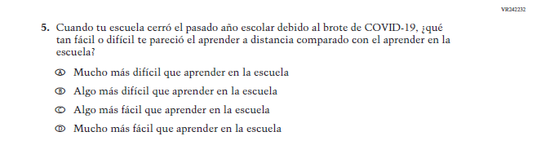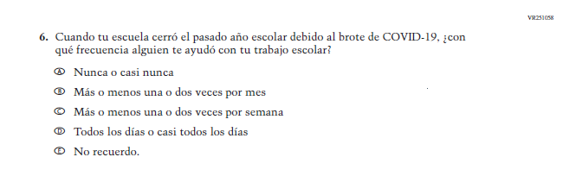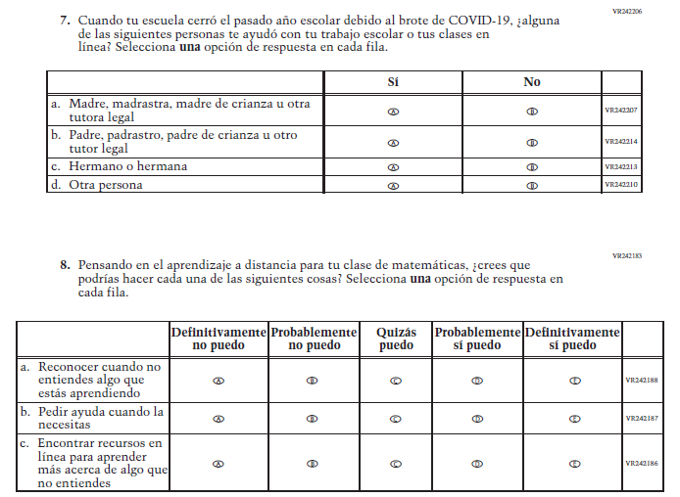

Appendix J-1t-s-PR: Operational Grade 4 COVID-19 (Math) (New)
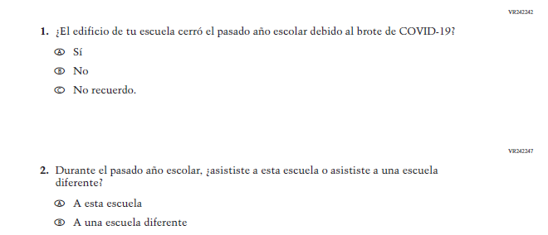
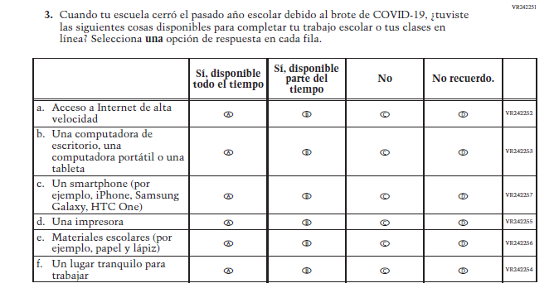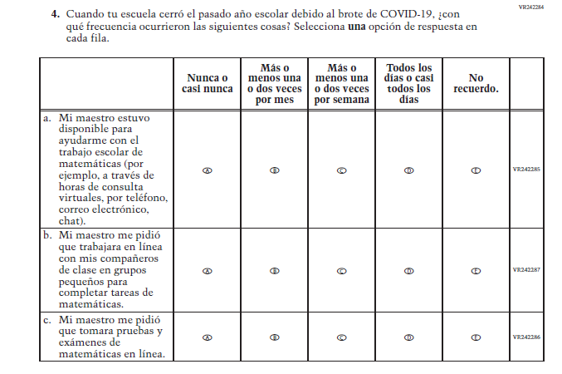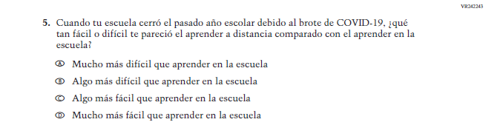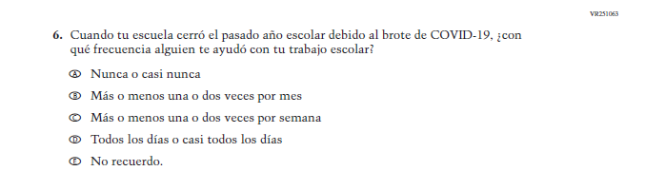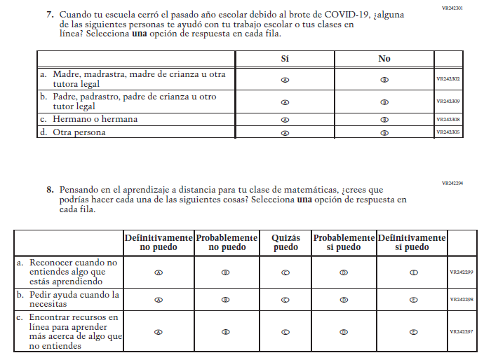

Appendix J-1u-s-BL: Operational Grade 8 COVID-19 (Math) (New)
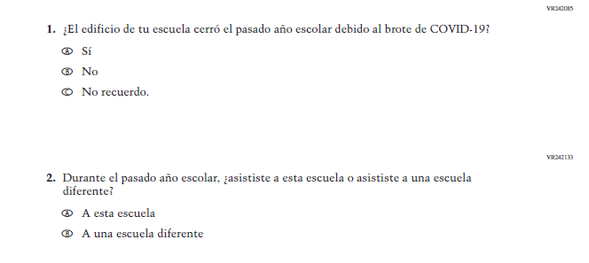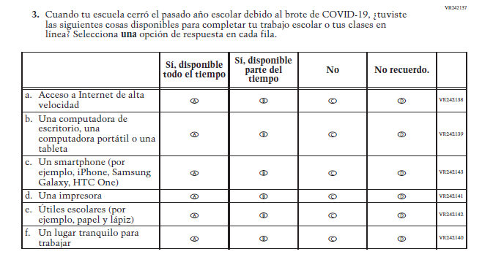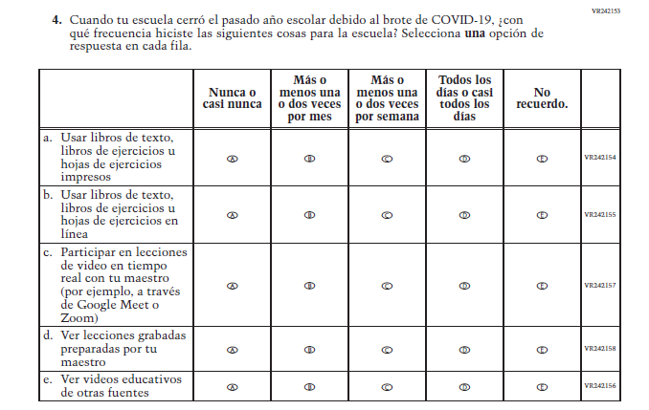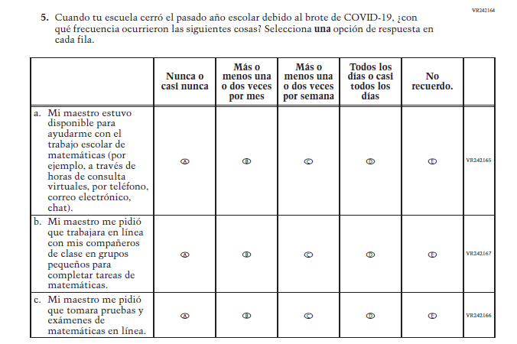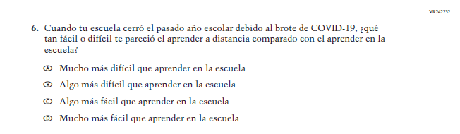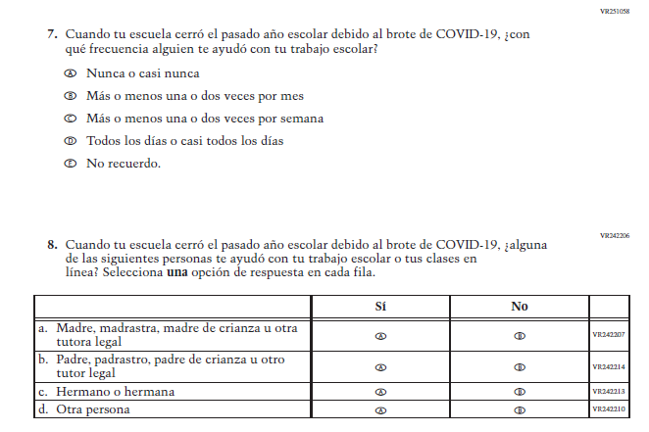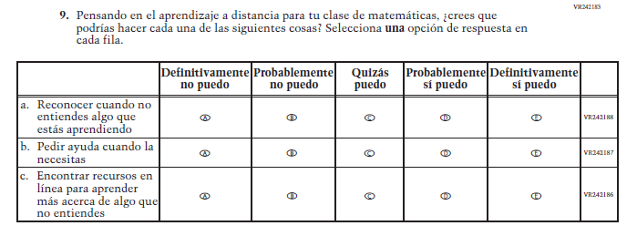

Appendix J-1v-s-PR: Operational Grade 8 COVID-19 (Math) (New)
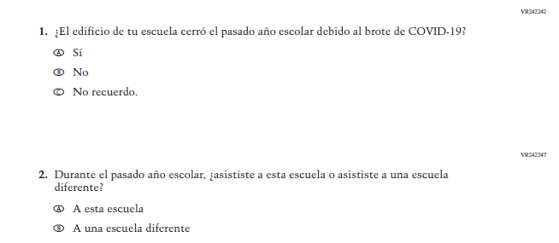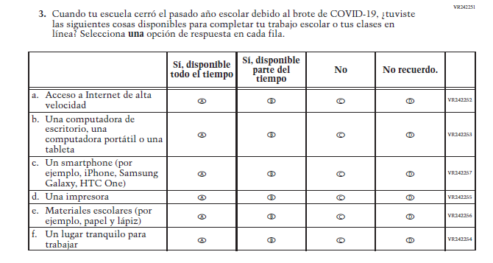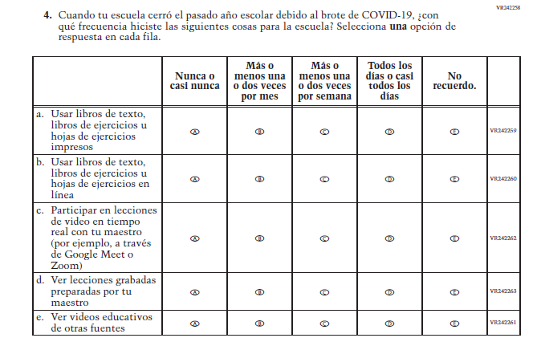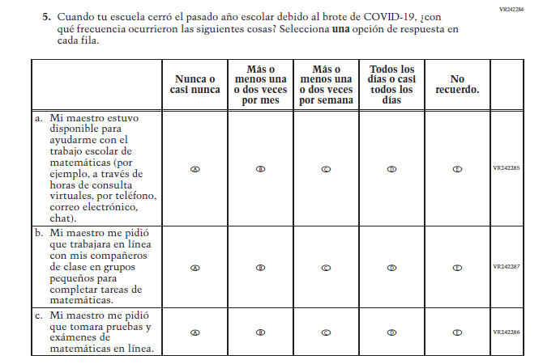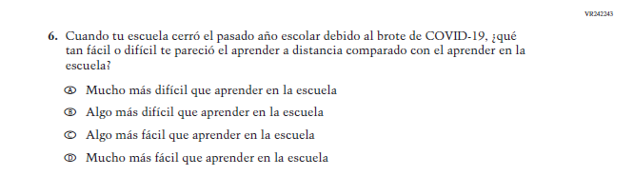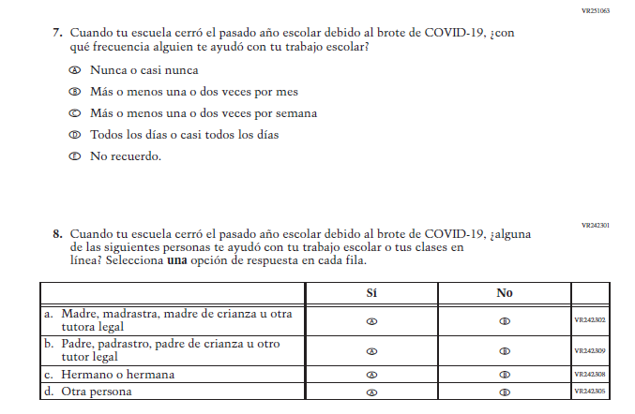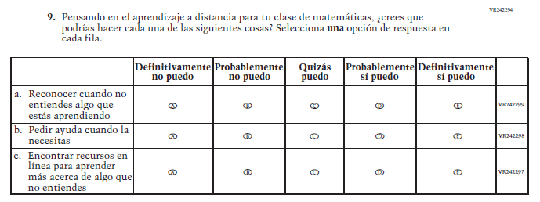

Appendix J-1w-s-BL: Online Grade 4 (CORE) (New)
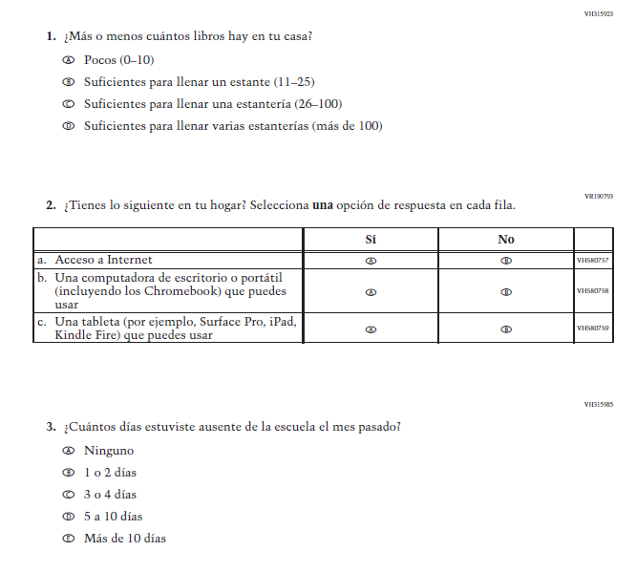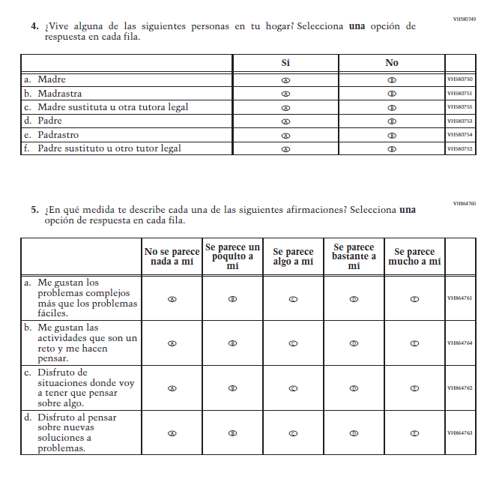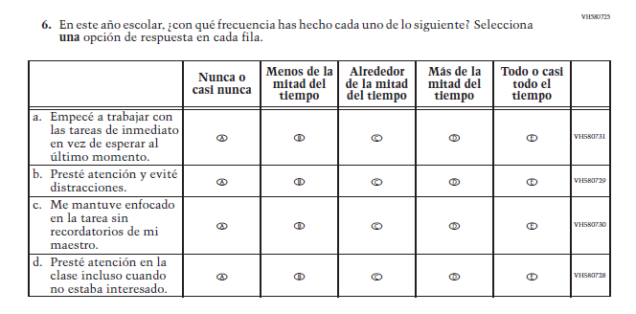

Appendix J-1x-s-PR: Online Grade 4 (CORE) (New)
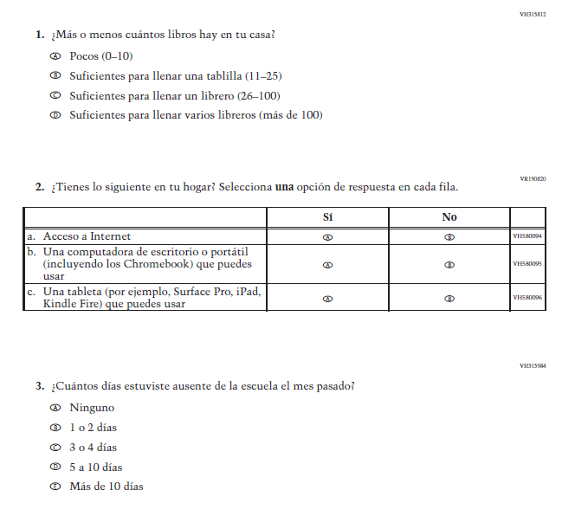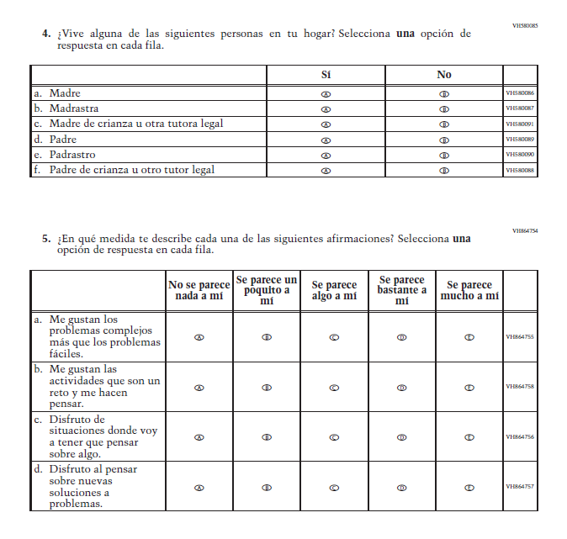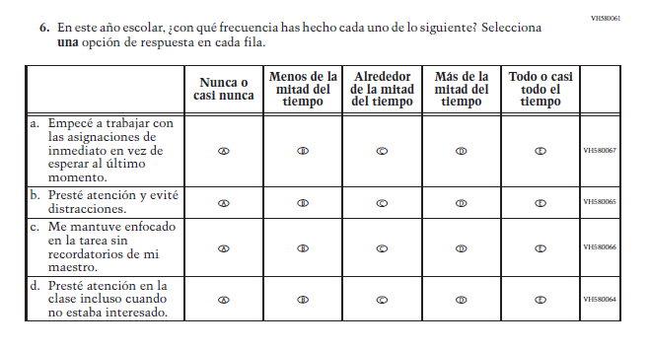

Appendix J-1y-s-BL: Online Grade 8 (CORE) (New)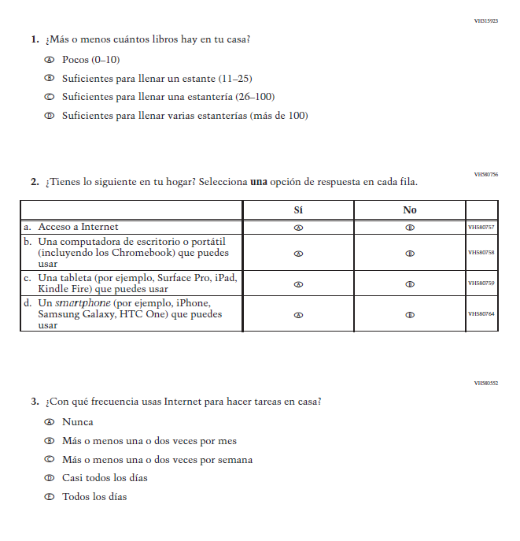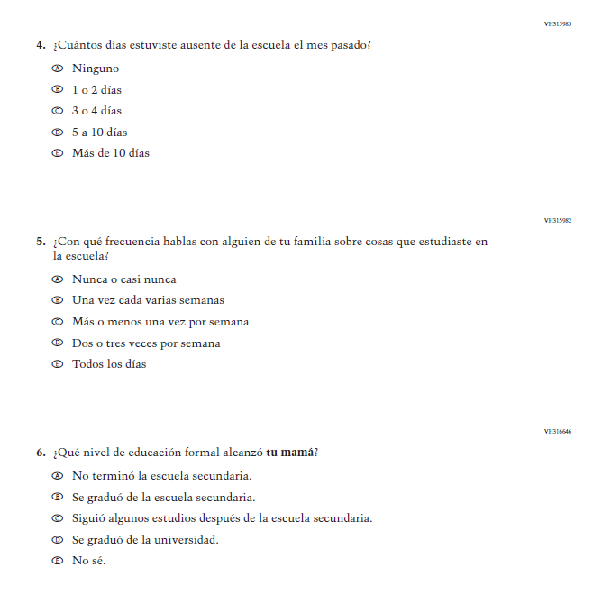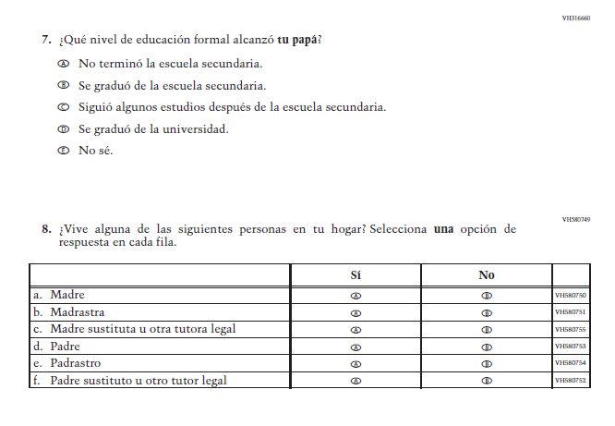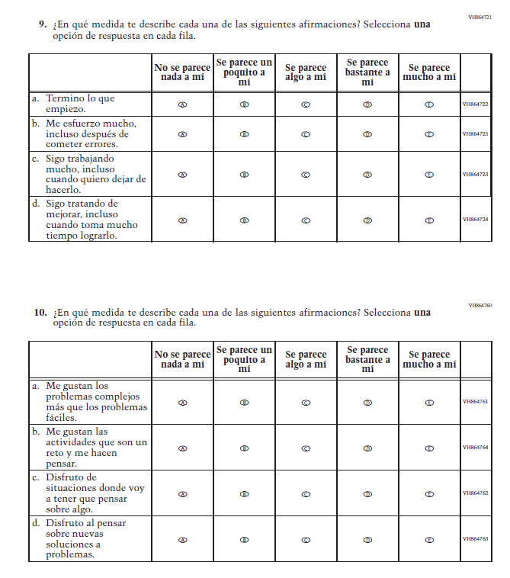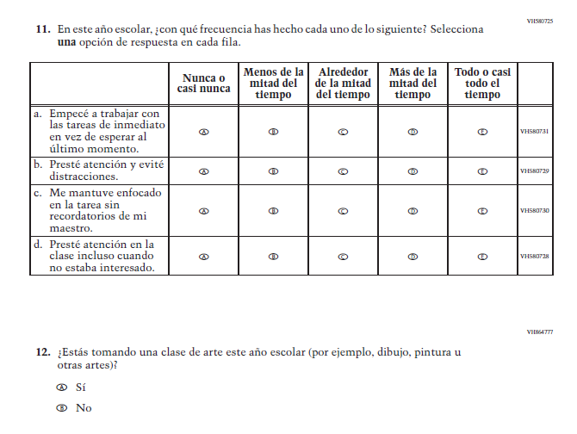

Appendix J-1z-s-PR: Online Grade 8 (CORE) (New)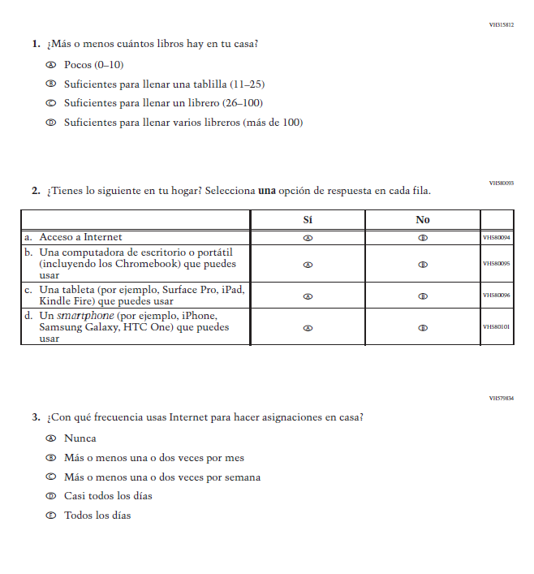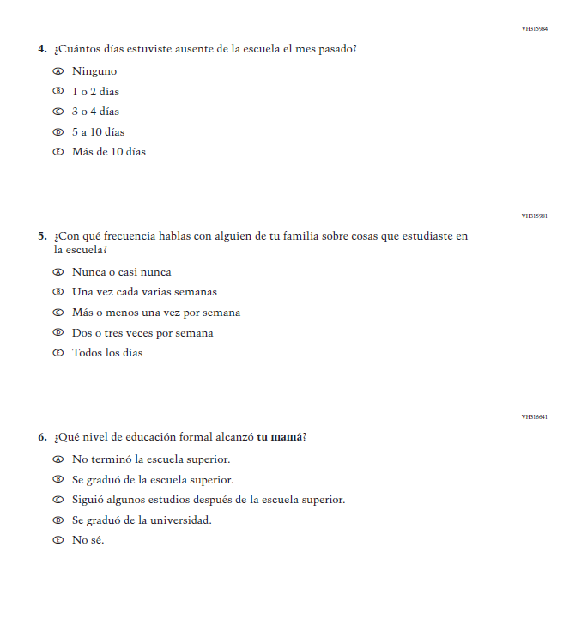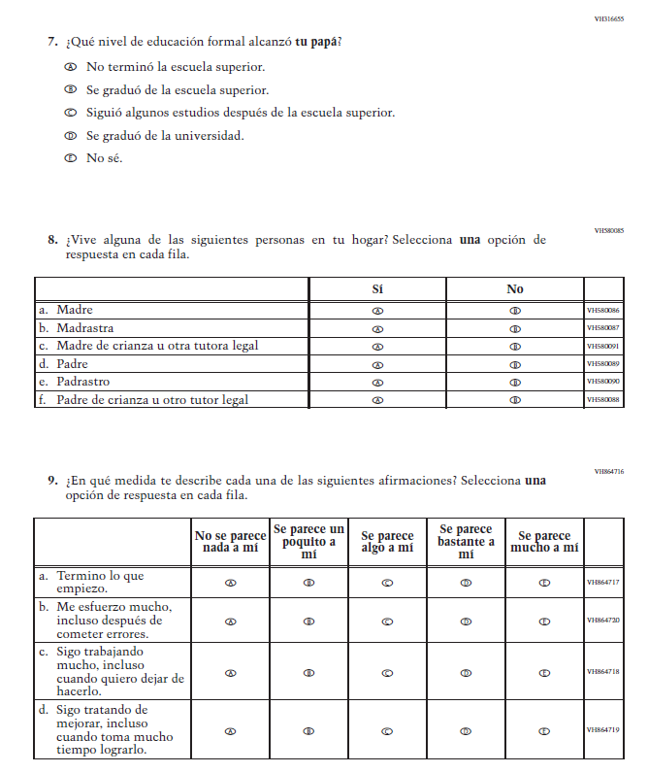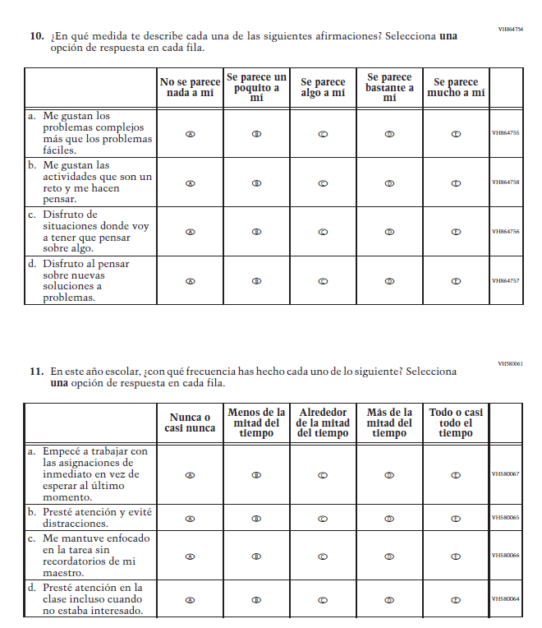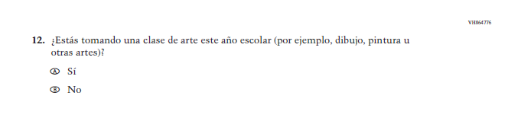

Appendix J-1aa-s-BL: Online Grade 4 (Math) (New)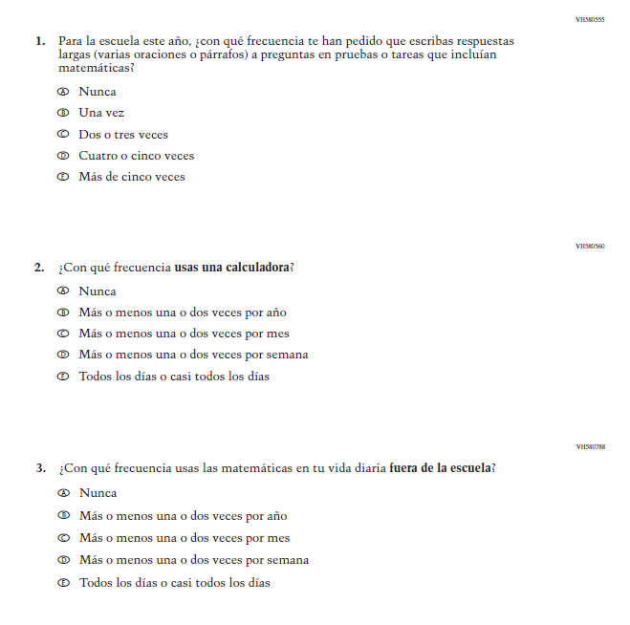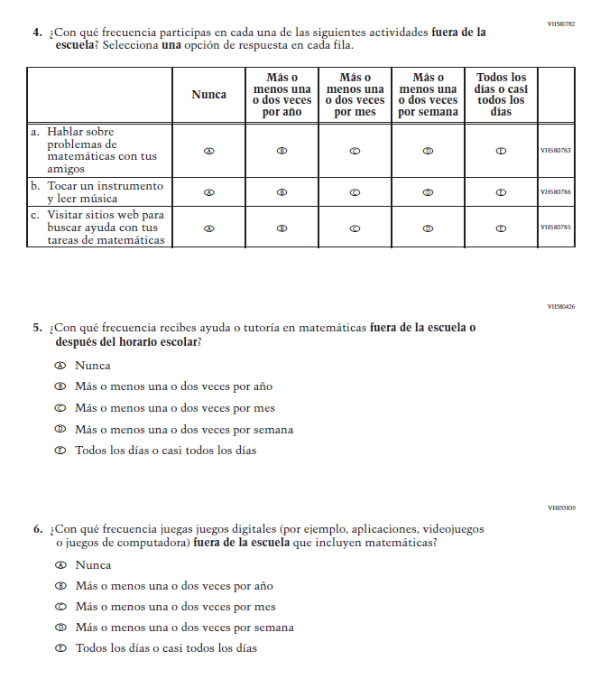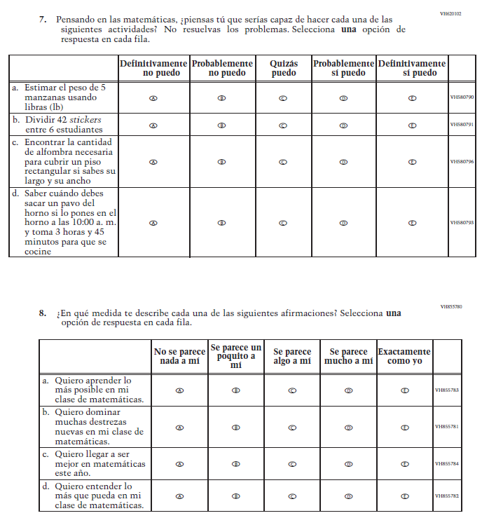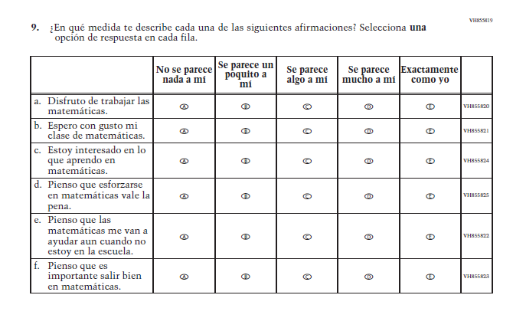

Appendix J-1bb-s-PR: Online Grade 4 (Math) (New)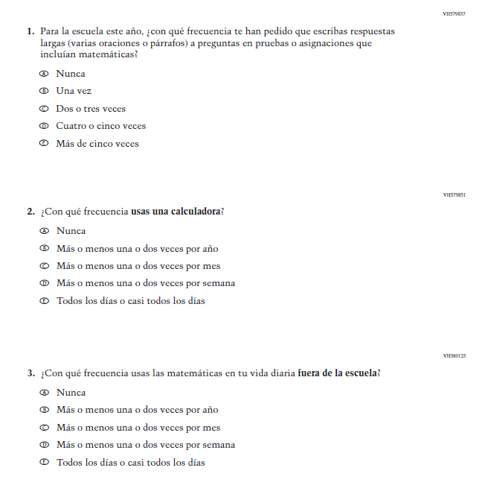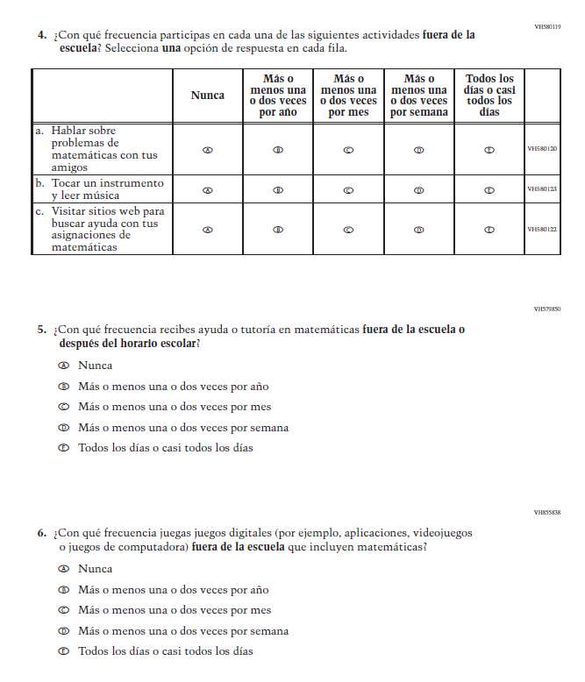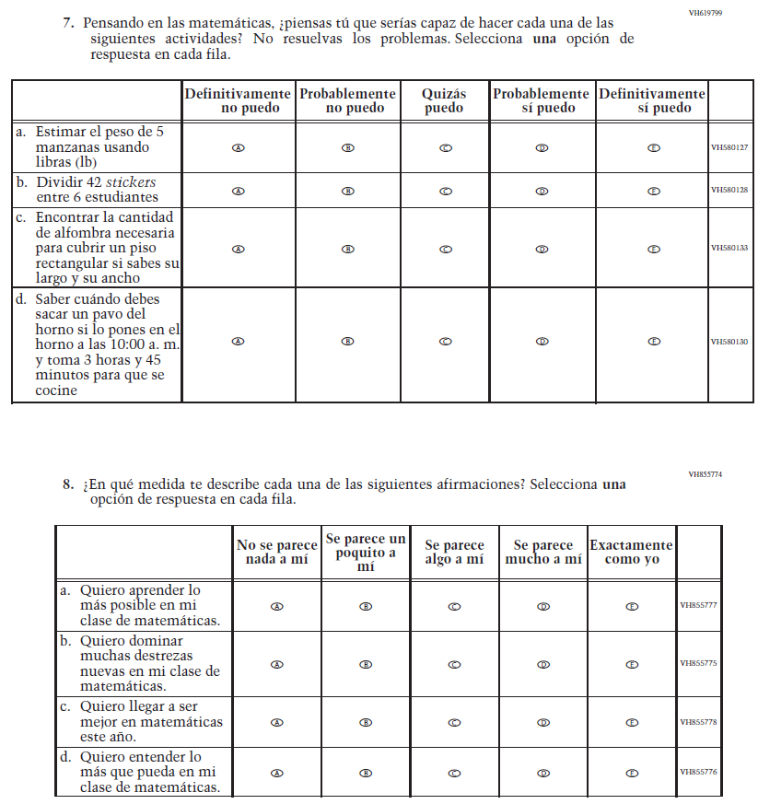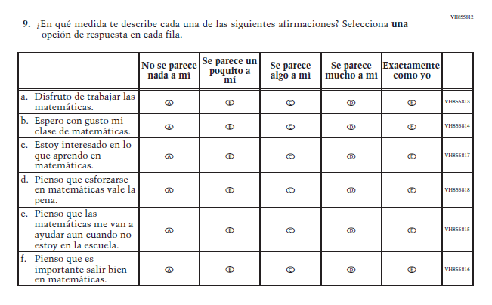

Appendix J-1cc-s-BL: Online Grade 8 (Math) (New)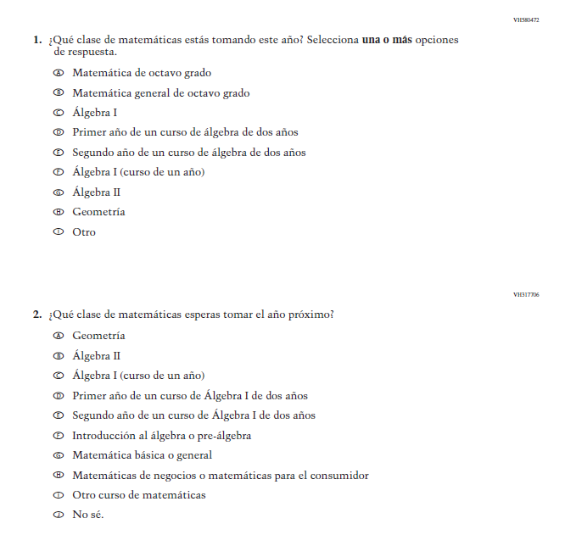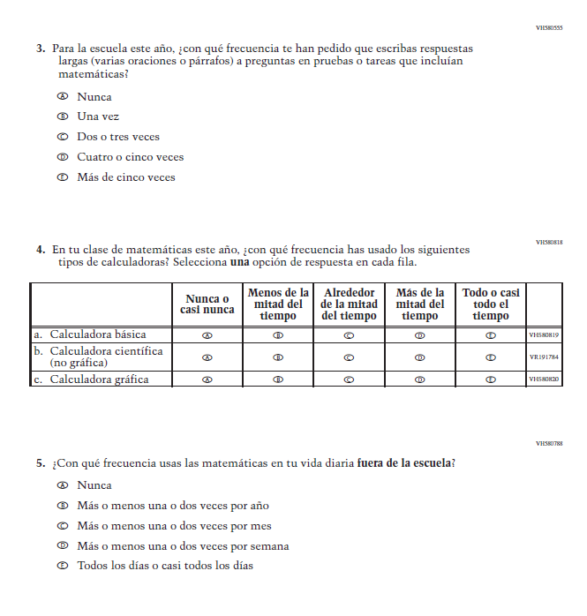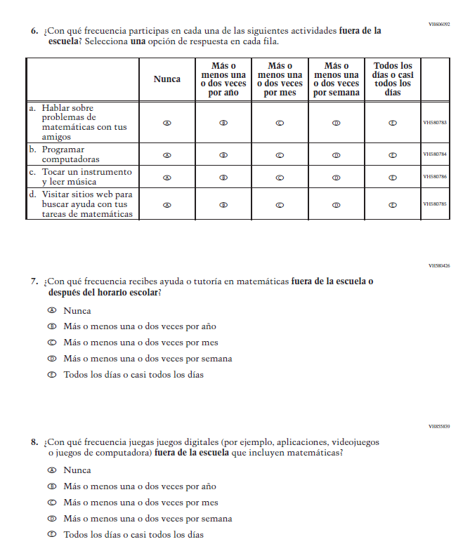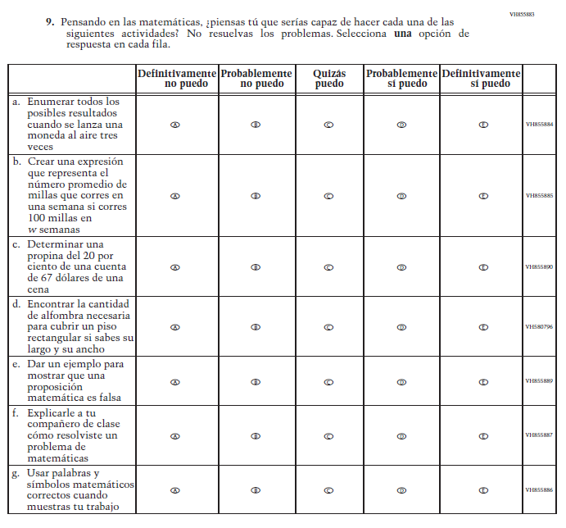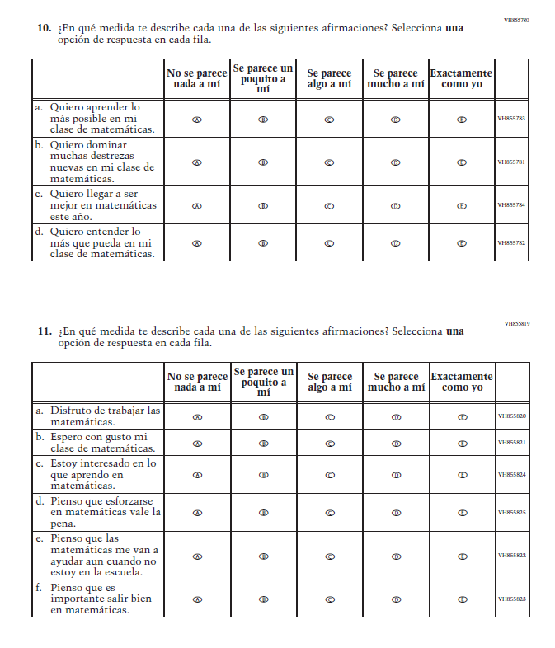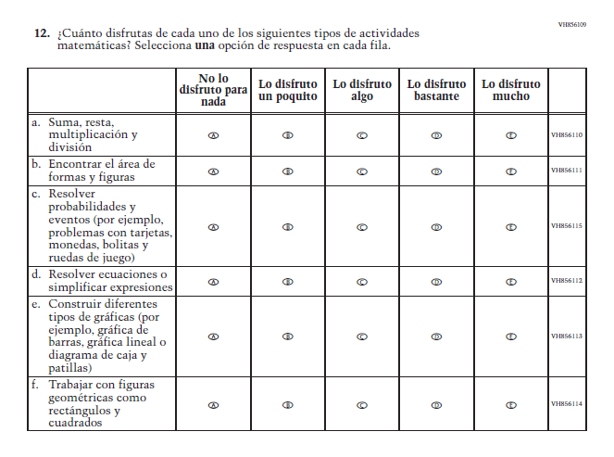

Appendix J-1dd-s-PR: Online Grade 8 (Math) (New)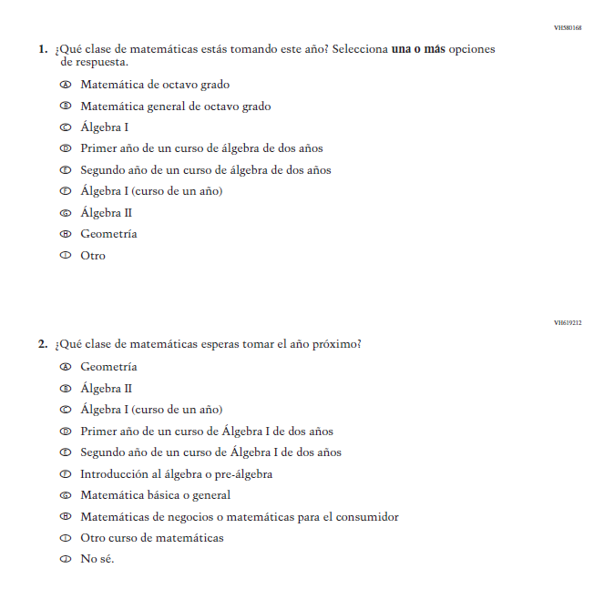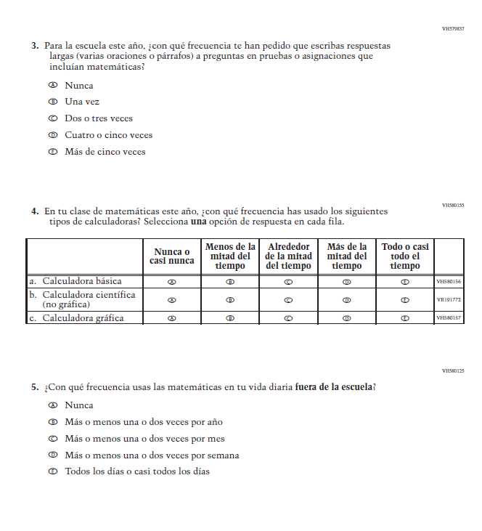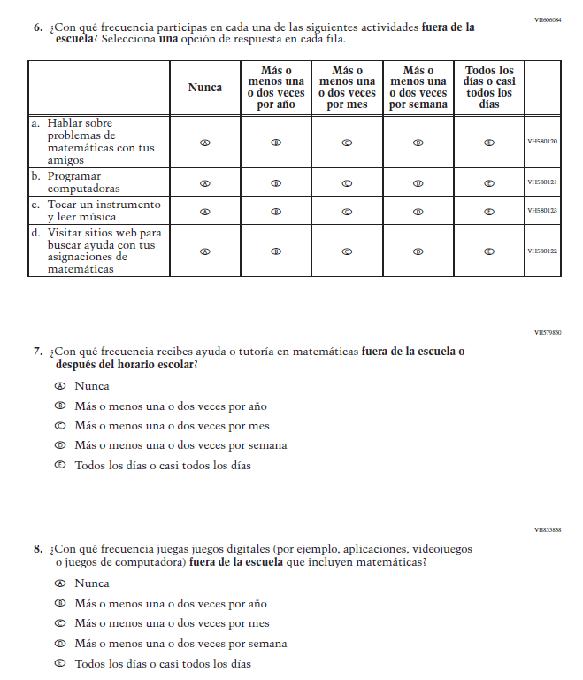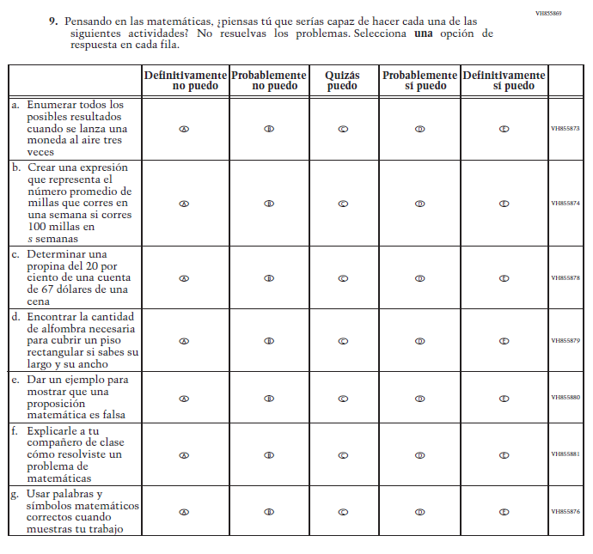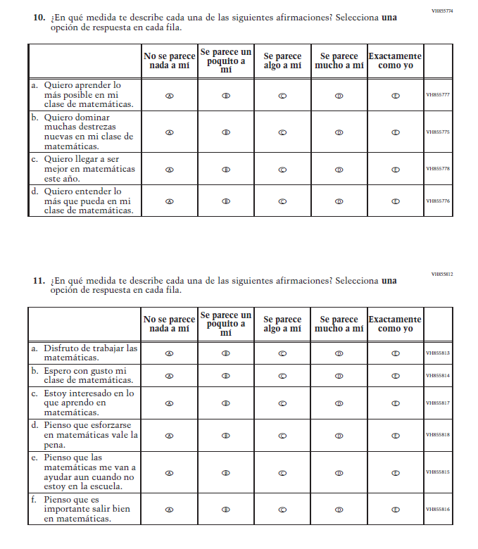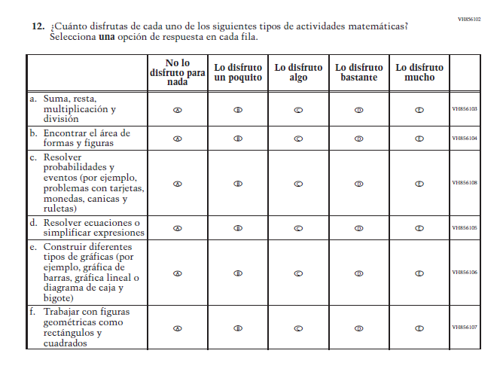

Appendix J-1ee-s-BL: Online Grade 4 (Reading) (New)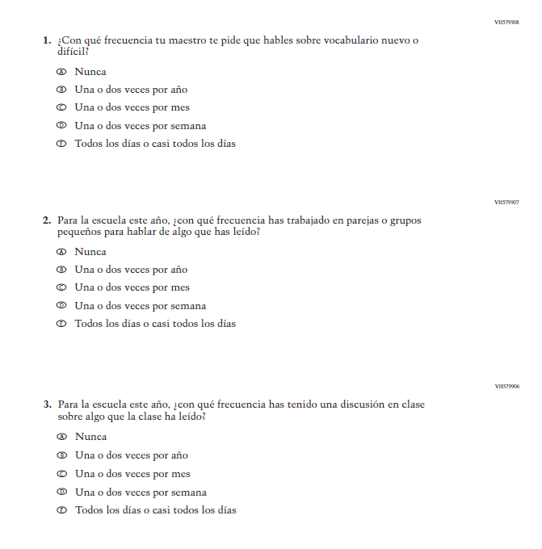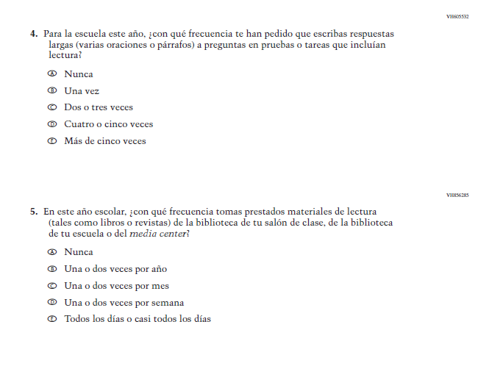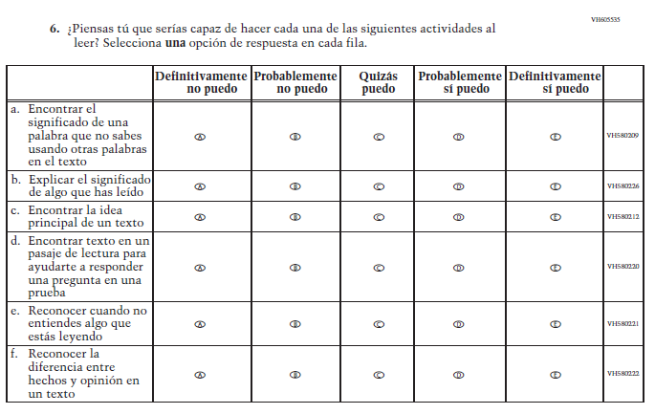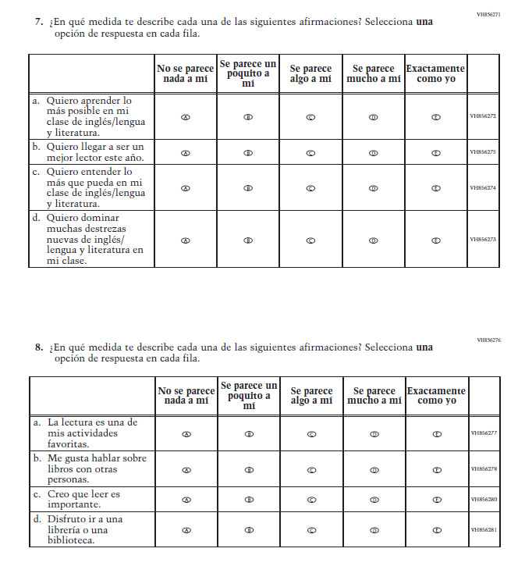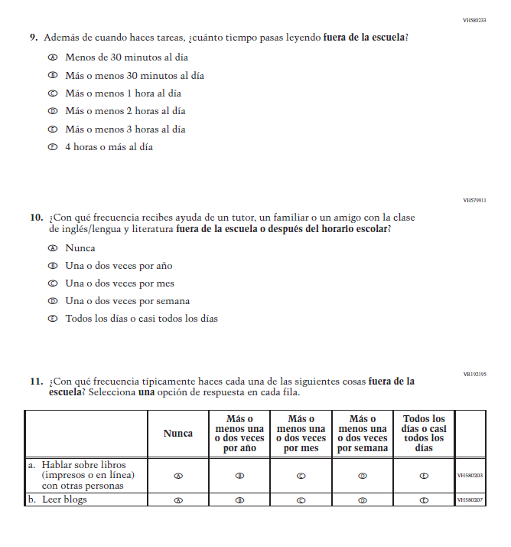

Appendix J-1ff-s-BL: Online Grade 8 (Reading) (New)
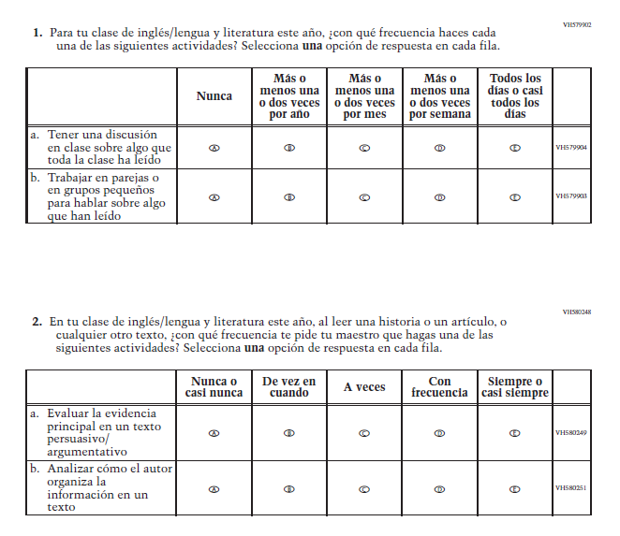
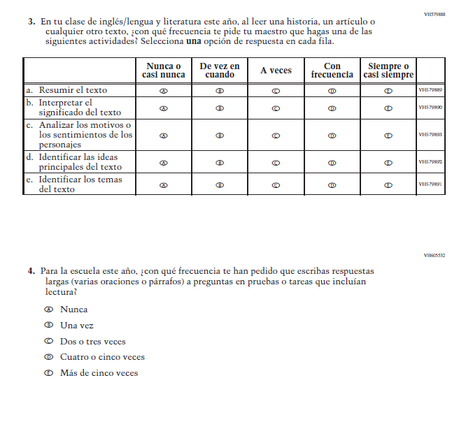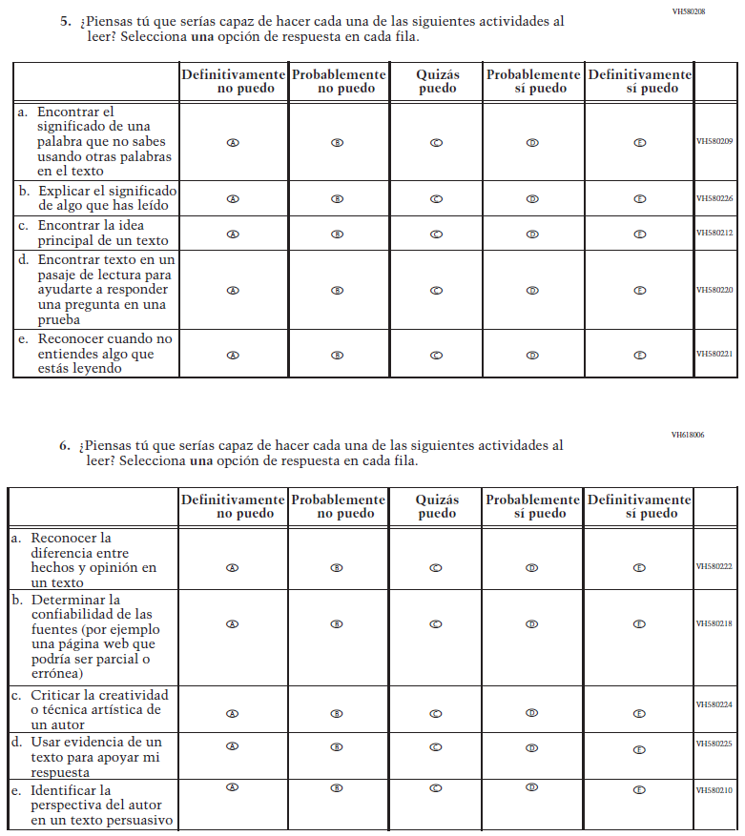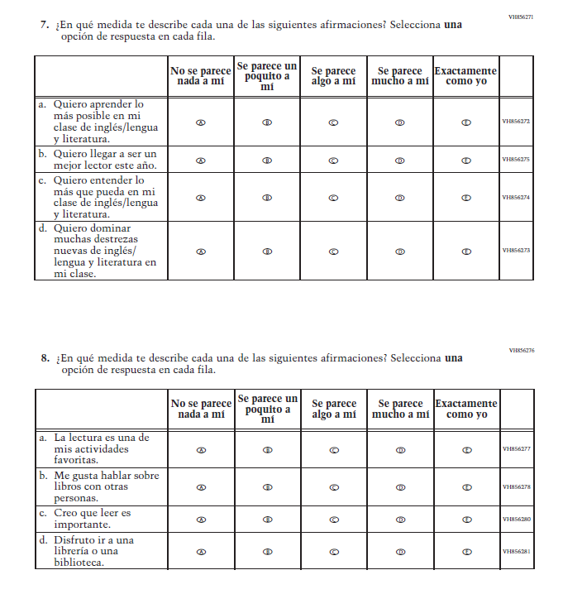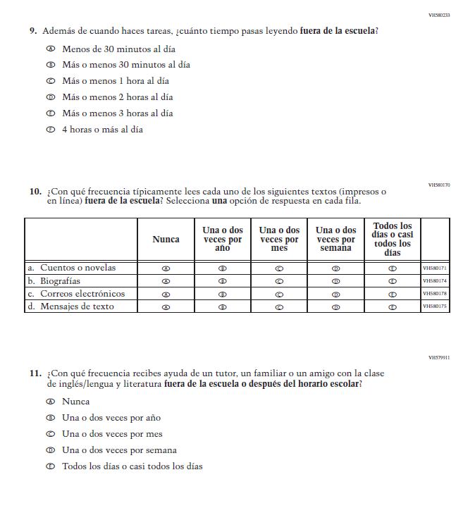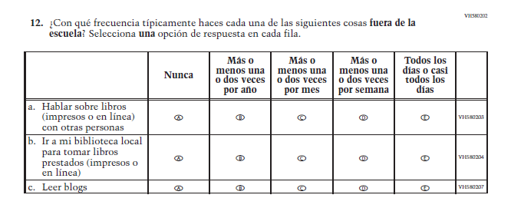

Appendix J-1gg-s-BL: Online Grade 4 COVID-19 (ELA) (New)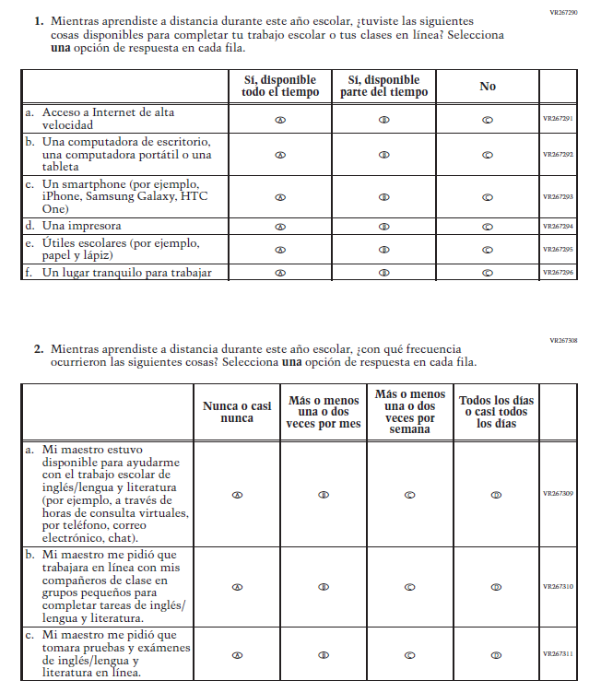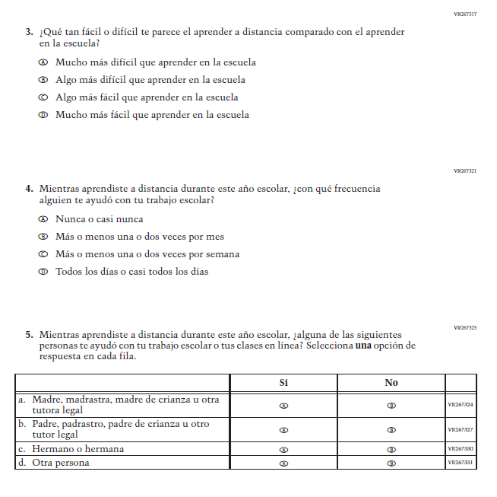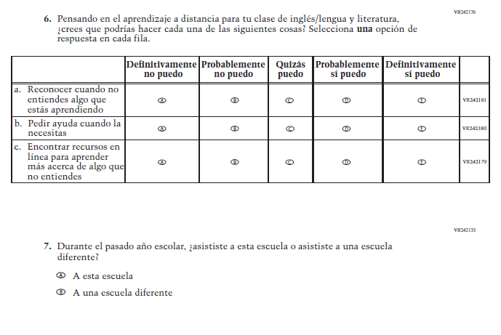
Appendix J-1hh-s-BL: Online Grade 4 COVID-19 (Math) (New)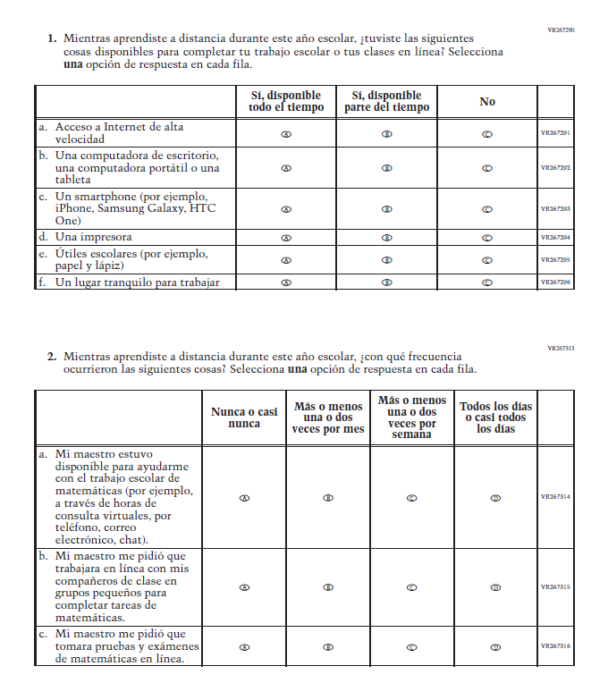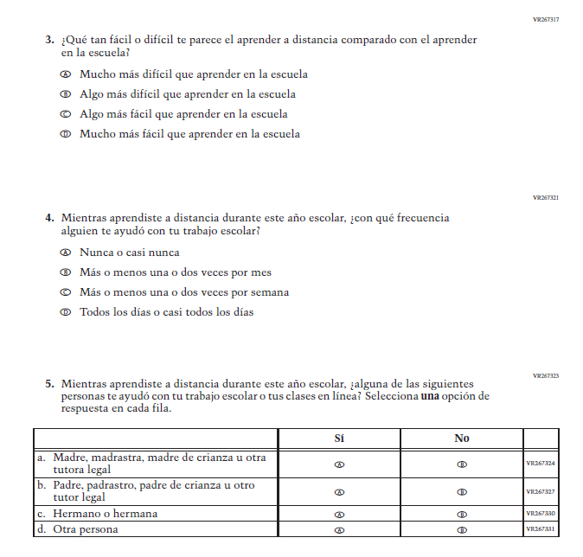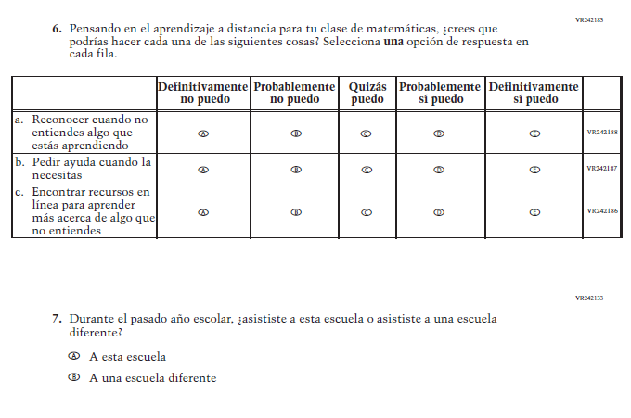

Appendix J-1ii-s-PR: Online Grade 4 COVID-19 (Math) (New)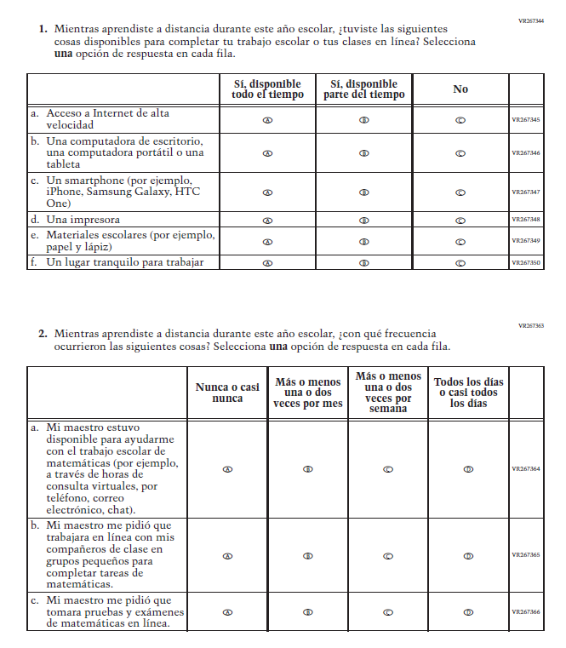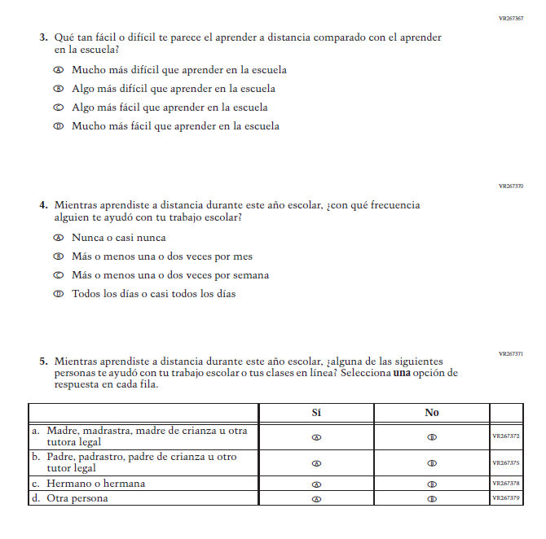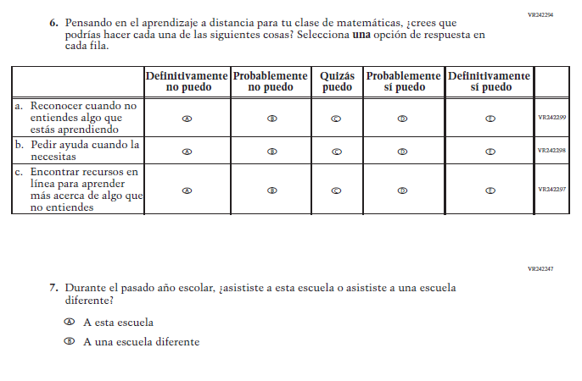

Appendix J-1jj-s-BL: Online Grade 8 COVID-19 (ELA) (New)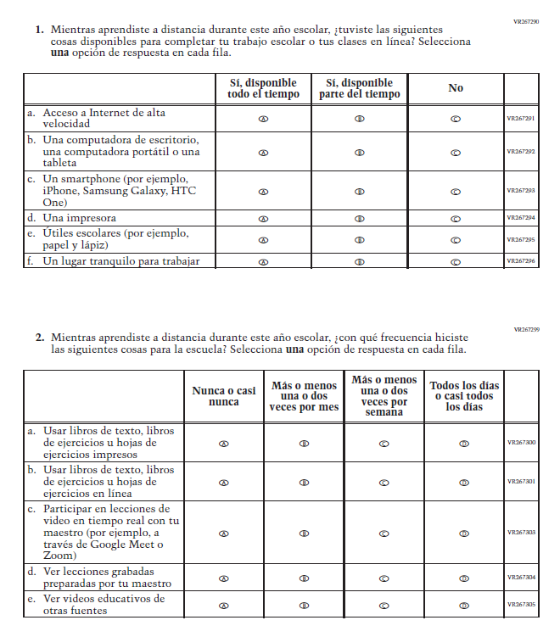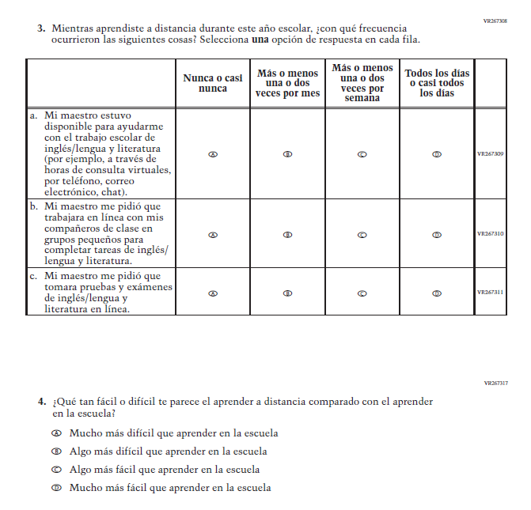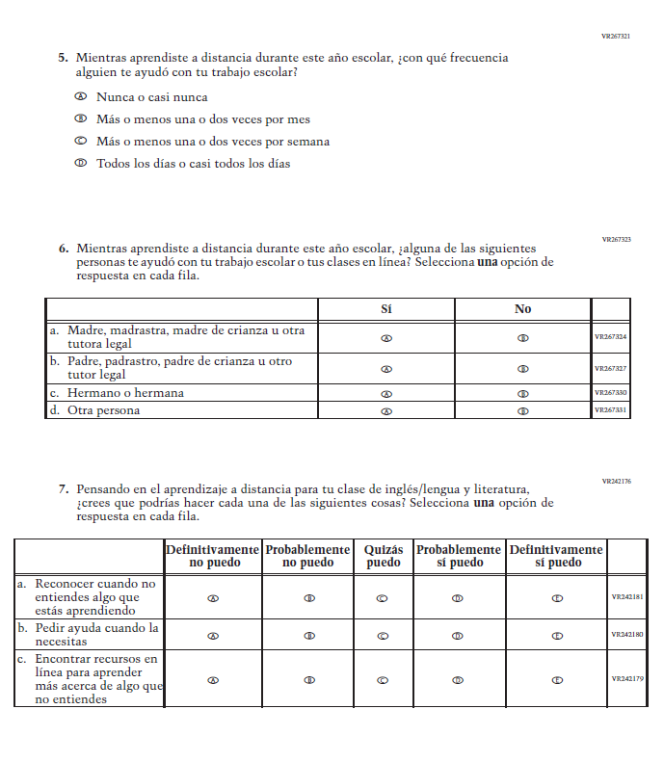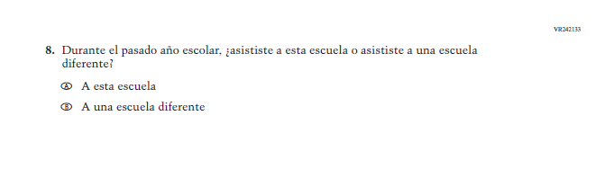

Appendix J-1kk-s-BL: Online Grade 8 COVID-19 (Math) (New)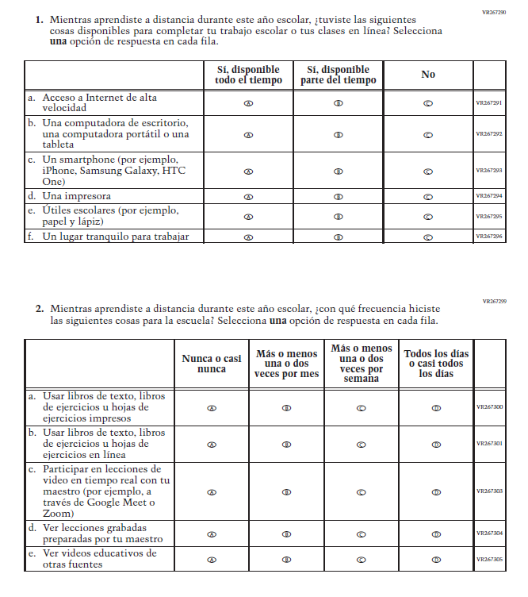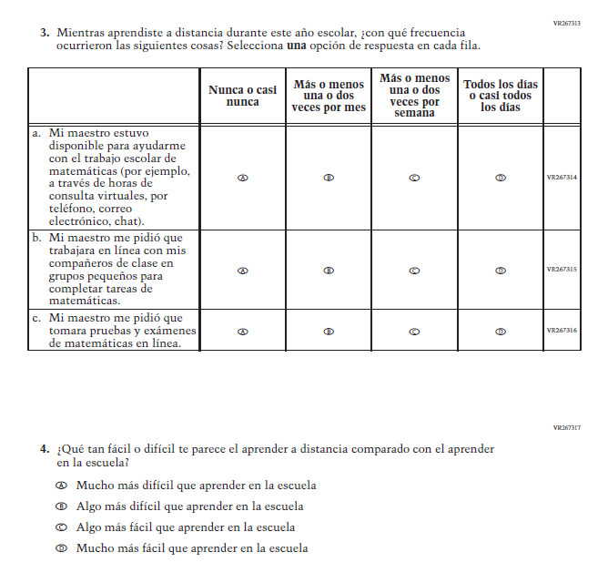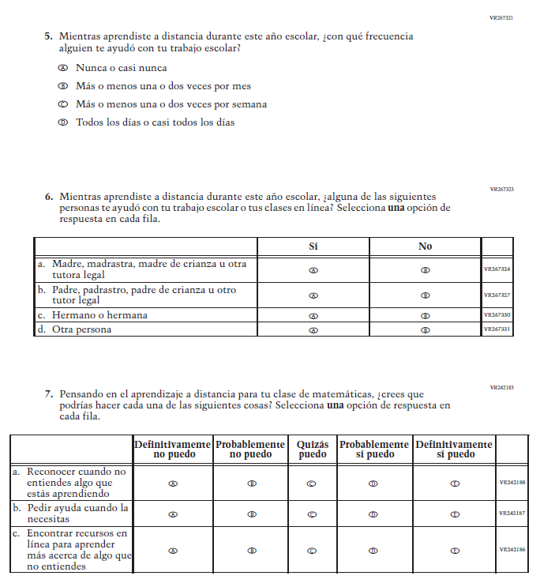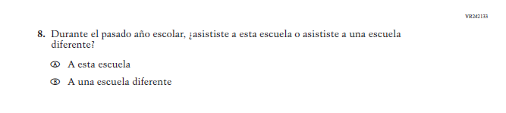

Appendix J-1ll-s-PR: Online Grade 8 COVID-19 (Math) (New)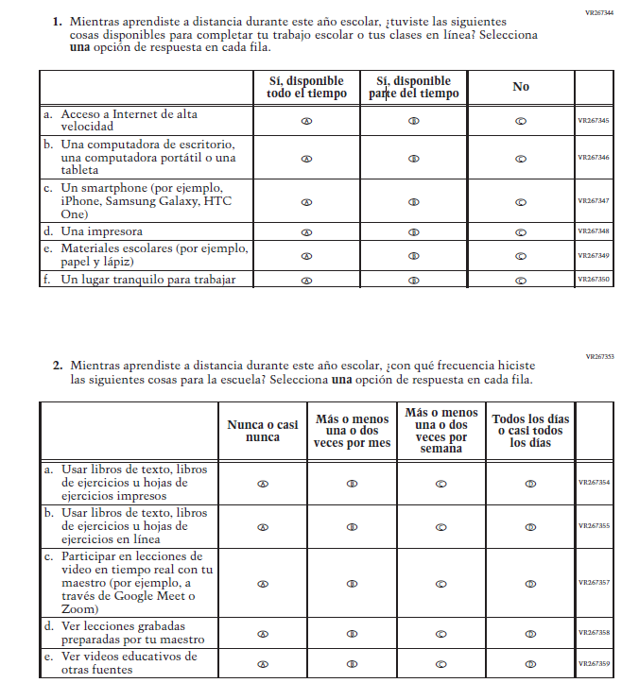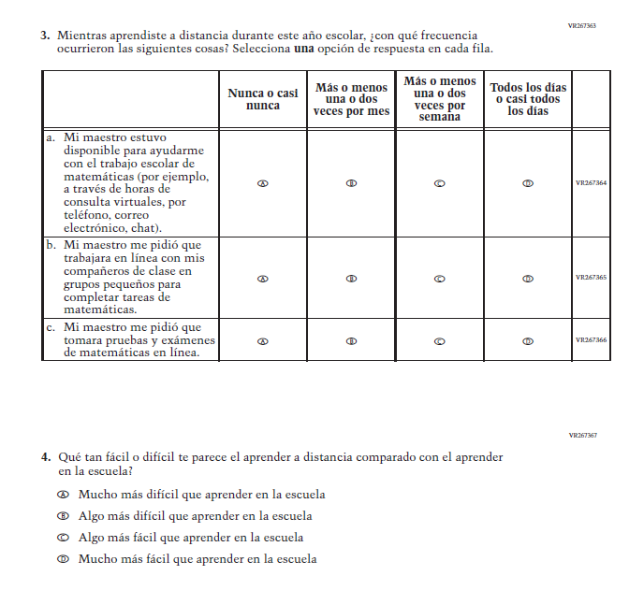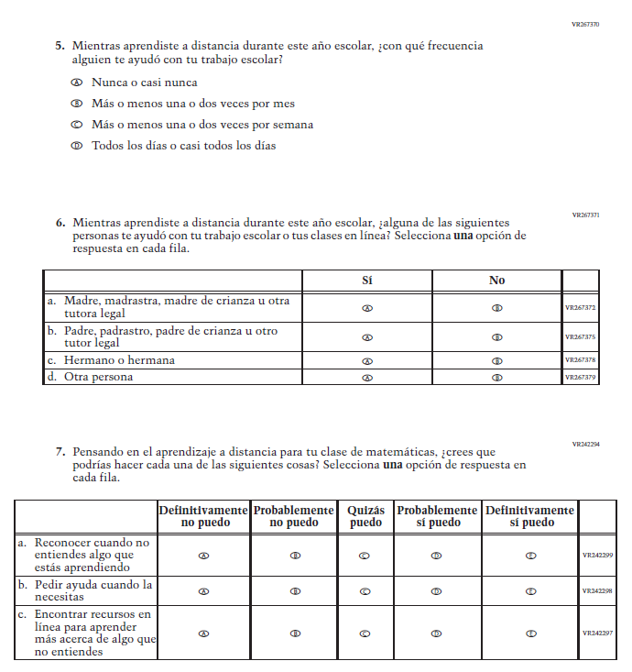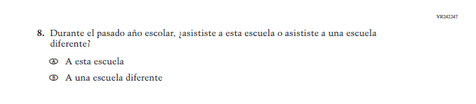

Teacher Login Screen

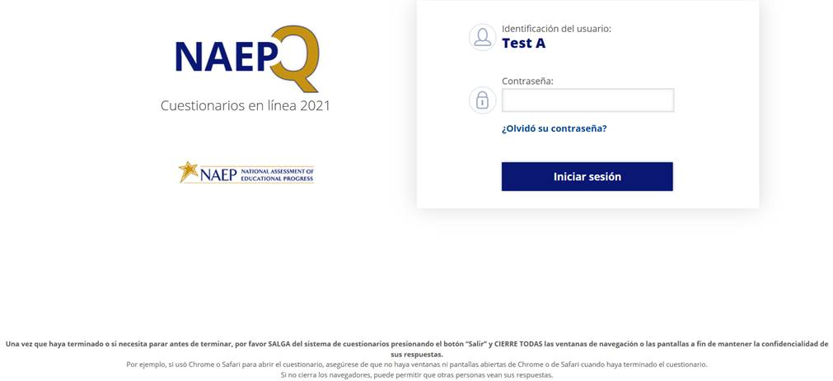
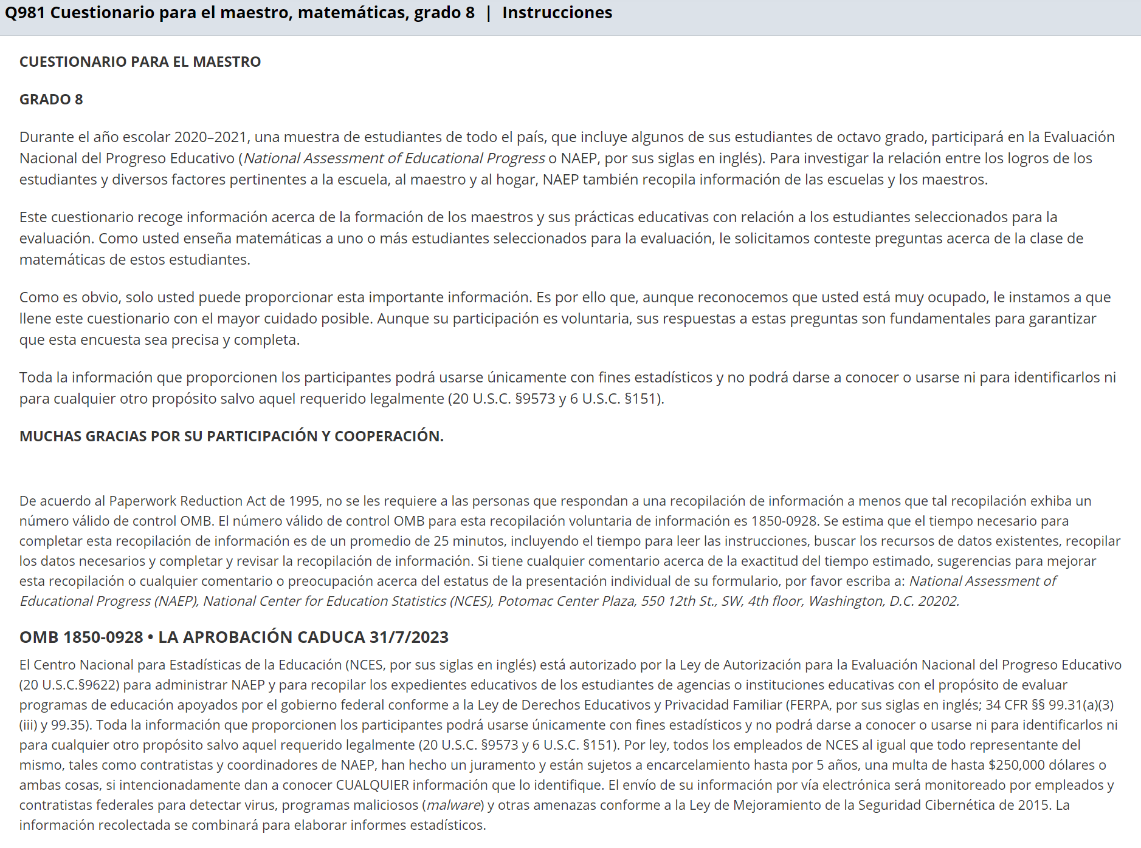

Appendix J-2-s: Spanish Translations of Teacher Questionnaires

Appendix J-2a-s-PR: Summary of Changes Operational Grade 4 CORE
2021 Operational Grade 4 Core Teacher – Puerto Rico
Previous item | 2021 item | D/A/R/NC+ | Rationale
VH835832  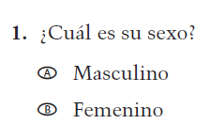  (2019 Operational Grade 4 Teacher Core – Puerto Rico) | VH835832  Issue: Gender | NC | N/A
VH319761  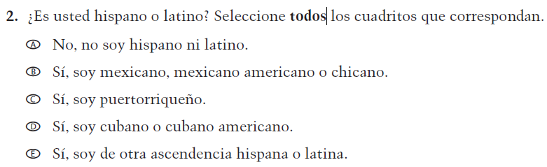  (2019 Operational Grade 4 Teacher Core – Puerto Rico) | VH319761  Issue: Race/Ethnicity | NC | N/A
VH319763  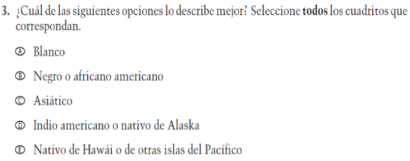  (2019 Operational Grade 4 Teacher Core – Puerto Rico) | VH319763  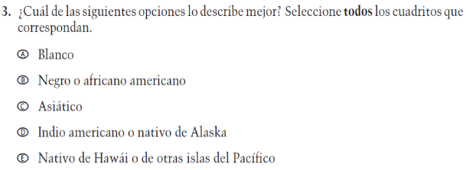  Issue: Race/Ethnicity | NC | N/A

2021 Operational Grade 4 Core Teacher – Puerto Rico
Previous item | 2021 item | D/A/R/NC+ | Rationale
VH319764  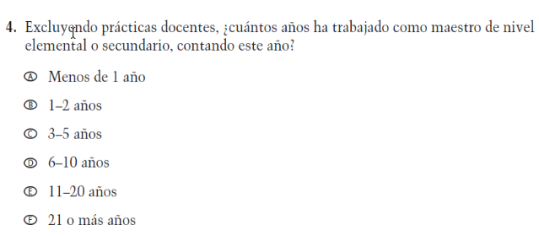  (2019 Operational Grade 4 Teacher Core – Puerto Rico) | VH319764  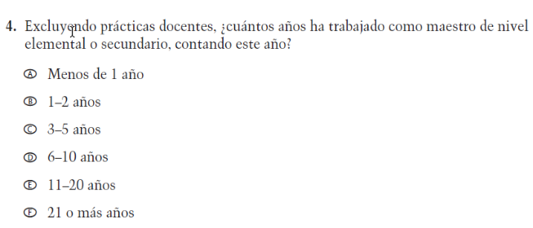  Issue: Teacher Preparation | NC | N/A
VH835831  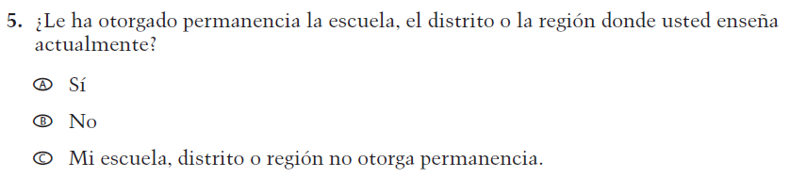  (2019 Operational Grade 4 Teacher Core – Puerto Rico) | VH835831  Issue: Teacher Preparation | NC | N/A
VH319767  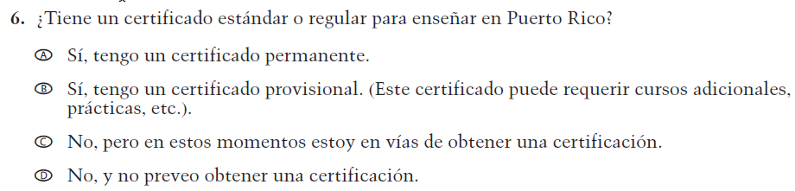  (2019 Operational Grade 4 Teacher Core – Puerto Rico) | VH319767  Issue: Teacher Preparation | NC | N/A

2021 Operational Grade 4 Core Teacher – Puerto Rico
Previous item | 2021 item | D/A/R/NC+ | Rationale
VH319769  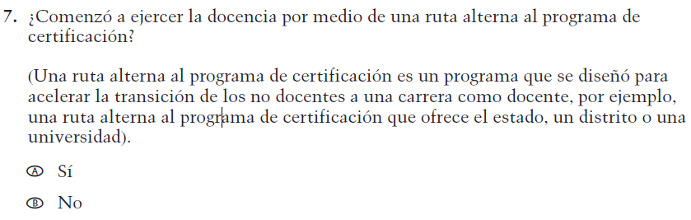  (2019 Operational Grade 4 Teacher Core – Puerto Rico) | VH319769  Issue: Teacher Preparation | NC | N/A
VH319773  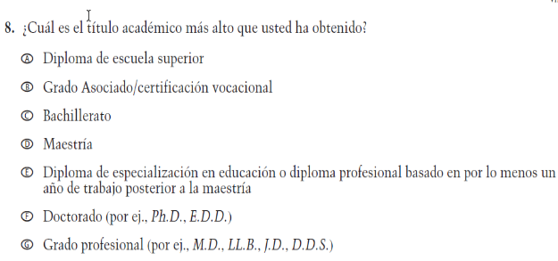  (2019 Operational Grade 4 Teacher Core – Puerto Rico) | VH319773  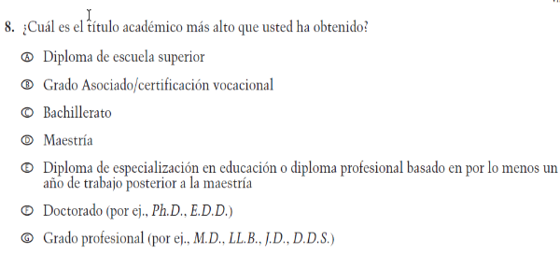  Issue: Teacher Preparation | NC | N/A
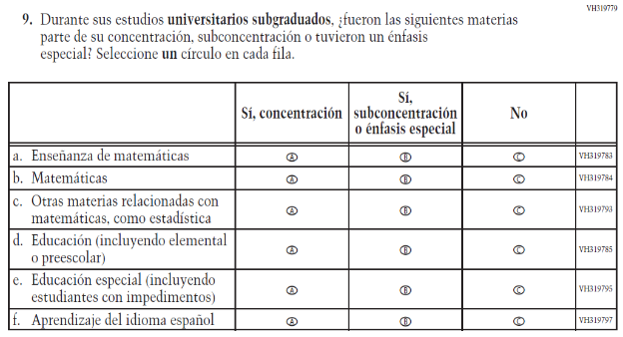  (2019 Operational Grade 4 Teacher Core – Puerto Rico) | 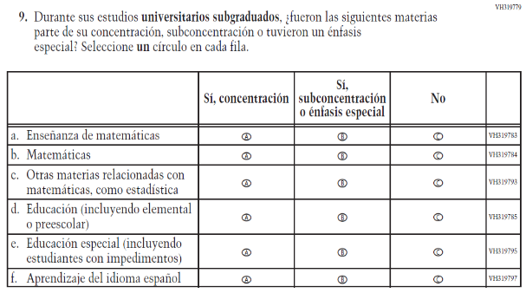  Issue: Teacher Preparation | NC | N/A

2021 Operational Grade 4 Core Teacher – Puerto Rico
Previous item | 2021 item | D/A/R/NC+ | Rationale
VH319827  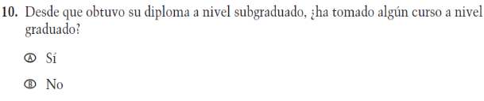  (2019 Operational Grade 4 Teacher Core – Puerto Rico) | VH319827  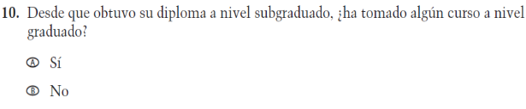  Issue: Teacher Preparation | NC | N/A
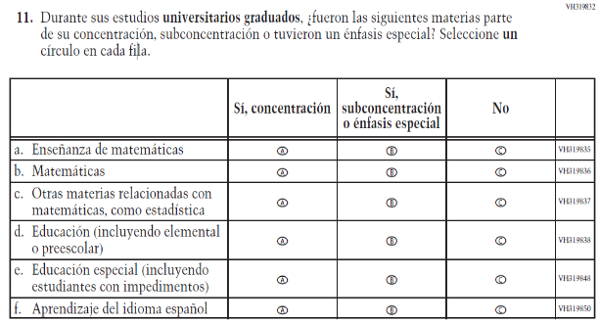  (2019 Operational Grade 4 Teacher Core – Puerto Rico) | 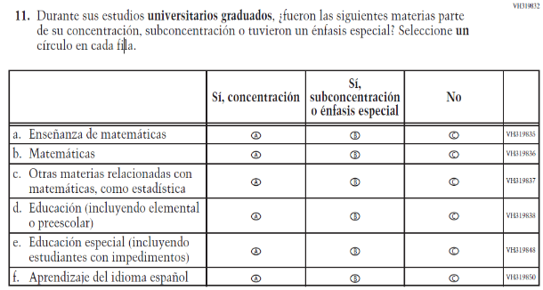  Issue: Teacher Preparation | NC | N/A
VH579698  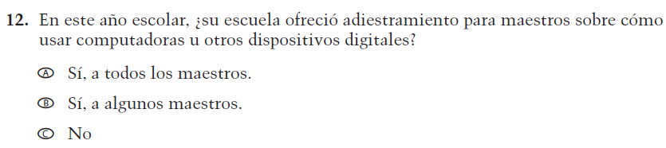  (2019 Operational Grade 4 Teacher Core – Puerto Rico) | VH579698  Issue: Technology Use | NC | N/A

2021 Operational Grade 4 Core Teacher – Puerto Rico
Previous item | 2021 item | D/A/R/NC+ | Rationale
VH579699  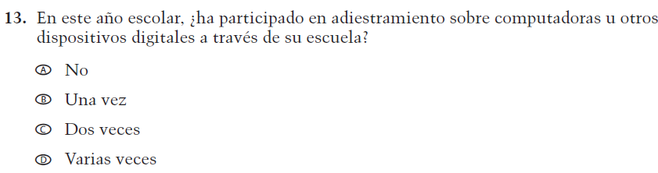  (2019 Operational Grade 4 Teacher Core – Puerto Rico) | VH579699  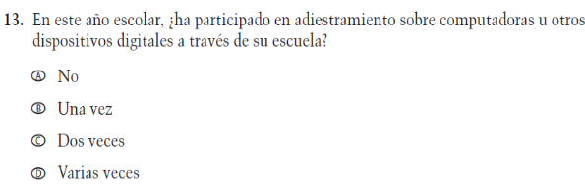  Issue: Technology Use | NC | N/A
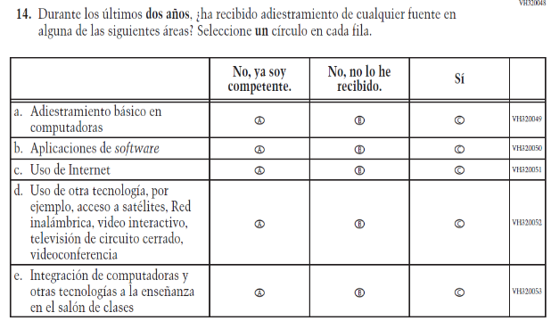  (2019 Operational Grade 4 Teacher Core – Puerto Rico) | 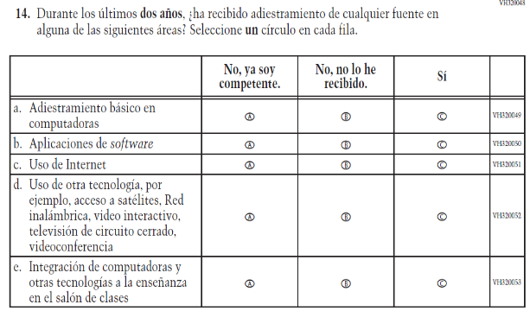  Issue: Technology Use | NC | N/A
VH893860  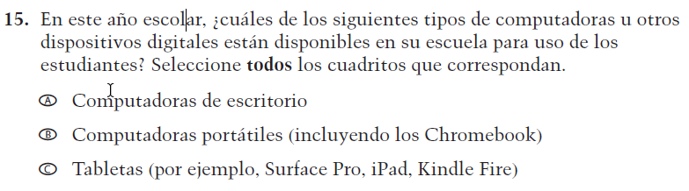  (2019 Operational Grade 4 Teacher Core – Puerto Rico) | VH893860  Issue: Technology Use | NC | N/A

2021 Operational Grade 4 Core Teacher – Puerto Rico
Previous item | 2021 item | D/A/R/NC+ | Rationale
VH579690  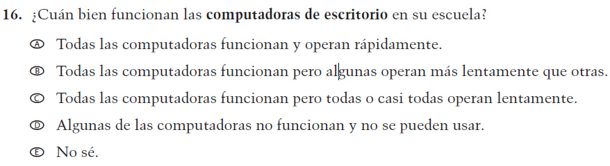  (2019 Operational Grade 4 Teacher Core – Puerto Rico) | VH579690  Issue: Technology Use | NC | N/A
VH579692  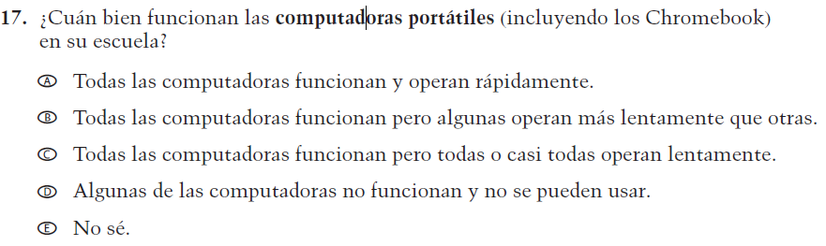  (2019 Operational Grade 4 Teacher Core – Puerto Rico) | VH579692  Issue: Technology Use | NC | N/A
VH579694  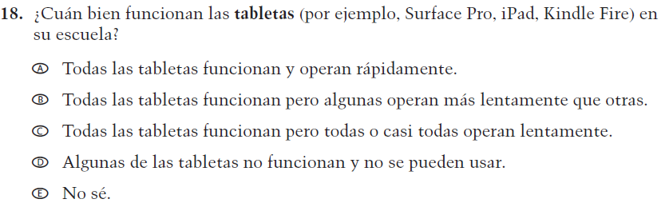  (2019 Operational Grade 4 Teacher Core – Puerto Rico) | VH579694  Issue: Technology Use | NC | N/A

2021 Operational Grade 4 Core Teacher – Puerto Rico
Previous item | 2021 item | D/A/R/NC+ | Rationale
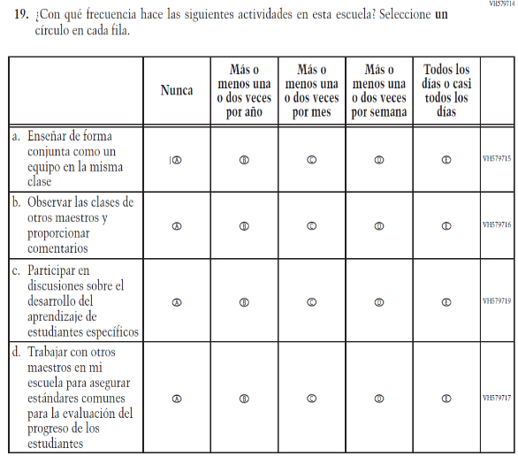  (2019 Operational Grade 4 Teacher Core – Puerto Rico) | 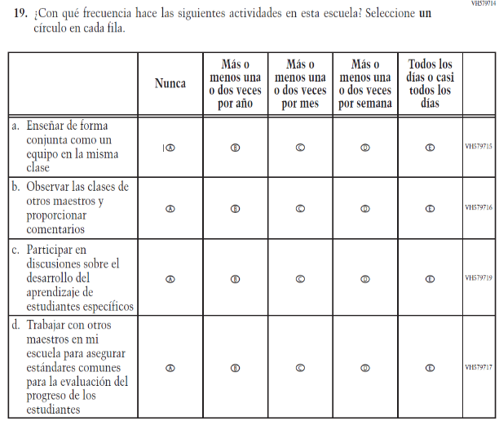  Issue: School Climate | NC | N/A
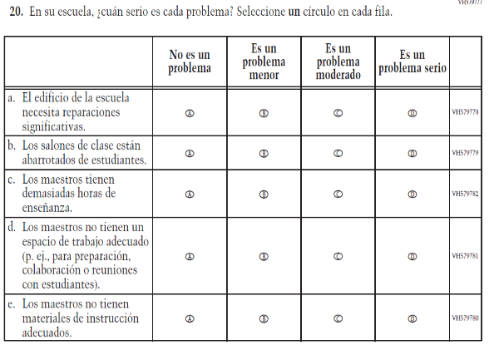  (2019 Operational Grade 4 Teacher Core – Puerto Rico) | 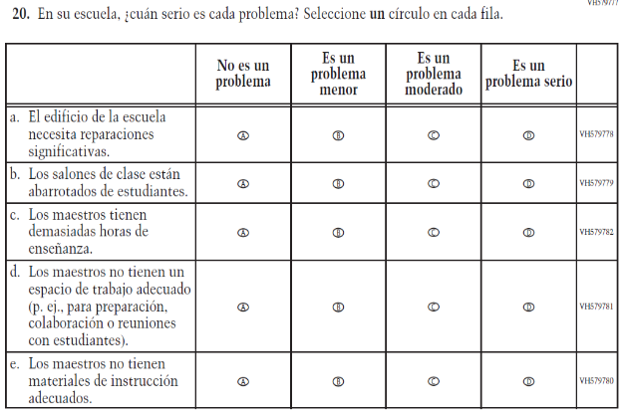  Issue: School Climate | NC | N/A

2021 Operational Grade 4 Core Teacher – Puerto Rico
Previous item | 2021 item | D/A/R/NC+ | Rationale
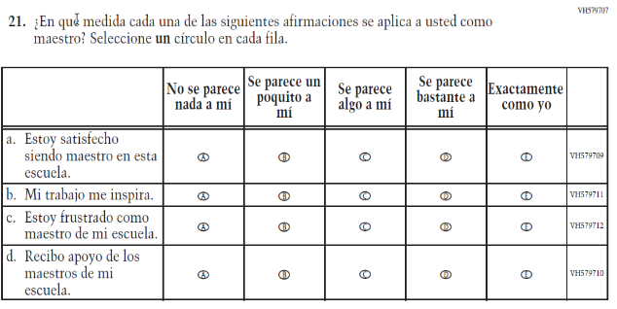  (2019 Operational Grade 4 Teacher Core – Puerto Rico) | 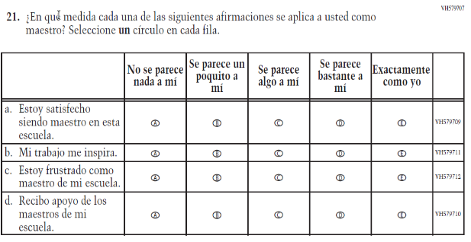  Issue: School Climate | NC | N/A
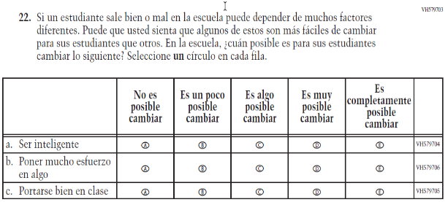  (2019 Operational Grade 4 Teacher Core – Puerto Rico) | 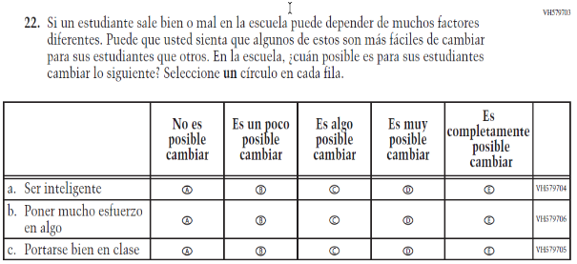  Issue: School Climate | NC | N/A

Appendix J-2a-s-PR: Operational Grade 4 CORE
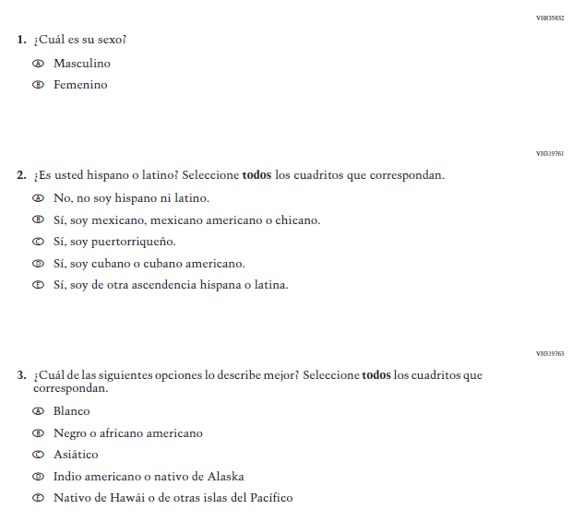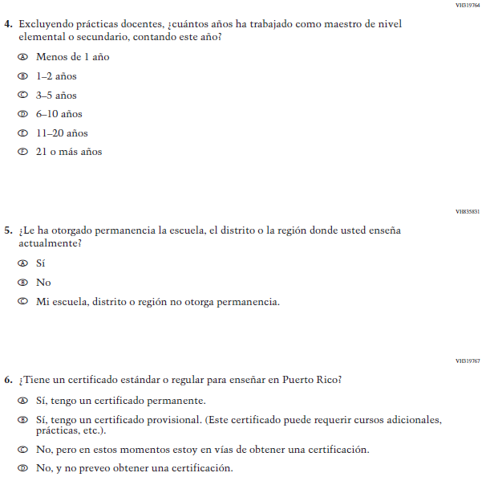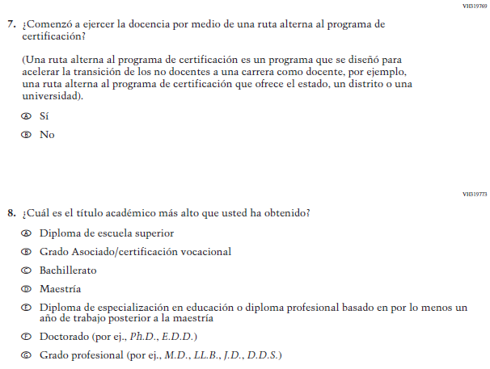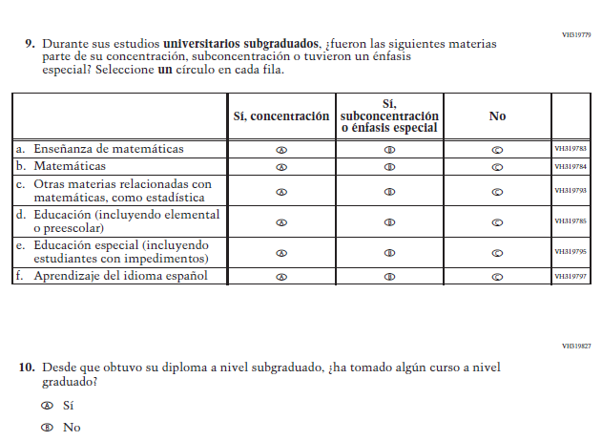
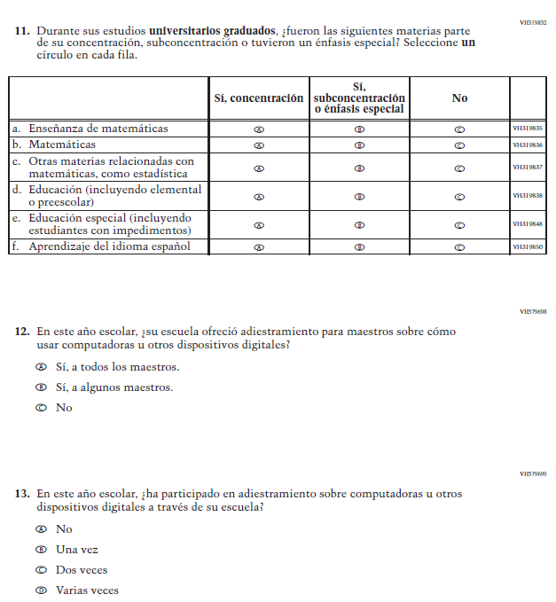
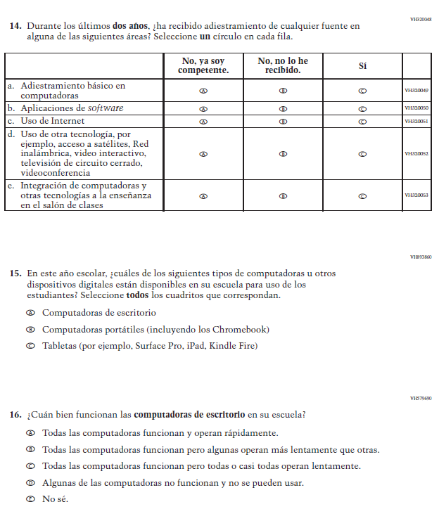
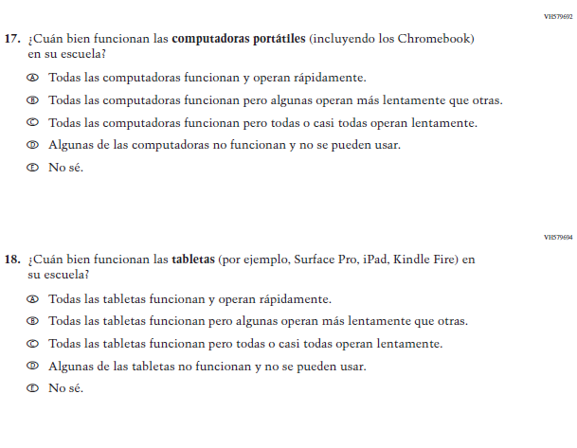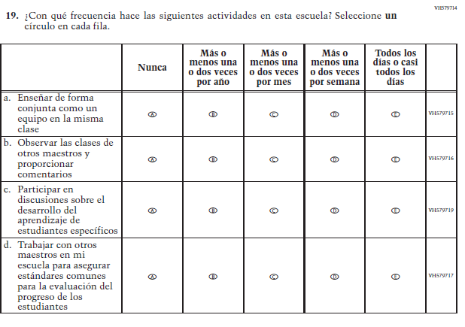
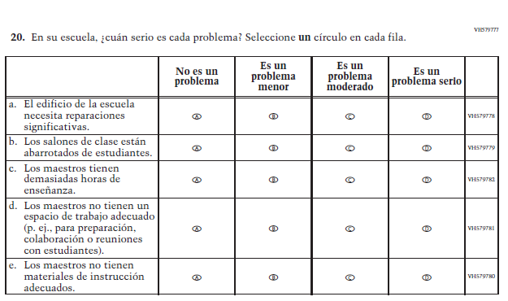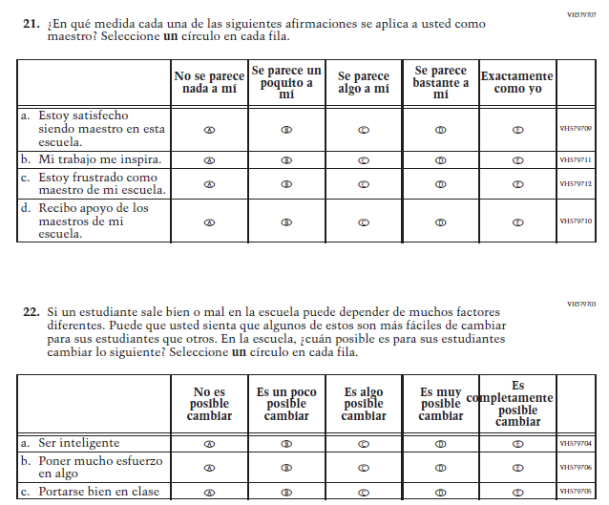

Appendix J-2b-s-PR: Summary of Changes Operational Grade 8 CORE
2021 Operational Grade 8 Core Teacher – Puerto Rico
Previous item | 2021 item | D/A/R/NC+ | Rationale
VH835832  (2019 Operational Grade 8 Teacher Core – Puerto Rico) | VH835832  Issue: Gender | NC | N/A
VH319761  (2019 Operational Grade 8 Teacher Core – Puerto Rico) | VH319761  Issue: Race/Ethnicity | NC | N/A
VH319763  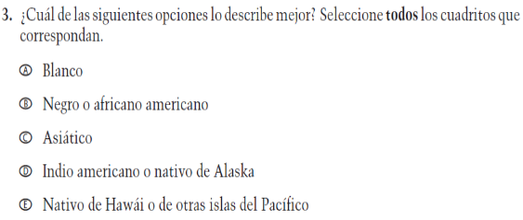  (2019 Operational Grade 8 Teacher Core – Puerto Rico) | VH319763  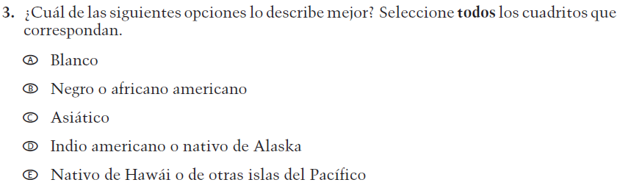  Issue: Race/Ethnicity | NC | N/A

2021 Operational Grade 8 Core Teacher – Puerto Rico
Previous item | 2021 item | D/A/R/NC+ | Rationale
VH319764  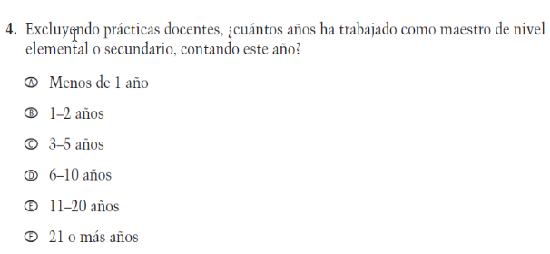  (2019 Operational Grade 8 Teacher Core – Puerto Rico) | VH319764  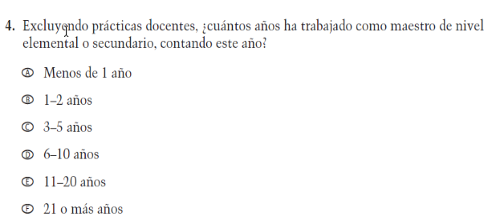  Issue: Teacher Preparation | NC | N/A
VH319892  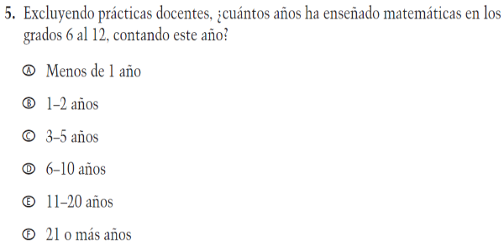  (2019 Operational Grade 8 Teacher Core – Puerto Rico) | VH319892  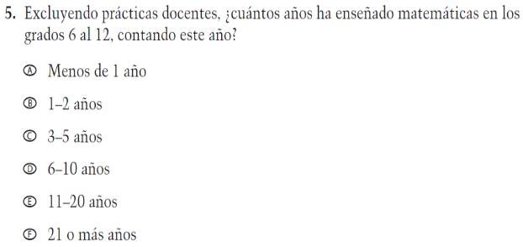  Issue: Teacher Preparation | NC | N/A
VH835831  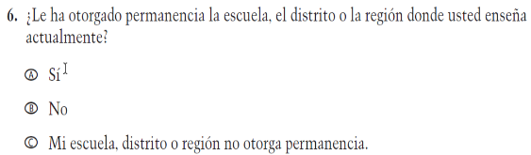  (2019 Operational Grade 8 Teacher Core – Puerto Rico) | VH835831  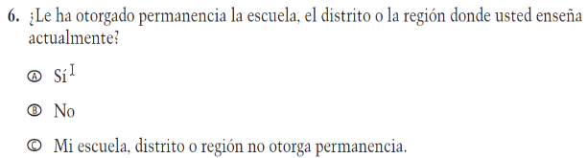  Issue: Teacher Preparation | NC | N/A

2021 Operational Grade 8 Core Teacher – Puerto Rico
Previous item | 2021 item | D/A/R/NC+ | Rationale
VH319767  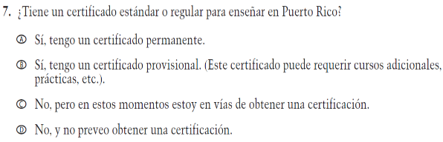  (2019 Operational Grade 8 Teacher Core – Puerto Rico) | VH319767  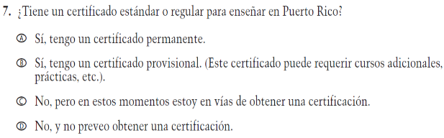  Issue: Teacher Preparation | NC | N/A
VH319769  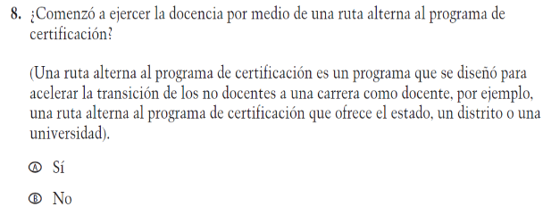  (2019 Operational Grade 8 Teacher Core – Puerto Rico) | VH319769  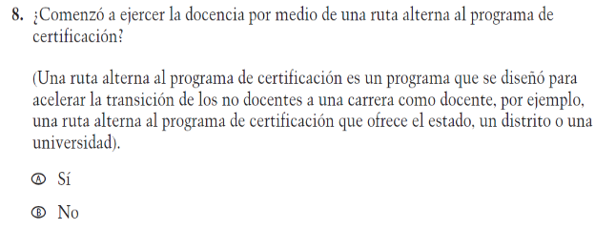  Issue: Teacher Preparation | NC | N/A
VH319773  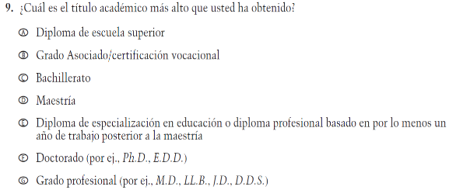  (2019 Operational Grade 8 Teacher Core – Puerto Rico) | VH319773  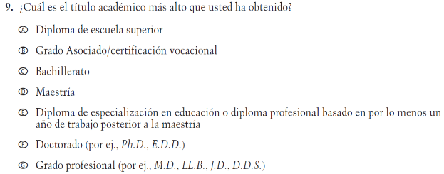  Issue: Teacher Preparation | NC | N/A

2021 Operational Grade 8 Core Teacher – Puerto Rico
Previous item | 2021 item | D/A/R/NC+ | Rationale
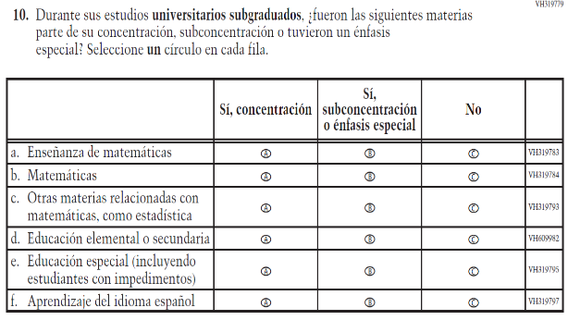  (2019 Operational Grade 8 Teacher Core – Puerto Rico) | 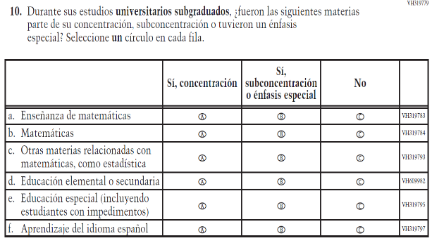  Issue: Teacher Preparation | NC | N/A
VH319827  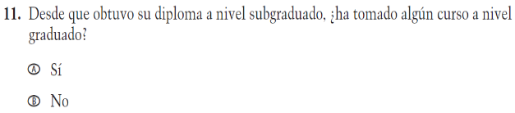  (2019 Operational Grade 8 Teacher Core – Puerto Rico) | VH319827  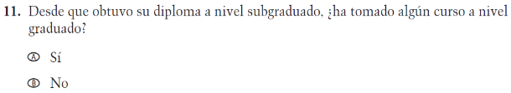  Issue: Teacher Preparation | NC | N/A
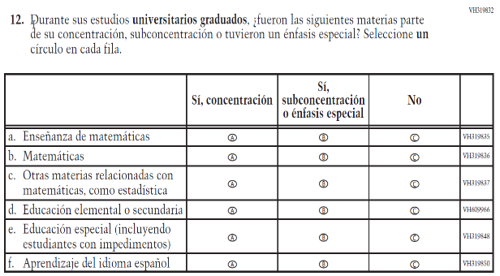  (2019 Operational Grade 8 Teacher Core – Puerto Rico) | 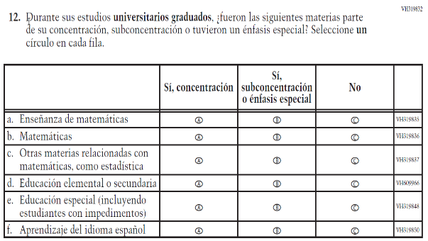  Issue: Teacher Preparation | NC | N/A

2021 Operational Grade 8 Core Teacher – Puerto Rico
Previous item | 2021 item | D/A/R/NC+ | Rationale
VH579698  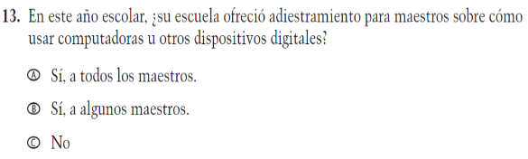  (2019 Operational Grade 8 Teacher Core – Puerto Rico) | VH579698  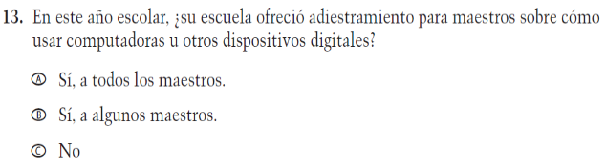  Issue: Technology Use | NC | N/A
VH579699  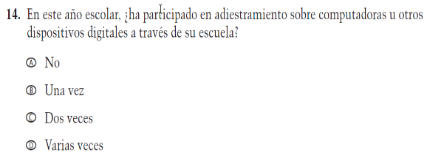  (2019 Operational Grade 8 Teacher Core – Puerto Rico) | VH579699  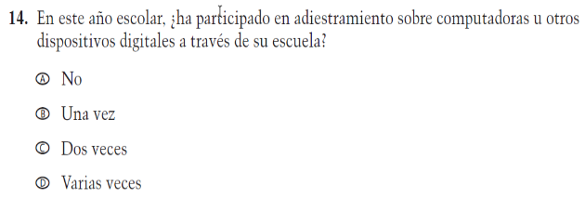  Issue: Technology Use | NC | N/A
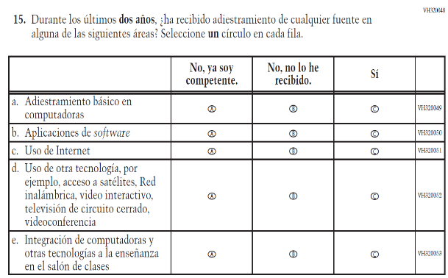  (2019 Operational Grade 8 Teacher Core – Puerto Rico) | 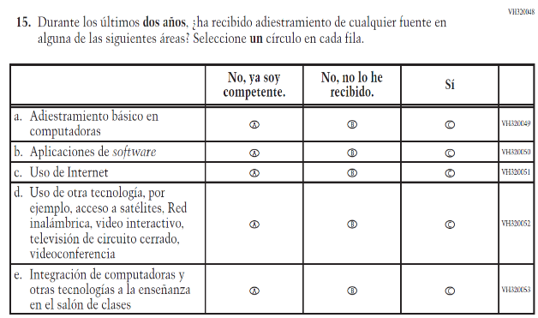  Issue: Teacher Preparation | NC | N/A

2021 Operational Grade 8 Core Teacher – Puerto Rico
Previous item | 2021 item | D/A/R/NC+ | Rationale
VH893860  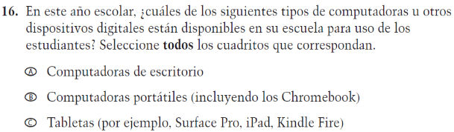  (2019 Operational Grade 8 Teacher Core – Puerto Rico) | VH893860  Issue: Technology Use | NC | N/A
VH579690  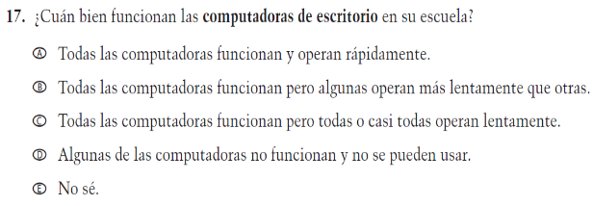  (2019 Operational Grade 8 Teacher Core – Puerto Rico) | VH579690  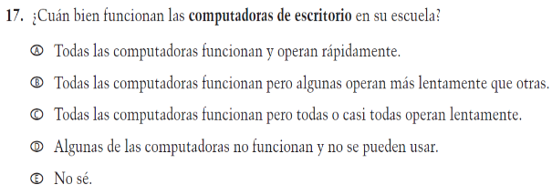  Issue: Technology Use | NC | N/A
VH579692  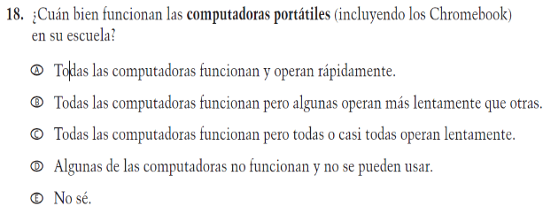  (2019 Operational Grade 8 Teacher Core – Puerto Rico) | VH579692  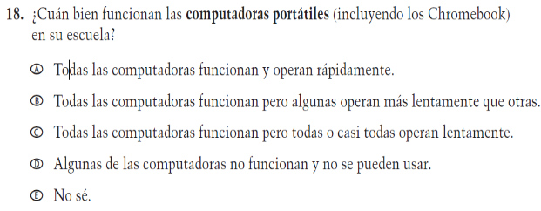  Issue: Technology Use | NC | N/A
VH579694  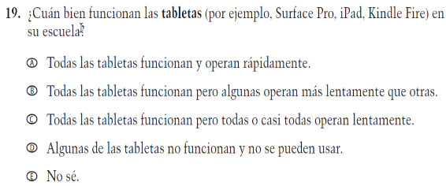  (2019 Operational Grade 8 Teacher Core – Puerto Rico) | VH579694  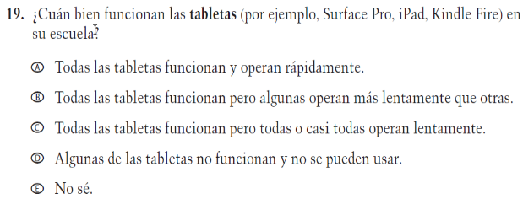  Issue: Technology Use | NC | N/A

2021 Operational Grade 8 Core Teacher – Puerto Rico
Previous item | 2021 item | D/A/R/NC+ | Rationale
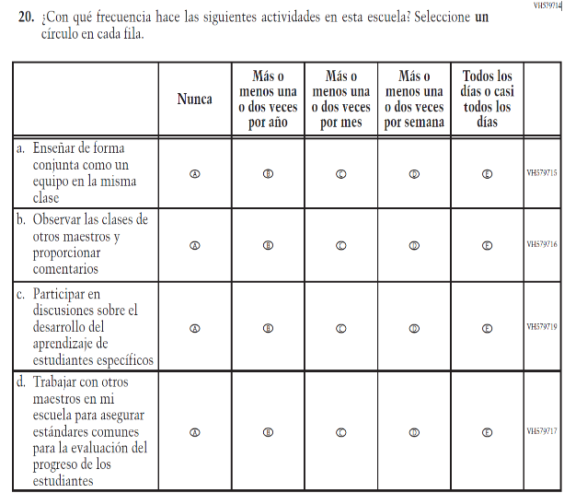  (2019 Operational Grade 8 Teacher Core – Puerto Rico) | 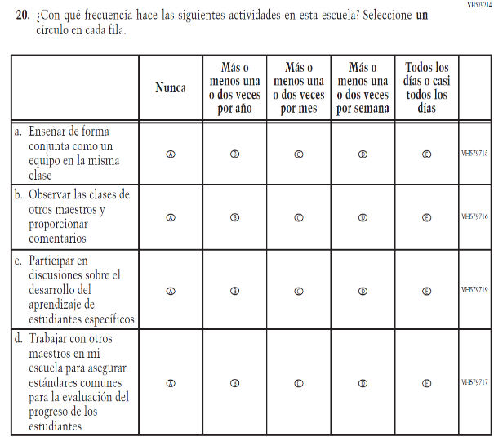  Issue: School Climate | NC | N/A
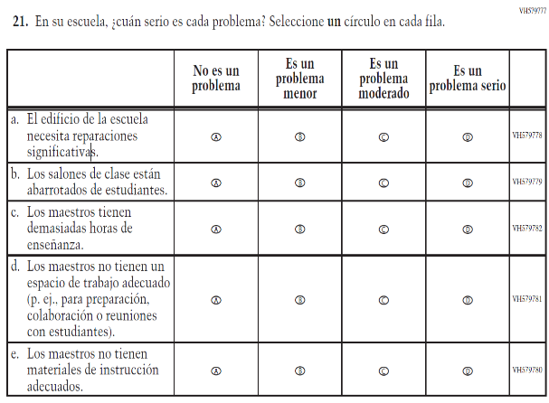  (2019 Operational Grade 8 Teacher Core – Puerto Rico) | 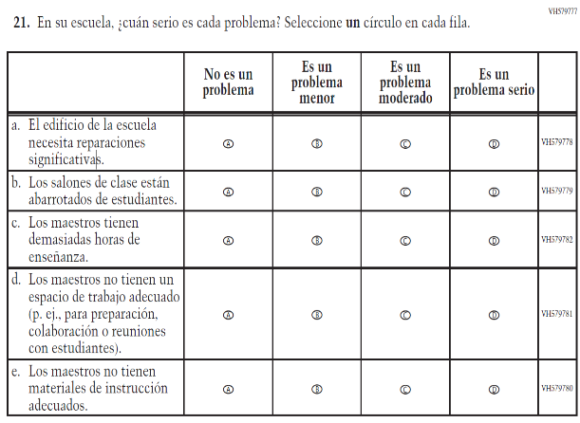  Issue: School Climate | NC | N/A

2021 Operational Grade 8 Core Teacher – Puerto Rico
Previous item | 2021 item | D/A/R/NC+ | Rationale
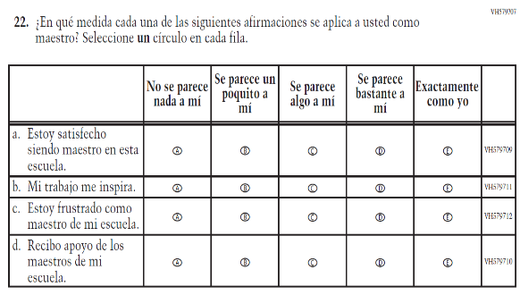  (2019 Operational Grade 8 Teacher Core – Puerto Rico) | 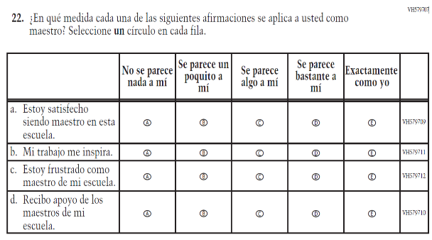  Issue: School Climate | NC | N/A
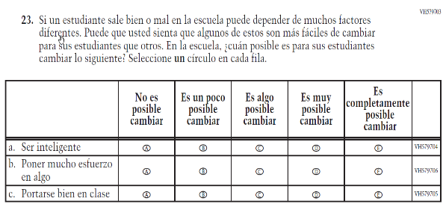  (2019 Operational Grade 8 Teacher Core – Puerto Rico) | 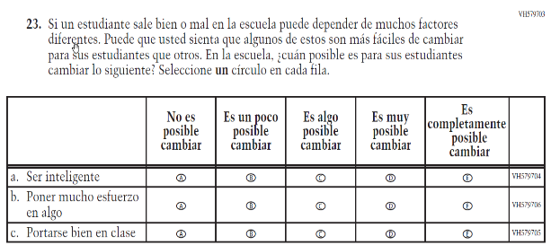  Issue: Desire for Learning | NC | N/A

Appendix J-2b-s-PR: Operational Grade 8 CORE
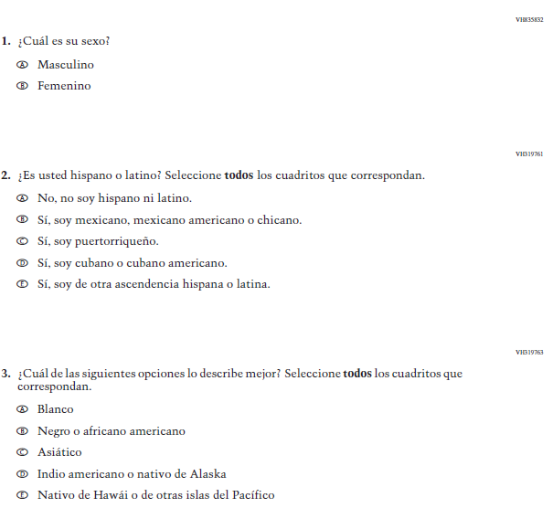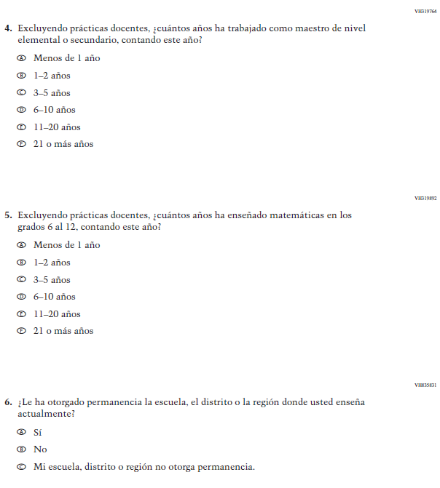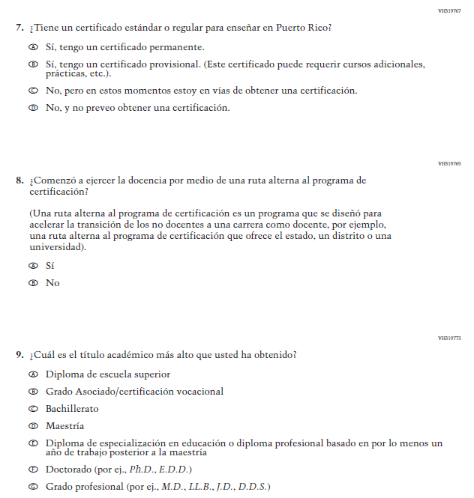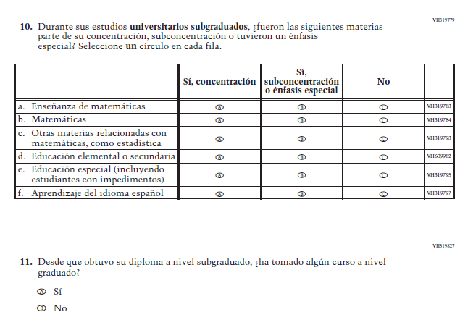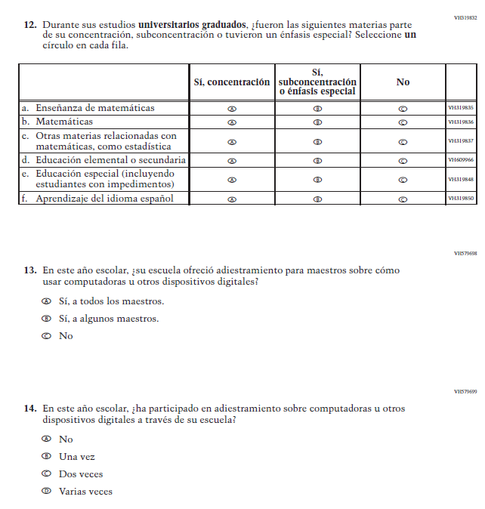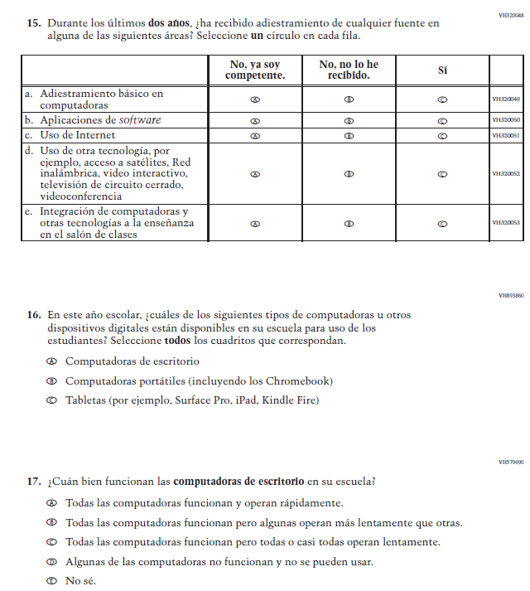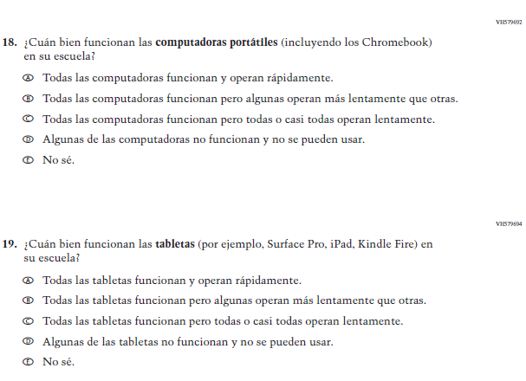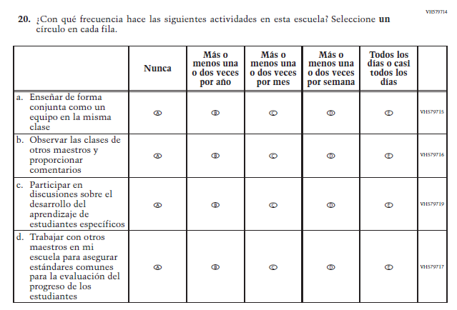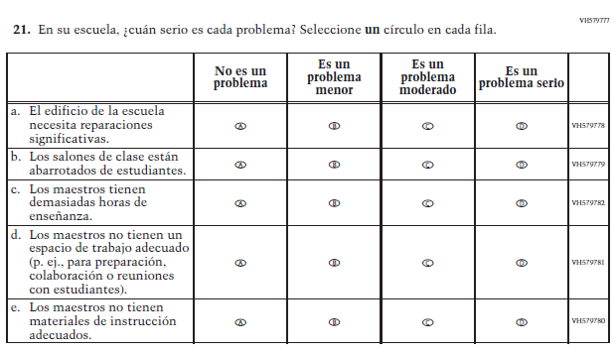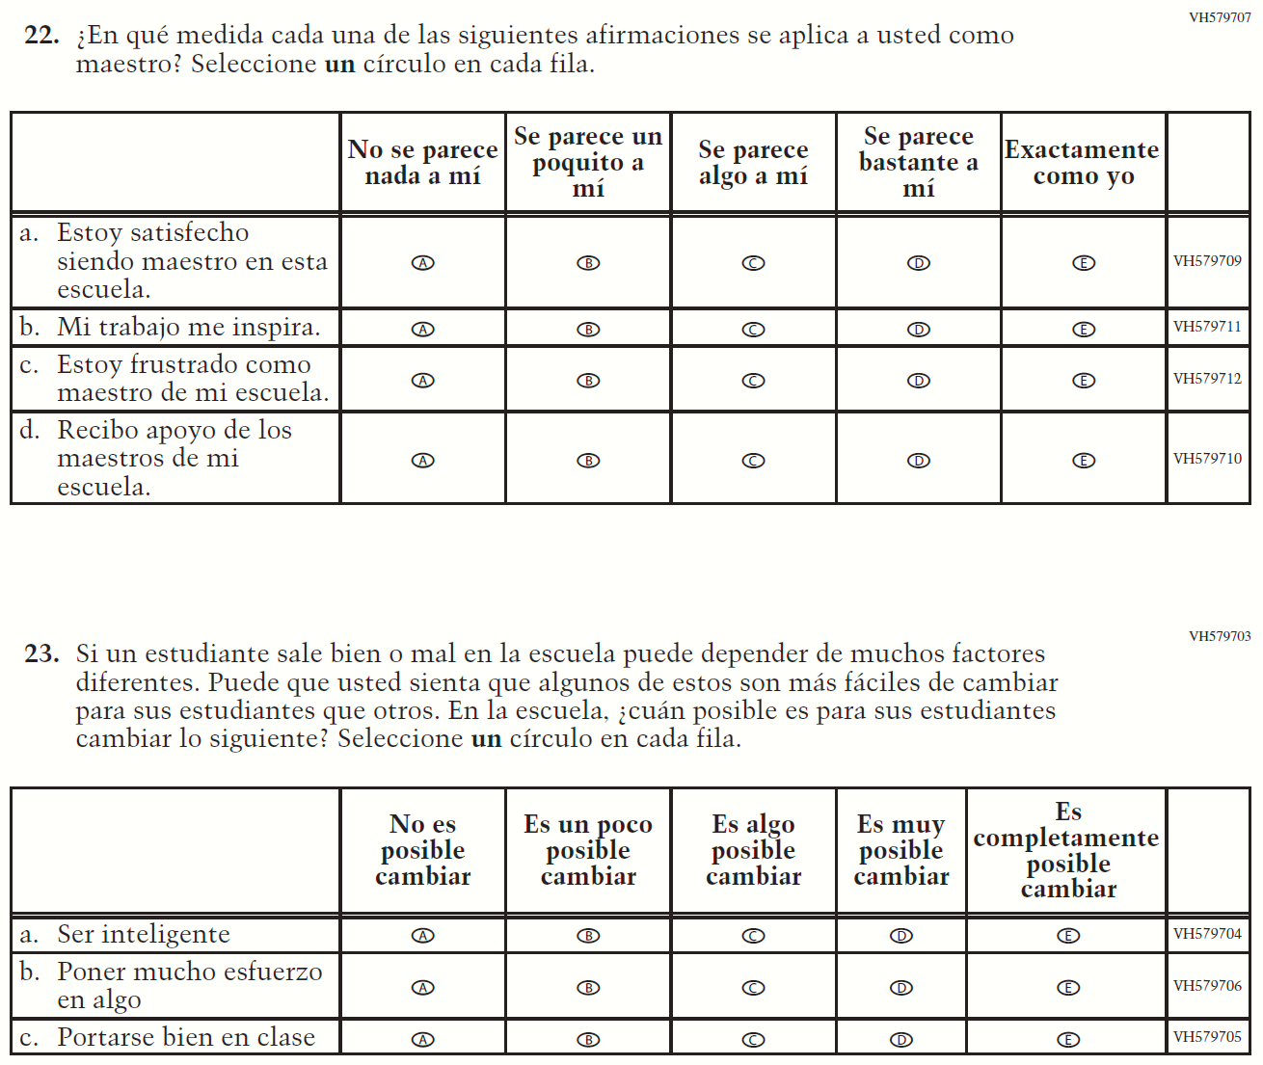

Appendix J-2c-s-PR: Summary of Changes Operational Grade 4 Mathematics
2021 Operational Grade 4 Mathematics Teacher – Puerto Rico
Previous item | 2021 item | D/A/R/NC+ | Rationale
VH320096  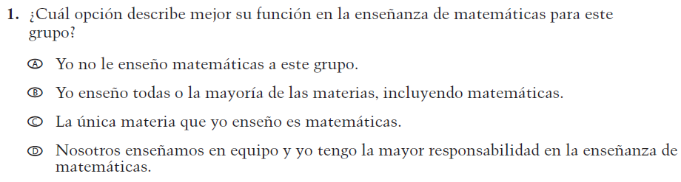  (2019 Operational Grade 4 Teacher Mathematics – Puerto Rico) | VH320096  Issue: Resources for Learning and Instruction | NC | N/A
VH579728  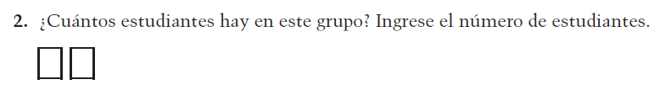  (2019 Operational Grade 4 Teacher Mathematics – Puerto Rico) | VH579728  Issue: Resources for Learning and Instruction | NC | N/A
VH857347  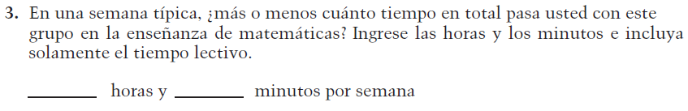  (2019 Operational Grade 4 Teacher Mathematics – Puerto Rico) | VH857347  Issue: Resources for Learning and Instruction | N/C | N/A
VH320121  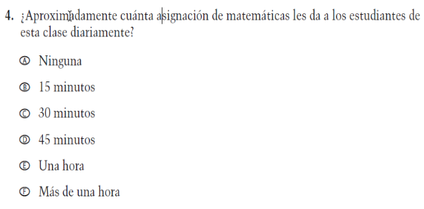  (2019 Operational Grade 4 Teacher Mathematics – Puerto Rico) | VH320121  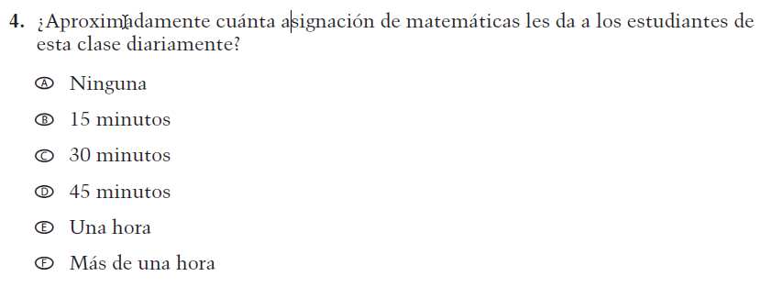  Issue: Organization of Instruction | NC | N/A

2021 Operational Grade 4 Mathematics Teacher – Puerto Rico
Previous item | 2021 item | D/A/R/NC+ | Rationale
VH320125  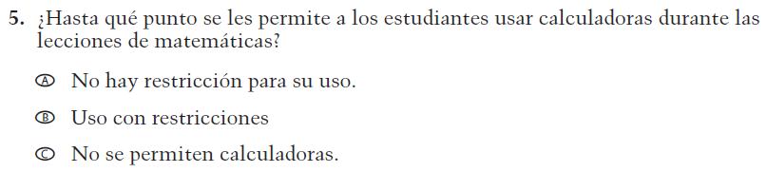  (2019 Operational Grade 4 Teacher Mathematics – Puerto Rico) | VH320125  Issue: Organization of Instruction | NC | N/A
VH320129  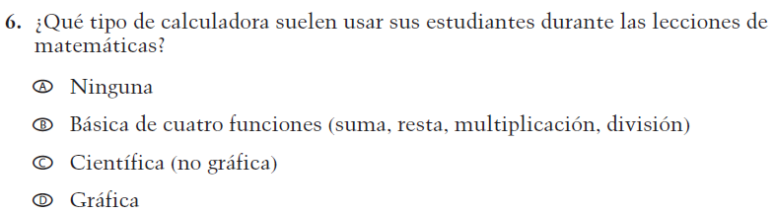  (2019 Operational Grade 4 Teacher Mathematics – Puerto Rico) | VH320129  Issue: Resources for learning and instruction | NC | N/A
VH320132  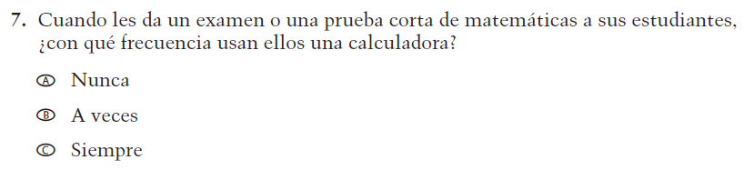  (2019 Operational Grade 4 Teacher Mathematics – Puerto Rico) | VH320132  Issue: Organization of Instruction | NC | N/A
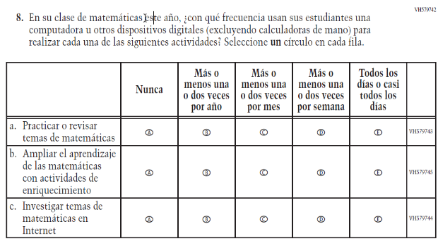  (2019 Operational Grade 4 Teacher Mathematics – Puerto Rico) | 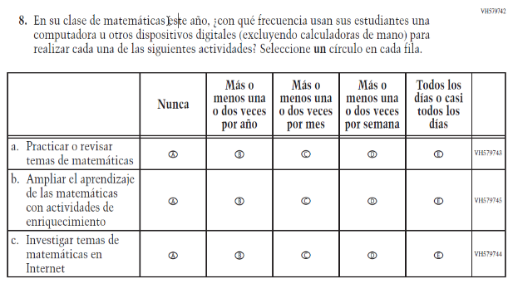  Issue: Organization of Instruction | NC | N/A

2021 Operational Grade 4 Mathematics Teacher – Puerto Rico
Previous item | 2021 item | D/A/R/NC+ | Rationale
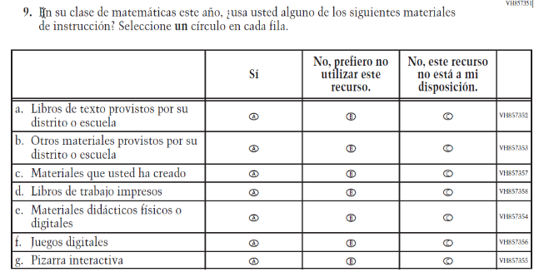  (2019 Operational Grade 4 Teacher Mathematics – Puerto Rico) | 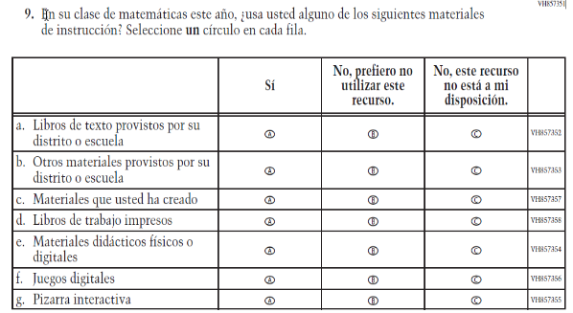  Issue: Resources for Learning and Instruction | NC | N/A
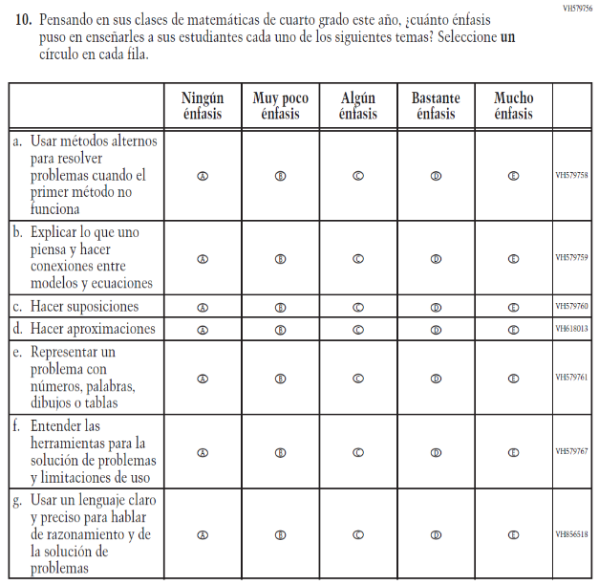  (2019 Operational Grade 4 Teacher Mathematics – Puerto Rico) | 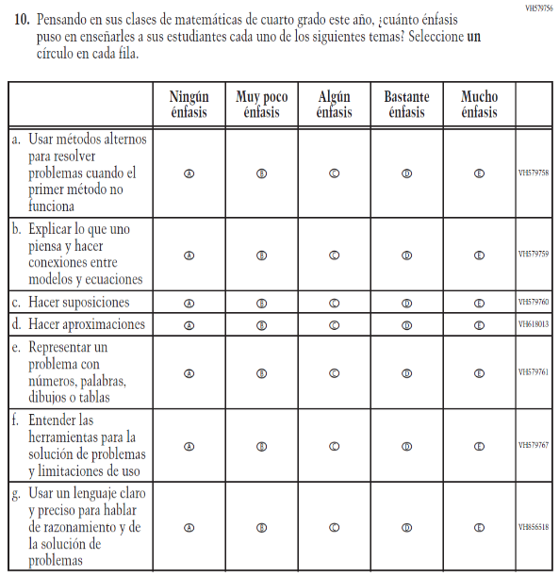  Issue: Organization of Instruction | NC | N/A

2021 Operational Grade 4 Mathematics Teacher – Puerto Rico
Previous item | 2021 item | D/A/R/NC+ | Rationale
VH320151  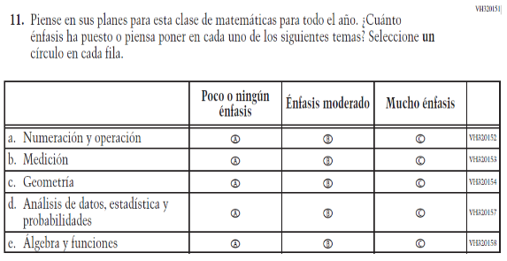  (2019 Operational Grade 4 Teacher Mathematics – Puerto Rico) | VH320151  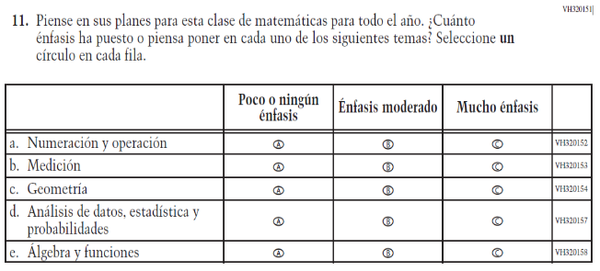  Issue: Organization of Instruction | NC | N/A
VH320200  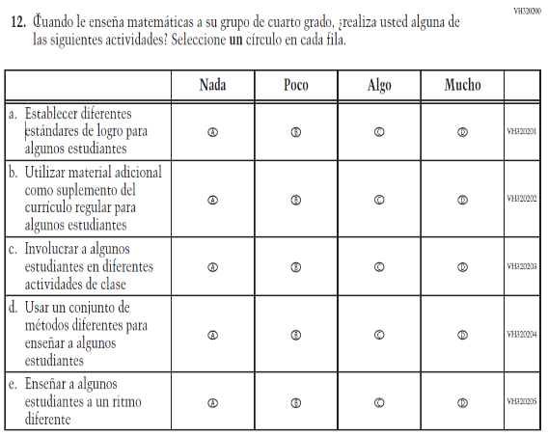  (2019 Operational Grade 4 Teacher Mathematics – Puerto Rico) | VH320200  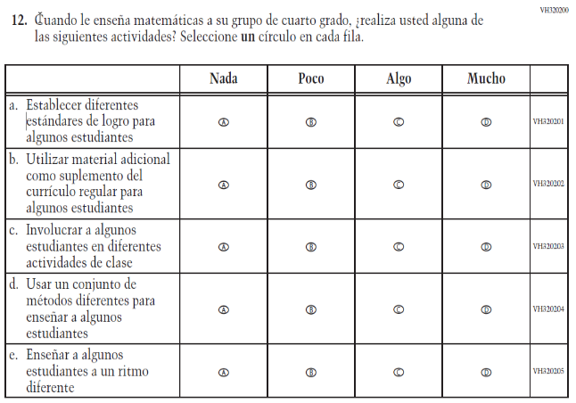  Issue: Organization of Instruction | NC | N/A

2021 Operational Grade 4 Mathematics Teacher – Puerto Rico
Previous item | 2021 item | D/A/R/NC+ | Rationale
VH579746  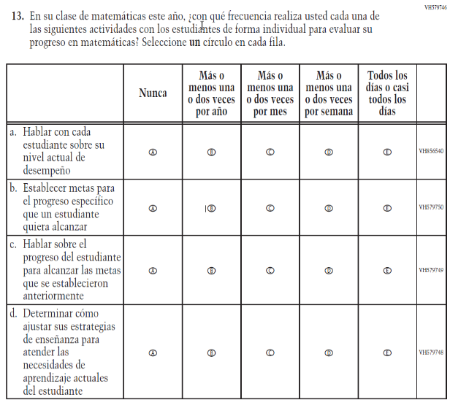  (2019 Operational Grade 4 Teacher Mathematics – Puerto Rico) | VH579746  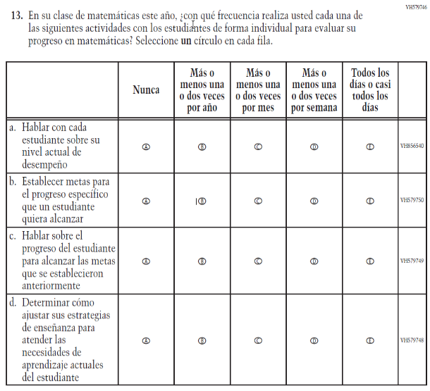  Issue: Organization of Instruction | NC | N/A
VH579768  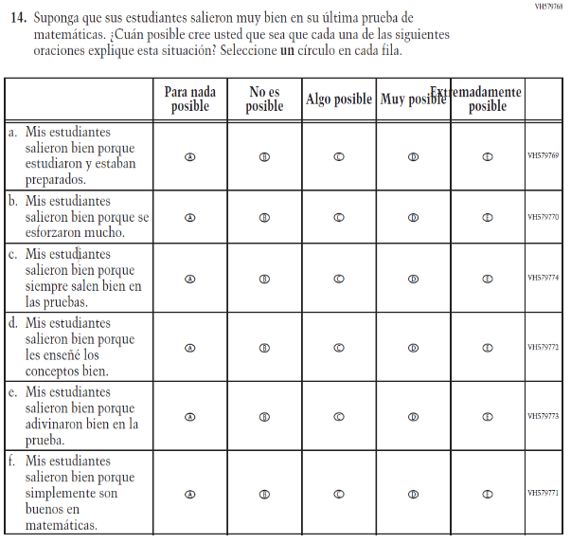  (2019 Operational Grade 4 Teacher Mathematics – Puerto Rico) | VH579768  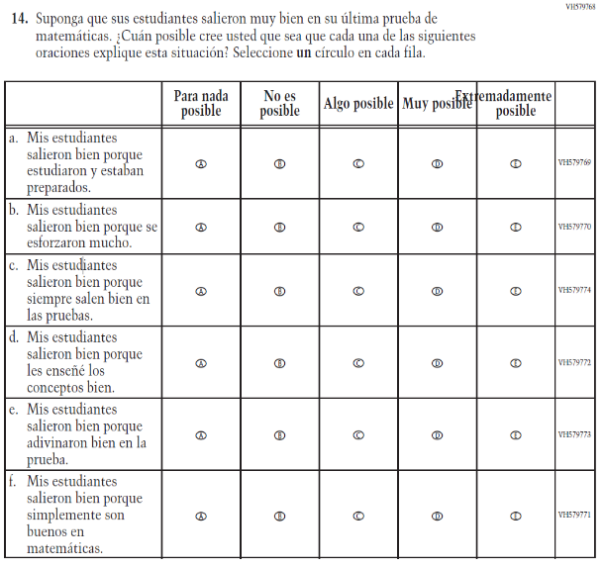  Issue: Teacher Preparation | NC | N/A

2021 Operational Grade 4 Mathematics Teacher – Puerto Rico
Previous item | 2021 item | D/A/R/NC+ | Rationale
VH579775  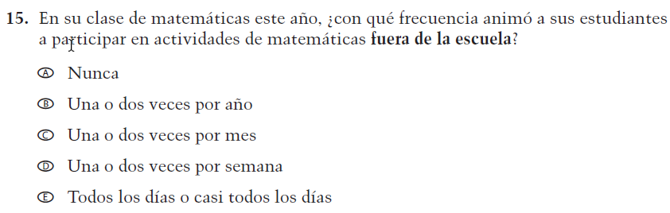  (2019 Operational Grade 4 Teacher Mathematics – Puerto Rico) | VH579775  Issue: Resources for Learning and Instruction | NC | N/A
VH579776  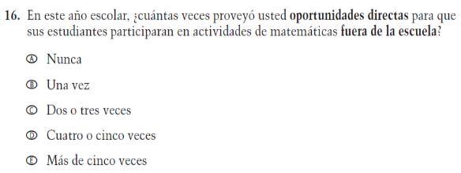  (2019 Operational Grade 4 Teacher Mathematics – Puerto Rico) | VH579776  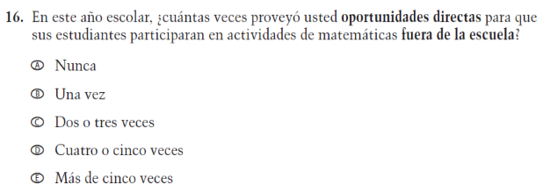  Issue: Resources for Learning and Instruction | NC | N/A

Appendix J-2c-s-PR: Operational Grade 4 Mathematics
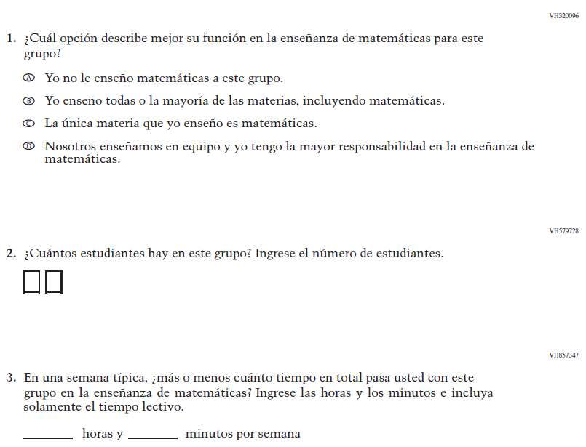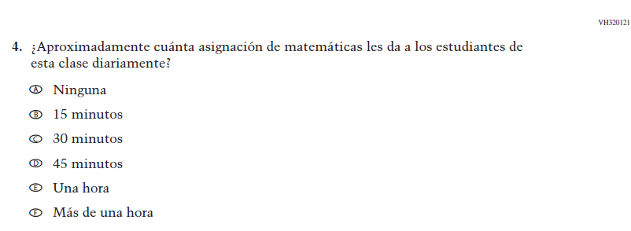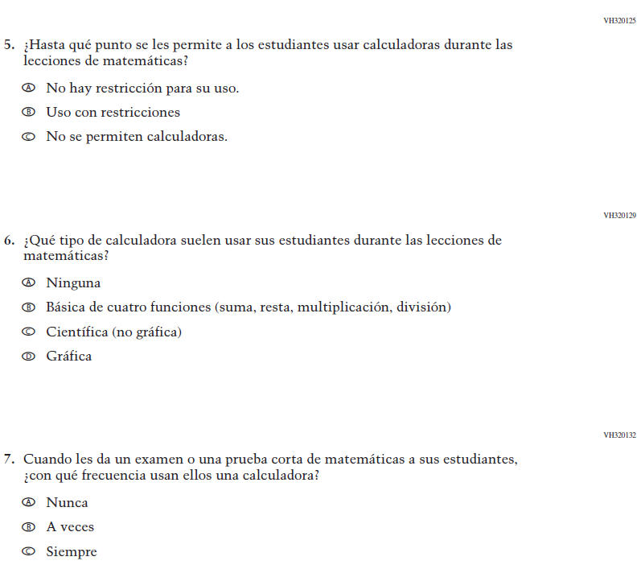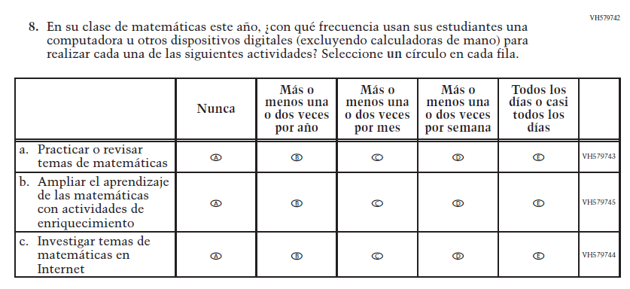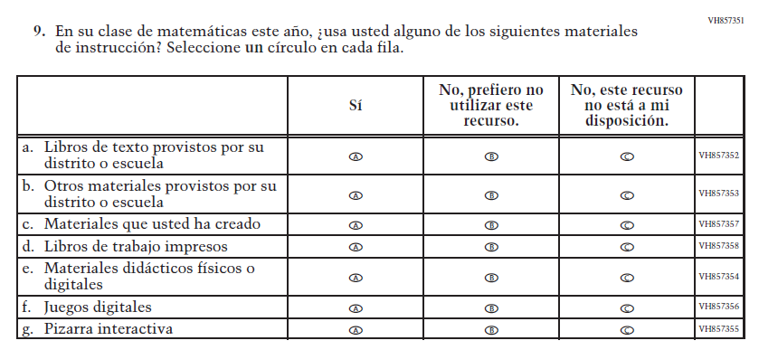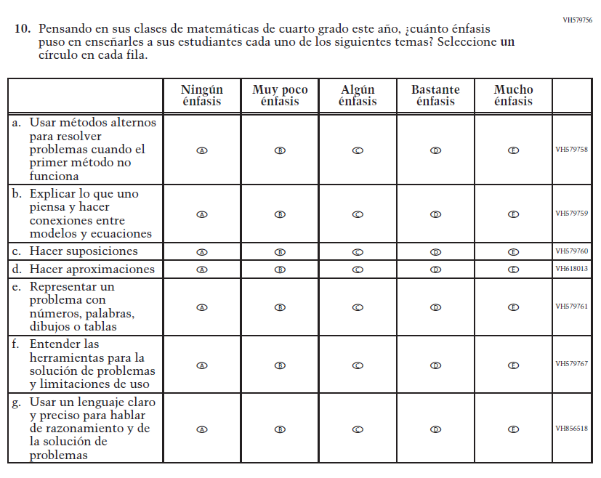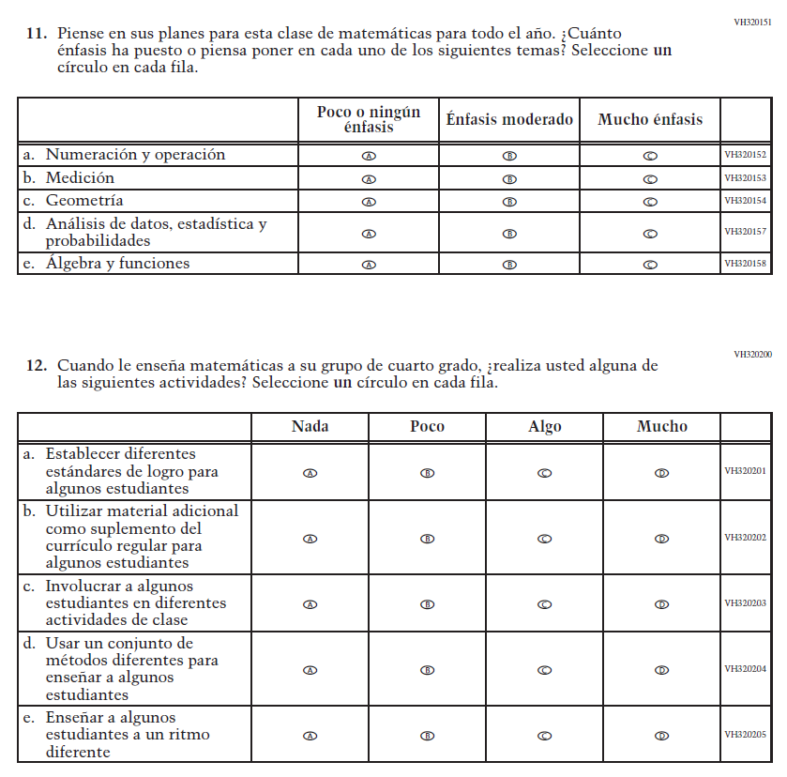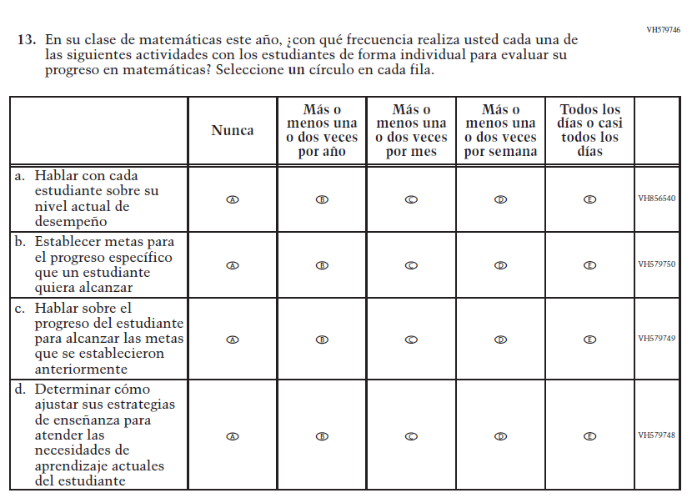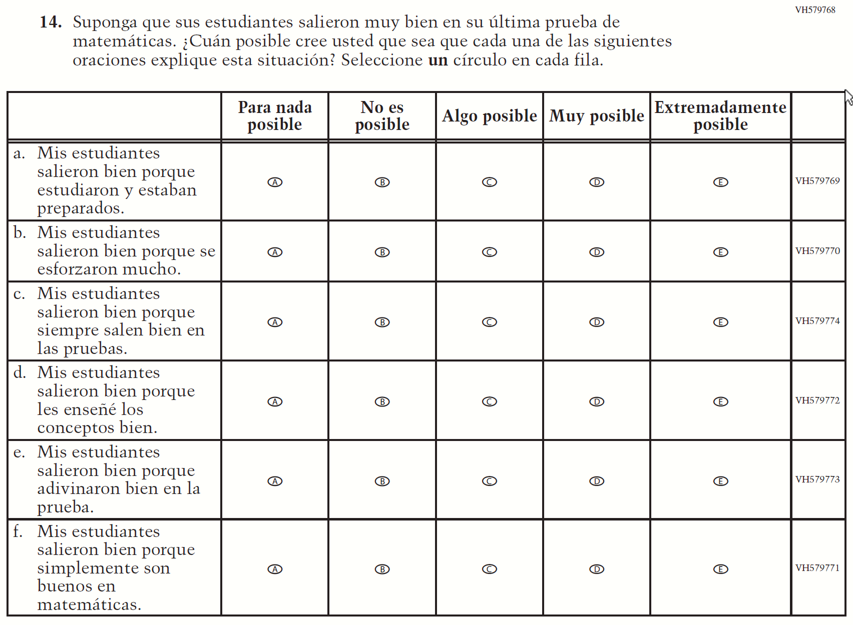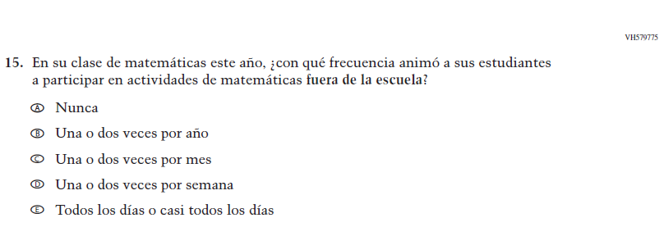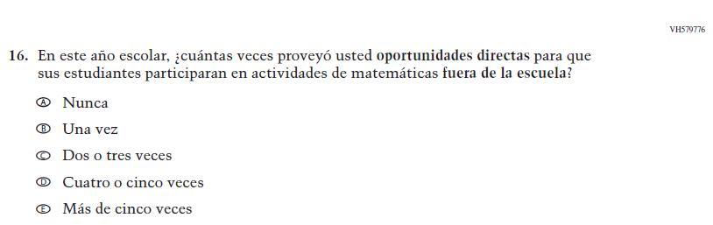

Appendix J-2d-s-PR: Summary of Changes Operational Grade 8 Mathematics
2021 Operational Grade 8 Mathematics Teacher – Puerto Rico
Previous item | 2021 item | D/A/R/NC+ | Rationale
VH320096  (2019 Operational Grade 8 Teacher Mathematics – Puerto Rico) | VH320096  Issue: Resources for Learning and Instruction | NC | N/A
VH579728  (2019 Operational Grade 8 Teacher Mathematics – Puerto Rico) | VH579728  Issue: Resources for Learning and Instruction | NC | N/A
VH857347  (2019 Operational Grade 8 Teacher Mathematics – Puerto Rico) | VH857347  Issue: Resources for Learning and Instruction | N/C | N/A
VH320121  (  2019 Operational Grade 8 Teacher Mathematics – Puerto Rico) | VH320121  Issue: Organization of Instruction | NC | N/A

2021 Operational Grade 8 Mathematics Teacher – Puerto Rico
Previous item | 2021 item | D/A/R/NC+ | Rationale
VH320125  (2019 Operational Grade 8 Teacher Mathematics – Puerto Rico) | VH320125  Issue: Organization of Instruction | NC | N/A
VH320129  (2019 Operational Grade 8 Teacher Mathematics – Puerto Rico) | VH320129  Issue: Resources for Learning and Instruction | NC | N/A
VH320132  (2019 Operational Grade 8 Teacher Mathematics – Puerto Rico) | VH320132  Issue: Organization of Instruction | NC | N/A
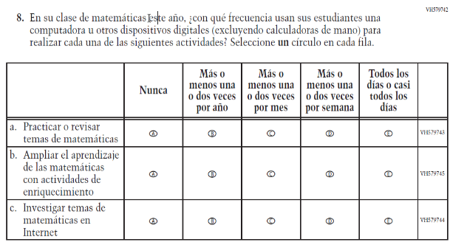  (2019 Operational Grade 8 Teacher Mathematics – Puerto Rico) | 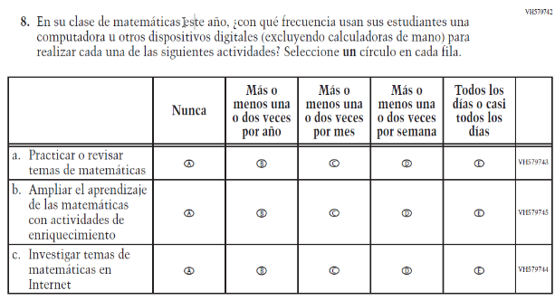  Issue: Organization of Instruction | NC | N/A

2021 Operational Grade 8 Mathematics Teacher – Puerto Rico
Previous item | 2021 item | D/A/R/NC+ | Rationale
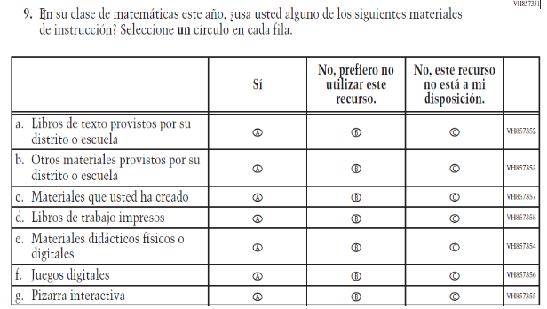  (2019 Operational Grade 8 Teacher Mathematics – Puerto Rico) | Issue: Resources for Learning and Instruction | NC | N/A
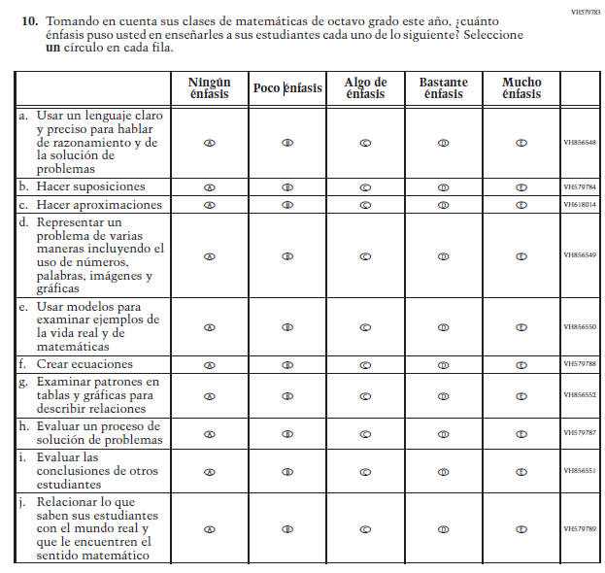  (2019 Operational Grade 8 Teacher Mathematics – Puerto Rico) | Issue: Organization of Instruction | NC | N/A

2021 Operational Grade 8 Mathematics Teacher – Puerto Rico
Previous item | 2021 item | D/A/R/NC+ | Rationale
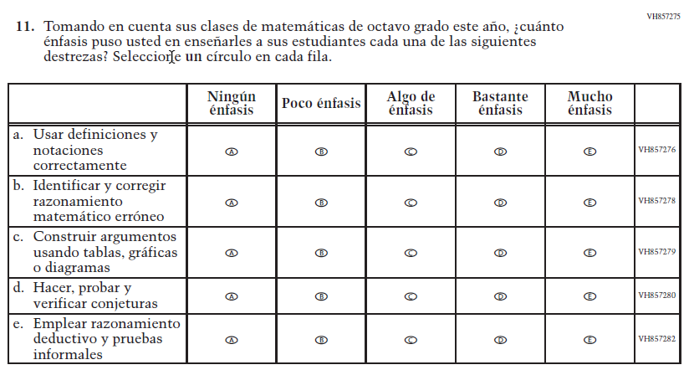  (2019 Operational Grade 8 Teacher Mathematics – Puerto Rico) | Issue: Organization of Instruction | NC | N/A
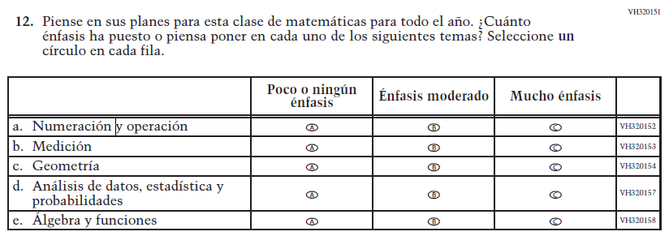  (2019 Operational Grade 8 Teacher Mathematics – Puerto Rico) | Issue: Organization of Instruction | NC | N/A

2021 Operational Grade 8 Mathematics Teacher – Puerto Rico
Previous item | 2021 item | D/A/R/NC+ | Rationale
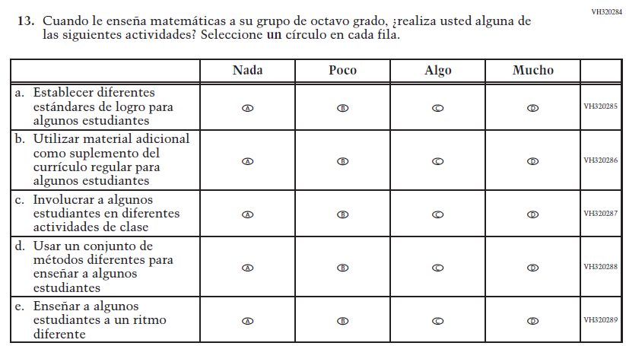  (2019 Operational Grade 8 Teacher Mathematics – Puerto Rico) | Issue: Organization of Instruction | NC | N/A
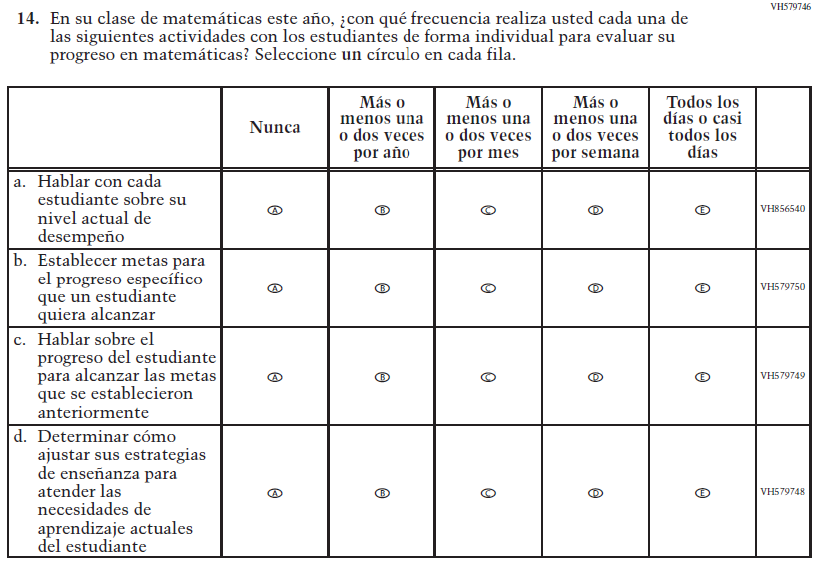  (2019 Operational Grade 8 Teacher Mathematics – Puerto Rico) | Issue: Organization of Instruction | NC | N/A

2021 Operational Grade 8 Mathematics Teacher – Puerto Rico
Previous item | 2021 item | D/A/R/NC+ | Rationale
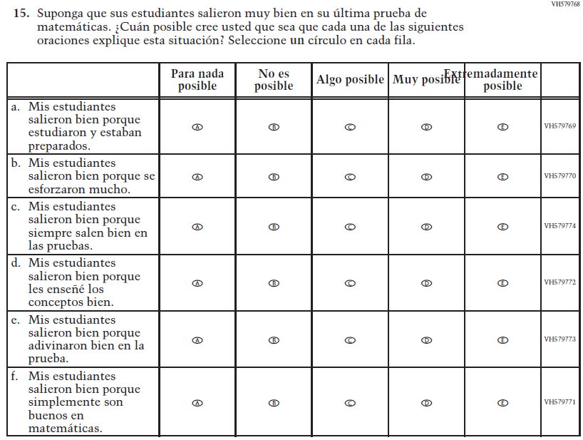  (2019 Operational Grade 8 Teacher Mathematics – Puerto Rico) | Issue: Teacher Preparation | NC | N/A
VH579775  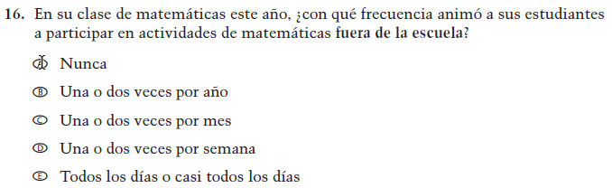  (2019 Operational Grade 8 Teacher Mathematics – Puerto Rico) | VH579775  Issue: Resources for Learning and Instruction | NC | N/A

2021 Operational Grade 8 Mathematics Teacher – Puerto Rico
Previous item | 2021 item | D/A/R/NC+ | Rationale
VH579776  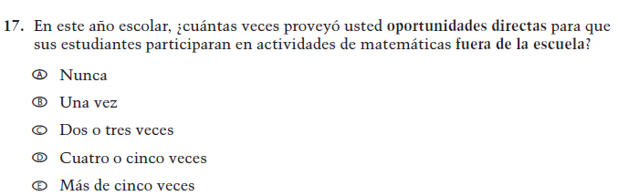  (2019 Operational Grade 8 Teacher Mathematics – Puerto Rico) | VH579776  Issue: Resources for Learning and Instruction | NC | N/A
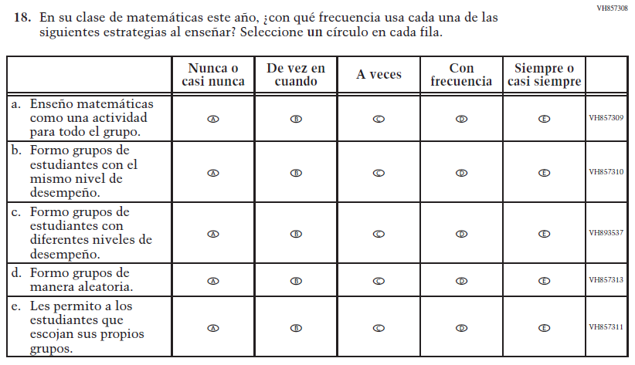  (2019 Operational Grade 8 Teacher Mathematics – Puerto Rico) | Issue: Organization of Instruction | NC | N/A

Appendix J-2d-s-PR: Operational Grade 8 Mathematics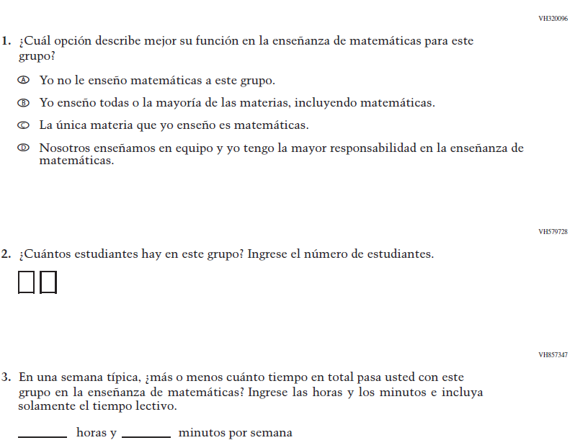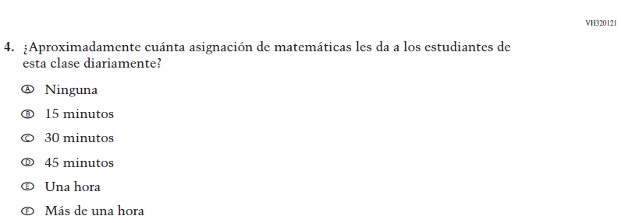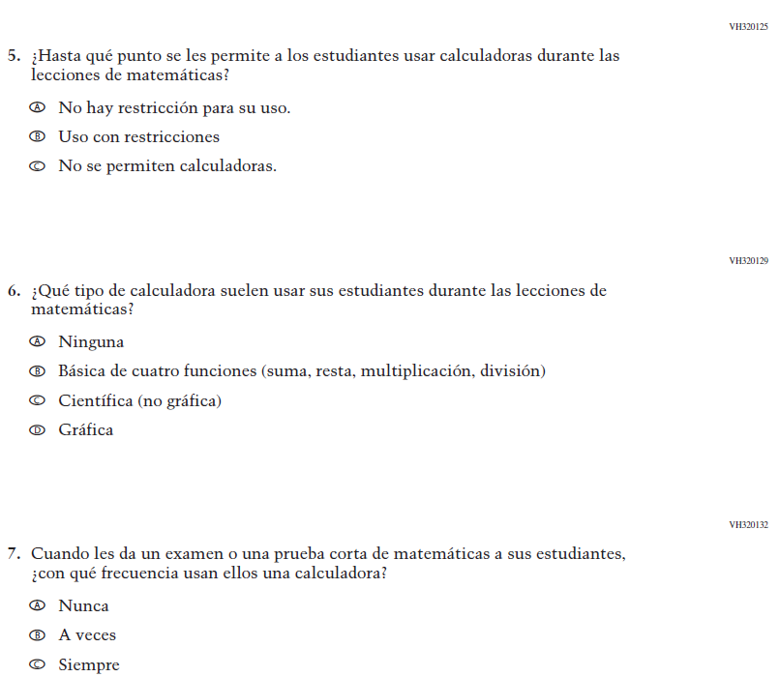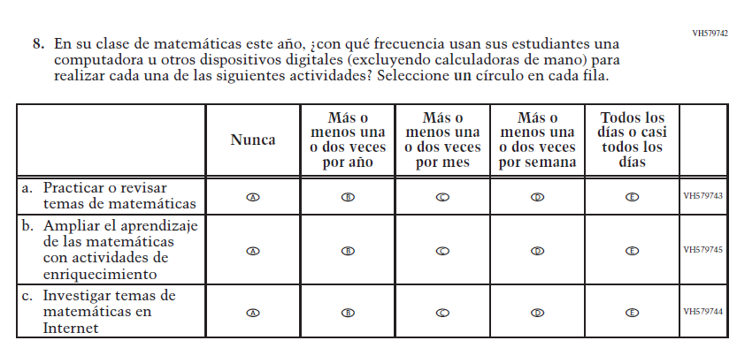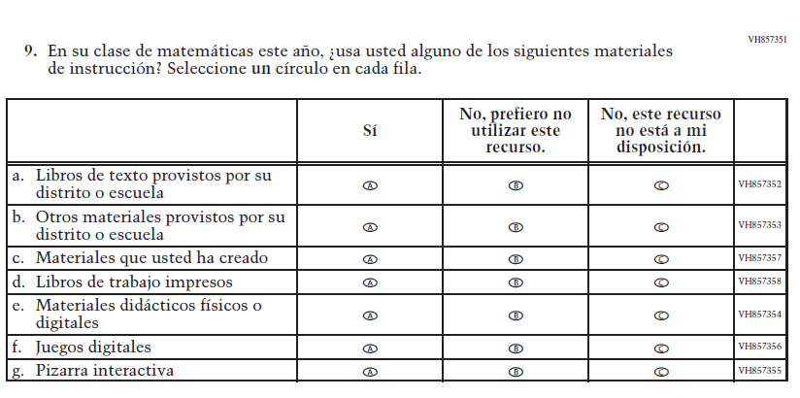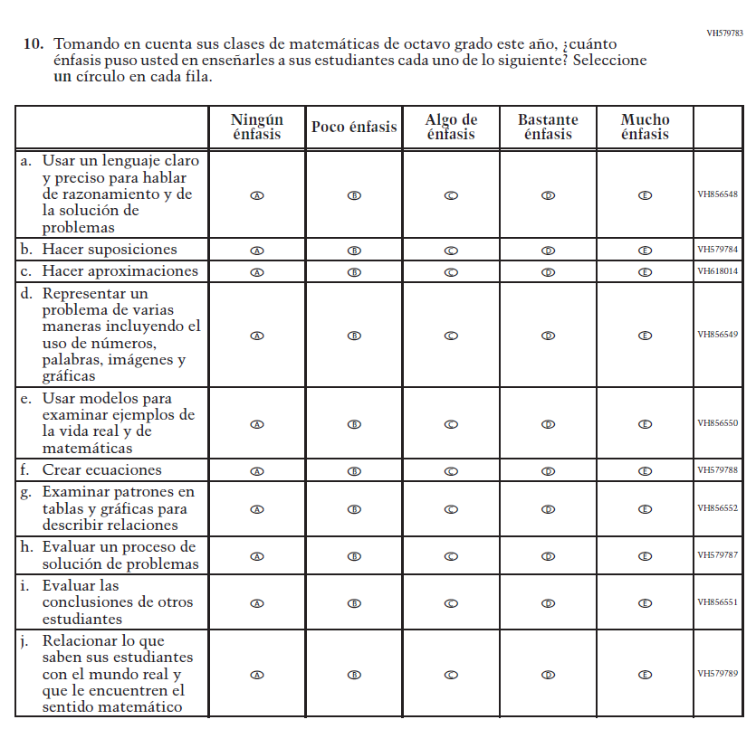
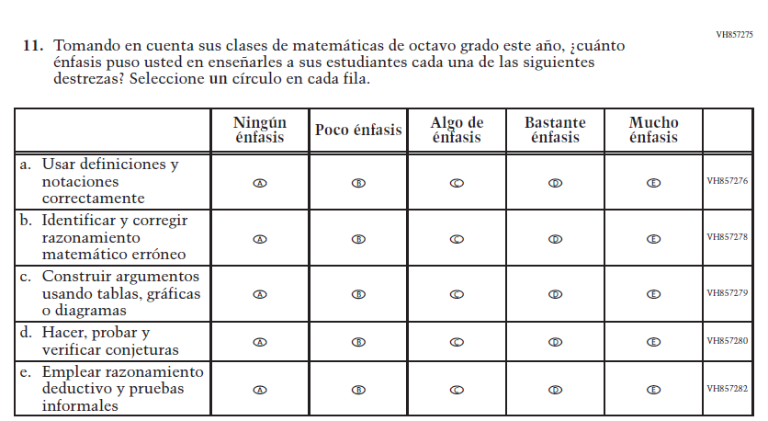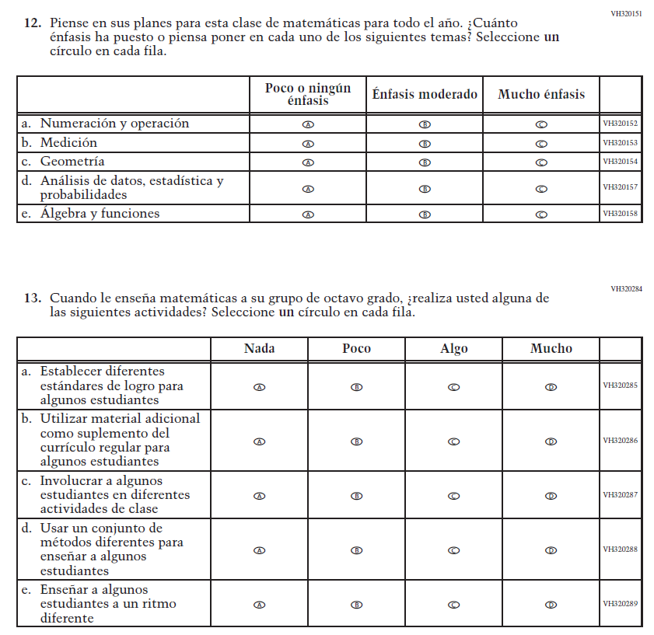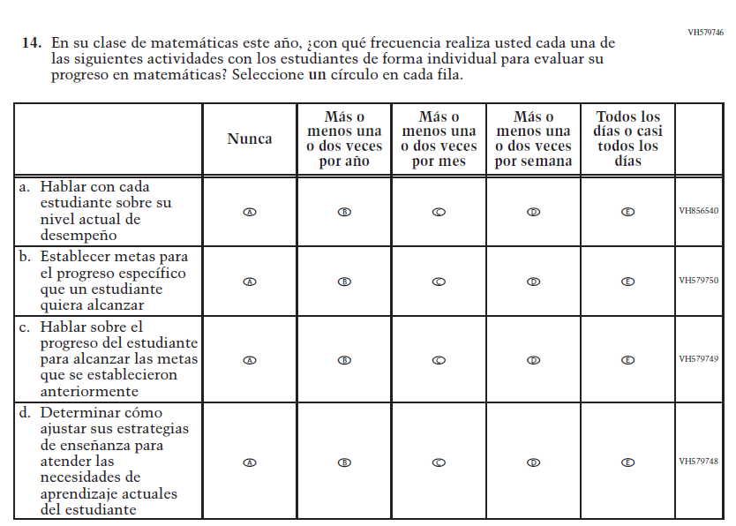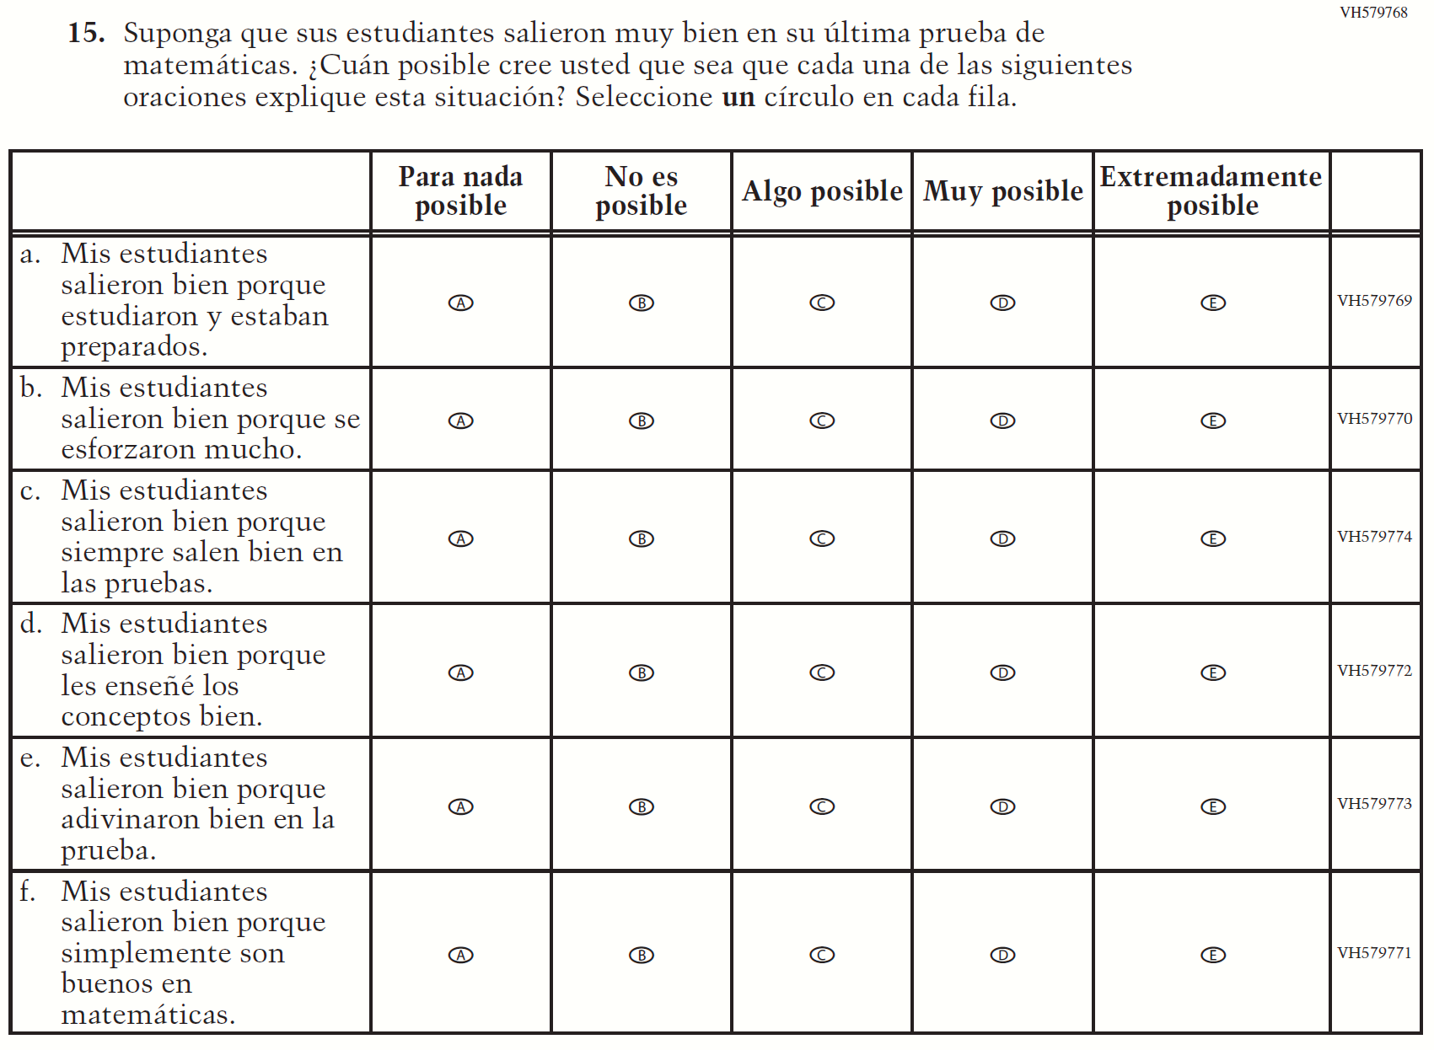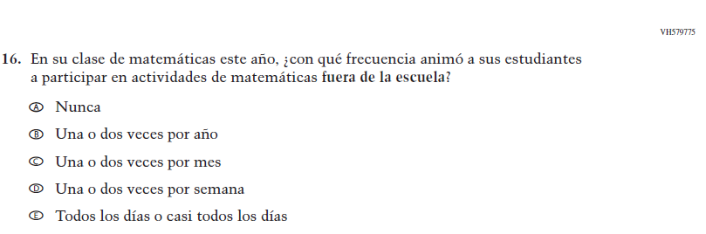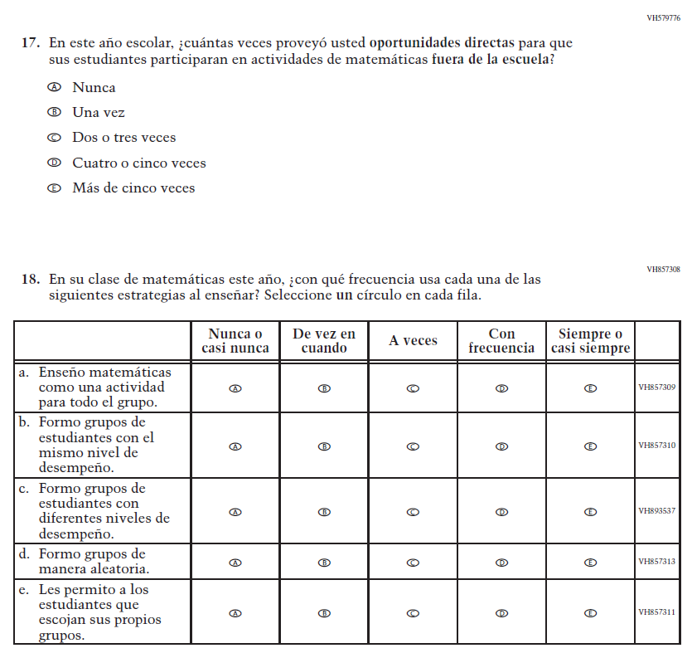

Appendix J-2e-s-PR: Operational Grade 4 COVID-19 (New)
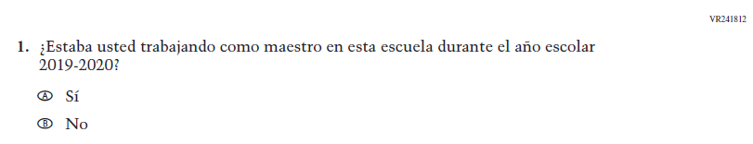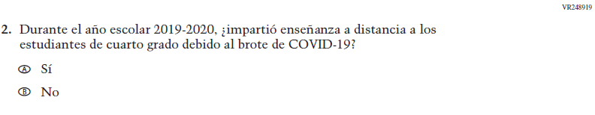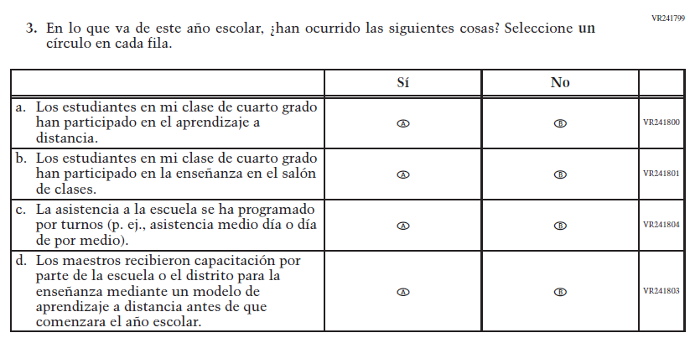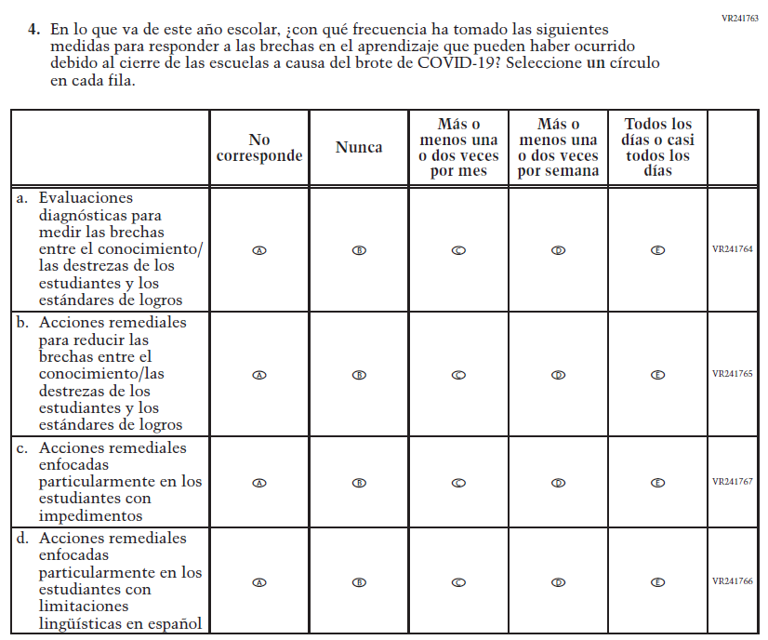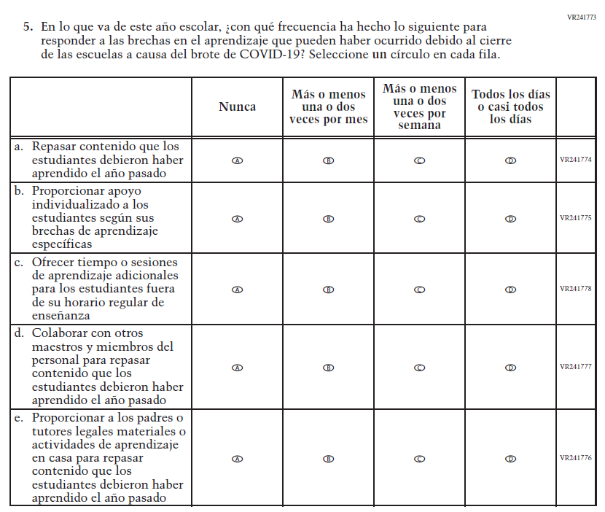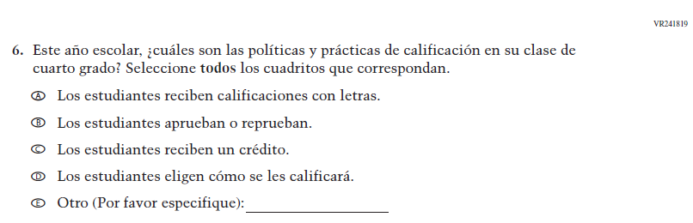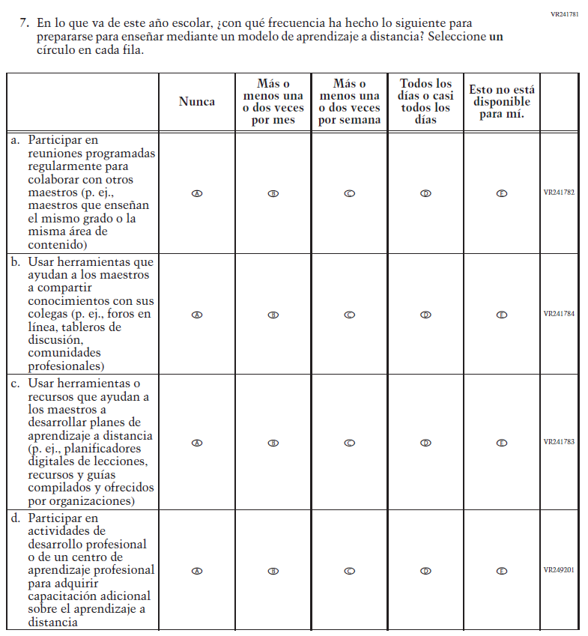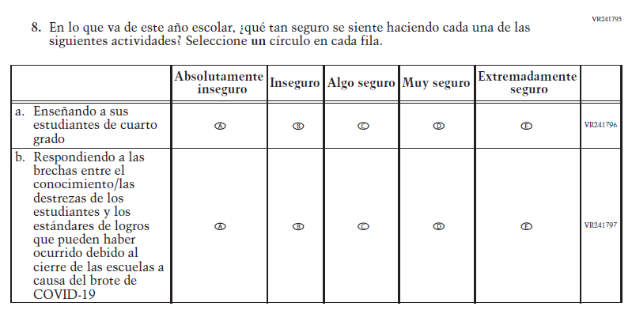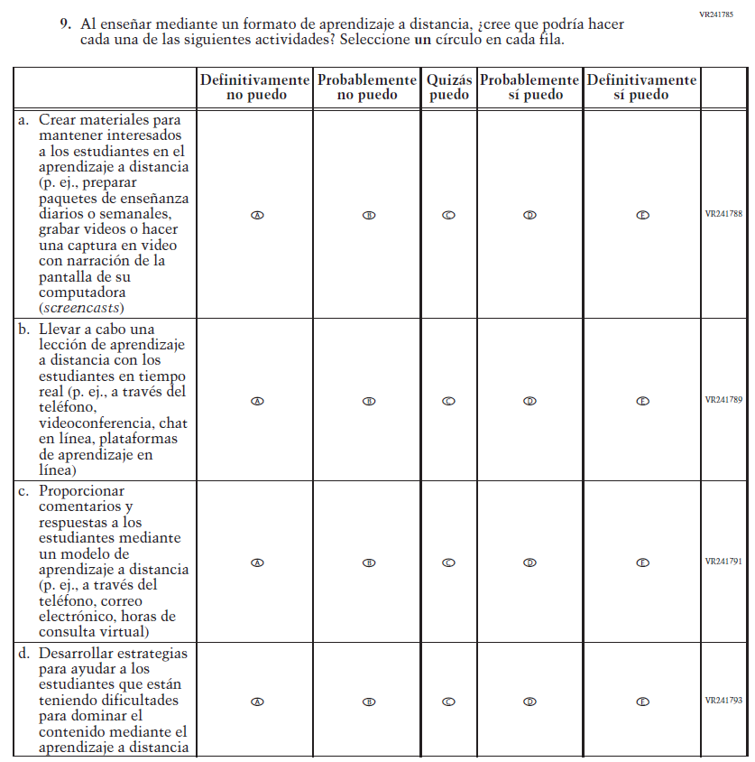

Appendix J-2f-s-PR: Operational Grade 8 COVID-19 (New)
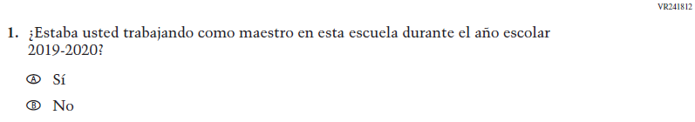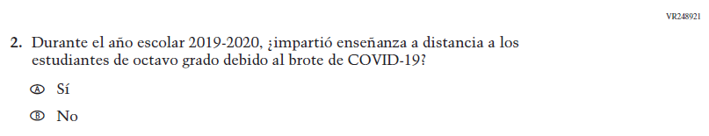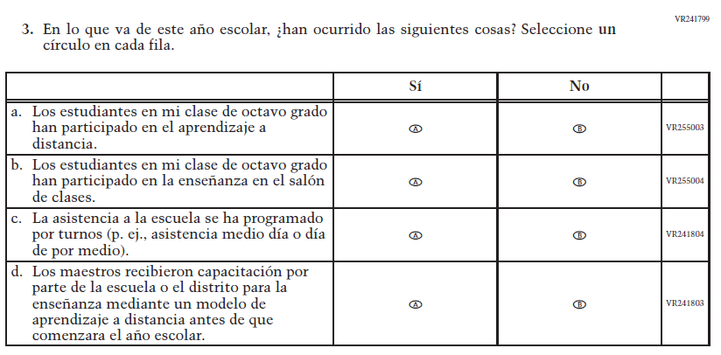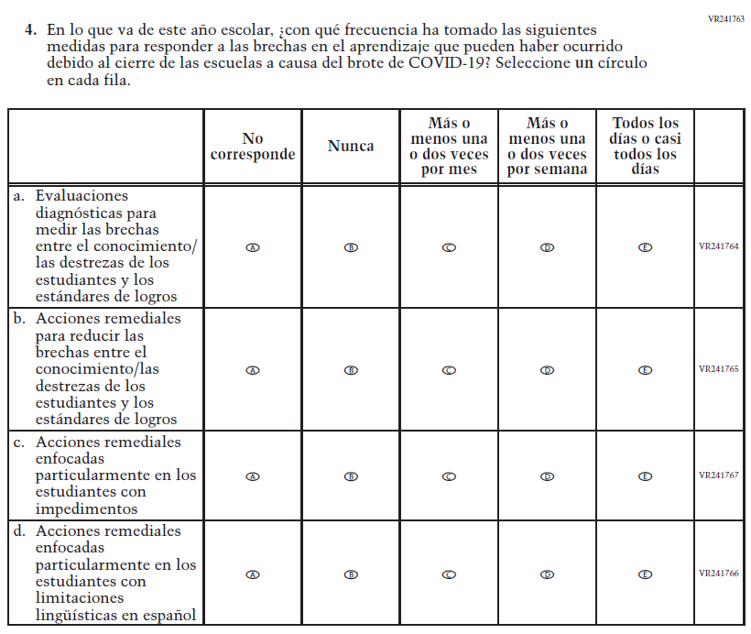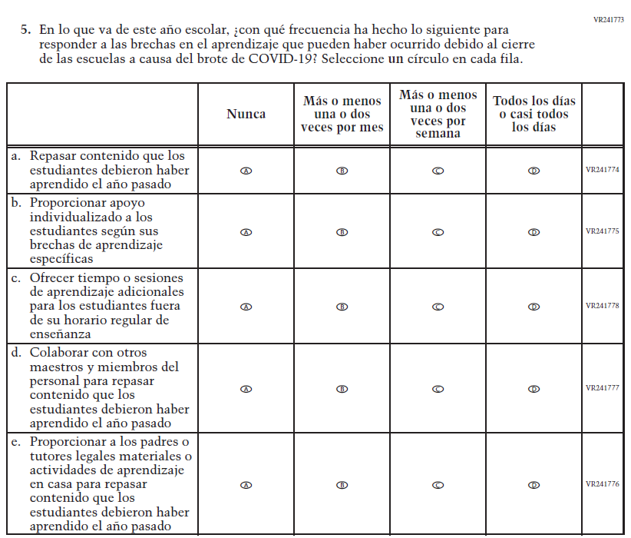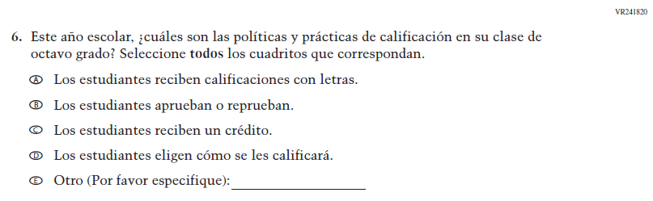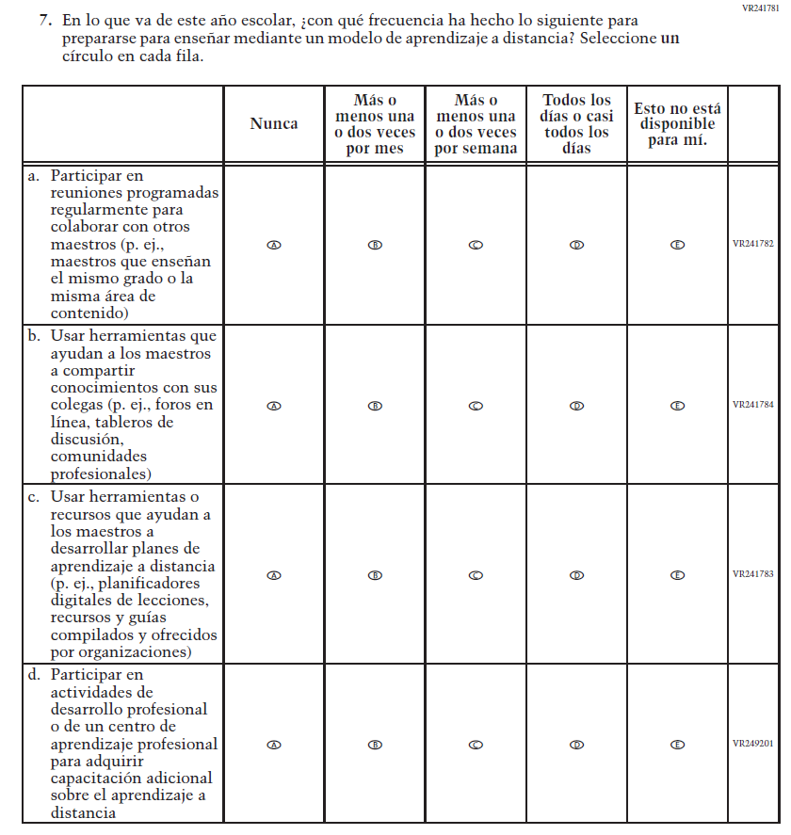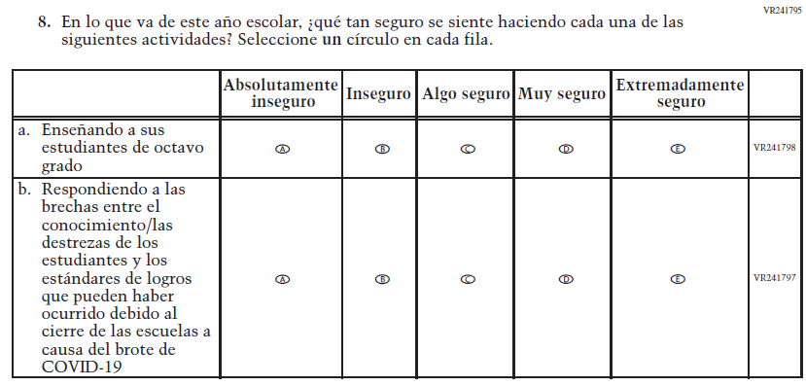
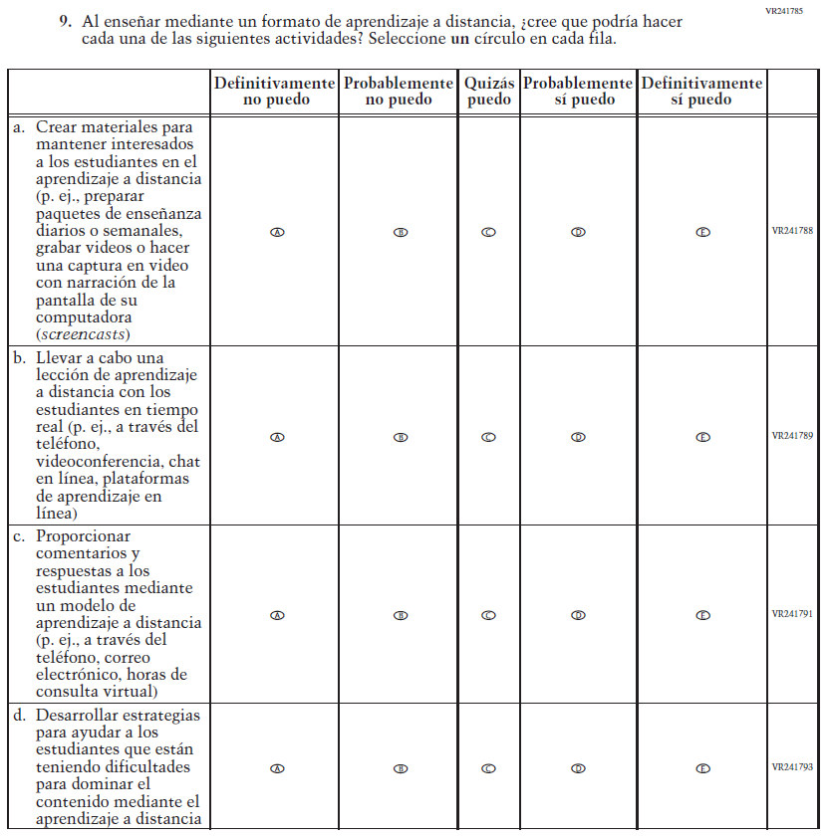

School Administrator Login Screen

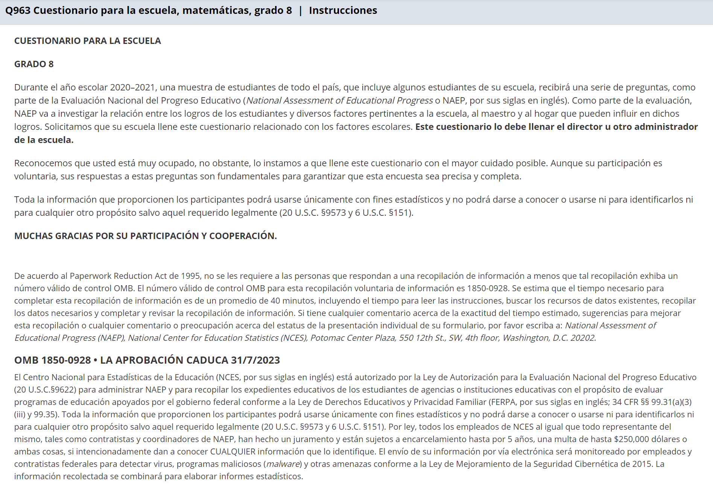

Appendix J-3-s: Spanish Translations of School Questionnaires

Appendix J-3a-s-PR: Summary of Changes Operational Grade 4 CORE
2021 Operational Grade 4 Core School – Puerto Rico
Previous item | 2021 item | D/A/R/NC+ | Rationale
VH835832  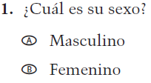  (2019 Operational Grade 4 School Core – Puerto Rico) | VH835832  Issue: Gender | NC | N/A
VH318287  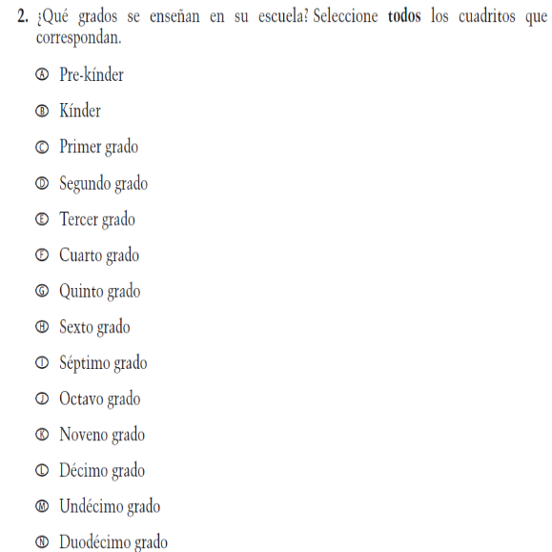  (2019 Operational Grade 4 School Core – Puerto Rico) | VH318287  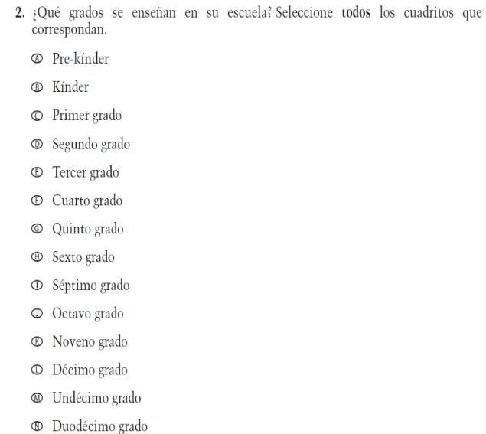  Issue: School Climate | NC | N/A

2021 Operational Grade 4 Core School – Puerto Rico
Previous item | 2021 item | D/A/R/NC+ | Rationale
VH893344  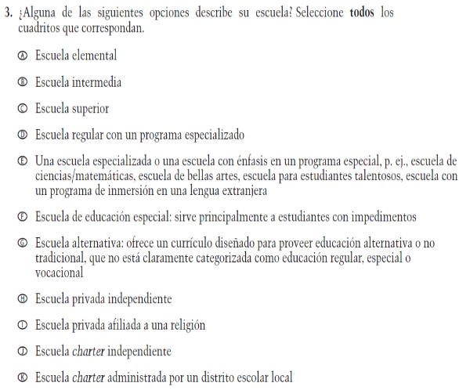  (2019 Operational Grade 4 School Core – Puerto Rico) | VH893344  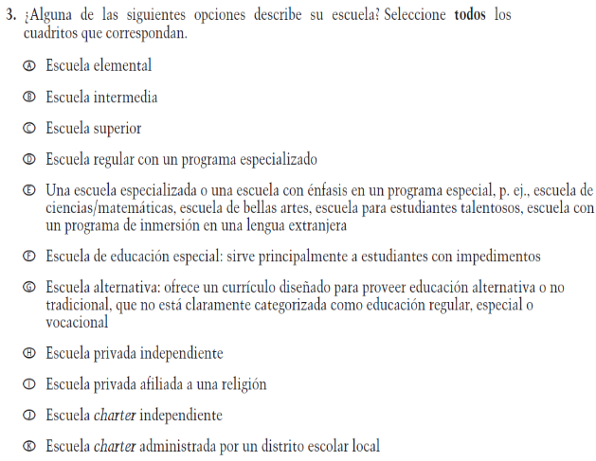  Issue: School Climate | NC | N/A
VH835855  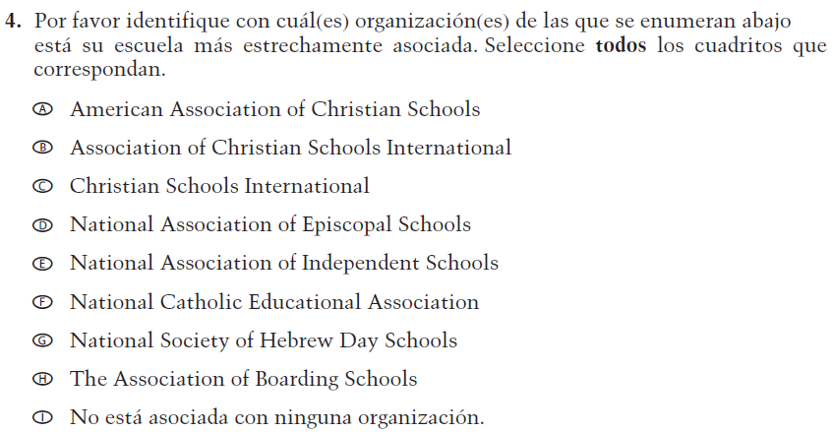  (2019 Operational Grade 4 School Core – Puerto Rico) | VH835855  Issue: School Climate | NC | N/A

2021 Operational Grade 4 Core School – Puerto Rico
Previous item | 2021 item | D/A/R/NC+ | Rationale
VH318289  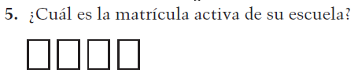  (2019 Operational Grade 4 School Core – Puerto Rico) | VH318289  Issue: School Climate | NC | N/A
VH318292  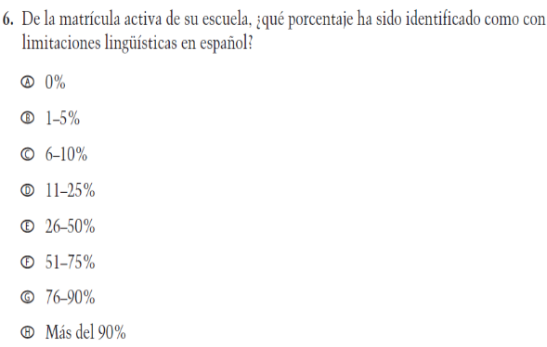  (2019 Operational Grade 4 School Core – Puerto Rico) | VH318292  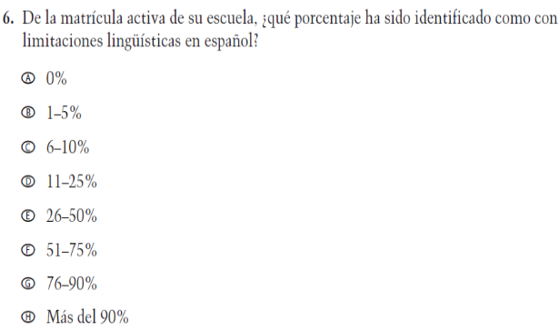  Issue: School Climate | NC | N/A
VH318291  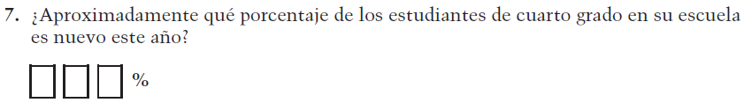  (2019 Operational Grade 4 School Core – Puerto Rico) | VH318291  Issue: School Climate | NC | N/A

2021 Operational Grade 4 Core School – Puerto Rico
Previous item | 2021 item | D/A/R/NC+ | Rationale
VH318298  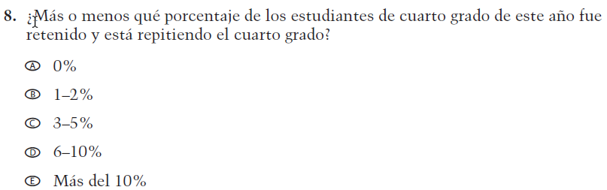  (2019 Operational Grade 4 School Core – Puerto Rico) | VH318298  Issue: School Climate | NC | N/A
VH318293  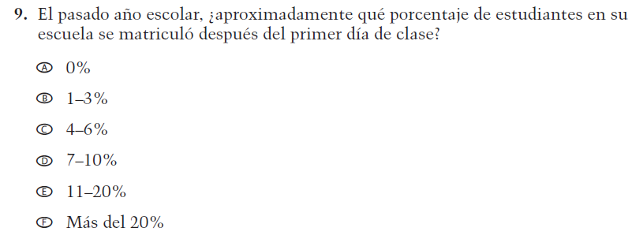  (2019 Operational Grade 4 School Core – Puerto Rico) | VH318293  Issue: School Climate | NC | N/A
VH318294  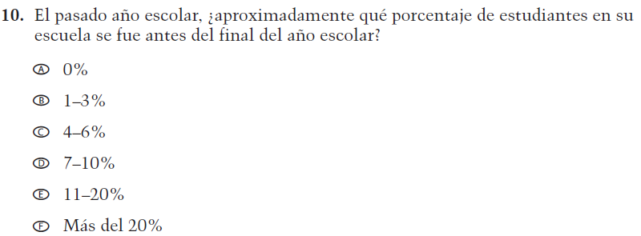  (2019 Operational Grade 4 School Core – Puerto Rico) | VH318294  Issue: School Climate | NC | N/A

2021 Operational Grade 4 Core School – Puerto Rico
Previous item | 2021 item | D/A/R/NC+ | Rationale
VH318297  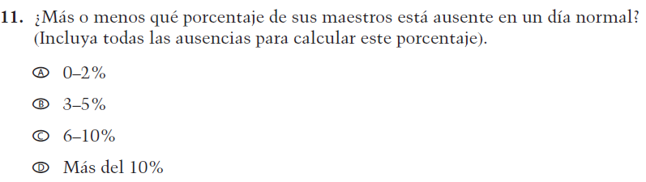  (2019 Operational Grade 4 School Core – Puerto Rico) | VH318297  Issue: School Climate | NC | N/A
VH318299  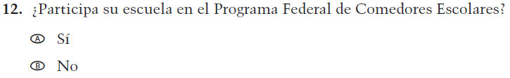  (2019 Operational Grade 4 School Core – Puerto Rico) | VH318299  Issue: Socioeconomic Status | NC | N/A
VH318300  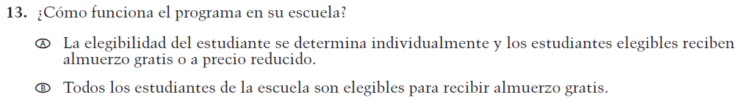  (2019 Operational Grade 4 School Core – Puerto Rico) | VH318300  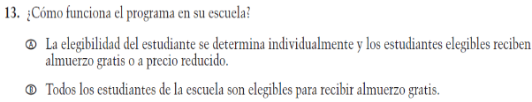  Issue: Socioeconomic Status | NC | N/A
VH318303  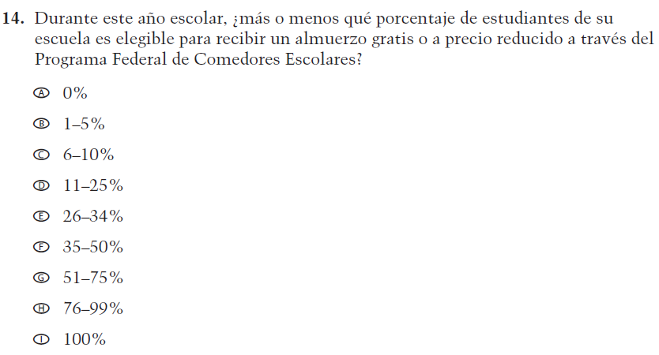  (2019 Operational Grade 4 School Core – Puerto Rico) | VH318303  Issue: Socioeconomic Status | NC | N/A

2021 Operational Grade 4 Core School – Puerto Rico
Previous item | 2021 item | D/A/R/NC+ | Rationale
VH318304  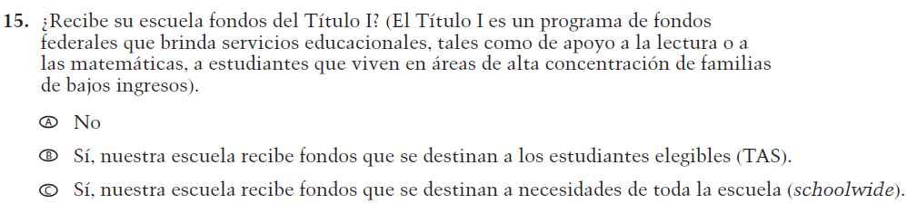  (2019 Operational Grade 4 School Core – Puerto Rico) | VH318304  Issue: Socioeconomic Status | NC | N/A
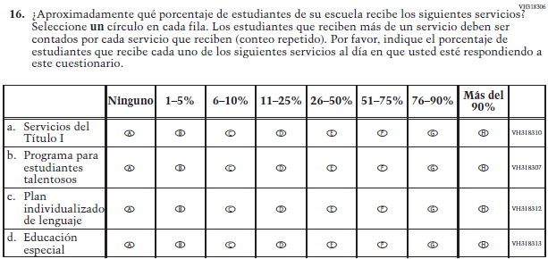  (2019 Operational Grade 4 School Core – Puerto Rico) | 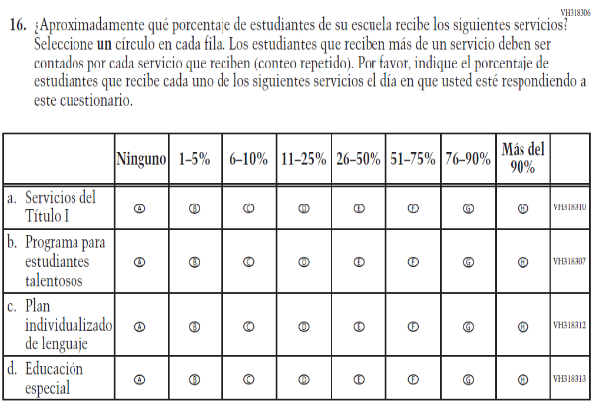  Issue: School Climate | R - “al día en que usted” changed to “el día en que usted” in SL  NC – subitems a through d | To correct a grammar error.
VH318316  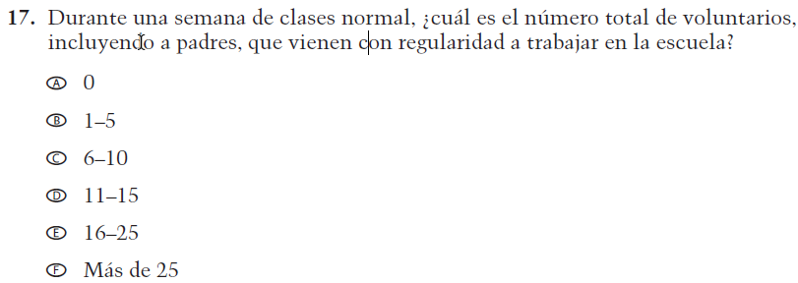  (2019 Operational Grade 4 School Core – Puerto Rico) | VH318316  Issue: School Climate | NC | N/A

2021 Operational Grade 4 Core School – Puerto Rico
Previous item | 2021 item | D/A/R/NC+ | Rationale
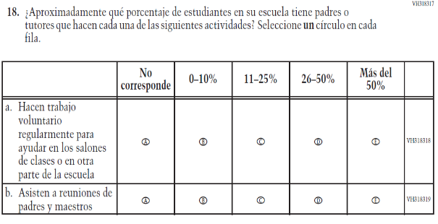  (2019 Operational Grade 4 School Core – Puerto Rico) | 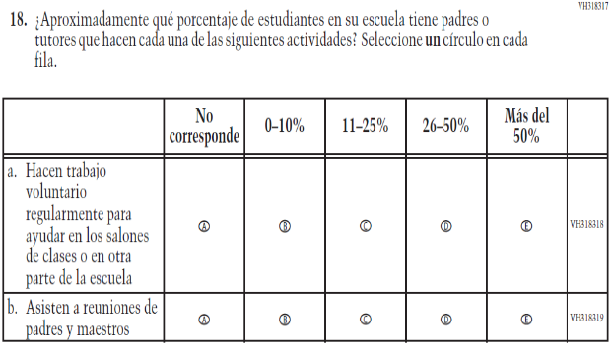  Issue: School Climate | NC | N/A
VH318321  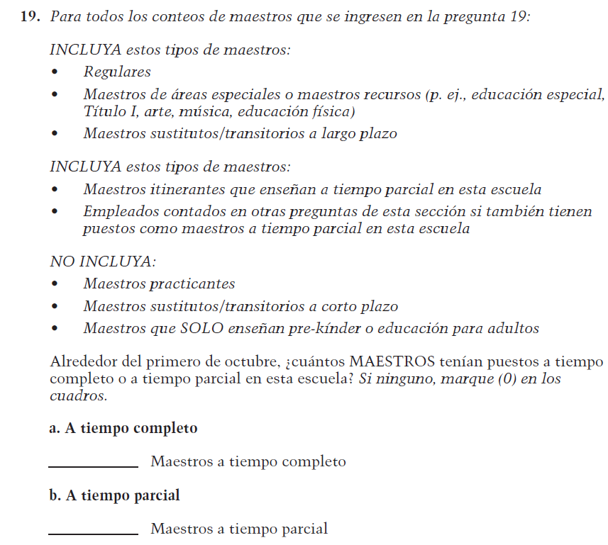  (2019 Operational Grade 4 School Core – Puerto Rico) | VH318321  Issue: School Climate | NC | N/A

2021 Operational Grade 4 Core School – Puerto Rico
Previous item | 2021 item | D/A/R/NC+ | Rationale
VH835853  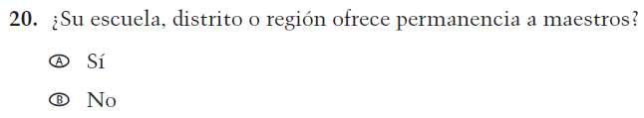  (2019 Operational Grade 4 School Core – Puerto Rico) | VH835853  Issue: School Climate | NC | N/A
VH893347  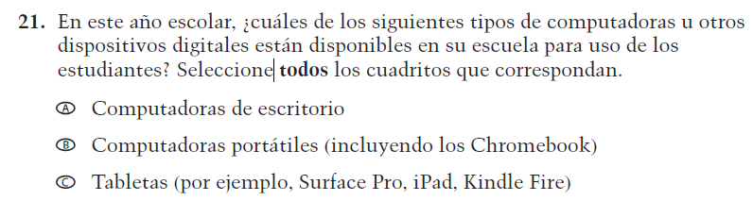  (2019 Operational Grade 4 School Core – Puerto Rico) | VH893347  Issue: Technology Use | NC | N/A
VH579614  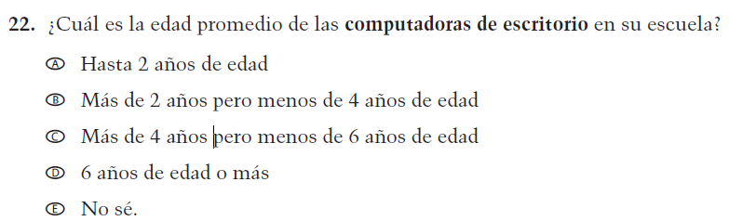  (2019 Operational Grade 4 School Core – Puerto Rico) | VH579614  Issue: Technology Use | NC | N/A

2021 Operational Grade 4 Core School – Puerto Rico
Previous item | 2021 item | D/A/R/NC+ | Rationale
VH893348  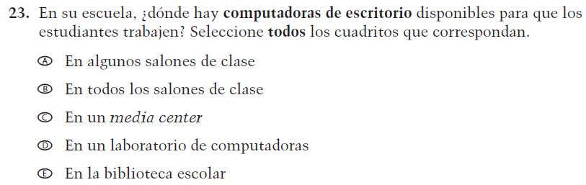  (2019 Operational Grade 4 School Core – Puerto Rico) | VH893348  Issue: Technology Use | NC | N/A
VH579616  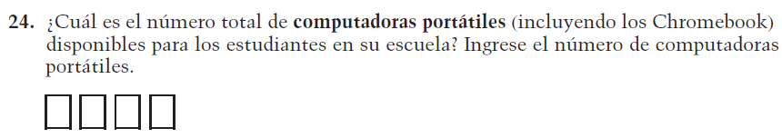  (2019 Operational Grade 4 School Core – Puerto Rico) | VH579616  Issue: Technology Use | NC | N/A
VH579617  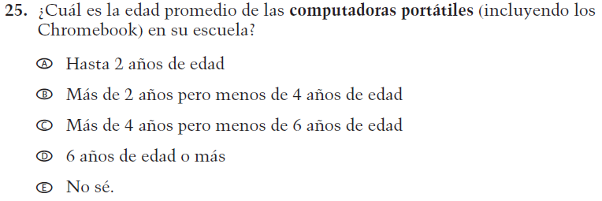  (2019 Operational Grade 4 School Core – Puerto Rico) | VH579617  Issue: Technology Use | NC | N/A

2021 Operational Grade 4 Core School – Puerto Rico
Previous item | 2021 item | D/A/R/NC+ | Rationale
VH893351  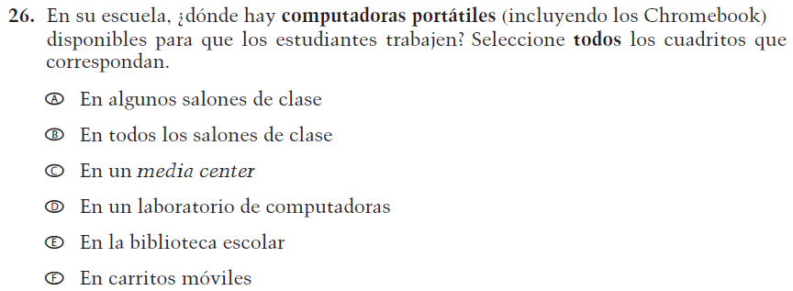  (2019 Operational Grade 4 School Core – Puerto Rico) | VH893351  Issue: Technology Use | NC | N/A
VH579619  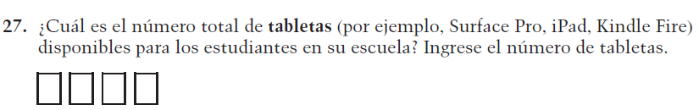  (2019 Operational Grade 4 School Core – Puerto Rico) | VH579619  Issue: Technology Use | NC | N/A
VH579620  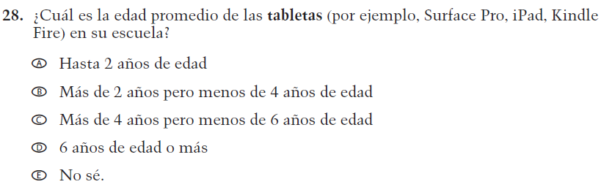  (2019 Operational Grade 4 School Core – Puerto Rico) | VH579620  Issue: Technology Use | NC | N/A

2021 Operational Grade 4 Core School – Puerto Rico
Previous item | 2021 item | D/A/R/NC+ | Rationale
VH893352  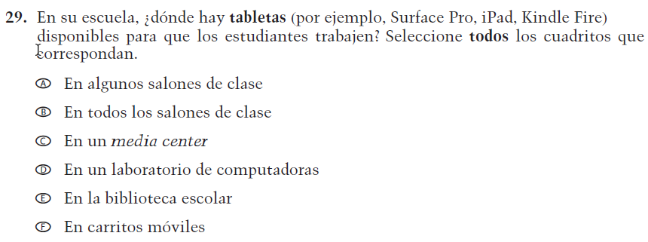  (2019 Operational Grade 4 School Core – Puerto Rico) | VH893352  Issue: Technology Use | NC | N/A
VH579601  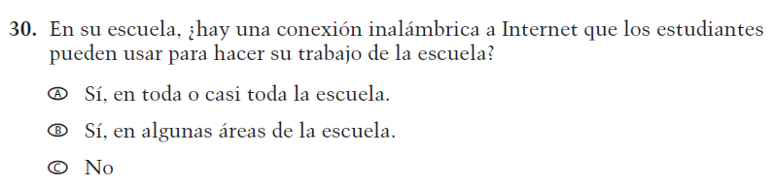  (2019 Operational Grade 4 School Core – Puerto Rico) | VH579601  Issue: Technology Use | NC | N/A

Appendix J-3a-s-PR: Operational Grade 4 CORE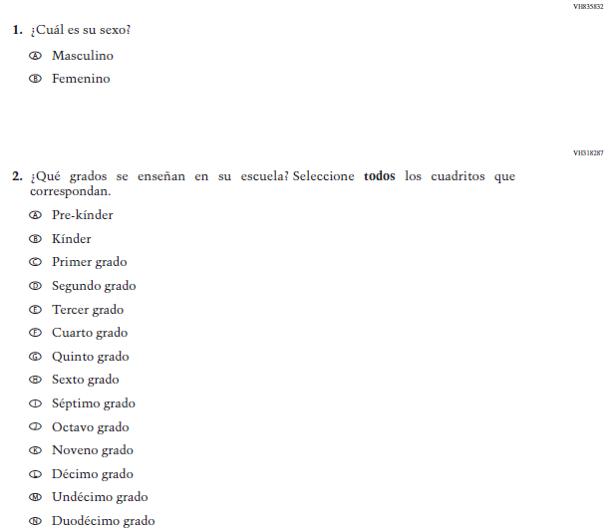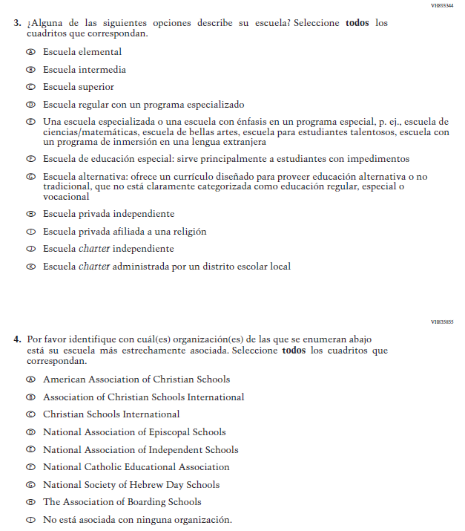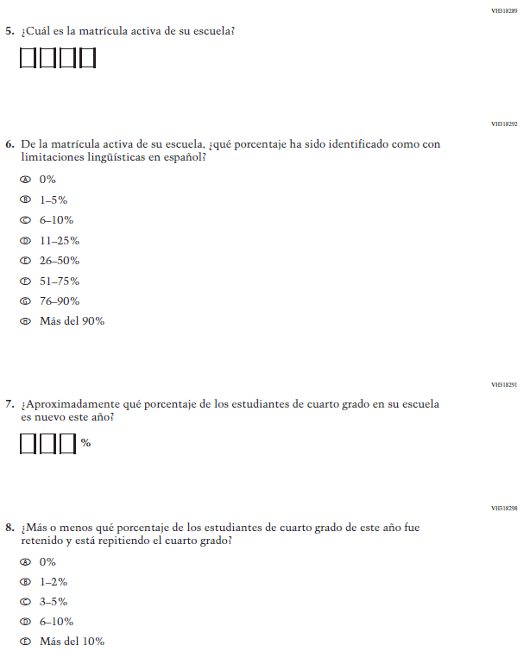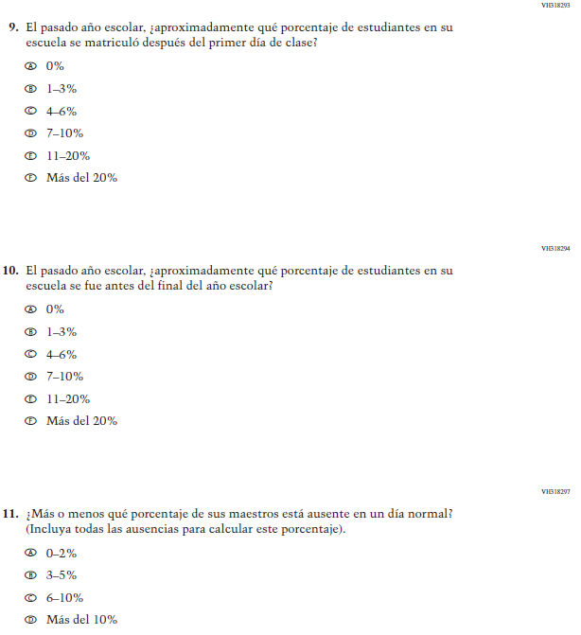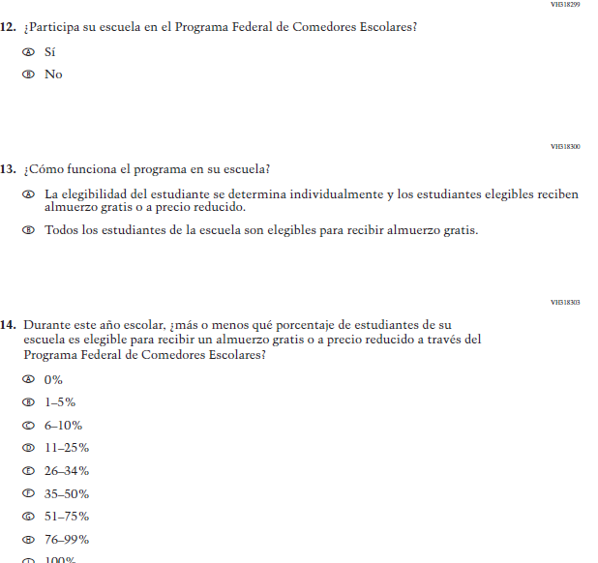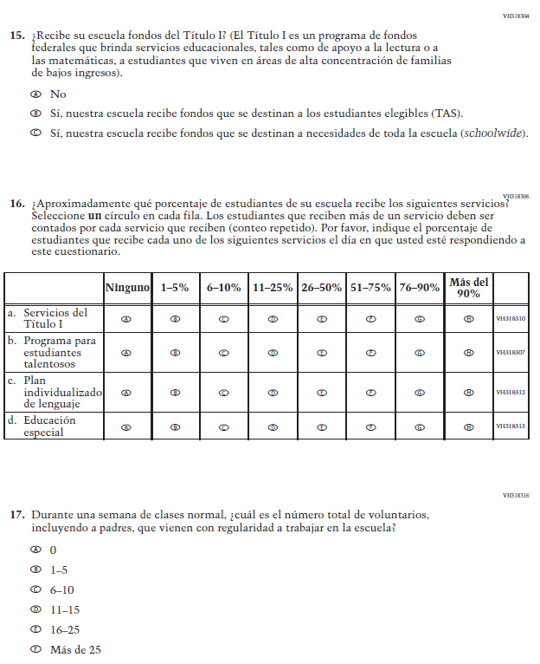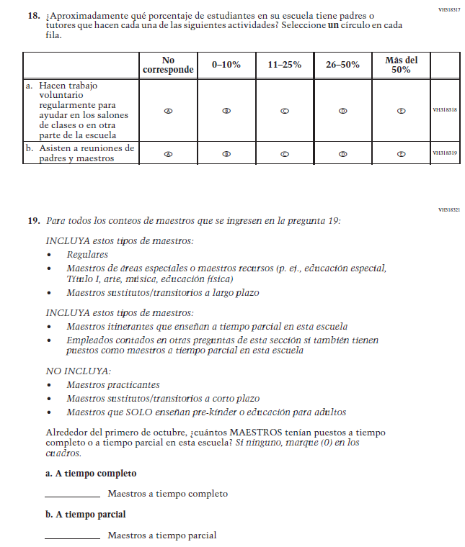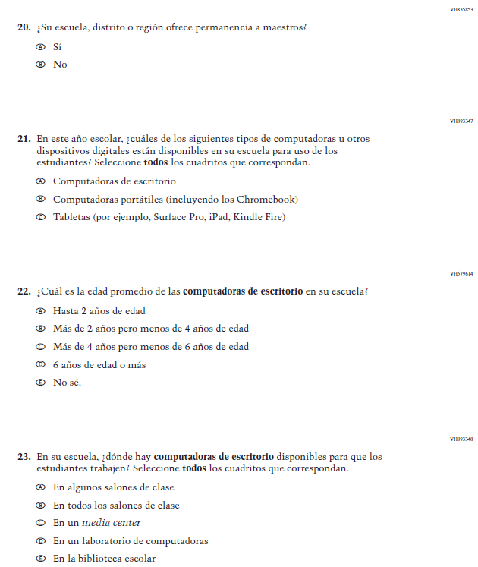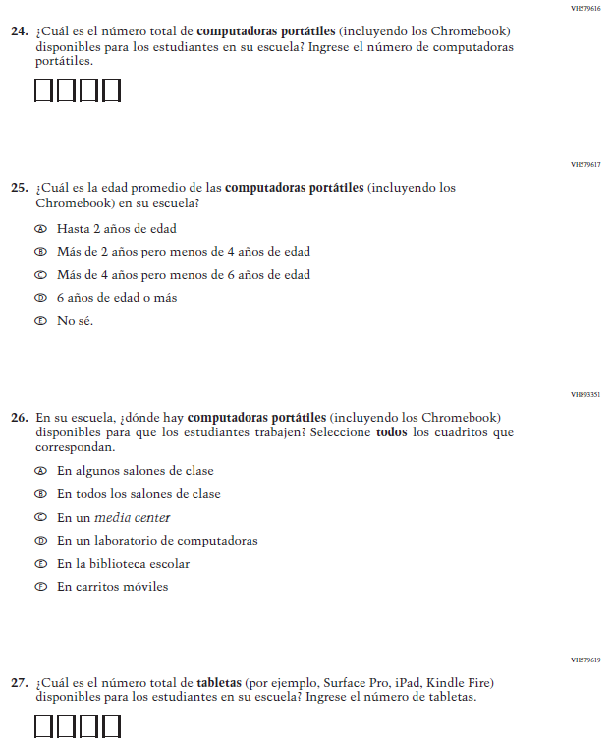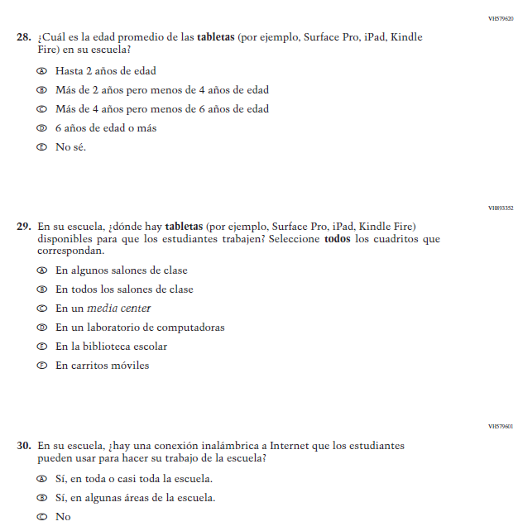

Appendix J-3b-s-PR: Summary of Changes Operational Grade 8 CORE
2021 Operational Grade 8 Core School – Puerto Rico
Previous item | 2021 item | D/A/R/NC+ | Rationale
VH835832  (2019 Operational Grade 8 School Core – Puerto Rico) | VH835832  Issue: Gender | NC | N/A
VH318287  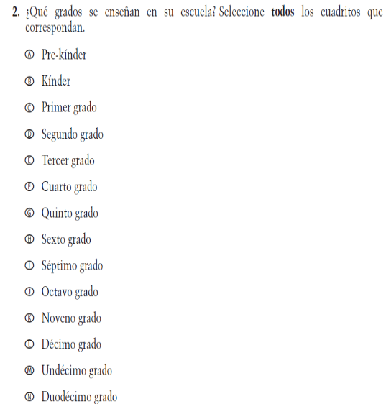  (2019 Operational Grade 8 School Core – Puerto Rico) | VH318287  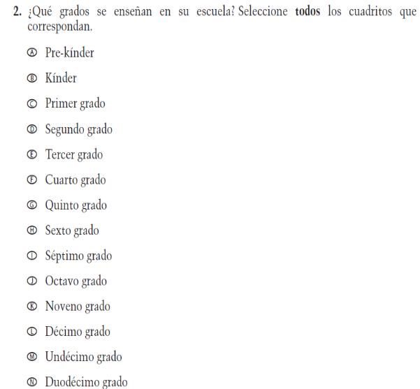  Issue: School Climate | NC | N/A

2021 Operational Grade 8 Core School – Puerto Rico
Previous item | 2021 item | D/A/R/NC+ | Rationale
VH893344  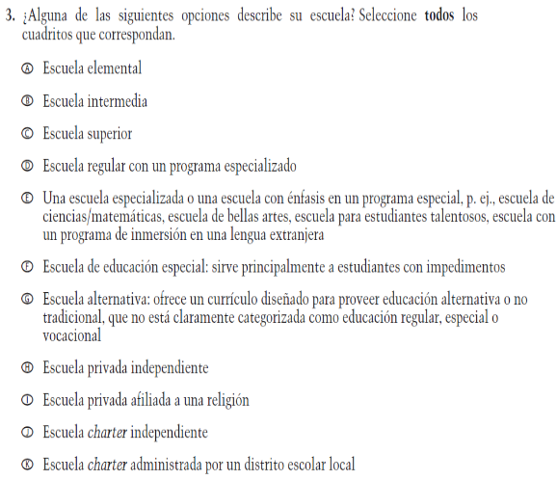  (2019 Operational Grade 8 School Core – Puerto Rico) | VH893344  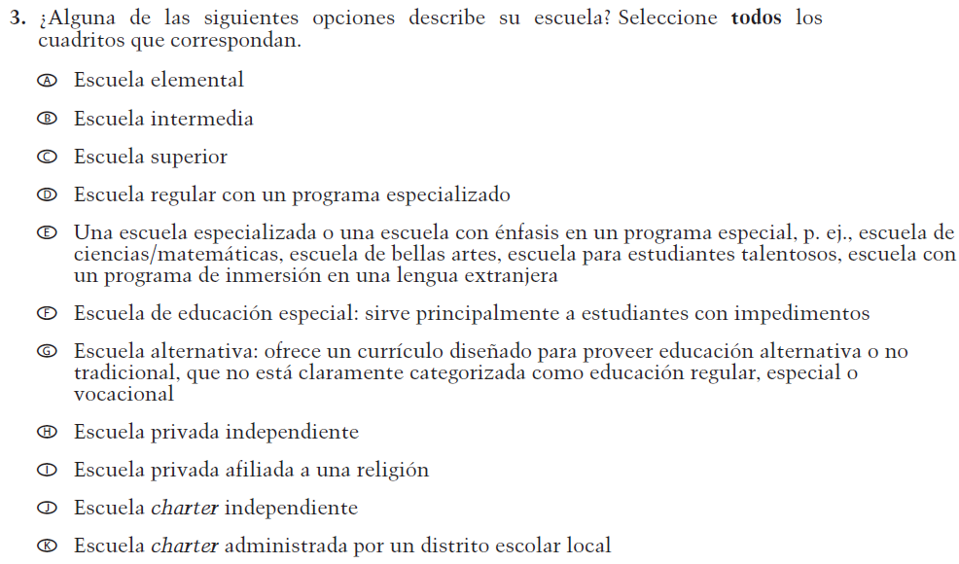  Issue: School Climate | NC | N/A
VH835855  (2019 Operational Grade 8 School Core – Puerto Rico) | VH835855  Issue: School Climate | NC | N/A

2021 Operational Grade 8 Core School – Puerto Rico
Previous item | 2021 item | D/A/R/NC+ | Rationale
VH318289  (2019 Operational Grade 8 School Core – Puerto Rico) | VH318289  Issue: School Climate | NC | N/A
VH318292  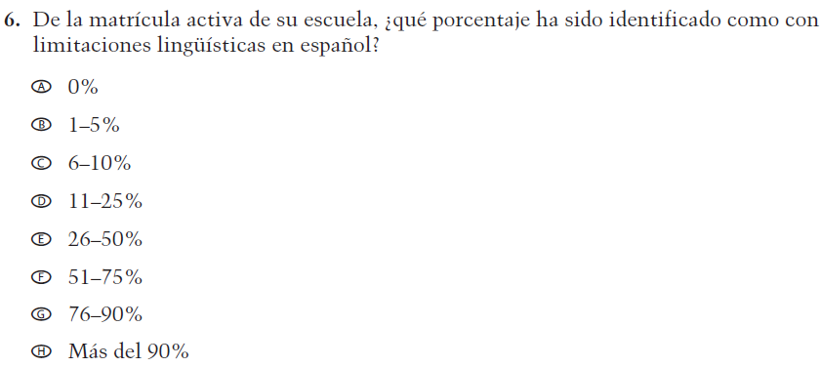  (2019 Operational Grade 8 School Core – Puerto Rico) | VH318292  Issue: School Climate | NC | N/A
VH318558  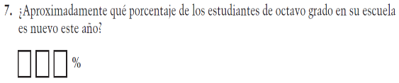  (2019 Operational Grade 8 School Core – Puerto Rico) | VH318558  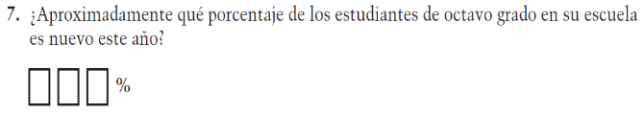  Issue: School Climate | NC | N/A

2021 Operational Grade 8 Core School – Puerto Rico
Previous item | 2021 item | D/A/R/NC+ | Rationale
VH319391  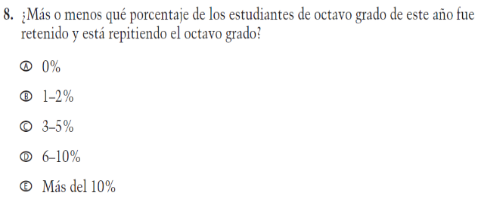  (2019 Operational Grade 8 School Core – Puerto Rico) | VH319391  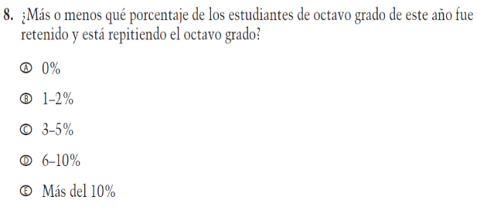  Issue: School Climate | NC | N/A
VH318293  (2019 Operational Grade 8 School Core – Puerto Rico) | VH318293  Issue: School Climate | NC | N/A
VH318294  (2019 Operational Grade 8 School Core – Puerto Rico) | VH318294  Issue: School Climate | NC | N/A

2021 Operational Grade 8 Core School – Puerto Rico
Previous item | 2021 item | D/A/R/NC+ | Rationale
VH318297  (2019 Operational Grade 8 School Core – Puerto Rico) | VH318297  Issue: School Climate | NC | N/A
VH318299  (2019 Operational Grade 8 School Core – Puerto Rico) | VH318299  Issue: Socioeconomic Status | NC | N/A
VH318300  (2019 Operational Grade 8 School Core – Puerto Rico) | VH318300  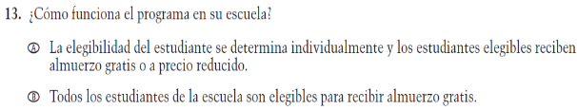  Issue: Socioeconomic Status | NC | N/A
VH318303  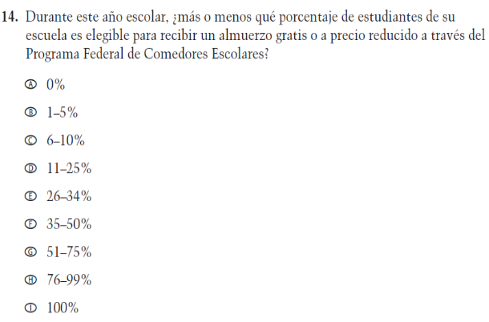  (2019 Operational Grade 8 School Core – Puerto Rico) | VH318303  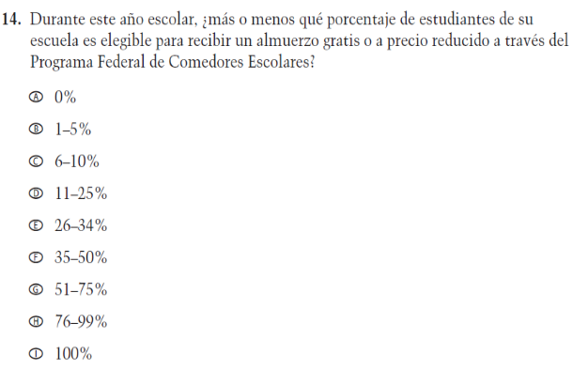  Issue: Socioeconomic Status | NC | N/A

2021 Operational Grade 8 Core School – Puerto Rico
Previous item | 2021 item | D/A/R/NC+ | Rationale
VH318304  (2019 Operational Grade 8 School Core – Puerto Rico) | VH318304  Issue: Socioeconomic Status | NC | N/A
(2019 Operational Grade 8 School Core – Puerto Rico) | 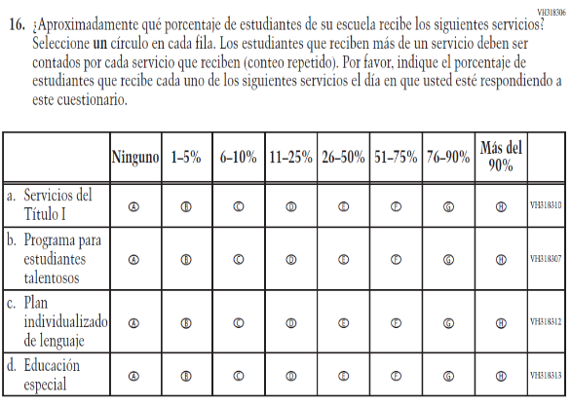  Issue: School Climate | R - “al día en que usted” changed to “el día en que usted” in SL  NC – subitems a through d | To correct a grammar error.
VH318316  (2019 Operational Grade 8 School Core – Puerto Rico) | VH318316  Issue: School Climate | NC | N/A

2021 Operational Grade 8 Core School – Puerto Rico
Previous item | 2021 item | D/A/R/NC+ | Rationale
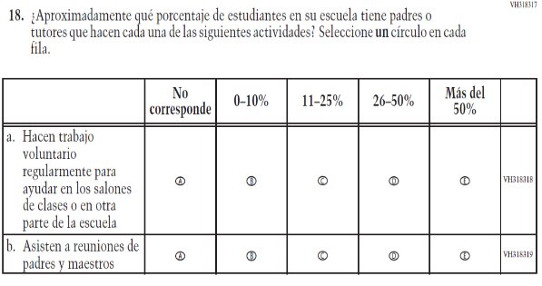  (2019 Operational Grade 8 School Core – Puerto Rico) | 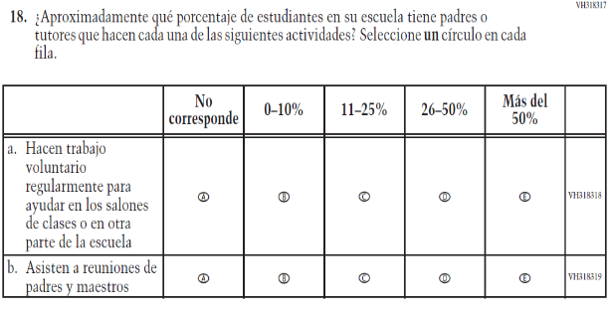  Issue: School Climate | NC | N/A
VH318321  (2019 Operational Grade 8 School Core – Puerto Rico) | VH318321  Issue: School Climate | NC | N/A

2021 Operational Grade 8 Core School – Puerto Rico
Previous item | 2021 item | D/A/R/NC+ | Rationale
VH835853  (2019 Operational Grade 8 School Core – Puerto Rico) | VH835853  Issue: School Climate | NC | N/A
VH893347  (2019 Operational Grade 8 School Core – Puerto Rico) | VH893347  Issue: Technology Use | NC | N/A
VH579614  (2019 Operational Grade 8 School Core – Puerto Rico) | VH579614  Issue: Technology Use | NC | N/A

2021 Operational Grade 8 Core School – Puerto Rico
Previous item | 2021 item | D/A/R/NC+ | Rationale
VH893348  (2019 Operational Grade 8 School Core – Puerto Rico) | VH893348  Issue: Technology Use | NC | N/A
VH579616  (2019 Operational Grade 8 School Core – Puerto Rico) | VH579616  Issue: Technology Use | NC | N/A
VH579617  (2019 Operational Grade 8 School Core – Puerto Rico) | VH579617  Issue: Technology Use | NC | N/A

2021 Operational Grade 8 Core School – Puerto Rico
Previous item | 2021 item | D/A/R/NC+ | Rationale
VH893351  (2019 Operational Grade 8 School Core – Puerto Rico) | VH893351  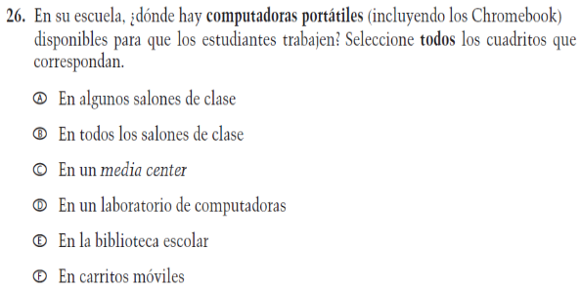  Issue: Technology Use | NC | N/A
VH579619  (2019 Operational Grade 8 School Core – Puerto Rico) | VH579619  Issue: Technology Use | NC | N/A
VH579620  (2019 Operational Grade 8 School Core – Puerto Rico) | VH579620  Issue: Technology Use | NC | N/A

2021 Operational Grade 8 Core School – Puerto Rico
Previous item | 2021 item | D/A/R/NC+ | Rationale
VH893352  (2019 Operational Grade 8 School Core – Puerto Rico) | VH893352  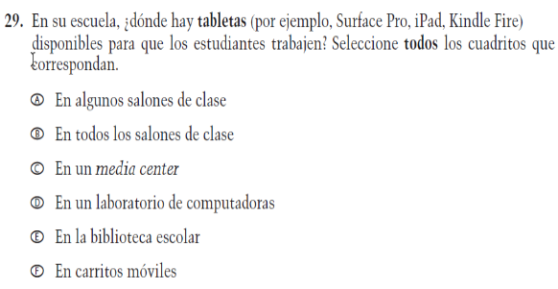  Issue: Technology Use | NC | N/A
VH579601  (2019 Operational Grade 8 School Core – Puerto Rico) | VH579601  Issue: Technology Use | NC | N/A

Appendix J-3b-s-PR: Operational Grade 8 CORE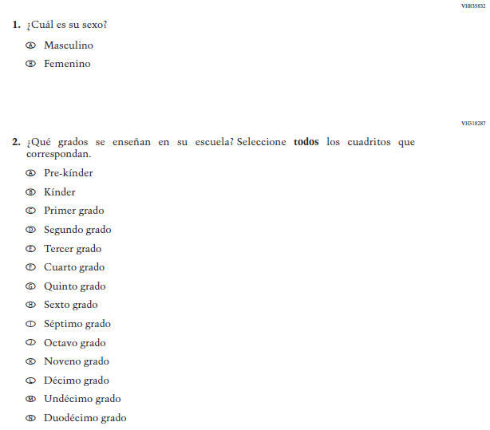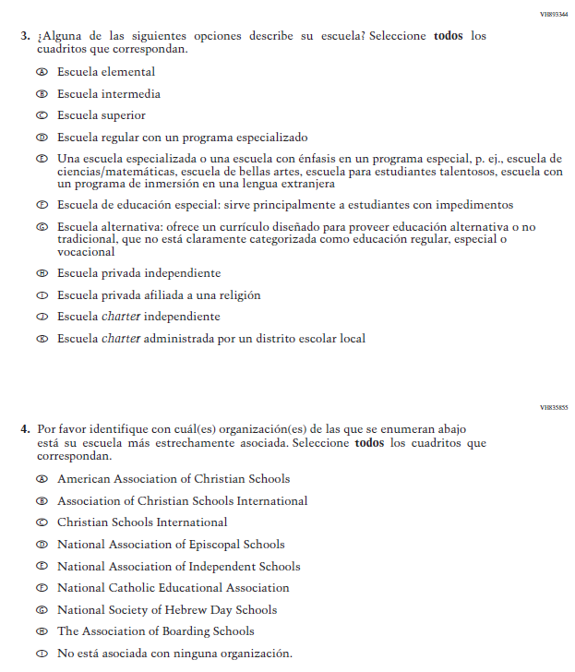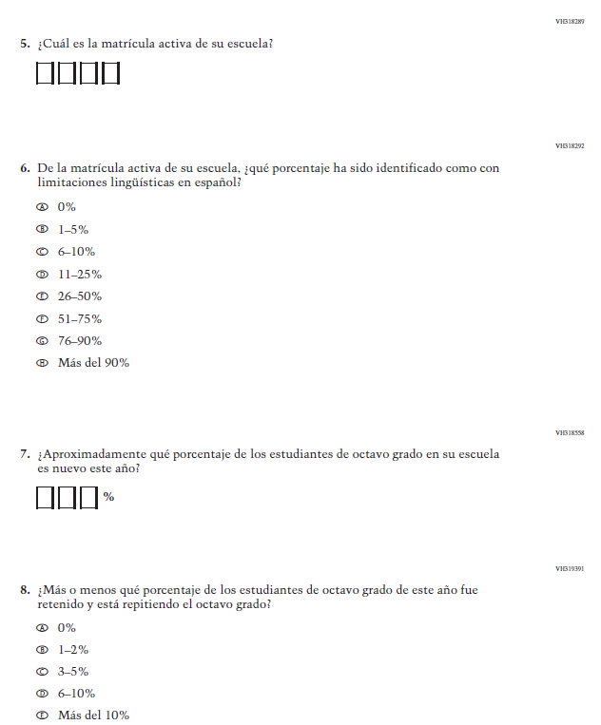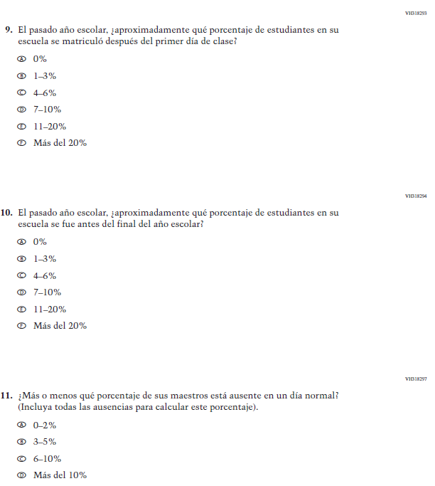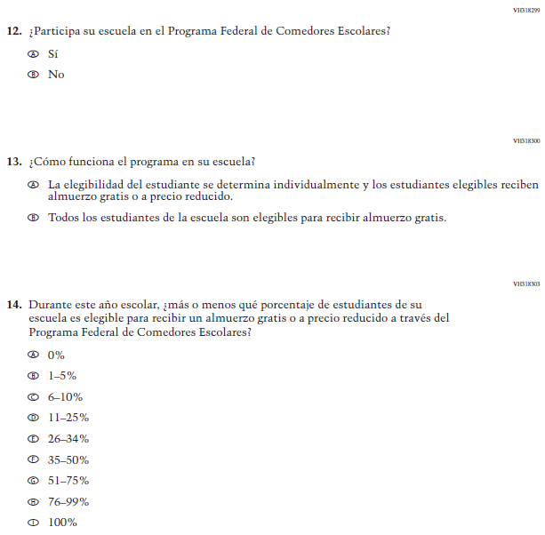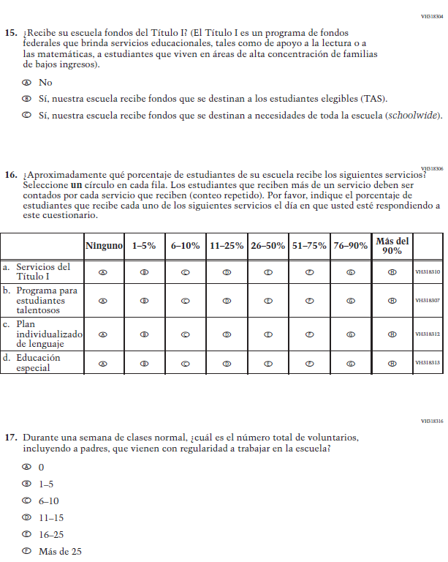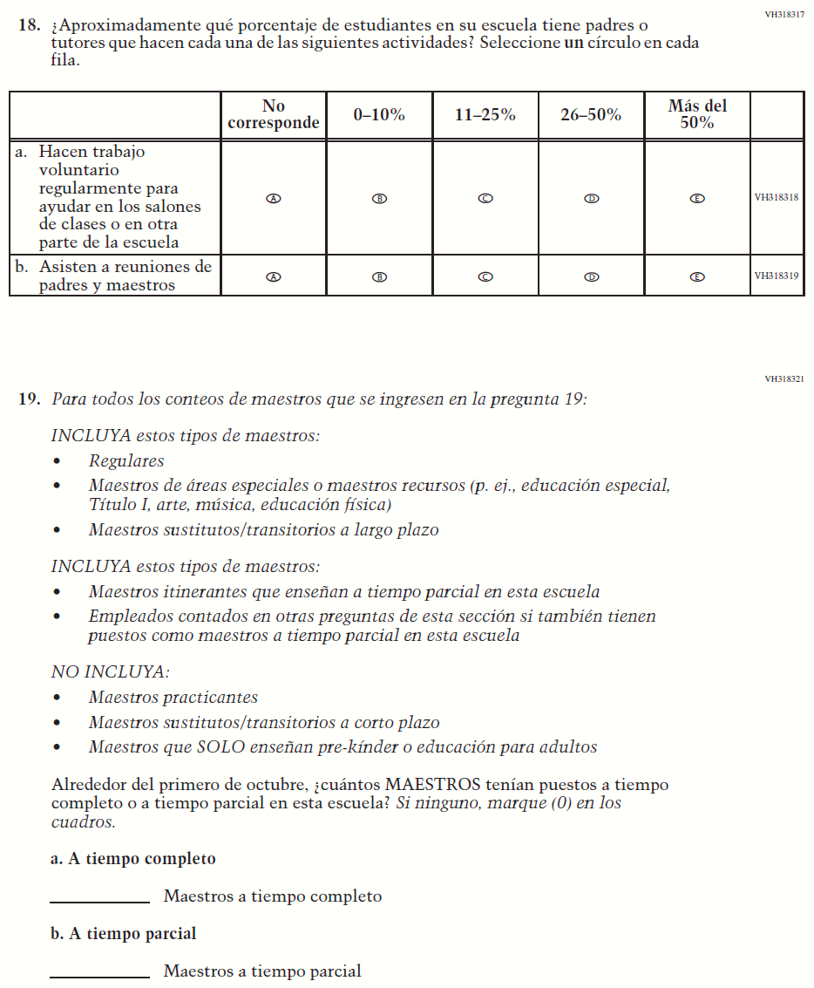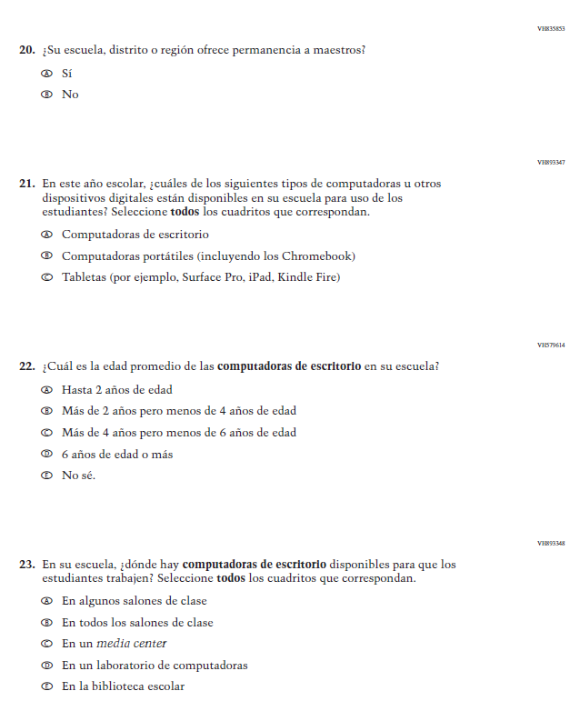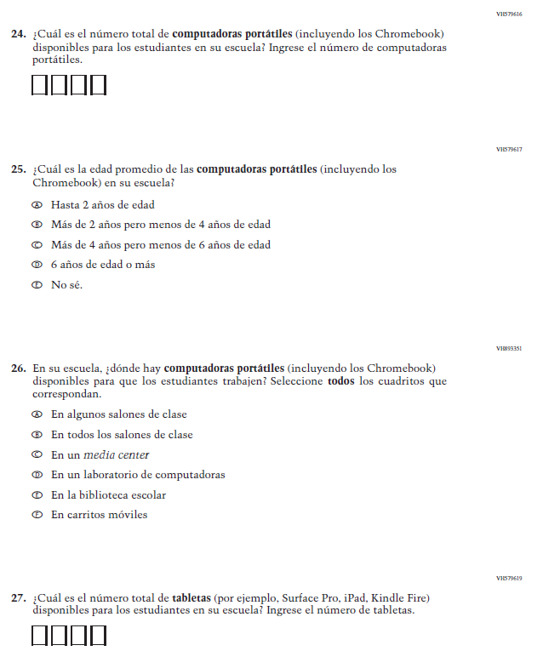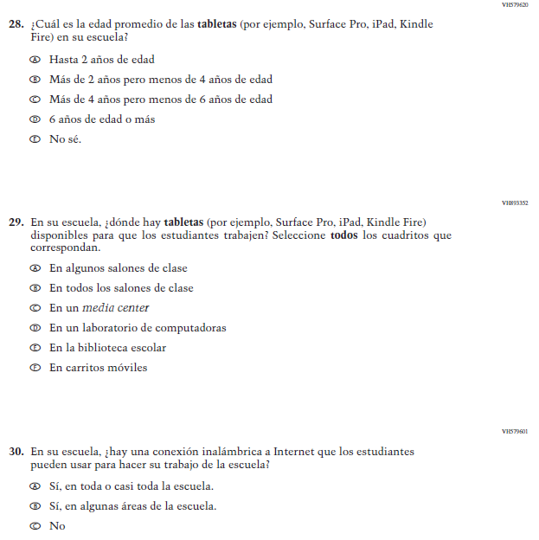

Appendix J-3c-s-PR: Summary of Changes Operational Grade 4 Mathematics
2021 Operational Grade 4 Mathematics School – Puerto Rico
Previous item | 2021 item | D/A/R/NC+ | Rationale
VH579623  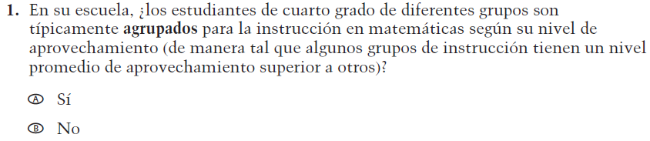  (2019 Operational Grade 4 School Mathematics – Puerto Rico) | VH579623  Issue: Resources for Learning and Instruction | NC | N/A
VH857365  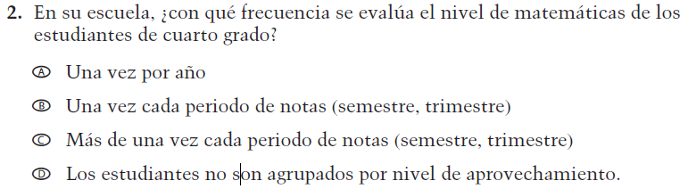  (2019 Operational Grade 4 School Mathematics – Puerto Rico) | VH857365  Issue: Organization of Instruction | NC | N/A
VH579648  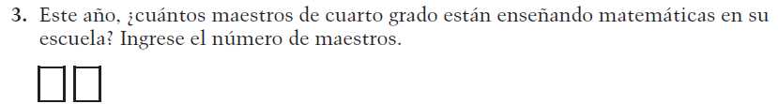  (2019 Operational Grade 4 School Mathematics – Puerto Rico) | VH579648  Issue: Resources for Learning and Instruction | N/C | N/A
VH318441  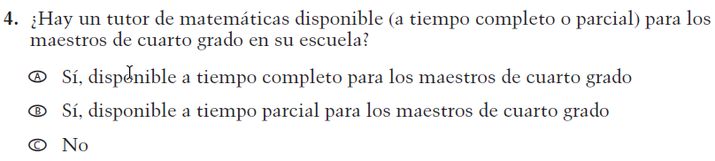  (2019 Operational Grade 4 School Mathematics – Puerto Rico) | VH318441  Issue: Resources for Learning and Instruction | NC | N/A

2021 Operational Grade 4 Mathematics School – Puerto Rico
Previous item | 2021 item | D/A/R/NC+ | Rationale
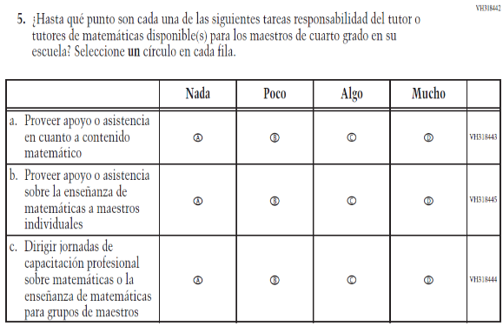  (2019 Operational Grade 4 School Mathematics – Puerto Rico) | 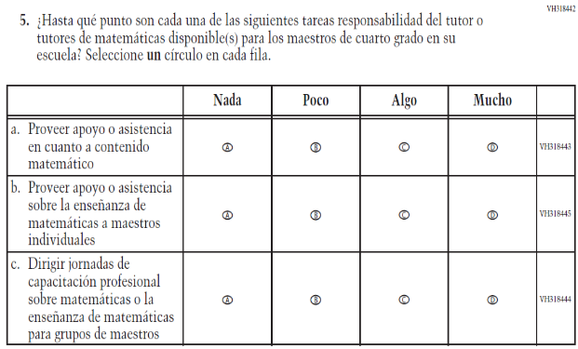  Issue: Resources for Learning and Instruction | NC | N/A
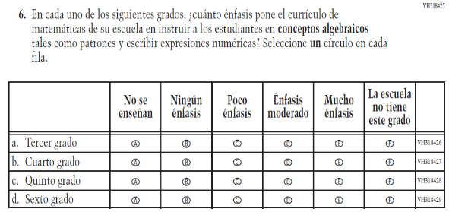  (2019 Operational Grade 4 School Mathematics – Puerto Rico) | 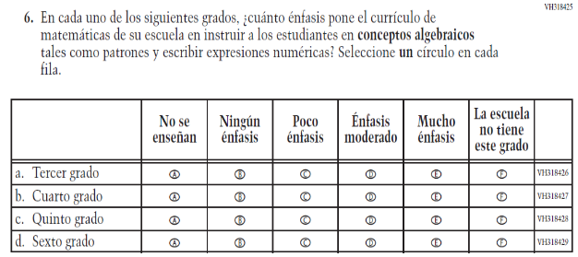  Issue: Organization of Instruction | NC | N/A
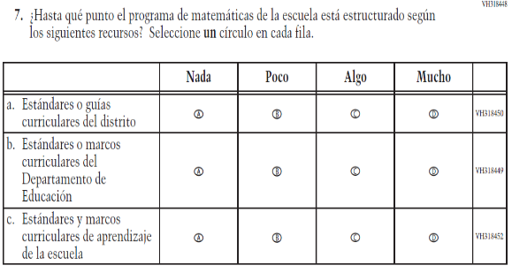  (2019 Operational Grade 4 School Mathematics – Puerto Rico) | 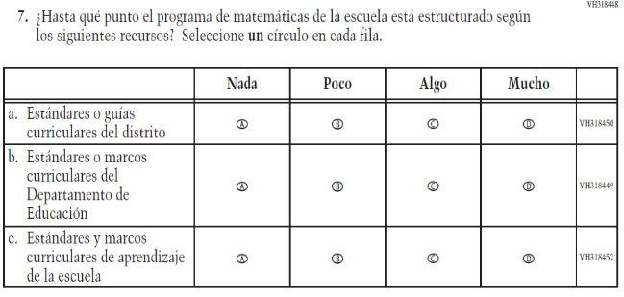  Issue: Organization of Instruction | NC | N/A

2021 Operational Grade 4 Mathematics School – Puerto Rico
Previous item | 2021 item | D/A/R/NC+ | Rationale
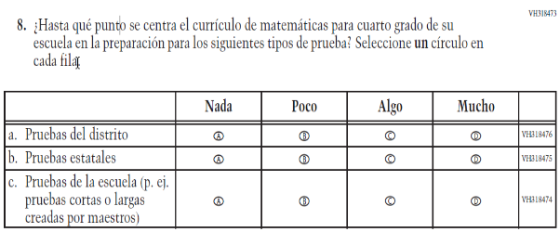  (2019 Operational Grade 4 School Mathematics – Puerto Rico) | 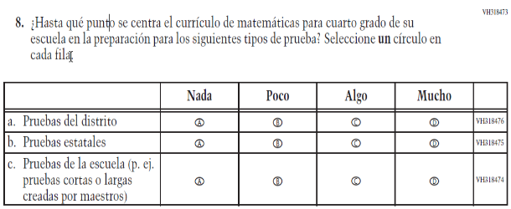  Issue: Organization of Instruction | NC | N/A
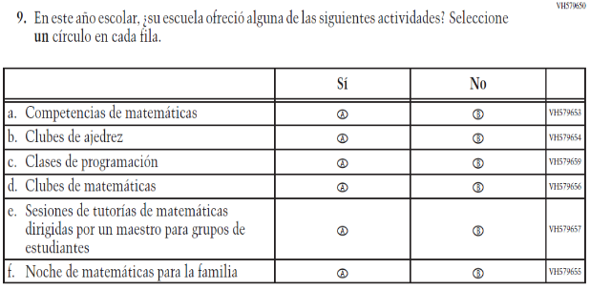  (2019 Operational Grade 4 School Mathematics – Puerto Rico) | 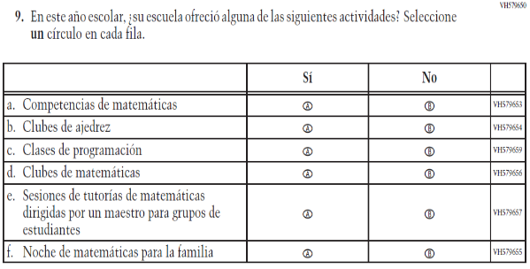  Issue: Resources for Learning and Instruction | NC | N/A

Appendix J-3c-s-PR: Operational Grade 4 Mathematics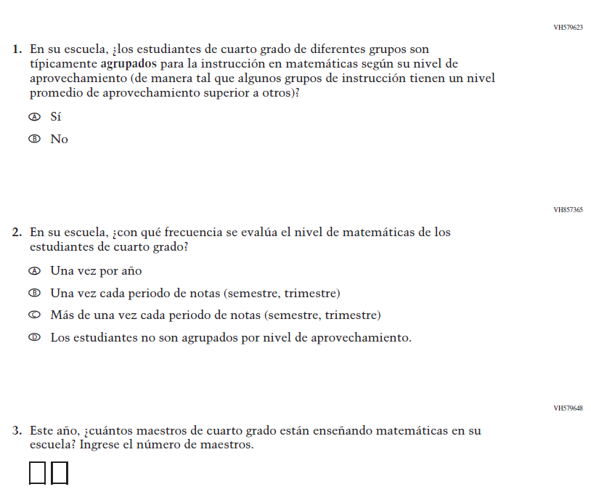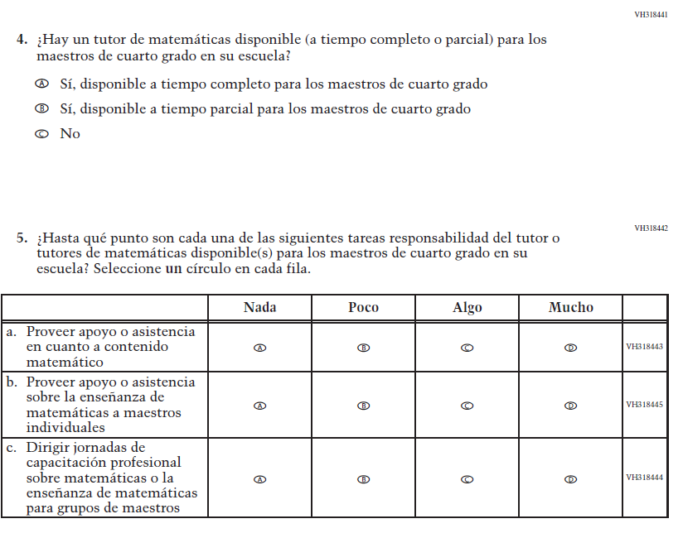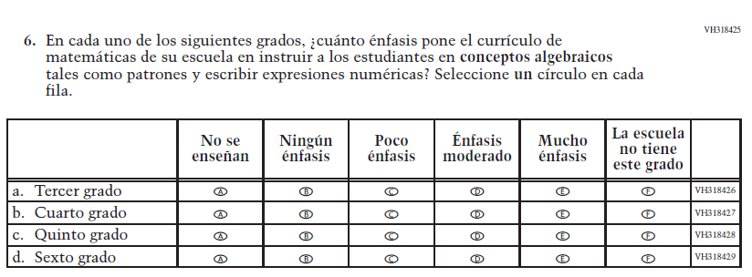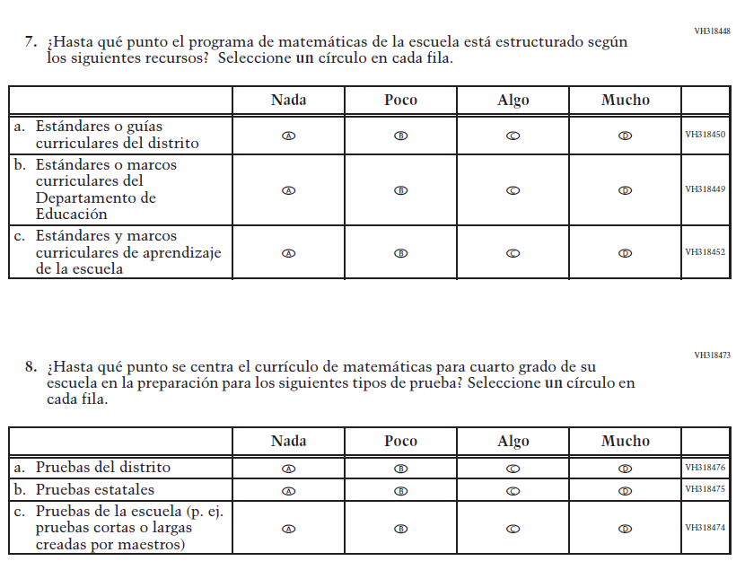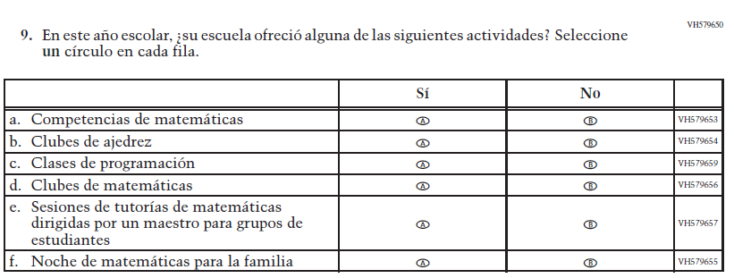

Appendix J-3d-s-PR: Summary of Changes Operational Grade 8 Mathematics
2021 Operational Grade 8 Mathematics School – Puerto Rico
Previous item | 2021 item | D/A/R/NC+ | Rationale
VH610664  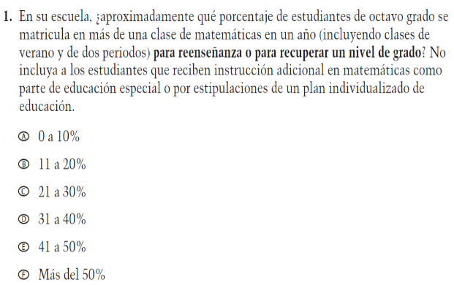  (2019 Operational Grade 8 School Mathematics – Puerto Rico) | VH610664  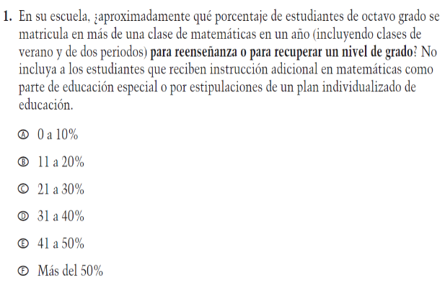  Issue: Organization of Instruction | NC | N/A
VH610661  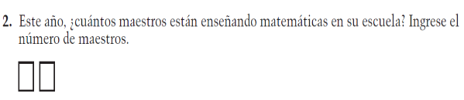  (2019 Operational Grade 8 School Mathematics – Puerto Rico) | VH610661  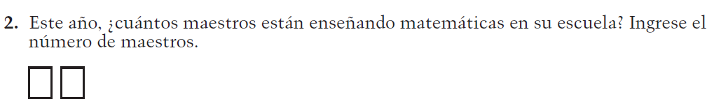  Issue: Resources for Learning and Instruction | NC | N/A
VH857377  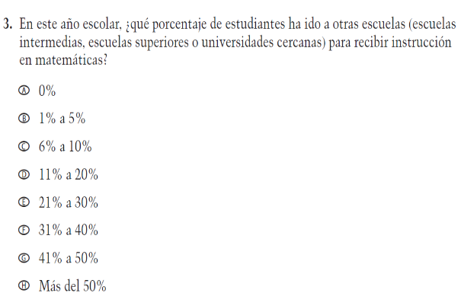  (2019 Operational Grade 8 School Mathematics – Puerto Rico) | VH857377  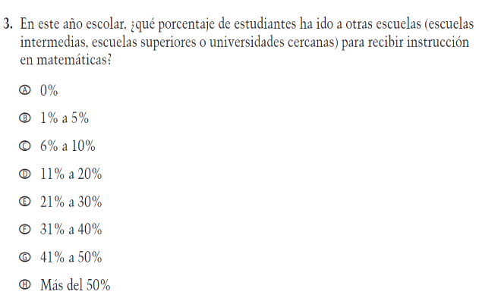  Issue: Resources for Learning and Instruction | N/C | N/A

2021 Operational Grade 8 Mathematics School – Puerto Rico
Previous item | 2021 item | D/A/R/NC+ | Rationale
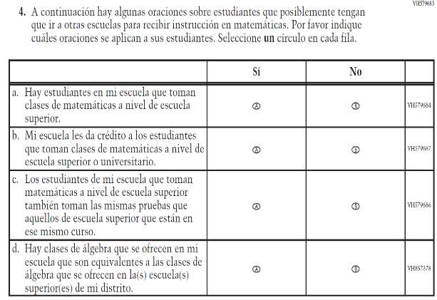  (2019 Operational Grade 8 School Mathematics – Puerto Rico) | 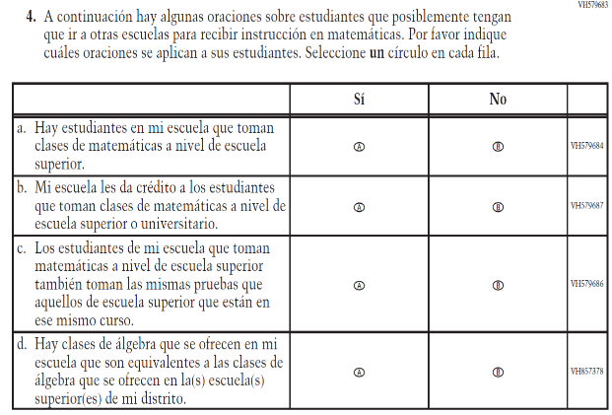  Issue: Resources for Learning and Instruction | NC | N/A
VH318639  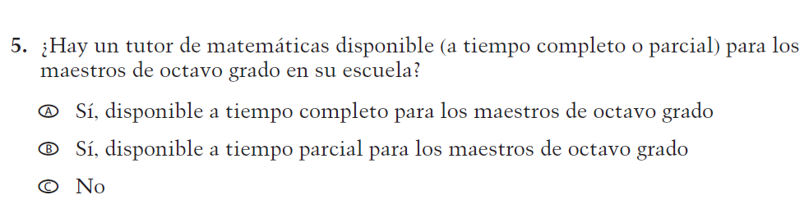  (2019 Operational Grade 8 School Mathematics – Puerto Rico) | VH318639  Issue: Resources for Learning and Instruction | NC | N/A
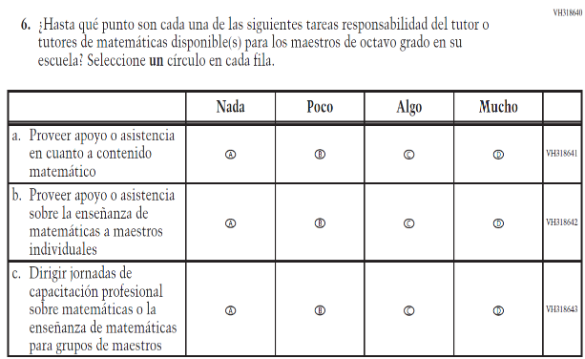  (2019 Operational Grade 8 School Mathematics – Puerto Rico) | 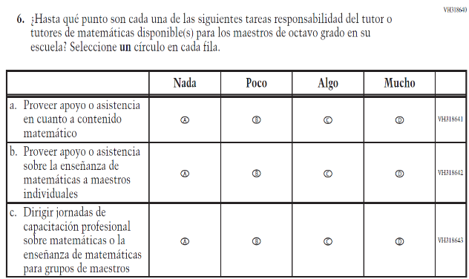  Issue: Resources for Learning and Instruction | NC | N/A

2021 Operational Grade 8 Mathematics School – Puerto Rico
Previous item | 2021 item | D/A/R/NC+ | Rationale
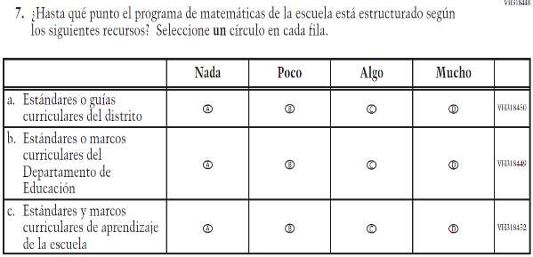  (2019 Operational Grade 8 School Mathematics – Puerto Rico) | 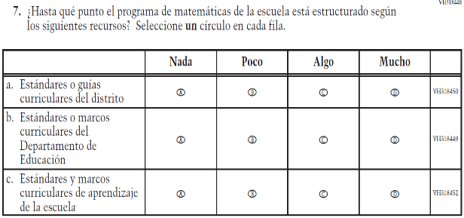  Issue: Organization of Instruction | NC | N/A
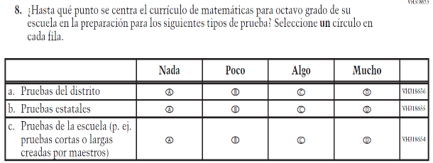  (2019 Operational Grade 8 School Mathematics – Puerto Rico) | 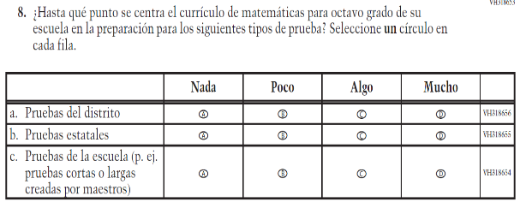  Issue: Organization of Instruction | NC | N/A
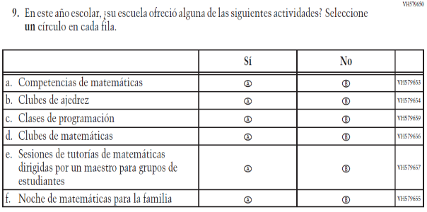  (2019 Operational Grade 8 School Mathematics – Puerto Rico) | 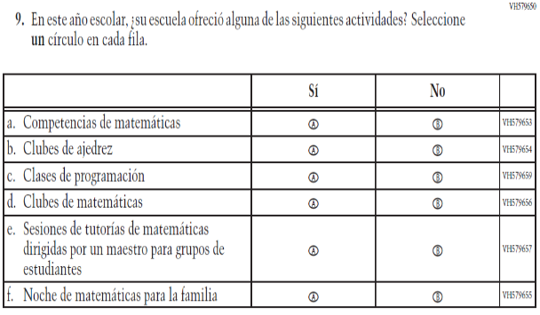  Issue: Resources for Learning and Instruction | NC | N/A

Appendix J-3d-s-PR: Operational Grade 8 Mathematics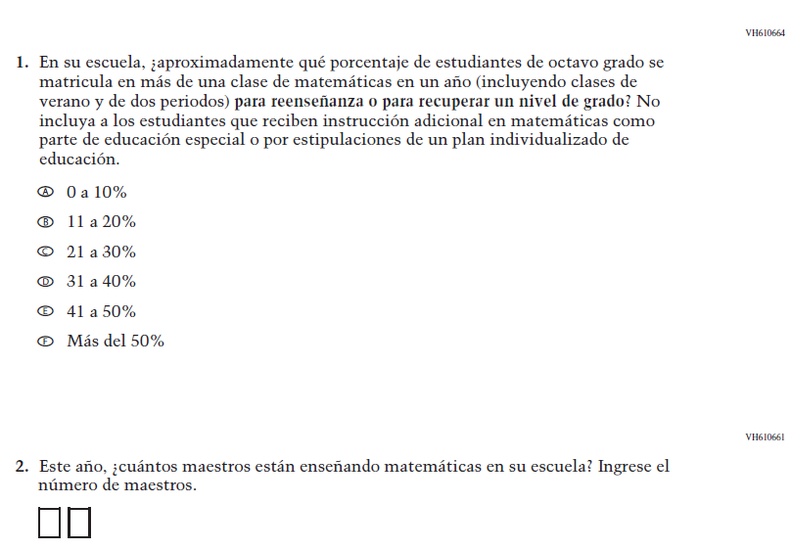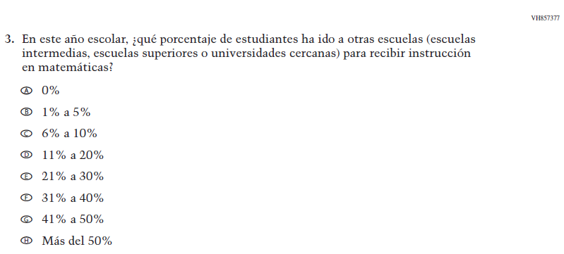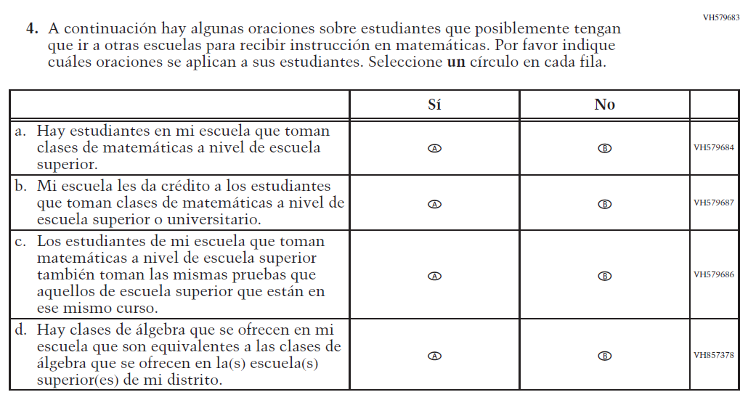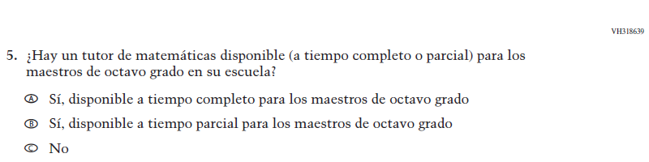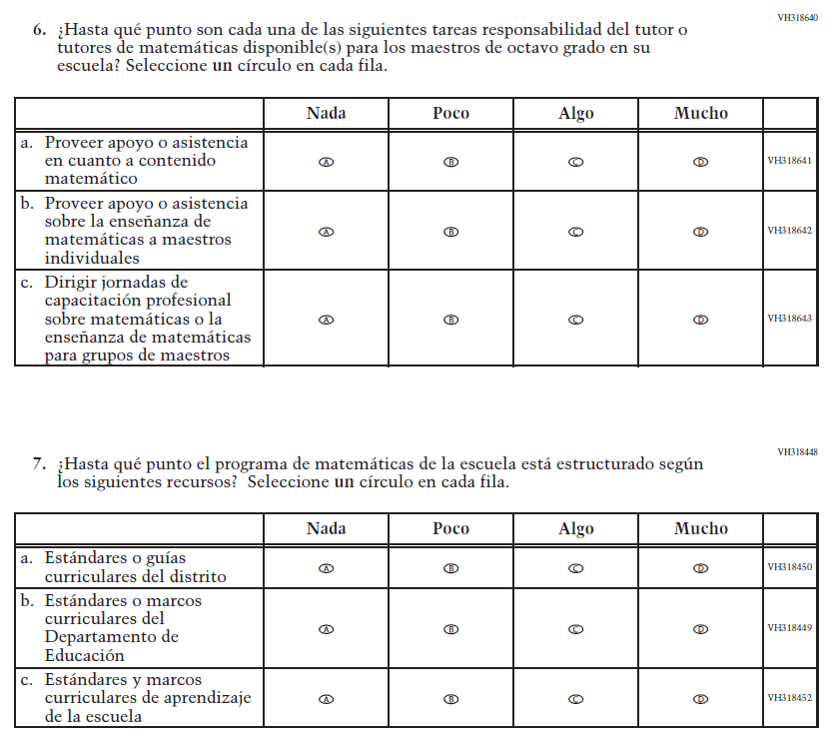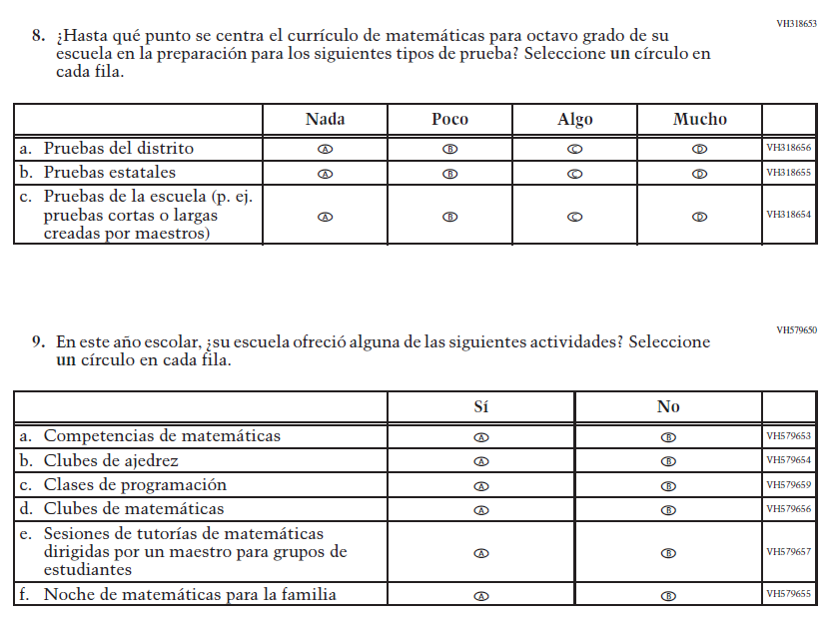

Appendix J-3e-s-PR: Operational Grade 4 COVID-19 (New)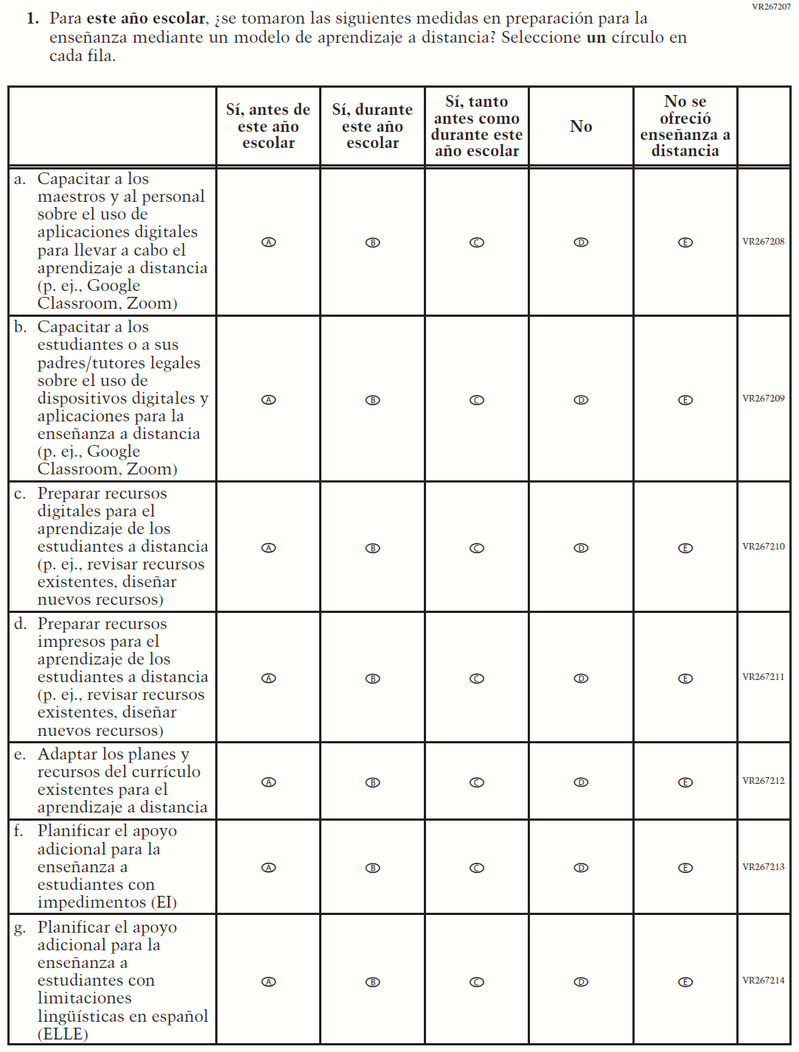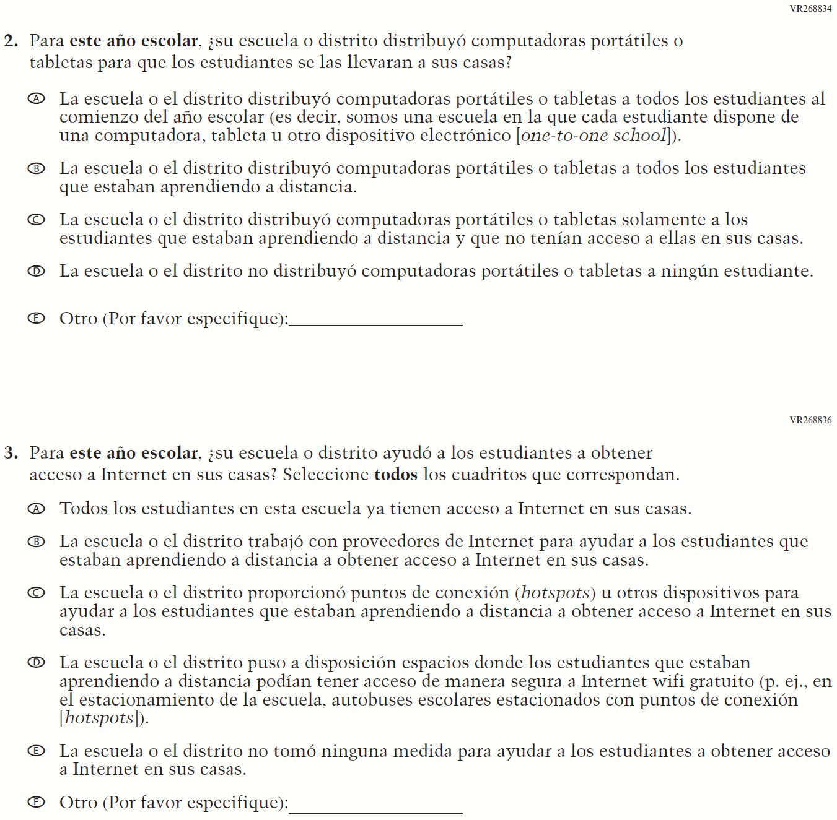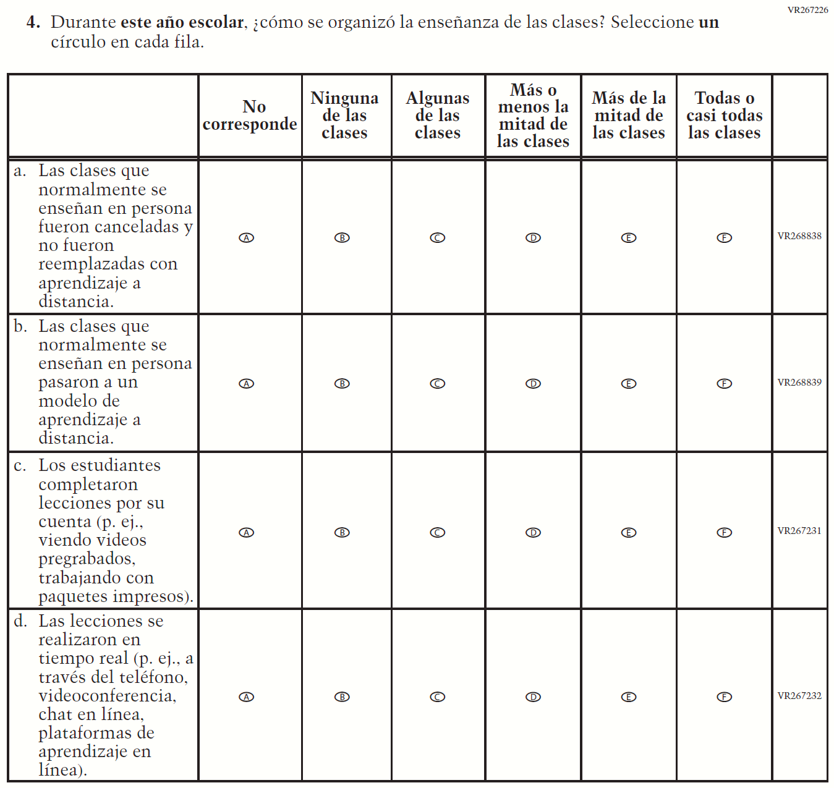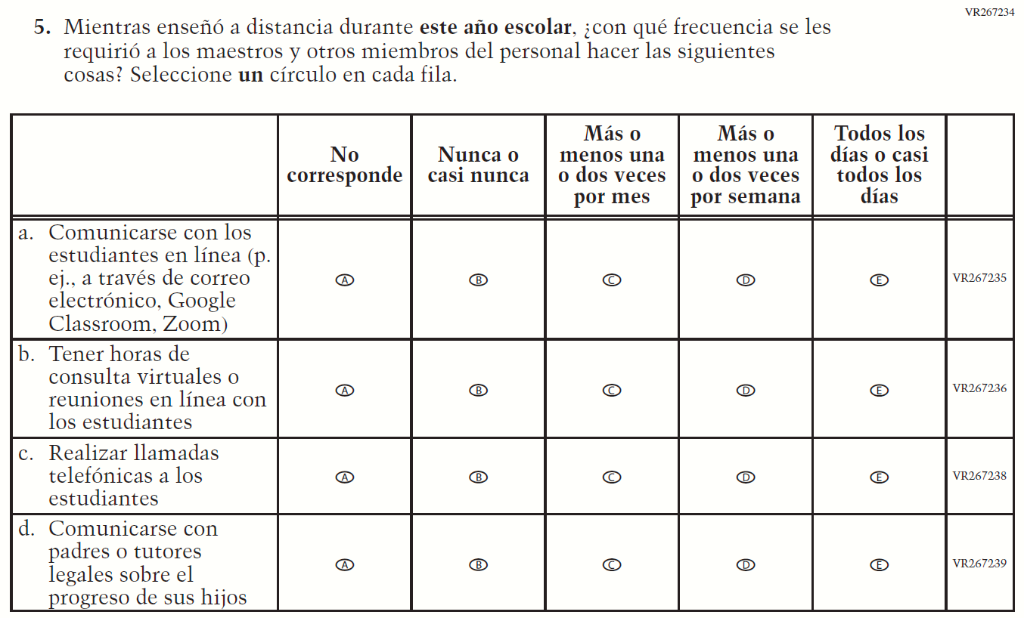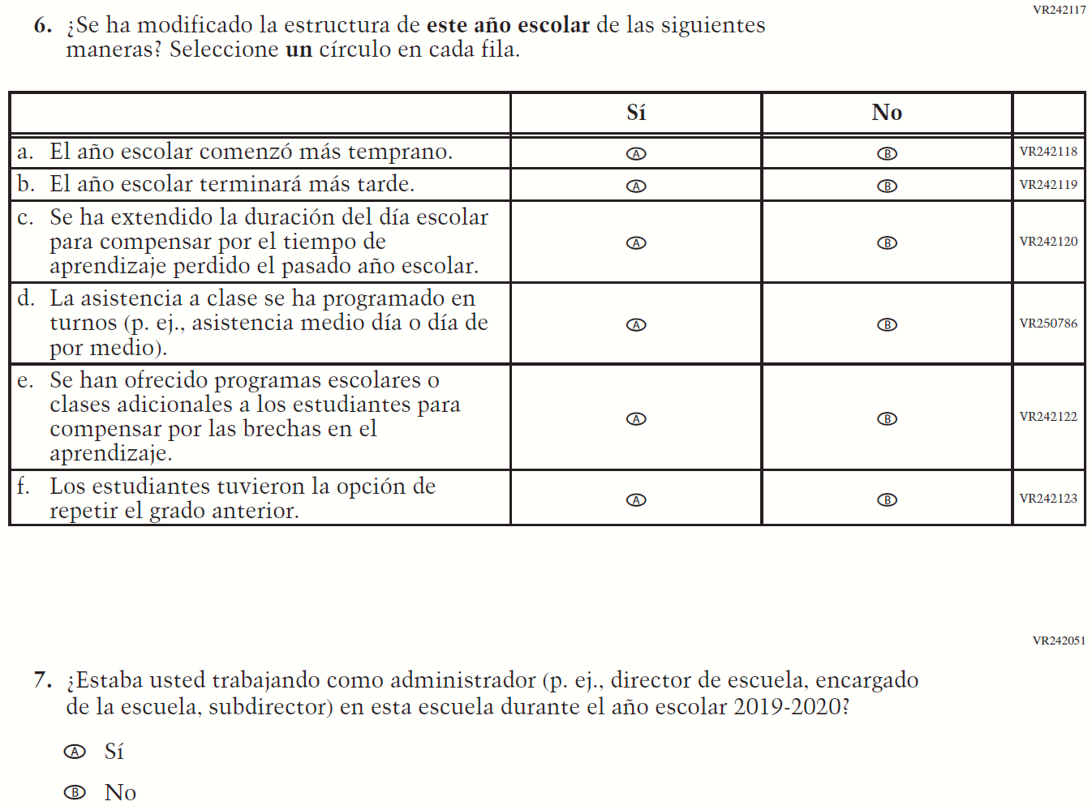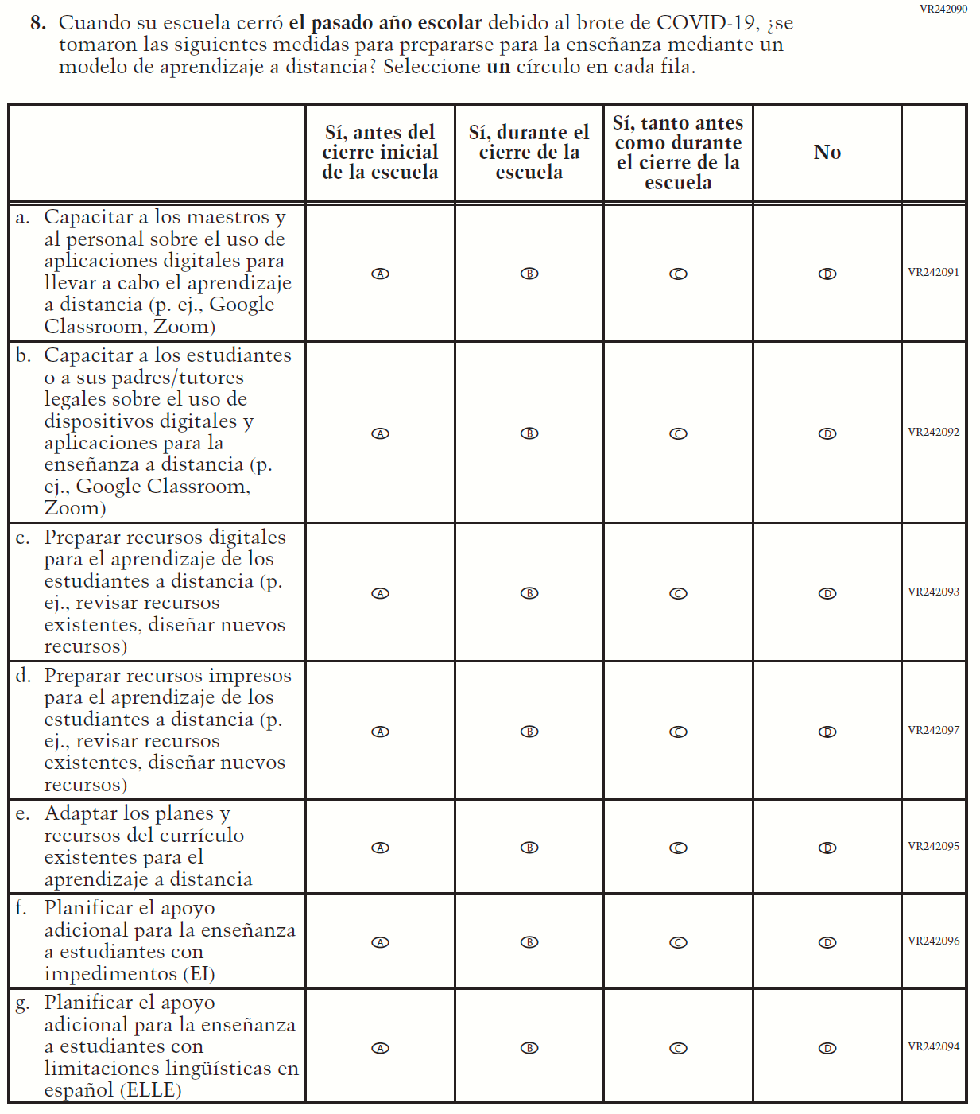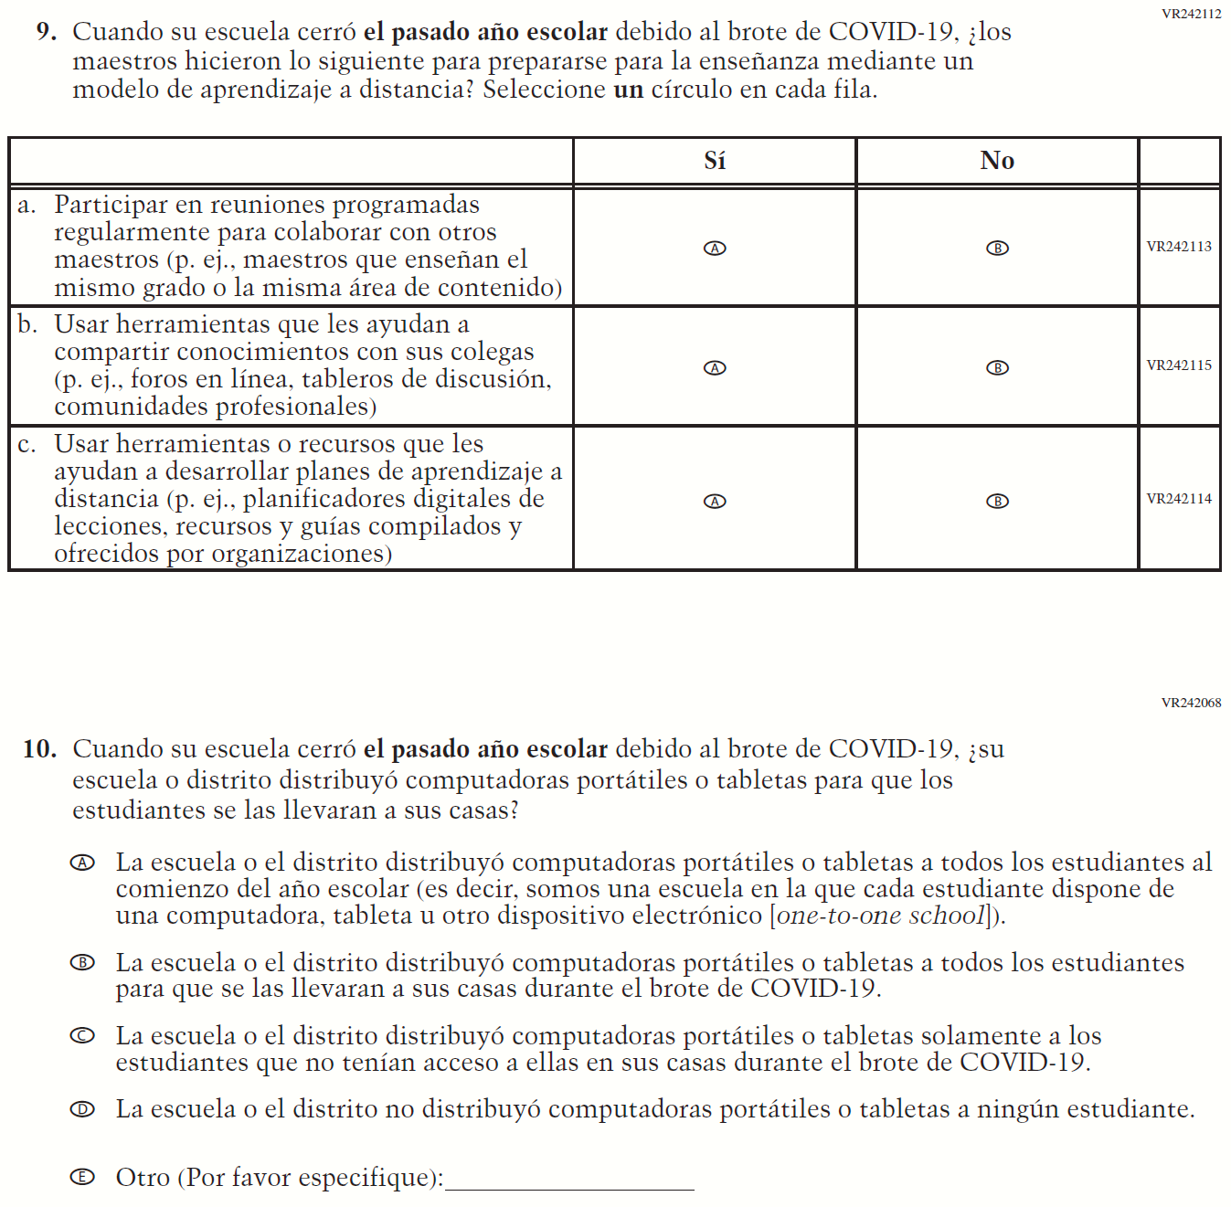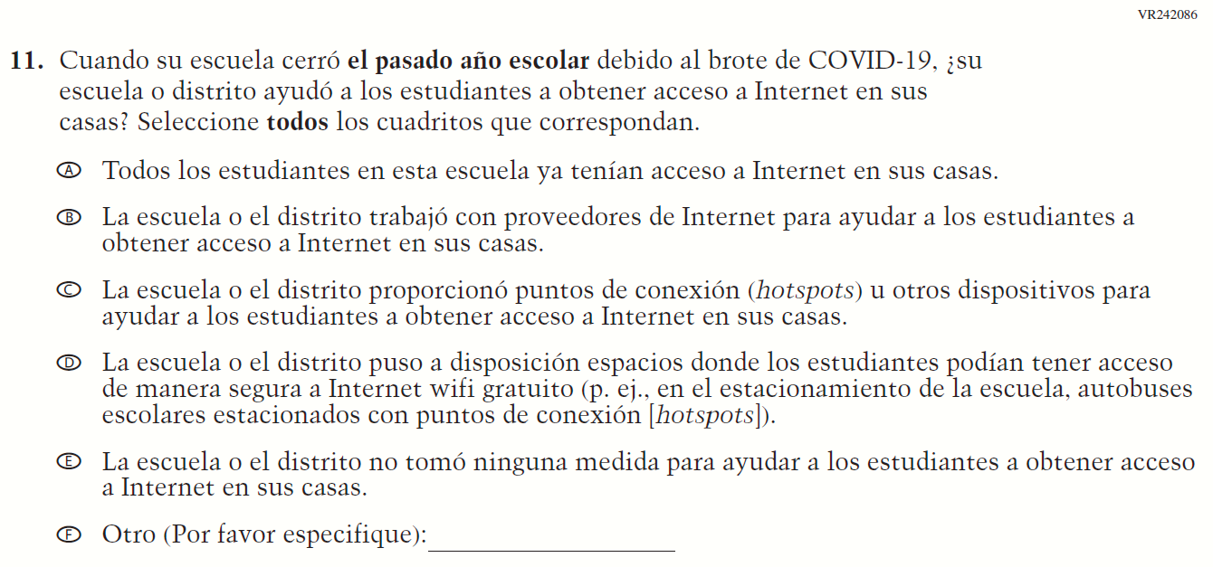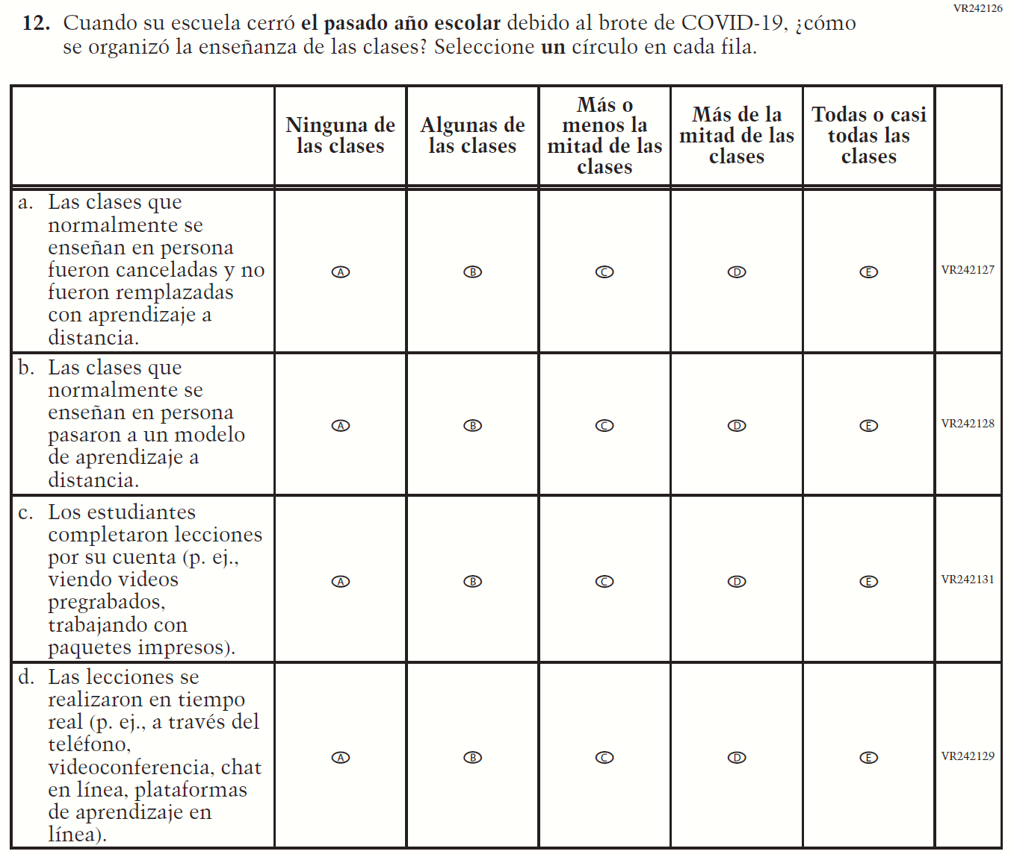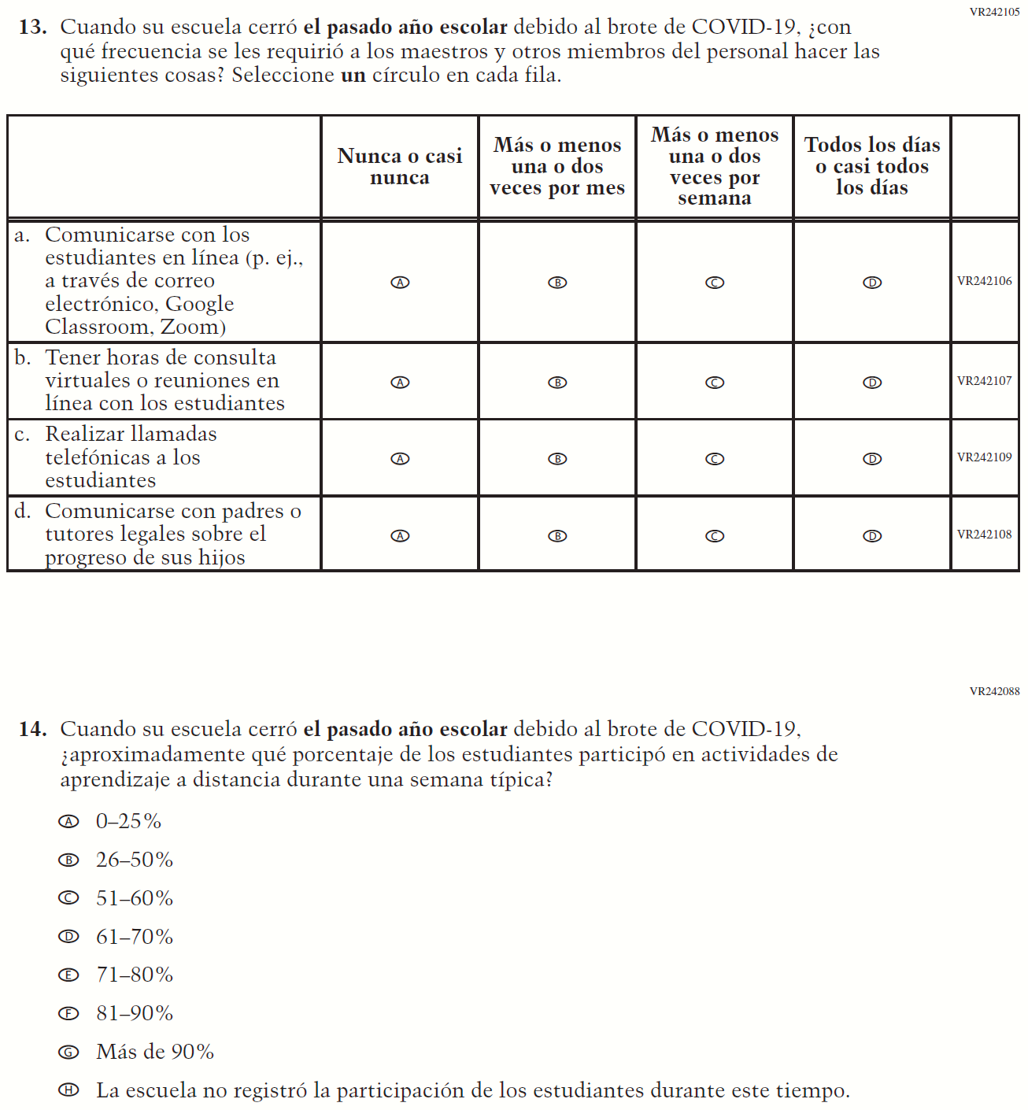

Appendix J-3f-s-PR: Operational Grade 8 COVID-19 (New)
