NATIONAL CENTER FOR EDUCATION STATISTICS NATIONAL ASSESSMENT OF EDUCATIONAL PROGRESS

National Assessment of Education Progress (NAEP)
2022
Long-Term Trend (LTT) 2020 Update 2

Appendix K4

Long Term Trend (LTT) 2022 Student Questionnaires

OMB# 1850-0928 v.22

March 2021
No changes since March 2019 (1850-0928 v.15)

This appendix is unchanged from v. 15 of this package, which described NAEP 2019-2020. Due to COVID-19 school closures in Spring 2020, although LTT 9 and LTT 13 were successfully administered, LTT 17 was not administered on schedule. We now plan to administer LTT 17 in Spring 2022. The materials here represent our best plans for the administration of LTT 17 at this time and will be finalized in Amendment #1 by June 2021.

Table of Contents
Appendix K4-1: Summary of Changes Operational Age 9 Mathematics 3
Appendix K4-2: Operational Age 9 Mathematics 5
Appendix K4-3: Summary of Changes Operational Age 13 Mathematics 8
Appendix K4-4: Operational Age 13 Mathematics 11
Appendix K4-5: Summary of Changes Operational Age 17 Mathematics 14
Appendix K4-6: Operational Age 17 Mathematics 18
Appendix K4-7: Summary of Changes Operational Age 9 Reading 22
Appendix K4-8: Operational Age 9 Reading 25
Appendix K4-9: Summary of Changes Operational Age 13 Reading 28
Appendix K4-10: Operational Age 13 Reading 31
Appendix K4-11: Summary of Changes Operational Age 17 Reading 34
Appendix K4-12: Operational Age 17 Reading 37

Sample NAEP Questionnaire Cover Page
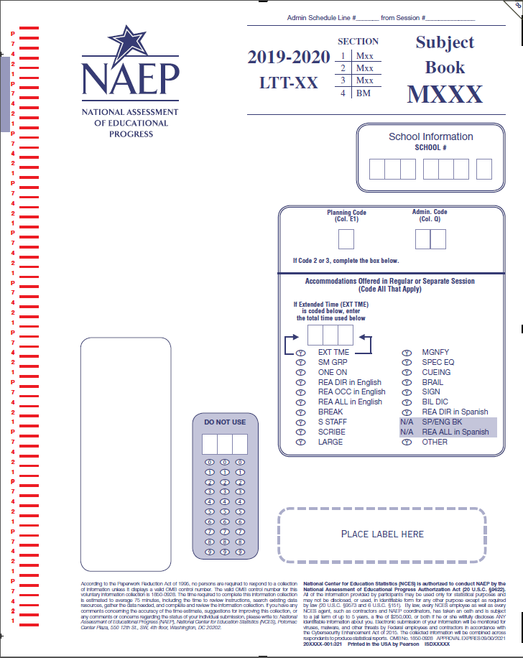

Appendix K4-1: Summary of Changes Operational Age 9 Mathematics
2019/2020 Operational Age 9 Long Term-Trend Mathematics Student
Previous item | 2019/2020 LTT item | D/RV/NC | Rationale
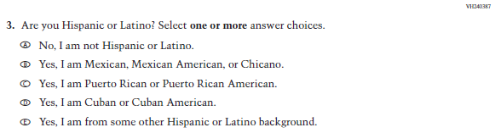  (2019 Grade 4, 8, and 12; Appendix F p. 10 #6) | 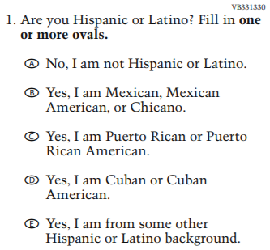 | NC | N/A
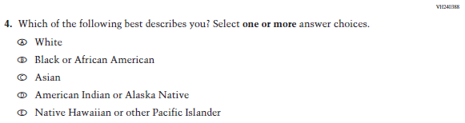  (2019 Grade 4, 8, and 12; Appendix F p.10 #7) | 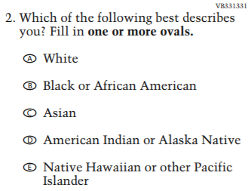 | NC | N/A
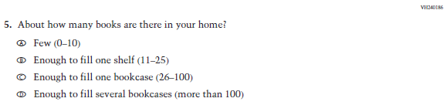  (2019 Grade 4, 8, and 12; Appendix F p.10 #8) | 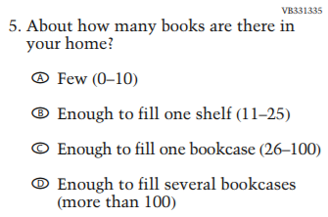 | NC | N/A
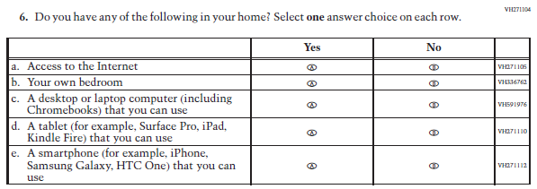  (2019 Grade 4, 8, and 12; Appendix F p.11 #9) | 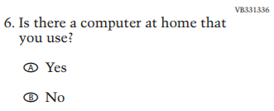 | RV | This item was revised and incorporated into a matrix item (sub-item “c”) for 2019 operational
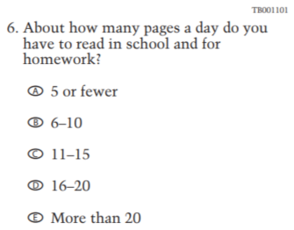  (2015 Grade 4, 8, and 12; Appendix F p. 376 #6 ) | 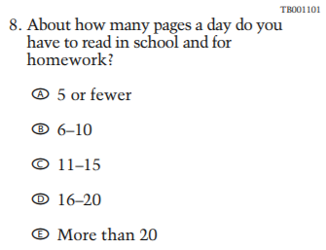 | NC | N/A
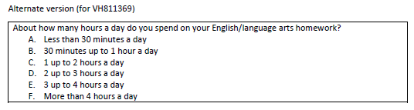  (2018 Grade 4, 8, and 12 Appendix F p.179 alternate version for VH811369) | 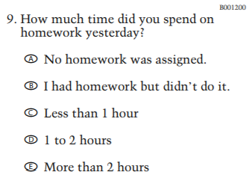 | RV | An alternate version to this LTT item was tested in cognitive lab in Writing.
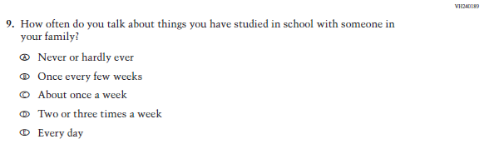  (2019 Grade 4, 8, and 12; Appendix F p.12 #12) | 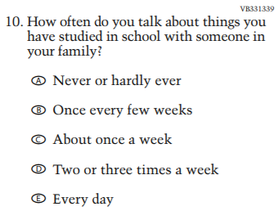 | NC | N/A
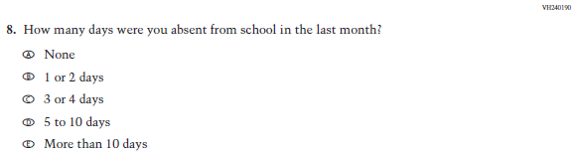  (2019 Grade 4, 8, and 12; Appendix F p.24 #11) | 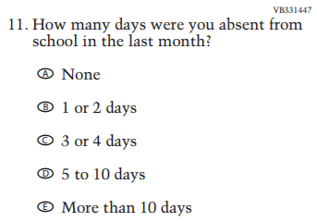 | NC | N/A
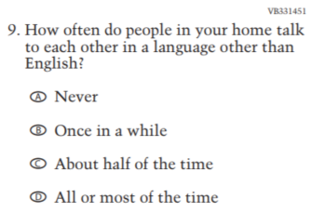  (2015 Grade 4, 8, and 12; Appendix F p. 377 #9) | 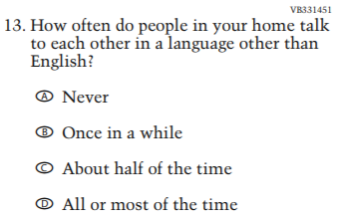 | NC | N/A
NOTE: This column indicates whether the item was dropped (D), added (A), revised version (RV), or there was no change (NC).

Appendix K4-2: Operational Age 9 Mathematics

VB331330
- Are you Hispanic or Latino? Fill in one or more ovals.
  - No, I am not Hispanic or Latino.
  - Yes, I am Mexican, Mexican American, or Chicano.
  - Yes, I am Puerto Rican or Puerto Rican American.
  - Yes, I am Cuban or Cuban American.
  - Yes, I am from some other Hispanic or Latino background.
VB331331
- Which of the following best describes you? Fill in one or more ovals.
  - White
  - Black or African American
  - Asian
  - American Indian or Alaska Native
  - Native Hawaiian or other Pacific Islander
VB331335
- About how many books are there in your home?
  - Few (0–10)
  - Enough to fill one shelf (11–25)
  - Enough to fill one bookcase (26–100)
  - Enough to fill several bookcases (more than 100)
VB331336
- Is there a computer at home that you use?
  - Yes
  - No

TB001101
- About how many pages a day do you have to read in school and for homework?
  - 5 or fewer
  - 6–10
  - 11–15
  - 16–20
E More than 20
BO001200
- How much time did you spend on homework yesterday?
  - No homework was assigned.
  - I had homework but didn’t do it.
  - Less than 1 hour
  - 1 to 2 hours
  - More than 2 hours
VB331339
- How often do you talk about things you have studied in school with someone in your family?
  - Never or hardly ever
  - Once every few weeks
  - About once a week
  - Two or three times a week
  - Every day
VB331447
- How many days were you absent from school in the last month?
  - None
  - 1 or 2 days
  - 3 or 4 days
  - 5 to 10 days
  - More than 10 days

VB331451
- How often do people in your home talk to each other in a language other than English?
  - Never
  - Once in a while
  - About half of the time
  - All or most of the time

Appendix K4-3: Summary of Changes Operational Age 13 Mathematics
2019/2020 Operational Age 13 Long-Term Trend Mathematics Student
Previous item | 2019/2020 LTT item | D/ RV/NC | Rationale
(2019 Grade 4, 8, and 12; Appendix F p. 23 #6) |  | NC | N/A
(2019 Grade 4, 8, and 12; Appendix F p. 23 #7) |  | NC | N/A
(2019 Grade 4, 8, and 12; Appendix F p. 23 #8) |  | NC | N/A
(2019 Grade 4, 8, and 12; Appendix F p. 24 #9) |  | RV | This item was revised and incorporated into a matrix item (sub-item “c”) for 2019 operational
(2015 Grade 4, 8, and 12; Appendix F p. 380 #6) |  | NC | N/A
(2018 Grade 4, 8, and 12; Appendix F p. 193 alternate version for VH811369) |  | RV | An alternate version to this LTT item was tested in cognitive lab in Writing.
(2019 Grade 4, 8, and 12; Appendix F p. 25 #12) |  | NC | N/A
(2019 Grade 4, 8, and 12; Appendix F p. 24 #11) |  | NC | N/A
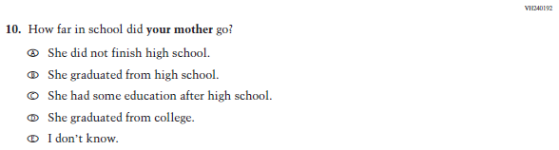  (2019 Grade 8 and 12; Appendix F p. 25 #13) | 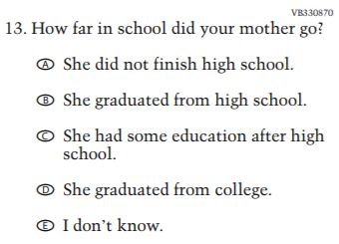 | NC | N/A
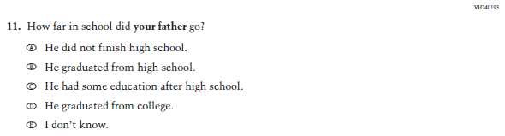  (2019 Grade 8 and 12; Appendix F p. 25 #14) | 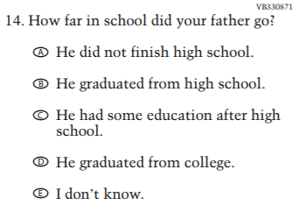 | NC | N/A
(2015 Grade 4, 8, and 12; Appendix F p. 381 #11) | 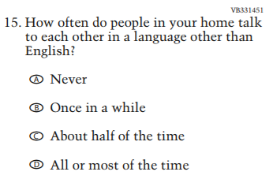 | NC | N/A
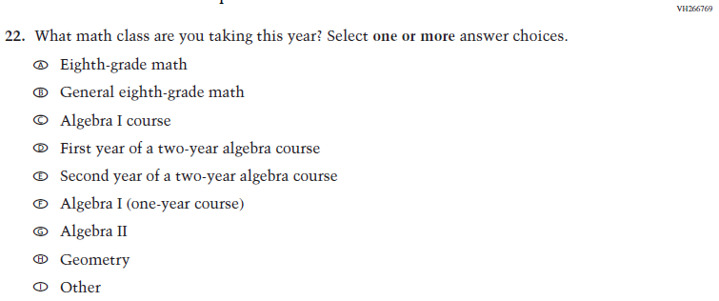  (2019 Grade 8; Appendix F p. 103 #25) | 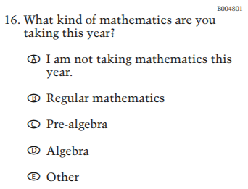 | RV | This item was revised for 2019 operational.
NOTE: This column indicates whether the item was dropped (D), added (A), revised version (RV), or there was no change (NC).

Appendix K4-4: Operational Age 13 Mathematics

VB331330
- Are you Hispanic or Latino? Fill in one or more ovals.
  - No, I am not Hispanic or Latino.
  - Yes, I am Mexican, Mexican American, or Chicano.
  - Yes, I am Puerto Rican or Puerto Rican American.
  - Yes, I am Cuban or Cuban American.
  - Yes, I am from some other Hispanic or Latino background.
VB331331
- Which of the following best describes you? Fill in one or more ovals.
  - White
  - Black or African American
  - Asian
  - American Indian or Alaska Native
  - Native Hawaiian or other Pacific Islander
VB331335
- About how many books are there in your home?
  - Few (0–10)
  - Enough to fill one shelf (11–25)
  - Enough to fill one bookcase (26–100)
  - Enough to fill several bookcases (more than 100)
VB331336
- Is there a computer at home that you use?
  - Yes
  - No

TB001101
- About how many pages a day do you have to read in school and for homework?
  - 5 or fewer
  - 6–10
  - 11–15
  - 16–20
E More than 20
BO001200
- How much time did you spend on homework yesterday?
  - No homework was assigned.
  - I had homework but didn’t do it.
  - Less than 1 hour
  - 1 to 2 hours
  - More than 2 hours
VB331339
- How often do you talk about things you have studied in school with someone in your family?
  - Never or hardly ever
  - Once every few weeks
  - About once a week
  - Two or three times a week
  - Every day
VB331447
- How many days were you absent from school in the last month?
  - None
  - 1 or 2 days
  - 3 or 4 days
  - 5 to 10 days
  - More than 10 days

VB330870
- How far in school did your mother go?
  - She did not finish high school.
  - She graduated from high school.
  - She had some education after high school.
  - She graduated from college.
  - I don’t know.
VB330871
- How far in school did your father go?
  - He did not finish high school.
  - He graduated from high school.
  - He had some education after high school.
  - He graduated from college.
  - I don’t know.
VB331451
- How often do people in your home talk to each other in a language other than English?
  - Never
  - Once in a while
  - About half of the time
  - All or most of the time
BO004801
- What kind of mathematics are you taking this year?
  - I am not taking mathematics this year.
  - Regular mathematics
  - Pre-algebra
  - Algebra
  - Other

Appendix K4-5: Summary of Changes Operational Age 17 Mathematics
2019/2020 Operational Age 17 Long-Term Trend Mathematics Student
Previous item | 2019/2020 LTT item | D/RV/NC | Rationale
(2019 Grade 4, 8, and 12; Appendix F p. 37 #5) |  | NC | N/A
(2019 Grade 4, 8, and 12; Appendix F p. 37 #6) |  | NC | N/A
(2019 Grade 4, 8, and 12; Appendix F p. 37 #7) |  | NC | N/A
(2019 Grade 4, 8, and 12; Appendix F p. 37 #8) |  | RV | This item was revised and incorporated into a matrix item (sub-item “c”) for 2019 operational.
(2015 Grade 4, 8, and 12; Appendix F p. 384 # 6) |  | NC | N/A
(2018 Grade 4, 8, and 12; Appendix F p. 228 alternate version for VH811369) |  | RV | An alternate version to this LTT item was tested in cognitive lab in Writing.
(2019 Grade 4, 8, and 12; Appendix F p.39 #11) |  | NC | N/A
(2019 Grade 4, 8, and 12; Appendix F p. 38 #10) |  | NC | N/A
(2019 Grade 8 and 12; Appendix F p. 39 #12) |  | NC | N/A
(2019 Grade 8 and 12; Appendix F p. 39 #13) |  | NC | N/A
(2015 Grade 4, 8, and 12; Appendix F p. 385 #11) |  | NC | N/A
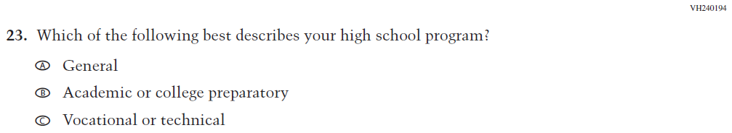  (2019 Grade 12; Appendix F p. 49 #28) | 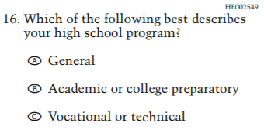 | NC | N/A
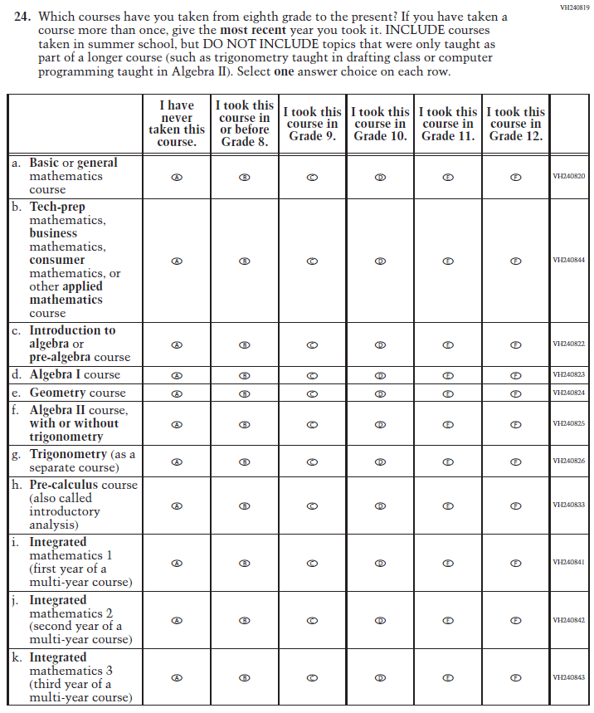  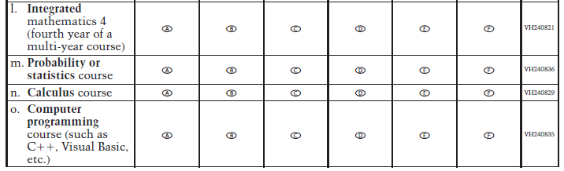  (2019 Grade 12; Appendix F p. 118 #1) | 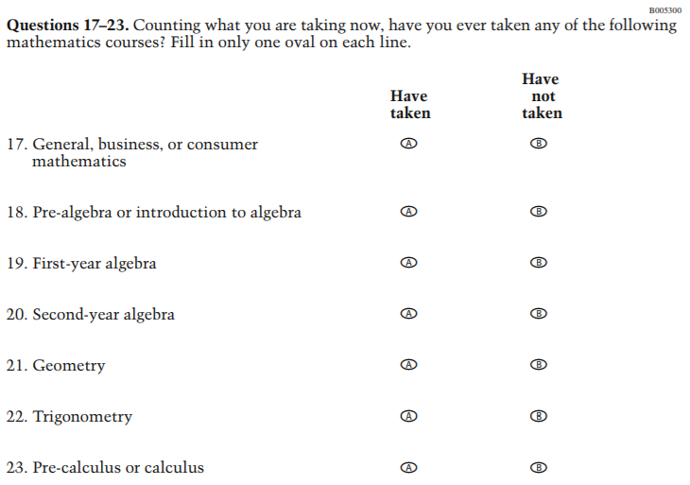 | RV | This item was revised for 2019 operational.
NOTE: This column indicates whether the item was dropped (D), added (A), revised version (RV), or there was no change (NC).

Appendix K4-6: Operational Age 17 Mathematics

VB331330
- Are you Hispanic or Latino? Fill in one or more ovals.
  - No, I am not Hispanic or Latino.
  - Yes, I am Mexican, Mexican American, or Chicano.
  - Yes, I am Puerto Rican or Puerto Rican American.
  - Yes, I am Cuban or Cuban American.
  - Yes, I am from some other Hispanic or Latino background.
VB331331
- Which of the following best describes you? Fill in one or more ovals.
  - White
  - Black or African American
  - Asian
  - American Indian or Alaska Native
  - Native Hawaiian or other Pacific Islander
VB331335
- About how many books are there in your home?
  - Few (0–10)
  - Enough to fill one shelf (11–25)
  - Enough to fill one bookcase (26–100)
  - Enough to fill several bookcases (more than 100)
VB331336
- Is there a computer at home that you use?
  - Yes
  - No

TB001101
- About how many pages a day do you have to read in school and for homework?
  - 5 or fewer
  - 6–10
  - 11–15
  - 16–20
  - More than 20
BO001200
- How much time did you spend on homework yesterday?
  - No homework was assigned.
  - I had homework but didn’t do it.
  - Less than 1 hour
  - 1 to 2 hours
  - More than 2 hours
VB331339
- How often do you talk about things you have studied in school with someone in your family?
  - Never or hardly ever
  - Once every few weeks
  - About once a week
  - Two or three times a week
  - Every day
VB331447
- How many days were you absent from school in the last month?
  - None
  - 1 or 2 days
  - 3 or 4 days
  - 5 to 10 days
  - More than 10 days
VB330870
- How far in school did your mother go?
  - She did not finish high school.
  - She graduated from high school.
  - She had some education after high school.
  - She graduated from college.
  - I don’t know.
VB330871
- How far in school did your father go?
  - He did not finish high school.
  - He graduated from high school.
  - He had some education after high school.
  - He graduated from college.
  - I don’t know.
VB331451
- How often do people in your home talk to each other in a language other than English?
  - Never
  - Once in a while
  - About half of the time
  - All or most of the time
HE002549
- Which of the following best describes your high school program?
  - General
  - Academic or college preparatory
  - Vocational or technical

BO005300
- Counting what you are taking now, have you ever taken any of the following mathematics courses? Fill in only one oval on each line.
 | Have taken | Have not taken
a. General, business, or consumer mathematics | A | B | VC373212
b. Pre-algebra or introduction to algebra | A | B | VC373213
c. First-year algebra | A | B | VC373217
d. Second-year algebra | A | B | VC373220
e. Geometry | A | B | VC373221
f. Trigonometry | A | B | VC373222
g. Pre-calculus or calculus | A | B | VC373224

Appendix K4-7: Summary of Changes Operational Age 9 Reading
2019/2020 Operational Age 9 Long-Term Trend Reading Student
Previous item | 2019/2020 LTT item | D/ RV/NC | Rationale
(2019 Grade 4, 8, and 12; Appendix F p. 10 #6) |  | NC | N/A
(2019 Grade 4, 8, and 12; Appendix F p.10 #7) |  | NC | N/A
(2019 Grade 4, 8, and 12 Appendix F p.10 #8) |  | NC | N/A
(2019 Grade 4, 8, and 12; Appendix F p.11 #9) |  | RV | This item was revised and incorporated into a matrix item (sub-item “c”) for 2019 operational.
(2015 Grade 4, 8, and 12; Appendix F p. 376 #6) |  | NC | N/A
(2018 Grade 4, 8, and 12; Appendix F p.179 alternate version for VH811369) |  | RV | An alternate version to this LTT item was tested in cognitive lab in Writing.
(2019 Grade 4, 8, and 12; Appendix F p.12 #12) |  | NC | N/A
(2019 Grade 4, 8, and 12; Appendix F p.24 #11) |  | NC | N/A
(2015 Grade 4, 8, and 12; Appendix F p. 377 #9) |  | NC | N/A
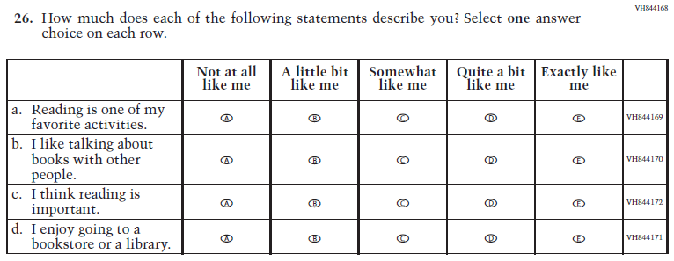  (2019 Grade 4, 8, and 12; Appendix F p.59 #10) | 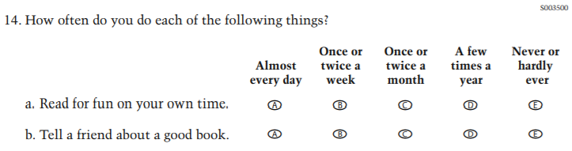 | RV | The 2019 operational version of this LTT item has revised response options and sub-item wording.
NOTE: This column indicates whether the item was dropped (D), added (A), revised version (RV), or there was no change (NC).

Appendix K4-8: Operational Age 9 Reading

VB331330
- Are you Hispanic or Latino? Fill in one or more ovals.
  - No, I am not Hispanic or Latino.
  - Yes, I am Mexican, Mexican American, or Chicano.
  - Yes, I am Puerto Rican or Puerto Rican American.
  - Yes, I am Cuban or Cuban American.
  - Yes, I am from some other Hispanic or Latino background.
VB331331
- Which of the following best describes you? Fill in one or more ovals.
  - White
  - Black or African American
  - Asian
  - American Indian or Alaska Native
  - Native Hawaiian or other Pacific Islander
VB331335
- About how many books are there in your home?
  - Few (0–10)
  - Enough to fill one shelf (11–25)
  - Enough to fill one bookcase (26–100)
  - Enough to fill several bookcases (more than 100)
VB331336
- Is there a computer at home that you use?
  - Yes
  - No

TB001101
- About how many pages a day do you have to read in school and for homework?
  - 5 or fewer
  - 6–10
  - 11–15
  - 16–20
  - More than 20
BO001200
- How much time did you spend on homework yesterday?
  - No homework was assigned.
  - I had homework but didn’t do it.
  - Less than 1 hour
  - 1 to 2 hours
  - More than 2 hours
VB331339
- How often do you talk about things you have studied in school with someone in your family?
  - Never or hardly ever
  - Once every few weeks
  - About once a week
  - Two or three times a week
  - Every day
VB331447
- How many days were you absent from school in the last month?
  - None
  - 1 or 2 days
  - 3 or 4 days
  - 5 to 10 days
  - More than 10 days

VB331451
- How often do people in your home talk to each other in a language other than English?
  - Never
  - Once in a while
  - About half of the time
  - All or most of the time
SO003500
- How often do you do each of the following things?
 | Almost every day | Once or twice a week | Once or twice a month | A few times a year | Never or hardly ever
a. Read for fun on your own time. | A | B | C | D | E | VC375071
b. Tell a friend about a good book. | A | B | C | D | E | VC375073

Appendix K4-9: Summary of Changes Operational Age 13 Reading
2019/2020 Operational Age 13 Long-Term Trend Reading Student
Previous item | 2019/2020 LTT item | D/RV/NC | Rationale
(2019 Grade 4, 8, and 12; Appendix F p.23 #6) |  | NC | N/A
(2019 Grade 4, 8, and 12; Appendix F p. 23 #7) |  | NC | N/A
(2019 Grade 4, 8, and 12; Appendix F p. 23 #8) |  | NC | N/A
(2019 Grade 4, 8, and 12; Appendix F p. 24 #9) |  | RV | This item was revised and incorporated into a matrix item (sub-item “c”) for 2019 operational.
(2015 Grade 4, 8, and 12; Appendix F p. 380 #6) |  | NC | N/A
(2018 Grade 4, 8, and 12; Appendix F p. 193 alternate version for VH811369) |  | RV | An alternate version to this LTT item was tested in cognitive lab in Writing.
(2019 Grade 4, 8, and 12; Appendix F p. 25 #12) |  | NC | N/A
(2019 Grade 4, 8, and 12; Appendix F p. 24 #11) |  | NC | N/A
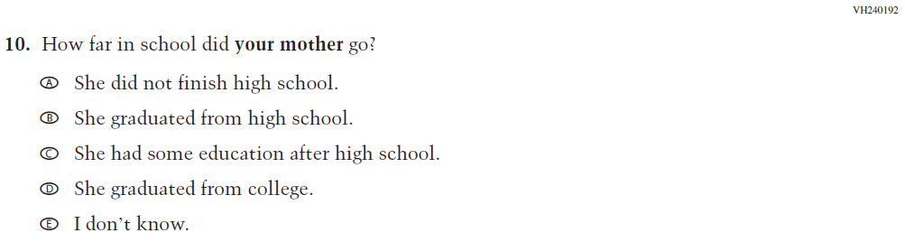  (2018 Grade 8 and 12; Appendix F p. 25 #13) | 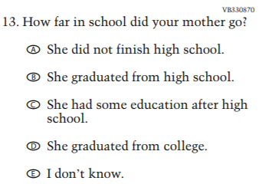 | NC | N/A
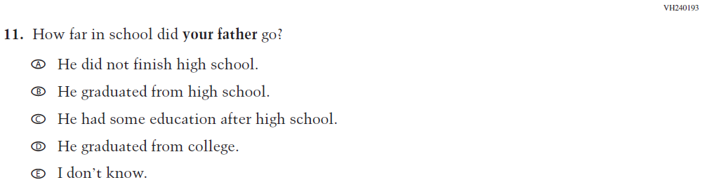  (2019 Grade 8 and 12; Appendix F p. 25 #14) | 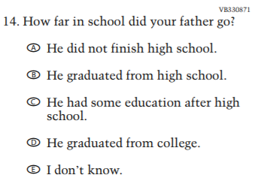 | NC | N/A
(2015 Grade 4, 8, and 12; Appendix F p. 381 #11) | 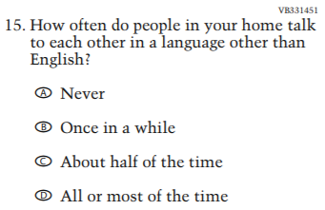 | NC | N/A
(2019 Grade 4, 8, and 12; Appendix F p. 72 #10) | 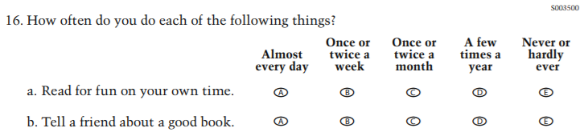 | RV | The 2019 operational version of this LTT item has revised response options and sub-item wording.
NOTE: This column indicates whether the item was dropped (D), added (A), revised version (RV), or there was no change (NC).

.

Appendix K4-10: Operational Age 13 Reading

VB331330
- Are you Hispanic or Latino? Fill in one or more ovals.
  - No, I am not Hispanic or Latino.
  - Yes, I am Mexican, Mexican American, or Chicano.
  - Yes, I am Puerto Rican or Puerto Rican American.
  - Yes, I am Cuban or Cuban American.
  - Yes, I am from some other Hispanic or Latino background.
VB331331
- Which of the following best describes you? Fill in one or more ovals.
  - White
  - Black or African American
  - Asian
  - American Indian or Alaska Native
  - Native Hawaiian or other Pacific Islander
VB331335
- About how many books are there in your home?
  - Few (0–10)
  - Enough to fill one shelf (11–25)
  - Enough to fill one bookcase (26–100)
  - Enough to fill several bookcases (more than 100)
VB331336
- Is there a computer at home that you use?
  - Yes
  - No

TB001101
- About how many pages a day do you have to read in school and for homework?
  - 5 or fewer
  - 6–10
  - 11–15
  - 16–20
  - More than 20
BO001200
- How much time did you spend on homework yesterday?
  - No homework was assigned.
  - I had homework but didn’t do it.
  - Less than 1 hour
  - 1 to 2 hours
  - More than 2 hours
VB331339
- How often do you talk about things you have studied in school with someone in your family?
  - Never or hardly ever
  - Once every few weeks
  - About once a week
  - Two or three times a week
  - Every day
VB331447
- How many days were you absent from school in the last month?
  - None
  - 1 or 2 days
  - 3 or 4 days
  - 5 to 10 days
  - More than 10 days
VB330870
- How far in school did your mother go?
  - She did not finish high school.
  - She graduated from high school.
  - She had some education after high school.
  - She graduated from college.
  - I don’t know.
VB330871
- How far in school did your father go?
  - He did not finish high school.
  - He graduated from high school.
  - He had some education after high school.
  - He graduated from college.
  - I don’t know.
VB331451
- How often do people in your home talk to each other in a language other than English?
  - Never
  - Once in a while
  - About half of the time
  - All or most of the time
SO003500
- How often do you do each of the following things?
 | Almost every day | Once or twice a week | Once or twice a month | A few times a year | Never or hardly ever
a. Read for fun on your own time. | A | B | C | D | E | VC375071
b. Tell a friend about a good book. | A | B | C | D | E | VC375073

Appendix K4-11: Summary of Changes Operational Age 17 Reading
2019/2020 Operational Age 17 Long-Term Trend Reading Student
Previous item | 2019/2020 LTT item | D/RV/NC | Rationale
(2019 Grade 4, 8, and 12; Appendix F p. 37 #5) |  | NC | N/A
(2019 Grade 4, 8, and 12; Appendix F p. 37 #6) |  | NC | N/A
(2019 Grade 4, 8, and 12; Appendix F p. 37 #7) |  | NC | N/A
(2019 Grade 4, 8, and 12; Appendix F p. 37 #8) |  | RV | This item was revised and incorporated into a matrix item (sub-item “c”) for 2019 operational.
(2015 Grade 4, 8, and 12; Appendix F p. 384 #6) |  | NC | N/A
(2018 Grade 4, 8, and 12; Appendix F p. 228 alternate version for VH811369) |  | RV | An alternate version to this LTT item was tested in cognitive lab in Writing.
(2019 Grade 4, 8, and 12; Appendix F p.39 #11) |  | NC | N/A
(2019 Grade 4, 8, and 12; Appendix F p. 38 #10) |  | NC | N/A
(2018 Grade 8 and 12; Appendix F p. 39 #12) |  | NC | N/A
(2019 Grade 8 and 12; Appendix F p. 39 #13) |  | NC | N/A
(2015 Grade 4, 8, and 12; Appendix F p. 385 #11) |  | NC | N/A
(2019 Grade 12; Appendix F p. 49 #28) | 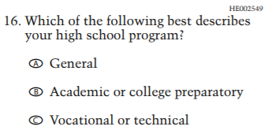 | NC | N/A
(2019 Grade 4, 8, and 12; Appendix F p. 86 #9) | 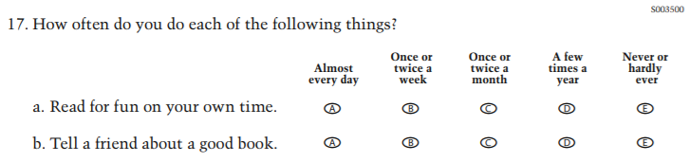 | RV | The 2019 operational version of this LTT item has revised response options and sub-item wording.
NOTE: This column indicates whether the item was dropped (D), added (A), revised version (RV), or there was no change (NC).

Appendix K4-12: Operational Age 17 Reading

VB331330
- Are you Hispanic or Latino? Fill in one or more ovals.
  - No, I am not Hispanic or Latino.
  - Yes, I am Mexican, Mexican American, or Chicano.
  - Yes, I am Puerto Rican or Puerto Rican American.
  - Yes, I am Cuban or Cuban American.
  - Yes, I am from some other Hispanic or Latino background.
VB331331
- Which of the following best describes you? Fill in one or more ovals.
  - White
  - Black or African American
  - Asian
  - American Indian or Alaska Native
  - Native Hawaiian or other Pacific Islander
VB331335
- About how many books are there in your home?
  - Few (0–10)
  - Enough to fill one shelf (11–25)
  - Enough to fill one bookcase (26–100)
  - Enough to fill several bookcases (more than 100)

VB331336
- Is there a computer at home that you use?
  - Yes
  - No

TB001101
- About how many pages a day do you have to read in school and for homework?
  - 5 or fewer
  - 6–10
  - 11–15
  - 16–20
  - More than 20
BO001200
- How much time did you spend on homework yesterday?
  - No homework was assigned.
  - I had homework but didn’t do it.
  - Less than 1 hour
  - 1 to 2 hours
  - More than 2 hours
VB331339
- How often do you talk about things you have studied in school with someone in your family?
  - Never or hardly ever
  - Once every few weeks
  - About once a week
  - Two or three times a week
  - Every day
VB331447
- How many days were you absent from school in the last month?
  - None
  - 1 or 2 days
  - 3 or 4 days
  - 5 to 10 days
  - More than 10 days
VB330870
- How far in school did your mother go?
  - She did not finish high school.
  - She graduated from high school.
  - She had some education after high school.
  - She graduated from college.
  - I don’t know.
VB330871
- How far in school did your father go?
  - He did not finish high school.
  - He graduated from high school.
  - He had some education after high school.
  - He graduated from college.
  - I don’t know.
VB331451
- How often do people in your home talk to each other in a language other than English?
  - Never
  - Once in a while
  - About half of the time
  - All or most of the time
HE002549
- Which of the following best describes your high school program?
  - General
  - Academic or college preparatory
  - Vocational or technical

SO003500
- How often do you do each of the following things?
 | Almost every day | Once or twice a week | Once or twice a month | A few times a year | Never or hardly ever
a. Read for fun on your own time. | A | B | C | D | E | VC375071
b. Tell a friend about a good book. | A | B | C | D | E | VC375073

