Part 1 – USAJOBS portion of the application process
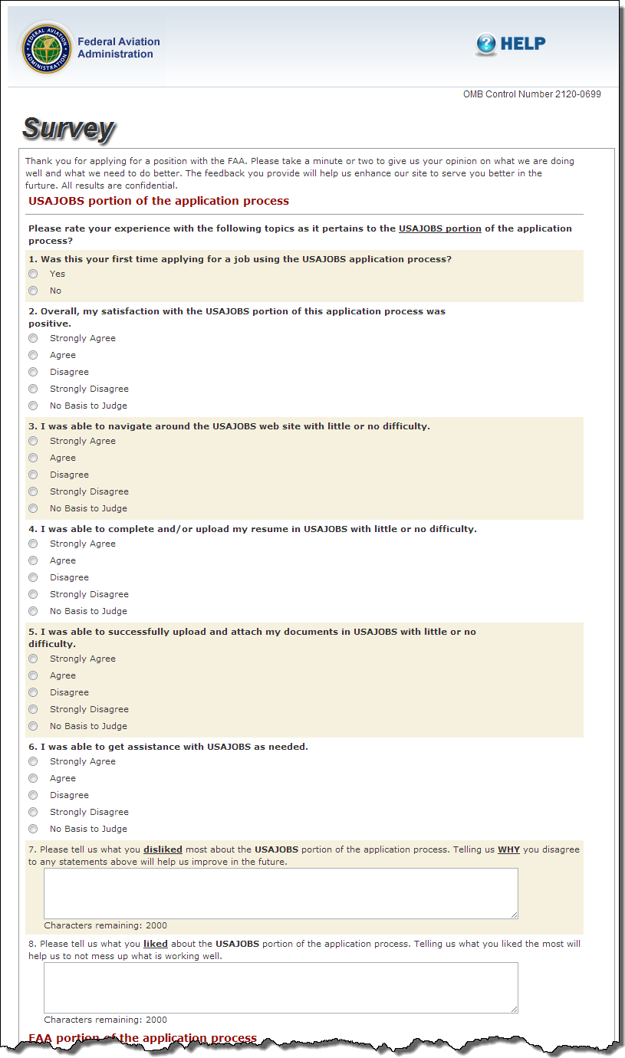
Part 2- FAA Portion of the application process
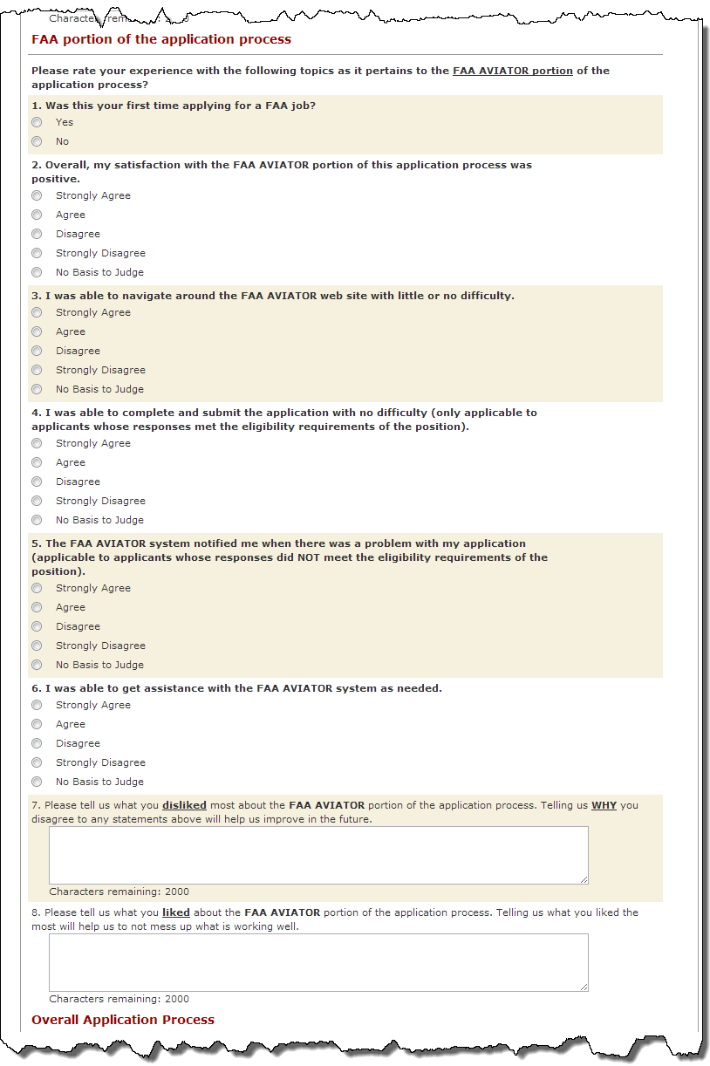
Part 3 – Overall Application Process
