FCC Form2100, Application for Media Bureau Video Service Authorization, Schedule A

OMB CONTROL NUMBER: 3063-0027 Edition Date: April 2021

Estimated Time Per Response: 2 hours

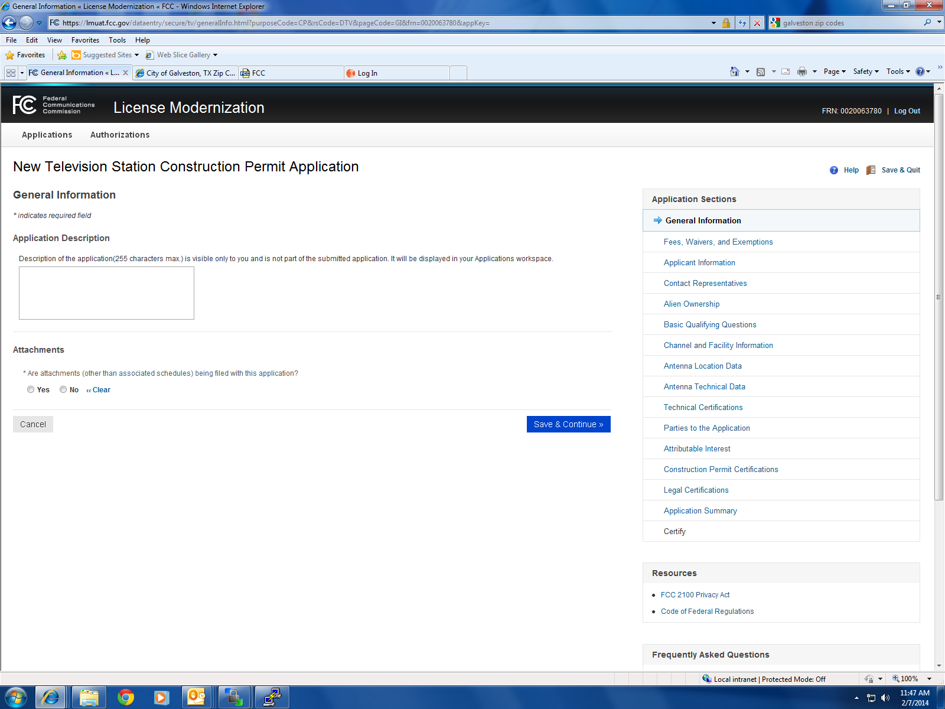

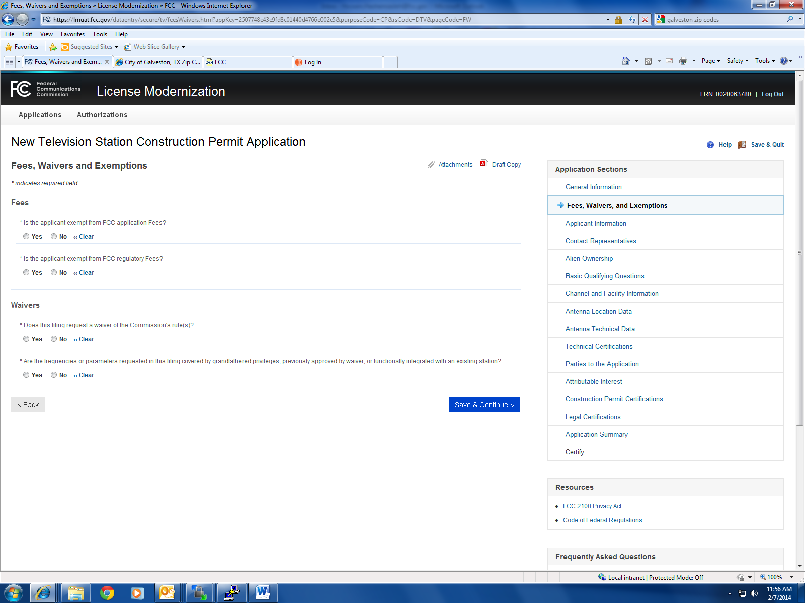

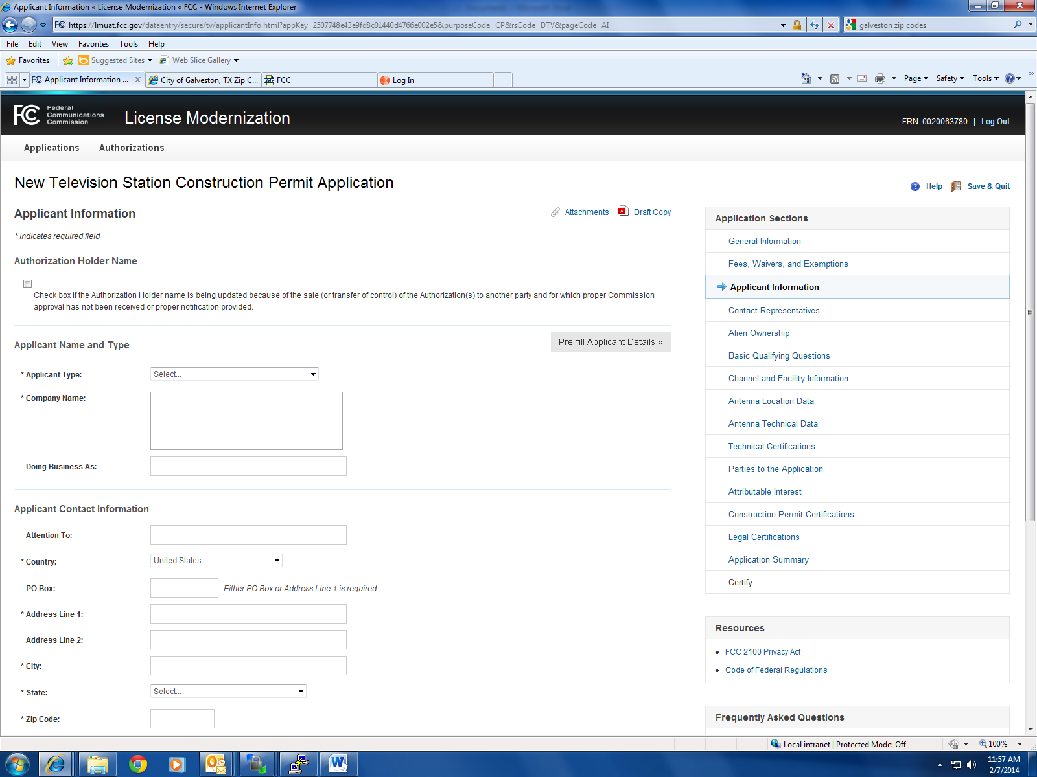

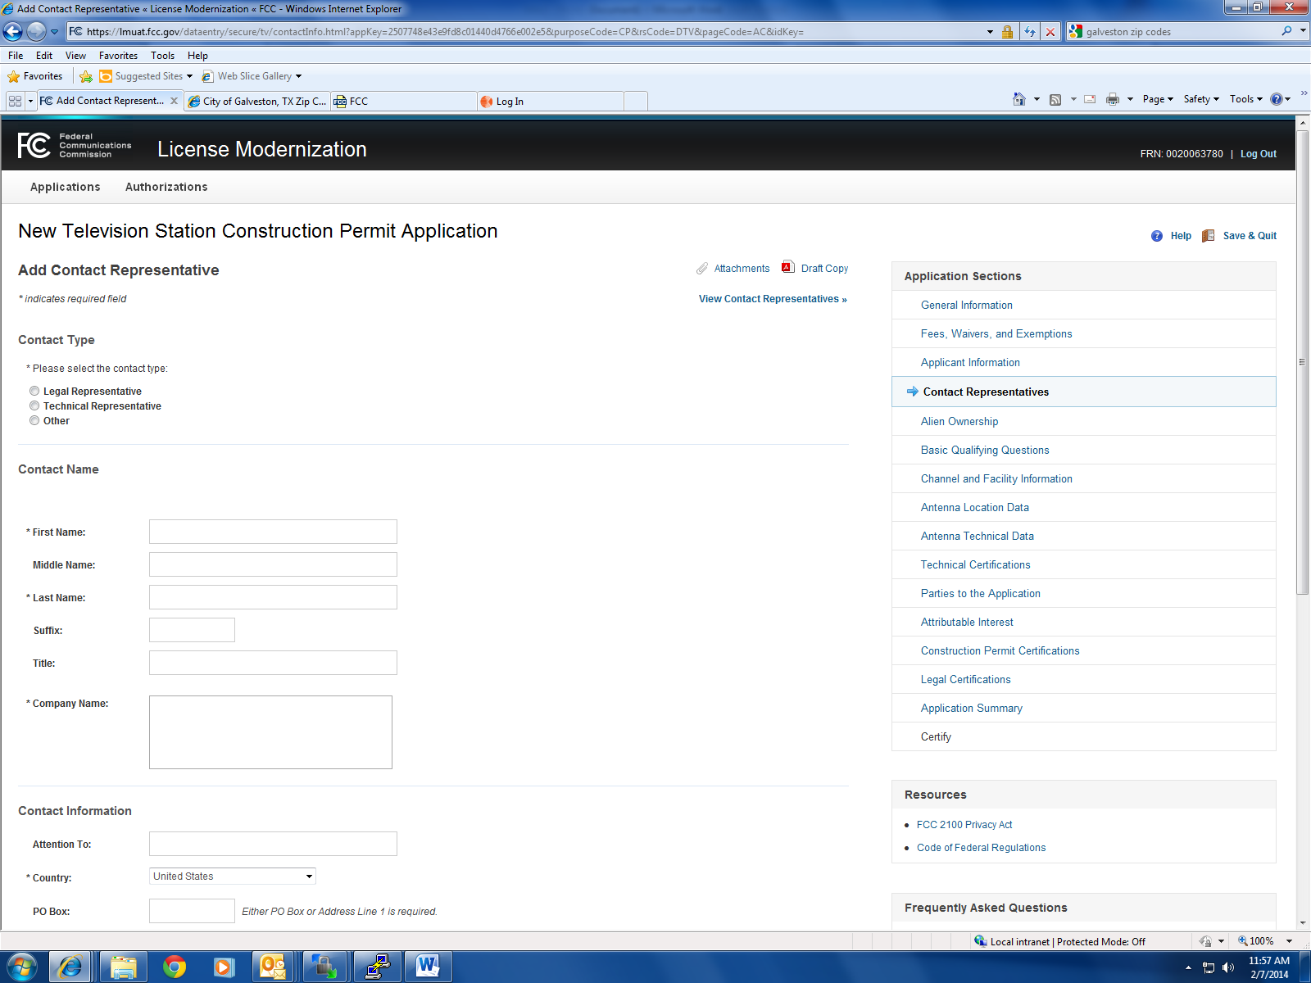

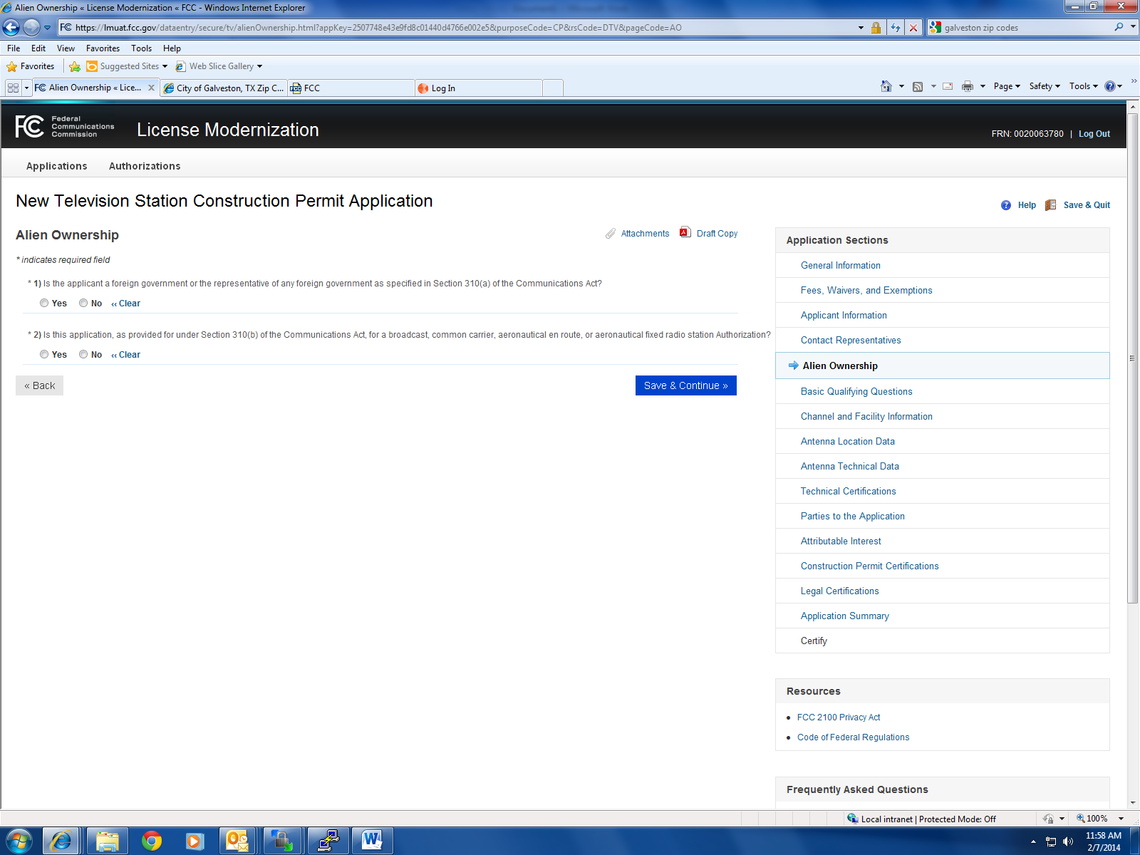

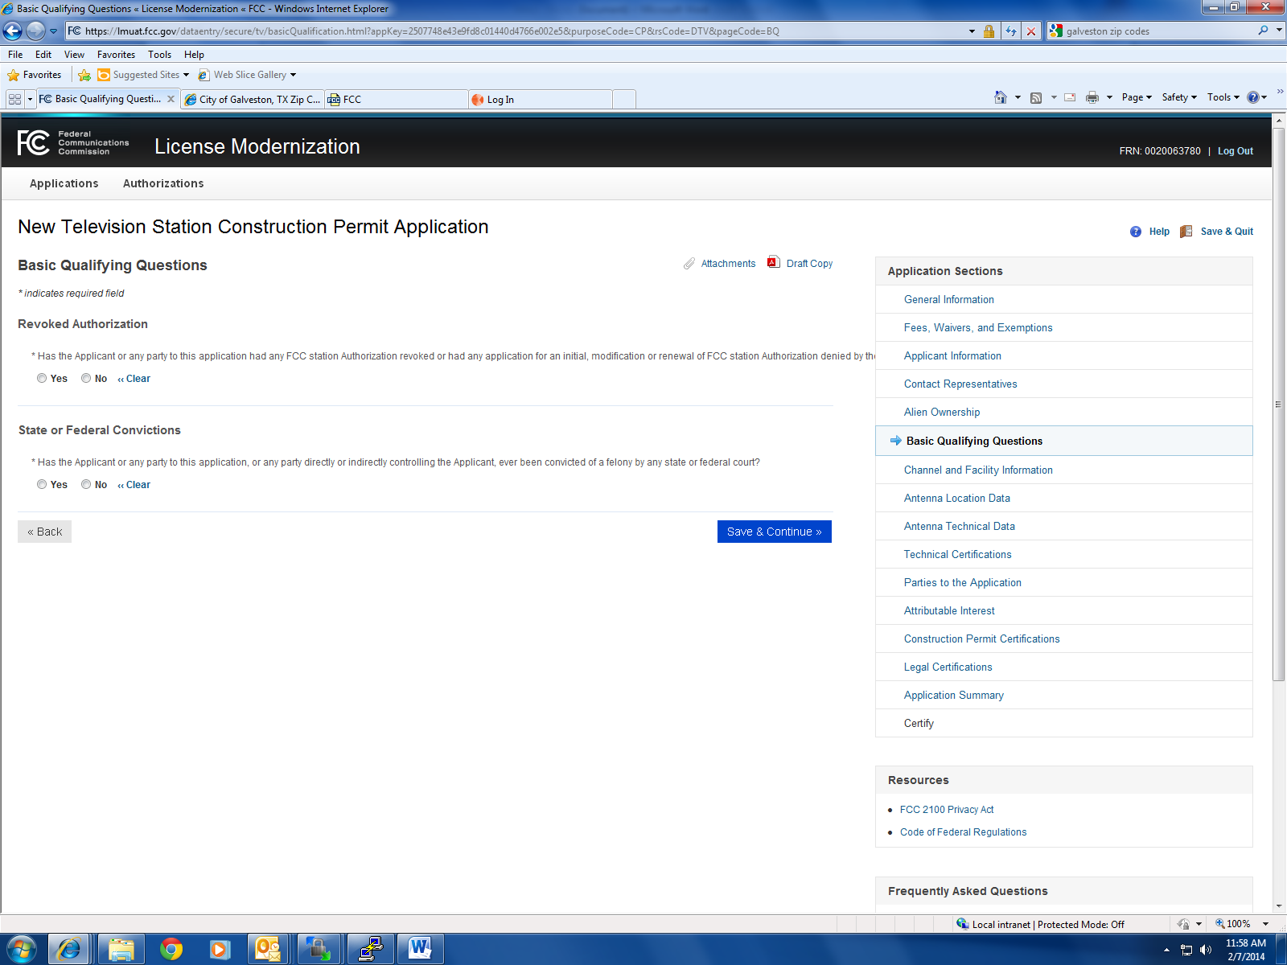



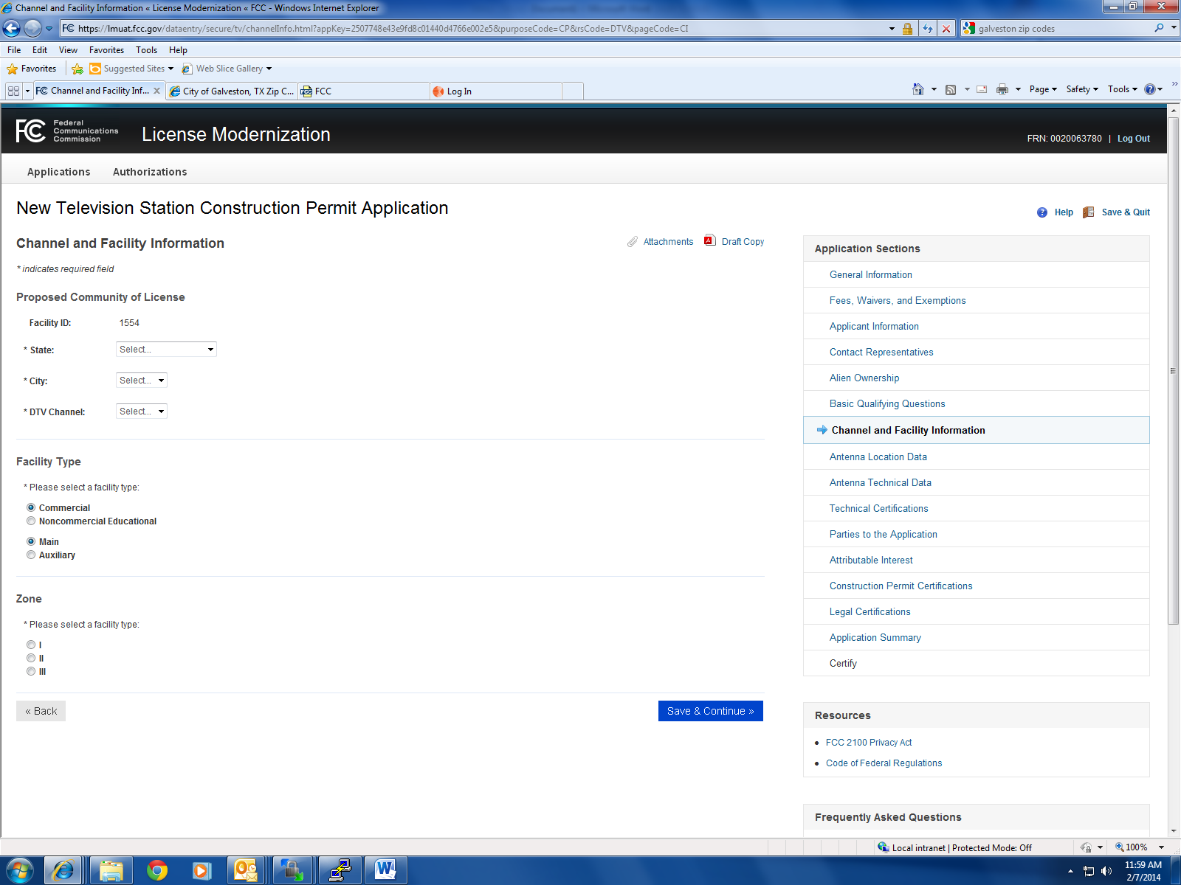

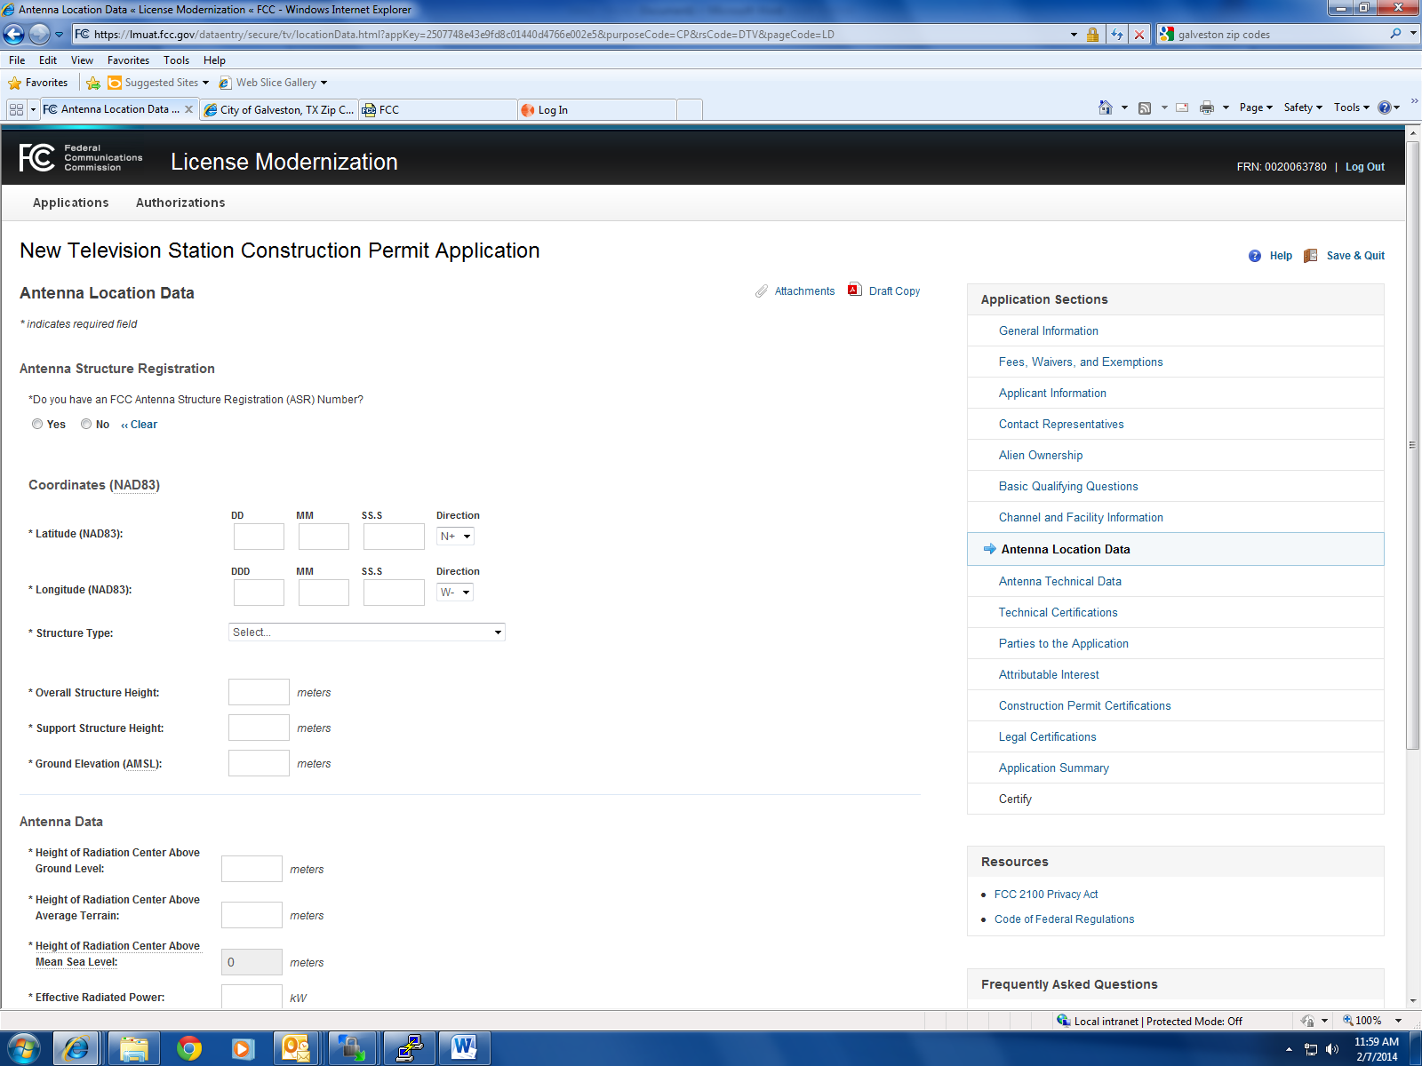

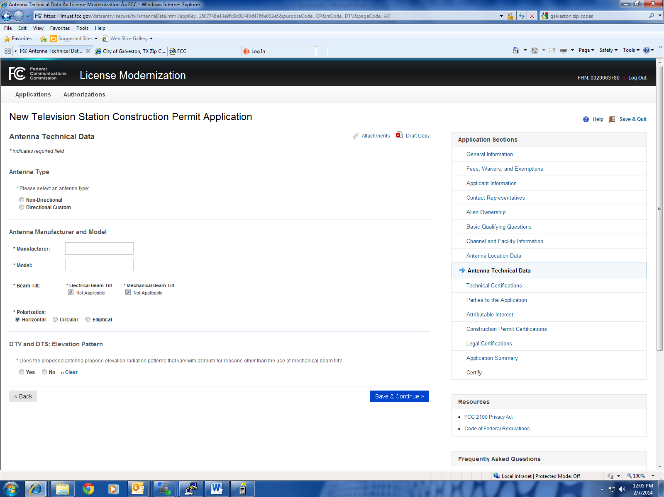

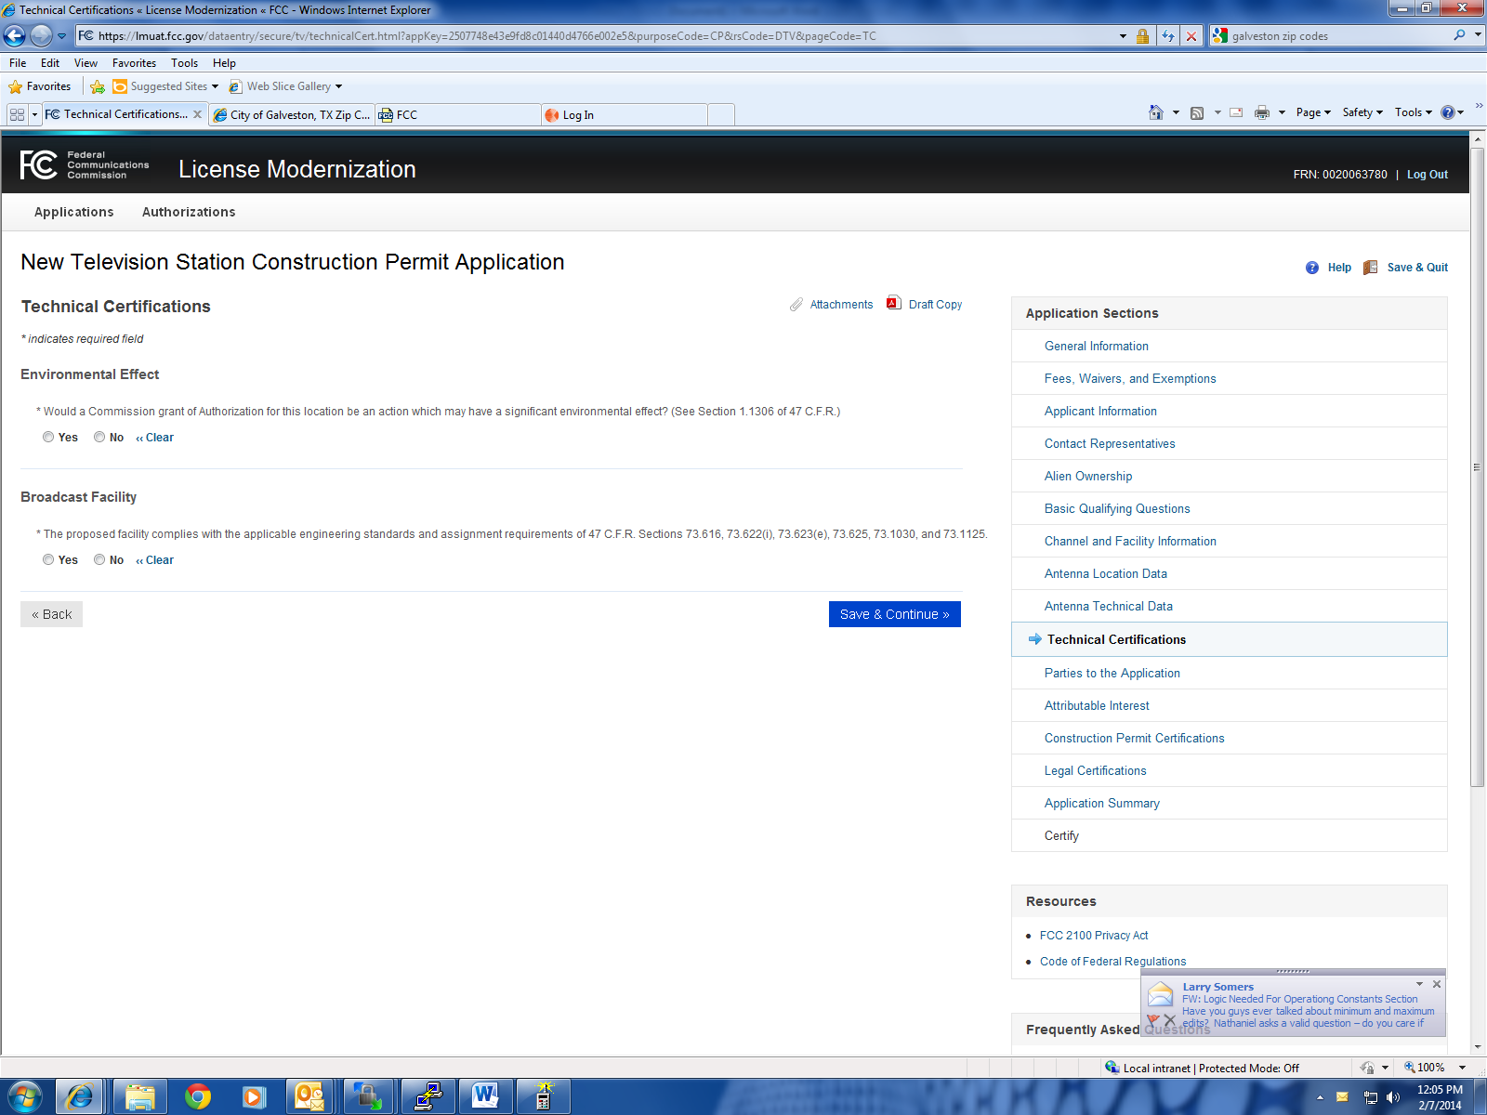

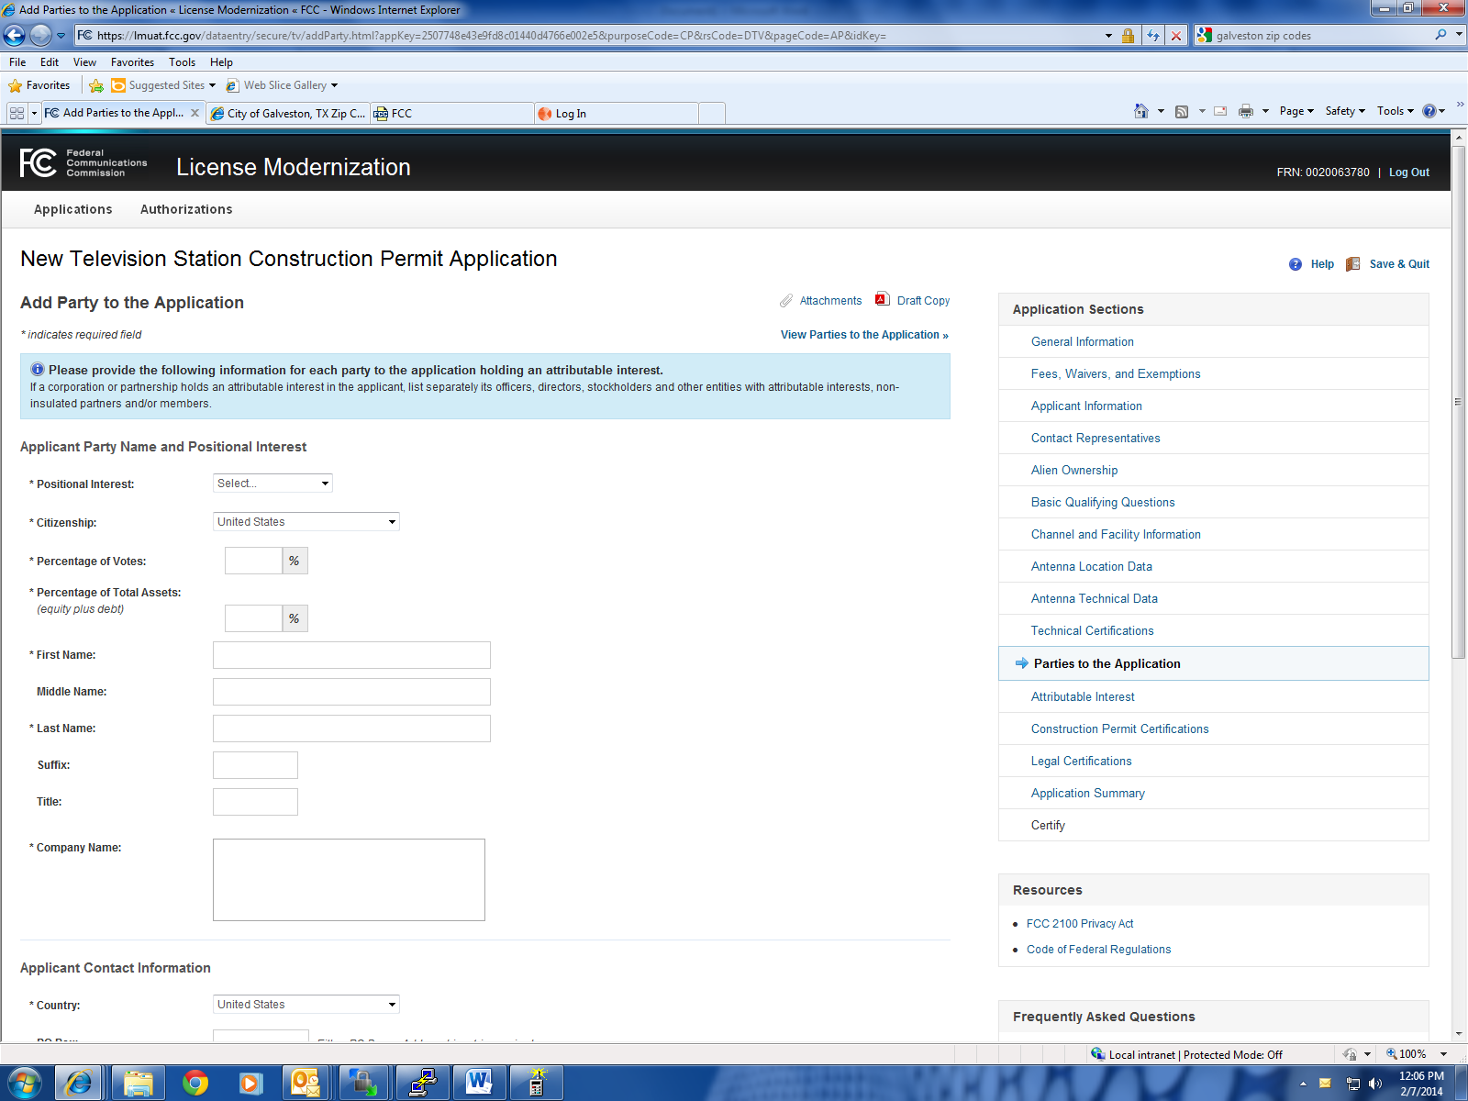

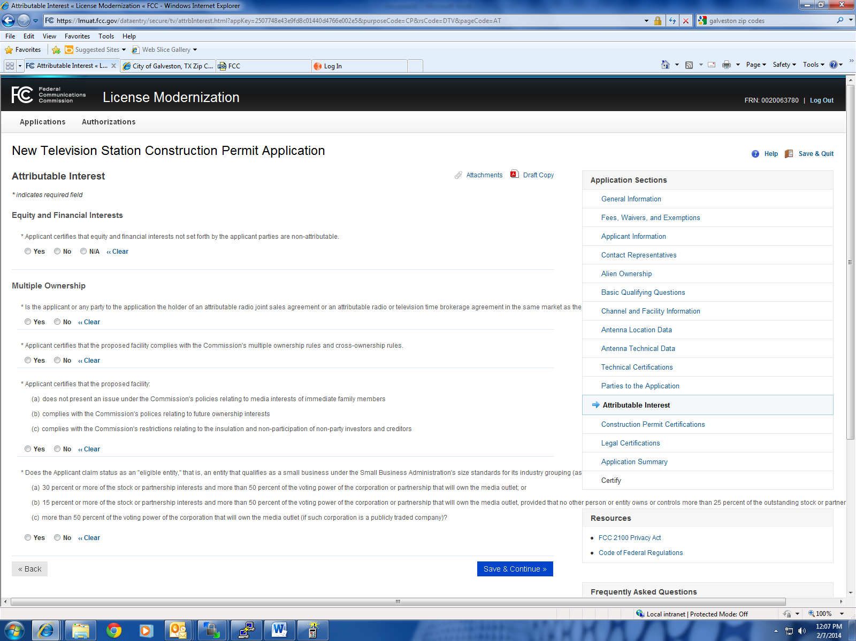

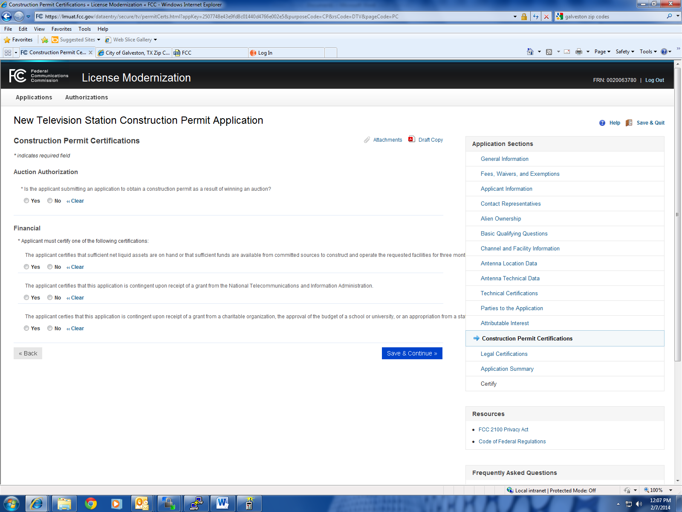

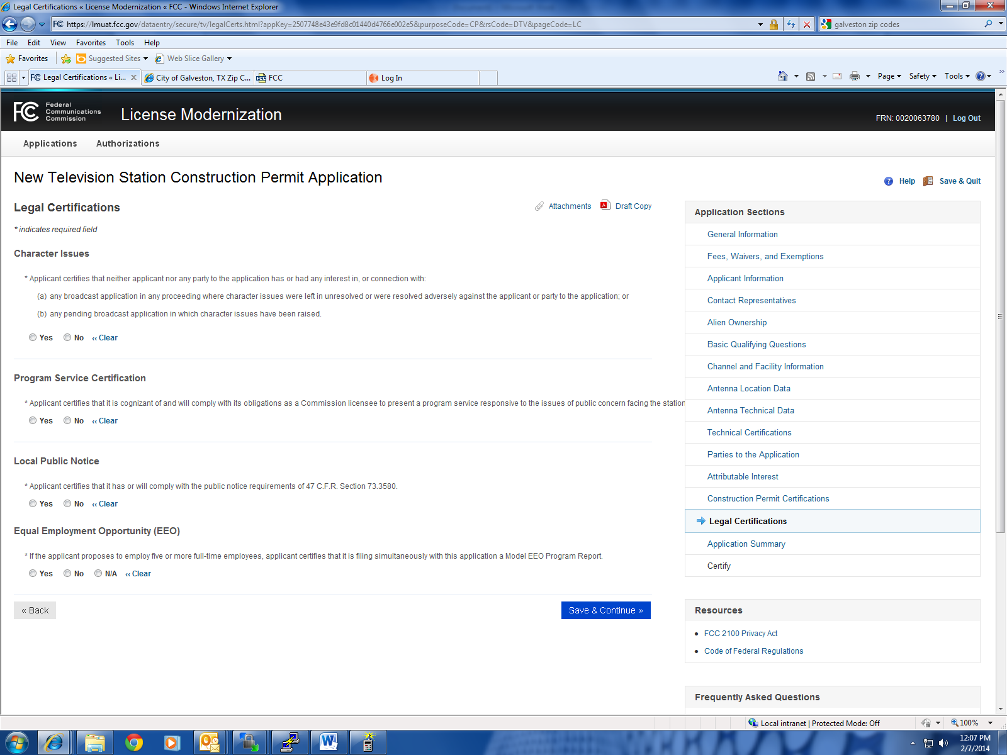

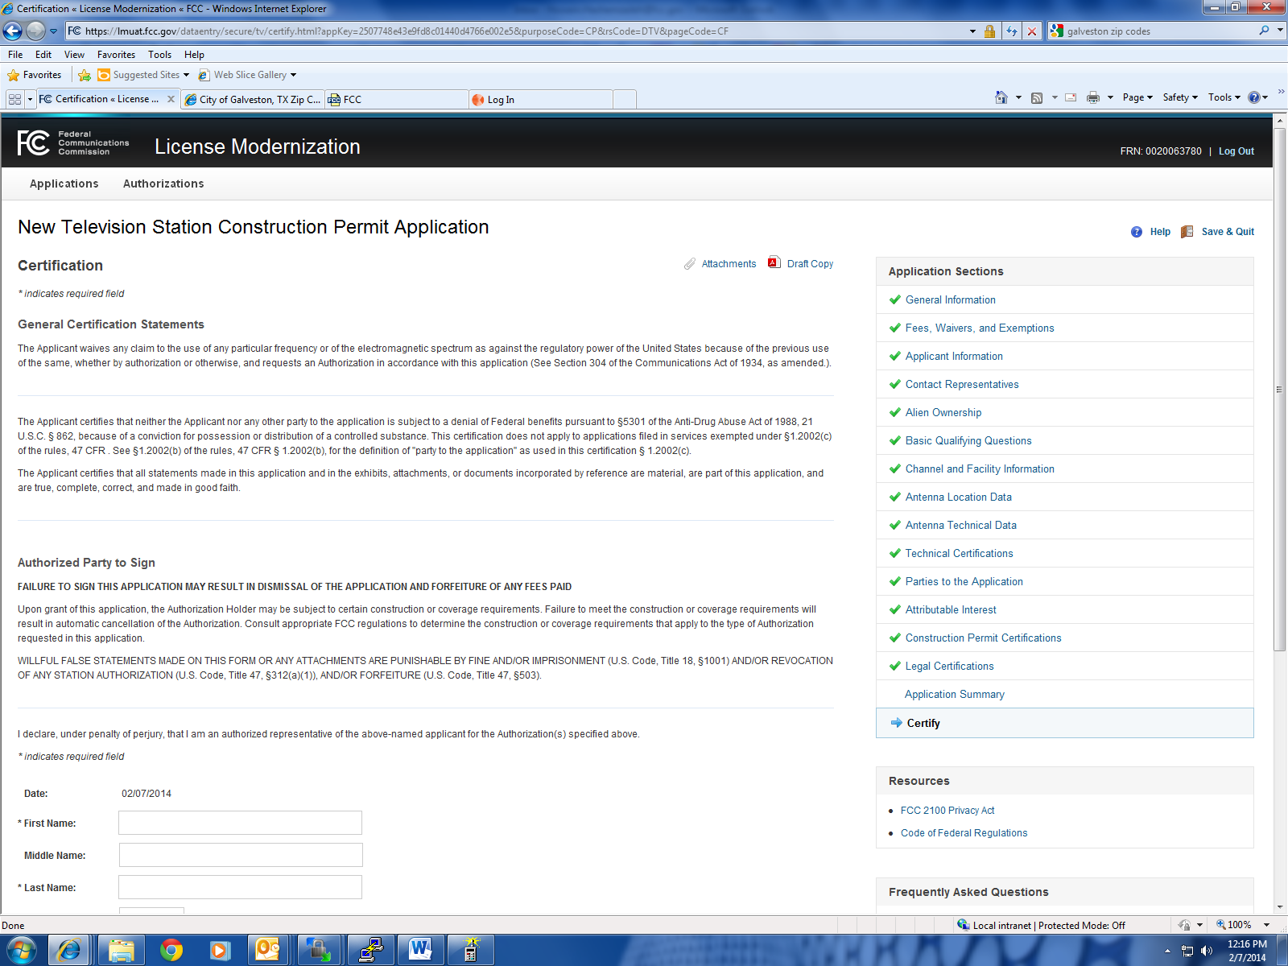

**Modification of a License to Convert from DTV to DTS Application**

**Construction Permit Certifications**

**Post-Incentive Auction Expedited Processing**

An application concerning a post-incentive auction channel must complete the following questions. A station applying for a construction permit to build its post-incentive auction channel will receive expedited processing if its application (1) does not seek to expand the noise-limited service contour in any direction beyond that established by the post-incentive auction channel reassignment public notice establishing the new post-incentive auction channel assignments; (2) specifies facilities that match or closely approximate those defined in the post-incentive auction channel reassignment public notice; and (3) is filed within 90 days of the release of the post-incentive auction channel reassignment public notice.

The proposed DTV facility complies in the following respects:

* It will operate on the DTV channel for this station as established in the post-incentive auction channel reassignment public notice.

Yes No 

* It will operate post-incentive auction facilities that do not expand the noise-limited service contour in any direction beyond that established by the post-incentive auction channel reassignment public notice.

Yes No 

* It will operate post-incentive auction facilities that match or reduce by no more than five percent with respect to predicted population from those defined in the post-incentive auction channel reassignment public notice.

Yes No .

* The antenna structure to be used by this facility has been registered by the Commission and will not require reregistration to support the proposed antenna, OR the FAA has previously determined that the proposed structure will not adversely affect safety in air navigation and this structure qualifies for later registration under the Commission's phased registration plan, OR the proposed installation on this structure does not require notification to the FAA pursuant to 47 C.F.R. Section 17.7.

Yes No 

**Environmental Effect**

* Would a Commission grant of Authorization for this location be an action which may have a significant environmental effect? (See 47 C.F.R. Section 1.1306)

Yes No 

**Broadcast Facility**

* The proposed facility complies with all of the following applicable rule sections. 47 C.F.R. Sections 74.709, 74.793(e), 74.793(f), 74.793(g), 74.793(h).

Yes No 

**Interference Protection Provisions**

* The proposed TV station satisfies the interference protection provisions of 47 C.F.R. Section 73.626.

Yes No 

**DTS Facility Requirements**

The proposed DTS facility satisfies the requirements in 47 C.F.R. Section 73.626 in the following respects:

* The combined coverage from all of the DTS transmitters in the proposed DTS facility covers all of the station's authorized service area, as required in 47 C.F.R. Section 73.626(f)(1).

Yes No 

* **Each DTS transmitter's coverage is contained within the TV station's Table of Distances area (47 C.F.R. Section 73.626(c)) and/or its authorized service area, except where such extension of coverage meets the requirements of 47 C.F.R. Section 73.626(f)(2).**

Yes, coverage entirely contained within these areas.  
Yes, but coverage exceeds these areas but meets the requirements of 47 C.F.R. Section 73.626(f)(2)  
No   


* Each DTS transmitter's coverage is contiguous with at least one other DTS transmitter's coverage, as required in 47 C.F.R. Section 73.626(e)(3).

Yes No 

* The coverage from one or more DTS transmitter(s) in the DTS facility provide(s) principal community coverage, as required in 47 C.F.R. Section 73.626(e)(4).

Yes, one transmitter provides principal community coverage.   
Yes, multiple transmitters provide principal community coverage.   
No   
‹‹ Clear All Above the previous selection. This option voids all previous answers to this question.

* The combined field strength of all of the DTS transmitters in the proposed DTS facility do not cause interference to another station in excess of the criteria specified in 47 C.F.R. Section 73.616, as required in 47 C.F.R. Section 73.626(e)(5).

Yes No 

***Note:*** *The combined field strength level shall be determined by a "root-sum-square" calculation, where the combined field strength level at a given location is equal to the square root of the sum of the squared field strengths from each transmitter in the DTS network at that location.*

* Each DTS transmitter in the proposed DTS facility is located within either the TV station's Table of Distances area or its authorized service area.

Yes No ‹‹ Clear the previous selection. This option voids all previous answers to this question.

**FCC NOTICE TO INDIVIDUALS REQUIRED BY THE**

**PAPERWORK REDUCTION ACT**

We have estimated that each response to this collection of

information will take 2 hours. Our estimate includes the time to

read the instructions, look through existing records, gather and

maintain the required data, and actually complete and review the

form or response. If you have any comments on this burden

estimate, or on how we can improve the collection and reduce

the burden it causes you, please e-mail them to [**pra@fcc.gov**](mailto:pra@fcc.gov)or

send them to the Federal Communications Commission, AMDPERM,

Paperwork Reduction Project (3060-0928),

Washington, DC 20554. Please DO NOT SEND

COMPLETED APPLICATIONS TO THIS ADDRESS.

Remember - you are not required to respond to a collection of

information sponsored by the Federal government, and the

government may not conduct or sponsor this collection, unless it

displays a currently valid OMB control number of if we fail to

provide you with this notice. This collection has been assigned

an OMB control number of 3060-0928.

**THE FOREGOING NOTICE IS REQUIRED BY THE**

**PAPERWORK REDUCTION ACT OF 1995, P.L. 104-13,**

**OCTOBER 1, 1995, 44 U.S.C. Section 3507.**