OMB Control No. 3060-0806

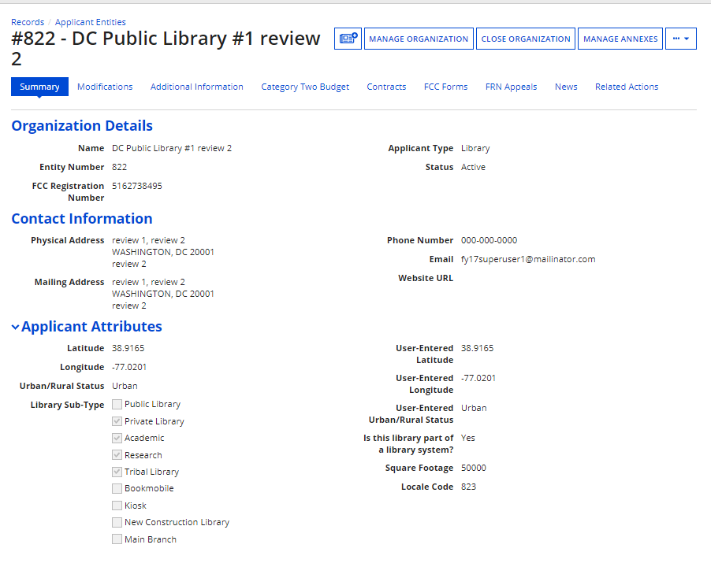
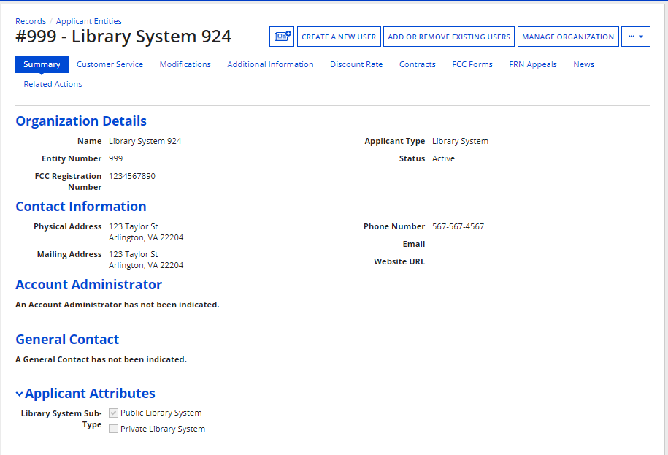
Screenshots of Current Entity Profile (by entity type): We propose, among other things, a modification that only will require district-wide information, as well as simplify how a school district counts its students. We also propose to require library system-wide information, rather than library entity information, such as square footage.
School | School District
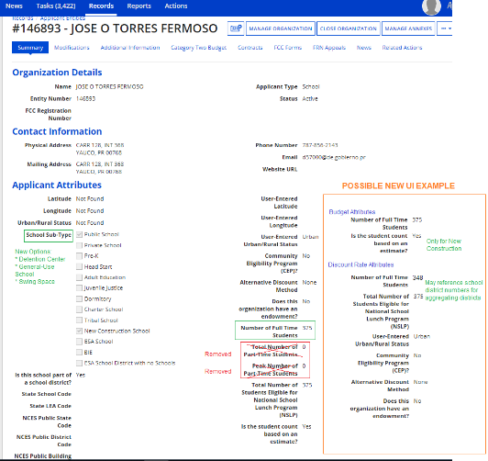 | 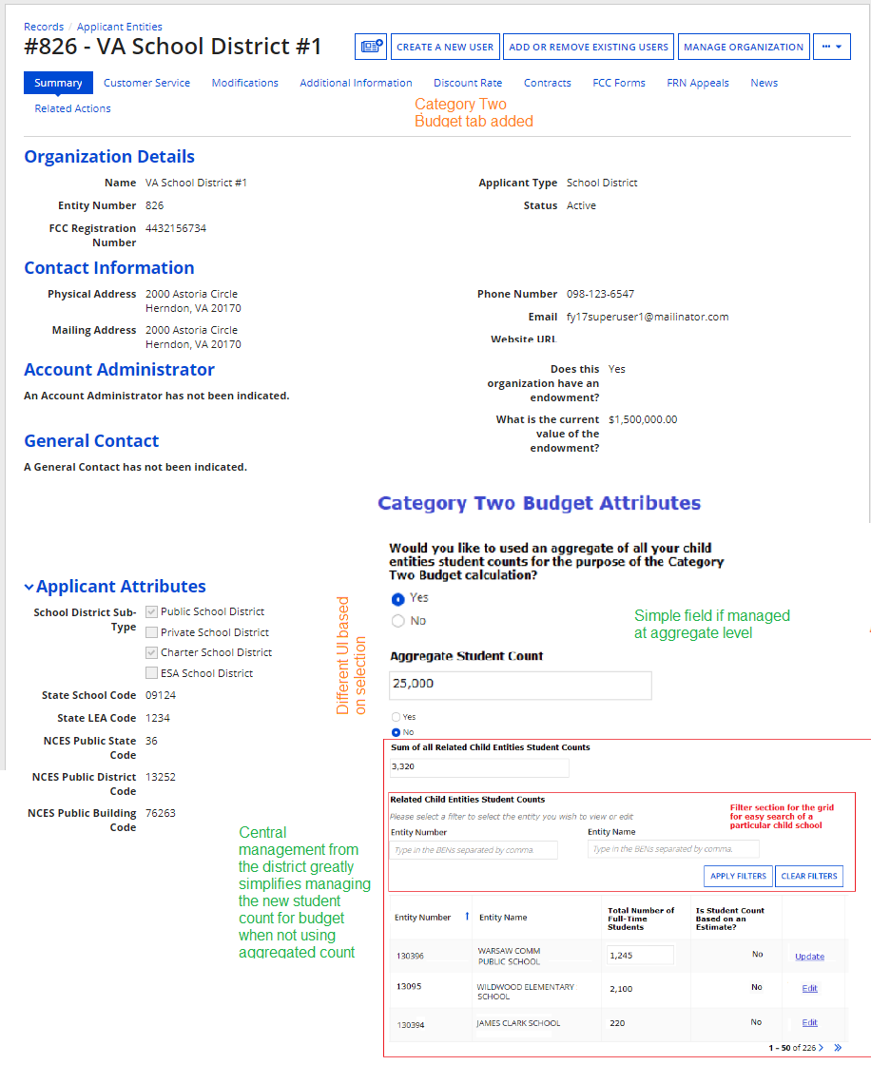
Library | Library System

Screenshot of Current Cost Allocation Screen: Among other modifications, we remove the cost allocation fields for category two recipients of service for non-consortium applicants, as these fields are no longer necessary under the district-wide budgets.
