**OMWI Request for OMB Approval for FID-SA Changes**

**Justification:** FDIC’s Office of Minority and Women Inclusion is revising language on its FID-SA application and the associated PDF download, to clarify privacy information pertaining to its users.

**Change Requests:**

1. Change to FID-SA online application Privacy Language in FID-SA application’s Legal Disclaimer:

* Current FID-SA application Legal Disclaimer (with highlighted language requiring revision)

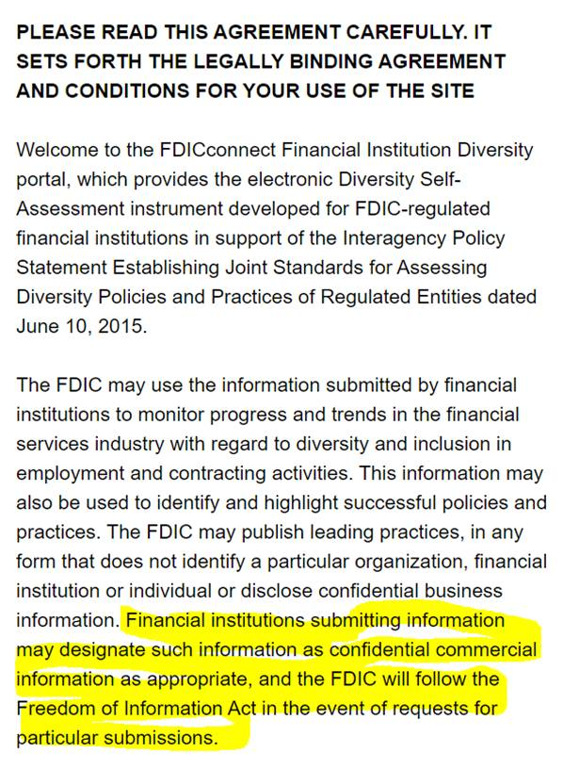

* Revised Paragraph to FID-SA’s online Legal Disclaimer (revised language highlighted):

The FDIC may use information submitted by financial institutions to monitor progress and trends in the financial services industry with regard to diversity and inclusion in employment and contracting activities. This information may also be used to highlight successful policies and practices. The FDIC may publicize leading practices in any form that does not reveal the identity of any organization, financial institution or individual, and does not disclose any confidential business information or trade secrets. The FDIC will treat the information submitted as confidential to the extent permitted by law and will not disclose it unless required by law.

1. Change to FID-SA application Privacy Language contained in PDF Download. See attached redlined and clean copies.