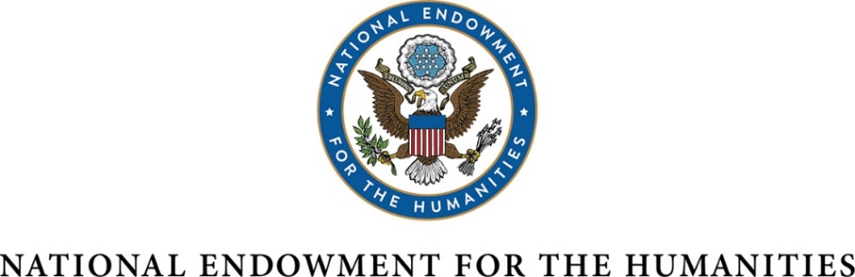

Extension of the Generic Clearance Authority

OMB Control Number 3136-0134

Supporting Statement A

- In his letter to Sally Katzen, Office of Information and Regulatory Affairs, Office of Management and Budget dated February 3, 1994, Sheldon Hackney, then Chairman of the National Endowment for the Humanities (NEH), requested that the authority for reviewing and approving some agency information collection requests under the Paperwork Reduction Act be delegated to NEH. On July 7, 1994, OMB approved a generic clearance authority for all NEH collections of information, excluding surveys, evaluations or other data calls used for policy-making purposes. On July 18, 1997, June 1, 2000, June 24, 2003, June 8, 2006, June 22, 2009, July 17, 2012, June 19, 2015, and June 28, 2018, OMB approved three-year extensions of the generic clearance authority. This submission requests that NEH again be granted a three-year extension of the existing generic clearance authority.

- Currently, NEH has 47 information collection instruments covered under the generic clearance authority.

40 of the 47 information collections are Notices of Funding Opportunities (NOFOs) for NEH grant programs. Each NOFO is aligned with the government wide format and sequencing set forth in Appendix I of 2 CFR 200, and includes instructions on how to prepare an application. Five information collections are instructions used by NEH recipients to submit financial and performance reports, and the remaining information collection is used to recruit peer reviewers.

3. NEH has attained the goal of 100 percent electronic collection of information. Currently, applicants access the agency’s NOFOs from the NEH website (http://www.neh.gov/) or Grants.gov (http://www.grants.gov/). All grant applications are collected electronically via Grants.gov. Reporting instructions are available on the NEH website, and recipients submit reports electronically via eGMS Reach, the agency’s electronic grant management system.

4. The Office of General Council, Office of Grant Management, and Office of the Chairman all participate in an internal clearance process to review NOFOs and publications to ensure that duplication is avoided.

5. Every effort has been made to streamline the application instructions and to simplify the entire process. To ensure uniformity with other federal grantmaking agencies, NEH has aligned the format and sequencing of its NOFOs with Appendix I of 2 CFR 200. The agency's internal clearance process ensures that no undue burden is placed on applicants for NEH funding.

6. The majority of NEH grant competitions have a single annual application deadline, although a few accept proposals multiple times per year.

7. Only one of the exceptions, number three, requiring respondents to submit more than an original and two copies of any document, applies to NEH. OMB has allowed NEH an exception to the three-copy limit to accommodate the agency’s peer review process. In the past it was necessary to require applicants to submit multiple copies of each application, but all submissions are now via Grants.gov. If duplication of the application is necessary, the burden is now on the agency.

8. On January 27, 2021 and April 6, 2021, NEH published notices in the Federal Register to solicit comments from the public on this proposed information collection. The agency received one public comment, dated January 27, 2021, which expressed general concern about the benefit of this information collection to the taxpayer. NEH acknowledged the comment but determined that it did not call for any change to the planned information collection since the opinion expressed was of a general nature and did not pertain to any specific aspects of the information collection.

NEH program staff assemble panels of experts to review submitted proposals for each competition. After the competition, NEH consults these experts regarding the clarity and value of the NOFO. Panelists informally comment on the burden of response required by applicants. In addition, NEH notes and evaluates suggestions for revising NOFOs received from applicants responding to the invitation for comments found in the burden statement contained in each information collection. Efforts are continually being made to shorten and simplify application instructions in response to suggestions made by respondents.

The public may comment on NOFOs during webinars and at presentations by staff at the annual meetings of NEH constituent organizations such as the Modern Language Association, the Organization of American Historians, the American Historical Association, and the PBS Program Fair.

9. No payments or gifts are provided to any of the respondents.

10. NEH includes notice in all its NOFOs in compliance with the Privacy Act.

11. NEH does not solicit information on sexual behavior, religious beliefs, or other personal matters.

12. The estimate of the hour burden for the thirteen collections of information included in the NEH's generic clearance authority is 296,433 hours. We have based this estimate on 6,767 responses from applicants, recipients, and peer reviewers. The hours per response varies among the thirteen collections from thirty minutes for a recipient to complete a form certifying gifts collected to release NEH matching funds, to a maximum of sixty hours for an applicant to prepare an application for funding. Each collection of information contains the required burden statement which estimates the time to complete. The burden estimates have been revised over the years to more accurately reflect the time needed to complete a form or prepare an application.

The annualized cost to the respondents is estimated at $20,975,599 (up from $6,004,182 in 2018). NEH estimates that the total annual reporting hours by respondents is 296,433 (up from 88,815 reported in our 2018 renewal). This increase is largely attributed to a more accurate estimation of the time necessary to complete a grant application from 15 hours to 60 hours; see response to 15 below. In addition, the average wage of respondents has slightly increased since our last submission, and is estimated at $70.76 (previously $67.55).

13. See response to 12. above. The cost estimate is based solely on the cost of the respondent's time to complete the information collection. The two cost components, total capital/start-up and operation/maintenance/purchase of services are not applicable.

14. The annualized cost to NEH is estimated at $1,912,354 (down from $2,111,613 in 2018.) NEH has calculated that 6,767 responses are made per year to the thirteen information collection requests. Approximately four hours are spent by NEH staff reviewing and processing each response at an average hourly wage of $70.65 (6,767 responses x 4 hours x $70.65).

15. The change is an adjustment. This is due to a slight decrease in the anticipated number of respondents from 7,815 to 6,767 annually and an increase in the estimated time per response that more accurately reflects the hours required to complete a grant application. Previously, NEH estimated 15 hours were needed; further study has increased the estimate to 60 hours per proposal. The burden estimate for forms and reporting requirements has not changed.

16. Not applicable.

17. Not applicable

18. Not applicable.

B. Collections of Information Employing Statistical Methods

NEH information collections covered by this clearance do not employ statistical methods.

