Non-substantive Change Request for the Custom Works Survey
OMB docket number - 0535-0266

The National Agricultural Statistics Service (NASS) is submitting a non-substantive change request for the addition of breakout questions for hay bailing and silage bagging. NASS received a request from the Wisconsin Department of Agriculture, Trade and Consumer Protection to collect and publish this information for future custom rates surveys. In addition, respondents for the 2020 Wisconsin survey requested to make the questionnaire easier to respond.

Included in this change request is to remove the predefined weights of bales to accommodate different bale weights (the ??? below) in States.

The new questions that will be added to Section 6 of the questionnaire are:
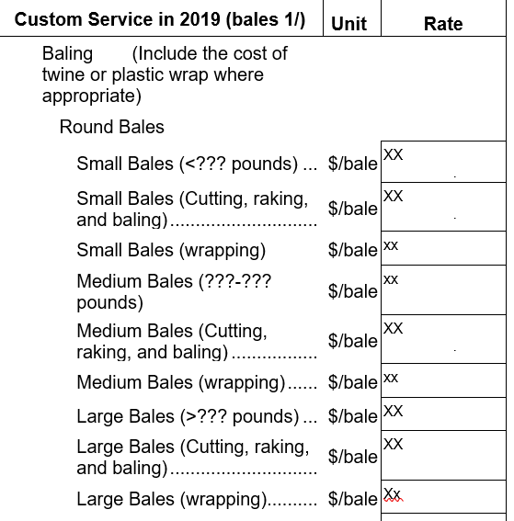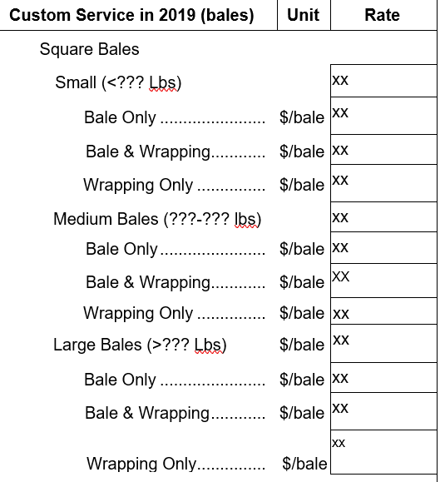

The new questions that will be added to Section 9 of the questionnaire are:
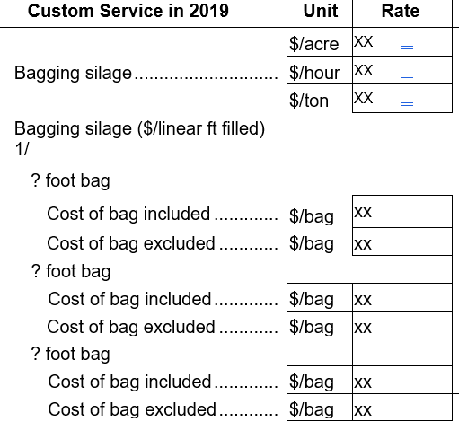

In addition, the CIPSEA reference on the first page was updated to reflect the current 2018 law.

There will be no changes to the sample size, survey methodology, or overall respondent burden because of this non-substantive change.

