H7. Child Food Diary
This page has been left blank for double-sided copying.

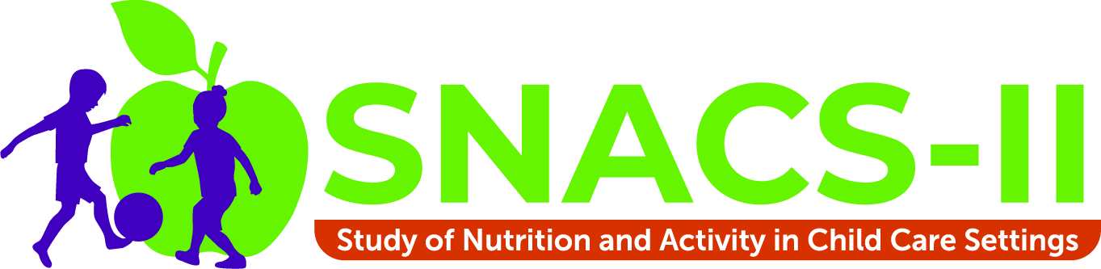
OMB Number: 0584-xxxx
Expiration Date: xx/xx/20xx

Child Food Diary

As part of the second Study of Nutrition and Activity in Child Care Settings, we will ask you [and your child] questions about the foods and drinks your child had on the day before the interview.

Completing the Child Food Diary in advance will help make the interview a little easier for you. It should take about 10 minutes to complete. You do not need to return the completed Child Food Diary.

Directions

On the day before the interview, please write down on the Child Food Diary everything your child eats and drinks outside of child care. Be sure to record everything your child had for breakfast, lunch, dinner, and snacks while at home or elsewhere when they were not in child care. We will talk with your child care provider about the food they provided to your child. So, do not include foods provided by the child care provider. However, if you sent any foods or drinks with your child to child care, please be sure to record these items.

[For AR/OSHCCs only: If your child attended school (in addition to child care), be sure to record these foods on the Child Food Diary. Please ask your child to tell you about all foods and drinks they had while at school.] If needed, talk with others who may have served foods and drinks to your child when your child was not in child care. Here is what you need to record in the Child Food Diary:

- Date. Write down which date you are recording the foods and drinks for your child. For example, if your interview is scheduled for [DATE], the Child Food Diary should be a recording of all foods and drinks eaten by your child on [DATE].

- Did your child attend child care on this day? Circle either “Yes” or “No” to indicate if your child went to child care on the day for which you are completing the Child Food Diary.

- When did your child eat or drink? Write down the time and/or name of the meal for each food or drink.

- What did your child eat or drink? Write down one food or drink per line. Include all foods and drinks your child had, including water.

- How much did your child eat or drink? Record the quantity of each food and drink that your child had. Record the quantity using household measures such as cups, bowls, plates, or number of items (such as ¼ cup, ½ piece, 2 slices, etc.)
The top section of the Child Food Diary includes some examples to show you the type of information you should record.

Date: ___/___/2023 Did your child attend child care on this day? (circle one) Yes No

REMINDER
- Do include foods and drinks your child had for breakfast, lunch, dinner, and snacks while at home or elsewhere when they were not in child care.
- Do include foods and drinks you sent with your child to child care.
- Do not include foods and drinks provided by the child care provider.

Time and/or name of meal (breakfast, lunch, dinner, snack) | What did your child eat or drink? | How much did your child eat or drink?
Example:
7:30 AM - Breakfast | Waffle | 2 small waffles
7:30 AM - Breakfast | Banana | ½ medium banana
7:30 AM - Breakfast | 2% milk | ½ cup
5:30 PM - Dinner | Cheese sandwich | ½ sandwich
5:30 PM - Dinner | Pear slices | 4 slices

Date: ___/___/2023 Did your child attend child care on this day? (circle one) Yes No

REMINDER
- Do include foods and drinks your child had for breakfast, lunch, dinner, and snacks while at home or elsewhere when they were not in child care.
- Do include foods and drinks you sent with your child to child care.
- Do not include foods and drinks provided by the child care provider.

Time and/or name of meal (breakfast, lunch, dinner, snack) | What did your child eat or drink? | How much did your child eat or drink?
Example:
7:30 AM - Breakfast | Waffle | 2 small waffles
7:30 AM - Breakfast | Banana | ½ medium banana
7:30 AM - Breakfast | 2% milk | ½ cup
5:30 PM - Dinner | Cheese sandwich | ½ sandwich
5:30 PM - Dinner | Pear slices | 4 slices

Date: ___/___/2023 Did your child attend child care on this day? (circle one) Yes No

REMINDER
- Do include foods and drinks your child had for breakfast, lunch, dinner, and snacks while at home or elsewhere when they were not in child care.
- Do include foods and drinks you sent with your child to child care.
- Do not include foods and drinks provided by the child care provider.

Time and/or name of meal (breakfast, lunch, dinner, snack) | What did your child eat or drink? | How much did your child eat or drink?
Example:
7:30 AM - Breakfast | Waffle | 2 small waffles
7:30 AM - Breakfast | Banana | ½ medium banana
7:30 AM - Breakfast | 2% milk | ½ cup
5:30 PM - Dinner | Cheese sandwich | ½ sandwich
5:30 PM - Dinner | Pear slices | 4 slices

