H11. Parent Interview for ASA24 Only

This page has been left blank for double-sided copying.

OMB Number: 0584-XXXX
Expiration Date: XX/XX/20XX

Study of Nutrition and Activity in Child Care Settings II (SNACS-II)

Parent Interview for ASA24 Only (Out-of-Care Day or Usual Intake Subsample)

The Food and Nutrition Service (FNS) is collecting this information to understand the nutritional quality of CACFP meals and snacks, the cost to produce them, and dietary intakes and activity levels of CACFP participants. This is a voluntary collection and FNS will use the information to examine CACFP operations. The collection does request personally identifiable information under the Privacy Act of 1974. Responses will be kept private to the extent provided by law and FNS regulations. According to the Paperwork Reduction Act of 1995, an agency may not conduct or sponsor, and a person is not required to respond to, a collection of information unless it displays a valid OMB control number. The valid OMB control number for this information collection is 0584-xxxx. The time required to complete this information collection is estimated to average 0.5 hours (30 minutes) per response, including the time for reviewing instructions, searching existing data sources, gathering and maintaining the data needed, and completing and reviewing the collection of information. Send comments regarding this burden estimate or any other aspect of this collection of information, including suggestions for reducing this burden, to: U.S. Department of Agriculture, Food and Nutrition Service, Office of Policy Support, 1320 Braddock Place, 5th Floor, Alexandria, VA 22314. ATTN: PRA (0584-xxxx). Do not return the completed form to this address.

INTRODUCTION
VOICEMAIL SCRIPT: Hello, this message is for [CONSENTED PARENT NAME]. This is [INTERVIEWER NAME] from the second Study of Nutrition and Activity in Child Care Settings, or SNACS-II. We had scheduled an interview appointment with you for [date, time]. Please call our toll-free number, [insert #], today to reschedule the interview appointment with [you/you and CHILDNAME]. The interview will take no more than 30 minutes. After [you/you and [CHILDNAME] complete the interview, we will send you a $30 gift card. We look forward to speaking with you today.
INTRO: Hello, my name is [INTERVIEWER NAME] from Westat. I am calling about the second Study of Nutrition and Activity in Child Care Settings. May I please speak to [CONSENTED PARENT NAME]?
- RESPONDENT ON PHONE GO TO CONSENT
- NEW RESPONDENT COMES TO PHONE [REPEAT INTRO]
- RESPONDENT NOT AVAILABLE [SCHEDULE CALLBACK]
- WRONG NUMBER [DISPO AS WRONG NUMBER – PERSON]
- GATEKEEPER REFUSAL [SOFT REFUSAL]
- DO NOT WISH TO PARTICIPATE I’m sorry to hear that you do not wish to participate. The information you would have provided is very valuable to improving the program. Can you tell me the reason for choosing not to participate? ADDRESS ISSUES/CONCERNS ABOUT STUDY, IF NEEDED. CODE AS REFUSAL

CONSENT: Thank you for agreeing to continue in the second Study of Nutrition and Activity in Child Care Settings.
IF DATA RETRIEVAL INTERVIEW ONLY: I would like to get the details about the foods and drinks [CHILDNAME] had [DAY] that you were unable to report during our earlier call [IF SECTIONS B-F INCOMPLETE: and then ask you about [CHILDNAME]’s physical activity and some general information about your household]. GO TO Q1
IF DATA RETRIEVAL AND 2ND ICD INTERVIEW: I would like to get the details about the foods and drinks [CHILDNAME] had [DAY] that you were unable to report during our earlier call, and then ask you about what [CHILDNAME] had to eat and drink yesterday. [IF SECTIONS B-F INCOMPLETE: I will also ask you about [CHILDNAME]’s physical activity and some general information about your household]. You will receive a $20 gift card to thank you for completing the interview from [yesterday/(DAY)] and another $30 gift card for completing today’s interview. GO TO Q1
IF 2nd ICD INTERVIEW: I understand that your child went to [Center/Provider/Afterschool Program] [yesterday/(DAY)]. I would like to ask you some questions about what [CHILDNAME] had to eat and drink [yesterday/(DAY)]. [IF SECTIONS B-F INCOMPLETE: I will also ask you about [CHILDNAME]’s physical activity and some general information about your household]. You will receive a $30 gift card to thank you for your participation. GO TO Q1
IF OCD INTERVIEW: I would like to ask you some questions about what [CHILDNAME] had to eat and drink [yesterday/(DAY)] [IF SECTIONS B-F INCOMPLETE: and about [CHILDNAME]’s physical activity and some general information about your household]. You will receive a $30 gift card to thank you for your participation.
This interview is voluntary. That means you can skip any question and you can stop at any time. Taking part in this study will not affect your benefits in any way – either now or in the future. Your information will be kept private and used only for research purposes according to state and federal law. We will not include information that identify you or your family members in any report. The responses of all parents taking part in the study will be combined for reporting purposes. GO TO Q1
IF ICD NOT COMPLETE (AND NO LONGER POSSIBLE), SCHEDULE OCD: We tried to contact you [last week/a few weeks ago] for the second Study of Nutrition and Activity in Child Care Settings. We are interested in completing the parent interview with you and to gather information in what [CHILDNAME] ate on a day when [CHILDNAME] did not attend childcare at [Center/Provider/ Afterschool program].The interview will take no more than 30 minutes and we will pay you $30 after the interview. GO TO CONCLUSION QUESTION C4.

- I would like to start by asking about foods and drinks [CHILDNAME] had …
IF DR INTERVIEW ONLY OR IF 2ND ICD OR OCD INTERVIEW ONLY: [yesterday/(DAY)].
IF DR AND 2ND ICD INTERVIEW: on [DAY] and then ask about foods and drinks (she/he)] had [yesterday/(DAY)].
[IF CHILD ATTENDS AR/OSHCC: You may wish to have [CHILD NAME] participate in the first part of the interview with you, if [she/he] can provide details about what [she/he] had to eat and drink [yesterday/(DAY)]. Do you have the details about what [CHILDNAME] had to eat and drink [yesterday/(DAY)] on your Child Food Diary?
- Yes GO TO Q1.1
- No IF CHILD ATTENDS AR/OSHCC: GO TO Q1.2; ELSE GO TO Q1.3

  - And do you have your Child Food Diary with you? I will wait while you get it.
- Yes GO TO Q2
- No IF CHILD ATTENDS AR/OSHCC: GO TO Q1.2; ELSE GO TO Q1.3

  - Is [CHILDNAME] available now to assist with the interview?
- Yes GO TO Q2
- No GO TO Q1.3

  - Are you able to tell me about foods and drinks [CHILDNAME] had [yesterday/(DAY)]?
- Yes GO TO Q2
- No Because you don’t have the information about foods and drinks [CHILDNAME] had [IF DR AND 2ND ICD INTERVIEW: on (DAY) and] [yesterday/(DAY)] [IF CHILD ATTENDS AR/OSHCC: and [CHILDNAME] is not available to help with the interview], we can reschedule the interview for later. GO TO CONCLUSION

- Do you have any questions about the interview before I begin?
- Yes ADDRESS QUESTIONS/CONCERNS ABOUT STUDY, THEN PROCEED.
- No

SECTION A: ASA24

IF DR INTERVIEW: I would like to [collect/start by collecting] the details about the foods and drinks [CHILDNAME] had on [DAY] that you could not report during our earlier call.
PROGRAMMER: LAUNCH ASA24 FOR DR INTERVIEW; THEN IF 2ND ICD OR OCD INTERVIEW BEING COLLECTED, CONTINUE; ELSE GO TO CONCLUSION.
IF NOT DR INTERVIEW: I would like to ask about what [CHILDNAME] had to eat and drink [yesterday/(DAY)]. Please use the information you recorded on the Child Food Diary to remind you of the foods and drinks [CHILDNAME] had [yesterday/(DAY)].
[IF 2ND ICD INTERVIEW: Since we observed the foods and beverages [CHILDNAME] had while at [Center/Provider/Afterschool Program], you do not need to report anything that [Center/Provider/Afterschool Program] provided. But, if [CHILDNAME] brought any foods or drinks from home to [Center/Provider/Afterschool Program], please be sure to tell me about them.] Please include all foods eaten at home, [IF CHILD ATTENDS AR/OSHCC: while at school – including foods brought from home to school, as well as foods] shared by friends, purchased at the store, a fast food place, or restaurant.
To help you report the amounts of foods and beverages that [CHILDNAME] had [yesterday/(DAY)], I may ask you to look at the pictures in the Food Model Booklet, or you can use your own measuring cups and spoons. Do you have the Food Model Booklet ready to help with the interview?
- Yes
- No Do you have your own measuring cups and spoons available to help with the interview?
- Yes I will wait a few minutes while you get them.
- No That is fine, we can still do the interview now.

LAUNCH ASA24

Exhibit A: Meal-based Quick List Screenshot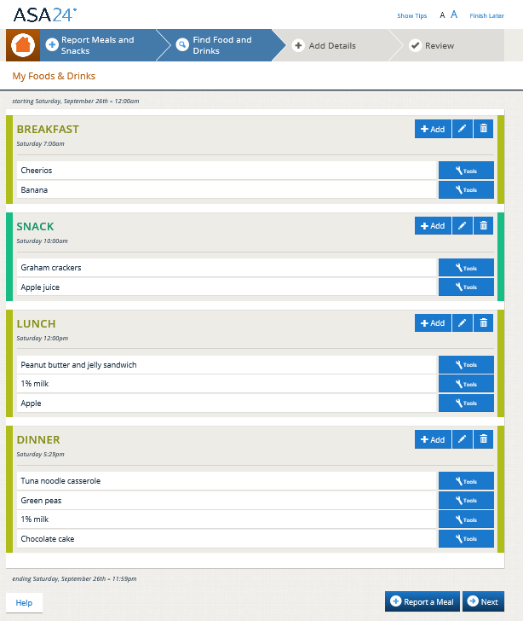
Exhibit B. Detail Screenshot (Example question)
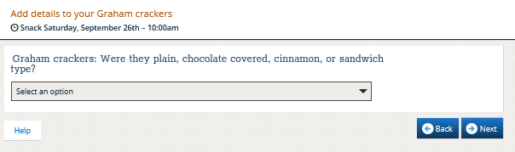
Exhibit C. Review Screenshot
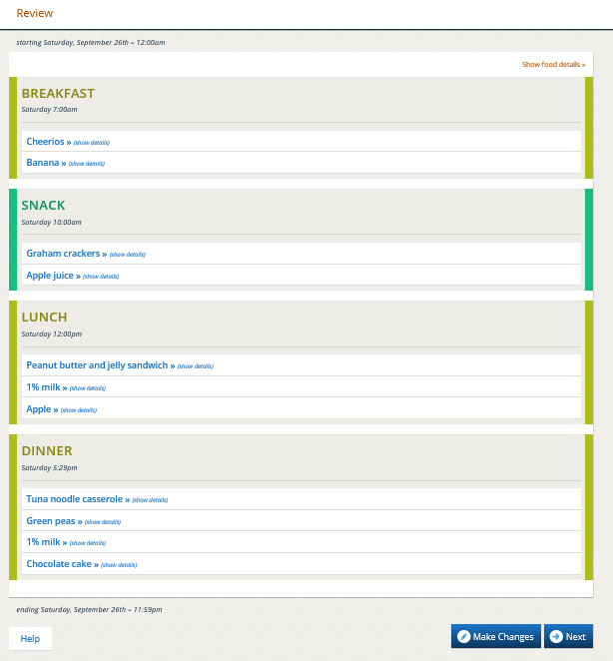

Exhibit D. Forgotten Foods List Screenshot (Example question)
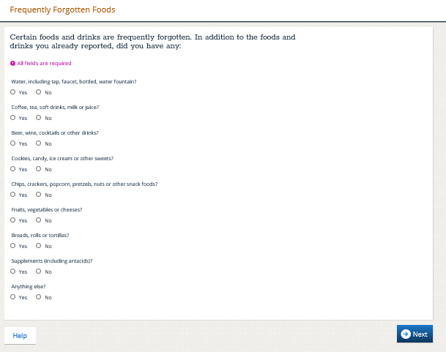
Exhibit E. Usual Amount Screenshot
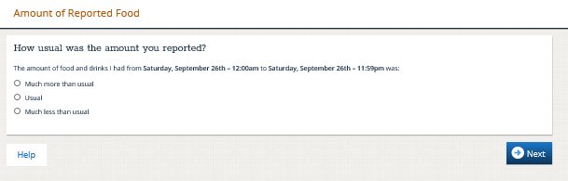

INTERVIEWER: NEEDS DATA RETRIEVAL?
- No
- Yes

INTERVIEWER: RECORD WHO COMPLETED THE ASA24:
- Parent only
- Child and parent together
- Child only

PROGRAMMER: IF SECTIONS B-F FROM 1ST ICD PARENT INTERVIEW ARE NOT COMPLETE, LAUNCH SECTIONS B-F.
GO TO CONCLUSION

CONCLUSION

BOX 1
IF ASA24 NOT COMPLETE GO TO C1
IF ASA24 COMPLETE, AND ADDITIONAL INTERVIEWS SCHEDULED GO TO C3 (UPCOMING INTERVIEWS)
IF ASA24 COMPLETE, NO ADDITIONAL INTERVIEWS SCHEDULED, AND 2nd OUT OF CARE USUAL INTAKE NEEDED GO TO C4 (SCHEDULE 2ND OUT OF CARE INTERVIEW)
IF ASA24 COMPLETE, NO ADDITIONAL INTERVIEWS SCHEDULED OR NEEDED GO TO THANK YOU

DATA RETRIEVAL
- [IF ASA24 WAS STARTED BUT NOT COMPLETE: You have just given us valuable information for this study.] Since you were not able to provide the details about the foods and drinks [CHILDNAME] had [yesterday/(day)], please get this information and I can call you back. [IF CHILD ATTENDS AR/OSHCC: You may wish to have [CHILDNAME] participate in the interview with you, if [she/he] can provide details about what [she/he] had to eat and drink [yesterday/(DAY)]. [IF SECTIONS B-F NOT COMPLETE: We can also complete the rest of today’s interview at that time.]. Should I call you later today or tomorrow?
- YES
- CALL BACK TODAY GO TO C2
- CALL BACK TOMORROW (AUTO FILL DATE) GO TO C2
- NO (PARENT NOT AVAILABLE FOR CALL BACK LATER TODAY OR TOMORROW) This interview will take no more than 10 minutes. When is the earliest we can call you to complete this interview?
- DATE [WITHIN 3 DAYS OF INTERVIEW]: ______________ GO TO C2
- IF DATE 3 DAYS AFTER INTERVIEW GO TO BOX 2

- What time would you like us to call?
Time: ______________□ AM □ PM

Great, thank you. We will call you then. Before I let you go…

BOX 2
IF ADDITIONAL INTERVIEWS SCHEDULED GO TO C3 (UPCOMING INTERVIEWS)
IF NO ADDITIONAL INTERVIEWS SCHEDULED, AND 2nd OUT OF CARE USUAL INTAKE NEEDED GO TO C4 (SCHEDULE 2ND OUT OF CARE INTERVIEW)
IF NO ADDITIONAL INTERVIEWS SCHEDULED OR NEEDED GO TO THANK YOU
UPCOMING INTERVIEWS:
- It looks like you are scheduled to talk with us on [DATE] about what [CHILDNAME] ate and drank on [DATE]. This interview will take no more than 30 minutes and you will receive [IF FIRST ICD INTERVIEW: $20; IF 2ND ICD OR OCD INTERVIEW: $30] after you complete the interview. Is this still a good day and time to call you?
- YES
- NO When is a good day and time to call you?
- RESCHEDULE DATE
DATE:
- RESCHEDULE TIME
TIME: _______________ AM PM
- REFUSED I’m sorry to hear that you no longer wish to participate. The information you would have provided is very valuable to improving the program. Can you tell me the reason for choosing not to participate? ADDRESS ISSUES/CONCERNS GO TO REFUSAL CONVERSION

IF 2nd OUT OF CARE USUAL INTAKE NEEDED GO TO SCHEDULE 2ND OUT OF CARE INTERVIEW
IF NO ADDITIONAL INTERVIEWS SCHEDULED OR NEEDED GO TO C7

SCHEDULE 2nd OUT OF CARE INTERVIEW
I see here that you have also been selected for an additional interview about what [CHILDNAME] ate and drank on a day when she/he did not attend child care. This will take no more than 30 minutes and you will receive $30 after you complete the interview.
- Thinking about the next two weeks, when will your child not attend child care?
- Day: ______________ Date: __________
- Day: ______________ Date: __________
- Day: ______________ Date: __________
- Day: ______________ Date: __________
- Day: ______________ Date: __________
- Day: ______________ Date: __________
- Day: ______________ Date: __________
- Based on what you just told me, we would like to call you on: [ONE DAY AFTER FIRST AVAILABLE DAY AND DATE]
Does this work for you?
- YES GO TO C6
- NO GO TO ONE DAY AFTER NEXT AVAILABLE DAY AND IDENTIFY THE DAY THAT WORKS BEST.
DATE: ___ / ___ / ______ GO TO C6
- REFUSED I’m sorry to hear that you no longer wish to participate. The information you would have provided is very valuable to improving the program. Can you tell me the reason for choosing not to participate? GO TO THANK YOU

- What time should we call you?
Time: ______________□ AM □ PM
- Thank you. I have it here that we will be talking with you soon on [NEXT INTERVIEW DATE]. And is this [###-###-####] still the best number to reach you?
- YES
- NO What number should I call you at?
Telephone number: ___-___-____.
- May we also send you a text message reminder at this telephone number?
- YES
- NO Do you have a number we can use for a text message reminder?
- YES Telephone number: ___-___-____.
- NO May we send you an email remainder for your next interview at [EMAIL, IF EMAIL ADDRESS PROVIDED IN CONSENT]?
YES Email address:_______________
NO Since we are not able to send you a reminder, please remember that we will call you at [DATE, TIME].
IF RESPONSE TO PARENT INTERVIEW Q1.3 = NO GO TO C9; OTHERWISE GO TO CHILD FOOD DIARY REMINDER.
- Would you like me to send you the Child Food Diary at [EMAIL ADDRESS] before the next interview?
- YES GO TO CHILD FOOD DIARY REMINDER
- NO
- Send to a different email address: _______________________ GO TO CHILD FOOD DIARY REMINDER
- Not needed. To use your own paper, please be sure to record the time of day and/or the meal or snack at which your child had the food or drink, the name of the food or drink, and the amount your child had. GO TO CHILD FOOD DIARY REMINDER

CHILD FOOD DIARY REMINDER
Great, thank you. The study team will send you a reminder about this interview and to complete the Child Food Diary at [TELEPHONE NUMBER FROM C7/C8 OR EMAIL ADDRESS FROM C8].
IF ICD INTERVIEW IS SCHEDULED: As a reminder, you do not need to include any foods or drinks provided by [Center/Provider/Afterschool Program]. But, if [CHILDNAME] brought any foods or drinks from home to [Center/Provider/Afterschool Program], please be sure to write them down.
Please write down all foods eaten at home, [IF CHILD ATTENDS AR/OSHCC: while at school – including foods brought from home to school,] shared by friends, purchased at the store, fast food place, or restaurant.
If needed, talk with others who may have served foods and drinks to your child when your child was not in child care. [IF CHILD ATTENDS AR/OSHCC: You may wish to have [CHILDNAME] participate in the interview with you, if [she/he] can provide details about what [she/he] had to eat and drink [yesterday/(DAY)].

THANK YOU

I would like to confirm your mailing address so that we can send you [IF DR AND 2ND ICD INTERVIEW: the $20 gift card for completing your first interview and $30 for completing this second interview] [IF 2ND ICD INTERVIEW OR OCD INTERVIEW: a $30 gift card]. The address I have is: [ADDRESS]. Is this correct?
- YES
- NO What is your current address?
PROBE: Is there an apartment number?
PROBE: This is where we will mail your gift card.
STREET 1: ___________________________________________________
STREET 2: ___________________________________________________
APT. #: ________________
CITY: ___________________________________________
STATE: ________________ (SELECT FROM DROP DOWN)
ZIP: _________________________
Thank you for participating in this important study.

REFUSAL CONVERSION

I’m sorry to hear that you do not wish to participate. The information you would have provided is very valuable to improving the program. Can you tell me the reason for choosing not to participate?

IF: I don’t do surveys/don’t want my child to participate in a study.
ANSWER: I understand, but this study will help the U.S. Department of Agriculture understand the food and activities provided in child care settings. The results will help improve the program.

IF: I don’t know if you are who you say you are.
ANSWER: I can give you our 800 number to call and confirm the authenticity of the study.

IF: I don’t know how the results will be used.
ANSWER: The U.S. Department of Agriculture needs to periodically assess programs funded by the government. This study will help them understand the food and activities provided in child care settings, and this information may help improve child care programs.

IF: I don’t want the government to know about me/my child.
ANSWER: Researchers and program staff must follow all federal and state laws to protect your privacy. Study reports will combine your answers with those from others to summarize what we found. We will never report names or addresses. This way, no one can identify you, your child, or your child care provider.

IF: It's a bad time.
ANSWER: We can schedule a callback for a time that would be good for you.
Date _____________ Time _____________________

IF STILL HESITANT: [SAMPLED SITE NAME] is one of about 1,300 child care providers across the country that are helping USDA understand the food and activities provided in child care settings. We want to be sure that the study includes people like yourself, to ensure that the study findings are fair and accurate. We really want to include your household in the study. If now is a bad time, we can schedule the interview during the day or in the evening, any time that is better for you.

IF RESPONDENT AGREES TO PARTICIPATE, RESUME INTERVIEW
IF STILL REFUSES, THANK AND COMPLETE

Authority: This information is being collected under the authority of the Healthy, Hunger-Free Kids Act of 2010 (P. L. 111-296), Section 305.
Purpose: The Food and Nutrition Service (FNS) is collecting this information to evaluate the nutritional quality of Child and Adult Care Food Program (CACFP) meals and snacks, the cost to produce them, and dietary intakes and activity levels of CACFP participants.
Routine Use: The records in this system may be disclosed to private firms that have contracted with FNS to collect, aggregate, analyze, or otherwise refine records for the purpose of research and reporting to Congress and appropriate oversight agencies, and/or departmental and FNS officials.
Disclosure: Disclosing the information is voluntary, and there are no consequences to you as an individual participant in the CACFP for not providing the information.
The System of Records Notice for this information collection is USDA/FNS-8, FNS Studies and Reports, which can be located at https://www.govinfo.gov/content/pkg/FR-1991-04-25/pdf/FR-1991-04-25.pdf (p. 19078).

These are programming notes. On screen this will take the interviewer to the correct screen.

