Attachment G.4: Telephone Script for Focus Group Confirmation

OMB Control Number: 0584-0524
Expiration Date: 12/31/2022

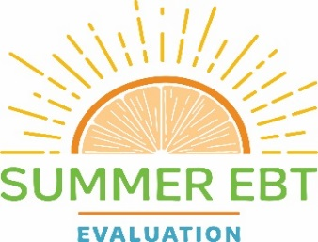

SFA Liaison: Hello! Is this [Focus Group Participant’s Name]? Congratulations! You were selected to participate in the 2019-2022 Summer EBT Evaluation Focus Group, which is part of the United States Department of Agriculture (USDA) Food and Nutrition Service (FNS) 2019-2022 Summer EBT Evaluation. We very much look forward to speaking with you on [SCHEDULED TIME AND DATE AND LOCATION].

You are one of a small group of parents or caregivers who has been asked to share your knowledge and experience of participating in Summer EBT.

During the focus group we will ask questions about your family’s experiences with Summer EBT —topics such as using the benefit card, how you learned about Summer EBT, and how to improve Summer EBT. You will receive a $25 Visa gift card to help cover any transportation and/or childcare costs.

We greatly appreciate your support of this study and look forward to seeing you on [SCHEDULED DATE AND TIME AND LOCATION].

Pandemic Note: We will participate with appropriate social distancing protocols in place, or you may choose to attend virtually via this link: <WEBEX INFORMATION>

Do you have any questions for us? Thank you again for agreeing to participate.

The Food and Nutrition Service (FNS) is conducting this study to obtain information about the experiences of the Summer Electronic Benefit Transfer (EBT) Project by grantees, retailers, school districts and participants. Participation in this study is voluntary and the information collected will be used to understand how Summer EBT projects are implemented in varying settings. This study does not collect personally identifiable information. Information collected in this study will be kept private to the full extent permitted by law. According to the Paperwork Reduction Act of 1995, an agency may not conduct or sponsor, and a person is not required to respond to, a collection of information unless it displays a valid OMB control number. The valid OMB control number for this information collection is 0584-0524. The time required to provide this information collection is estimated to average 5 minutes per response, including the time to review instructions, search existing data resources, gather and maintain the data needed, and complete and review the collection of information. Send comments regarding this burden estimate or any other aspect of this collection of information, including suggestions for reducing this burden, to: USDA/Food and Nutrition Service, Office of Policy Support, 1320 Braddock Place, 5th Floor, Alexandria, VA 22314 ATTN: PRA (0584-0524).

