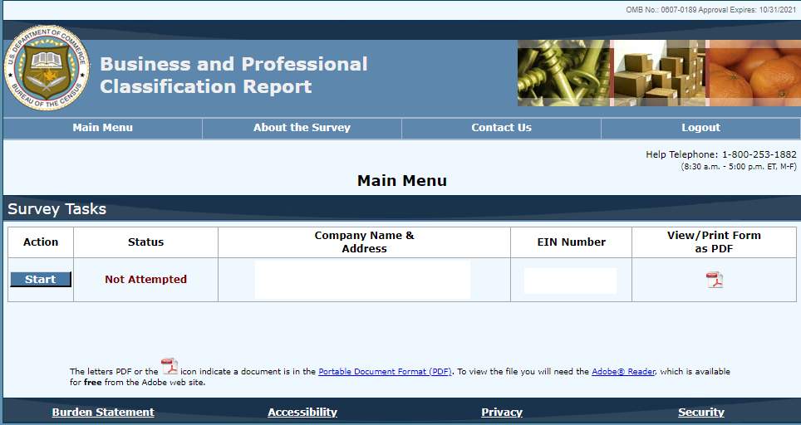

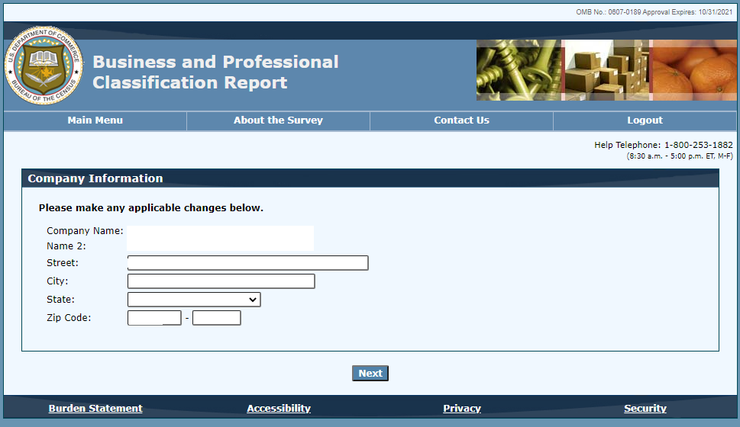

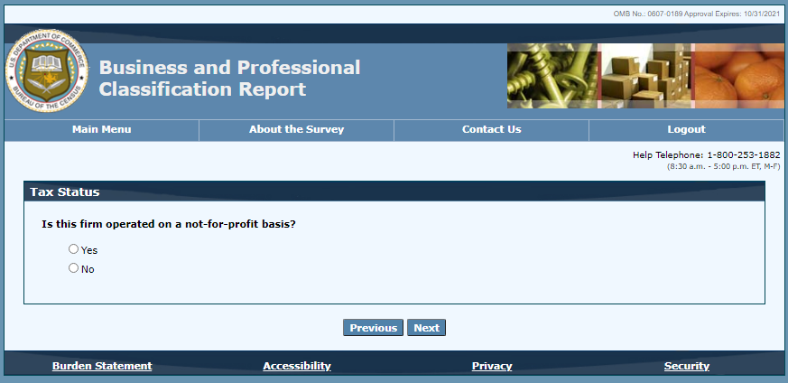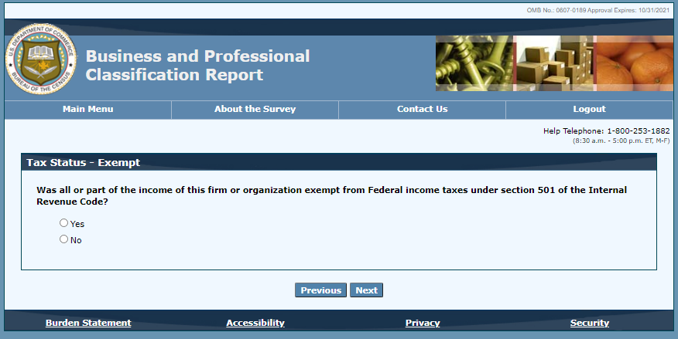

**PLEASE NOTE THAT ONLY ESTABLISHMENTS THAT SELECT RETAIL TRADE, WHOLESALE, MANUFACTURING WILL BE DIRECTED TO THE ABOVE SCREEN**



