InPort Screenshots (13 Pages)
Form 1: Data Set Identification
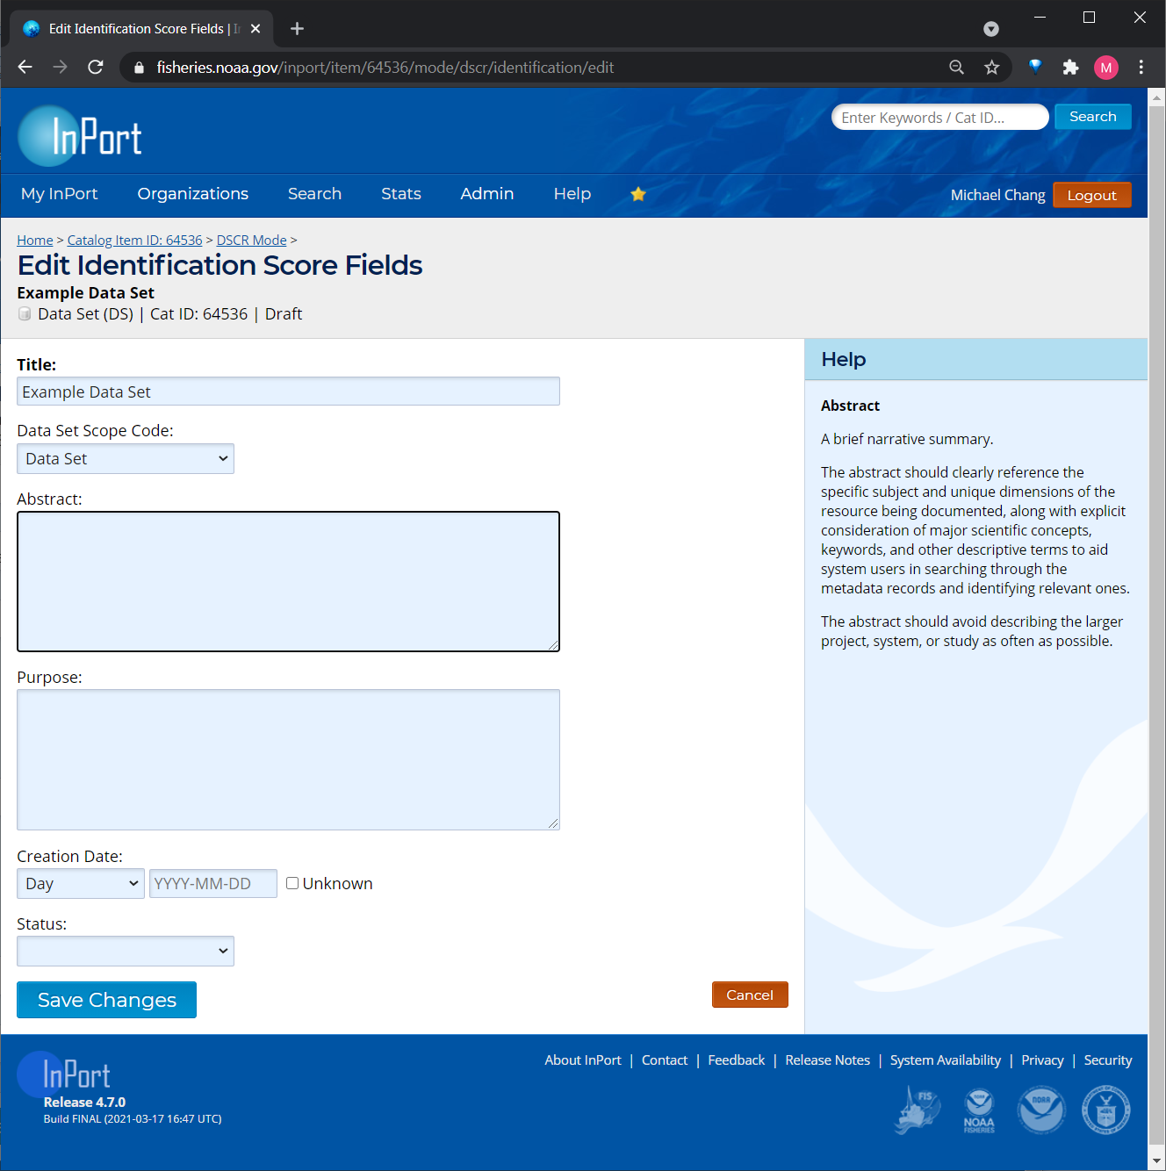
A Federal agency may not conduct or sponsor, and a person is not required to respond to, nor shall a person be subject to a penalty for failure to comply with an information collection subject to the requirements of the Paperwork Reduction Act of 1995 unless the information collection has a currently valid OMB Control Number. The approved OMB Control Number for this information collection is 0648-0024. Without this approval, we could not conduct this information collection. Public reporting for this information collection is estimated to be approximately 2.5 hours per response, including the time for reviewing instructions, searching existing data sources, gathering and maintaining the data needed, and completing and reviewing the information collection. All responses to this information collection are voluntary. Send comments regarding this burden estimate or any other aspect of this information collection, including suggestions for reducing this burden to the NMFS, Michael.chang@noaa.gov. Geospatial metadata is requested in accordance with Executive Order 12906 and NOAA Administrative Order 212-5.

Form 2: Keywords
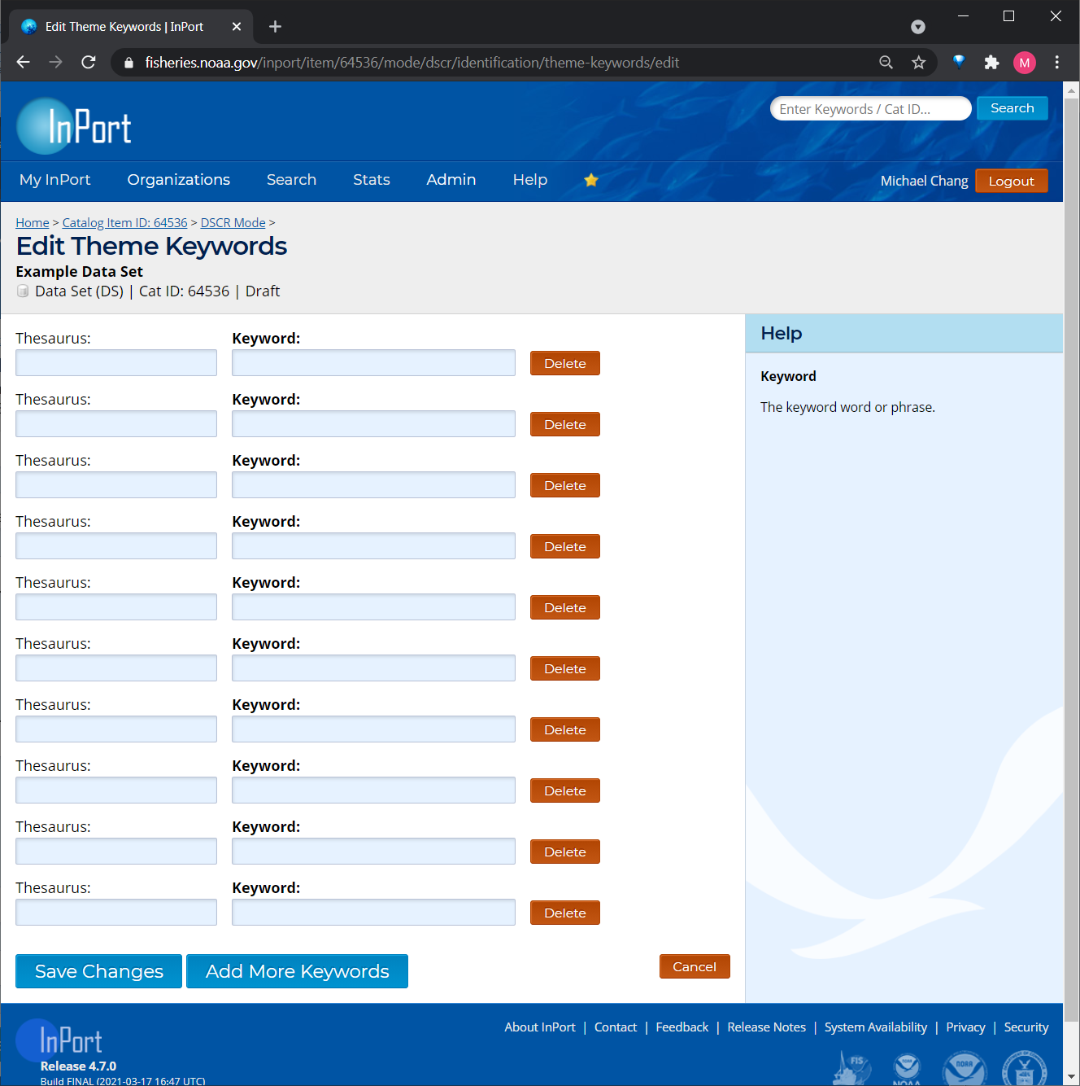

Form 3: Access
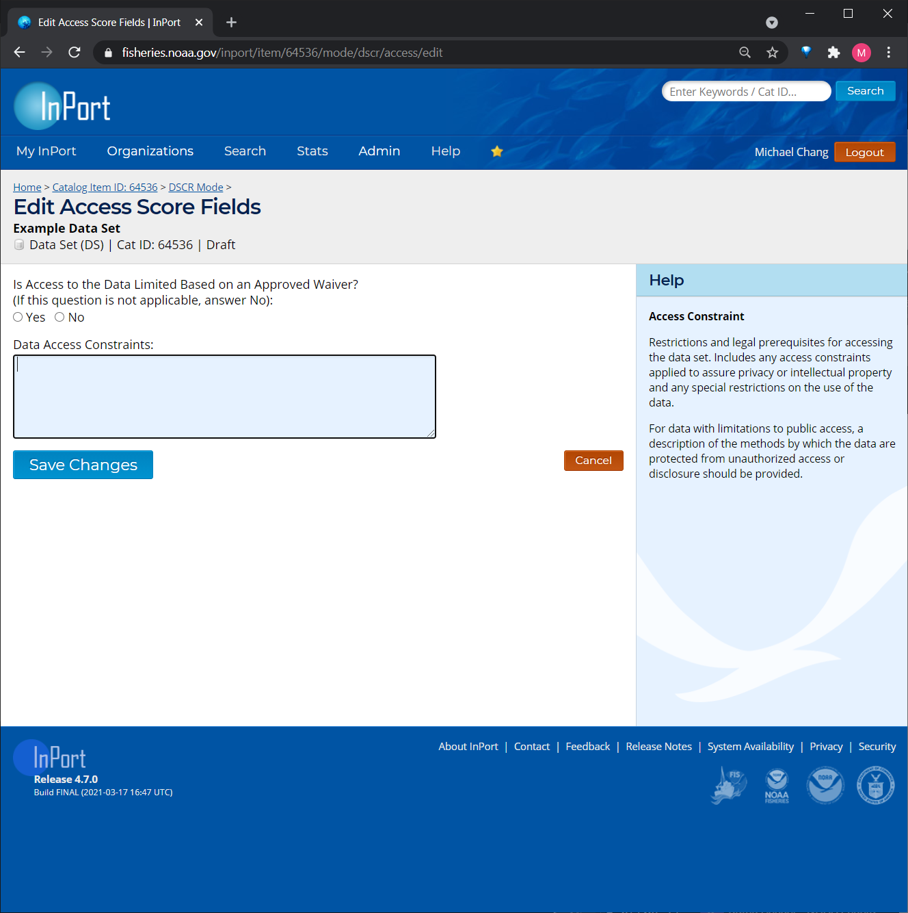

Form 4: Distribution
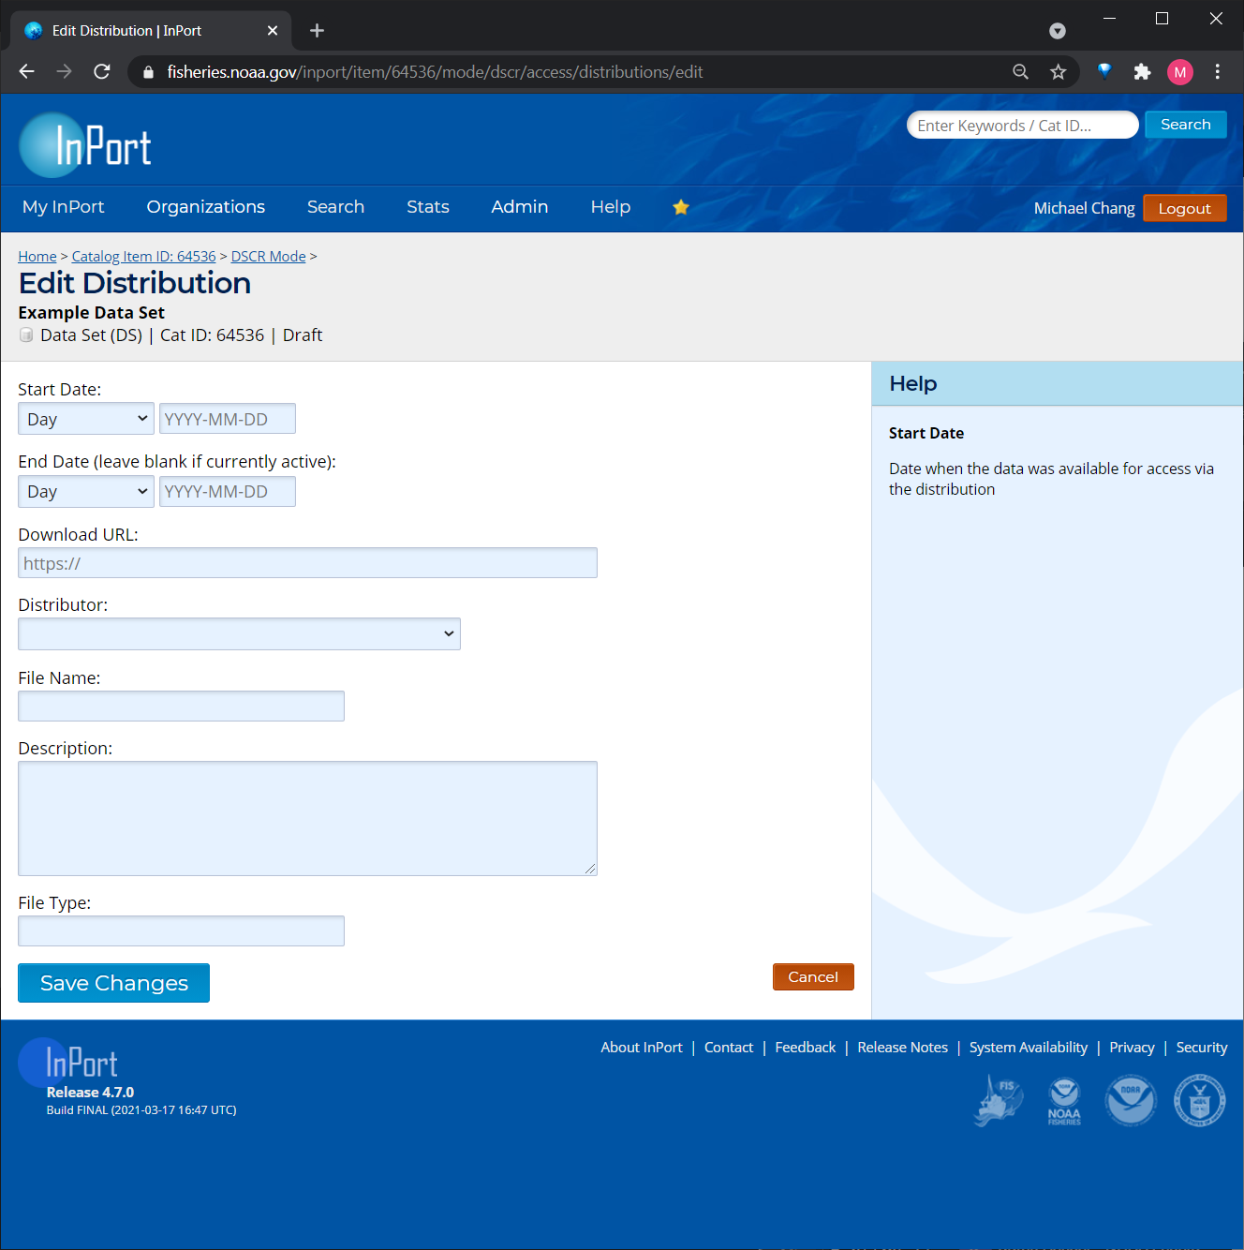

Form 5: Time Frame
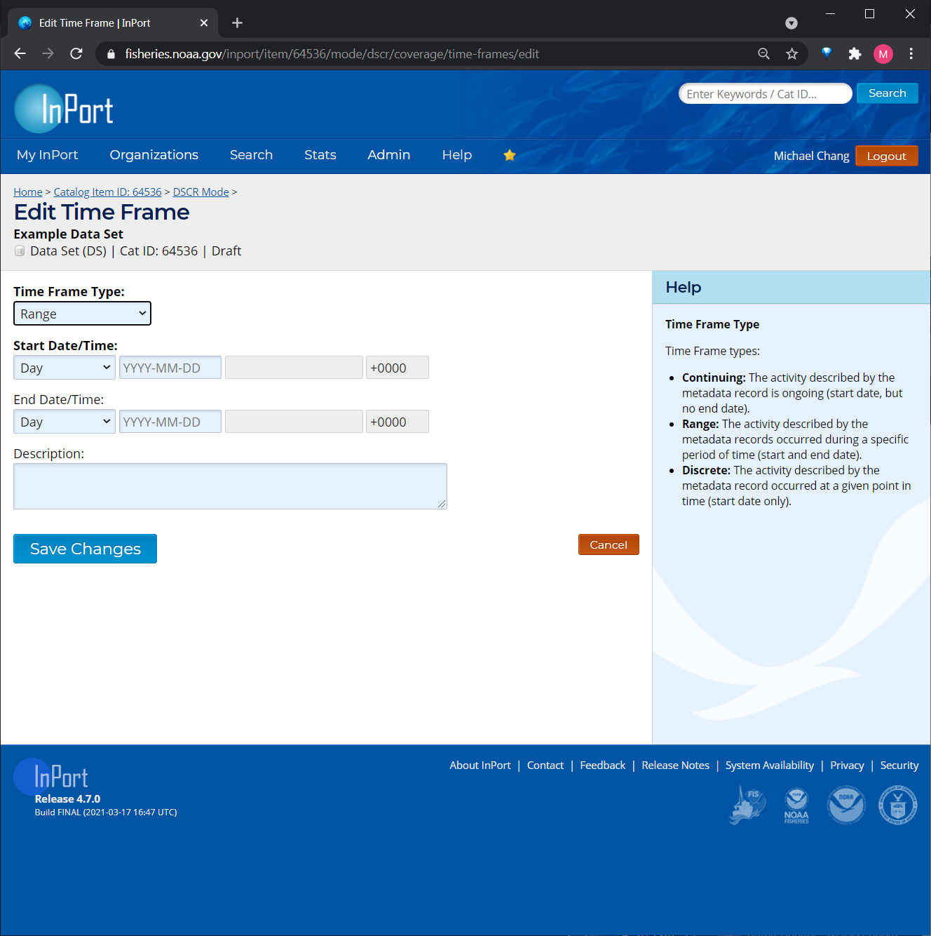

Form 6: Geographic Area
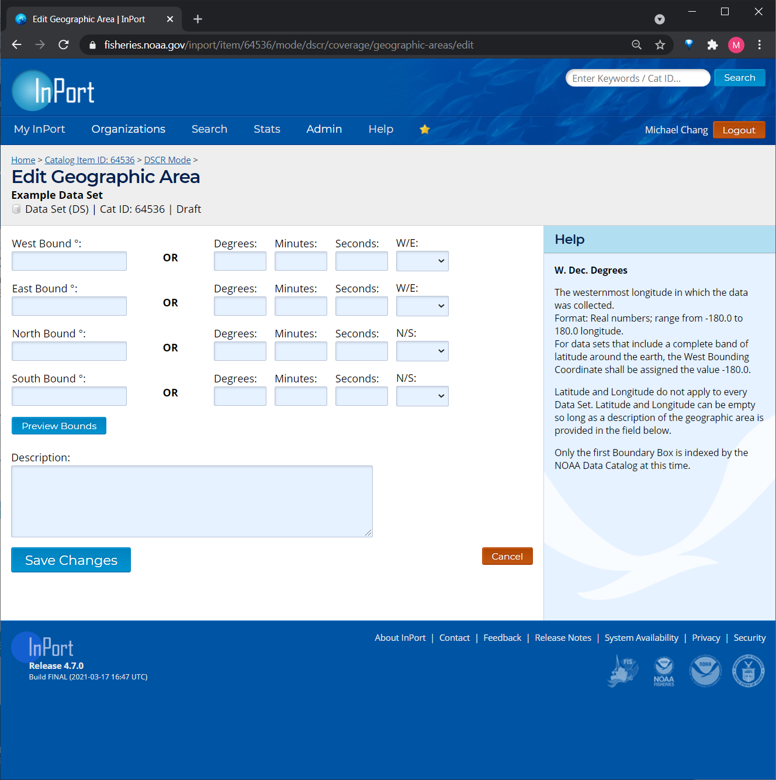

Form 7: History
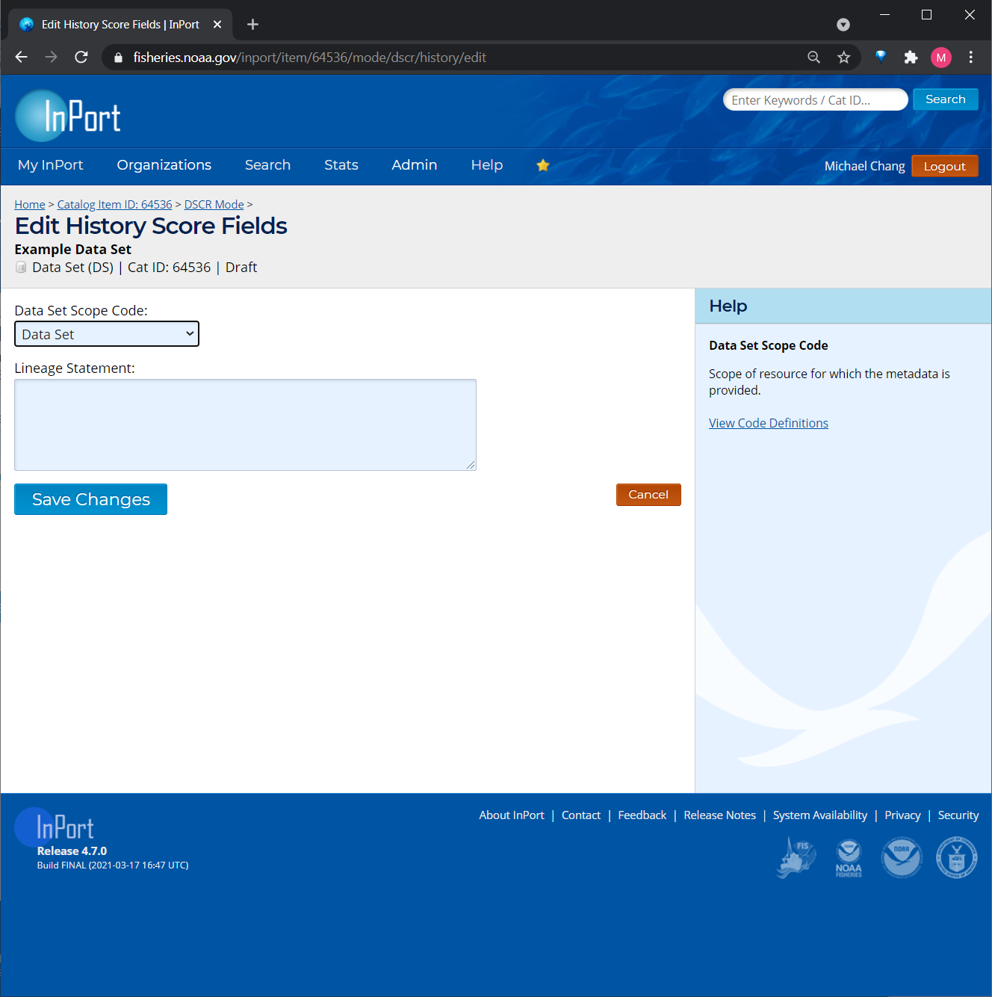

Form 8: Lineage Source
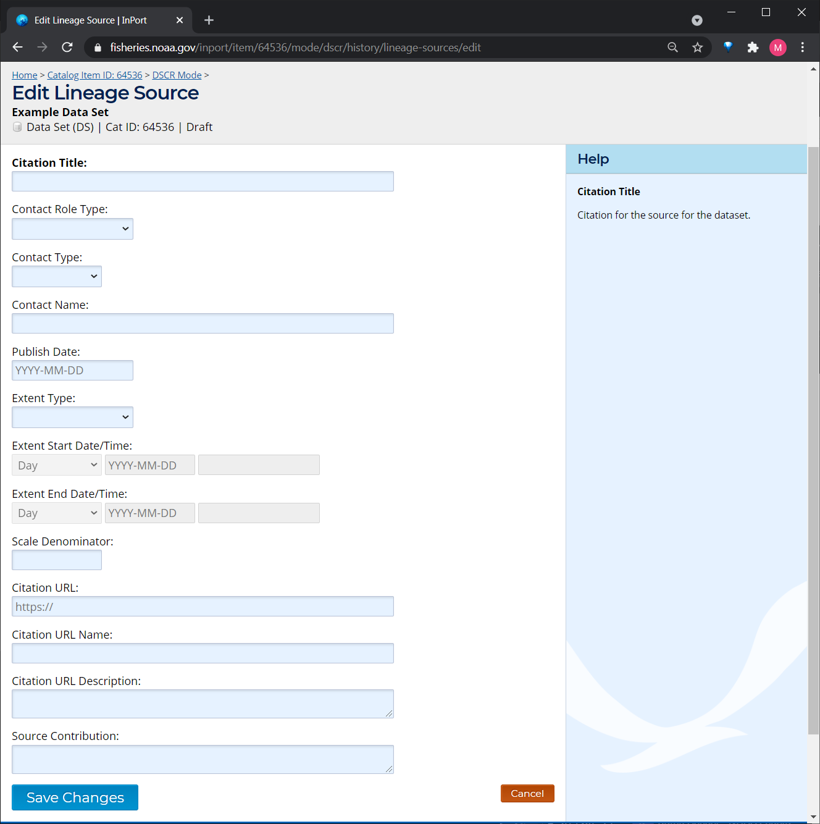

Form 9: Lineage Process Steps
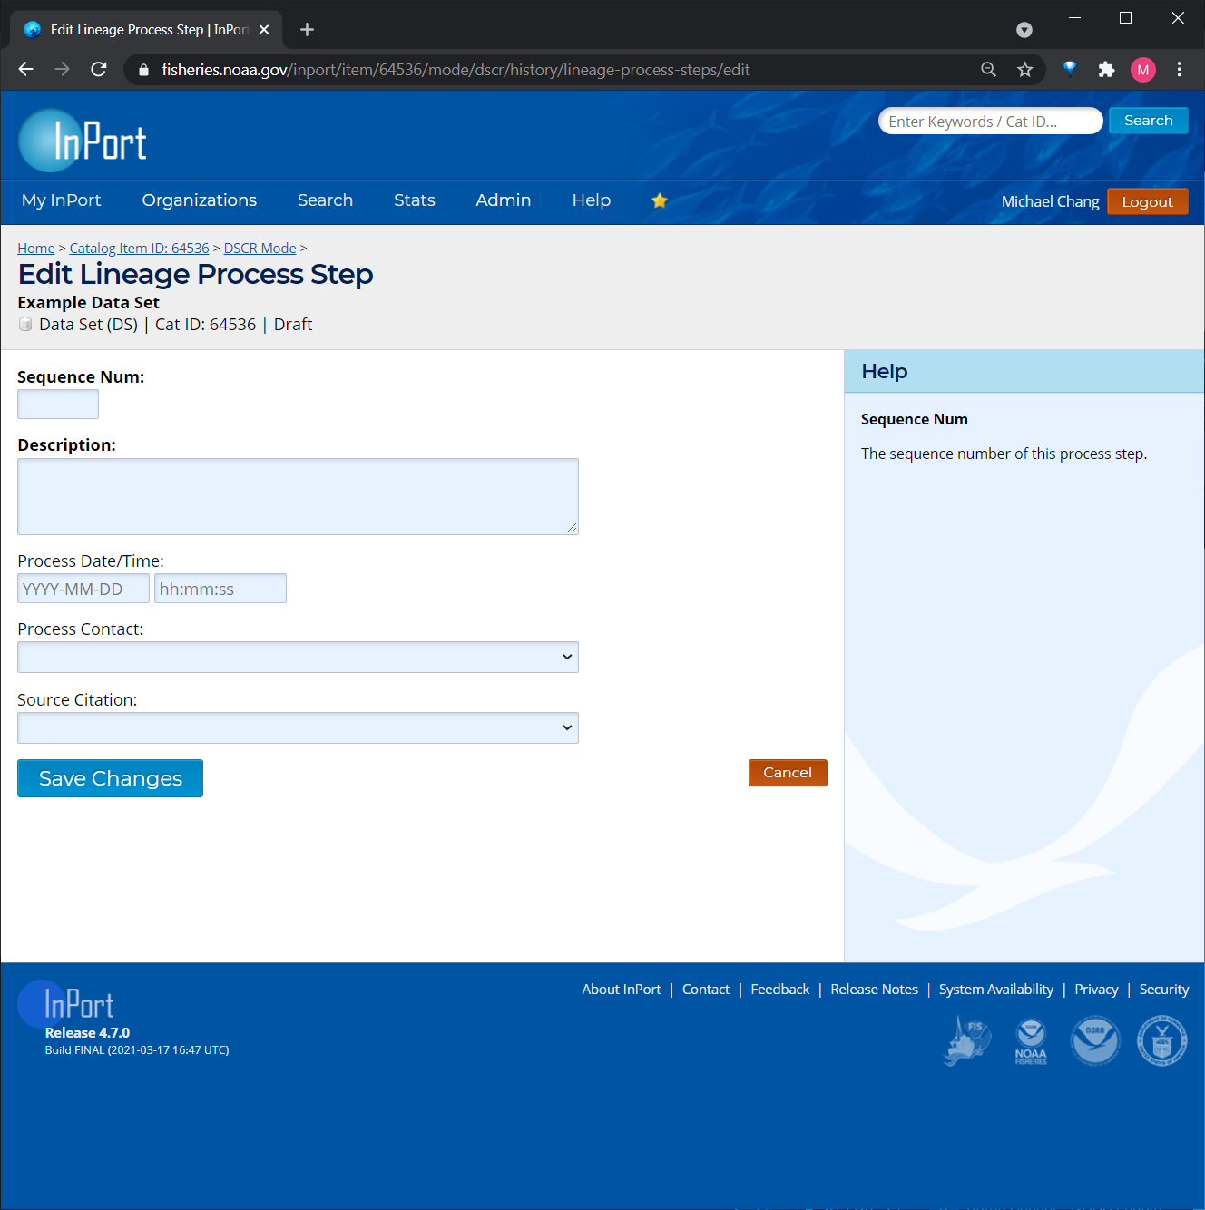

Form 10: Instruments
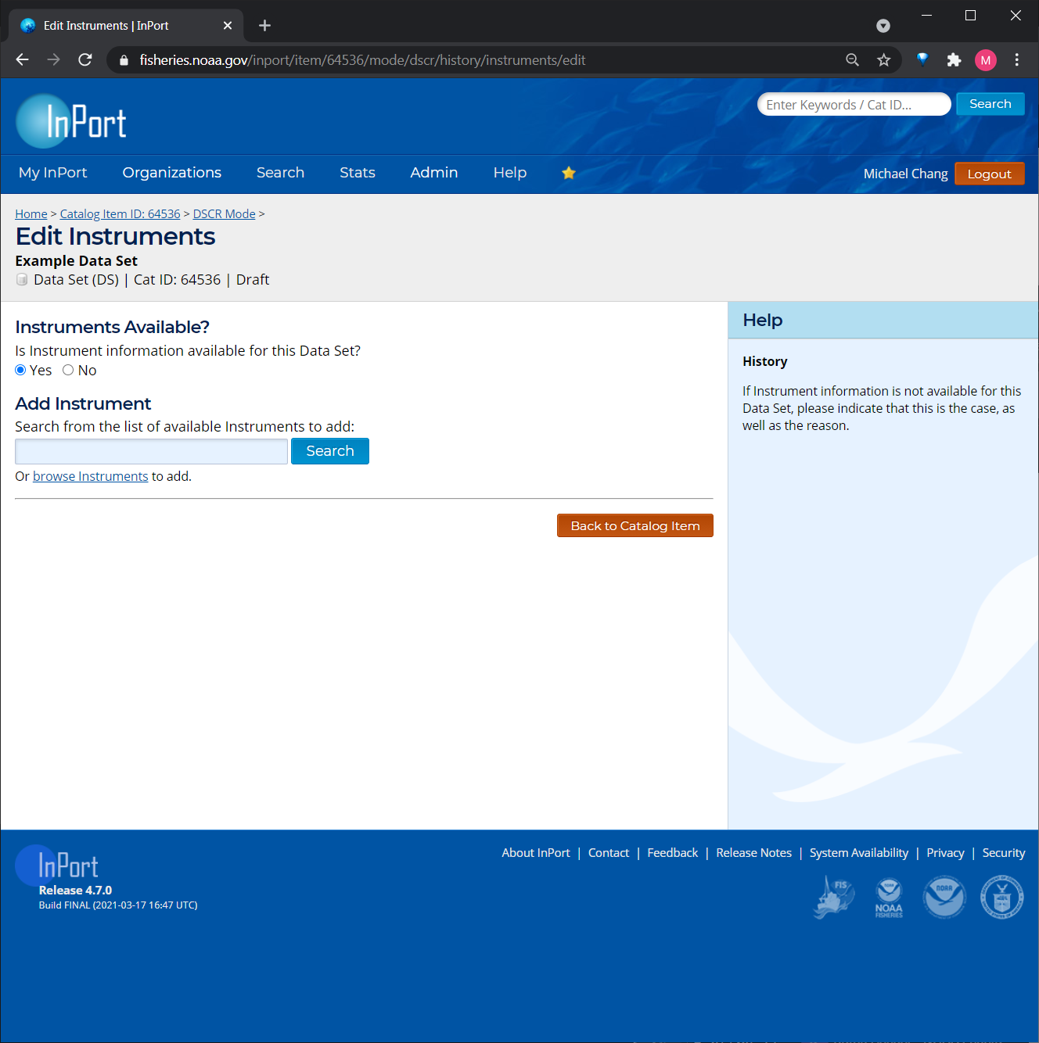

Form 11: Platforms
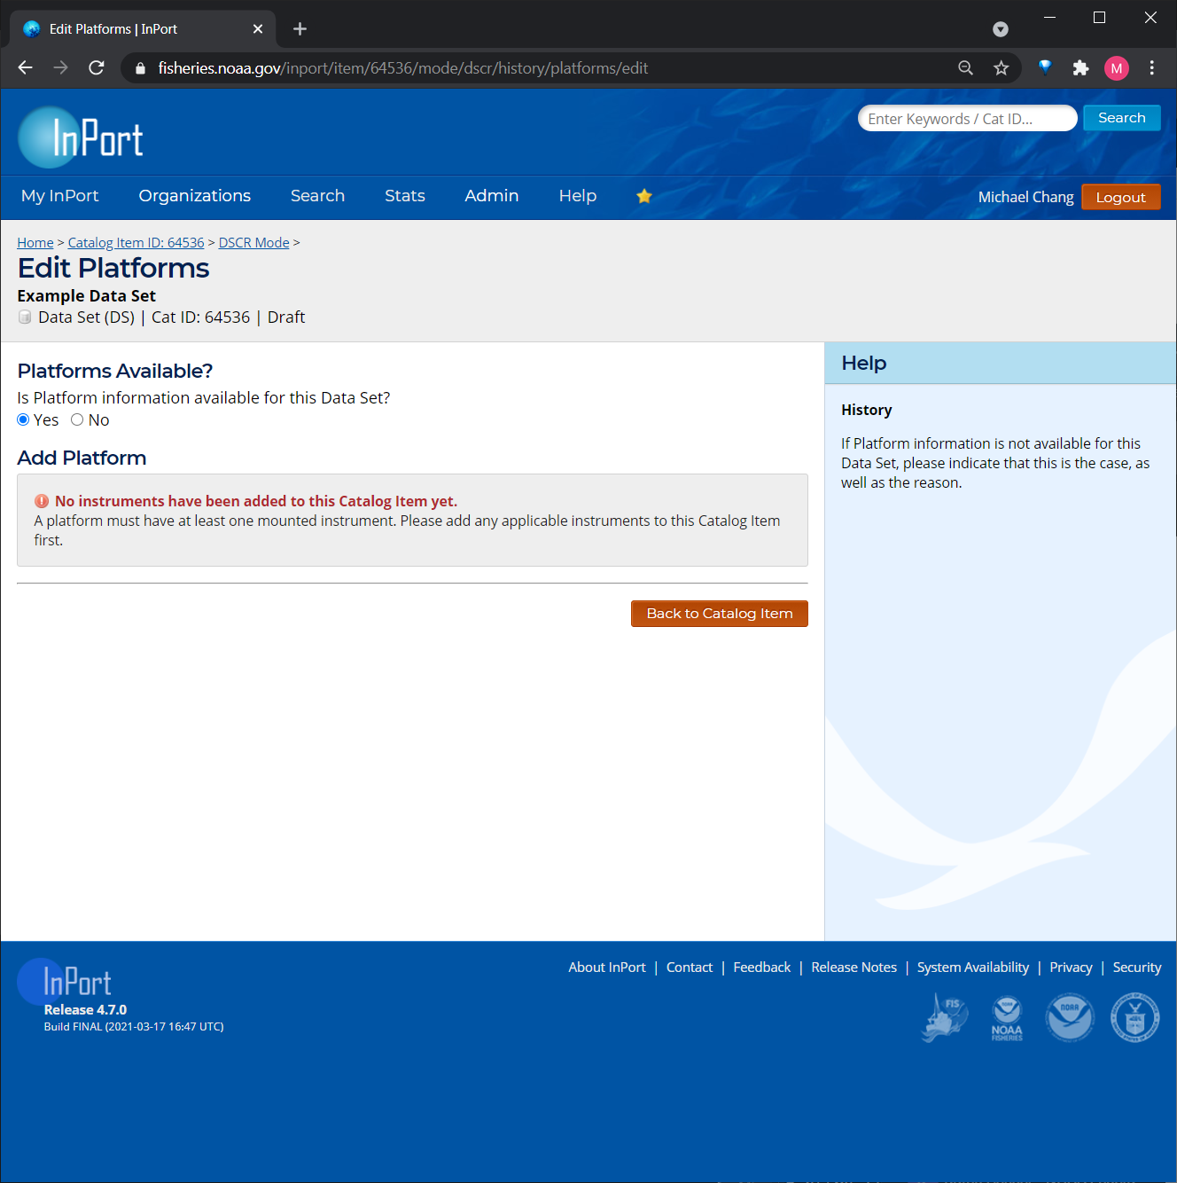

Form 12: Quality
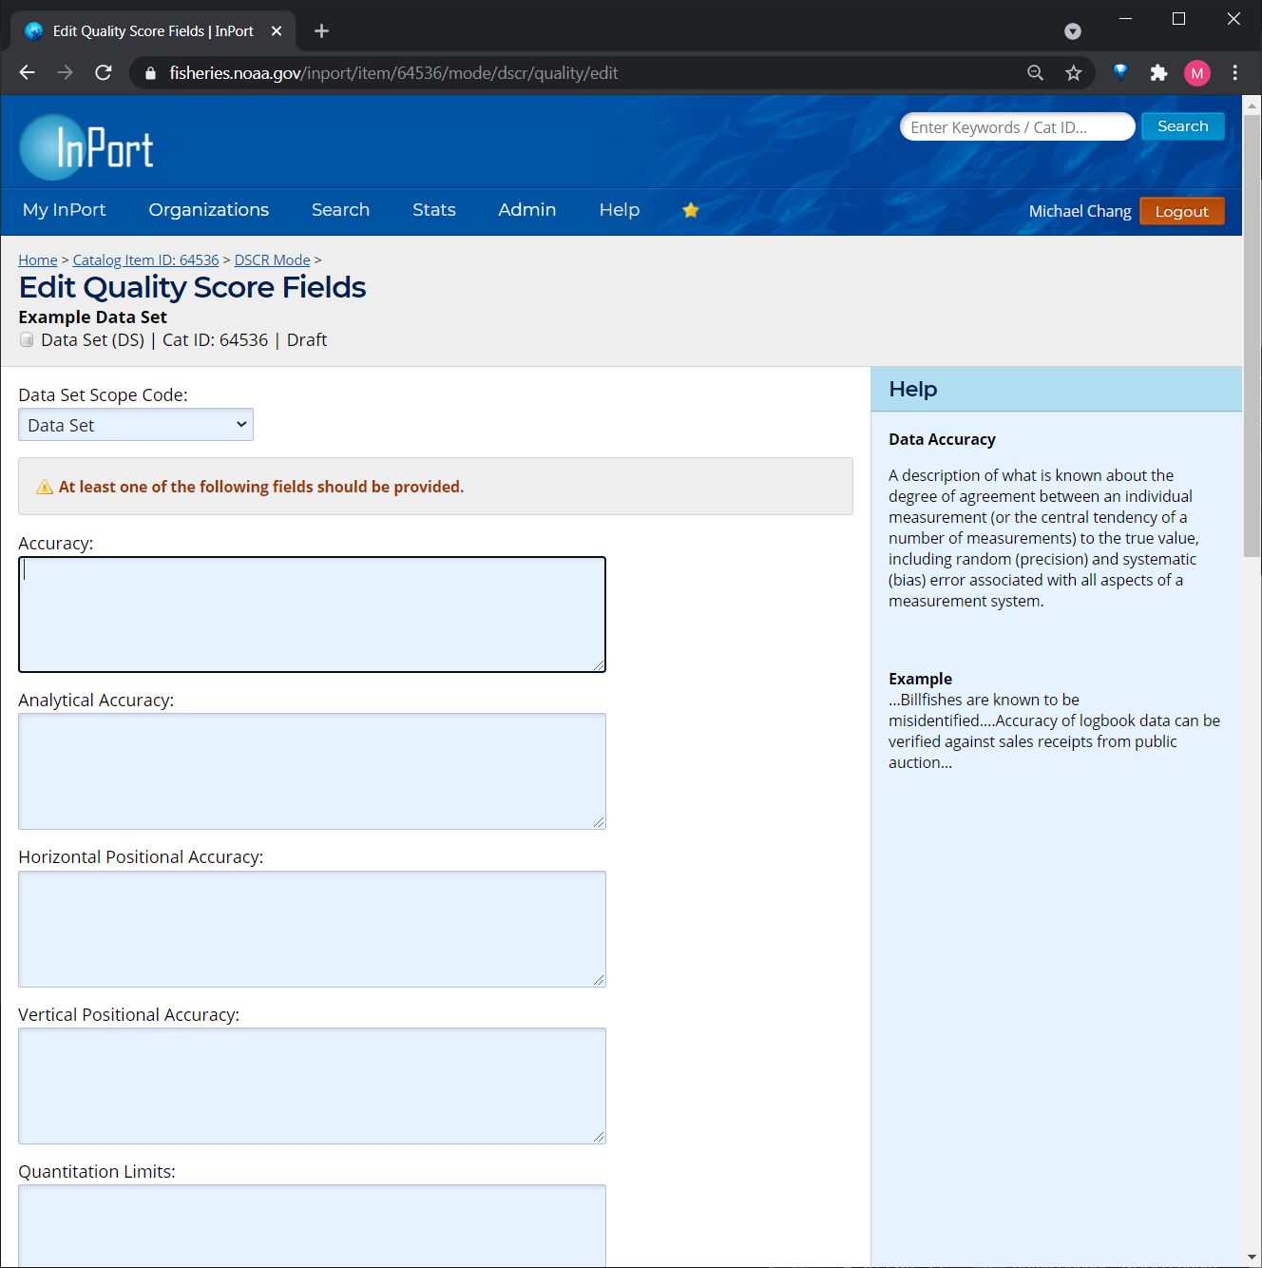

Form 13: URLs
