Please enter your survey code: _____
Coastal communities are facing ongoing threats from coastal hazards, such as storms and flooding. These hazards have many effects, including flooded or damaged homes and buildings, erosion, and loss of beaches, dunes, and coastal wetlands. Hurricane Sandy is a recent example. Scientists expect these threats to continue in the future.
There are many ways that coastal communities can respond to the risks of coastal storms and flooding, but all of these involve tradeoffs. This survey asks for your opinions about these tradeoffs. The goal of the survey is to identify the types of policies that would be supported by you and others in your region. Your answers will be compiled with those of other respondents and sent to local officials to help them decide how to best protect your community.
This research study is being conducted by the University of New Hampshire Survey Center on behalf of the National Oceanic and Atmospheric Administration (NOAA). Your address was randomly selected from all addresses in the Seacoast region of New Hampshire and bordering communities in Massachusetts and Maine. We anticipate approximately 2,000 residents will respond, but our goal is to get as many as possible. By completing the survey, you are consenting to participate in this research. Although we hope that you will answer every question, you are free to skip any questions. Your participation is voluntary, and you may withdraw your consent and discontinue participation at any time. The survey will take approximately 20 minutes to complete. You will not be individually identified and your responses will be used for statistical purposes only.
Thank you in advance for your participation. If you have questions about the research, please feel free to contact Andrew Smith at 603-862-2226 or by email at andrew.smith@unh.edu. If you have questions about your rights as a research subject, you may contact Dr. Julie Simpson in UNH Research Integrity Services at 603-862-2003 or Julie.Simpson@unh.edu to discuss them. By clicking "I Agree" you are agreeing to participate in this study.
RISKS AND ADAPTATION
The first set of questions will ask about your opinions and experiences related to potential coastal hazards and other local environmental issues.

- How much of a problem do you think each of the following are in your community?
[scale: Not at all, Minor, Moderate, Major, Unsure]
  - Coastal storms
  - Coastal flooding
  - Riverine flooding
  - Shoreline erosion

- How do you think the following will change in the next 10 years?
[scale: Decrease, Stay about the same, Increase, Unsure]
  - Coastal storms
  - Coastal flooding
  - Riverine flooding
  - Shoreline erosion
- Do you own or rent property on or near a body of water, such as a river, stream, wetland, pond, or ocean?
  - Yes
  - No
- Has your home or property been damaged from the following in the past five years?
[scale: Yes, No, Unsure]
  - Coastal storms
  - Coastal flooding
  - Riverine flooding
  - Shoreline erosion
- Have any of the following been done on your home or property in the past five years?
[scale: Yes, No]
- [IF 3=TRUE] Install shoreline walls or riprap (rocky material placed along a shoreline)
- [IF 3=TRUE] Plant, restore, or preserve the natural shoreline
- Put all or part of your property into a conservation easement
- Improve drainage (for example, drainage ditches/pipes)
- Raise all or part of your house
- Install wet floodproofing (for example, flood vents)
- Install sump pumps
- How likely are you to do any of the following on your home or property in the next 10 years?
[scale: Not at all, Slightly, Moderately, Very, Extremely]
- [IF 3=TRUE] Install shoreline walls or riprap (rocky material placed along a shoreline)
- [IF 3=TRUE] Plant, restore, or preserve natural shoreline
- Put all or part of your property into a conservation easement
- Improve drainage (for example, drainage ditches/pipes)
- Raise all or part of your house
- Install wet floodproofing (for example, flood vents)
- Install sump pumps
- Move away because of flooding, storms, and/or erosion
- [IF 3=TRUE] To what degree would the following factors make you more likely to install shoreline walls or riprap on your home or property?
[scale: No effect, Minor effect, Moderate effect, Major effect]
- Effectiveness at reducing damage from flooding
- Effectiveness at reducing damage from shoreline erosion
- My or my family’s attachment to the property
- Municipal or state regulations and ordinances
- If my neighbors have installed shoreline walls or riprap
- The way shoreline walls or riprap look
- Cost of installing shoreline walls or riprap
- [IF 3=TRUE] To what degree would the following factors make you more likely to plant, restore, or preserve the natural shoreline on your home or property?
[scale: No effect, Minor effect, Moderate effect, Major effect]
- Effectiveness at reducing damage from flooding
- Effectiveness at reducing damage from shoreline erosion
- My or my family’s attachment to the property
- Municipal or state regulations and ordinances
- If my neighbors have planted, restored, or preserved the natural shoreline
- The way the natural shoreline looks
- Cost of planting, restoring, or preserving the natural shoreline
- Buffer lands are naturally vegetated areas surrounding water bodies. The following is a list of potential policies or ordinances that could be implemented to better manage buffer lands in New Hampshire. How supportive would you be of each potential policy or ordinance?
[scale: Strongly opposed, Opposed, Neither, Supportive, Strongly supportive, Unsure]
  - Limit fertilizer and pesticide use within buffer lands
  - Restrict new development within buffer lands (development setback)
  - Restrict the cutting or removal of natural vegetation within buffer lands
  - Purchase buffer lands for conservation by public or private organizations
  - Reduce property taxes on privately owned buffer lands
- How often do you use the following methods to get information on local environmental issues?
[scale: Never, Rarely, Sometimes, Often, Always]
- Newspapers, other print publications
- TV
- Websites/apps for news outlets
- Social media
- Directly from people (for example, friends, family, neighbors)
- Community bulletin board
- An organized educational workshop or meeting
- How credible do you consider these informational sources on local environmental issues?
[scale: Not at all, Slightly, Moderately, Very, Extremely]
- Local government
- State government
- Federal government
- Non-profit organizations
- Academic institutions
WHAT IS MOST IMPORTANT TO YOU?
This and the following section refer to the Seacoast region of New Hampshire, which is defined by the seventeen coastal zone communities shown in the map below. Regardless of how familiar you are with the Seacoast region of New Hampshire, your opinions are important to us.
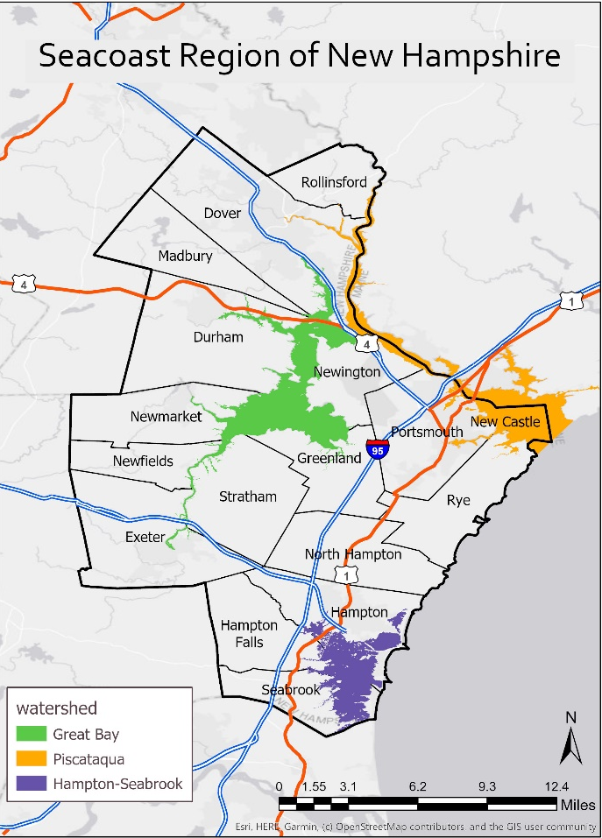

- Are you a seasonal or year-round resident of the Seacoast region of New Hampshire?
  - Seasonal resident (I live in the Seacoast region of New Hampshire only part of the year)
  - Year-round resident (I live in the Seacoast region of New Hampshire all year)
  - Neither (I do not live in the Seacoast region of New Hampshire during any part of the year)
- [IF #12.c = TRUE] Have you ever visited the Seacoast region of New Hampshire?
  - Yes
  - No
- [(IF 12.a = TRUE OR 12.b = TRUE OR 13 = TRUE) OR (IF 12 = SKIP OR 13 = SKIP)] Below is a list of statements about the Seacoast region of New Hampshire. Please read each statement and state your level of agreement or disagreement.
[scale: Strongly disagree, Disagree, neither, Agree, Strongly agree, Unsure]
- I feel the Seacoast region of New Hampshire is a part of me.
- I identify strongly with the Seacoast region of New Hampshire.
- The Seacoast region of New Hampshire means a lot to me.
- The Seacoast region of New Hampshire is the best place for the activities I like to do.
- No other place can compare to the Seacoast region of New Hampshire.
- I enjoy activities in the Seacoast region of New Hampshire more than in any other place.
- The Seacoast region of New Hampshire contributes to the character of my community.
- I feel a strong sense of community in the Seacoast region of New Hampshire.
- I feel connected to the other people who live in the Seacoast region of New Hampshire.
- I would feel less attached to the Seacoast region of New Hampshire if the native plants and animals that live here disappeared.
- I learn a lot about myself when spending time in the natural environment in the Seacoast region of New Hampshire.
- It is important to protect the natural environment in the Seacoast region of New Hampshire.
COMPARING MANAGEMENT OPTIONS
There are many different ways to manage estuarine and coastal shorelines in the Seacoast region of New Hampshire. The most common approaches used by coastal communities are (1) hard defenses or armoring and (2) soft or natural defenses.
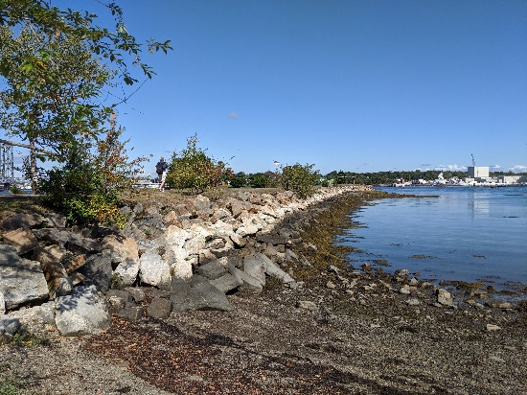
Hard defenses include seawalls and bulkheads to hold back the sea. Soft defenses include beaches, dunes, wetlands, and other natural areas that have the ability to absorb and slow floodwaters. Both approaches can protect homes, facilities, and transportation, but hard defenses often provide the most effective protection. Flooding can still occur under both approaches in severe storms.

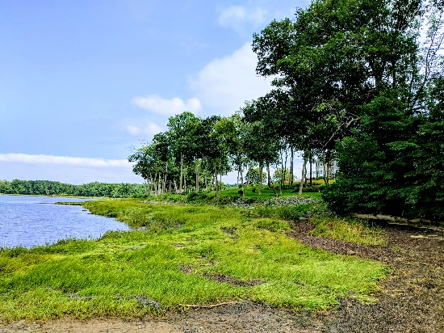
Hard defenses can be costly to build and maintain and can cause natural areas to be lost. As water levels rise, natural areas tend to move landward, but when there are hard defenses in place, there is nowhere for the natural areas to go, and they can be eroded away. Soft defenses can preserve beaches, wetlands, and other natural areas as habitat and public amenities, but can require restrictions on coastal development.

- When considering options to manage the Seacoast region of New Hampshire shorelines, how important to you are each of the following?
[scale: Not at all, Slightly, Moderately, Very, Extremely]
- Private homes and property are protected
- Government respects the right of private landowners to use and develop their land
- Recreational areas such as beaches and parks are protected
- Natural areas and habitat are protected
- The natural character of the waterfront is maintained
- Taxes and fees paid by my household do not increase
- Facilities such as police stations and schools are protected
- Roads and transportation facilities are protected
- Loss of human life is avoided
- Public services, such as electricity, water, and telephone, are protected
- Flood insurance rates paid by homeowners do not increase
This rest of this section will ask you to compare different policies to manage the shoreline in the Seacoast region of New Hampshire. You will be shown four different sets of policies on different pages and asked to select which ones you would prefer based on the outcomes and funding sources of the policies. Assume the cost to your household for each policy would be the same. You may also choose to reject the proposed options and retain the status quo. Treat each page as a separate and independent choice. Do not compare choices between pages.
The technical details of each policy (for example, how/where to build a particular seawall or restore wetlands) would be determined by experts. Each management policy will lead to different outcomes, and we are interested in your opinions on those outcomes.
Please review each policy carefully. The results of this survey will be given to policy makers in the Seacoast region of New Hampshire to help determine future actions.

Outcome | Policy Option A | Policy Option B | Neither (Status Quo)
Amount of wetlands covered by vegetation | Maintain | Increase | Maintain
Amount of beach covered by sand dunes | Maintain | Decrease | Maintain
Amount of shoreline shielded by seawalls and coastal armoring | Maintain | Decrease | Maintain
Number of homes protected from flooding during a storm | Increase | Increase | Maintain
Rate of shoreline erosion | Decrease | Increase | Maintain
The funds to implement this policy would come from | ALL residents of New Hampshire | ANYONE who resides in or visits the Seacoast region of New Hampshire | NO additional funds required

- Which policy option would you prefer?
- Policy Option A
- Policy Option B
- Neither (Status Quo)
- How certain are you that you prefer the policy option you just selected?
  - Not at all
  - Slightly
  - Moderately
  - Very
  - Extremely
Outcome | Policy Option A | Policy Option B | Neither (Status Quo)
Amount of wetlands covered by vegetation | Maintain | Increase | Maintain
Amount of beach covered by sand dunes | Maintain | Decrease | Maintain
Amount of shoreline shielded by seawalls and coastal armoring | Maintain | Decrease | Maintain
Number of homes protected from flooding during a storm | Increase | Increase | Maintain
Rate of shoreline erosion | Decrease | Increase | Maintain
The funds to implement this policy would come from | ALL residents of New Hampshire | ANYONE who resides in or visits the Seacoast region of New Hampshire | NO additional funds required

- Which policy option would you prefer?
- Policy Option A
- Policy Option B
- Neither (Status Quo)
- How certain are you that you prefer the policy option you just selected?
  - Not at all
  - Slightly
  - Moderately
  - Very
  - Extremely
Outcome | Policy Option A | Policy Option B | Neither (Status Quo)
Amount of wetlands covered by vegetation | Maintain | Increase | Maintain
Amount of beach covered by sand dunes | Maintain | Decrease | Maintain
Amount of shoreline shielded by seawalls and coastal armoring | Maintain | Decrease | Maintain
Number of homes protected from flooding during a storm | Increase | Increase | Maintain
Rate of shoreline erosion | Decrease | Increase | Maintain
The funds to implement this policy would come from | ALL residents of New Hampshire | ANYONE who resides in or visits the Seacoast region of New Hampshire | NO additional funds required

- Which policy option would you prefer?
- Policy Option A
- Policy Option B
- Neither (Status Quo)
- How certain are you that you prefer the policy option you just selected?
  - Not at all
  - Slightly
  - Moderately
  - Very
  - Extremely
Outcome | Policy Option A | Policy Option B | Neither (Status Quo)
Amount of wetlands covered by vegetation | Maintain | Increase | Maintain
Amount of beach covered by sand dunes | Maintain | Decrease | Maintain
Amount of shoreline shielded by seawalls and coastal armoring | Maintain | Decrease | Maintain
Number of homes protected from flooding during a storm | Increase | Increase | Maintain
Rate of shoreline erosion | Decrease | Increase | Maintain
The funds to implement this policy would come from | ALL residents of New Hampshire | ANYONE who resides in or visits the Seacoast region of New Hampshire | NO additional funds required

- Which policy option would you prefer?
- Policy Option A
- Policy Option B
- Neither (Status Quo)
- How certain are you that you prefer the policy option you just selected?
  - Not at all
  - Slightly
  - Moderately
  - Very
  - Extremely
- Thinking about the potential management policies you just compared, how strongly do you agree or disagree with the following statements?
[scale: Strongly disagree, Disagree, Neither, Agree, Strongly agree, Unsure]
- The survey provided enough information for me to make informed choices.
- I do not believe the proposed management policies are feasible.
- It is important to manage estuarine and coastal lands in the Seacoast region of New Hampshire, no matter how high the costs.
- I am against any more regulations and government spending.
- My household should not have to pay any amount to manage estuarine and coastal lands in the Seacoast region of New Hampshire.
- My support levels would be the same if this were being considered by the New Hampshire legislature.
- How important were each of the following when deciding between proposed management policies?
[scale: Not at all, Slightly, Moderately, Very, Extremely]
  - I thought I might directly benefit from the policies
  - Wanting to preserve the environment for future generations rather than myself
  - [IF 12c = TRUE & IF Q13 = FALSE] If I may visit the Seacoast region of NH in the next few years
  - Believing it is our responsibility to preserve the environment
  - So others could enjoy the Seacoast region of New Hampshire rather than for myself
MAKING SURE EVERYONE IS REPRESENTED
This is the final section of the survey. The following questions ensure that all groups are fairly represented. All answers are confidential.
- What is your sex?
- Male
- Female
- Other
- In what year were you born? __________
- Are you Hispanic or Latino?
- Yes
- No
- What is your race? (select all that apply)
- White/Caucasian
- Black/African American
- Asian
- Native Hawaiian/other Pacific Islander
- American Indian/Alaskan Native
- Other, please specify ______
- What is the highest level of education you have completed?
- Less than 9th grade
- 9th to 12th grade, no diploma
- High school graduate (includes equivalency)
- Some college, no degree
- Associate's degree
- Bachelor's degree
- Graduate or professional degree
- Are you currently employed?
- Yes
- No
- What was your annual household income in 2020?
- Less than $10,000
- $10,000 to $19,999
- $20,000 to $29,999
- $30,000 to $39,999
- $40,000 to $49,999
- $50,000 to $59,999
- $60,000 to $74,999
- $75,000 to $99,999
- $100,000 to $149,999
- $150,000 to $199,999
- $200,000 or more
- [IF Q12<3] How long have you lived in the Seacoast region of New Hampshire? __________ years
[IF Q12 = 3] How long have you been a resident of your current town? __________ years
- How long have you been a resident of your current state? __________ years
- Do you own or rent this residence (where this survey was mailed to)?
- Own
- Rent
- Other
- How many people, including yourself, live in your household? __________
- How many of these people are at least 18 years old? __________
- Please use the space below for additional comments.

