**TAB 1 – APACS milCloud home page**

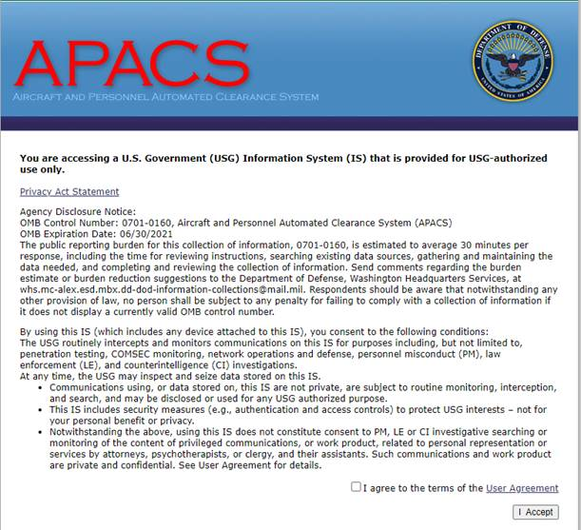

**Tab 2 – APACS milCloud Privacy Act Statement**

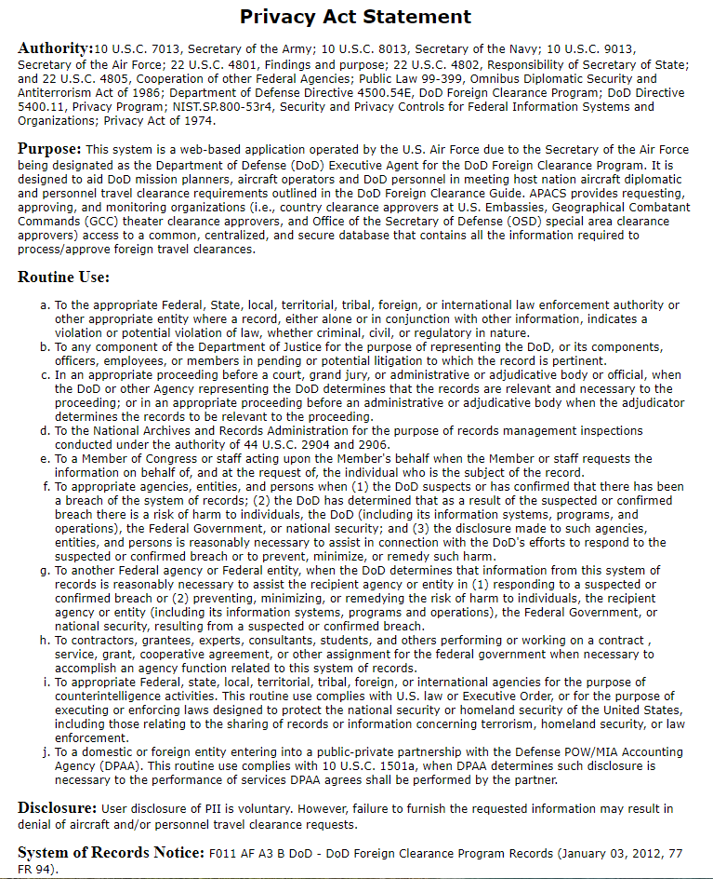

**Tab 3 – APACS milCloud Login Page**

**­**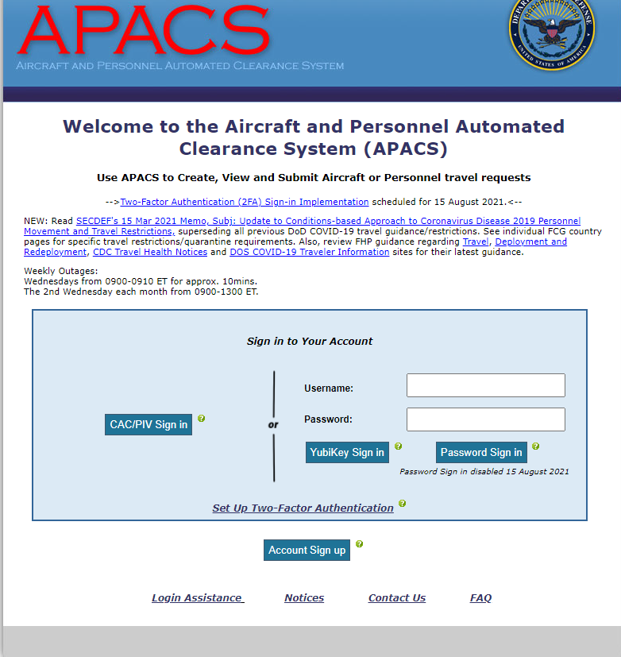

**Tab 4 – APACS milCloud Internal Home (after login)**

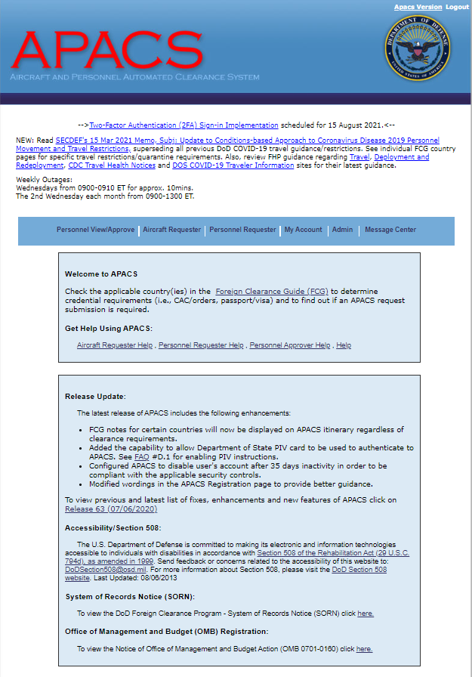

**Tab 5 – APACS milCloud Traveler Notes (PII Requirements – Netherlands)**

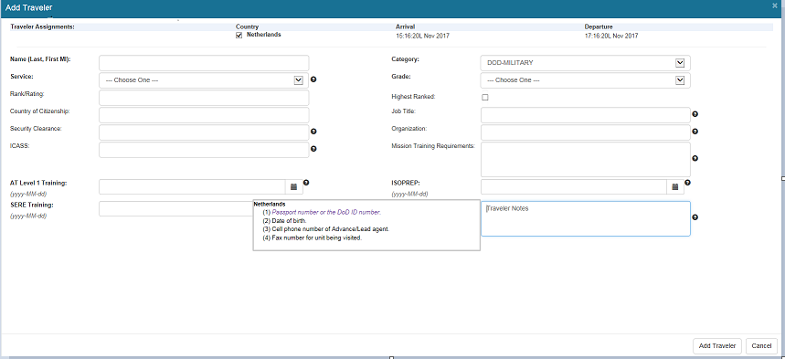

**Tab 6 – APACS milCloud Security Clearance Requirement (Netherlands)**

