Defense Travel System

OMB Control Number 0704-0577

Privacy and Ethics Policy Disclaimer

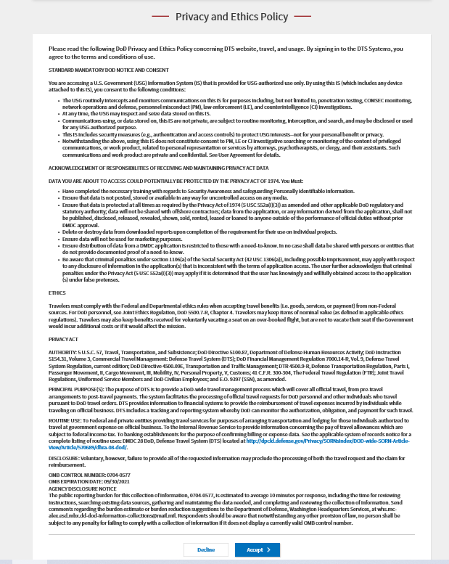
User Selects “Decline” System Response:
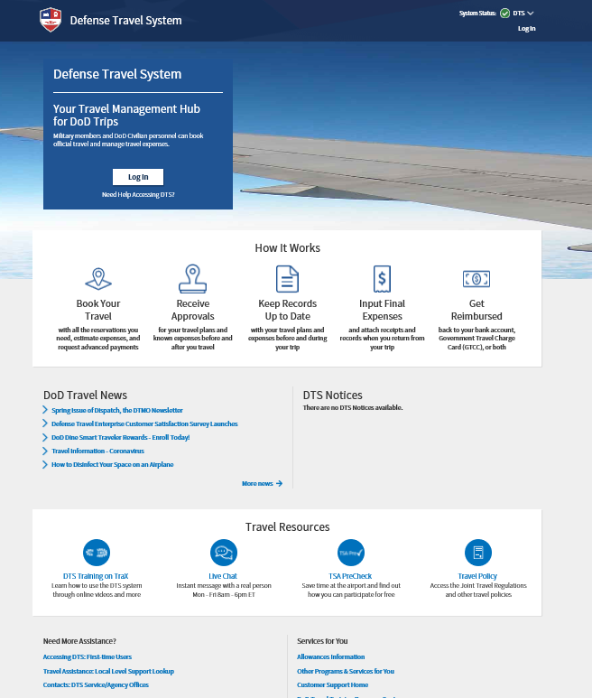

Welcome to the Self Registration Tool
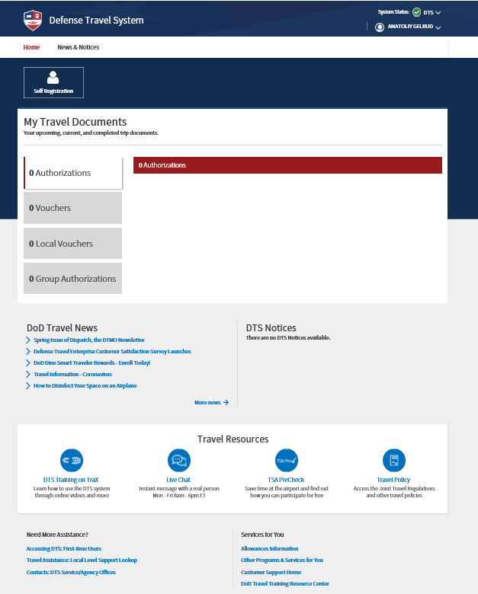

New Profile Creation
The following is a series of screens to populate a profile for a new user:

Screen 1:
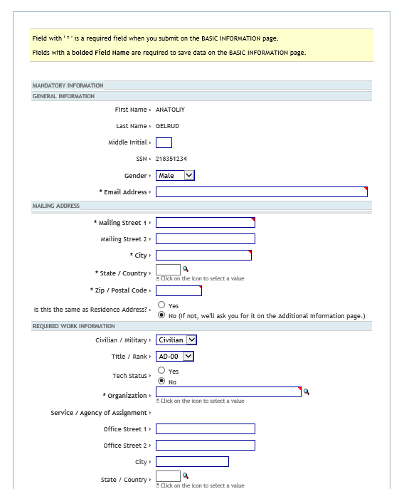

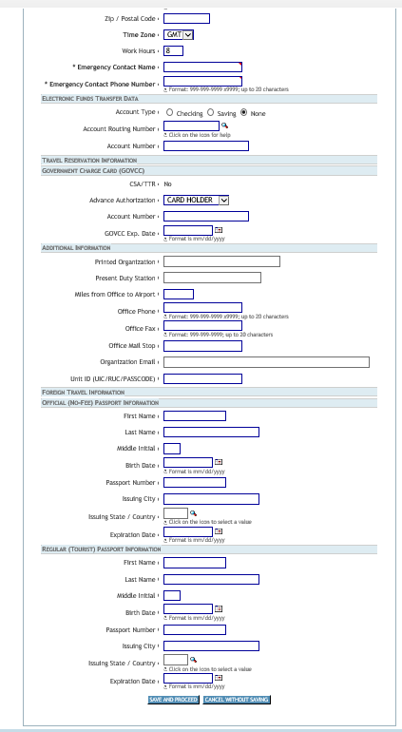

Civilian/Military List of Values Screen:
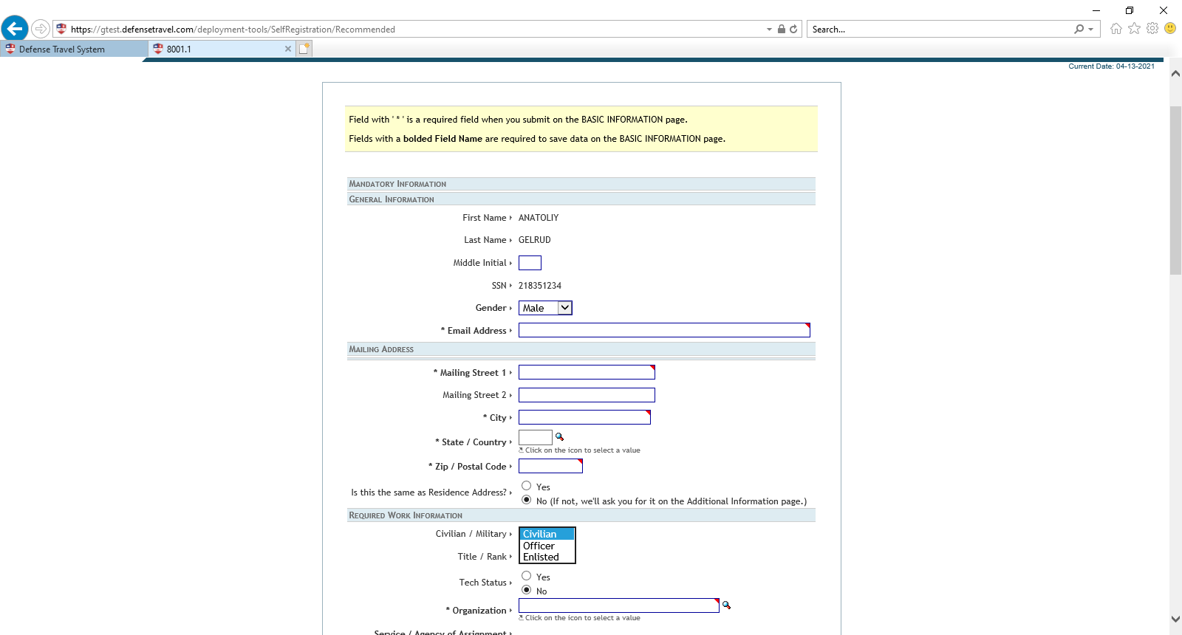

Title/Rank List of Values Screen
Civilian: if user selects “civilian”, the list of values shows the following:

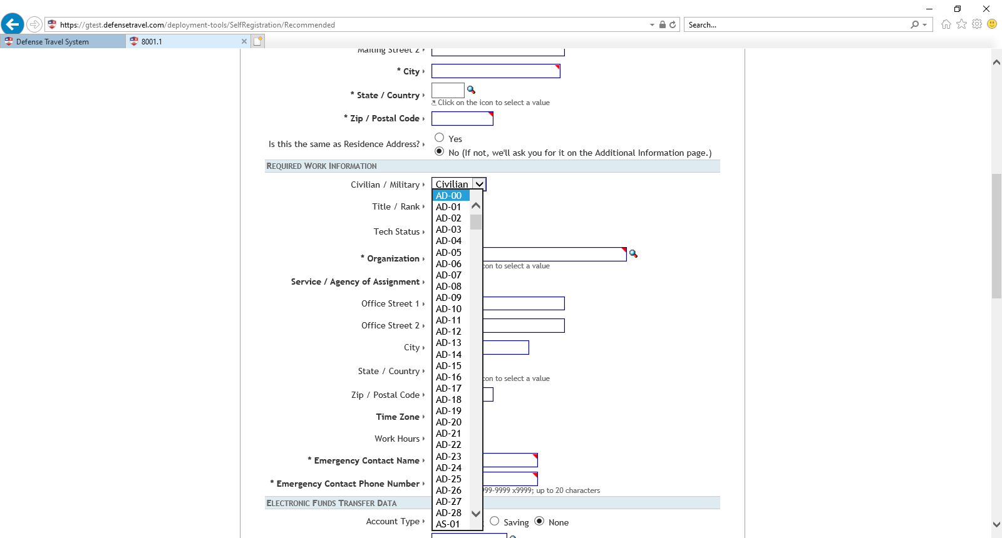

Officer: if user selects “officer”, the list of values shows the following:
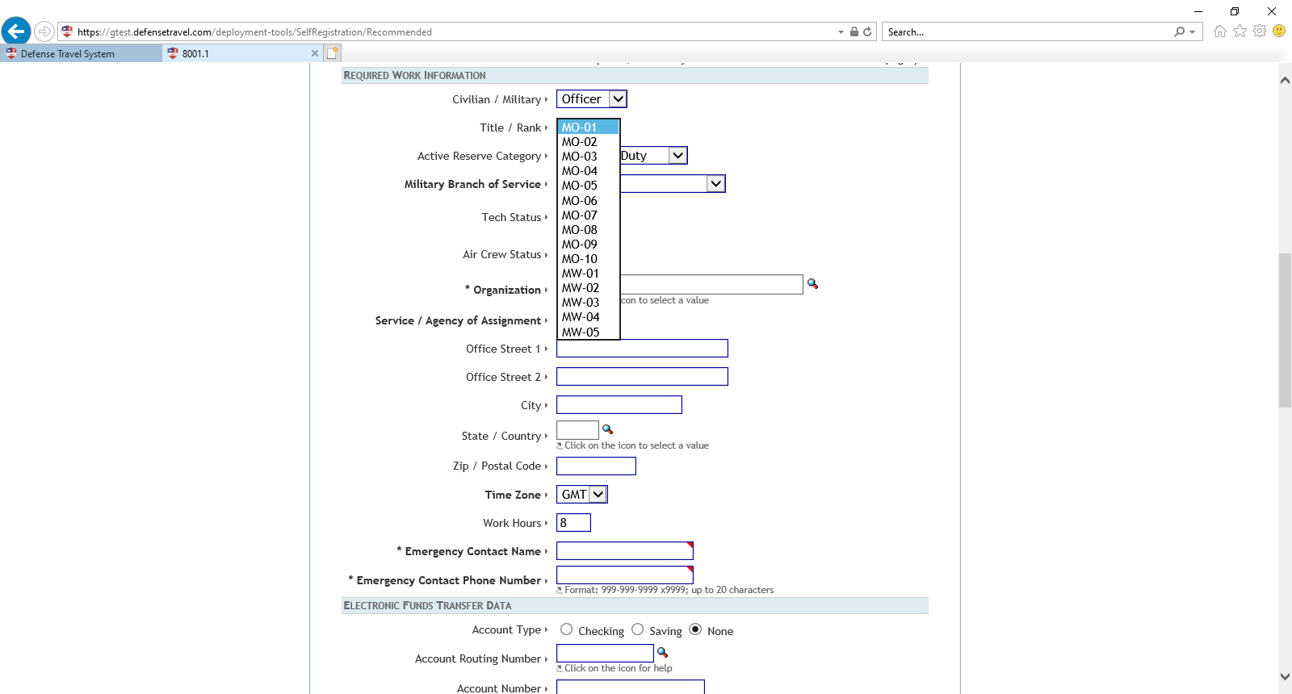

Enlisted: if user selects “enlisted”, the list of values shows the following:

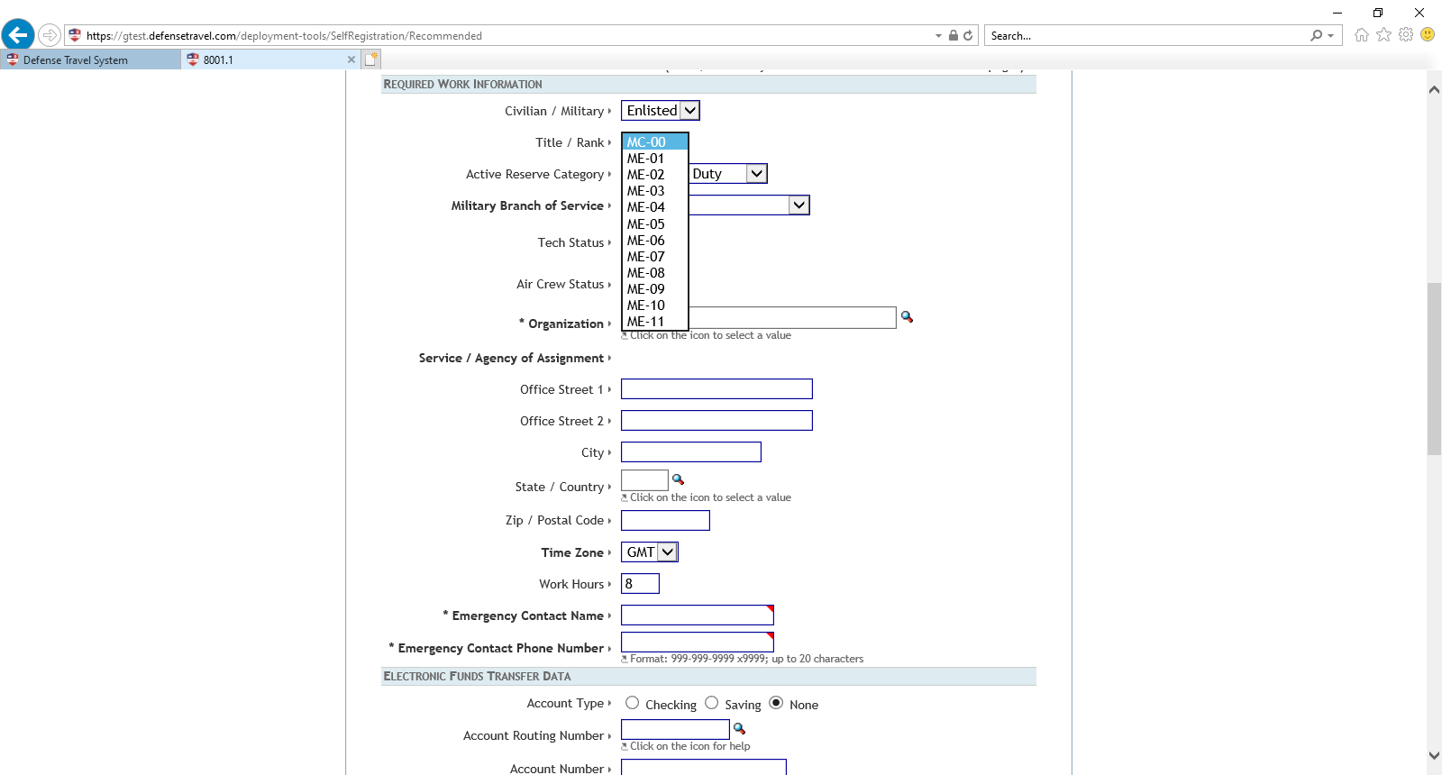

Screen 2: Advanced Authorization List of Values: Option “Card Holder”:

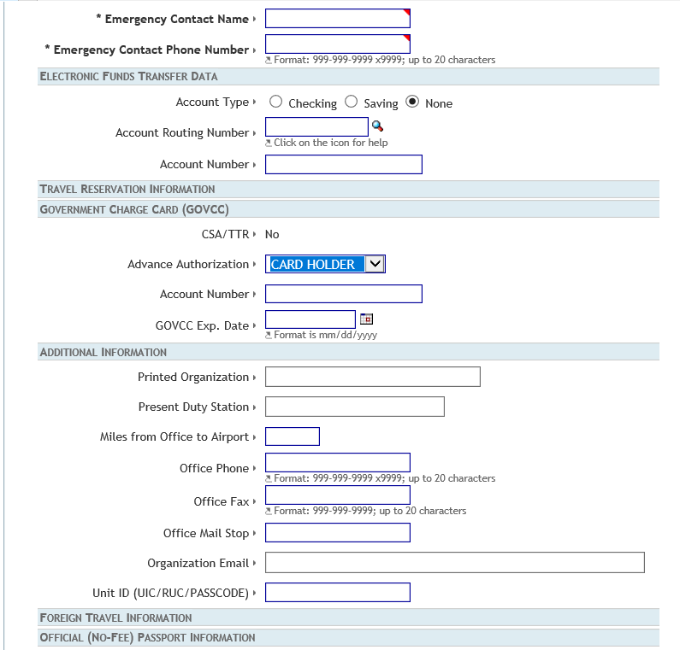

Advance Authorization List of Values: Option “Advanced Authorization”:

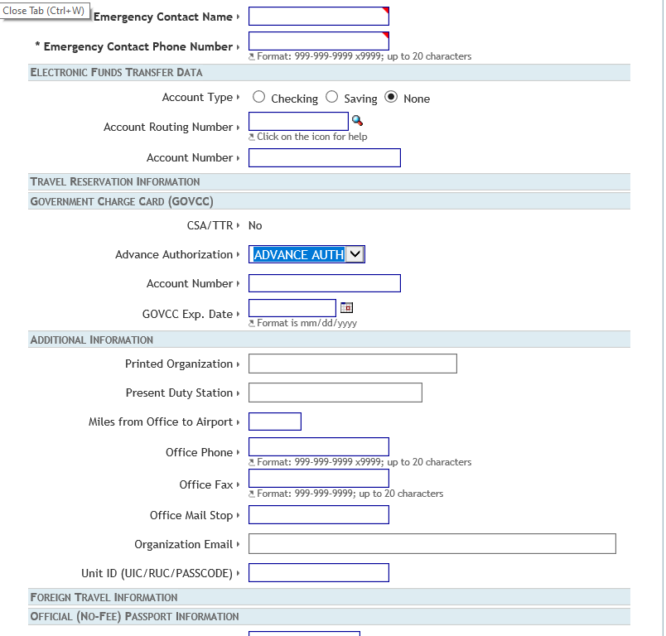

Screen 3:

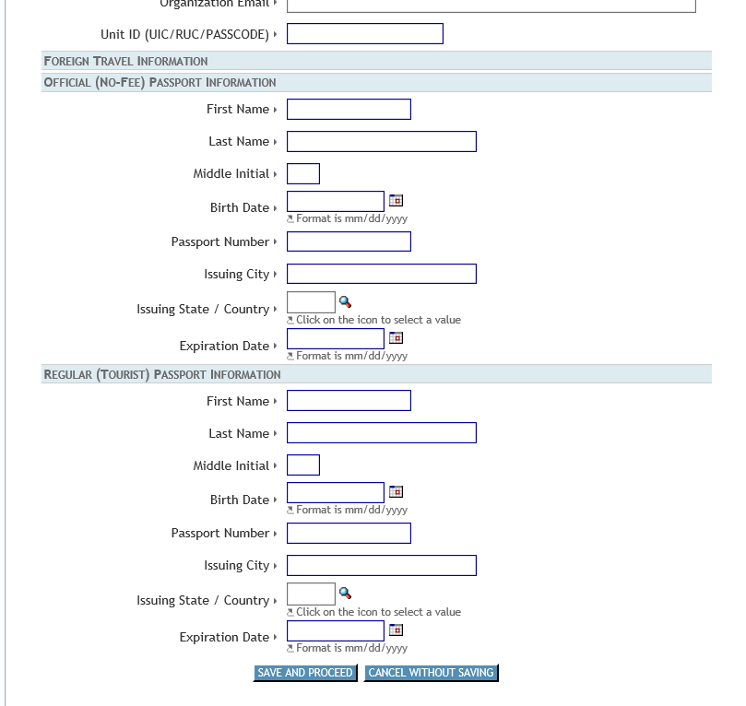

Edit Profile
Existing users access this screen to change any profile information

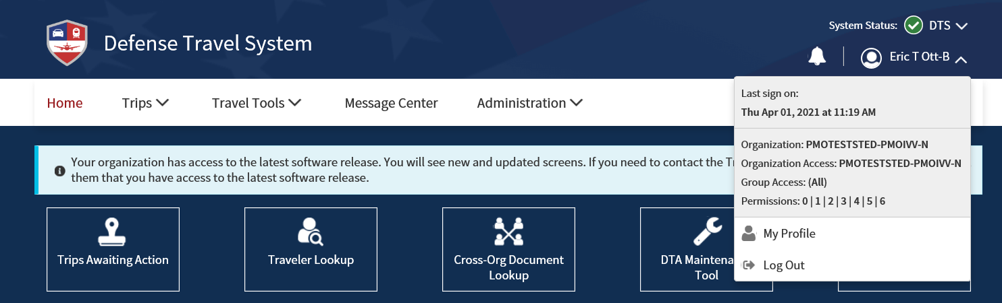

Personal Information:

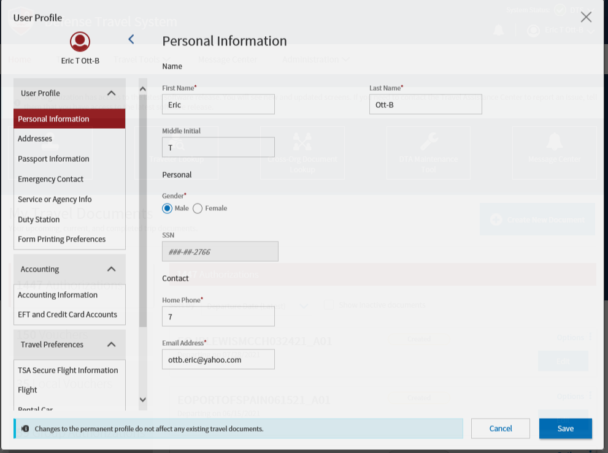
Address screen:
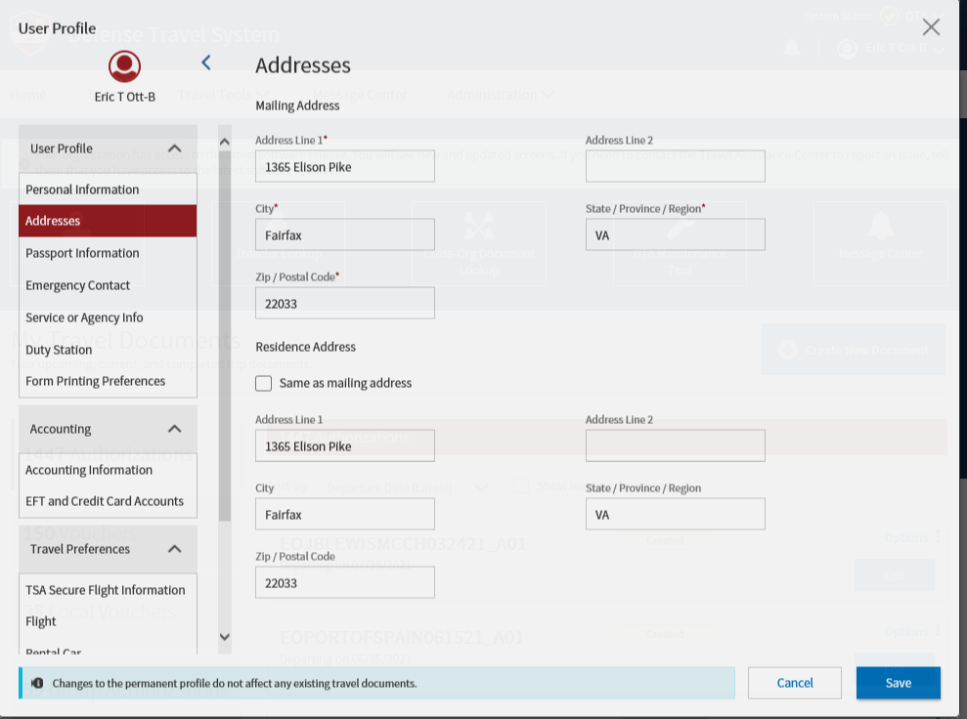

Passport Information screen:
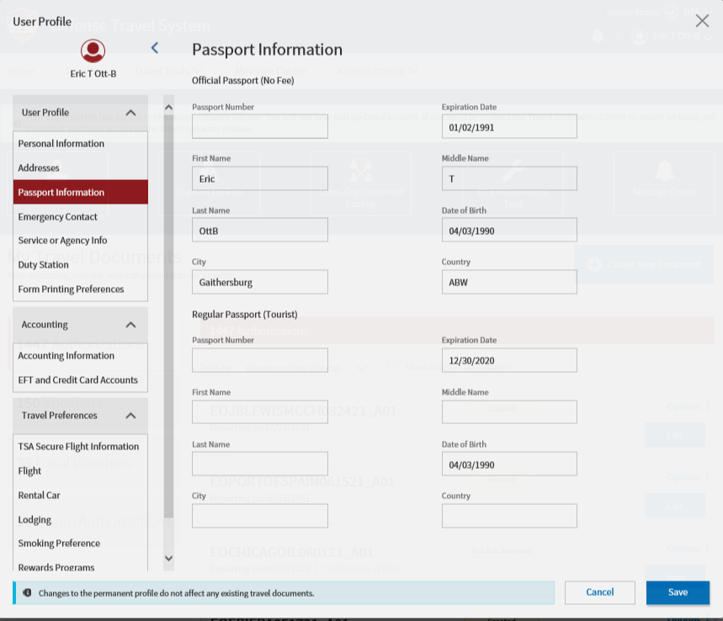

Emergency Contact screen:
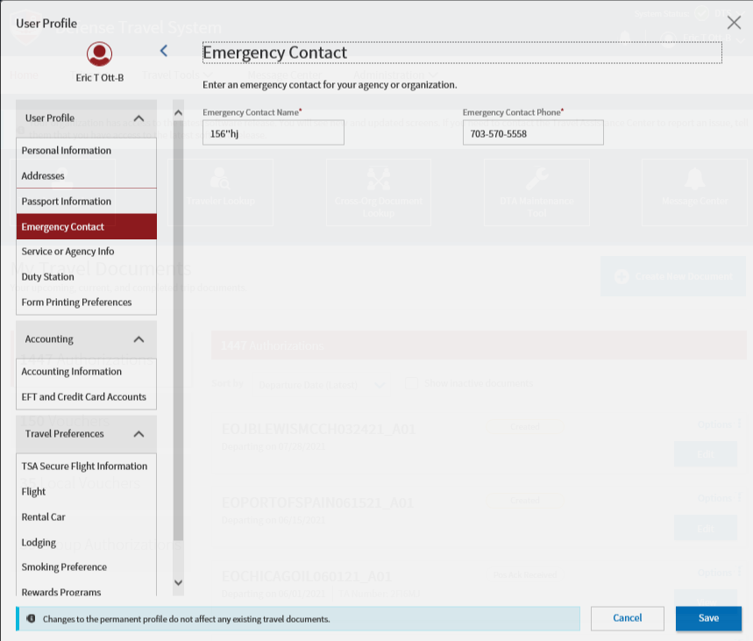

Service or Agency info screen:
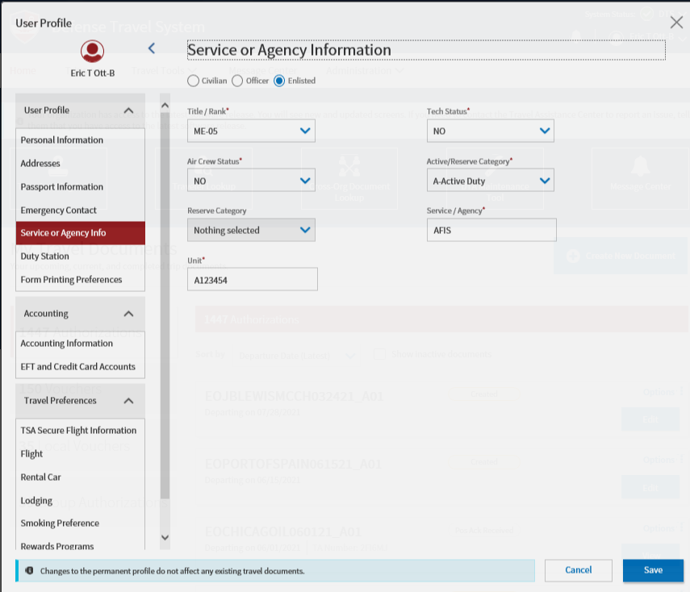

Duty Station screen:
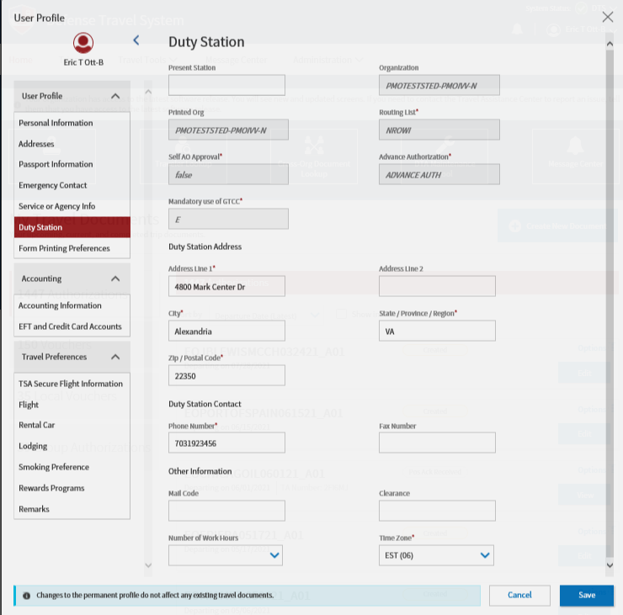

Form Printing Preferences screen:
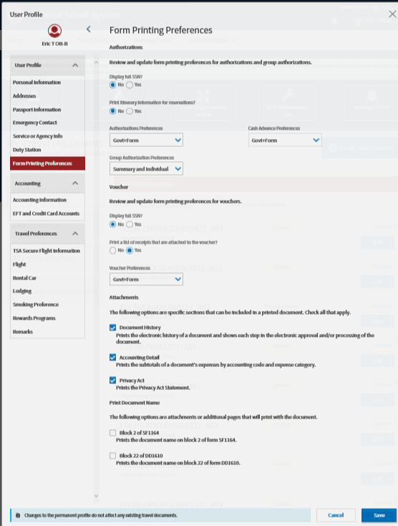

Accounting
Accounting Information screen:
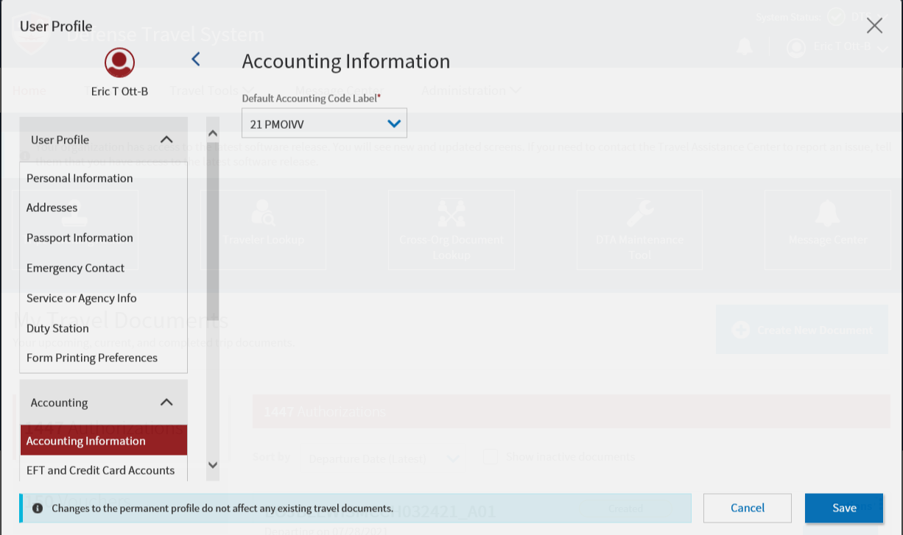

EFT and Credit Card Accounts screen:
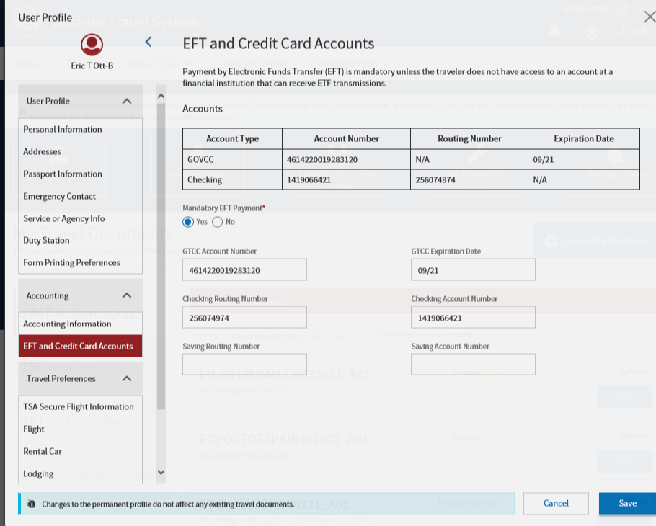

Travel Preferences
TSA Secure Flight Information screen:
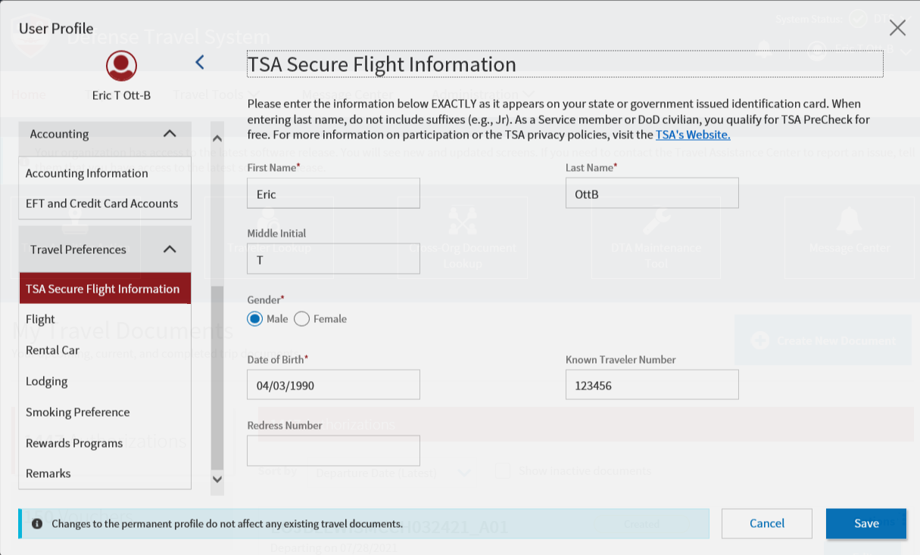

Flight screen:
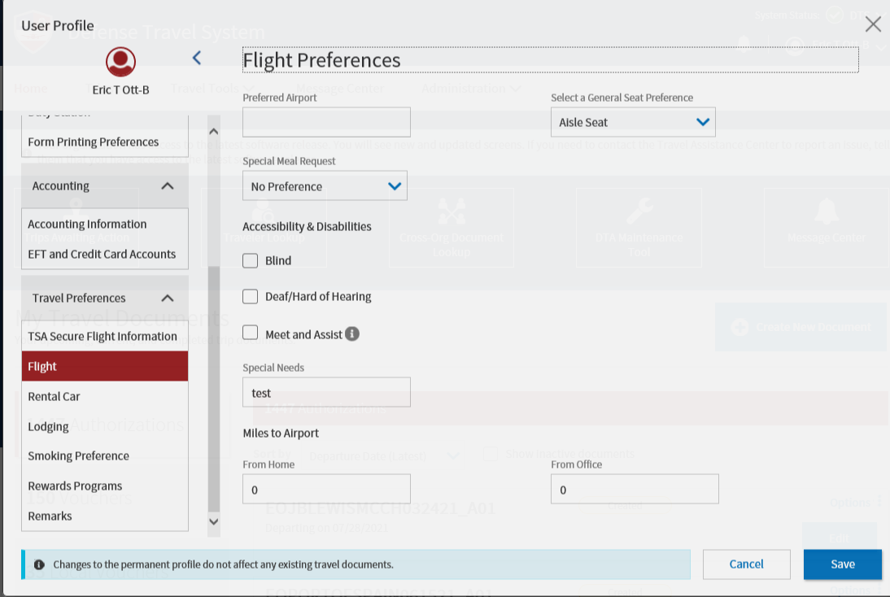

Rental Car screen:
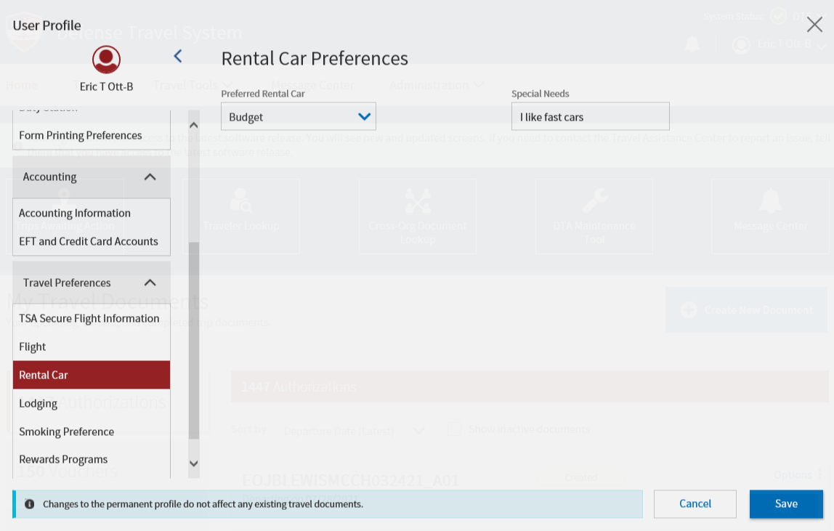

Lodging screen:
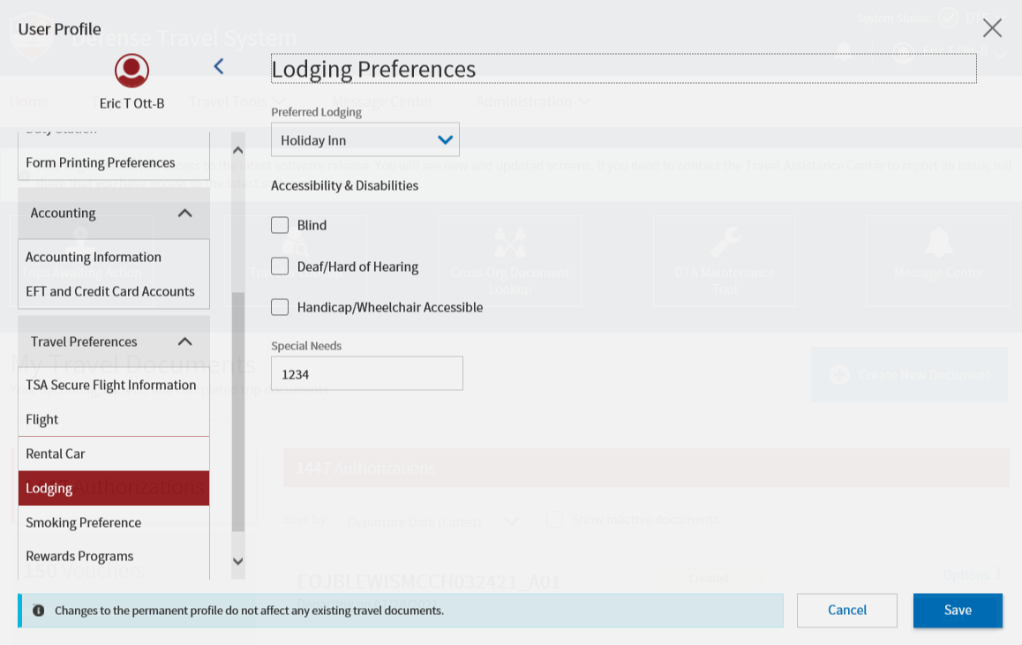

Smoking Preference screen:
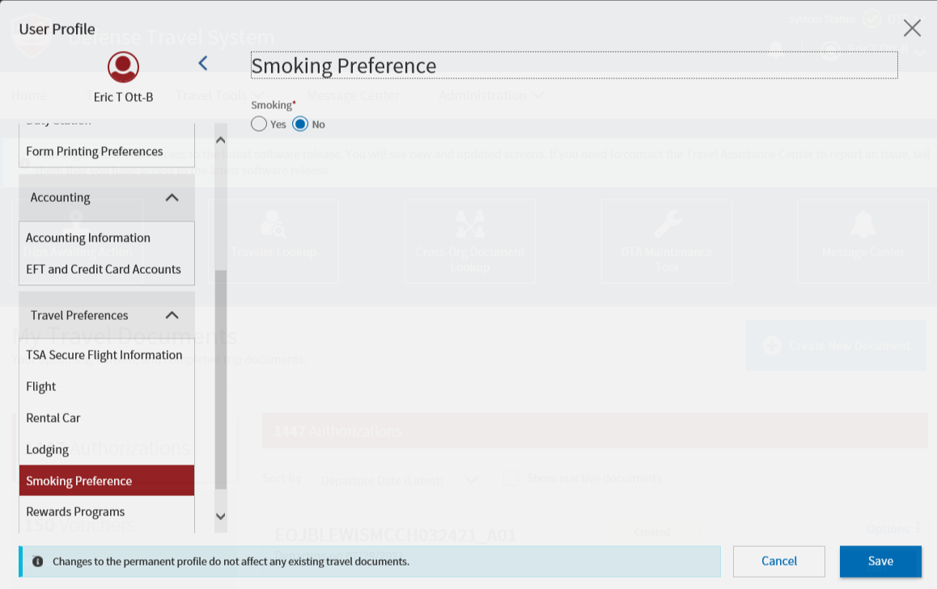

Reward Programs screen:
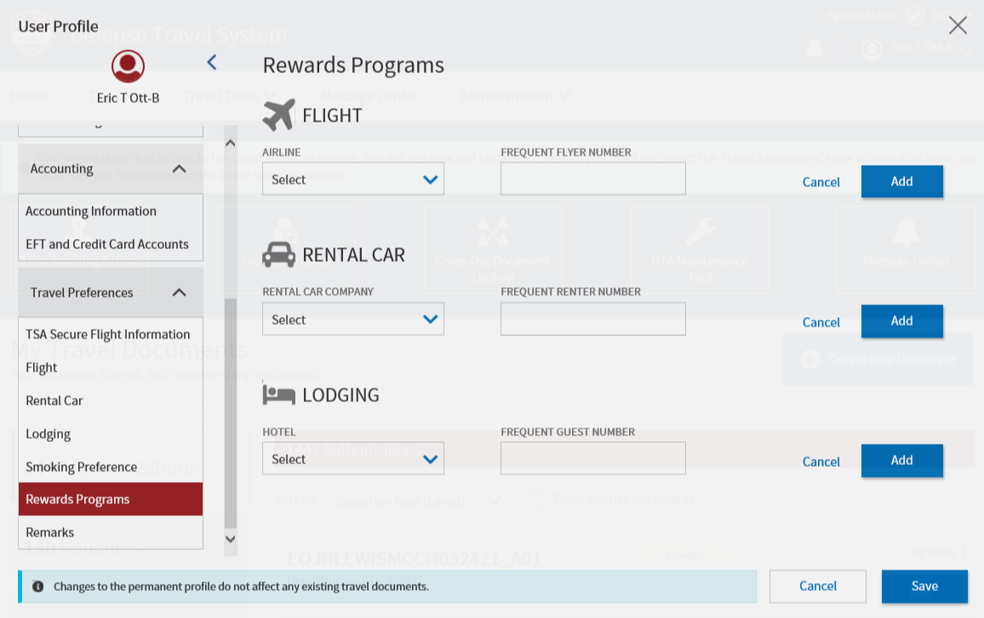

Remark screen:
