**Agency information:**

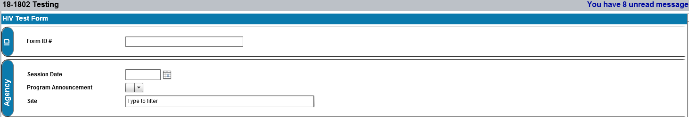

Client information: **Local Client ID# is not reported to CDC.**

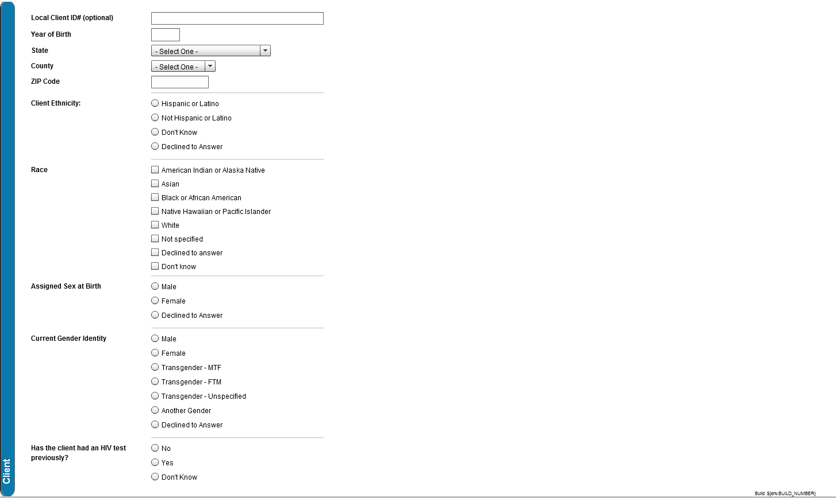

**HIV test information:**

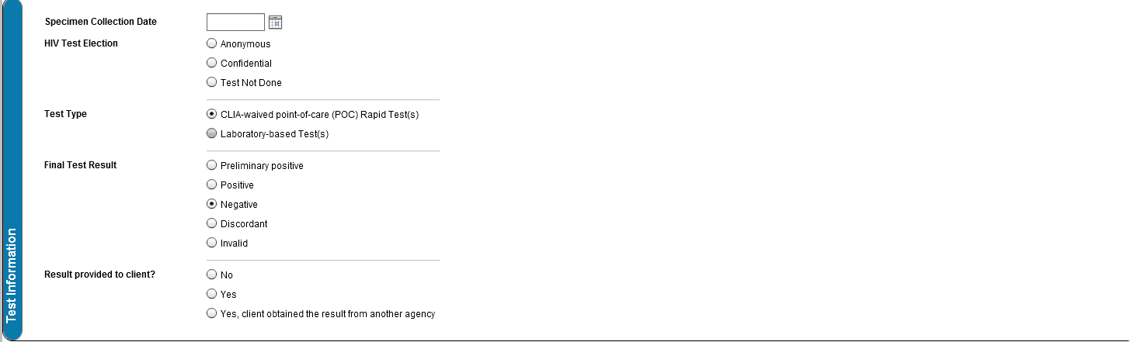

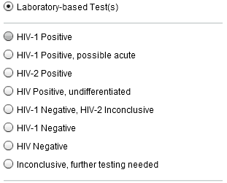

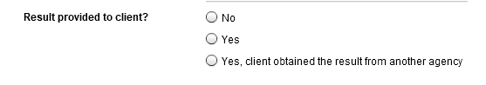

**Negative test result**

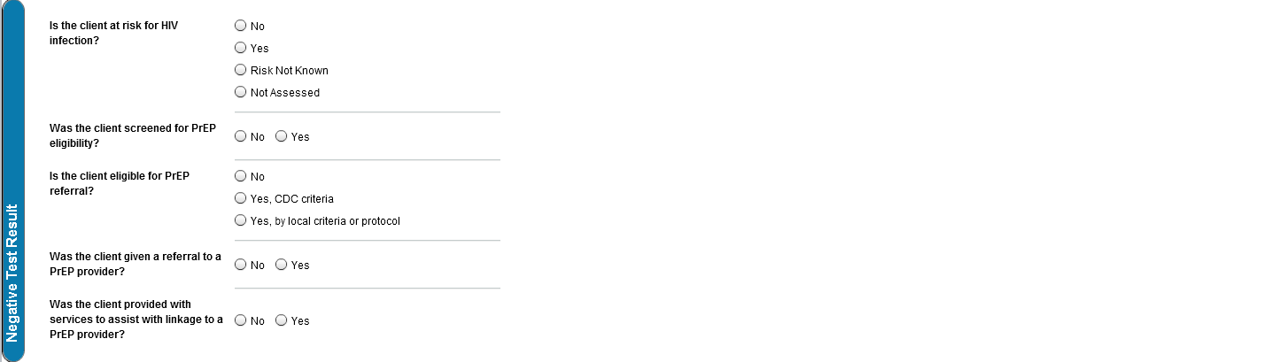

**Positive test result**

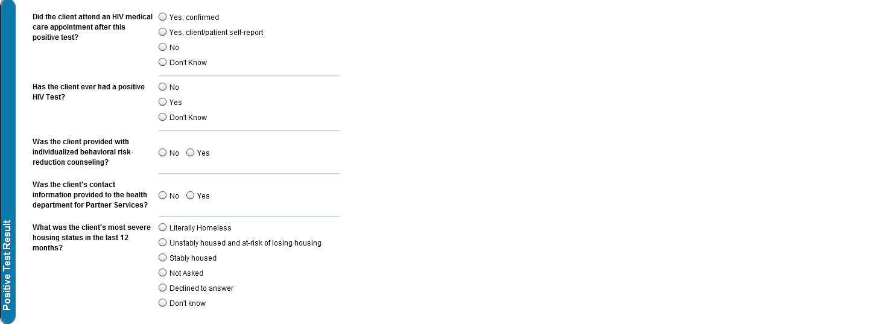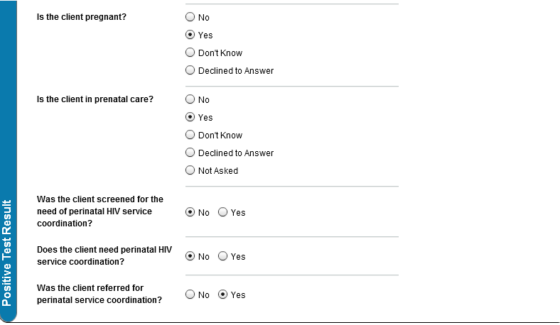

**Additional test information**

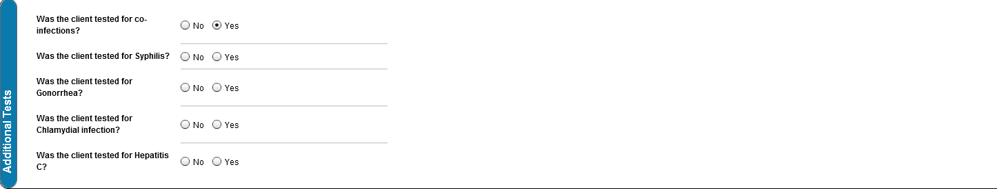

**PrEP**

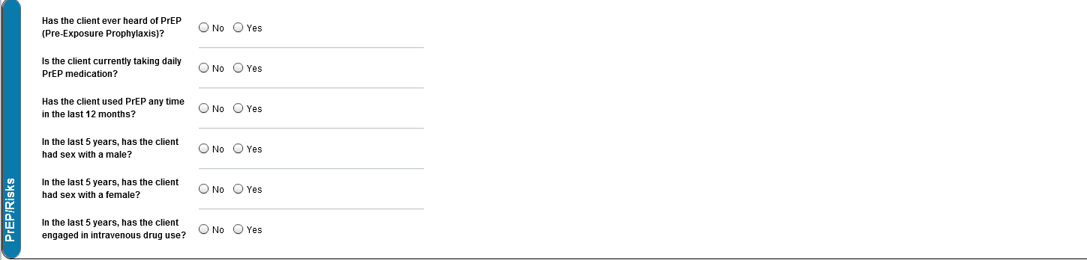

**Essential Support Services**