Welcome Screen
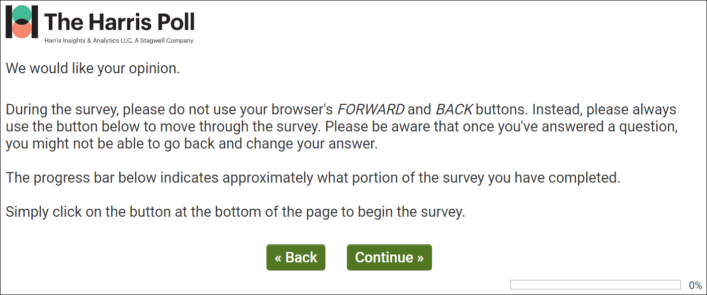

dmConsent
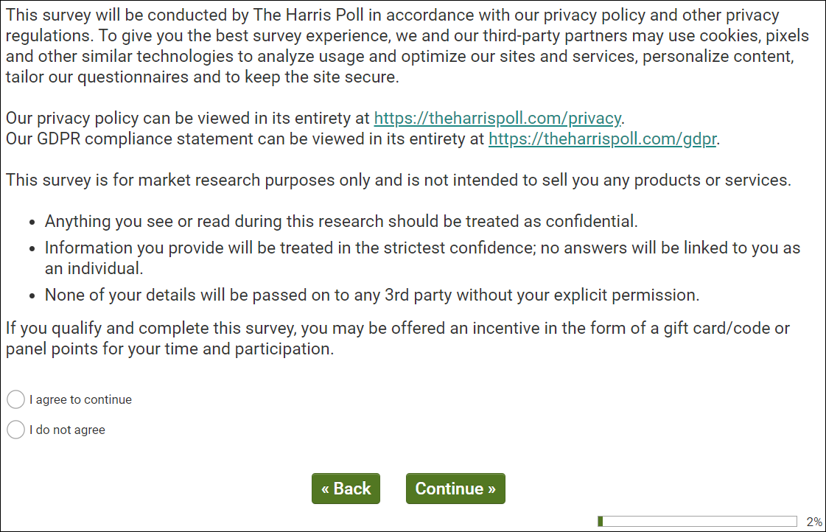
Public reporting burden for this collection of information is estimated to average 15 minutes per response,
including the time for reviewing instructions, searching existing data sources, gathering and maintaining the
data needed, and completing and reviewing the collection of information. An Agency may not conduct or
sponsor, and a person is not required to respond to, a collection of information unless it displays a current
valid OMB control number. Send comments regarding this burden estimate or any other aspect of this
collection of information, including suggestions for reducing this burden, to NIH, Project clearance
Branch, 6705 Rockledge Drive, MSC 7974, Bethesda, MD 20892-7974, ATTN: PRA (XXXX-XXXX). Do
not return the completed form to this address.

dmCntry
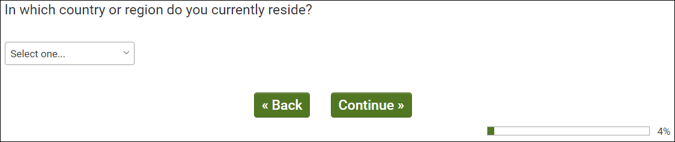
OMB Control Number: XXXX-XXXX
Expiration Date: XX/XX/XXXX

dmGen & dmAge
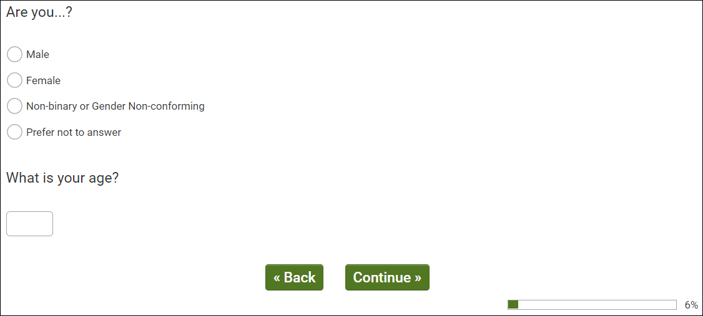
OMB Control Number: XXXX-XXXX
Expiration Date: XX/XX/XXXX

dmHispUS
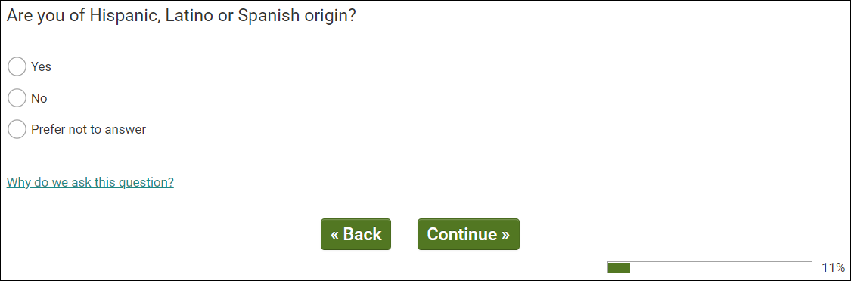
OMB Control Number: XXXX-XXXX
Expiration Date: XX/XX/XXXX

dmRaceMUS
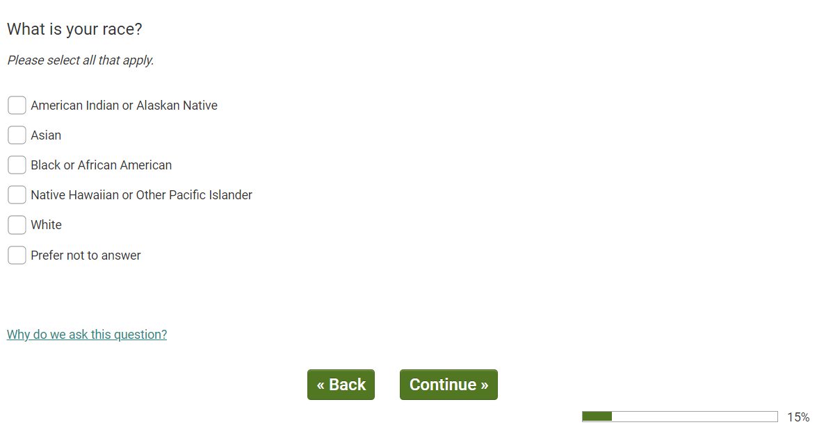
OMB Control Number: XXXX-XXXX
Expiration Date: XX/XX/XXXX

Q5
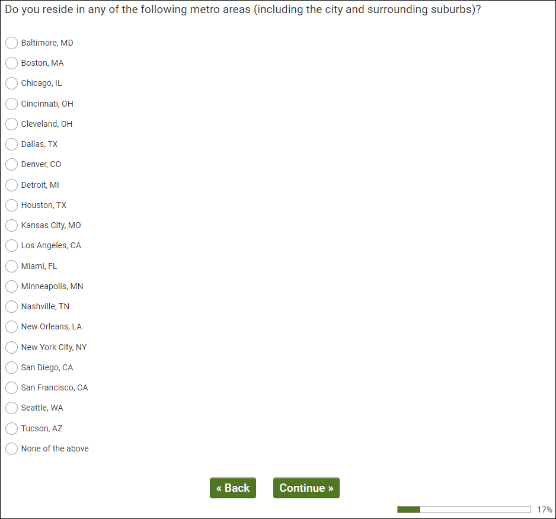
OMB Control Number: XXXX-XXXX
Expiration Date: XX/XX/XXXX

dmEmploy
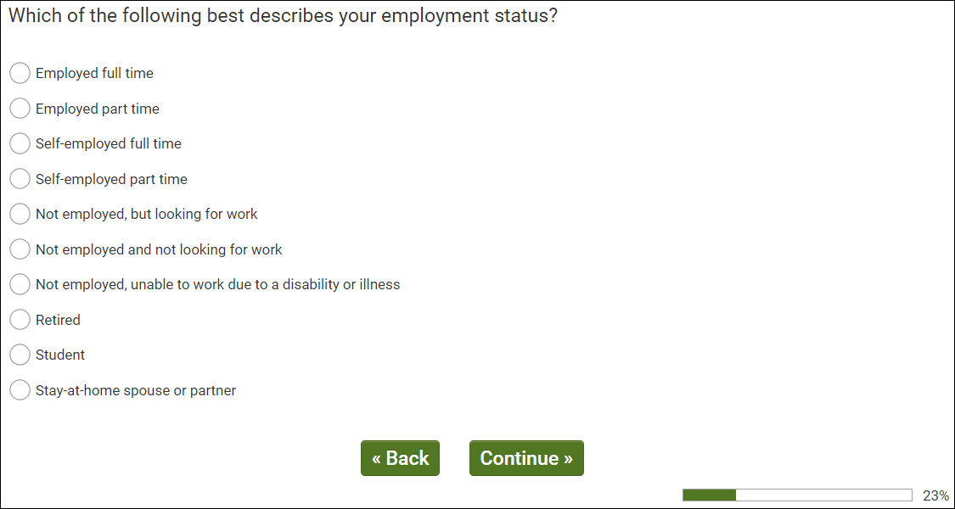
OMB Control Number: XXXX-XXXX Expiration Date: XX/XX/XXXX

Q10
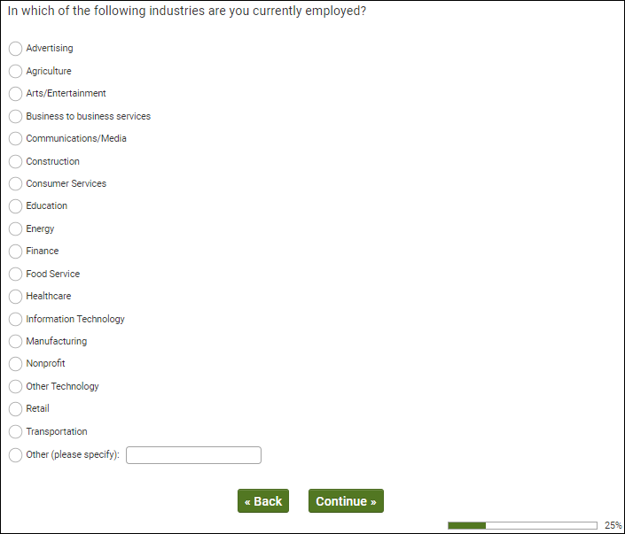
OMB Control Number: XXXX-XXXX
Expiration Date: XX/XX/XXXX

Q20
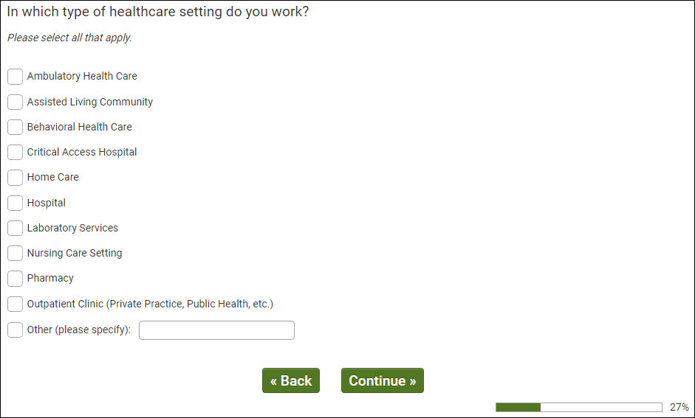
OMB Control Number: XXXX-XXXX
Expiration Date: XX/XX/XXXX

Q30
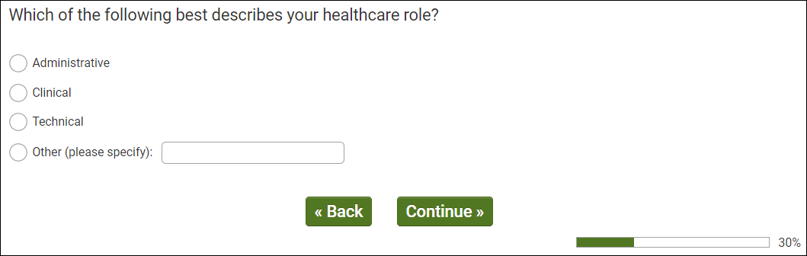
OMB Control Number: XXXX-XXXX
Expiration Date: XX/XX/XXXX

Q40
OMB Control Number: XXXX-XXXX
Expiration Date: XX/XX/XXXX

Q50
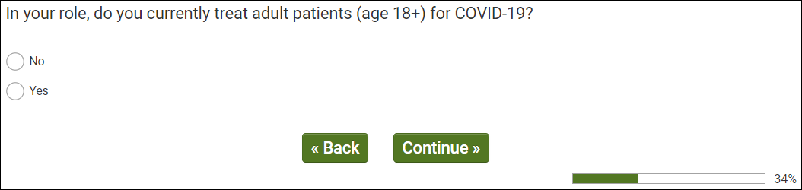
OMB Control Number: XXXX-XXXX
Expiration Date: XX/XX/XXXX

Q60
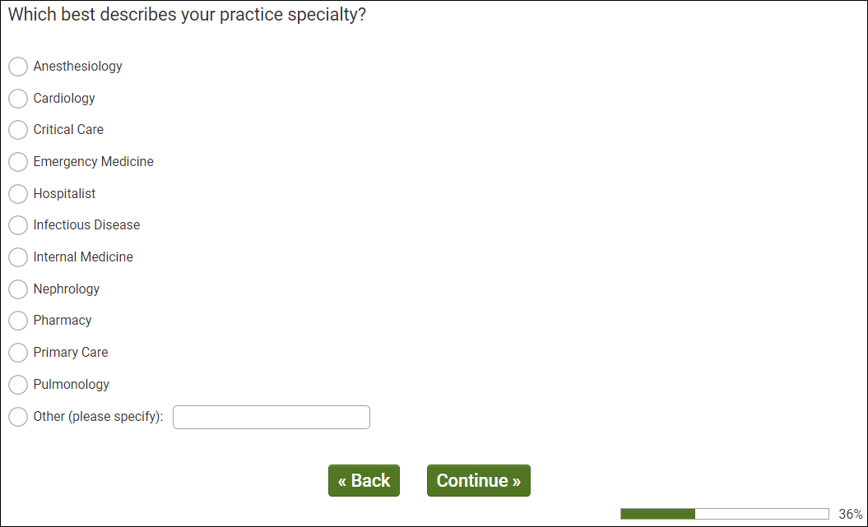
OMB Control Number: XXXX-XXXX
Expiration Date: XX/XX/XXXX

Q100
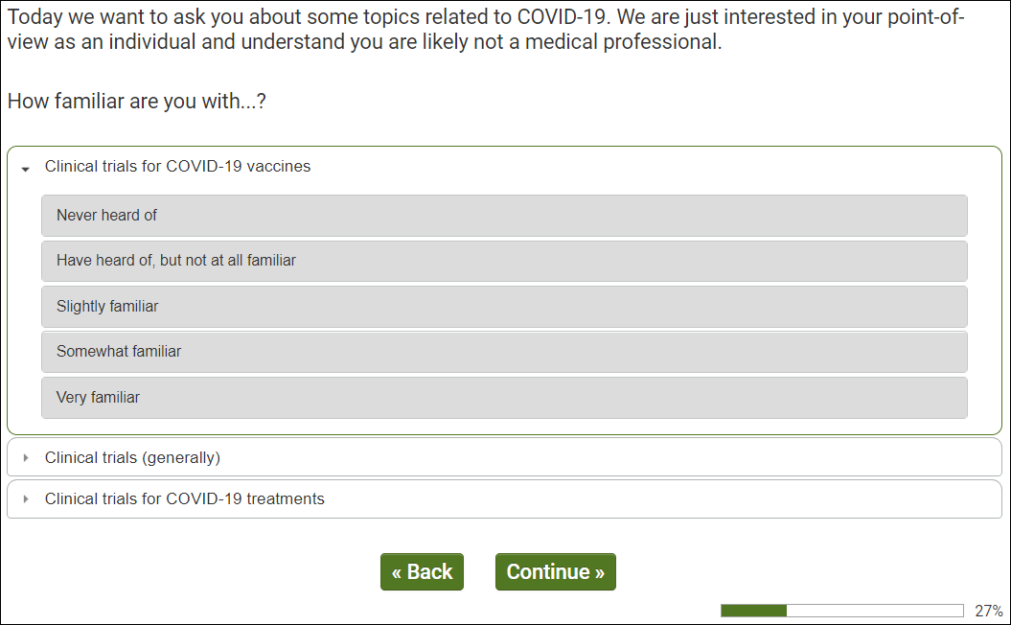
OMB Control Number: XXXX-XXXX
Expiration Date: XX/XX/XXXX

Q105
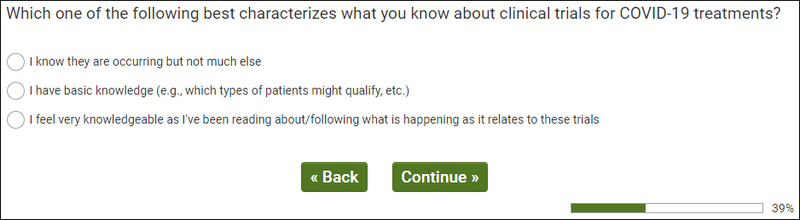
OMB Control Number: XXXX-XXXX Expiration Date: XX/XX/XXXX

Q108
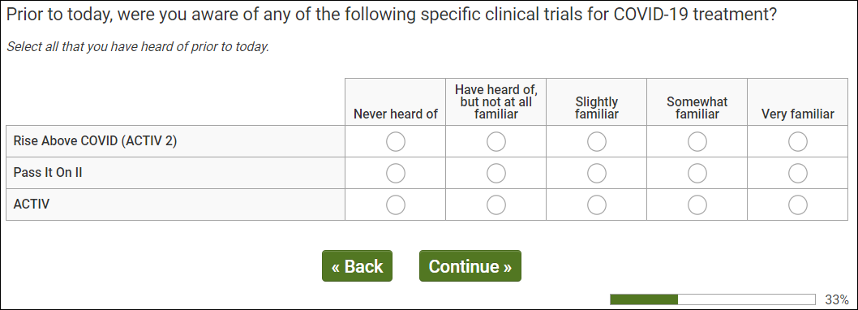
OMB Control Number: XXXX-XXXX
Expiration Date: XX/XX/XXXX

Q110
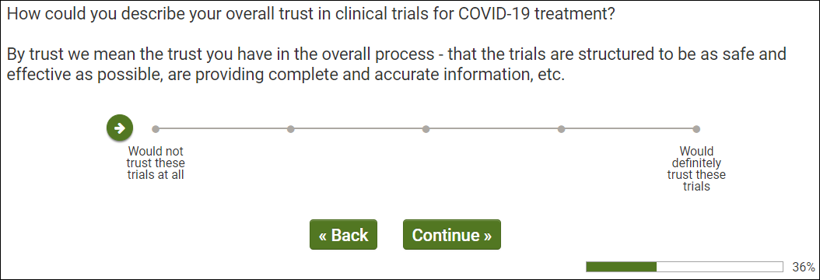
OMB Control Number: XXXX-XXXX
Expiration Date: XX/XX/XXXX

Q111
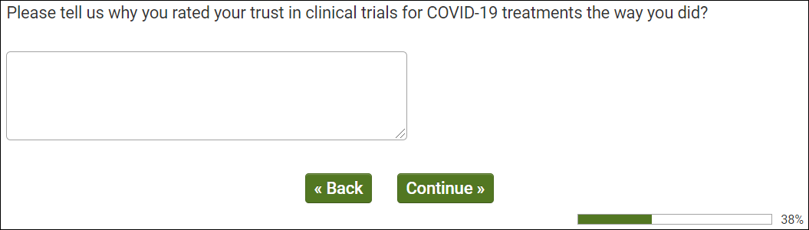
OMB Control Number: XXXX-XXXX
Expiration Date: XX/XX/XXXX

Q115
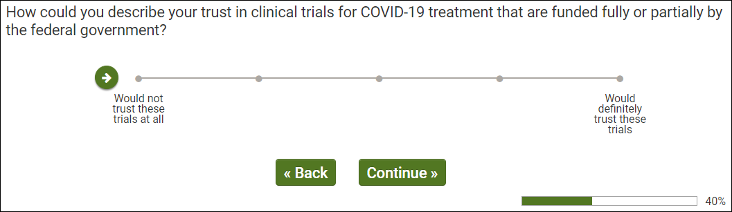
OMB Control Number: XXXX-XXXX
Expiration Date: XX/XX/XXXX

Q119
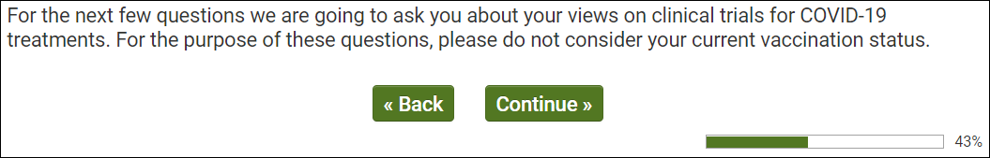
OMB Control Number: XXXX-XXXX
Expiration Date: XX/XX/XXXX

Q120
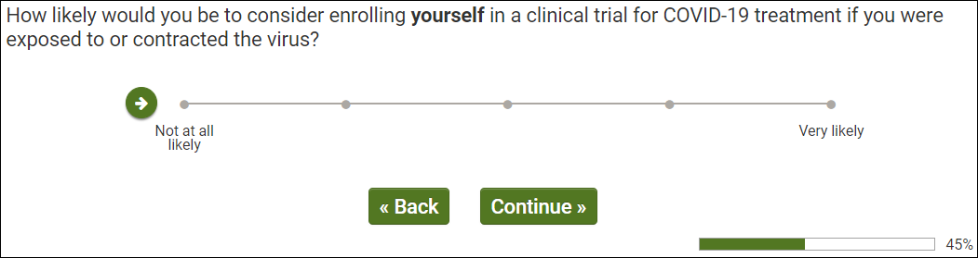
OMB Control Number: XXXX-XXXX
Expiration Date: XX/XX/XXXX

Q125
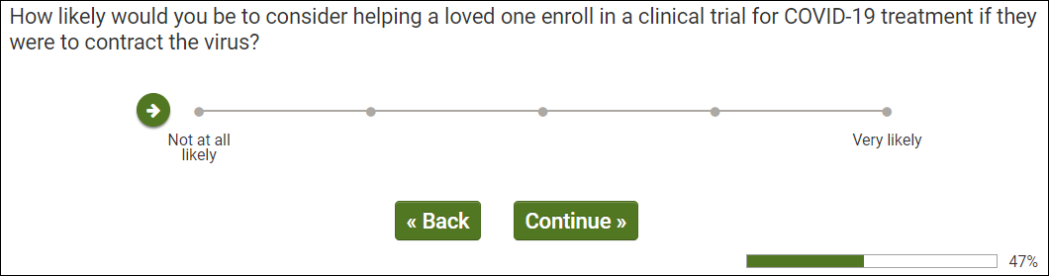
OMB Control Number: XXXX-XXXX
Expiration Date: XX/XX/XXXX
Q130
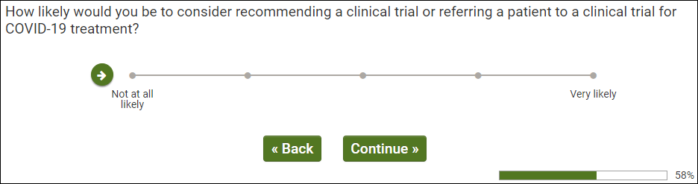
OMB Control Number: XXXX-XXXX Expiration Date: XX/XX/XXXX

Q135
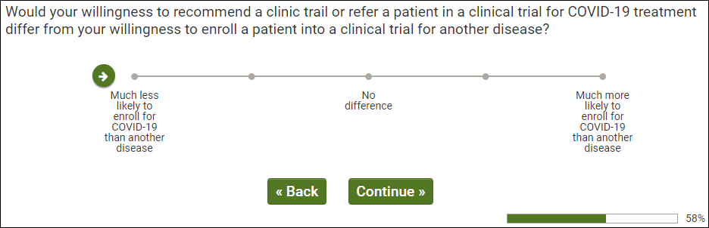
OMB Control Number: XXXX-XXXX
Expiration Date: XX/XX/XXXX

Q136
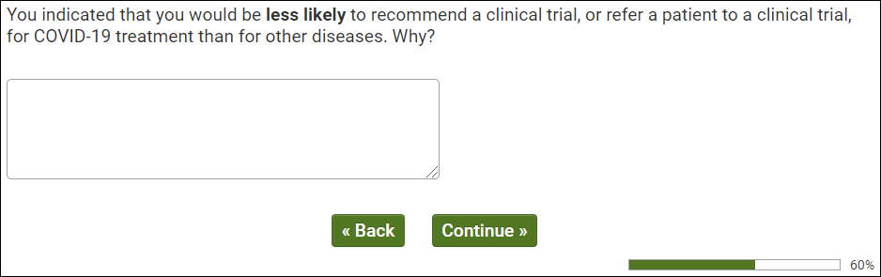
OMB Control Number: XXXX-XXXX
Expiration Date: XX/XX/XXXX

Q137
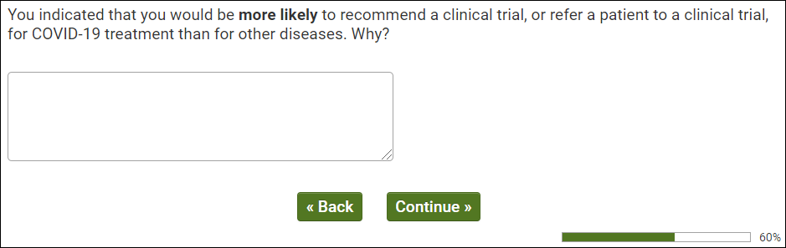
OMB Control Number: XXXX-XXXX
Expiration Date: XX/XX/XXXX

Q200
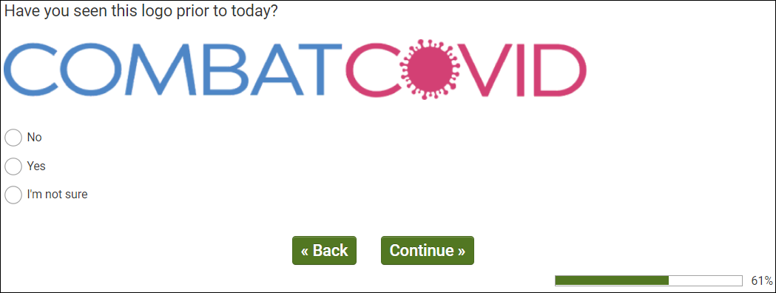
OMB Control Number: XXXX-XXXX
Expiration Date: XX/XX/XXXX

Q201
OMB Control Number: XXXX-XXXX
Expiration Date: XX/XX/XXXX

Q202
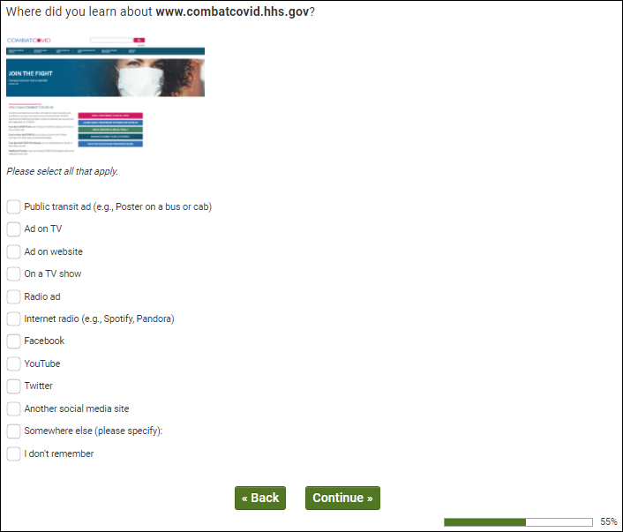
OMB Control Number: XXXX-XXXX
Expiration Date: XX/XX/XXXX

Q205
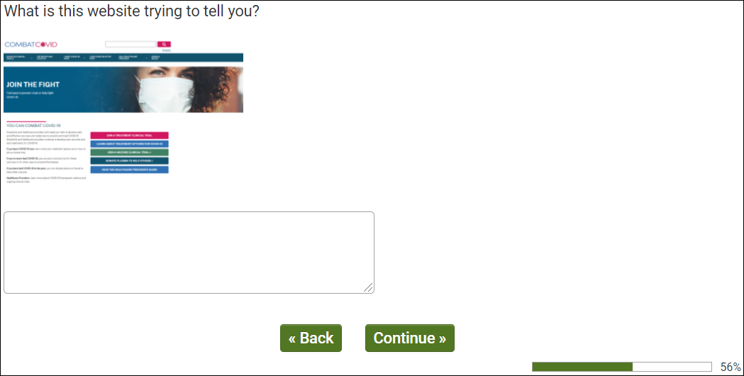
OMB Control Number: XXXX-XXXX
Expiration Date: XX/XX/XXXX

Q210
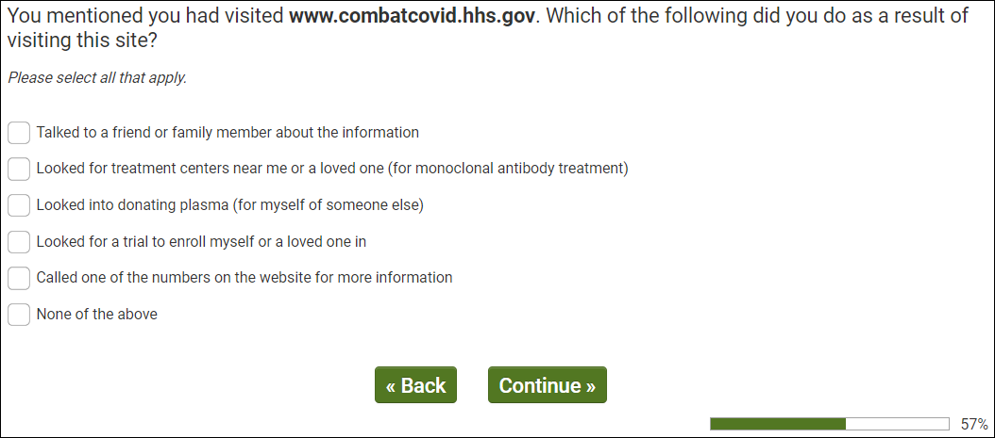
OMB Control Number: XXXX-XXXX
Expiration Date: XX/XX/XXXX

Q215
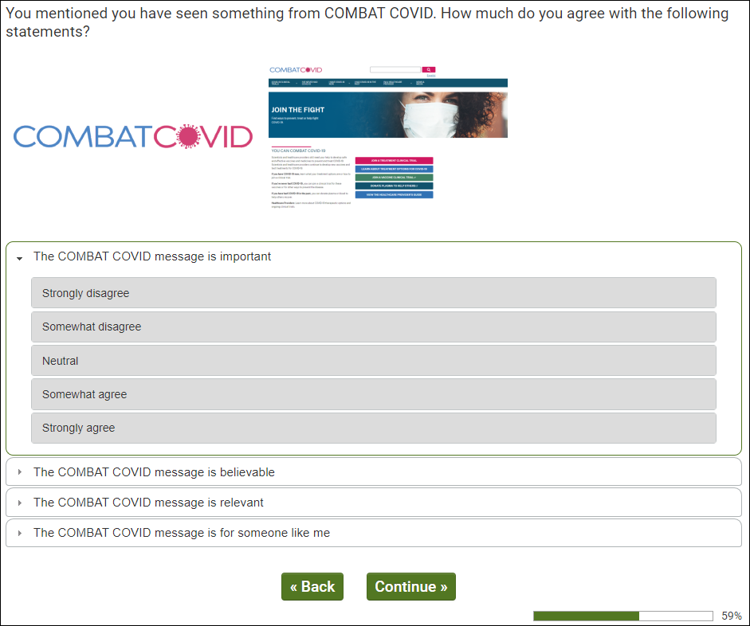
OMB Control Number: XXXX-XXXX
Expiration Date: XX/XX/XXXX

Q220
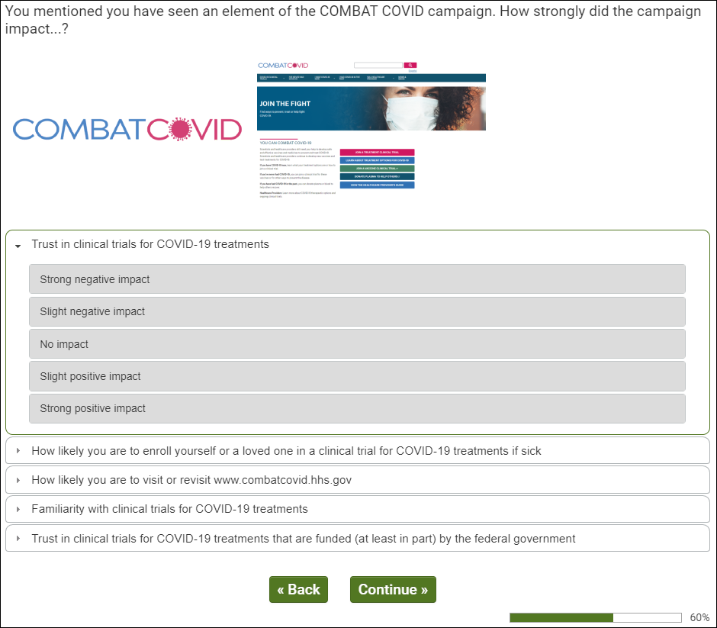
OMB Control Number: XXXX-XXXX
Expiration Date: XX/XX/XXXX

Q300
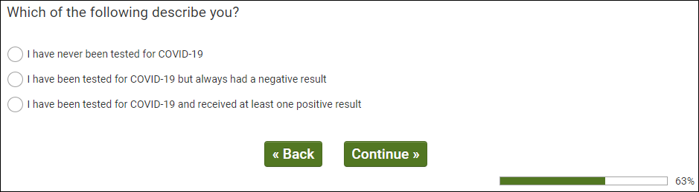
OMB Control Number: XXXX-XXXX
Expiration Date: XX/XX/XXXX

Q305
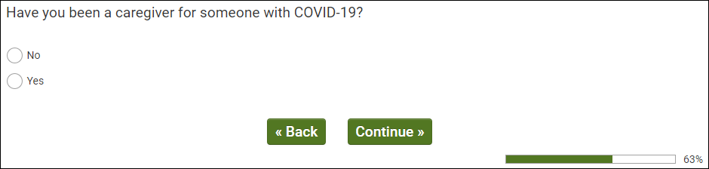
OMB Control Number: XXXX-XXXX
Expiration Date: XX/XX/XXXX

Q310
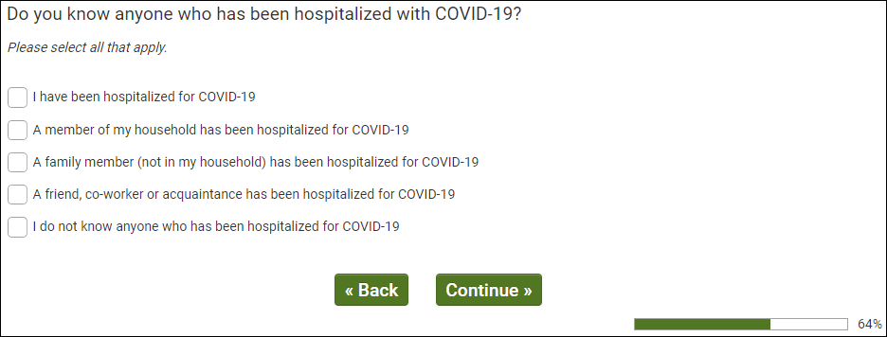
OMB Control Number: XXXX-XXXX
Expiration Date: XX/XX/XXXX

Q315
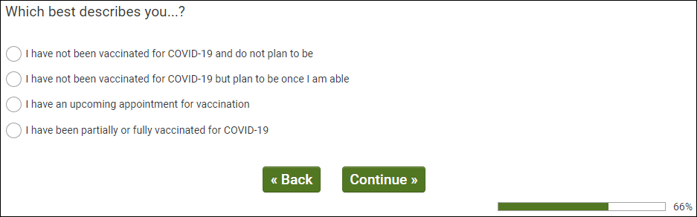
OMB Control Number: XXXX-XXXX
Expiration Date: XX/XX/XXXX

Q320
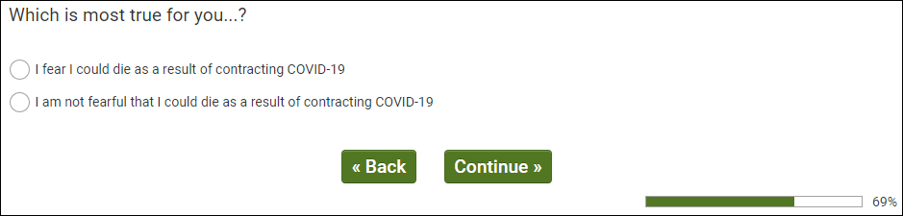
OMB Control Number: XXXX-XXXX
Expiration Date: XX/XX/XXXX

Q335
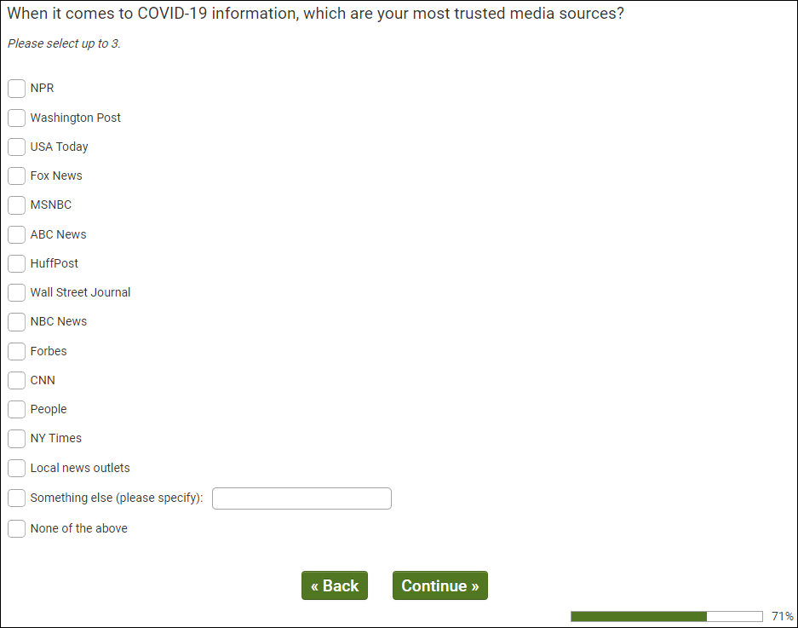
OMB Control Number: XXXX-XXXX
Expiration Date: XX/XX/XXXX

Q340
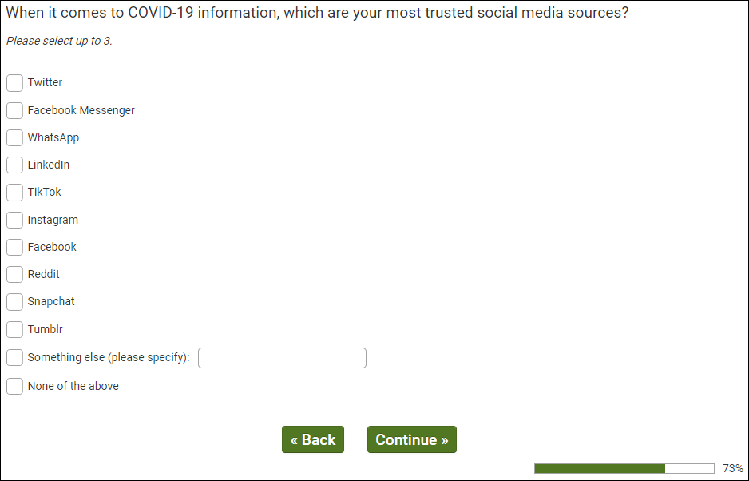
OMB Control Number: XXXX-XXXX
Expiration Date: XX/XX/XXXX

Q405
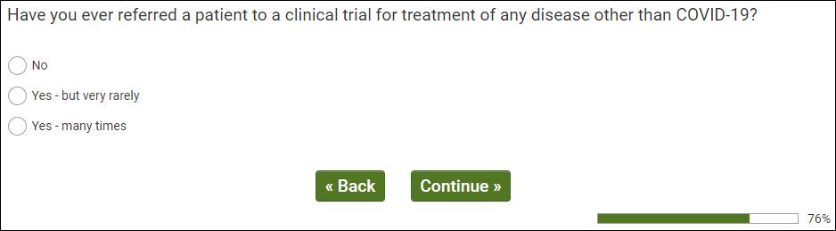
OMB Control Number: XXXX-XXXX
Expiration Date: XX/XX/XXXX

Q410
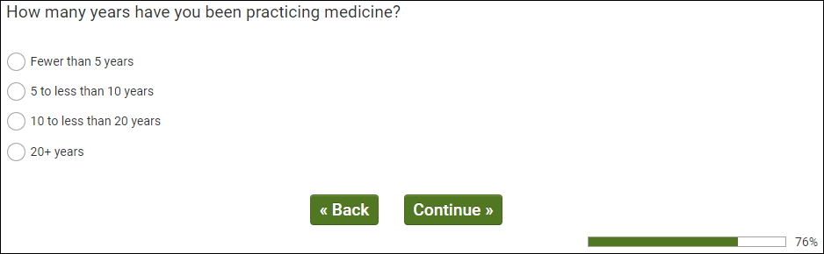
OMB Control Number: XXXX-XXXX Expiration Date: XX/XX/XXXX

Q415
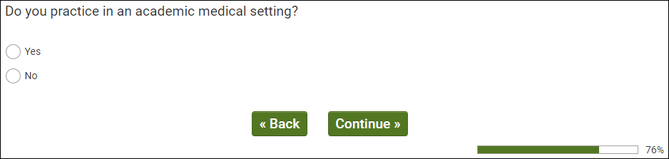
OMB Control Number: XXXX-XXXX
Expiration Date: XX/XX/XXXX

Q420
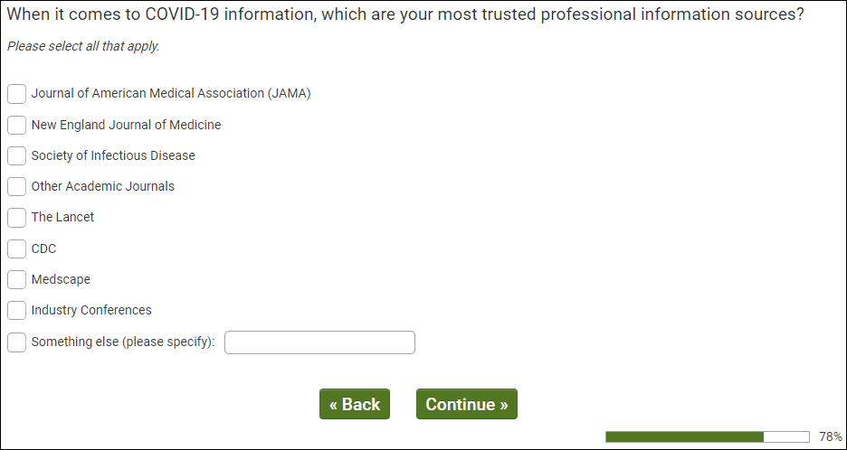
OMB Control Number: XXXX-XXXX
Expiration Date: XX/XX/XXXX
Q425
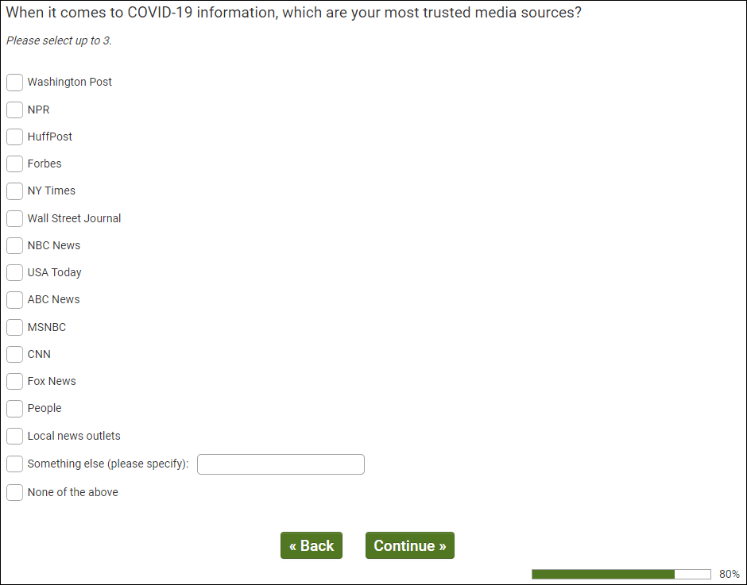
OMB Control Number: XXXX-XXXX
Expiration Date: XX/XX/XXXX

Real Answer Check
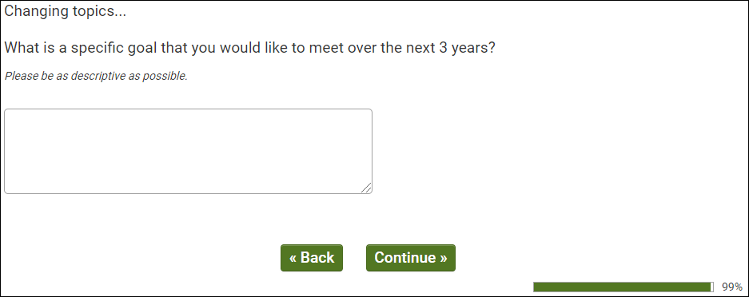
OMB Control Number: XXXX-XXXX
Expiration Date: XX/XX/XXXX
ISQ Check
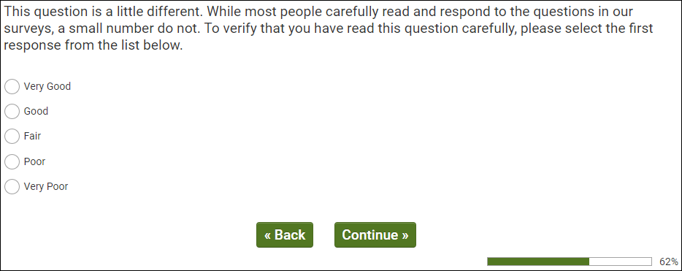
OMB Control Number: XXXX-XXXX
Expiration Date: XX/XX/XXXX

dmStateUS
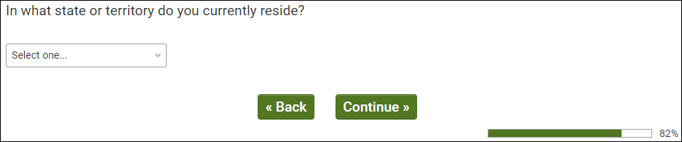
OMB Control Number: XXXX-XXXX
Expiration Date: XX/XX/XXXX

dmZipUS
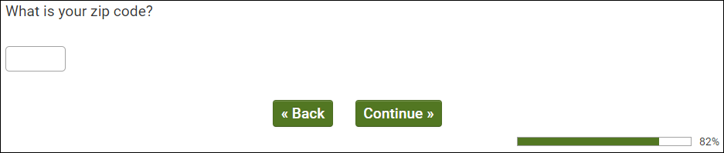
OMB Control Number: XXXX-XXXX
Expiration Date: XX/XX/XXXX

Q330
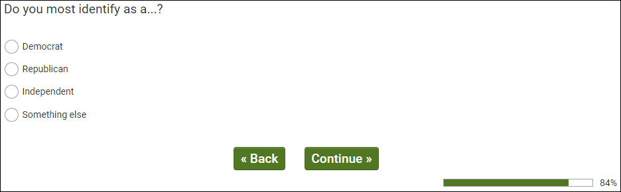
OMB Control Number: XXXX-XXXX
Expiration Date: XX/XX/XXXX

dmEduUS
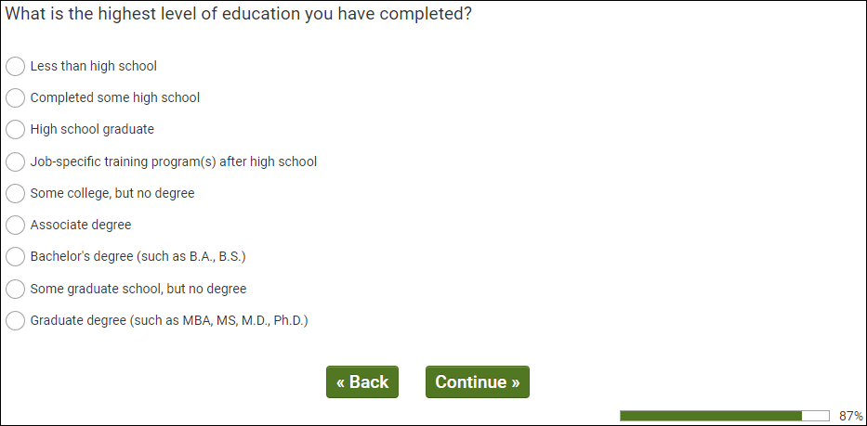
OMB Control Number: XXXX-XXXX
Expiration Date: XX/XX/XXXX

dmMarStat
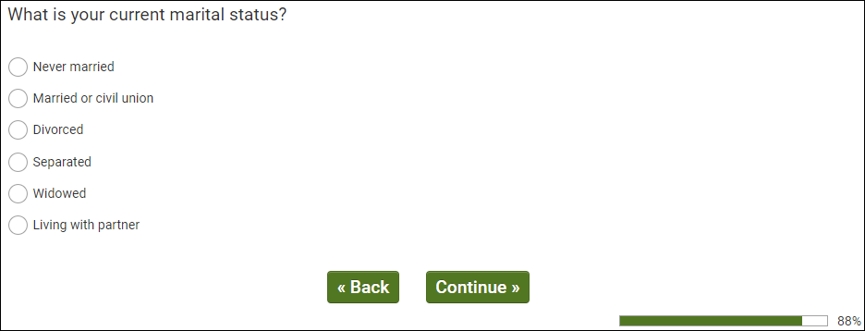
OMB Control Number: XXXX-XXXX
Expiration Date: XX/XX/XXXX

dmAdultHh
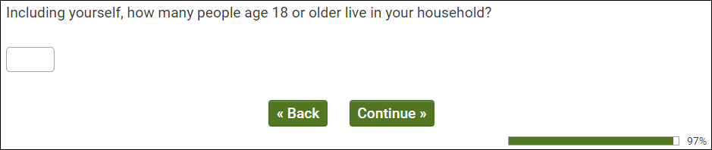
OMB Control Number: XXXX-XXXX
Expiration Date: XX/XX/XXXX

dmChildHh
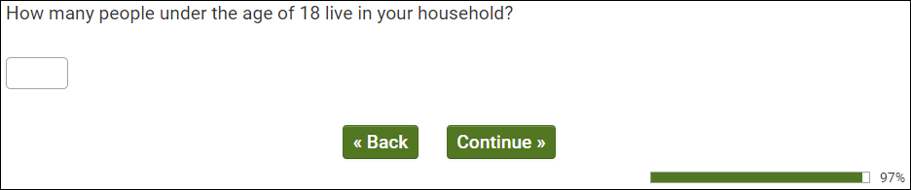
OMB Control Number: XXXX-XXXX
Expiration Date: XX/XX/XXXX

dmHhIncUS
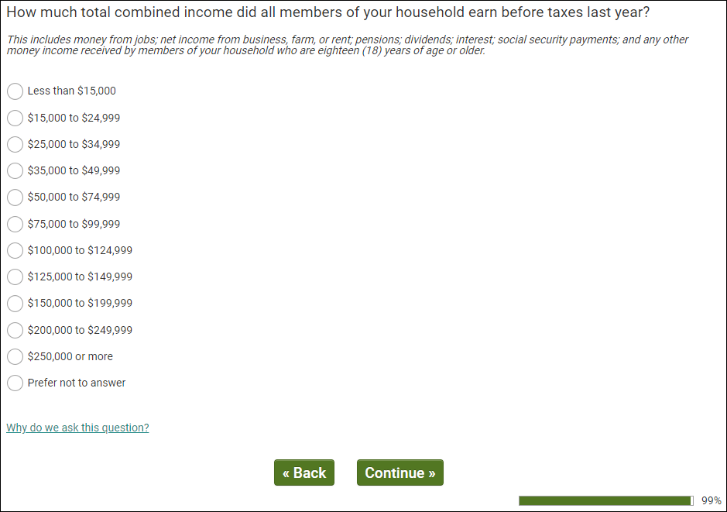
OMB Control Number: XXXX-XXXX
Expiration Date: XX/XX/XXXX

