[Month, Year]
[Respondent Name]
[Respondent Address]
[Respondent City, State Zip]

Dear [Respondent Name]:

Within the next few weeks, an interviewer from NORC at the University of Chicago will be calling you to ask you to take part in a special telephone survey related to the coronavirus (COVID-19) pandemic. We have selected you because of your recent participation in the Medicare Current Beneficiary Survey.
The interviewer will ask you a short set of questions about your experiences during the coronavirus pandemic. The telephone survey will take about 15 minutes of your time.
Your participation in this special survey is your choice. Your Medicare benefits cannot be affected in any way by your decision to participate or the answers you provide, and your information will be kept private to the extent permitted by law, as prescribed by the Federal Privacy Act of 1974.
If you have any questions, please call NORC toll-free at 1-877-389-3429, or email mcbs@norc.org. If it would be more convenient for you to set up an appointment for your interview, please call or email us.
We know many Medicare beneficiaries are concerned about the spread of coronavirus and the threat it poses to their well-being. I hope you will be able to help us with this important project.
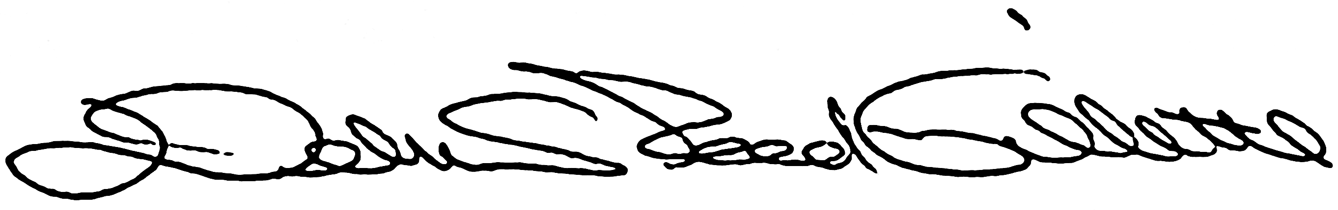
Debra Reed-Gillette, Director
Medicare Current Beneficiary Survey
Centers for Medicare & Medicaid Services

