[Month, Year]
[Respondent Name]
[Respondent Address]
[Respondent City, State Zip]

Dear [Respondent Name]:

Within the next few weeks, a representative of our agency will contact you by phone to ask permission to interview you about your experiences receiving Medicare services. The representative will ask to talk with you by phone for about an hour during a time that would be convenient to you.
The Centers for Medicare & Medicaid Services is conducting this survey to better understand the experiences of people with Medicare. The best way to gather this information is by hearing directly from people with Medicare. Your response is important now more than ever, as we gather information about the impact of the recent coronavirus (COVID-19) outbreak on your Medicare and your ability to access health care services.
We have selected you as part of a sample of people with Medicare from across the United States that can give us an accurate picture of how well people’s health care needs are being met. Your participation in the study is your choice. Your Medicare benefits cannot be affected in any way by your decision to participate or the answers you provide.
Your safety and privacy is our greatest priority. Previously, our representatives would visit you in-person to conduct the interview. However, due to the coronavirus outbreak, our interviewers will contact you by phone to set up an appointment and to complete the interview. The information you provide will be kept private to the extent permitted by law, as prescribed by the Federal Privacy Act of 1974.
The representative who will contact you is from NORC at the University of Chicago, the research institution collecting this information for us. If you have any questions or would like to schedule an appointment for your phone interview, please call NORC toll-free at 1-877-389-3429, or email mcbs@norc.org. The enclosed brochure has more information about why we are conducting this study. You can also visit the study website at mcbs.norc.org.
I hope you’ll be able to help us with this important project to improve Medicare services.
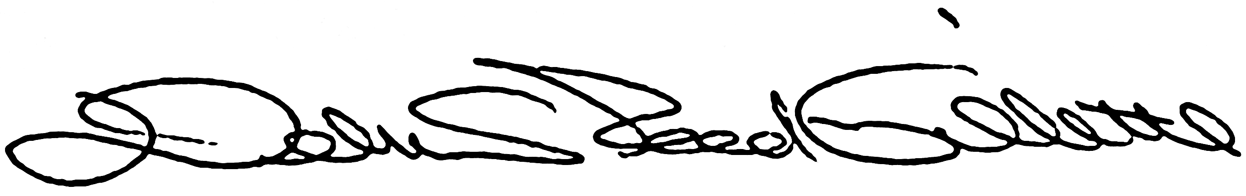
Debra Reed-Gillette, Director
Medicare Current Beneficiary Survey
Centers for Medicare & Medicaid Services

