[Month, Year]
[Respondent Name]
[Respondent Address]
[Respondent City, State Zip]

Dear [Respondent Name]:

Recently we attempted to contact you regarding the Medicare Current Beneficiary Survey (MCBS). NORC is contracted by the Centers for Medicare & Medicaid Services to conduct the MCBS. We mailed you a letter in late July and we have included another copy of this letter for your reference. In addition, one of our professional NORC interviewers has tried to reach you by telephone.
First, if you have already completed the survey we thank you for taking time to speak with us. If you have not yet completed the survey, I am writing to request your permission to schedule a phone call with one of our interviewers to discuss this important study. The survey can be completed by phone at a time that is convenient for you.
To complete the interview, call us at 1-877-389-3429.
You have been invited to participate in the MCBS as one of the many people eligible for Medicare. Your participation helps provide an accurate picture of how well the health care needs of people like you are being met across the United States. We respect your right to security and privacy. Your participation in the survey is your choice. Your Medicare benefits cannot be affected in any way by your decision to participate or the answers you provide.
We look forward to talking with you about this important survey. You can visit the survey website at mcbs.norc.org or call the toll-free number above to speak with a representative to learn more about the MCBS.
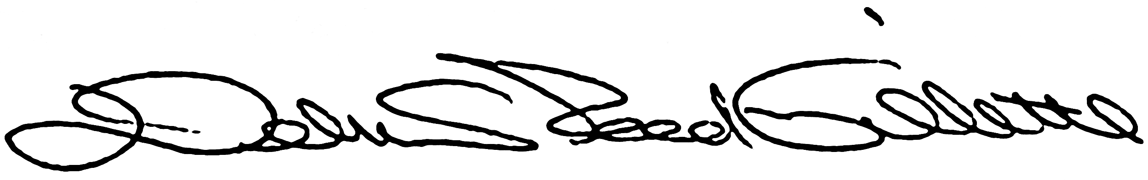
Debra Reed-Gillette, Director
Medicare Current Beneficiary Survey
Centers for Medicare & Medicaid Services

